Strategies in Pay-For-Performance

1034-12027

Final Report

May 18, 2011

**Prepared for:**

Washington State Legislature

Re: Chapter 37, Laws of 2010

61st Legislature

2010 1st Special Session

Supplemental Operating Budget

**Prepared by:**

L&M Policy Research, LLC

Attn: Julia Doherty

P.O. Box 42026

Washington, D.C. 20015

Phone: (202) 249-8945

Fax: (202) 249-1784

E-mail: JDoherty@LMPolicyResearch.com

Table of Contents

ACKNOWLEDGMENTS 1

executive summary 2

Background 2

Study Methods 2

Qualitative Findings 3

P4P Quality Dimensions 4

Decision Points 5

Design, Adoption, and Implementation Issues 6

Lessons Learned from Other States 6

Federal Nursing Home Value-Based Purchasing Demonstration 7

Quantitative Illustrations of Alternative P4P Approaches 8

Recommendations 8

introduction 11

background 13

Pay-for-Performance in the Nursing Home Setting 13

Federal Nursing Home Value-Based Purchasing Demonstration 13

Program Performance Measures and Financial Incentives 14

Washington State: The Environment on the Ground 16

Overview of Facilities 16

Staffing 16

Deficiencies Reported Through Annual Health Inspection 17

Ownership 18

Average Per Diem Rates and Cost Components 19

Study Methods 23

Qualitative Methods 23

Quantitative Methods 25

Data Sources 26

Performance Measures and Weighting 26

Limitations 27

qualitative findings 29

Major P4P Quality Dimensions 29

Staffing 31

Consumer Satisfaction 33

Clinical Quality Indicators 35

Survey Performance 37

Culture Change 39

Other Quality Dimensions 43

Efficiency 45

Avoidable Hospitalizations 46

Access 47

Re-envisioning 49

Quality Improvement Program 50

Decision Points 50

Risk Adjustment 50

Payout and Budget 51

Eligibility and Participation 55

Design, Adoption, and Implementation Issues 56

Lessons Learned from Other States 59

Iowa’s P4P Program 59

Pay-for-Performance Summary 59

Best Practices and Advice to Washington 61

Minnesota’s P4P Program 64

Pay-for-Performance Summary 64

Best Practices and Advice to Washington 65

Oklahoma’s P4P Program 68

Pay-for-Performance Summary 68

Best Practices and Advice to Washington 69

Utah’s P4P Program 71

Pay-for-Performance Summary 71

Best Practices and Advice to Washington 71

Vermont’s P4P Program 73

Pay-for-Performance Summary 73

Best Practices and Advice for Washington 74

Cross-cutting Lessons from Other States 75

Quantitative Illustrations of alternative p4p approaches 77

Alternative Performance Rating Approaches 77

Five-Star Ratings 77

Pressure Sore Rating 78

Increased Need for Help with Daily Activities 79

Rewarding Improvement in Performance 80

Combined Measures of Improvements and Absolute Quality 82

Characteristics of Nursing Homes with High Performance Scores 82

Relationship between Per Diem Payments and Quality 88

Winners under Different Payment Scenarios 91

Budget Impacts of Pay-for-Performance 91

Percentage Per Patient Per Diem Rewards 92

Fixed Dollar Add-on Rewards 93

Findings 93

conclusions and recommendations 95

Conclusions about Key Decision Points 95

Broad Conclusions and Recommendations 97

references 100

appendix A - Interviews 102

Washington State Stakeholder Interviewees 102

Washington State Stakeholders Interview Protocol 104

Other State Representatives of Nursing Home P4P Programs 111

Other State Representatives Interview Protocol 112

appendix B - Stakeholder Meeting #1 116

Nursing Home Payment Workgroup Participants 116

Teleconference Presentation Materials, Nov. 16, 2010 117

appendix C - Stakeholder Meeting #2 128

Webinar Participants 128

Webinar Poll Results 130

Webinar Exit Survey Results 138

Webinar Questions and Comments 145

Webinar Presentation Materials, Jan. 6, 2011 150

List of Figures

Figure 1. Webinar Poll: Which Major Quality Dimension is Most Important to Include? 31

Figure 2. Webinar Poll: Which Other Quality Dimension is Most Important to Include? 44

Figure 3. Webinar Poll: Which Other Quality Dimension is Least Important to Include? 45

Figure 4. Funding Source Ratings from Webinar 53

Figure 5. Payment Structure Ratings from Webinar and Stakeholders 54

Figure 6. Scatter Plot of Total Payment Rate and Overall Rating 89

Figure 7. Scatter Plot of Total Payment Rate and % Residents with Pressure Sores 90

Figure 8. Scatter Plot of Total Payment Rate and % Residents Needing Help with Daily Activities 90

List of Tables

Table 1. RN, LPN/LVN, and CNA Nurse Staffing Levels 17

Table 2. Deficiencies Reported in Annual Health Inspection, by Deficiency Category 18

Table 3. Distribution of Ownership Type 19

Table 4. Breakout of Nursing Home Medicaid Payment Components, 2011 21

Table 5. Stakeholder Impressions of Major Quality P4P Dimensions 30

Table 6. Stakeholder Ranking of Major Quality Dimensions 38

Table 7. Stakeholder Ratings of Aspects of Culture Change 41

Table 8. Stakeholder Ratings of Other Quality Dimensions 43

Table 9. Stakeholder Rankings of Funding Sources 52

Table 10. WA Nursing Homes’ Current Five-Star Ratings 77

Table 11. Distribution of Overall Rating 78

Table 12. Distribution of Pressure Sore Quality Rating 79

Table 13. Distribution of Need for Increased Help Quality Measure 80

Table 14. Improvement in Five-Star Ratings 81

Table 15. Improvements in Star Ratings between 2009-2010, by 2010 Number of Stars 81

Table 16. Characteristics of Nursing Homes Benefiting under P4P Star-Rating Scenario 83

Table 17. Additional Characteristics under P4P Star-Rating Scenarios 84

Table 18. Characteristics of Nursing Homes Benefiting under Two P4P Individual Quality Measure Scenarios 85

Table 19. Additional Characteristics of Nursing Homes under Two P4P Individual Quality Measure Scenarios 86

Table 20. Characteristics of Nursing Homes Benefiting under Two Improvement Rating Scenarios 87

Table 21. Additional Characteristics under Two Improvement Rating Scenarios 88

Table 22. Correspondence between Winners in Different Rating Systems 91

Table 23. Correspondence between Winners in Quality Measure Ratings 91

Table 24. Total Program Payments Assuming a per Patient per Diem Rate Increase of One, Two, and Three Percent for Alternative Payment Scenarios 92

Table 25. Total Program Payments Assuming a Per Patient Per Diem Rate Increase of $1, $2, or $3 for Alternative Payment Scenarios 93

# ACKNOWLEDGMENTS

This project is the culmination of a broad and collegial effort by numerous individuals. This report was written by Julia Doherty, M.H.S.A, project director; Judy Goldberg Dey, Ph.D.; Catherine Jo; and Rachel Dolin of L&M Policy Research (L&M); and Edward A. Miller, Ph.D., of University of Massachusetts, Boston. The report was edited by David Grabowski, Ph.D. of Harvard University; and Pedro Gozalo, Ph.D.; and Vince Mor, Ph.D., of Brown University; and Myra Tanamor, M.P.P, of L&M Policy Research. The qualitative research was co-designed and conducted by L&M staff and Dr. Miller, with comprehensive note-taking and analysis by Catherine Jo and Jon Polit of L&M. The quantitative research was designed by the full study team, including our colleagues from Harvard and Brown Universities, and conducted by Dr. Dey, William Pajerowski and Jon Polit of L&M. The team would like to thank all of the Washington state stakeholders, who generously gave their time, perspective, and insight, and the key informants from other states with nursing home pay-for-performance programs for sharing their knowledge, experiences, and expert advice. Finally, we would like to thank our project officer at the Department of Social and Health Services (DSHS), Ken Callaghan, chief, Office of Rates Management, Management Services Division, for his guidance and thoughtful feedback throughout the study process. We also thank his colleagues at DSHS who have shared valued experience and insight and provided the technical assistance in conducting the stakeholder teleconferences and Webinar.

# executive summary

The Washington State Legislature in 2010 directed the Department of Social and Health Services (DSHS) to contract an outside entity to both review pay-for-performance (P4P) strategies other states use in their Medicaid programs and gather stakeholder input on potential quality measures, and conduct quantitative analyses to provide a foundation for the potential implementation of a P4P program in Washington. As such, the Washington DSHS contracted L&M Policy Research, LLC, and its consultants from Brown and Harvard Universities and the University of Massachusetts Boston, Pedro Gozalo, Ph.D., David Grabowski, Ph.D., Edward Alan Miller, Ph.D., and Vincent Mor, Ph.D., to conduct a study and submit a report as outlined by the state legislature.

This report provides a summary of the study team’s work. It first summarizes the current nursing home P4P experience around the country, discusses input obtained from stakeholders, and provides a quantitative analysis to illustrate the potential impact of alternative approaches to P4P program design. Finally, we present important issues for consideration as policymakers and stakeholders move forward in designing a P4P program within the Washington Medicaid nursing home reimbursement system.

## Background

According to the Centers for Medicare & Medicaid’s (CMS) Nursing Home Compare database, 229 nursing homes are currently operating in the state of Washington (not all of these nursing homes bill the state but nonetheless participate in either Medicare or Medicaid) – 10 of these facilities are located within a hospital, while the remaining 219 are freestanding. Just under two thirds (61.1 percent), or 140 nursing homes, are part of a multi-home system. Most nursing homes involve residents and family in decision making, with 74.2 percent of facilities operating a resident council and an additional 23.1 percent operating a council involving both residents and family. Approximately 26 percent of nursing homes operate in King County.

## Study Methods

The Washington state legislature tasked DSHS with engaging consultants to answer the following research questions:

1. What P4P strategies should Washington consider for implementation in nursing homes?
2. What is the potential impact involved in implementing those strategies?
3. What factors might facilitate or impede successful introduction of P4P?

To answer these questions, the study team employed both qualitative and quantitative methods. On the qualitative side, we first updated our environmental scan of nursing home activities both in Washington and throughout the country with a special focus on P4P program initiatives. In conjunction with DSHS, the study team then identified key stakeholders that would be involved or interested in the implementation of P4P in Washington and designed multiple methods for soliciting their input. The study team developed a protocol and conducted key informant interviews to solicit similar information from a wide variety of stakeholders (22 individuals) representing single nursing homes, local and national nursing home chains, and nursing home associations. The study team conducted a second set of key informant interviews concurrently with 11 individuals involved in the implementation of P4P in nursing homes in other states: Iowa, Minnesota, Oklahoma, Utah, and Vermont. In November of 2010, the study team held the first of two stakeholder meetings, both to provide stakeholders with a sense of the nature of nursing home P4P programs around the country and, most importantly, to solicit input should P4P be included as part of Washington state’s nursing home reimbursement strategy. In order to solicit as much input as possible, the study teamconducted a second meeting in the form of a Webinar, via the Internet, on January 6, 2011. Almost 300 individuals were invited to participate, including representatives of the 201 nursing homes paid by the state’s Medicaid program, as well as representatives from the state’s two major nursing home associations, Washington Health Care Association and Aging Services of Washington, and government representatives.

On the quantitative side, we developed a series of P4P scenarios based on a variety of weighting approaches and facility characteristics to illustrate the impact of different potential scenarios reflecting alternative approaches in the P4P program design process. Nursing home variables considered include clinical quality, staffing, inspection, location, size, and occupancy – both currently and in previous time periods – to simulate the impact of rewarding improvements, in addition to high absolute performance scores.

The team created a preliminary analytic file using the most recently available Nursing Home Compare data from 2009 and 2010 and additionally used WA DSHS January 2011 nursing home Medicaid payment rate data containing both per diem payment amounts and total Medicaid patient days. The two datasets were joined using the nursing home name, leading to a crosswalk of 201 of the 229 nursing homes. The impact analysis provides approximate broad budgetary implications.[1] We considered several alternatives to highlight the distributional implications of different possible choices and parameters that could be considered in P4P program design. When more than one measure of performance is used, the weighting of the measurement must be decided. While the indicators chosen reflect possibly policy-relevant quality measures, they are in no way indicative of all possible indicators or the product of a consensus-building exercise to develop the most important measures. They are used to demonstrate the possible implications of measurement choices Washington may make based on readily available data. Further analyses and modeling later in the process when decisions about measurement, weighting, and scoring had been made, will yield more accurate projections.

## Qualitative Findings

The study team solicited input from stakeholders on 10 P4P dimensions, five of which it considered “major P4P quality dimensions” – staffing, consumer satisfaction, clinical quality indicators, survey performance, and culture change – and five of which it grouped together as “other quality dimensions” – efficiency, avoidable hospitalizations, access, “re-envisioning,”[2] and quality improvement programs. The study team also solicited input from stakeholders on key decision points, including risk adjustment, payout and budget, and eligibility and participation. Finally, the team sought stakeholder input on broad program design, adoption, and implementation issues; and it reviewed and examined patterns associated with lessons from experiences with P4P in Iowa, Minnesota, Oklahoma, Utah, and Vermont.

### P4P Quality Dimensions

After asking stakeholder interviewees their background and general perspective on quality, we focused on the major dimensions of quality most frequently used in nursing home P4P programs to date – staffing, survey performance, culture change, consumer satisfaction, and clinical quality indicators. Approximately three-quarters of those interviewed favored including the clinical quality indicators in P4P; more than two-thirds favored including consumer satisfaction. On the other hand, fewer than half favored including staffing and culture change in P4P; and a little fewer than one-quarter, favored survey deficiencies.

*Staffing, Culture Change, and Survey Performance.* Forty-one percent of stakeholders interviewed supported including a staffing component in a P4P program; turnover and retention were believed to be particularly important measures to consider. Most stakeholders felt low turnover generally indicates greater levels of and consistency in staffing and, in turn, higher quality of care and increased employee empowerment and productivity. While stakeholders supported the idea of culture change and the broad categories of quality of life, worker empowerment, and improvements to physical plant and organizational processes, it was unclear how the dimension would be designed, how performance would be measured, and whether financial and administrative resources would be available to fund this endeavor. The current three-year transition to the new Quality Indicator Survey (QIS) system was generally viewed optimistically, although it will prove to be an obstacle to using survey deficiencies as a P4P measure until the new system is in place throughout the state. This transition was viewed as important since Washington was considered by a number of stakeholders to be more punitive than other states in assigning deficiencies, and stakeholders expressed concern over tying survey deficiencies to P4P.[3]

*Consumer Satisfaction.* For both the stakeholders interviewed and the stakeholders polled during the Webinar, resident or family satisfaction was perceived as one of if not the most important dimension to include in a nursing home P4P program. Most stakeholder discussions focused on incorporating consumer satisfaction information in a way that is useful and minimizes the administrative and financial burden for facilities. Stakeholders considered it a direct indicator of quality care and as having a natural correlation with performance in other dimensions. Washington does not currently require facilities to administer a customer satisfaction survey; therefore, if consumer satisfaction were included as a P4P measure, the state would either need to require all facilities to adopt a standard tool, contract with a vendor, or allow facilities to use their own, either implemented in-house or through a contractor of their choice. Stakeholders expressed mixed reactions to these options, noting that regardless of whether or not a standard tool or practice is mandated for all nursing facilities, additional funding would be required for this to occur.

*Clinical Quality Indicators.* Stakeholders indicated that clinical quality indicators was one of the more important dimensions to include in a nursing home P4P program, with the majority of interviewees (68 percent) ranking it among the top three most important dimensions and 29 percent of poll respondents identifying it as the most important dimension. Most stakeholders believed they are a useful indicator of the quality of care patients receive, and since the data are already being collected, they should be used. Stakeholders, however, recognized that there are several complications associated with using clinical metrics, including the inability to distinguish between clinical problems acquired within the facility versus those acquired within the community or endemic to the patient population. Another concern raised involves the use of MDS 2.0 data, which some believed is not sensitive enough to be a useful indicator of performance; stakeholders expressed cautious optimism regarding MDS 3.0, feeling that it may yield more accurate and fine-tuned information.

*Other Quality Dimensions.* During both the interviews and the Webinar, we asked stakeholders for input on the potential importance of including other dimensions in a P4P program in the state, such as efficiency, access, avoidable hospitalizations, and presence of a quality improvement program. We also asked about the value of including a dimension reflective of state efforts to re-envision the role of the nursing home in the continuum of care or, in other words, encouraging facilities to become a hub in a service delivery model that spans the continuum from hospitalization to post-acute care to long-term assistance, preferably at home and in the community.

Stakeholders expressed mixed feelings toward the efficiency dimension.Although most recognized hospitalizations are extremely costly to the health care system, they expressed concerns about using it as a measure in P4P, given challenges in defining and measuring which hospitalizations were truly avoidable. Most stakeholders either supported or were undecided about including access to care as a dimension, with few opposing it outright. Stakeholders’ responses were also mixed when asked about re-envisioning as a dimension. A number of interviewees expressed reservations because they were unsure what re-envisioning meant and what, exactly, it might entail in practice.

Finally,most interviewees believed it was essential for facilities to have quality improvement plans in place, although it was unclear whether they supported including quality improvement plans or processes as a P4P dimension. Others mentioned that, should it be included as a dimension, facilities would need to demonstrate in some way not just that a plan was in place, but used in practice as part of an on-going quality improvement effort.

### Decision Points

*Risk Adjustment.* More than two-thirds of stakeholders interviewed supported risk adjustment for certain dimensions, namely: staffing, clinical quality indicators, and possibly survey deficiencies.

*Payout and Budget.* Most stakeholders believed the state should ensure nursing homes receive a sufficient base payment before implementing P4P – and most supported the adoption of a provider tax as a means for funding the new appropriations. In terms of the structure of the incentive, stakeholders generally preferred a fixed dollar per diem add-on followed by a percentage of the per diem rate; few commented on the option of structuring the incentive as a lump-sum payment. And most interviewees believed both absolute performance and improvement should be accounted for in P4P.

*Eligibility and Participation*. Most stakeholders believed participation in P4P should be voluntary, although a few interviewees asserted that changing provider behavior would instead require mandatory participation.

### Design, Adoption, and Implementation Issues

When reflecting on P4P, stakeholders reported the factors they believed would facilitate or impede program implementation and adoption. Interviewees viewed favorably the fact that the existing reimbursement system is already largely performance-based with case mix and other incentives, perhaps as precedent for further incentivizing performance with P4P. Factors considered especially critical to the success of a P4P program included actively engaging a variety of stakeholders and other experts throughout the design and implementation process, improving collaboration between the state and providers, minimizing providers’ administrative burdens, and emphasizing flexibility and simplicity in P4P program design and development. The majority of stakeholders also emphasized the need to keep P4P simple, enabling administrators to focus on quality improvements and policymakers to better understand the connection between spending and health outcomes.

Factors considered especially salient impediments to implementing P4P included the adverse effect of the current fiscal climate on existing reimbursement levels, the lack of evidence regarding the likely efficacy of P4P in the nursing home setting, and the potential use of administratively burdensome data collection and reporting processes.

Stakeholders offered several suggestions as to the most effective means of program implementation. Several advocated taking an incremental approach to program roll-out, beginning with a more general trial period that would be followed by the phasing in of more sophisticated measures. This tactic would enable facilities to first gain experience with measurement and reporting and a deeper understanding of program goals and expectations before focusing on nuances.

### Lessons Learned from Other States

A review of other states’ experiences implementing P4P programs reveals several key lessons for Washington. Notably, Washington stakeholders also mentioned many of these lessons, suggesting broad support.

Engaging a wide range of stakeholders early on and throughout the P4P design and adoption process is key to achieving buy-in for a P4P program.

Establishing a taskforce comprised of representatives from the nursing home industry; consumer advocacy groups; and the state ombudsmen, rate setting, and survey and certification offices, among other groups, is integral to ensuring stakeholder input and consensus on an ongoing basis.

Discussing with stakeholders the underlying philosophical underpinnings to undergird a P4P program is essential. Similarly, the state should establish meaningful measures that can be regularly refined to ensure that they adequately measure performance, and take advantage of and encourage innovations in quality assessment.

Minimizing the administrative burden and data-collection requirements associated with the adoption of a P4P program is key. Current providers should be permitted to use existing systems to report performance when appropriate.

Including a measure of consumer satisfaction and quality of life should be a priority despite the potential need to collect new data. There are a variety of ways to incorporate such measures that offer a range of flexibility and resource expenditures on the part of facilities.

Funding a P4P program with new money would more likely garner support from providers and facilitate program adoption, whereas funding P4P through a redistribution of existing resources may elicit opposition and generate contention. States facing difficult budget situations have either suspended or reduced the scope of their P4P program. Others have drawn in new revenue to support their programs through a provider tax.

Phasing in P4P slowly, beginning with performance measurement, followed by public report cards, and, finally, an introduction of P4P incentives, offers a number of advantages in terms of stakeholder acceptance and learning. Moreover, program simplicity, particularly in the early stages, can facilitate acceptance and ease administration. Similarly, ensuring flexibility in the program would allow it to evolve over time, enabling facilities and the state to gain knowledge integral to continuously improving the system.

### Federal Nursing Home Value-Based Purchasing Demonstration

Beyond state P4P programs, the Centers for Medicare & Medicaid Services (CMS) launched the Nursing Home Value-Based Purchasing (NHVBP) Demonstration in July 2009 to investigate the effects of P4P within Medicare. The three-year program, implemented by Abt Associates, Inc. (Abt),[4] is taking place in three states – Arizona, New York, and Wisconsin. Abt determines the annual distribution of payments by ranking facilities based on performance scores, which are contingent on “treatment” facilities generating cost savings – relative to the performance of a comparison group in each state – through the reduction of avoidable hospitalizations and other costs (Abt Associates, 2009). The overall performance scores combine several measures and the encompassing payments are based on both performance level and overall improvement compared to other homes within each state across the three years (Abt Associates, 2009) for the following categories:

* Staffing levels and turnover (30 points),
* Avoidable hospitalizations (30 points),
* Minimum Data Set (MDS) quality measures (20 points),
* Survey domains (20 points).

All hospital-based and freestanding Medicare-certified facilities in each state had the option to enroll, which ultimately yielded 41 participating homes (31%) in Arizona, 86 participating homes (13%) in New York, and 62 participating homes (16%) in Wisconsin. A significant amount has been written about the CMS nursing home demonstration program design, including a document prepared by Abt Associates, Inc., describing the rationale for each measure selected and both the weighting and scoring for each domain.[5] While there may be interesting lessons learned through this demonstration program, the information and quality data collected during the first full operational year of the demonstration is not yet available for evaluation or consideration by the research team for this report.

## Quantitative Illustrations of Alternative P4P Approaches

The research team also performed quantitative analyses. This analysis models the way a nursing home performance payment system might function within the state and highlights changes in the pool of winners as the choice of measures or measurement weight changes. The data sources and scenarios considered are unlikely to be used in a final P4P system design; however, they detail the current environment and highlight some of the general kinds of incentives under consideration. Because we were limited to Nursing Home Compare data, not all P4P scenarios discussed or implemented in other states could be analyzed.

There are many options for the state to consider when designing a P4P incentive payment, including whether to reward absolute quality, improvements over time, or both; whether to use a composite rating, a raw percentage, a case-mix adjusted percentage, or some combination thereof; as well as which outcome measures are most appropriate on which to base payment. In addition to highlighting this range of decisions, the quantitative portion of the study demonstrates the significant effect program design may have on determining winners: Only four percent of all nursing homes were eligible to receive an incentive payment for four out of the five scenarios estimated and none were eligible for all.

It is also possible to determine a fixed number of payment incentives that will be awarded, along with a payment amount, as is the design in Vermont. In general, a payment model can be provided that will meet any budgetary goals. As discussed earlier, however, payments should be designed to provide appropriate incentives. If the payments are too small – particularly in proportion to the operational costs of implementing required changes – or too unlikely to be rewarded, there will be little incentive to change behavior to improve quality. When considering the costs of the program, policymakers should also consider the costs associated with data collection and administration.

## Recommendations

*Include a range of quality measures in constructing performance scores.* We suggest the state rely on multiple quality dimensions to assess performance, including MDS-based quality indicators, consumer/family satisfaction scores, staffing measures, and survey deficiencies (with a minimum threshold). Single measure systems heighten the risk of unduly penalizing providers who perform well overall. Multiple measure systems, by contrast, spread the risk of poor performance across multiple quality dimensions, thereby minimizing the chances of erroneously singling out otherwise higher performing providers.

*Reward facilities based on composite measure scores.* The state should use the various quality measures to construct an overall quality index, as opposed to paying on individual domains of quality. That is, a nursing home’s scores across multiple quality domains would be pooled to create a total composite score, with individual measures contributing to that score being assigned different weights to emphasize their relative importance. Use of a composite score approach would simplify the calculation and reporting of program outcomes. Careful attention, however, would need to be given to the weighting of the different measures, particularly if they are not correlated, as insufficient weighting could make it difficult to distinguish providers for purposes of distributing the bonuses. Absent substantial weighting, only those providers performing well below or above average on most measures would stand out.

*Blend payment based on both absolute performance and improvement.* In basing payment on absolute performance, nursing homes would be ranked according to their performance scores in the current period, with incentive payments being based on achieving a minimum threshold or high levels on those scores. Making rewards contingent on absolute performance would benefit already high performing providers. On the other hand, in basing payment on improvement, nursing homes would be ranked according to their level of performance relative to an earlier period as opposed to its actual level, with incentive payments being contingent on the level of improvement achieved. Rewards for improvement could encourage and help current low and medium-low performers that may otherwise have trouble initially reaching absolute-style benchmarks. Benefits from helping such low performers reach acceptable minimum levels of quality (even if just in a few key measures) may have the biggest marginal return per dollar invested in improving overall quality. The state might also consider rewarding improvement but only if actual performance exceeds a certain minimum level.

*Consider rewarding high performance, not penalizing poor performance.* Offer rewards to the top scoring facilities, rather than penalizing the worst performing facilities. Build in incentives for poor performers who show improvement over time.

*Consider rewarding facilities on the basis of a fixed dollar add-on or bonus rather than as a percentage of the per diem rate.* Dollar add-ons would be the same across all facilities, regardless of their base level of payment. By contrast, a percentage add-on would award higher amounts to facilities with higher reimbursement rates, regardless of performance. Thus, while awards under the percentage approach would be dependent, in part, on a facility’s costs, a fixed dollar add-on or bonus would exclusively reward performance.

*Risk adjustment of quality measures is essential.* In constructing the performance scores, adequately account for the underlying risk of residents across facilities. Otherwise, the P4P system will create incentives to admit healthier residents and restrict access to residents with complex needs.

*Be as transparent as possible.* Give facilities as much information as possible early on and throughout the program’s operation. Be careful to balance the importance of transparency against the complexity required in providing adequate risk adjustments that need to be in place to avoid the risks of adverse selection.

*Report measures/scores publicly.* All measures and composite scores should be publicly reported on the state Web site. Public reporting can inform residents and discharge planners, further incentivize quality improvement by the facilities, and assist the state with the rollout of new/revised measures.

*Monitor the system for potential unintended consequences.* In a P4P program, facilities are only rewarded for that which is measured. There is the possibility that, if excluded, other important dimensions of quality may not receive the attention that they deserve.

*If possible, use new sources of revenue to fund reward payments.* To minimize risk on the part of providers, the state should use “new” dollars to fund the program rather than reallocating existing dollars. For example, one potential source of new funding would be to fund the rewards, in part, through rate increases from a future year.

In summary, P4P programs can be designed in a variety of different ways, and there is no single design that has been demonstrated to achieve the best outcomes. Washington’s Medicaid nursing home reimbursement system already rewards performance in several areas. Prominent examples include case-mix adjustment, the exceptional care rate add-on, and the state’s current P4P initiative which rewards/penalizes facilities achieving low/high direct care staff turnover. The purpose of this report was to explore the possibility of adopting a much more comprehensive pay-for-performance program that accounts for facility performance in a variety of areas. With this in mind, Washington has a lot of flexibility to make the choices that work best for its particular environment.

When identifying the best design, the state must first bring key stakeholders together to determine the underlying philosophy and principles that will guide design and implementation of the program. As the state discusses the underlying principles of the P4P program design, it should consider focusing on rewarding high performance rather than penalizing poor performers. A second step will be to canvass the possibilities in terms of the quality measures and P4P domains, recognizing the key decision points in question. The state should consider including a range of quality measures when constructing performance scores. Obtaining input from those involved in quality measurement both within facilities and from the state will be critical, as will careful assessment of the potential up and down sides of given design choices. The use of multiple quality measures that result in a composite score that is appropriately risk adjusted will be critical to the P4P program’s success. Experience in other states suggests that the system would be best phased in over time to give both facilities and the state time to learn and refine the program, and that the system should reward both absolute performance and improvement. Regardless of what system is adopted, the state should consider using new sources of revenue to fund reward payments. In an effort to make the system as transparent as possible, the state will benefit from making the measures public so facilities and consumers can see the relative rankings and use this knowledge to inform their operational and care decisions moving forward. As with any new payment system, monitoring for potential unintended consequences as well as conducting annual assessments of the program successes and potential improvements moving forward will be important.

# introduction

When the Commission of Chronic Illness and several states reported numerous nursing home licensure problems in the early 1960s, the Public Health Service began investigating the state of care delivery in facilities across the nation, prompting it to issue the Nursing Home Standards Guide, which called for “basic minimum standards applicable to all nursing homes” (Castle & Ferguson, 2010). Since that time – and necessitated by government payment after the creation of Medicare and Medicaid in 1965 – nursing homes have been the subject of much regulatory scrutiny, with both state and federal agencies introducing standards that more readily ensure quality care delivery to nursing home residents. Two decades after this federal shift in focus, the Institute of Medicine released a report in 1986 that characterized nursing home care across the nation as “shockingly deficient,” which, in turn, prompted the series of 47 recommendations included in the Omnibus Reconciliation Act of 1987 (also referred to as the Nursing Home Reform Act) that sought to more clearly encourage quality care among the nation’s nursing homes (Castle & Ferguson, 2010).

Throughout the last two decades, policymakers have developed a number of quality indicators meant to gauge the state of nursing home care while incentivizing facilities and providers to attain a higher standard of service delivery. Initially, this pursuit focused on penalizing facilities that failed to meet federal and state standards; but, increasingly, focus has shifted toward programs that seek to promote better performance. In some states, this effort has manifested in the creation of state and federal report cards, which publish information on nursing home quality (Castle &Lowe 2005). Among other efforts, pay-for-performance (P4P) programs seek to motivate quality improvement through better alignment of financial incentives (Arling, Job & Cooke, 2009). The amount of reimbursement a provider receives under such programs is, at least in part, determined by performance – a divergence from the traditional fee-for-service system of paying a fixed amount for services regardless of outcomes that has for decades driven the financial side of the health care industry. Although first considered as early as 1980 through a randomized controlled experiment with 36 nursing homes, P4P initiatives are still relatively uncharted in the nursing home setting (Norton, 1992; Weissert, Scanlon, Wan, & Skinner, 1983).

In 2010 the Washington state legislature directed the Department of Social and Health Services (DSHS) to contract with an outside entity to review P4P strategies other states use in their Medicaid programs, gather stakeholder input on potential quality measures, and conduct quantitative analyses to provide a foundation for the potential implementation of a P4P program in Washington. For states experiencing budgetary constraints, as well as an inevitable population boom that will likely put pressure on the state’s long-term care (LTC) industry over the next 30 years, the implementation of a successful P4P program could become an important component of future nursing home care. As such, the Washington DSHS engaged L&M Policy Research, LLC, and its consultants from Brown and Harvard Universities and the University of Massachusetts Boston, Pedro Gozalo, Ph.D., David Grabowski, Ph.D., Edward Alan Miller, Ph.D., and Vincent Mor, Ph.D., to conduct a study and submit a report as outlined by the state legislature. The study team has performed both qualitative and quantitative research, exploring the critical success factors and challenges associated with designing and implementing a P4P program in the state. The qualitative research comprised an environmental scan, a series of interviews with both stakeholders in Washington as well as policymakers in other states, a teleconference, and a Webinar conducted with nursing home stakeholders in the state. Using the knowledge gained from stakeholders and the environmental scan and working within the limitations of the data available, the study team developed a series of potential scenarios involving various P4P program dimensions to devise the quantitative analyses. These analyses illustrate the potential impact of alternative approaches to P4P program design on nursing homes in the state and estimate the costs of such a program.

This report presents results of the study team’s work. It first summarizes the current nursing home P4P experience around the country, discusses input obtained from stakeholders, and provides quantitative analyses to illustrate the potential impact of alternative approaches to P4P program design. Finally, we present issues for consideration as policymakers and stakeholders move forward in designing a P4P program within the Washington Medicaid nursing home reimbursement system.

# background

## Pay-for-Performance in the Nursing Home Setting

The 1980 randomized controlled experiment of 36 nursing homes in San Diego, Calif. – targeting the admission of sicker residents, improvements in function and health status and appropriate discharge – represented the first step in a shift in focus from quantity to quality of care delivery in the nursing home setting (Norton, 1992; Weissert et al., 1983; Werner, Konetzka, & Liang, 2010). While there has been significant interest in P4P in general, with some Medicaid programs incorporating aspects of P4P into their reimbursements systems, nursing home-specific P4P programs are not common. The randomized controlled experiment of the San Diego nursing homes is still the only such formal evaluation of a nursing home P4P program conducted thus far. This is noteworthy given that nursing homes offer an environment particularly conducive to implementing P4P. Care is generally delivered through a relatively straightforward organizational structure, in a single setting and under controlled conditions (Arling et al., 2009). Furthermore, unlike in hospital and outpatient settings, a single payer (Medicaid) dominates most nursing homes’ revenue streams (Werner et al., 2010). A few factors may render these potential benefits null, however: complex patient populations, comparatively low Medicaid payment rates, conflicting incentives between Medicare and Medicaid, and traditional challenges associated with measuring and monitoring quality (Arling et al., 2009; Werner et al., 2010). As a result, P4P has more often been applied to hospitals, physician practices, and individual health care providers – and it has not yielded particularly promising results, uncovering issues associated with performance measurement, provider participation rates and behavior alteration, and incentive structure (Rosenthal & Frank, 2005; Arling et al., 2009).

Although the federal government has traditionally sought to ensure quality outcomes through regulation, state Medicaid programs have recently taken on a more active role, emphasizing the value obtained from the health care dollar while seeking improved outcomes. Iowa was the first state to implement a nursing home P4P program under Medicaid, and an evaluation of the program released in 2002 cited general improvements in resident satisfaction, nursing hours, employee retention rates, and rates of deficiency-free facility surveys (Arling et al., 2009). A 2010 study by Werner et al. found 14 states with planned or existing nursing home P4P programs, with 3,050 facilities enrolled in the nine operational programs in 2007, representing 20 percent of homes nationwide and 16.7 percent of all residents. Among the active programs, five either required participation for all nursing homes within the scope of the program – usually within a state – or automatically considered all nursing homes for incentive-based compensation calculated from previously collected quality measures. One program was voluntary and open to all facilities in the state, and one program was more selective, requiring homes to submit a plan for quality improvements that had to be approved for participation. The terminated programs also varied: one required participation by all facilities receiving Medicaid payments; two programs were voluntary and open to all facilities in the state; and two were select programs.

### Federal Nursing Home Value-Based Purchasing Demonstration

Beyond state P4P programs, the Centers for Medicare & Medicaid Services (CMS) launched the Nursing Home Value-Based Purchasing (NHVBP) Demonstration in July 2009 to investigate the effects of P4P within Medicare. The three-year program, implemented by Abt Associates, Inc. (Abt),[6] is taking place in three states – Arizona, New York, and Wisconsin. Abt determines the annual distribution of payments by ranking facilities based on performance scores, which are contingent on “treatment” facilities generating cost savings – relative to the performance of a comparison group in each state – through the reduction of avoidable hospitalizations and other costs (Abt Associates, 2009). The overall performance scores combine several measures and the encompassing payments are based on both performance level and overall improvement compared to other homes within each state across the three years (Abt Associates, 2009) for the following categories:

* Staffing levels and turnover (30 points),
* Avoidable hospitalizations (30 points),
* Minimum Data Set (MDS) quality measures (20 points),
* Survey domains (20 points).

All hospital-based and freestanding Medicare-certified facilities in each state had the option to enroll, which ultimately yielded 41 participating homes (31%) in Arizona, 86 participating homes (13%) in New York, and 62 participating homes (16%) in Wisconsin. A significant amount has been written about the CMS nursing home demonstration program design, including a document prepared by Abt Associates, Inc., describing the rationale for each measure selected and both the weighting and scoring for each domain.[7] While there may be interesting lessons learned through this demonstration program, the information and quality data collected during the first full operational year of the demonstration is not yet available for evaluation or consideration by the research team for this report.

### Program Performance Measures and Financial Incentives

Although there have been relatively few P4P initiatives in the nursing home setting, programs have varied considerably in terms of both the chosen performance measures and the size and type of financial incentive used. All six of the states Arling et al. (2009) studied – Georgia, Iowa, Kansas, Minnesota, Ohio, and Oklahoma – used performance measures that generally fell into three categories: structure (organization resources and inputs), process (care practices and treatments), and outcome (impacts on health, function, and quality of life). Most programs include a mixture of all three categories because, as Castle & Ferguson (2010) explain, all three have both advantages and disadvantages. Although structural indicators are often easier to measure, they are not necessarily good indicators of quality: facilities could theoretically meet the standards required without providing quality care. Process measures are also often easy to interpret, but they are frequently limited in scope, assessing what is being done without evaluating its appropriateness (Castle & Ferguson, 2010). Furthermore, process measures are often criticized for measuring documentation as opposed to actual quality. In contrast, outcome measures are much more indicative of quality service delivery and readily influenced by resident health outcomes; but they too have downsides, as they are easily influenced by non-care factors, such as genetics and the environment (Castle & Ferguson, 2010).

Within these categories, most nursing home P4P programs have chosen at least four different indicators, and none have used fewer than three (Werner et al., 2010). According to Briesacher, Field, Baril, & Gurwitz (2009), who conducted an environmental scan of nursing home P4P initiatives from 1980 to 2007, programs utilized measures that fell into eight domains, although no one program covered all eight: 1) staffing, 2) survey and certification performance, 3) quality indicators from the MDS, 4) facility efficiency, 5) service to Medicaid enrollees, 6) resident and family satisfaction, 7) resident quality of life, and 8) other outcomes. Similarly, Werner et al. (2010) divided the measures used in current and potential P4P programs into traditional (such as staffing, regulatory deficiencies, resident satisfaction, and clinical quality) and non-traditional indicators (such as occupancy, efficiency, Medicaid use, and culture change or establishment of more home-like environments). Despite the range of indicators among P4P programs, most used data from the MDS, nursing home inspections, consumer or nursing home employee surveys, and facility cost reports (Arling et al., 2009). There also exists a discernable division between earlier and later programs in terms of the type of indicators chosen. Whereas the majority of terminated programs evaluated performance using measures of cost, health outcomes, and care delivery, active programs focus on quality of life and nursing home employee satisfaction, with some incorporating costs. In general, active programs emphasized quality over cost measures, revealing a clear paradigm shift in terms of program objectives (Briesacher et al., 2009; Arling et al., 2009).

As with performance measures, the type and amount of financial incentives varied among programs. Despite the variation, Briesacher et al. (2009) note the importance of awarding incentive payments large enough to account for the costs associated with developing a system most conducive to quality care delivery, which is often linked to larger staffs and improved information technology. In general, among the six states Arling et al. (2009) studied, programs used a bonus or add-on to the facilities’ per diem rates in the form of either a relative percentage increase or a fixed dollar amount. The award was generally the result of either attaining a target level of performance or a certain ranking in the context of other participating homes, and the proportion of providers receiving the payment varied from 38 to 87 percent (Werner et al., 2010). In terms of the monetary award itself, Briesacher et al. (2009) found little variation among payments, which ranged from a 25 cents flat bonus per resident day to a five percent increase in the daily per diem rate; the range of annual expenditures was much greater, however, varying from a low of $500,000 (Utah’s Nursing Home Quality Improvement Initiative) to a high of $20 million (Illinois Quality Incentive Program).

In the federal demonstration, financial rewards will only be paid if savings occur in a given state, measured by comparing participating facilities to other like facilities in that state for the same period. Should the specific savings occur, they are to be awarded to facilities performing at or above the 80th percentile for performance level or in the same range for performance improvement, provided they are no lower than the 40th percentile for overall performance. In addition, in the event that savings goals are attained, homes in the top 10 percent for overall quality will receive a payment 20 percent larger than the other 10 percent of homes receiving payments for that category, adjusted for resident days. Furthermore, facilities eligible for both an overall quality and improvement payment will receive the higher of the two rewards (Abt Associates, 2009).

An analysis of the basic structure of terminated and active P4P programs highlights a couple pervasive trends. In terms of enrollment, active programs have more often been automatic or mandatory as opposed to earlier programs, which were voluntary in nature – a possible indication of the increasing emphasis on performance-based payments in the nursing home sector. This trend, coupled with the more frequent use of quality of life and nursing home employee satisfaction measures, indicate that nursing home P4P initiatives are increasingly patient-oriented.

## Washington State: The Environment on the Ground

During the next 30 years, the U.S. Census Bureau projects the population of Medicare-eligible citizens will increase by 89 percent, and the state of Washington is certainly no exception to this trend. According to a report released by the AARP in 2009, the state will experience a 106 percent increase in residents 65 and older, with the greatest jump in the 75- to 84-age bracket (115 percent) (Houser, Fox-Grage, & Gibson, 2009) – a fact that will likely strain the state’s LTC industry, which accounted for $1.3 billion in Medicaid state spending for the elderly and persons with disabilities during 2007,[8] $595 million of which financed the care for nursing home residents. Coupled with this population boom, the state’s LTC industry is currently contending with significant Medicaid budget retrenchments resulting from overall shortfalls that have impacted all major state programs. According to a report published by the Washington State Budget & Policy Center, the 2009-11 state budget called for a 11.3 percent reduction in state education spending, a 7.3 percent reduction in programs supporting community public safety and economic development, a 9.3 percent reduction in programs promoting healthy living and environmental health and a 9.7 percent reduction to areas providing economic security (Chapman & Nicholas, 2010).

## Overview of Facilities

According to the CMS’s Nursing Home Compare database, 229 nursing homes are currently operating in the state of Washington (not all of these nursing homes bill the state but nonetheless participate in either Medicare or Medicaid) – 10 of these facilities are located within a hospital, while the remaining 219 are freestanding. Just under two thirds (61.1 percent), or 140 nursing homes, are part of a multi-home system. Most nursing homes involve residents and family in decision making, with 74.2 percent of facilities operating a resident council and an additional 23.1 percent operating a council involving both residents and family. Approximately 26 percent of nursing homes operate in King County. Below we present the distribution of several characteristics of nursing homes operating in the state.

### Staffing

Table 1 presents relative nurse staffing levels for three staff types for nursing homes operating in Washington state during 2009-10. The table shows that nursing homes in the state have a much higher level of certified nursing assistant (CNA) hours per resident per day (2.6) than registered nurse (RN) or licensed practical or vocational nurse (LPN/LVN) hours (0.9 and 0.7, respectively). Washington nursing homes average 79 residents.

Table 1. RN, LPN/LVN, and CNA Nurse Staffing Levels

|  |  |  |  |  |  |
| --- | --- | --- | --- | --- | --- |
| Variable | Total # of Facilities | Mean | Standard Deviation | Min. | Max. |
| Total Number of Residents | 229 | 79.0 | 36.3 | 12.0 | 201.0 |
| RN Hours Per Resident Per Day | 225 | 0.9 | 0.5 | 0.3 | 4.7 |
| LPN/LVN Hours Per Resident Per Day | 225 | 0.7 | 0.3 | 0.0 | 2.5 |
| CNA Hours Per Resident Per Day | 225 | 2.6 | 0.6 | 0.6 | 5.5 |

Source: Study team analysis of 2010 Nursing Home Compare database.

Note: Facilities with missing values were omitted in the categories where data was unavailable.

### Deficiencies Reported Through Annual Health Inspection

Another set of nursing home characteristics available through Nursing Home Compare are the facility health deficiencies reported during the most recent annual health inspections. Although facilities also undergo an annual fire and safety inspection, the study team did not include deficiencies reported from this inspection. Table 2 presents a breakdown of the deficiencies considered in this study by Nursing Home Compare categories. Washington nursing homes most often incurred deficiencies related to quality care and environmental factors, and the average home received several deficiencies during its inspection. Each deficiency is also rated for severity, scope, and level of harm, although the study team did not analyze that here.

Table 2. Deficiencies Reported in Annual Health Inspection, by Deficiency Category

|  |  |  |  |  |
| --- | --- | --- | --- | --- |
| Deficiency Category  Count = 229 | Mean | Standard Deviation | Minimum | Maximum |
| Administration Deficiencies | 0.3 | 0.7 | 0 | 5 |
| Environmental Deficiencies | 1.2 | 1.2 | 0 | 6 |
| Mistreatment Deficiencies | 0.3 | 0.6 | 0 | 3 |
| Nutrition and Dietary Deficiencies | 0.5 | 0.7 | 0 | 5 |
| Pharmacy Service Deficiencies | 0.8 | 0.9 | 0 | 4 |
| Quality Care Deficiencies | 2.2 | 1.8 | 0 | 9 |
| Resident Assessment Deficiencies | 0.9 | 1.0 | 0 | 4 |
| Resident Rights Deficiencies | 0.8 | 1.0 | 0 | 5 |
| **Total Health Deficiencies** | **7.0** | **4.5** | **0** | **24** |

Source: Study team analysis of 2010 Nursing Home Compare database.

### Ownership

Among Washington nursing homes, 74.7 percent are for-profit, 19.7 percent are non-profit and the remaining 5.7 percent are government-owned. Table 3 presents a further breakout of this distribution.

Table 3. Distribution of Ownership Type

|  |  |  |
| --- | --- | --- |
| Ownership Type | Count | Percentage |
| For profit – Corporation | 152 | 66.4% |
| For profit – Individual | 3 | 1.3% |
| For profit – Limited liability company | 2 | 0.9% |
| For profit – Partnership | 14 | 6.1% |
| Government – Federal | 1 | 0.4% |
| Government – Hospital district | 7 | 3.1% |
| Government – State | 5 | 2.2% |
| Non profit – Church related | 12 | 5.2% |
| Non profit – Corporation | 32 | 14.0% |
| Non profit – Other | 1 | 0.4% |
| **Total** | **229** | **100.0%** |

Source: Study team analysis of 2010 Nursing Home Compare database.

### Average Per Diem Rates and Cost Components

To provide a sense of relative costs per patient day in Washington’s nursing homes and their influence on per diem payment rates, the study team utilized the 2011 payment rate data from the state and identified 201 out of 229 facilities in operation.[9] [10]

The state of Washington’s Nursing Home Rates Section of the Office of Rates Management (ORM), part of the Aging and Disability Services Administration (ADSA) of the DSHS, prospectively sets Medicaid reimbursement rates individually for each nursing facility, representing the maximum level of payment per patient day for each facility. ORM bases the rates on each home’s allowable costs, occupancy level, and individual care needs. More specifically, the rates are computed from a series of 10 components (the first seven are the main components, which, apart from direct care, are subject to minimum occupancy adjustments):

*Direct care*, which represents 57 percent of the total nursing facility payment and incorporates payment for direct care staff wages and benefits, non-prescription medication, and medical supplies, is set using case-mix principles;

*Therapy care*, which represents about one percent of the total nursing facility payment and includes physical, occupational, and speech therapy payments;

*Support services*, which generally accounts for 13 percent of nursing home spending, including dietary services, housekeeping, and laundry;

*Operations*, which account for about 20 percent of nursing facility payments, including administrative, utilities, accounting, and maintenance costs;

*Variable return*, which accounts for about one percent of payments, awarding facilities based on relative efficiency and calculated as a percentage of the combined costs of direct care, therapy care, support services, and operations;

*Property*, which reflects allowable depreciation expense for assets used in the provision of patient care, accounts for about four percent of nursing home payments;

*Financing allowance*, at less than one percent of nursing facility payments, includes a rate of return on the net book value of a facility’s tangible fixed assets amounting to 8.5 percent for those acquired on or after May 17, 1999, and 10 percent for those acquired before that date;

*Low-wage worker add-on*, which accounts for approximately one percent of nursing home payments, is equal to $1.57 per resident day and intended to increase wages and benefits and/or staffing levels in lower-paid job categories;

*Exceptional care rate add-on,* which, under certain circumstances, provides for an increase in the direct care and/or therapy component of the rate for purposes of providing care to certain categories of Medicaid residents, including those with exceptional care needs, traumatic brain injury, specialized service requirements, and ventilator or tracheotomy care.

*P4P supplemental payment add-*on, which rewards facilities with a direct care staff turnover rate of 75 percent or below, is contingent upon funding derived from a one percent reduction of rates for facilities with direct care staff turnover rates above 75 percent (Washington State House of Representatives, Ways & Means Committee, 2011).[11]

While the total payment per patient day – $165.85 on average – is likely the key payment variable of interest, Table 4 presents more detailed information on the relative impact on the rate of the 10 major components used in Washington’s nursing home reimbursement system.

Table 4. Breakout of Nursing Home Medicaid Payment Components, 2011

|  |  |  |  |  |  |
| --- | --- | --- | --- | --- | --- |
| Cost Component | Count | Mean | Standard Deviation | Minimum | Maximum |
| Direct Care | 201 | $95.20 | $30.49 | $60.67 | $466.26 |
| Therapy Care | 201 | $1.46 | $2.78 | $0.00 | $34.32 |
| Support Services | 201 | $22.51 | $2.85 | $13.52 | $25.77 |
| Operations | 201 | $32.47 | $4.43 | $2.83 | $36.35 |
| Property | 201 | $5.80 | $3.07 | $1.12 | $16.22 |
| Financing Allowance | 201 | $6.26 | $5.33 | $0.52 | $34.07 |
| Variable Return | 201 | $0.89 | $0.36 | $0.34 | $1.82 |
| Low-wage worker payment add-on in the amount of $1.57 per resident day | 201 | $1.47 | $0.32 | $0.00 | $1.57 |
| Payment Add-On for Facilities with Direct Care Staff Turnover Rate of 75% or Below | 201 | $0.00 | $0.04 | $0.00 | $0.52 |
| One Percent Reduction to the rates of Facilities with Direct Care Staff Turnover Rate above 75%. | 201 | -$0.21 | $0.53 | -$1.91 | $0.00 |
| **Total Rate Per Patient Day** | 201 | $165.85 | $36.49 | $103.53 | $577.57 |

Source: Study team analysis of 2010 Nursing Home Compare database and January 2011 Nursing Home Payment Rate data.

Either directly or indirectly, all component rates are based on the number of resident days – subject to minimum occupancy levels – for the relevant cost report period. From 1985 until 1991, the state rebased Medicaid rates annually, contributing to average yearly growth in payment rates of 10 percent; the state decided to rebase rates every other year from 1992 to 1995, which decreased the annual rate of growth to between six and nine percent (DSHS, 2002). The frequency of rebasing changed once again in 1996, when Washington began doing so every three years, which yielded yearly growth in payment rates between three and five percent from 1996 to 2000 (DSHS, 2002).

Current rates are based on direct care, operations support services, and therapy care from the 2007 cost report data, and on July 1, 2012, ORM will begin using the 2010 cost report, though there are proposals to delay this process by a year; the state rebases property and financing components annually (Navigant, 2011). After that, rates will be rebased every other year (on the even-numbered year). ORM sets limits on allowable costs at the lower of either a facility’s actual costs or applicable ceiling, set as a percentile of the median cost, including 112 percent for direct care, 110 percent for both therapy care and support services, and 100 percent for operations. There is a budget dial in which the legislature sets a statewide weighted average maximum nursing facility payment rate for each state fiscal year (SFY). ORM is required to reduce rates for all Medicaid participating nursing homes by a uniform percentage, after notice and on a prospective basis only, if the statewide average facility total rate approaches these limits.

# Study Methods

The Washington state legislature tasked DSHS with engaging consultants to answer the following research questions:

1. What P4P strategies should Washington consider for implementation in nursing homes?
2. What is the potential impact involved in implementing those strategies?
3. What factors might facilitate or impede successful introduction of P4P?

Since the state has not yet developed specific goals for a Medicaid nursing home P4P program, this initial study was designed to describe basic approaches in P4P program design and, perhaps more importantly, solicit stakeholder input for policymakers as they begin to define the nature, size, and orientation of the P4P program.

As part of the team’s effort to solicit stakeholder input, it presented stakeholders with information about the basic dimensions of P4P as well as measures that current state and federal programs use. Through the qualitative work described below, the study team began a discussion with stakeholders about the appropriateness of focusing on key P4P dimensions and measures in the state, given the environment in which a P4P program would be operating. Consideration was given to key decision points in P4P program design and approaches for which stakeholders expressed a preference.

## Qualitative Methods

The study team first updated its environmental scan of nursing home activities both in Washington and throughout the country with a special focus on P4P program initiatives. This scan used as its foundation knowledge previously acquired from reports prepared for the state legislature in 2007 and 2008. The scan also incorporated an updated version of a literature scan conducted as part of the evaluation of CMS’s national nursing home P4P demonstration program.

In conjunction with DSHS, the study team then identified key stakeholders that would be involved or interested in the implementation of P4P in Washington and designed multiple methods for soliciting their input. Specific activities included interviews with a targeted subset of these stakeholders and other key informants, acquiring their thoughts on P4P program design and implementation; a session with the Nursing Home Payment Work Group, reviewing other nursing home P4P programs and soliciting member input; and a Webinar to which all stakeholders were invited to participate, ask questions, and inform the discussion.

The study team developed a protocol and conducted interviews to solicit similar information from a wide variety of stakeholders representing single nursing homes, local and national nursing home chains, and nursing home associations. Key informants were assured that none of their comments would be directly attributed to them or their organization and would, instead, be incorporated as part of a larger summary report. On several occasions, multiple individuals representing the same organization or association participated in a single interview (the largest group was composed of six people).[12] Overall, the study team completed 10 interviews with 22 individuals; Appendix A includes a complete list of interviewees. These discussions helped capture the perspective of a variety of nursing homes and other key stakeholders as it relates to introducing a P4P program in Washington, as well as the general sentiments surrounding its potential design and implementation.

The study team conducted a second set of key informant interviews concurrently with 11 individuals involved in the implementation of P4P in nursing homes in other states: Iowa, Minnesota, Oklahoma, Utah, and Vermont. Interviews focused on soliciting their experiences in designing and implementing P4P programs in their state. They also provided the study team with an opportunity to supplement background material already collected on the five programs analyzed. Appendix A includes the interview protocols. Interviewees were asked to comment on the design, implementation, and effectiveness of their state’s P4P programs. They were asked what they might do differently if they were developing a new program in today’s environment. Key barriers and critical success factors were also identified.

In November of 2010, the study team held the first of two meetings with stakeholders, both to provide stakeholders with a sense of the nature of nursing home P4P programs around the country and, most importantly, to solicit input should P4P be included as part of Washington state’s nursing home reimbursement strategy. This meeting, which took place via teleconference, included the study team and members of the Nursing Home Payment Workgroup. Appendix B includes a participant list. During this session, we outlined the basic dimensions of nursing home P4P programs, described CMS’s national demonstration of P4P in Medicare, and reviewed decision points the state should consider as it designs a nursing home P4P program.

In order to solicit as much input as possible, the study team conducted a second stakeholder meeting in the form of a Webinar, via the Internet, on January 6, 2011. This meeting involved a broader set of stakeholders. Almost 300 individuals were invited to participate, including members of the Nursing Home Payment Workgroup; representatives of the 201 nursing homes paid by the state’s Medicaid program; representatives from the state’s two major nursing home associations, Washington Health Care Association and Aging Services of Washington; and government representatives. Ultimately, 74 individuals registered for the event and 57 participated.

All participants, including panel members, participated via a Web-based application. The Webinar promoted interaction between stakeholders and the study team, enabling polling, question and answer sessions, discussion, and an exit survey. To promote response uniformity, the polling and exit survey questions were consistent with those asked of key informants interviewed earlier during the study.

Stakeholders could choose from several response methods including: 1) responding to polling questions by voting; 2) indicating to the moderator they had a question so that they could vocalize their question to the larger group; 3) submitting written questions during the session to which the panelists responded throughout the Webinar; and/or 4) completing an exit survey. Appendix C includes a list of Webinar participants, the Webinar presentation, and a summary of the polling and exit survey results obtained during and after the Webinar.

Information gathered through the methods described provided the team with a better understanding of the environment in which a P4P program in Washington must operate and important context policymakers should consider as they move forward with the P4P program design. The following section provides an overview of the quantitative methods used to illustrate potential impact-specific decision points and the impact that particular measures could have on the nursing home environment within the state.

## Quantitative Methods

The study team developed a series of alternative P4P scenarios based on a variety of weighting approaches and facility characteristics to illustrate the impact of different potential scenarios reflecting alternative approaches in the P4P program design process. These analyses are provided to advance the discussion regarding P4P implementation in the state, accounting for stakeholder perspectives. Nursing home variables included clinical quality, staffing, inspection, location, size, and occupancy – both currently and in previous time periods – to simulate the impact of rewarding improvements, in addition to high absolute performance scores. Ultimately, the analyses reported are designed to assist the state and its stakeholders in understanding the potential impact of a few P4P alternatives both on the state budget and on the full range of nursing home groups. Prevailing data limitations should be recognized, however: For example, information on resident satisfaction, culture change adoption, and other potential quality dimensions are currently lacking. As such, the analyses reported assess a limited range of P4P possibilities and are thus provided for illustrative purposes only.

Any state or organization designing a P4P program must first select performance measures, specify scoring rules, and calculate the size of the payment pool. While the qualitative analysis outlines several possible dimensions the state could choose in its program, the quantitative analysis is limited to dimensions that appear in the Nursing Home Compare data: staffing, survey deficiencies, and clinical quality. Reliance on Nursing Home Compare further limits the particular measures available to operationalize these dimensions; other measurement strategies may ultimately be deemed more appropriate. Thus, for example, the choice of measures for staffing could involve additional information gathering (such as requiring facilities to provide payroll data). Similarly, the choice of survey deficiency measures might take into account the new Quality Indicator Survey (QIS) process the federal government is phasing in while the choice of clinical quality might take into account the revised MDS measures that have not yet been released.

The MDS is compiled from the federally mandated assessment of all Medicare- and Medicaid-certified nursing homes, including clinical evaluations of all residents. The newest version of the MDS, version 3.0, was implemented in October 2010, and is expected to be available in the spring of 2012 (CMS, 2010). The quantitative analysis models the way a nursing home performance payment system might work and highlights changes in the pool of winners as the choice of performance measure or measure weight changes. Data from the new dataset (MDS version 3.0) will likely not match the data currently available for this analysis. Further, to truly estimate the impact of an actual P4P program – as opposed to the potential impact of broad approaches – one would need to know the specifics of the measures selected and decisions made by policymakers as to the value or weight assigned to each domain and respective indicator. While the study team’s illustrative analyses estimate the potential total cost of such a program, actual cost would depend on factors that have not yet been determined. Thus, these preliminary analyses suggest likely bounds for the cost impact of alternative P4P scenarios.

### Data Sources

The team created a preliminary analytic file using the most recently available Nursing Home Compare data from 2009 and 2010 and additionally used WA DSHS January 2011 nursing home Medicaid payment rate data containing both per diem payment amounts and total Medicaid patient days. The two datasets were joined using the nursing home name, leading to a crosswalk of 201 of the total 229 nursing homes present in Nursing Home Compare. The impact analysis provides approximate broad budgetary implications.[13]

### Performance Measures and Weighting

We considered several alternatives to highlight the distributional implications of different possible choices and parameters that could be considered in P4P program design. When more than one measure of performance is used, the weighting of the measurement must be decided. For example, more important performance measures may be given higher weight, or, alternatively, each measure may be given equal weight. Program designers must also consider whether to include absolute performance in the measure or consider improvements over time – or some combination of the two. Even if absolute performance measures are chosen, it may be appropriate to average individual measure values over a time period to increase confidence in the estimate of facility performance used.

While the indicators chosen reflect possibly policy-relevant quality measures, they are in no way indicative of all possible indicators or the product of a consensus-building exercise to develop the most important ones. They are used to demonstrate the possible implications of measurement choices Washington may make based on readily available data. Similarly, for each measure of performance chosen, we chose a performance point that would put a facility in the category of receiving a P4P incentive. Again, this is a parameter subject to consideration and we present these determinations for illustrative purposes only. Ultimately, the cut-point chosen in any P4P design will greatly affect the numbers of winners in the system.

We present three alternative P4P approaches that would provide performance payments for absolute quality. The first P4P design utilizes CMS’s five-star rating system. While the study team recognizes that the five-star system may not be universally accepted and may not adequately reflect the priorities of Washington state, it nonetheless takes into account measures that reflect commonly considered dimensions in P4P program design and is useful for illustrative purposes. The five-star system uses the results of health inspections, case-mix adjusted staffing levels – both registered nurse (RN) hours per resident day and total staffing hours (RN+ LPN+ nurse aide hours) per resident day, and quality measures based on MDS. The five-star overall rating does not weight all of these elements equally, emphasizing data that may be more reliable or more important to CMS (CMS, 2010).

Weighting decisions should emphasize the goals of any P4P program the state develops in ensuring quality, taking into consideration the reliability and importance of the data elements to policymakers and other stakeholders. The selection and weighting of performance measures may also consider the extent to which the measure is under the facility’s control and the extent to which it could provide incentives to reduce access or compromise care along another measure not included in the P4P system. In addition, while the CMS overall rating system includes a variety of measures for each quality dimension included – staffing, deficiencies, and clinical quality – most extant P4P programs include a portion of these within their particular system.

We also present two unweighted single-measure P4P approaches that reward payment for absolute quality, proxied first by the percentage of residents requiring increased help with activities and next by the percentage of residents with pressure sores. These demonstrate that a P4P system may also be designed simply, avoiding difficult-to-understand or complex systems. Here, it is important to note that the quality measure chosen will greatly affect who becomes a winner in the system.

In addition to illustrating P4P systems based exclusively on rewarding absolute quality, we illustrate a P4P approach that rewards improvements as well as a mixed system that rewards both absolute quality and improvement. For simplicity, we present a P4P approach that rewards improvements in the overall star ratings received; however, P4P systems can reward performance over time along any type of measure or time period selected.

For each P4P approach illustrated in the quantitative analysis section, we present several descriptive statistics to better understand the distributional impacts of a P4P incentive, including the percentage of facilities receiving a P4P incentive by size, county (King County or not), setting (freestanding or part of a hospital), and corporate multi-facility ownership. We also present the relationship between per diem costs and performance measures as scatter plot figures.

Finally, to better understand how the choice of performance measure may affect which facilities receive an incentive payment and the sensitivity of winners to the design of the system, we show how many facilities would receive the incentive under all of the outlined P4P approaches and how many would receive the incentive under one, two, three, or more approaches. All five P4P approaches – chosen exclusively for illustration– are described in more detail in the quantitative analysis section.

## Limitations

The study team has identified several limitations of this research. As with all qualitative research, the findings are limited by the number of interviews conducted and the availability of key informants during the research period. The interviews were time-limited and designed to solicit input on a significant amount of material to gain stakeholders’ perspectives on quality, the goals of P4P, and the pros and cons of various dimensions as well as potential P4P measures. While the interviews provide important insight into the perspectives of various types of stakeholders, facilities, and associations they do not necessarily reflect a representative sample of stakeholders. In addition, when multiple stakeholders took part in a call, such as when a number of nursing home administrators from one association participated as a group, individuals were limited in their ability to express their perspective. It is for this reason the study team openly solicited input from stakeholders through the additional two meetings described above, offering at least one method for providing input from all relevant parties.

The limitations associated with the quantitative analyses are broad, given that the scenarios presented are fictitious and purely for illustrative purposes to provide both policymakers and stakeholders a sense of the potential impact of different decision points. A complete quantitative analysis cannot be conducted until the state has identified specific aspects of the P4P programs it wishes to consider, including such system characteristics as dimensions, indicators, scoring and weighting, funding, and performance payment distribution.

# qualitative findings

Active nursing home P4P programs, typically designed to encourage quality improvements and reward those already providing quality nursing home services, focus on a combination of dimensions, such as structure, process, and outcome measures. The study team solicited input from stakeholders on 10 P4P dimensions, five of which were considered “major P4P quality dimensions” – staffing, consumer satisfaction, clinical quality indicators, survey performance, and culture change – and five of which were grouped together as “other quality dimensions” – efficiency, avoidable hospitalizations, access, “re-envisioning”[14], and quality improvement programs. The study team also solicited input from stakeholders on key decision points, including risk adjustment, payout and budget, and eligibility and participation. Finally, the team sought stakeholder input on broad program design, adoption, and implementation issues; and it also reviewed and examined patterns associated with lessons from experiences with P4P in Iowa, Minnesota, Oklahoma, Utah, and Vermont.

## Major P4P Quality Dimensions

Table 5 describes stakeholder interviewees’ perspectives regarding which major quality dimensions should be included in a Medicaid P4P program. Approximately three-quarters of those interviewed favored including the clinical quality indicators in P4P; more than two-thirds favored including consumer satisfaction. On the other hand, fewer than half favored including staffing and culture change in P4P; and a little less than one-quarter favored survey deficiencies.

Table 5. Stakeholder Impressions of Major Quality P4P Dimensions

|  |  |  |  |  |
| --- | --- | --- | --- | --- |
| Major Quality Dimensions  Count = 22 | | | | |
|  | Yes | No | Maybe | No Response |
| **Staffing** | 41% | 22% | 37% | 0% |
| **Consumer Satisfaction** | 68% | 18% | 14% | 0% |
| **Clinical Quality Indicators** | 77% | 5% | 18% | 0% |
| **Survey Performance** | 23% | 59% | 18% | 0% |
| **Culture Change** | 41% | 32% | 27% | 0% |

*Source: Study Team Stakeholder Interviews*

Given the technical limitations associated with collecting stakeholder input via the Webinar, polling questions around the major quality dimensions yielded less nuanced responses. Webinar participants instead identified the most and least important quality dimensions to be included in a P4P program via a live electronic poll. As shows, respondents clearly identified consumer satisfaction as the most important major quality dimension to be included in a P4P program, followed by clinical quality indicators and staffing. Over 15 percent of Webinar respondents indicated instead that survey performance was the most important quality dimension, while none selected culture change.

Figure . Webinar Poll: Which Major Quality Dimension is Most Important to Include?



*Source: ‘Pay for Performance Research Project Discussion’ Webinar conducted by the team on January 6, 2011. Webinar results are percentages of total respondents to a given question. 13 of the 57 attendees, 23 percent of the sample, did not respond to this question.*

When asked which of the same five dimensions they considered least important to a P4P program, Webinar participants responded consistently: More than half identified culture change as the least important dimension.

The following sections describe stakeholders’ perspectives on the five major P4P dimensions discussed with them across the interviews, teleconference, and the Webinar. It is important to note that while stakeholders expressed opinions on each of these dimensions, they were hesitant to support the inclusion or exclusion of a dimension in a nursing home P4P program without understanding more details about the actual indicator used, the specific components involved, the means for measurement, and the respective weight assigned to each indicator. Ultimately, stakeholder support for a nursing home P4P program in Washington will be contingent on an understanding of these details and their perceived ability to maintain or achieve improvements in the areas being measured with the indicators eventually selected.

### Staffing

Most P4P programs include staffing as a quality dimension with measures such as nursing and other direct care staffing (hours per resident day); staff retention or turnover rate; and use of pool, temporary, or contract staff. Forty-one percent of stakeholders interviewed supported including a staffing component in a P4P program; turnover and retention were believed to be particularly important measures to consider. While stakeholders reported that the recent economic downturn has made turnover and retention less of a problem than is typically the case, many agreed that as the economy improves, turnover would increase once again with adverse implications for quality.

Most stakeholders felt low turnover generally indicates greater levels of and consistency in staffing and, in turn, higher quality of care and increased employee empowerment and productivity. One stakeholder noted, “When you have high recruitment and retention, it shows that you’re providing adequate wages and salaries and benefits. When you have a consistent care provider in a setting, your care is good. They know the patients, they know the processes, they know the accountabilities and securities that our clients need.”

Similarly, stakeholders believed use of pooled or contract staff was indicative of inconsistent staffing, with detrimental effects for resident satisfaction. One stakeholder noted, “again, you’ve got the new person coming in to care for Mom…and I think if you talk with most folks, they would prefer…that it’s that same person and a person that they gained trust and a friendship with.” While stakeholders acknowledged the low-wage worker and supplemental P4P payment add-ons currently in place in Washington, a few questioned their effectiveness in improving recruitment and retention, as intended. Others worried that reducing rates by one percent for facilities with high turnover rates (>75 percent) has had a negative impact on low-performing facilities that could ill afford to receive a reduction in payment.

With a few exceptions, stakeholders generally did not support using the quantity of staff or staffing ratios as a measure in a P4P program. Measuring hours per patient day was seen as challenging and, according to one stakeholder, “there’s not a real consistent standard … yet in terms of what goes into the hours per patient day because you have some staff that provide direct care, some that don’t, and people count them a little bit differently.” A few stakeholders mentioned that some facilities have better systems or are more efficient than others and so a facility could have lower staffing levels and yet provide higher quality of care. Stakeholders participating in over one quarter of the interviews emphasized the need to consider the patient population and make sure the staffing mix was appropriate for the acuity level and case mix. “The issue with staffing ratios is that sometimes people staff to that ratio, but then people needed more than that,” one stakeholder said. “That’s where we’ve been proponents of staffing to meet the needs of those you serve. If you look at it as a measure, it becomes complex – you don’t have a set number.”

Another key question involves inclusion of particular staffing categories within the overall measure. Most states focus their measure on nursing staff (e.g., certified nursing assistants, licensed practical nurses, and registered nurses), but “You…have to incorporate therapists and other ancillary personnel. If you have a lot of therapy, your patients are spending a lot of time in therapy, and therapists become the important caregivers,” one stakeholder noted. A staffing measure that does not consider therapists or ancillary personnel might penalize facilities that utilize these types of staff at the expense of some nursing personnel even though doing so might be clinically appropriate for the particular patient population served.

Concerns regarding the use of staffing ratios include potential legal, administrative, and financial ramifications, particularly if mandated by the state. One stakeholder noted that since introducing minimum staffing requirements, California has devoted significant time and resources to auditing the legislated minimum hours required per patient day. At the same time, the nursing home industry has faced class action lawsuits claiming it did not meet the levels mandated. Another stakeholder observed that at existing funding levels it would be difficult for facilities to increase staffing to the levels required unless they could afford to do so by taking fewer Medicaid beneficiaries and more private-pay and Medicare residents.

A few stakeholders questioned the more general usefulness of staffing as a measure of performance, noting, “It’s more important to measure the performance and outcome more directly,” perhaps first by determining if residents’ needs are being met – such as through reliance on the MDS-derived clinical quality indicators – and second by investigating the multitude of reasons as to why this might be the case. It is in this latter respect that the turnover, distribution, and quantity of staffing might be important, not to mention the level of staffing training and leadership nursing home administrators provide. Indeed, staff training was cited as a critical variable, particularly as nursing homes serve an increasingly complex patient population, characterized by higher acuity and chronic disease.

Another prevalent stakeholder concern regarding the more general usefulness of staffing in P4P was the limited ability some facilities have to meet those standards, particularly given the current economic environment and the disparity among rural and urban providers – both in patient population served and resources available. One stakeholder observed, “If you’re so underfunded, how do you solve some of the turnover problems? You…propose to take some more of the money away and give it to people who are doing it better, but you haven’t given a chance to the people who are not doing as well to try to do better, so you’re just kind of putting salt on the wound.”

Data on staffing has historically come from cost reports, a source with which most stakeholders indicated they were comfortable, since it displays multiple categories and uses previously collected aggregate data. The limitations stakeholders identified as being associated with using staffing data from cost reports included accuracy and the potential for inconsistency in how staffing data are reported across various facilities.

Stakeholders expressed mixed responses regarding the use of separately reported payroll data, which is being used in the federal value-based purchasing demonstration. A few stakeholders noted that “it’s too paper cost intensive, too many different systems, and too labor intensive” and, particularly in this economic environment, where nursing home staff are already experiencing a substantial administrative burden, “to require additional payroll data and all this sort of stuff would cause a hornet’s nest to quickly happen.” Still, other stakeholders observed that, in contrast to cost report data, payroll data is “dynamic,” “immediate,” “new,” and “detailed.” One stakeholder initially expressed skepticism about payroll data but then acknowledged that if “the feds go to it and there’s a national data source that actually works, then that’s a different story.”

### Consumer Satisfaction

Resident or family satisfaction is another common dimension in nursing home P4P programs, as eight of the nine states with existing nursing home P4P programs include it as a quality measure (Werner et al., 2010). Some states, such as Minnesota, develop their own tool with which to assess resident or family satisfaction and require their facilities to use it, while other states, such as Utah, allow facilities to use their own tool.

For both the stakeholders interviewed and the stakeholders polled during the Webinar, resident or family satisfaction was perceived as one of, if not the most, important dimension to include in a nursing home P4P program. Most stakeholder discussions focused on incorporating consumer satisfaction information in a way that is useful and minimizes the administrative and financial burden for facilities. Stakeholders considered it a direct indicator of quality care and as having a natural correlation with performance in other dimensions. In the words of one stakeholder, “If you’re having good surveys and good clinical indicators, you’re going to have satisfied residents.” Given this correlation, one stakeholder mentioned that if there was not an easy way to collect useful and comparable resident satisfaction data, then it would be appropriate to focus a P4P program on other dimensions – particularly staffing, clinical quality indicators and survey deficiencies – and assume that if a facility is performing well on those measures, then it performs well on resident or family satisfaction as well.

Washington does not currently require facilities to administer a customer satisfaction survey; therefore, if consumer satisfaction were included as a P4P measure, the state would either need to require all facilities to adopt a standard tool, contracting with a vendor such as My InnerView or Vital Research, or allow facilities to use their own, either implemented in-house or through a contractor of their choice. Stakeholders expressed mixed reactions to these options. On the one hand, a standard tool would allow the state to compare facilities against each other and would be a useful starting point for facilities that do not yet have a customer satisfaction tool in place. But on the other hand, some facilities have already invested resources in developing their own tools and, in the context of the current economic climate where facilities are stretched for resources, would not be willing to take on the additional costs and administrative burden associated with adopting and implementing a new tool. One stakeholder suggested allowing facilities to use their own tools as long as they include the same general categories of questions and comply with set standards regarding to sample size, response rate, and survey respondent type.

Several stakeholders noted that regardless of whether or not a standard tool or practice is mandated for all nursing facilities, additional funding would be required to implement it. One stakeholder suggested payment for the survey should come from the state, perhaps funded through the providers’ license fees since they would provide a constant stream of revenue. Other stakeholders assumed that facilities would have to shoulder the burden of adopting a new tool.

A few stakeholders expressed concerns about the methodology used to collect resident or family satisfaction data. One stakeholder supported the idea of including a satisfaction measure in P4P but wondered how it could be done; methods used in the past yielded high scores among all facilities, making it difficult to distinguish which were performing better than others. The stakeholder observed, “From talking to nursing home owners, it seems like they’re just not effective – like everybody gets 90 percent or something like that. It just doesn’t seem like there’s an effective way of doing that right now.” Another stakeholder believed it important to consider the timing during which residents and families fill out the surveys. Typically, facilities request residents and family members complete the surveys before they have anything negative to report, which, in turn, yields more positive results than if they were administered at a later point in time. The sample size, response rate, and targeted survey respondent were additional sources of concern since they could all influence a facility’s satisfaction score. Other questions included what percentage of people would need to fill out the survey in order for the results to be useful, and who should fill out the survey – the residents or the resident’s family. Stakeholders indicated that families may offer valuable input, particularly when the resident suffers from mental health conditions or is receiving palliative care.

Although several stakeholders discussed the potential scope of a resident or family satisfaction survey there was no consensus on the issue. One stakeholder suggested focusing on “overall results rather than real specific results, like overall recommendation for care or overall quality of care,” while another stakeholder asserted that a resident satisfaction survey should cover a slew of issues, both broad and specific, including not only quality of care but also quality of life. Yet another stakeholder suggested that a satisfaction score take into account a facility’s response to the survey, noting that while a resident or family satisfaction score is important, the follow-up and how the facility responds to the feedback from the customer” are also key.

### Clinical Quality Indicators

Clinical quality indicators refer to clinical problems and characteristics currently measured by the MDS, such as new pressure sores, physical restraints, moderate to severe pain, catheters left in place, urinary tract infections, bowel or bladder incontinence, increased need for help with activities of daily living (ADLs), changes in walking or mobility, new falls, and unexplained weight loss. Four states[15] include clinical quality indicators in their P4P programs, but most of them include only about three to five indicators, most commonly pain, physical restraints, and new pressure sores (Werner et al., 2010).

In both the interviews and the Webinar poll, stakeholders indicated that clinical quality was one of the more important dimensions to include in a nursing home P4P program, with the majority of interviewees (68 percent) ranking it among the top three most important dimensions and 29 percent of poll respondents identifying it as the most important dimension. Most stakeholders believed it is a useful indicator of the quality of care patients receive, and since the data are already being collected, they should be used.

Stakeholders, however, recognized that there are several complications associated with using clinical metrics, one of which is the fact that facilities serve different populations. Some facilities serve poorer, sicker, or more specialized residents than others, which may skew measurement; scoring poorly on clinical indicators may be more of a reflection of the patient population than the quality of care provided. If clinical indicators are incorporated into a P4P program, they will need to be risk adjusted to account for differences in resident acuity and case mix across providers.

Stakeholders indicated that data accuracy and proper coding are additional concerns, given that there is high turnover and varied levels of experience among people conducting the assessment. Improper or insufficient training could result in some facilities underreporting incidence of conditions and, thus, appearing to provide better treatment to their patients. Alternatively, facilities with properly trained staff might be penalized for correctly recording patient conditions and therefore accurately depicting their high acuity. If clinical indicators are included as a P4P dimension, facilities will need to provide proper training to all assessment staff and implement quality control processes and procedures to ensure accuracy in data coding. The state currently conducts case-mix accuracy reviews every 12 to 15 months, reviewing a large sample of resident assessments in each facility and tracking error rates. This process could prove critical for furthering the accuracy of resident assessments as well.

Another concern raised involves the use of MDS 2.0 data. Some stakeholders believed it was not fine-tuned enough to be a useful indicator of performance. Since the data is collected at a single point in time, it does not adequately capture changes in patients’ conditions. Furthermore, it does not distinguish clinical problems acquired within the nursing home from those acquired within the community, rendering attribution of a patient’s condition to a particular nursing home’s care impossible. Stakeholders believed P4P measures must be “within the control of the facility to affect the outcome,” and the MDS 2.0 clinical quality indicators do not allow for that.

Stakeholders recognized MDS 2.0 would only be used in the short-term since MDS 3.0 was in the process of being implemented. Most interviewees believed that MDS 3.0 would yield more accurate and detailed data than MDS 2.0 and would be more effective in identifying nursing home-acquired conditions. Still, one stakeholder expressed skepticism: “I would really wonder about the accuracy of it because it’s very complex. I don’t think we have enough experience with this new tool to really know.”

Although a few stakeholders mentioned they did not feel they had the clinical expertise to judge which clinical indicators should be included, most expressed opinions about specific indicators discussed. There was some debate over the use of catheters left in place as a possible measure. One stakeholder believed that it could be a useful measure since practice varies from facility to facility, but another stakeholder expressed an opposing view, noting that they are generally not used in the industry, and if they were included as a measure, the state would “pay a lot for people who are already doing what they’re doing.” Similarly, several people noted that physical restraints would probably not be a useful measure since usage was already low across the state. One interviewee remarked, “[Washington is] way below the national average on restraints. When we have a sudden increase it’s often because someone is coding the MDS incorrectly.” Stakeholders did not view incontinence and pain as particularly useful measures. One observed, “With our populations there’s such a preponderance of [incontinence]…I don’t think there would be any gain.” One interviewee remarked that there was not enough science behind pain management for it to be a robust measure, while another believed Washington’s pain management program was already progressive and commented, “When I look at a pay-for-performance I’m thinking it’s supposed to move behaviors towards something, so I don’t know how you would change any behaviors in pain specifically, because the vast majority are moving in that direction already.”

In terms of tracking indicators, stakeholders highlighted pressure sores because they are “something that most facilities ought to be focusing on all the time anyway.” Another stakeholder expressed modest support for tracking ADLs and changes in mobility since they “are more objective than others.”

Many stakeholders contemplated how indicators might be measured and provided suggestions. Some suggested combining measures; not only are many interrelated, but it might be useful to analyze a patient’s current condition as well as its antecedents and implications. One interviewee remarked, “I would want to know what [a fall] would be based on. Just the fall, or combined with something else? Injury, cognitive status.” Another interviewee noted that “if we’re trying to raise the acuity, if we’re trying to get people back on their feet and back in the community, then the level of acuity has to rise considerably…So I don’t know if the number of instances is important so much as there’s a plan of care in place.” Stakeholders presented ideas on specific measures as well; for UTIs, for example, the issue is not whether patients have them but whether they are being treated quickly. Another interviewee noted that incentives already exist to reduce falls and ADL limitations, and if they are included in a P4P program, there may be duplicate efforts that will need to be reconciled.

### Survey Performance

Eight of the nine states with existing nursing home P4P programs include survey deficiencies as a quality measure (Werner et al., 2010). Measurement of performance varies by state: Some, such as Minnesota, consider the number, scope, and severity of care deficiencies, while others, such as Iowa and Utah, allocate points according to a threshold (Arling et al., 2009; Werner et al., 2010). Data on survey deficiencies is typically gathered through state nursing home inspections (i.e., from the online survey, certification, and reporting (OSCAR) system).

The majority of stakeholders did not support including survey deficiencies as a dimension in a nursing home P4P program, noting they are not a reliable indicator of quality of care or performance given their susceptibility to bias, human error, and interpretation. In fact, when asked to rank the five major quality dimensions in order of importance for inclusion in a P4P program, interviewees most frequently ranked survey deficiencies last or next to last. Stakeholder rankings are provided in Table 6.

Table 6. Stakeholder Ranking of Major Quality Dimensions

|  |  |  |  |  |  |
| --- | --- | --- | --- | --- | --- |
| Ranking of Quality Dimensions  Count = 22 | | | | | |
|  | First | Second | Third | Fourth | Fifth |
| **Staffing** | 18% | 5% | 5% | 23% | 9% |
| **Consumer Satisfaction** | 36% | 23% | 9% | 0% | 9% |
| **Clinical Quality Indicators** | 18% | 9% | 41% | 5% | 0% |
| **Survey Performance** | 0% | 9% | 5% | 18% | 27% |
| **Culture Change** | 5% | 27% | 14% | 14% | 9% |

*Source: Study Team Stakeholder Interviews*

Many interviewees also indicated that surveyors vary in their training, methods, processes, and performance. Moreover, a few stakeholders believed that scores are driven more by the provider’s relationship with the surveyor – a “very adversarial” relationship – than by actual operational deficiencies.

In addition to repeated variability in survey methods and processes, the current three-year transition to the new QIS system – which should be fully implemented by fall 2011 – may prove a major obstacle to using survey deficiencies as a P4P measure. Thus, in the near term, some districts will be using the QIS while others will be using the standard survey, rendering the comparison of results across the state difficult if not impossible. Still, once it has been implemented, the QIS could lessen concerns related to survey bias related to a P4P measure, as it will be composed of data provided by both the nursing homes and surveyors. While not all the stakeholders were familiar with the new system, in general, stakeholders expressed modest support for the QIS and believed it is more outcome-focused, person-centered, and objective than the traditional process.

Stakeholders who regarded survey deficiencies as a potentially useful measure believed that despite their subjectivity, deficiencies were an indicator of quality of care already being assessed for all facilities and could not and should not be ignored. They also recognized that the absence of problematic citations in certain categories affecting patient care could be a means of ensuring that facilities meet minimum requirements for P4P payouts. One stakeholder believed that survey deficiencies correlated with staffing and clinical quality indicators, and so if a facility had adequate staffing and performed well on clinical quality indicators, then it would, in turn, have fewer survey deficiencies.

Some stakeholders signaled tempered support for survey deficiencies, suggesting the state consider deficiencies broadly and only in conjunction with other quality measures – not as a stand-alone measure – and that facilities be provided the opportunity to appeal their scores. Others advised that rather than focusing broadly, the state’s P4P program should exclusively concentrate on severe deficiencies related to direct patient care: “We believe that there are some surveyors out there that have gotten way out of control, and some of the less significant penalties that are levied on facilities just get ridiculous,” a stakeholder said. “I think you need to look at whether it’s impacting quality of care or whether or not the carpet being up in the corner of a service hallway is really impacting quality.”

Stakeholders noted that if survey deficiencies are included in a P4P program, setting a threshold for deficiencies would be a better metric than recording the number of deficiencies, although there was debate over whether that threshold should be a G-, H-, or immediate jeopardy (IJ)-level citation. One interviewee believed that a G-level citation is not reflective of systems issues and preferred to use level H as a threshold, observing that it indicates a pattern of care and “there’s the potential that it actually involves the system because more people were harmed by the problem.”

Another suggestion was to utilize the responsive complaint system in Washington, which receives and investigates complaints submitted by residents and compiles the “aggregate [number of] days of noncompliance [with findings from the survey and certification process].” The number of days a facility is in non-compliance could be an indicator that a facility has flaws system-wide.

In general, Washington was considered by a number of stakeholders to be more punitive than other states in assigning deficiencies, and stakeholders expressed concern over tying survey deficiencies to P4P.[16] Still, it should be noted that Washington’s P4P program, at least with regard to survey deficiencies/citations, would be benchmarked against Washington nursing facility performance – not the performance of nursing facilities in other states. Therefore, external stakeholder concerns about Washington’s more punitive deficiency/citation assignment should not be a concern. There was modest support for convening all the relevant stakeholders – including survey and certification staff – to discuss development and implementation of a system that yielded fair and useful results, particularly since the rollout of the QIS was regarded as a positive development.

### Culture Change

Culture change refers to the establishment of person-centered care or more home-like environments in nursing facilities. For the purposes of this study, we identified three dimensions of culture change: quality of life, worker empowerment, and the physical and organizational environment. Data related to culture change typically derives from quality-of-life and staff-satisfaction surveys (Arling et al., 2009). Nursing home P4P programs in Colorado, Oklahoma, and Utah have all incorporated elements of culture change, although its use has not been nearly as pervasive as survey deficiencies or resident satisfaction (Werner et al., 2010).

Washington stakeholders expressed mixed responses to the idea of including culture change in a P4P program, with over 30 percent indicating they did not think it should be included. Most stakeholders interviewed, however, felt culture change was an important measure, as it “lays over the whole thing – it’s the environment in which you do all those other things.” One stakeholder remarked that culture change is “very important for assessing quality… [and] customers are going to vote by their feet, and people who aren’t making a culture change towards the area of resident focus are going to die on the vine regardless of what’s done. It’s definitely a part of what we’re seeing and what the consumer is requesting.”

In contrast to widespread support among interview subjects, the majority (66 percent) of stakeholders responding during the Webinar polling indicated that culture change was the least important dimension to include in a P4P program when grouped with staffing, consumer satisfaction, clinical quality indicators, and survey performance.

While stakeholders supported the idea of culture change and the broad categories of quality of life, worker empowerment, and improvements to physical plant and organizational processes, they expressed major concerns about operationalizing the dimension. The term “culture change” was viewed as subjective, and its definition varied significantly even among the stakeholders interviewed. One said it pertained to “the…continuity of care and schedules, newer kinds of programs that you might implement at the facility that are based on patient-centered quality improvement.” Another stakeholder associated it with worker empowerment and upgrades to technology. Stakeholders expressed concern about being judged on a measure so susceptible to individual interpretation.

Since there are currently no standards for adherence to culture change, stakeholders questioned how the measure would be designed. Not only can culture change encompass a complex range of activities – from altering the physical plant to changing processes –it is also unlikely that one metric could suit all nursing homes, given their diverse patient populations and varying resources. For this reason, stakeholders pointed out that culture change would need to be addressed differently across, for example, urban versus rural settings and with a younger disabled resident populations versus an older resident population with significant dementia, for example. Some interviewees also noted the limitations associated with such a measure’s potential incorporation: “If we’re going to have really much more of a medical model of care in a nursing home … there are limitations in how much culture change you can have given your time with the residents and given that their care needs are much more acute and … medically intensive.”

Moreover, the same challenges associated with adopting a consumer satisfaction tool surfaced; in order to compare facilities along the culture change dimension, nursing homes throughout the state would have to use a standard tool, but designing and utilizing such a tool requires financial and administrative resources. A few stakeholders offered several ideas as to how the state might capture culture change indirectly through other measures. One stakeholder suggested incorporating culture change into a consumer satisfaction tool, while another suggested looking at staff turnover rates since facilities making progress on the worker empowerment aspects of culture change should exhibit stronger performance in this area.

The qualitative interviews we conducted offered the opportunity for a more nuanced discussion with stakeholders about the different aspects of culture change than was possible during either the stakeholder teleconference or the Webinar. During these discussions, we asked stakeholders which aspects of culture change should be included as a dimension in a P4P program (see

Table 7). Whereas two-thirds of interviewees favored quality of life, about half favored worker empowerment and one-quarter the physical plan/organizational processes.

Table 7. Stakeholder Ratings of Aspects of Culture Change

|  |  |  |  |  |
| --- | --- | --- | --- | --- |
| Aspects of Culture Change  Count = 22 | | | | |
|  | Yes | No | Maybe | No Response |
| Quality of Life | 68% | 32% | 0% | 0% |
| Physical Plant/Processes | 27% | 55% | 0% | 18% |
| Worker Empowerment | 45% | 0% | 5% | 50% |

*Source: Study Team Stakeholder Interviews*

#### Quality of Life

As one aspect of culture change, quality of life includes issues related to patient autonomy, privacy, security, dignity, meaningful activity, food enjoyment, individuality, and relationships. Most stakeholders said quality of life is an important dimension that should be incorporated into a P4P program, but as with other aspects of culture change, it is challenging to measure, and its scope is difficult to define. Some questioned whether quality of life should focus on systems-related issues, for example, “measuring what kind of dining system or what kind of paging system or what kind of technology people have or don’t have” or on procedures and programming, such as the existence of day-to-day services and activities. One stakeholder observed that certain aspects of quality of life would be more relevant for some facilities than others, depending on the needs of their patient populations.

Several stakeholders supported the use of surveys to collect quality-of-life data but again emphasized the need for a standard tool and method for data collection. One interviewee suggested that the quality of life protocol that quality assurance nurses use could be helpful in developing such a tool or method. Others believed the QIS could be a promising tool for collecting quality of life data, noting that it “has increased focus on quality of life” and investigates “how the resident feels about the quality of life within the facility…There’s a complete interview by the surveyors about their autonomy and whether they have an ability of choice. There’s a whole host of questions.” And as noted during the discussions on survey deficiencies, it will still be another two years before the QIS is fully implemented throughout the state.

Worker Empowerment

Another dimension, worker empowerment includes issues related to employee satisfaction with the work environment; management relations and teamwork; training opportunities and career advancement; and worker autonomy and consistent assignment. Most stakeholders considered worker empowerment an important measure of performance and correlated it with increased employee satisfaction, decreased turnover, and improved quality of care. Employee satisfaction surveys could capture data on worker empowerment, although the challenge of developing and administering a standard tool and methodology would once again apply.

Stakeholders additionally expressed concern as to whether employee satisfaction surveys could be susceptible to bias as a result of the labor movements underway in the state. One interviewee remarked, “My one concern would be how do you get around the fact that some facilities have very aggressive labor movements against them right now. I would not want to see [that] skew results because they’re having negotiations with staff over contracts…I know our labor unions in the state of Washington are very active and very powerful, and I think that some facilities could be penalized by that action which would not be fair.”

One stakeholder noted that employee engagement should be considered in assessing worker empowerment. Thus, one potential indicator could be whether a facility has a labor-management committee responsible for tackling issues such as scheduling, dining systems, and other worker concerns that impact quality of care and quality of life. It was noted that “you can’t get the workforce invested without them feeling like they’re part of the process.”

Physical Plants/Organizational Processes

The third culture change dimension relates to the facility’s physical plant and organizational processes and includes, for example, environmental adaptations; upgrades to technology (e.g., the implementation of electronic health records and nurse call systems); use of flexible dining schedules; availability of single-occupancy rooms; capital improvements; and presence of children, pets, and plants in the nursing home.

While stakeholders recognized the value of this dimension, they also acknowledged challenges of incorporating it into a P4P program, particularly with respect to funding and updating the physical plant. Washington has a capital authorization payment system, but the state is currently not reimbursing facilities for capital improvements. Moreover, stakeholders said the occupancy limits incorporated in Washington’s nursing home reimbursement system discouraged use of single-bed rooms. Stakeholders were generally uncomfortable having an incentive or limit based on improvements to the physical plant given that capital upgrades are not possible in the current budgetary climate; neither the state nor the facilities have the necessary funding.

In light of limitations posed by the prevailing budget environment, one interviewee proposed including a measure of physical plant changes “specific enough to see what progress [a] facility is making within the limitations that they have as far as their resources.” Other stakeholders suggested setting up a capital incentive program or grant fund similar to Utah’s, which could fund technology upgrades that help create a more homelike environment or enable more efficient use of staff resources.

Stakeholders generally regarded organizational processes as an important dimension of quality of care as well, noting that culture change is “more about the program and the processes than the bricks and mortar.” Staffing was regarded as a major piece of organizational processes, and stakeholders emphasized the need for greater continuity of care through more consistent assignments.

## Other Quality Dimensions

During both the stakeholder interviews and the Webinar, we asked stakeholders for input on the potential importance of including other dimensions in a P4P program in the state, including such issues as efficiency, access, avoidable hospitalizations, and presence of a quality improvement program. We also asked about the value of including a dimension reflective of efforts to re-envision the role of the nursing home in the continuum of care, or, in other words, encouraging facilities to become a hub in a service delivery model that spans the continuum from hospitalization to post-acute care to long-term assistance, preferably at home and in the community. The responses of interviewees are reflected in Table 8. Efficiency (46 percent) was most frequently considered of value for inclusion in P4P followed by the presence of a quality improvement program (36 percent).

Table 8. Stakeholder Ratings of Other Quality Dimensions

|  |  |  |  |  |
| --- | --- | --- | --- | --- |
| Other P4P Dimensions  Count = 22 | | | | |
|  | Yes | No | Maybe | No Response |
| **Efficiency** | 46% | 27% | 4% | 23% |
| **Avoidable Hospitalizations** | 27% | 32% | 14% | 27% |
| **Access** | 32% | 18% | 50% | 0% |
| **Re-envisioning** | 27% | 59% | 14% | 0% |
| **Quality Improvement Program** | 36% | 9% | 55% | 0% |

*Source: Study Team Stakeholder Interviews*

Due to the structure required for online polling, Webinar participants identified the dimensions most important for possible inclusion in a P4P program (Figure 2). Consistent with the interview findings, one third of stakeholders also identified the presence of a quality improvement program as well as avoidable hospitalization as important dimensions. Inconsistent with the interview findings, however, just 14 percent believed efficiency to be the most important in this regard.

Figure . Webinar Poll: Which Other Quality Dimension is Most Important to Include?



*Source: ‘Pay for Performance Research Project Discussion’ Webinar conducted by the team on January 6, 2011. Webinar results are percentages of total respondents to a given question. 15 of the 57 attendees, 26 percent of the sample, did not respond to this question.*

When asked the opposite question, over half of the Webinar stakeholders identified re-envisioning as the least important dimension to be considered in the development of a P4P program (Figure 3).

Figure . Webinar Poll: Which Other Quality Dimension is Least Important to Include?



*Source: ‘Pay for Performance Research Project Discussion’ Webinar conducted by the team on January 6, 2011. Webinar results are percentages of total respondents to a given question. 12 of the 57 attendees, 21 percent of the sample, did not respond to this question.*

### Efficiency

Iowa, Kansas, Ohio, and Vermont include efficiency as a quality dimension in their P4P programs (Werner et al., 2010), which may involve investigating a facility’s administrative and operating costs or requiring high occupancy rates. Differences across the interview and Webinar findings suggest that stakeholders have mixed feelings toward this dimension. Stakeholders supporting inclusion of efficiency said providing a given level of quality for less money should be rewarded, but also noted that the definition and measurement of efficiency will be key. They additionally emphasized it should not be considered in isolation from other indicators of quality or performance; one stakeholder, for example, suggested tying it into consumer or nursing home employee satisfaction, while another remarked, “The only way you can be successful with it is if you include it in an index with other measures.” Occupancy levels were not regarded as a useful measure. Stakeholders expressed discontent with the occupancy lids currently in place in Washington and pointed out its negative impact, particularly on rural facilities.

Stakeholders opposed to including efficiency provided a range of reasons for their opposition. While most favored efficiency as a concept, a few did not believe it belonged in a P4P program – specifically due to the challenges associated with concretely defining it. Some stakeholders interpreted efficiency as a facility’s ability to achieve higher or equal levels of quality with lower levels of staffing, but the current economic environment has forced all facilities to operate as efficiently as possible given the limited resources available. “With the funding that we currently have you can’t get more efficient than we already are,” one stakeholder said. Additional efficiencies wrung from the system will occur during the transition of high-cost patients from and into the nursing homes and other lower-cost settings, stakeholders said.

They also noted that measuring efficiency poses a problem. While technological and system upgrades might be considered indicators for efficiency, it is difficult to determine whether they result in providers spending more or less time with patients and whether this, in turn, translates into better outcomes. Some stakeholders said incentivizing efficiency seemed contrary to the goal of providing high-quality care to patients, particularly since nursing home care is so labor-intensive. “We’re high touch in our care setting,” one interviewee argued. “That goes to our labor and out staffing and the wages and benefits we pay…[We shouldn’t] reward understaffing or underpaying or providing fewer benefits.”

Washington’s reimbursement system includes a variable return component rate, which is an incentive payment for relative efficiency, determined by ranking facilities on the basis of their total combined and adjusted 1999 direct care, therapy care, support services, and operation costs. Those ranked in the highest cost quartile receive an additional one percent on their combined per resident day rates; those in the lowest quartile, an additional four percent; and so on in between. Variable return is being phased out and will be completely eliminated by July 1, 2011. In general, stakeholders supported phasing out variable return, noting its connection to efficiency was unclear. One stakeholder believed it was “kind of a perverse efficiency – sure, you’re holding down the costs, but then if you want people to spend for quality of care of residents, then that can be a negative result.” Still, another remarked that it was “the only discretionary revenue out there to higher-volume Medicaid providers. Discretionary revenue, when properly used, can be used to upgrade the building, but if it’s not available you can’t do it.” Instead of incorporating efficiency into a P4P program, one interviewee suggested revising nursing homes’ reimbursement, moving away from a cost-based to a price-based system – although doing so could compromise quality if such a system were underfunded.

### Avoidable Hospitalizations

We asked stakeholders about avoidable hospitalizations for key diagnoses such as congestive heart failure, electrolyte imbalance, respiratory disease, sepsis, and UTIs. Although most recognized that hospitalizations are extremely costly to the health care system, they expressed concerns about using it as a measure in P4P. There was concern that the concept may be too subjective to measure: “What is an avoidable readmission to the hospital?” and “how…would you say it was avoidable if you didn’t do [a] chart review?” The latter, in particular, reflects the more general concern that facilities do not have systems in place to track them.

Others were concerned that hospitals are pressured to discharge patients quickly – sometimes before the patient is ready. Incorporating avoidable hospitalizations would require distinguishing between hospital readmissions resulting from premature discharge and hospitalizations that were avoidable from the nursing home’s perspective. One stakeholder also noted that including the measure could result in “facilities not getting help for people because they don’t want to send them back to the hospital.” Another stakeholder observed that on some occasions, patients’ families push for hospital admission despite adequate nursing care and emphasized the need for providers and nursing homes to work together to educate families.

Some interviewees suggested ways of tracking avoidable hospitalizations, for example, by reviewing charts and billing information. One stakeholder suggested distinguishing rehospitalizations experienced by nursing home residents recently discharged from the hospital (for example, within 30 days of initial hospitalization) from nursing home residents living in their facilities for longer periods of time. The conditions precipitating rehospitalization are likely substantially different across short- and long-stay nursing home residents and the relative assignment of blame between the hospital and nursing facility more easily identifiable. Another stakeholder believed it was important to track “appropriate hospitalizations” to determine facilities’ compliance with patients’ desires at the end of life. Incorporating “appropriate hospitalizations” as a measure could involve looking into the location of death and determining “How many residents living in long-term care facilities are dying in [intensive-care units]? That gets back to [emergency room] utilization and resource utilization and the quality of life at the end of life…And appropriate should be defined by the patient [given]…their desires.”

### Access

Several states, including Georgia, Iowa, Kansas, Ohio, and Oklahoma, consider access to care a dimension that encourages facilities to serve certain populations, such as, for example, Medicaid beneficiaries; patients with behavioral problems, dementia, traumatic brain injury, bariatric conditions, mental health conditions or high acuity; tracheotomy-dependent patients; or the prison or criminal population (Arling et al., 2009). The rationale for including access to care is that facilities serving a higher proportion of more resource-intensive residents may not perform as well on standard measures of quality as facilities that serve a higher proportion of less resource-intensive residents. By providing incentive payments for serving disproportionately high numbers of more difficult cases, the state might help reduce the disparity that could otherwise exist between high-performing, well-funded facilities and low-performing, poorly financed facilities (Werner et al., 2010). Data on access to care might come from cost reports, MDS or other administrative systems (Arling et al., 2009).

Most stakeholders either supported or were undecided about including access to care as a dimension; few opposed it outright, although some populations were favored over others, the most controversial of which was the Medicaid population. Not surprisingly, facilities serving a high proportion of Medicaid residents were generally supportive of rewarding themselves for doing so. One interviewee pointed out “what [the state is] doing here is paying for Medicaid clients so therefore [they] should provide incentives for nursing homes” who take more of them. Additionally, facilities serving high proportions of Medicaid residents have a more difficult time transitioning their residents to other settings because assisted living and home- and community-based providers are less likely to accept them and, as a result, they become a longer-term financial burden on the state. Therefore, it makes sense to provide the facilities that serve them with an add-on or P4P payment. Finally, a few stakeholders raised the issue of equity, remarking that facilities that serve more Medicaid residents should have more access to a P4P incentive than facilities that serve a high proportion of private pay residents because payment tends to be substantially lower with respect to the former than the latter and, as such, it does not make sense to provide the latter with additional subsidies.

Other stakeholders, however, did not support providing an incentive to facilities serving a high proportion of Medicaid residents or using a certain percentage of Medicaid residents as criteria to participate in a P4P program. One stakeholder thought that approach might incentivize behavior the state is trying to prevent, noting, “There are several providers who have failed to put money back into their business for years and, thus, can only attract a Medicaid clientele, and…we might be rewarding them for that behavior. So I don’t see the logic to that being tied in all cases.” Another stakeholder remarked, “We have a first-come first-serve rule. You can’t control your door. Whoever first knocks has to be let in, regardless of payer source.” Other stakeholders said creating an incentive for taking Medicaid residents through P4P was not the appropriate channel for addressing the high costs of caring for them.

Stakeholders expressed mixed responses to the idea of incentivizing facilities to provide access to other special populations. Many stakeholders acknowledged: “There are a few different types of populations out there that sort of aren’t getting the care they need and nursing homes are a potential place for them to end up.” They also recognized that the problem must be addressed because “there’s a huge amount of Medicaid dollars spent on those types of clients residing in a hospital.” Bariatric patients and those with mental health and behavioral problems were regarded as the two populations most appropriate for this kind of incentive. Stakeholders mentioned that Washington’s “case mix system does not measure and cover those clients adequately,” and they cannot always afford to take those clients. One stakeholder suggested focusing on high-acuity patients, “those that are hardest to place in the nursing homes… It might be a way to incentivize acceptance or access for the higher acuities.”

Other interviewees, however, believed that creating an incentive within the P4P model was not the appropriate way of addressing the problems associated with caring for special populations such as these. Rather, they asserted, designing a program around a specific population or providing facilities with an add-on for certain services might be more appropriate. One stakeholder noted, “[Special populations] really should sometimes fall under special programs. If you end up with a building with a lot of mental health patients, it creates an entirely different kind of facility with a whole new set of problems. It’s truly a different situation. It has nothing to do with performance modeling…It needs to be a separate programmatic structure.” Another stakeholder suggested providing an add-on for specialty services such as behavioral health or medically complex care, commenting, “I don’t see that as a pay-for-performance program – I just see that as an add-on to take higher intensity patients that need higher levels of care or different levels of care.”

For this dimension, stakeholders provided several words of caution, such as, for example, emphasizing that any incentive formed around special populations should not be measured purely on the basis of the number of occupied beds since that indicator had been used in the ’90s and resulted in traumatic brain, ventilator care, and other special-needs patients being institutionalized for longer than necessary. Several other stakeholders suggested that before considering whether this dimension belongs in a P4P program, policymakers must first take a step back to assess whether an access-to-care problem exists and, if so, which population(s) it impacts. It would also be useful to analyze the various dynamics “that play into peoples’ willingness to take or not take certain clients.” For example, “there are some facilities that don’t want to take mental health clients because the support systems aren’t there” and “there are some people who don’t want to take bariatric patients because the money isn’t there to support the required staffing.”

### Re-envisioning

As noted above, the state has expressed growing interest in “re-envisioning” the role of nursing homes within the continuum of care, that is, encouraging nursing homes to become a hub in a service delivery model that spans the continuum. The re-envisioned role could include drawing on facilities’ expertise and resources to help transition clients from the hospital to the nursing home, to home- and community-based settings.

Stakeholders’ responses were mixed when asked about this dimension. Some interviewees supported its inclusion into a P4P program, pointing out the need for patients to have networks of care and believing nursing homes could be incentivized to create these networks and serve as a facilitator between hospitals and the community. In this role, nursing homes would help ensure patients are transitioned effectively from one setting to another and receive appropriate levels of care. Some stakeholders specifically supported providing facilities incentives to move patients into the least restrictive setting possible, given their conditions, noting that such an effort would improve Medicaid beneficiaries’ quality of life while helping reduce healthcare costs for the state.

The re-envisioned role may also include better management of hospital-to-nursing home transitions, which may include identifying “frequent fliers,” or patients who transition out of the hospital setting but end up returning because they had been discharged inappropriately or because the nursing facility failed to do as much as it could to keep them from being readmitted. Incentivizing better medical supervision is important in this context, stakeholders commented.

Not all stakeholders were supportive of promoting the “re-envisioned role,” however. A number of interviewees expressed reservations because they were unsure what re-envisioning meant and what, exactly, it may entail in practice. Stakeholders expressed interest in learning more about it but generally believed it was too early to make a decision on the dimension or suggest specific measures for it; more details would be needed, and the concept still had to be fleshed out.

Stakeholders expressed concern that incenting nursing homes to become a hub might distract them from their primary role of providing quality care within the home, which could be problematic because nursing homes will be serving an increasingly acutely ill population over time as less acutely ill patients transition out or are diverted to other settings. A few stakeholders also expressed concern that promoting this role could lead to inappropriate discharges. One interviewee remarked, “There’s been a number of terrible incidents in community-based settings in Washington state, and to pressure a nursing home to discharge inappropriately is wrong…To reward a provider for discharge could create wrong incentives.” Another stakeholder mentioned, “It would be completely inappropriate to reward us for pushing people out into an inappropriate level of care.”

Several other stakeholders observed that Washington was already on the cutting edge in transitioning patients out of nursing homes and because MDS 3.0 would also be encouraging the transition of low-acuity patients there was not much more nursing homes could do to serve as a hub. One stakeholder mentioned that external factors may be the reason that more people are not discharged, such as the fact that “there is no community setting in place to discharge folks, to get them out of the nursing home, so they sometimes back up into the facility despite the facility’s best efforts to discharge…it’s the system itself that isn’t there to support the effort.” Another stakeholder noted that “there is still going to be a certain amount of clients that either prefer staying in a nursing home or the nursing home is the appropriate place for them so…I don’t think nursing homes should be penalized for that…Actually trying to measure [this] and [putting it] into a system…I don’t know, that’s the challenge.”

### Quality Improvement Program

Stakeholders expressed mixed responses as to whether a P4P program should focus on process or outcome measures. Specifically, we most often discussed the presence or absence of quality improvement plans and/or processes with stakeholders. Colorado, for example, includes this measure in its P4P program, as does Utah (Briesacher et al., 2009). Most interviewees believed it was essential for facilities to have quality improvement plans in place, although it was unclear whether they supported including quality improvement plans or processes as a P4P dimension. One stakeholder noted that having a quality improvement plan is already a requirement in federal regulation, so everybody should have one.

Other stakeholders emphasized it was not sufficient to have a quality improvement plan or process in place; facilities needed to be accountable to it and use it regularly to measure their progress. One interviewee noted the importance of providing “evidence of it being active and a fluid and a living document and not simply something that someone has purchased…that sits on the shelf.” Said another, “having a plan is step one, but step two is you’re achieving certain components and step three is you’re fulfilling those components. It can’t be just because you have a plan therefore you’re done.”

While it is unclear how the state might confirm use of quality improvement plans or processes, a few stakeholders supported penalizing facilities for not adhering to their plans. One stakeholder also noted the importance in effectively formulating a quality improvement plan “jointly…with the employees and other sources of input.”

## Decision Points

### Risk Adjustment

More than two-thirds of stakeholders interviewed supported risk adjustment for certain dimensions, namely: staffing, clinical quality indicators, and possibly survey deficiencies. Interviewees pointed out that some facilities might perform worse on certain quality indicators because they serve higher acuity populations; and they generally agreed that differences such as these be incorporated into P4P measurement so facilities with more resource-intensive populations would not be penalized. Risk adjustment is one way of accounting for disparities in acuity across the patient populations served.

Stakeholders expressed reservations, however: Some asserted that risk adjustment might add to the complexity of a P4P program, while others were unsure how it could be done in practical terms, particularly if applied across a wide variety of measures. One stakeholder claimed that trying to risk adjust the clinical quality indicators had unearthed “major deficiencies in the system.” Another expressed concern that too much risk adjustment would occur, cautioning that “nursing home industry insiders…risk adjust to death until some things are so watered down that it doesn’t work anymore because they always have an excuse for why they’re not performing as well as someone else.” A few stakeholders qualified their support for risk adjustment, saying they would support it as long as “the right assessment tools” were available “so that facilities that take [higher need] patients are properly [reimbursed].”

### Payout and Budget

#### Funding Source

Most stakeholders believed that the state should ensure nursing homes receive a sufficient base payment before implementing P4P. Indeed, the general sentiment was that the state should not focus on P4P until facilities could cover their basic costs, particularly in light of prevailing challenges in the current fiscal environment. On the one hand, some said it would be inadvisable to draw money from the existing reimbursement rate to pay for P4P:“Right now … facilities with the current rates are just trying to survive so all you’re doing is making it worse if [you fund pay-for-performance by] taking it away.” Others said facilities first need to be made whole if additional money is indeed found. “In the current economic times it’s already cut to the marrow…if it was tied to a [consumer price index] increase…it should be something even above that in terms of new dollars not something that is needed to bring the facilities back closer to the current cost of providing care,” one stakeholder said.

Table 9 presents the stakeholders’ rankings of three alternative P4P potential funding sources. Figure 4 shows the Webinar participants’ preferences regarding the same three sources. Assuming basic costs were covered, nearly two-thirds of interview subjects (63 percent) and half of Webinar participants (55 percent) preferred allocating funding for P4P through new appropriations rather than carving it out of current levels. Most stakeholders supported the adoption of a provider tax as a means for funding the new appropriations. Consistent with widespread concern about the base rate, several suggested revenue from a provider tax be used to cover current costs first and, assuming funds were remaining, put toward the P4P program. Thus, while the “[the state could] easily use [a provider tax] for maintaining the reimbursement system in this budget environment,” “if [there was] money left over, that’s where…pay-for-performance [would] come in.” One stakeholder noted “no dollar amount will make them really take notice if they don’t have the resources to spend.”

Table 9. Stakeholder Rankings of Funding Sources

|  |  |  |  |  |
| --- | --- | --- | --- | --- |
| Funding Sources  Count = 22 | | | | |
|  | First | Second | Third | Blank |
| **New Money** | 63% | 0% | 5% | 32% |
| **Redistributed Funds** | 14% | 9% | 0% | 77% |
| **Money from Savings** | 5% | 0% | 5% | 90% |

*Source: Study Team Stakeholder Interviews.*

A few stakeholders opposed the use of a provider tax for P4P or any other purpose. One major concern was that the tax is assessed on all patients, except for those with Medicare – whether or not they are Medicaid or private pay – but the revenue goes back to nursing homes in the form of Medicaid reimbursement. As a result, facilities with a lower proportion of Medicaid residents – e.g., a large proportion of the state’s non-profit facilities – end up paying the tax without recouping the revenue. Thus, some were concerned that such “a tax just shifts more of the burden onto private pay people” and the facilities that serve them.

Figure . Funding Source Ratings from Webinar



*Source: ‘Pay for Performance Research Project Discussion’ Webinar conducted by the team on January 6, 2011. Webinar results are percentages of total respondents to a given question. 19 of the 57 attendees, 33 percent of the sample, did not respond to this question.*

In contrast to most stakeholders, a few – 14 percent of interviewees and 11 percent of Webinar participants – preferred that funding for P4P come from a redistribution of existing provider payments, noting that it was unlikely that new appropriations would be set aside for the program given the prevailing fiscal climate. Some felt funding should be carved out of the current rate and facilities only receive full reimbursement if they perform at a certain level. Thus, one stakeholder suggested that should the reimbursement rate be reduced due to budget reductions, say, by $10, facilities be given an opportunity to gain $5 back through some kind of P4P incentive. Opposition to redistributing funding stemmed from concern that efficiently operating high-performing facilities would, in effect, be penalized because some of their reimbursement would fund incentives for less-efficient, low-performing ones.

Only a handful of interviewees (five percent) but one-third of Webinar respondents (34 percent) believed P4P could be funded, in part, through savings. One potential source of savings might be more effective placement of patients to appropriate settings according to their needs. One stakeholder suggested that if the role of nursing homes was re-envisioned and they became a hub in the continuum of care “in theory, you take [the resulting] savings to fund this…If we were [then able to take] clients out of the hospital that we’re paying $900 or a $1000 a day [for]…we could move them into a nursing home and care for them for $300 a day – that savings could be used to fund a performance add-on outside of any reductions or any kind.”

#### Structure of Incentive

Most stakeholders interviewed did not enumerate on their vision for a specific structure of incentive (i.e., a lump sum, percentage of the per diem rate or fixed dollar add-on). In general, however, stakeholders preferred a fixed dollar per diem add-on followed by a percentage of the per diem rate; few commented on the option of structuring the incentive as a lump-sum payment.

Figure 5 shows the preferences of both Webinar participants and stakeholders regarding type of P4P payment structure. Nearly half of interviewees and Webinar participants supported a fixed-dollar add-on. Stakeholders noted that the dollar add-on would be more equitable and possibly more popular politically than a percentage of the per diem rate because it would be the same across all facilities, no matter their base level of payment. In contrast, a percentage add-on would award lower amounts to facilities with lower reimbursement rates, which some stakeholders regarded as unfair. “When you are doing it as a percentage,” argued one stakeholder, “then people who are already getting high rates are just getting higher amounts, and people who are getting lower rates … are getting lower amounts, so you’re doubly penalizing those on that at end. So I think a more fair way [to do this] is to do … a [fixed] add-on or a flat rate payment per bed.” A few stakeholders noted that a fixed dollar add-on would be a more appropriate payout for P4P since it would exclusively reward performance as opposed to a percentage of the per diem rate, which would be dependent on a facility’s cost.

Figure . Payment Structure Ratings from Webinar and Stakeholders

*Source: ‘Pay for Performance Research Project Discussion’ Webinar conducted by the team on January 6, 2011 and stakeholder interviews held throughout project duration. Webinar results are percentages of total respondents to a given question. Those people who did not respond to this question included informants who did not have a clear opinion on it; informants who were not asked this question; and webinar respondents who simply chose to leave the question blank for unknown reasons.*

There was no consensus regarding size of the incentive. Some stakeholders suggested the incentive would need to be large enough to encourage facilities to change their behavior and invest the necessary time and effort into reporting their data, but other stakeholders believed that in the current economic environment where facilities were struggling, even a small incentive would change behavior. In general, stakeholders believed the payout should be less than $10 per patient day, perhaps as low as $0.50, or between two to five percent of the reimbursement rate. One stakeholder noted that the size of the incentive should depend on how quickly the state plans to roll out P4P, that is, “if it’s [not] done the right way, you could go up to 2.5 percent, and that means that everybody knows it, we measure it for a couple of years, and it’s all transparent. If it’s done on the fly and just shot through, it needs to be a half percent or less.” Another stakeholder noted, “No dollar amount will make them really take notice if they don’t have the resources to spend.”

#### Financial Incentive Criteria

P4P may reward facilities on the basis of absolute performance, improvement over a period of time, or some mix of absolute performance and improvement. Rather than one or the other, most interviewees and Webinar participants believed both absolute performance and improvement should be accounted for in P4P. Several stakeholders emphasized that incentivizing improvement in performance should not come at the expense of rewarding high-performing facilities since “sustaining and enhancing quality improvement efforts would be equally important.” “If it is not a combination of absolute and past performance to show growth of change,” observed one interviewee, “those that are already excellent would be penalized…I’d hate to see those providers who have stepped up to the plate and really changed things for the better of the patient be penalized for that.” A few stakeholders suggested specific ideas, such as rewarding both absolute and improved performance for certain measures or weighting achievement of certain benchmarks more or less heavily than progress to those goals.

Other stakeholders preferred rewarding improvement in performance only because their concern was that those facilities with a lower proportion of Medicaid residents and higher reimbursement rates might be consistently rewarded while facilities with a higher Medicaid and lower reimbursement might consistently be overlooked. Perhaps this sentiment is best reflected in the comments of one interviewee who reported that “one of my big concerns with pay-for-performance has been whether or not it’s being set up to reward places that...already have the resources to [achieve high quality] rather than setting up a way to encourage facilities that aren’t doing a good job at changing their practices.” The goal of a P4P program should be to boost the performance of the lower performing facilities and, in the process, improve the overall quality of care in the nursing home system. According to one stakeholder, high-performing providers would continue performing at a high level because “they are self-driven and because they have solid leadership and superior systems and processes in place.”

### Eligibility and Participation

Most stakeholders believed participation in P4P should be voluntary, although a few interviewees asserted that changing provider behavior would instead require mandatory participation. One stakeholder observed that if participation were mandatory, Washington might not have sufficient funding to reward all facilities meriting a P4P incentive. Others remarked that if the incentive were significant and structured appropriately, it could compel behavior changes even if the program were not mandatory. Thus, for example, one stakeholder supported voluntary P4P participation with the caveat that facilities abstaining from participation would be eligible for only 95 percent of their reimbursement.

Several stakeholders favored establishing a threshold or criteria for participation and payout. Specific threshold criteria included:

Facilities with greater numbers of Medicaid residents typically have a more difficult time improving quality: The cutoff for P4P participation should be based on the proportion of a facility’s residents who are on Medicaid.

Some facilities have more resources with which to underwrite quality improvement: An economic threshold should be established whereby those with “excess” resources given their particular case mixes would not be permitted to participate.

Washington’s settlement process requires facilities to return unspent payments in direct care, therapy care, and support services; those that fail to spend up to their rate should not be permitted to participate in P4P.

Facilities exhibit wide variation in performance on prevailing quality measures, including survey deficiencies: Facility performance should be assessed according to a set of quality dimensions and only those with scores above a certain range (e.g., a G-, H-, I- or J-level citation) should be eligible to participate in the program

There are certain basic prerequisites for improving quality: Facilities should have a quality improvement plan in place in order to be eligible to participate.

Many consider staffing the most critical resource to be marshaled toward improving quality: Facilities should be required to demonstrate efforts to engage their workforce (for example, convening a labor-management committee) before they can participate.

Certain types of nursing homes (e.g., hospital-based facilities, essential community providers) are already receiving an extra payment or incentive under the existing reimbursement system: Participation in P4P should be reserved for those facilities that do not receive additional payments such as these.

## Design, Adoption, and Implementation Issues

#### ***Critical Success Factors and Barriers***

Stakeholders reported on the factors they believed would facilitate or impede program implementation and adoption. Some mentioned the current fiscal environment and reimbursement system as positive characteristics. A P4P program would more closely link spending on nursing homes to quality outcomes and, in the process, better enable the legislature to assess the return on its investment, especially now when budgetary resources are so scarce. Interviewees favorably viewed the existing reimbursement system’s performance-based features with case mix and other incentives (e.g., the low-wage worker add-on) that could serve as a precedent for further incentivizing performance. Said one stakeholder, “The rate is about 60 percent pay-for-performance today, meaning that 55 percent, the direct care rate, is adjusted for case-mix…rewarding facilities for caring for higher care clients. And [the] other little performance incentives [gets you to] 60 percent…Why can’t [it] be 100 percent pay-for-performance” throughout the rate?” Another stakeholder emphasized the importance of ensuring consideration of the broader context of the nursing home reimbursement system, the interplay between the different aspects of the system, and how they impact behavior.

Factors considered especially critical to the success of a P4P program included actively engaging a variety of stakeholders and other experts throughout the design and implementation process, encouraging collaboration between the DSHS and providers, minimizing providers’ administrative burdens, and emphasizing flexibility and simplicity in P4P program design and development.

Interviewees regarded engaging stakeholders not only in this early process of researching potential P4P strategies but also during subsequent stages as crucial. They suggested tasking a coalition of representatives of the provider, consumer, state survey, Medicaid, academic, and federal CMS communities to define specifically how a P4P program might be structured and implemented. Interviewees additionally deemed collaboration between DSHS and providers especially important for program success. In fostering a more open and trusting relationship some felt the state would be in a better position to gain the buy-in and expertise of key stakeholder groups

Interview subjects expressed concern about potential administrative burdens accompanying the adoption of a P4P program. Particularly in the current economic environment, stakeholders were wary of supporting a program without understanding the implications for reporting, measurement, and workload. They suggested the state should use existing data sources wherever possible: “I would hope that we don’t add another layer of measuring and reporting. I would hope that we could find some efficiencies…so we don’t add more work on the measurement side.” Still, there was some value placed on collecting certain new data such as information on resident and family satisfaction and quality of life as well as flexibility. Said one stakeholder, “the thing you don’t want to do is take away the flexibility that the facility has to best manage their care and their costs.” Thus, while agreeing that the focus should be on outcomes, some said facilities should be permitted some measure of freedom in determining how those outcomes are, in fact, met.

The majority of stakeholders also emphasized the need to keep P4P simple, enabling administrators to focus on quality improvements and policymakers to better understand the connection between spending and health outcomes; one stakeholder remarked that “if [state officials] just think of [P4P] as another sort of [complex] formula on a sheet where some nursing homes get more and some nursing homes get less … they’ll be more likely to cut it in a year or two.” Stakeholders also pointed out the complexity of the current cost reporting and reimbursement system, noting that the addition of further complexity would only create more challenges. Moreover, if a P4P program were too complicated, there would likely be additional frictions between state officials and providers in the way of formal dispute resolution and oversight. It was felt that P4P should be simple enough that providers could easily make the connection between the measures that were used and their behaviors. This, in turn, would better enable them to understand the connection between what they do and the payout that they received.

Factors cited by interviewees as challenges to implementing P4P included the:

Adverse effect of the current fiscal climate on existing reimbursement levels,

Lack of evidence regarding the likely efficacy of P4P in the nursing home setting,

Need for appropriate yet not administratively burdensome data collection and reporting processes, and

Degree to which P4P is a politically charged issue, as well as the general distrust by the provider community of state government.

Stakeholders identified the economy as the largest impediment to successful P4P implementation. Many wondered why the state was even considering performance improvement when a large proportion of facilities can barely stay afloat; others took this concern a step further, suspecting that P4P might be used to cut all or some facilities’ rates. Stakeholders indicated that in order for P4P to be implemented successfully, the state must first establish reimbursement levels high enough to cover facilities’ costs and then pay for P4P incentives with new funding, should it become available. “We’re underfunded currently, and that underfunding is growing,” one interviewee said. “I don’t know how they can pay for performance when they’re not covering people’s costs.” Said another, “if it’s taking away from the provider, it’s going to be less successful…than if there are added incentives to the current reimbursement system.”

Another impediment to P4P implementation is a prevailing lack of evidence regarding its efficacy in the nursing home setting. Certainly some measures are more valid and reliable than others; however, P4P programs have not been in existence long enough, nor used widely enough, for researchers to draw any conclusions about their ultimate effectiveness in achieving the outcomes desired. It is challenging to define the scope and structure of P4P: There are multiple potential indicators but little evidence about how to best to connect them with outcomes.

Stakeholders were especially concerned about administration, reporting that if implementation of P4P made the reimbursement system even more burdensome, it would be difficult to secure the buy-in of key stakeholder groups. The rollout of the QIS could create additional complications; several stakeholders viewed it with a certain degree of skepticism, noting how complex it is and that it had yet to be implemented throughout the state. Others believed that it nonetheless represented a considerable improvement over the current survey and certification system, with its patient-centered focus and potential for more uniform application by state inspectors. One stakeholder reported, “The only impediment I can think of is we have a number of data systems that are archaic. They’re old systems, so the ability to mine them effectively will be a limitation to whatever system you propose.”

P4P is a politically charged issue, and interviewees viewed these politics, as well as the general distrust between the provider community and state government, as potential impediments. It is likely that some provider groups will be more likely to oppose P4P than others, although most stakeholders, regardless of orientation, regarded its adoption with a certain degree of skepticism, indicating they were interested in finding out more details about how it would move forward in Washington and how long the process would be before deciding whether to ultimately withhold or lend their support. One stakeholder noted that a P4P program framed as a penalty was likely to be more controversial than one framed as an incentive; several others mentioned their preference for a “carrots” versus “sticks” approach.

#### ***Program Rollout and Implementation***

Stakeholders offered several suggestions as to the most effective means of program implementation. For instance, some recommended limiting the program to a few quality dimensions as opposed to targeting an extensive list of dimensions. Trying to incorporate too many dimensions into a P4P program might dilute the effectiveness of the program and obfuscate the relationship between measures and outcomes. “The fewer measures that we can put together that correlate greatest toward all the outcomes, the better,” suggested one individual. “We start loading up all these other measures and indicators, and it gets way too complex, and I think they lose their value.” Other stakeholders, however, believed that while the program might initially focus on a few dimensions, it could expand, incorporating additional dimensions as the program matures. As we describe later in this report, the P4P program in Utah, for example, successfully adopted this type of incremental approach.

Several stakeholders suggested looking beyond the particular measures used to phase in the P4P program more generally. Some proposed a trial period where facilities gain experience with the measures and reporting and a deeper understanding of the goals and expectations of the program. Said one interviewee, “When we implement this issue, we need to start gathering the metrics, tracking the metrics, look at it with nothing tied to it for a couple of years, and then implement what we want.” Said another, “The slow start is pretty key to success; to identify the quality measures, be clear on what the expectations of the program are before you attach any money.”

As part of phasing in the program, the state might develop and make a nursing home report card available based on the P4P measures used. Initially, this would provide facilities with an opportunity to put the necessary data reporting processes into place. Subsequently, it would provide facilities with the data necessary with which to adjust their behavior while tracking their progress toward program goals. This information would also permit the state to assess and, if necessary, adjust the program over time to ensure the measures and incentives used were still appropriate and relevant. It might be useful to consumers as well: “It’s another measurement,” observed one stakeholder, “that not only will help the industry as a whole but would help the facility to be more in tune with the consumer voting with their feet.” One stakeholder, however, highlighted a potential drawback, noting that “I don’t have any problem with report cards, but there is a cost to doing them and I’m not sure that anybody really looks at them.”

## Lessons Learned from Other States

The research team interviewed representatives from five states that have implemented nursing home P4P programs: Iowa, Minnesota, Oklahoma, Utah, and Vermont. The purpose of the interviews was to learn about other states’ experiences with P4P regarding the characteristics of their systems, challenges, and lessons learned. We also asked them for any advice they might provide to Washington as it considers introducing a P4P program.

## Iowa’s P4P Program

### Pay-for-Performance Summary

Iowa’s first pay-for-performance system – the Nursing Facility Accountability Measures program – began in 2002. It was in part adopted due to “concerns that facilities would reduce their cost [under price-based reimbursement] to a level that would be detrimental to the quality of care.” If a pricing system were put into place, the state believed some accountability measures were required to promote continued provision of quality care within the state’s facilities. Under the state’s original P4P system, facilities received points on the basis of 10 measures derived from facility cost reports: nursing hours provided, high employee retention rate, high occupancy rate, low administrative costs, and high Medicaid utilization. Those deriving from state Department of Inspections and Appeals data included: special licensure classification, deficiency free survey, and regulatory compliance if deficient. The state ombudsmen provided information on the resolution of complaints deriving from facility’s resident advocacy committees.

For most measures, facilities were eligible to receive a point based on their performance relative to established benchmarks, though they could receive two points if they were deficiency free and one or two points depending on their number of case-mix adjusted nursing hours provided. Facilities also had the option of earning an additional point for scoring higher than the 50th percentile on a standard resident-satisfaction instrument. This latter measure also required independent collection and compilation by an outside entity and a response rate of at least 35 percent. Facilities subsequently received a fixed per diem add-on calculated as a percentage of “the direct care plus non-direct care cost component patient-day-weighted medians.” Those scoring three to four points received one percent; five to six points, two percent; seven or more points, three percent. Those scoring less than three points received no add-on payment at all. Approximately 87 percent of facilities received some kind of add-on under this system.

Under the state’s original P4P approach, nursing homes received incentive payments based on their prior year’s performance. In 2008, several news sources identified facilities that continued to receive incentive payments despite substandard survey histories. Facilities that performed well enough in one year to qualify for quality incentive payments in the next continued to receive those payments even when they were found to have experienced serious deficiencies during that subsequent year. This led the legislature to modify the program whereby incentive payments were still based on the prior year’s performance but payout occurred retroactively at the conclusion of the fiscal year, contingent on “good behavior.” Thus, rather than receiving a per diem add-on during the rate-setting year, facilities received what they otherwise would have received but as a lump-sum payment at the end of the year. These end-of-year payments were reduced by 25 percent for each subsequent deficiency at the G level or higher; and they were taken away altogether if a facility failed to address any deficiency within the time period specified.

A much more comprehensive overhaul to the state’s P4P program took place in 2010, though it has yet to be funded and implemented. Under the system, renamed the Nursing Facility Pay-for-Performance Program, facilities will not be eligible to participate if they receive a deficiency at the H level or higher; and they are suspended from participation during any month they are denied payment for new admissions. As with the revised older system, incentive payments will be made retroactively on a lump-sum basis using the per diem add-on methodology; they will also be reduced or forfeited entirely based on the same deficiency criteria outlined. Facilities will receive up to 100 points based on measures included in one of four quality domains: Quality of Life (25 points); Quality of Care (59 points); Access (8 points); and Efficiency (8 points).

The Quality of Life domain includes two sub-categories: person-direct care and resident satisfaction. Person-direct care requires facilities to submit evidence of national accreditation as a person-centered provider and, barring that, self-certification with respect to dining, activities, resident choice, and consistent staffing. Resident satisfaction requires assessment of state ombudsman data, including the timing involved to resolve complaints and having a resident advocacy committee. It also requires use of an annual resident/family satisfaction survey. The Quality of Care domain includes three sub-categories: survey, staffing, and nationally reported quality measures. The survey measures are the same as those used previously. The staffing measures include one holdover – case-mix adjusted nursing hours – and three additions: staff turnover, education and development, and satisfaction. For both resident and employee satisfaction, any externally recognized survey tool may be used; furthermore, points will be allocated independently of survey results provided a response rate of at least 35 percent is obtained. The quality measures derive from the MDS and include: high-risk pressure ulcers, physical restraints, chronic care pain, and high achievement on the aforementioned three. The last two domains rely on the same indicators used previously: special licensure certification and high Medicaid utilization in the case of the access domain and high occupancy rate and low administrative costs in the case of the efficiency domain.

A desire to establish benchmarks and increase the thresholds necessary to achieve points on each measure informed development of the new system. Incentive payments will still be calculated as a percentage of the direct care and non-direct care patient-day weighted medians. Those scoring 0 to 50 points will not receive additional reimbursement; those receiving 51 to 60 points an additional one percent; 61 to 70, two percent; 71 to 80, three percent; 81 to 90, four percent; and 91 to 100, five percent. The estimated size of the prospective add-on payment ranges from $1.25 per patient day to $6.25. The new system will require that any add-on payments earned be used to support direct care staff through wages, benefits, and training opportunities. It also will require facilities’ performance on the quality measures be reported publicly. “Part of our goal was to make the results transparent,” our Iowa informant reported. “So we do plan to publish those results. Probably we’ll put something out on the nursing facility Website to show how, aggregately, facilities fared with this reporting.”

### Best Practices and Advice to Washington

From the very beginning, the development, implementation, and modification of P4P in Iowa have involved extensive stakeholder involvement. Iowa’s initial P4P system was designed by a workgroup comprised of industry representatives, advocacy groups, state agency personnel, legislative staff, and other interested parties. Subsequently, the workgroup met annually to review and update the system as needed, eventually redesigning it altogether at the direction of the state legislature. The unique expertise offered by the state ombudsmen and survey and certification staff in assessing quality and in considering redesign was especially informative. State officials also sought assistance from outside consultants. Lessons from other states’ experiences (e.g., Minnesota and Colorado) have proven informative as well.

Iowa’s program revealed the importance of having “philosophical discussions” about the exact purpose of P4P, which clarified the goals of the program, providing stakeholders with a sense of what they stood to gain by going through with the process. Engaging stakeholders early on and checking in with them frequently was seen as essential. This kept everyone on the same page, allowing feedback to flow back and forth between the state, providers, and other participants. It also helped ensure buy-in and consensus: Thus, despite disagreements, it was reported that the stakeholders involved “[ultimately went] to the legislature as a group with an agreement on [a] recommendation.”

Due to prevailing economic circumstances, the new system has yet to be implemented. The advisory workgroup has yet to meet due to lack of funding and staff resources available within the department. “The issue with the original system is that there wasn’t a lot of money put into [it],” our informant reported. “It was between $7 and $8 million, and it continued to be reduced until the system was suspended.” It was felt that should P4P be implemented in the current environment “it would probably…take money out of the system, but those that receive money would get more funding...It [is] going to be either budget neutral or a slight cost-saving” to the state. Interestingly, the department received permission from CMS to implement a provider tax effective April 2010. Rather than using a portion of the tax to fund P4P, the state is requiring that any payments facilities receive in excess of the costs of the tax be used to increase compensation for direct care workers and other staff. There is room to increase the provider tax, however, a portion of which could be directed toward P4P. This may happen in the future. Said our informant, “I think that’s what the industry is going to promote, is that the tax be increased to 5.5 percent and used to fully rebase and try to bring back accountability measures. Under the budget constraints it would be difficult to do this without the provider tax.”

P4P program developers thought it important that providers be permitted to use current systems to report performance wherever possible. This was less expensive and administratively burdensome and helped to encourage broader participation. “There was a lot of concern,” our informant reported, “that we didn’t want to add a bunch of new processes or forms. We tried to use what we had in place to gather the information.” Furthermore, regardless of the particular measures chosen, it was believed important to “establish industry-wide benchmarks, so anybody can qualify based on the benchmark.” This would not be possible should, say, only those scoring above a certain percentile on a particular quality measure receive points; here, some facilities would not qualify no matter the level of their performance in absolute terms. It also is important that facilities have room to make progress on the measures chosen. Thus, some measures were excluded from consideration because “there wasn’t much room for improvement” across the state.

Iowa’s experience suggests several strategies states may use to incorporate resident satisfaction data into P4P. Initially, for example, the state required facilities to use the same 10-question Resident Opinion Survey, though administration was voluntary. Later it will permit facilities to use any externally developed survey tool, though collection of this information will now be required. While points were originally awarded to facilities scoring in excess of the median, subsequent points will be awarded independent of survey results as long as a response rate of at least 35 percent is obtained.

Iowa takes a somewhat unique approach to measuring other aspects of quality as well. The advisory board believed the system should account for specific activities that improved resident quality of life. “We focused a lot on independence, freedom of choice for residents within their daily schedule,” reported our informant. “[We] wanted to develop a system that would reward the nursing facility for doing those specific best practice types of activities.” Facilities will be permitted to self-certify the presence of desired activities and processes, which includes filling out forms and providing evidence where possible (e.g., one month’s worth of menus and meal times). The challenge will be in verifying the information reported. This, perhaps, is one reason why facilities that receive national accreditation in person-centered care will automatically receive all possible points in this area. In other cases, the state may follow Colorado’s example in having an outside contractor determine whether each facility qualifies based on the material submitted. In general, the subjective nature of quality of life made it somewhat more challenging to measure than other quality dimensions. It was reported, for example, that “the [dimensions] that were more black and white, clearly measurable on their financial reports [or MDS], were a little easier to come to consensus on than quality of life issues that depend more on perspective.”

Iowa’s experience highlights the potential drawbacks of using historical data to reward facilities prospectively in that some facilities receiving add-on payments on the basis of prior performance in the old system had survey and certification issues during the subsequent year. The solution was to continue to reward facilities on the basis of past performance but to withhold payment until the end of the year, making receipt contingent on the scope and severity of any additional deficiencies received. That the state made these adjustments in light of prevailing media reports suggests the political sensitivity of the issue. Our informant also suggested that this might be something Washington needs to address with CMS, though they were unsure whether CMS would require the state to put anything into place to ensure that it did not occur.

Our respondents characterized Iowa’s P4P system as fairly complex – partially because the payout does not occur until the end of the year. “The retrospective aspect of this system brings in a little more complexity because you have to think about going back and mass-adjusting claims,” our stakeholder said. “That’s one thing that probably, if we had a choice, it wouldn’t be part of the system, but we felt that it had to continue to be in there.” Another reason is the large number of measures involved; more than 25 have been incorporated into the new system. Still another reason is the requirement that facilities track the incentive payments received to ensure that they go toward direct care staff compensation and education.

Iowa demonstrates considerable evolution in P4P over time. The system began by rewarding facilities during the rate year on the basis of ten measures derived from the previous year. It was then modified so that payments would be received at the end of the year, contingent on continued positive performance, at least where deficiencies were concerned. Subsequently, it was revised altogether, though still retaining significant aspects of the previous approach, to account for new thinking in quality measurement and how it should be rewarded. The state faced challenges developing the new system, though. The legislature gave the P4P workgroup a short timeline in which to develop it. “It is important,” our informant explained, “to allow enough time to establish meaningful measures of quality and make sure that they are adequately measuring performance.” Should the new system be implemented, it may be revised yet again. “I think phase one was going to be geared towards rewarding high performers,” reported our informant, “and then phase two would be geared towards improvement.”

## Minnesota’s P4P Program

### Pay-for-Performance Summary

Minnesota’s quality add-on, implemented by the state’s Department of Human Services, went into effect in October 2006. Incentive payments are based on a facility’s quality score, which ranges from 0 to 100. In the first year, this score was generated from measures readily derived from state administrative data systems, including 24 MDS quality indicators (40 points), the level of direct staff retention (25 points), the amount of direct staff turnover (15 points), use of pool staff (10 points), and survey deficiencies (10 points). In the second year, staffing turnover was replaced by the direct care staffing level, and a new dimension – resident satisfaction/quality of life. Weighting also changed somewhat with, for example, the total number of points devoted to staffing being reduced from 50 to 35 and the number of points devoted to satisfaction/quality of life being set at 20 where before it was zero.

Data for Minnesota’s quality measures come from several sources: Staffing level is derived from self-reported information on compensated hours; staff retention and the use of pooled staff from facility costs reports; quality indicators from the MDS; survey deficiencies from the Department of Health survey process; and resident satisfaction/quality of life from a standardized interview conducted by an independent contractor with a random sample of residents within each nursing facility. Rather than comparing relative performance among facilities, points within each quality component are awarded on the basis of fixed standards; for example, staff retention rates above 50 percent, survey deficiencies at the F or G level. Both resident satisfaction/quality of life and the clinical quality indicators are risk adjusted.

Nursing homes in Minnesota generally receive payment rates based on their prior year’s rate adjusted for inflation. The quality add-on received under the state’s P4P program is calculated as a percentage of this base rate and each year becomes a permanent part of a facility’s base payment. In the first year of the program, those scoring from 0 to 40 points did not receive an add-on; 100 points, a 2.4 percent add-on; and 40 to 100 points, an add-on based on a straight-line relationship with the summary quality score. For example, a facility scoring 70 points would receive a 1.2 percent add-on. The maximum quality add-on beginning October 2007 was 3.0 percent of the prior year's operating payment rate. Whereas the incentive payments averaged 1.0 percent in year 1, they averaged 0.13 percent a year later. The program has since been suspended due to budgetary constraints, although the quality information used continues to be collected and reported publicly through the Minnesota Nursing Home Report Card, where each facility receives a ranking of one to five stars on each measure. In addition to the quality measures already identified, information on the proportion of single-bed rooms is reported as well.[17]

A related quality improvement initiative is Minnesota’s Nursing Facility Performance-Based Payment Program (PIPP). Through this program, facilities may receive incentive payments of up to five percent of their base payment rate for projects lasting from one to three years. To qualify, facilities apply competitively on an individual or collaborative basis, proposing innovative projects meant to improve quality or efficiency, or successful diversion or discharge to residents' prior home or other community-based alternatives. Applicants are expected to demonstrate the kind of outcomes their projects are intended to achieve and how those outcomes will be measured, reported, and evaluated. If selected by the department, incentive payments that vary with project scope and complexity are incorporated into the winning facilities’ rates. Facilities that fail to achieve targets on the pertinent outcome measures are at risk of losing at least 20 percent of their incentive payment.

Incentive payments range from $.32 to $13.32 per day (Cooke, et al. 2010). During the program’s first two years, 158 of the state’s 383 nursing homes were funded to implement 45 projects under PIPP. Selected projects cover several areas. The most common pertain to clinical quality (fall reduction, bathing, pressure sore prevention) and technology (safe patient handling, alarm systems, environmental modifications). They also pertain to psychosocial issues (dance program, behavioral management, cognitive care), rebalancing (community transition skills, rehabilitation), and organizational change (person-centered care, culture change, nursing assistant mentoring). One example is a project proposed by a collaborative of nursing homes, which intended to implement a physiology exercise program for both nursing home residents and people from the community. The goal was to improve strength and balance, which would reduce activity-of-daily-living dependencies and lower the nursing home placement rates among community-based participants. Another example is a dementia calming room with columns of colored fluid and soothing music playing in the background. Still another is a collaborative project among 15 facilities designed to reduce falls. In one year this project exceeded its three-year target for reductions and continues to show improvement. Indeed, there is one participating facility with about 70 beds that in the last quarter has not had anybody fall. “What [PIPP] is doing is basically a quality-based R&D program,” our Minnesota informant said. “We draw out facilities with their ideas, their energy.” Funding appropriated for PIPP has grown considerably, increasing from $1.2 in state fiscal year 2007 to $6.7 million today, approximately 1.5 percent of the state’s Medicaid nursing home budget.

### Best Practices and Advice to Washington

Minnesota’s P4P program highlights the importance of in-depth and continuous involvement on the part of key stakeholders. “We started by working with all our stakeholders we could identify,” reported our informant, which included consumer advocacy groups, the nursing home associations, labor unions, Department of Health, and the Ombudsmen’s office. “We went through one process after another…to figure out what we could work on that was measuring quality… We then brought in consultants…to help us build [a] payment system that would tie in with the pay-for-performance. So as we moved forward there was an ongoing stakeholder interaction going on as part of that process.” In addition, the department convened a panel of nursing directors, seeking their advice on the potential relevance of the considered quality measures. Lessons from other states’ experiences in this area contributed as well. Actively engaging stakeholders increased buy-in because it provided key constituency groups with opportunities to voice their approvals and objections and to get used to the idea that while they may have lost some battles, they won others. In general, the nursing home industry and other stakeholder groups agreed on basic system design; there was more disagreement about measurement, weighting, and scoring, though many of these differences were ironed out over time as well.

A key distinction to consider when measuring quality is that between structure, process, and outcomes. The interviewee felt that programs effectively measuring clinical and quality outcomes do not have as much need to measure its antecedents: process and structure. He felt that outcomes have traditionally been ignored because they were more difficult to measure. But “now that we have built some pretty strong abilities to measure those outcomes, we ought to be using [them] for everything we can think of.” Although system developers believed that P4P should reward performance primarily on the basis of outcomes, a structural measure (staffing) was given prominence due to insistence from stakeholder groups with whom the state had consulted. Still, the number of points devoted to staffing was reduced during the program’s second year (Kane, et al. 2007).

Minnesota’s case illustrates that the size of the payout can vary considerably from year to year depending on the state budgetary situation and other factors. Thus, the first year’s incentive payment averaged 1.0 percent, the second year averaged 0.13 percent, and it has not been funded since. The size of the incentive payment declined so precipitously because once it was awarded it became permanently incorporated into the base rate. “The feeling among some of the policymakers,” it was reported, “was that it ought to be done as a quality add-on, put on the rate, and left there. What [others argue] and continue to want to do, is to have a pool of money that will be used for quality add-ons that will be effective for one year. At the end of that year, [you] take away that quality add-on and compute a new quantity. That wasn’t done, so once the money was put in the rates it was gone; it was not available to recycle.”

Some suggest that activity in Minnesota’s P4P system could be spurred by a redistribution of existing resources through a rate cut. Our informant, however, did not recommend this: “If you…tie [pay-for-performance] to a punitive posture or a rate-reduction which isn’t necessarily punitive but is still a very negative thing, you risk tainting [it].” A preferred strategy would be to tie it to, say, a cost-of-living adjustment (COLA), with 1.0 percent of that adjustment going into the quality add-on, the remaining 2.0 percent into an across-the-board COLA. Over the course of a few years the state might be able to build up the capacity to do rate adjustments of up to 5.0 percent. This strategy, however appealing, is unlikely in the current fiscal environment where the latest adjustment factor was zero.

Developing solid quality measures was seen as a central goal to Minnesota’s efforts to improve nursing home quality. It was stressed that one cannot reward performance without first establishing valid and reliable measurement instruments. Minnesota’s strategy for measuring resident satisfaction/quality of life has been criticized by some for being too detailed, lengthy, and costly. Our informant, however, believed that having an outside contractor measure it systematically using a standard, in-depth instrument is clearly justified. The state expends but “one-tenth of one percent” [of the nursing home budget on this]… Is it worth it to have a robust way of monitoring and improving the quality of the services for an additional one tenth of one percent?” In cases such as this, systematic measurement with a valid and reliable instrument trumps expediency.

Where appropriate, informants deemed risk adjustment especially critical: “I don’t know how you can pay for performance that you’re not measuring…with a high degree of reliability, in other words, risk adjusting.” For this reason it might be reasonable to look beyond the clinical quality indicators and satisfaction/quality of life to risk adjust other outcomes, perhaps even survey deficiencies that may be inversely related to facility size. “If I have 400 beds as opposed to 40 beds,” the stakeholder explained, “I have 10 times as many opportunities to get a deficiency.” The interviewee also indicated that gradations in award rates are important: that P4P scoring and reward systems should avoid creating “cliffs” and “plateaus” where, for example, a score between 31 and 40 gets a facility $1 and a score of 41 to 50 gets a facility $2. Furthermore, although system developers in Minnesota were most interested in incentivizing absolute performance, they nonetheless valued promoting improvement, provided it was sustained over a period of time.

The Minnesota case suggests the usefulness of phasing in P4P slowly, beginning with performance measurement followed by report cards before moving on to P4P. Report cards are important because they provide benchmarking data to facilities as well as providing consumers, discharge planners, and other referral staff with the information necessary to make objective comparisons across facilities. The process of developing Minnesota’s report card began in July 2002; it did not go into effect until three and a half years later, almost a year before implementation of the quality incentive program. The report card was implemented first because it was essential to ensure the development of a strong set of quality measures before moving forward. “A gradual approach has a lot of merit,” explained our informant. “We implemented our measures and we shared our findings with providers long before we went live on the report card. We changed things as a consequence… We had all these discussions about how to present the data, how to explore it. You’re adding layers on top of one another, and as you’re doing that you’re fixing your layers… It takes a lot of time.” Once you’ve identified your measures and disclosed them publicly then you can look for opportunities to tie them to payment.

Although the quality incentive programs remain suspended, the state continues to refine quality measurement. It was reported, for example, that the state used to account for survey deficiencies quite differently than it does now. Originally, the department looked at whether or not a facility had a deficiency in a specific list of F-tags identified as being most pertinent to resident care. Subsequently, it was demonstrated that some nursing homes that had scored well using this strategy actually had some serious problems, and consequently, the state developed a much more complicated algorithm with which to capture this dimension. The state also has begun collecting data on family satisfaction and is considering developing a risk-adjusted measure of successful discharge into the community. The latter is based on the observation that while some facilities discharge 85 percent of their Medicare residents to the community, other facilities, with discharge rates in the 40-to-60 percent range, may be focusing more on building their census than assuring the most appropriate placements.

Explicitly linking quality scores and costs may perhaps be an even more effective approach than a straight-on quality incentive payment. Indeed, this is what system developers in Minnesota had initially envisioned: “Rates [would be] determined by the facility’s quality score (0 to 100) and its costs relative to a statewide efficiency target” (Kane, et al. 2007). Here, high-quality facilities with low costs would be paid a rate that exceeded their costs, while facilities with low-quality and/or high costs were paid a rate below their costs. Ultimately, this system was not enacted by the state legislature because of opposition by certain stakeholder groups. Doing so, however, would have provided a much more powerful incentive to improve quality than the quality add-on approach adopted in its stead.

## Oklahoma’s P4P Program

### Pay-for-Performance Summary

Oklahoma’s P4P program, the Focus on Excellence Quality of Care Rating System, which is implemented by the Oklahoma Health Care Authority, went into effect in July 2007. Although a voluntary program, the state has been extremely successful in recruiting facilities to participate: Just two percent have yet to sign up despite the fact that agreeing to join is only the first step. Once they do so, participating facilities are required to sign a contract amendment indicating that they will file all required forms and cost reports and submit the requisite monthly administrative and annual survey data on time. The annual budget for the entire program was reported to be $560,000.

Nursing home payment in Oklahoma is based on three components: the base rate, direct care cost, and the other cost components. Incentive payments under Focus on Excellence are made quarterly as a percentage of the combined base rate and other cost components, which are basically static and the same for all participants. Initially, participating facilities received a 1.0 percent incentive simply for signing and executing their P4P contract amendment with the state successfully. Subsequently, facilities could earn up to a total of 10 points on the basis of 10 quality indicators. For every two points earned facilities receive an additional 1.0 percent of the base rate and other component: “So if they earn one to two points they get one percent, two to three percent they get two percent, and on up.” Thus, the add-on can range from one to five percent and anywhere from $1.09 to $5.45 extra per day.

To develop and administer the system, the state contracted with My InnerView. Data for two items – quality of life and resident/family satisfaction – derive from My InnerView’s family and resident satisfaction surveys. Data for another two items – employee satisfaction and system wide culture change – derive from My InnerView’s employee satisfaction survey. One reason the state requires use of a single vendor rather than allowing facilities to choose their own is to ensure uniformity, both in survey content and data-collection methodology. Each survey is administered twice per year through a four-week process. The first week, facilities send all resident names, family names, and employee names to My InnerView. The second week My InnerView sends out the exact number of surveys indicated. Residents and families receive their surveys directly. The resident survey includes a signature line indicating whether they received any assistance filling it out. Employee surveys are sent in bulk to the facilities, which have two weeks to ensure all surveys have been completed and returned. Response rates for each survey must be at least 30 percent for them to count toward a facility’s quality improvement score; a facility’s resident and family surveys may also be disqualified if more than 35 percent are returned because a bad address had been provided.

The facilities report data for most of the remaining indicators through their My InnerView Quality Profile, which includes information on CNA/nursing assistant turnover and retention and nurse turnover and retention. It also includes state survey compliance and various clinical measures – falls, catheters, physical constraints, weight loss/gain, and pressure ulcers. Data on direct care hours and the ratio of Medicare to Medicaid days are accounted for as well.

Facilities initially received a point on each of these measures if their scores exceeded the median score. Beginning in 2010, however, thresholds were established for each measure, including specific scores on the survey-based items and higher percentiles on most of the rest. To receive a point on survey compliance, facilities must be citation-free on or since their most recent standard survey or receive care-related citations no greater than D and non-care related citations no greater than E. To receive a point on the ratio-of-Medicare-to-Medicaid-days measure, facilities must have a Medicaid occupancy rate of at least 50 percent. “This is a Medicaid program,” explained our Oklahoma informant, “and [the state wants] to reward people for having Medicaid clients. It doesn’t make a whole lot of difference in their final, overall score, but we wanted to put something in to work toward that.” Thus, the purpose of this provision is to incentivize facilities to exceed the stated threshold in Medicaid use and, once above that threshold, to use Medicare wherever possible.

Apart from the ratio of Medicare to Medicaid patient days, each measure is also reported online at the Focus on Excellent Website. The Website makes performance information available to both nursing homes and the general public. Facilities can earn up to five stars on each of the ten quality measures reported, based on their quintile ranking.

### Best Practices and Advice to Washington

Oklahoma’s experience highlights the importance of developing and maintaining good relations with providers when implementing P4P. The Oklahoma Health Care Authority solicited the input of stakeholders before establishing Focus on Excellence, which made adoption and administration of the program much easier. “We’ve had stakeholder groups for the last 10 years,” our informant said. “We’ve had a taskforce for quality of care, we’ve had a taskforce for enhancing reimbursements… It’s probably been a three- to five-year experience on all of this, up to this point.” Given the ongoing, productive relationship between the state and the associations, a large proportion of the industry was on board with Focus on Excellence and even contributed to writing the policy that was eventually approved by the state legislature. Furthermore, Oklahoma has several taskforces involved in the program that continues to ensure consistent stakeholder input. Extensive industry involvement explains, in part, why there has been little-to-no resistance to such provisions as having to conduct the resident, family, and employee surveys administered by My InnerView.

Minimal additional data collection requirements have served to further industry involvement as well. With the exception of the surveys, most of the data used in the system – the clinical measures, deficiencies, staffing – are taken from existing data sources already provided to the authority. “What happens is [that] some of the information that they input has already been entered into another field for other types of issues, like the quality of care report, the MDS 3.0… As far as [it] goes, it probably takes them several hours a week to enter the data for the My InnerView system, but it was a pretty smooth transition because they already have the data available,” our informant said. Data reporting is performed online, which saves a lot of time administratively. “Yes, they still have two or three hours a week or more they spend doing those things,” it was observed, “but for a $1.09 per patient day it’s well worth it to them.”

Adoption of Focus on Excellence in Oklahoma was facilitated because the state drew on new money, at least initially. This is because implementation took place at a time when extra funding was still being added through annual adjustments for the cost of living. The new allocation of funds, rather than being distributed equally among facilities, was instead used to fund the P4P program. This meant that facilities did not have to take a reduction in rates for the system to be implemented, which helped with buy-in. It was pointed out, “If you’re going to do this with less money, it’s going to be contentious. It wouldn’t be pretty at all…Probably politically [facilities] wouldn’t want to do that if it was just a flat amount of money.” For the time being funding for Focus on Excellence has remained static due to prevailing budget difficulties. In the unlikely event that additional money became available the state would consider increasing the size of the incentive payments even more.

The authority delegated development and administration of Focus on Excellence to My InnerView, which worked under general guidelines included in the program’s authorizing legislation. Thus, for example, the legislature provided “an overview of the measures they wanted” and then the authority “based [its] work with My InnerView and the information [they possessed on employee satisfaction to develop] the culture change questions” used. Indeed, My InnerView was chosen largely because the state perceived it to be the “most well-equipped management company to decide on the specific quality measures that fell within the guidelines that the [Department] was given in the House bill.” The relative simplicity of Oklahoma’s reimbursement system has helped with administration as well. “Our neighbor Texas has a much more complex system,” it was observed. “They have 60 people…that work on the system. We have five. So it costs the state a lot less money, there’s a lot less time spent by the facilities…I don’t think, once we get this tweaked, that we’ll be paying much different than someone that’s paying thirty different rates for different patients.” The interviewee indicated it has been especially helpful that facilities performance scores have been made public. The nursing homes can see where they need to do better, perhaps improving relationships with employees and clients. The consumers can use the information reported when choosing a facility.

Oklahoma’s experience demonstrates the utility of phasing in P4P over time. As noted, before implementing the program fully, facilities were given additional reimbursement for filling out the new surveys, which worked well to encourage participation in the beginning. Facilities thus had the opportunity to acclimate to the My InnerView system, particularly with respect to developing and implementing the routines necessary to execute new data-entry requirements. Facilities then began receiving payment based on their quality scores, after which higher thresholds for receiving points were established for each of the measure used. That facilities did not, in fact, lose points with the adoption of more stringent criteria is “a sign,” according to our informant, “of improvements in quality and improvement in their ability to fill out the forms and find this information correctly.”

In addition, the Oklahoma system is not rigid – there is a committee (called the advisory board) that reviews data monthly and makes recommendations as to whether a given indicator is appropriate and measures quality of care. Initially, for example, surveys were conducted once a year. Believing that more frequent administration would yield more accurate information, the taskforce decided that it should be administered twice annually. Currently, there is discussion among the Focus on Excellence advisory board about replacing the ratio of Medicare to Medicaid measure. The current thinking is as follows: “ ‘Is this measure really working toward improving quality of care?’ The majority vote is that no, it’s not serving necessarily to improve quality of care [and] we need to focus on finding another measure focusing on that.” The taskforce is also looking at ways to reward improvement, which is “a little harder to implement than just the threshold itself.”

## Utah’s P4P Program

### Pay-for-Performance Summary

Utah’s P4P system began as a basic program in 2004, in which a facility simply needed to demonstrate it had a quality improvement plan and a means to measure that plan. At the time, any facility meeting these simple criteria became eligible for a share of a pool of money, which started out at $500,000 per year. The money for this pool, known as the QI1 program, is distributed as a lump-sum payment on the basis of Medicaid patient days. Thus, the payout individual facilities receive was partially dependent on proportion of Medicaid patients served, with facilities with higher ratios receiving more money. With the incorporation of several additional requirements, the QI1 has become somewhat more complex over time, though it is still relatively straightforward when compared to other states’ P4P programs.

For instance, now a facility with an IJ-level violation is disqualified from participating; facilities receiving a substandard quality of care level (F through L) may obtain only 50 percent of its potential award. The state subsequently required facilities to contract with an independent third party to conduct a customer satisfaction survey and demonstrate an action plan to address items that were rated below average on that survey. To qualify for the incentive payment, a facility must also have a plan for culture change and demonstrate that they are working on implementing that plan. They must have an employee satisfaction program in place as well. As the requirements have expanded, so too has the QI1 award pool, which has grown to $1.0 million annually. Individual facility payments range from $3,000 to $30,000 per year. Facility participation is voluntary: If they do not turn in their application, they do not qualify. It was estimated that more than 80 percent submit and application.

Utah has also established a separate pool of money with which to target capital improvements that improve quality. This is known as the QI2 program, and, like the QI1 program, it is administered within the Utah Department of Health. The purpose of QI2, according to our Utah informant, is to create “an expectation that quality of care and quality of life is not just about the clinical care you provide but sometimes the capital improvements you need to put into place.” Here, the state has come up with a “smorgasbord” of options from which facilities might choose. Examples include a nurse call system, vans, heavy duty lift, electronic health records, bathing systems, quality training, dining systems, and Heating, Ventilating, and Air Conditioning (HVAC). The state plans to continue to add options to the QI2 menu over time, so facilities will have many ways of earning an award and get to choose how they go about it. Basically, if facilities make the improvements listed and show the state evidence that they paid for them, they receive a fixed amount per Medicaid certified bed. Currently, $4,275,900 has been earmarked to the QI2 program.

### Best Practices and Advice to Washington

Utah keeps its QI1 and QI2 initiatives relatively flexible, making a conscience decision not to get down to the operational details of P4P implementation within each facility. In doing so, the state rewards quality and improvement, but it permits facilities to decide what improvements are most important. This allows each facility to grow at its own rate and assess its own strengths and weaknesses. The result, as our informant indicated, is “quite the variety of things people [are] doing” in this regard. The state also allows providers to choose their own contractor for purposes of measuring consumer satisfaction. “[The customer satisfaction survey must be] conducted by an independent, third-party entity on a quarterly basis,” it was reported. “We don’t say it must be this surveyor or that surveyor. They can choose their own.” Facilities also have flexibility when choosing benchmarks with which to formulate action plans to address survey items rated below average. They have discretion to choose from among the capital improvement options available as well, in addition to how they demonstrate commitment to culture change and employee satisfaction. “We’ve had quite a wide range of responses …[in relation to the latter],” our informant reported. “Facilities will do gym memberships, educational reimbursement, it’s really all over the board.” In general, the state has tried to make its P4P system “flexible enough that it has a benefit, but not so rigid that people who are making good effort and good strides are disqualified on technicalities.”

Utah’s experience also highlights the benefits of allowing P4P to evolve slowly over time. Simplicity was especially important during the program’s early stages. Thus, “in year one, [the state wanted] to make sure that [everybody had] a quality improvement program in place…That got everybody up to that bar...In the second year, [it] said…now you’ve got to identify one performance measure [related to you plan] that you’re actually showing improvement on.” Phasing in QI1 in this way gave facilities an opportunity to adjust to program requirements, including what they needed to do to receive a payout. It proved particularly beneficial for less sophisticated facilities because it encouraged them to create something more meaningful than what may have existed previously. This was also true with respect to the measurement of customer satisfaction where there had been varying degrees of prior experience. Thus, initially, the state simply required facilities to show evidence that they had a patient satisfaction survey. Then, the following year, they required facilities to demonstrate that one of the performance indicators targeted was related to their survey results. The state’s capital incentive program evolved in a stepwise fashion as well, beginning “with a small pot of money and … a small number of items” before expanding to the $4 million, nine-item program in operation today.

In general, the state took an incremental approach, phasing in P4P over four or five years because “nursing facilities seemed to be at a different level in each organization when it comes to quality improvement…[They] didn’t want to just penalize them outright because maybe historically they haven’t done something. The real goal was to improve quality all around.” The importance of provider education was emphasized. “One thing [that is necessary],” observed our informant, “is a lot education, perhaps some might even go as far as to say handholding through that process, so that the providers understand what’s required and what they can get on the back end.” It was reported that, at the beginning, the QI1 program manager helped guide a number of providers through the basics of what a quality improvement plan ought to have, including advice based on what other, more experienced facilities were doing.

Although the state planned to move ahead with P4P whether or not new money was available, implementation occurred simultaneously with the adoption of a provider tax or assessment, thereby facilitating industry buy-in. Thus, according to our informant, the state “had the full support of the association throughout the whole implementation” and it continues to do so. This includes participation on the state’s quality committee, which is “made up of state staff, several from the Medicaid program, a couple from licensing, resident assessment and certification, and then providers and the association executive director.” It should be pointed out, though, that despite the absence of industry opposition, the state has not achieved 100 percent participation in P4P. This was attributed largely to “changes in administrators, perhaps changes in ownership [where], in the transition, they kind of dropped the ball and didn’t take it through to the end.”

Our informant highlighted potential administrative impediments: “Especially with a lot of facilities, by the time you read through their QI apps and read through all the plans and measurements … [it eats] up a lot of time … So one year, I remember getting a stack literally three feet tall given to me, and that was a little daunting to work through.” This often occurs because a large proportion of facilities wait until the last minute, submitting the requisite materials close to the deadline. It was suggested that the deadlines for various facilities be staggered, especially in a large state, to avoid administrative burdens such as these. It also was suggested that if “you’ve got several hundred [applications], hopefully you have more than one person to roll through them.” Undertaking extensive outreach, sending out reminders and getting the word out through email alerts and association meetings, might prove helpful as well.

Utah’s experience demonstrates how a state can implement a P4P program that improves quality and gains the support and buy-in of providers. The program was a collaborative endeavor by the state and the provider community. Key lessons from Utah’s experience include the need to provide facilities with considerable flexibility in deciding which improvements need to be made and how, phase-in the P4P program, offer guidance to providers on an ongoing basis, and institute a provider tax.

## Vermont’s P4P Program

### Pay-for-Performance Summary

Vermont’s P4P initiative is essentially an awards program offering the top five nursing homes in the state a total of up to $500,000 annually. The program was initiated by the state legislature in 2004, and is run in conjunction with the statewide, voluntary Gold Star Employer Program, designed to foster and support best practices for recruitment and retention of caregivers, particularly direct care staff. The Gold Star Employer Program was developed, in part, with funding assistance from a Better Jobs Better Care grant from the Robert Wood Johnson Foundation. It is jointly sponsored by the Vermont Department of Disabilities, Aging and Independent Living and the Vermont Health Care Association. Participating facilities must meet several criteria. First, they must conduct a self-assessment of best practices in seven areas: 1) staff recruitment, 2) staff orientation and training, 3) staffing levels and work hours, 4) professional development and advancement, 5) supervision training and practices, 6) team approaches, and 7) staff recognition and support. Second, they must develop a plan for implementing a new best practice, or significantly expanding an existing one, during the subsequent year. Last, they must document progress toward their best practice goals. Gold Star had been in place for several years prior to becoming an integral part of the quality incentive reward initiative.

In order to be eligible to receive a quality incentive reward, facilities must participate in the Gold Star Employer Program. They also must be deficiency-free on their most recent health- and fire-safety inspection surveys. Most nursing homes are disqualified on the basis of the deficiency-free provision; “it’s a huge bar to get over,” according to our Vermont informant. Those that are deficiency-free, however, and participate in Gold Star are then ranked according to “objective standards of quality” such as resident satisfaction to determine who wins the awards. If more than five facilities qualify for the award, tied facilities are ranked according to cost efficiency, i.e., allowable costs per day, to determine the winners.

The amount awarded to each selected facility is based on the ratio of its Medicaid days to the total Medicaid days for all qualifying facilities. Each winning facility has substantial discretion in how its awards are used, though in doing so it must consult with its resident council and improve the quality of life of its Medicaid eligible residents. “Often they’ll take the money and as a team decide what they want to do with it,” it was reported. “They’ll usually roll it back into the facility to add a garden path or change some structure, or add new programming for the residents.” In recent years, approximately a quarter of the 42 nursing homes in the state have strived to receive the award. Homes of all kinds have won the award, both small and large, some hospital-based, some independent, and some part of a chain.

### Best Practices and Advice for Washington

Recognition for high quality can be a strong motivating factor beyond any pecuniary awards that a P4P system provides. Vermont is a small state with a small number of fairly high-performing nursing homes. It appears that the state’s incentive award system, combined with the Gold Star Employer Program, has been effective in encouraging high performers to strive toward continuous improvement. Rather than the monetary compensation facilities receive, it appears the notoriety associated with the award’s selectiveness is the strong motivating factor. “The money’s not huge,” reported our informant, “but I think it’s the recognition that they get when they actively go after these awards and actively work on these activities and prove that they can be the best of the best providers.” The Department holds an awards ceremony at each of the winning homes and “the staff comes out and it’s a big honor for them to be recognized by the state as being one of the top five nursing homes… They invite the local paper to come.”

The explicit purpose of Vermont’s quality incentive program is to “motivate the top percentile group [of nursing homes] in the state to continue to operate at their very best.” By focusing exclusively on the top five performing facilities, there is little, if any, incentive to motivate improvements among the state’s lower performing nursing homes. Based on this recognition, the program could be modified to spur improvement among some facilities in the middle to lower end of the quality-improvement continuum. Here the goal might be to reduce the number deficiencies or go without a severe deficiency within a specified period of time. The award and recognition associated therewith could be adjusted accordingly. Funding is the primary reason the program has been limited to the top-performing facilities. “[If the state could put more money into the program], it was reported, “[it] would try to move some of the people in the middle or lower end of the spectrum up.”

A long history of collaboration between the state and nursing home association facilitated implementation of Vermont’s quality incentive initiative. Indeed, being a small state with only 42 nursing homes and one nursing home association has perhaps made buy-in easier to obtain than in other states that have multiple associations representing hundreds of facilities. It also was suggested that since “there may [be too much] volume in other states to get deficiency-free surveys,” larger states might want to set a slightly lower bar, such as requiring facilities to be free of all major deficiencies to participate if a program such as this were to be implemented. This requirement could be made more stringent over time as facilities improved or the survey and certification process evolved. Ultimately, no criteria are set in stone. What works for Vermont could certainly be “modified or adapted to reflect the marketplace in other states.”

It was pointed out that personnel from both the rate setting and survey and certification divisions of the state health department are involved in determining which nursing homes receive a quality incentive award or not. This is because both groups have unique competencies that complement each other well during quality incentive program development and analysis. It was suggested that drawing baseline data and expertise from both groups would be important for other states such as Washington if they decided to move forward with a similar program. This would provide system developers a sense of how facilities are performing at present, both financially and with respect to quality measurement, which can help inform the P4P strategy ultimately chosen.

Tying P4P to an employee-based continuous quality care program was seen to work well. Grounding Vermont’s quality incentive initiative in the Gold Star Program is based on the premise that improving recruitment and retention and actively engaging direct care staff in decision making should have positive downstream effects. This includes successful completion of a quality improvement project, a deficiency-free survey, and recognition as one of the top five nursing homes in the state based on these and other objective measurements of quality.

Vermont’s experiences designing its quality incentive initiative suggest that the federal government can play a pivotal role in P4P program design. In particular, “CMS reviewed what [the state was] doing,” according to our informant, “and said that the only way we could do these awards was if we paid out the award based on some Medicaid day calculation.” Since some homes have more Medicaid days than others and some are larger than others, the awards are not equal. CMS’s instructions in this regard are, perhaps, the primary reason the size of the awards granted vary so significantly across the state.

## Cross-cutting Lessons from Other States

A review of other states’ experiences implementing P4P programs reveals several key lessons for Washington. Notably, Washington stakeholders also mentioned many of these lessons, suggesting broad support.

Engaging a wide range of stakeholders early on and throughout the P4P design and adoption process is key to achieving buy-in for a P4P program.

Establishing a task force comprised of representatives from the nursing home industry; consumer advocacy groups; and the state ombudsmen, rate setting, and survey and certification offices, among other groups, is integral to ensuring stakeholder input and consensus on an ongoing basis.

Discussing with stakeholders the underlying philosophical underpinnings to undergird a P4P program is essential. Similarly, the state should establish meaningful measures that can be regularly refined to ensure that they adequately measure performance and take advantage of and encourage innovations in quality assessment.

Minimizing the administrative burden and data-collection requirements associated with the adoption of a P4P program is key. Current providers should be permitted to use existing systems to report performance when appropriate.

Including a measure of consumer satisfaction and quality of life should be a priority despite the potential need to collect new data. There are a variety of ways to incorporate such measures that offer a range of flexibility and resource expenditures on the part of facilities.

Funding a P4P program with new money would more likely garner support from providers and facilitate program adoption, whereas funding P4P through a redistribution of existing resources may elicit opposition and generate contention. States facing difficult budget situations have either suspended or reduced the scope of their P4P program. Others have drawn in new revenue to support their programs through a provider tax.

Phasing in P4P slowly, beginning with performance measurement, followed by public report cards, and, finally, an introduction of P4P incentives, offers a number of advantages in terms of stakeholder acceptance and learning. Moreover, program simplicity, particularly in the early stages, can facilitate acceptance and ease administration. Similarly, ensuring flexibility in the program would allow it to evolve over time, ensuring that facilities and the state gain knowledge integral to continuously improving the system.

The next section of this report is designed to illustrate the potential impact of alternative scenarios on facilities with different characteristics and summarizes the quantitative analysis conducted by the study team.

# Quantitative Illustrations of alternative p4p approaches

The quantitative analysis models the way a nursing home performance payment system might function within the state and highlights changes in the pool of “winners” as the choice of measures or measurement weights changes. As noted previously in the methodology, the data sources and scenarios considered are unlikely to be used in a final P4P system design; however, they detail the current environment and highlight some of the general kinds of incentives under consideration. Because we were limited to Nursing Home Compare data, not all P4P scenarios discussed or implemented in other states could be analyzed. In addition to identifying potential “winners” under various scenarios, this section seeks to broadly estimate the potential total budgetary impact of such a program. As such, a cost would depend on factors that have not yet been determined; this analysis will suggest likely bounds for this impact.

## Alternative Performance Rating Approaches

### Five-Star Ratings

Nursing Home Compare ranks facilities in three performance areas: MDS quality measures, health inspections, and nurse staffing. Nursing homes receiving five stars under the rating system are considered to provide the best level of care in a given category while facilities receiving one star are deemed to have the worst. The overall score is a risk-adjusted composite created by CMS from the primary areas previously outlined. The overall rating relies most heavily on the health inspection survey, but, depending on its performance on the staffing and quality measure domains, a facility’s overall rating may be up to two stars higher or lower than its health inspection survey rating (CMS, 2010b). Table 10 presents the current mean and standard deviation of ratings for Washington nursing homes. Facilities in the state vary in quality: nursing homes within the sample received the full range of ratings from one to five.

Table . WA Nursing Homes’ Current Five-Star Ratings

|  |  |  |  |
| --- | --- | --- | --- |
| Rating | Count | Mean | Standard Deviation |
| Overall Rating | 229 | 3.0 | 1.3 |
| Quality Measures | 229 | 2.8 | 1.3 |
| Health Inspections | 229 | 2.8 | 1.3 |
| Total Nurse Staffing | 225 | 3.5 | 1.1 |

Source: Study team analysis of 2010 Nursing Home Compare database.

To gauge one P4P approach’s impact and demonstrate the facilities that might be rewarded for superior performance under such a scenario, the team considered which nursing homes would be eligible for an incentive payment based on receiving five stars under CMS’s overall rating system. Approximately 13.5 percent of facilities would be considered “winners,” as shown in Table 11. Two fifths of facilities (40.2 percent) would be eligible for an incentive payment should the criteria be broadened to four stars.

Table . Distribution of Overall Rating

|  |  |  |  |
| --- | --- | --- | --- |
| Rating | Count | Percentage | Cumulative Percentage |
| **5 Stars** | **31** | **13.5%** | **13.5%** |
| 4 Stars | 61 | 26.6% | 40.2% |
| 3 Stars | 55 | 24.0% | 64.2% |
| 2 Stars | 45 | 19.7% | 83.8% |
| 1 Stars | 37 | 16.2% | 100.0% |

Source: Study team analysis of 2010 Nursing Home Compare database.

### Pressure Sore Rating

The percentage of high-risk long-stay residents with pressure sores (Stage 1-4) could also be used in a P4P program. Pressure sores were highlighted by stakeholders as a good measure of quality and a current focus of many nursing homes; indicators measuring pressure sores are also considered in other P4P systems. Under this scenario, using Nursing Home Compare data, the lowest quintile, or 23.5 percent of facilities, would receive a performance incentive as shown in Table 12. The choice of measure – whether used in conjunction with other measures or independently – should be carefully considered, as it will significantly impact the facilities rewarded. Considerations might include whether or not the measure is under the control of the nursing home, and whether it might cause facilities to avoid certain types of patients. While risk adjustment should alleviate the concern that a facility might not take a patient at risk for a potentially worse outcome, it is important to consider whether risk adjustment is accurate and well understood by facilities. In addition, the number of individuals included under the measure might affect a nursing home’s incentives to reduce access – the nursing home may not want to compromise occupancy. For example, if a measure were only applicable to two percent of patients, then a facility might simply exclude these patients and possibly avoid penalization; however, if the measure were applicable to 100 percent of patients, then this would not be possible. Finally, the decision to grant the reward to the lowest quintile and therefore approximately one-quarter of facilities could be adjusted upward or downward.

Table . Distribution of Pressure Sore Quality Rating

|  |  |  |  |
| --- | --- | --- | --- |
| % Residents with Pressure Sores | Count | Percentage | Cumulative Percentage |
| **0-6%** | **52** | **23.5%** | **23.5%** |
| 6-9% | 43 | 19.5% | 43.0% |
| 9-11% | 32 | 14.5% | 57.5% |
| 11-14% | 49 | 22.2% | 79.7% |
| 14-44% | 45 | 20.3% | 100.0% |

Source: Study team analysis of 2010 Nursing Home Compare database.

### Increased Need for Help with Daily Activities

As a point of comparison, we developed an alternative scenario using the single quality measure reported in Nursing Home Compare indicating the percentage of long-stay residents whose need for assistance with daily activities (such as bed mobility, transferring, eating, and toileting) has increased this period compared to the prior assessment period. Stakeholders expressed modest support for tracking ADLs and changes in mobility since they “are more objective than others”; similar measures are also considered in other P4P systems. Again, under this scenario, the lowest quintile or 19.4 percent would receive a performance incentive, as shown in Table 13.

Table . Distribution of Need for Increased Help Quality Measure

|  |  |  |  |
| --- | --- | --- | --- |
| % Residents Needing Increased Help with Activities | Count | Percentage | Cumulative Percentage |
| **0-6%** | **43** | **19.4%** | **19.4%** |
| 6-9% | 44 | 19.8% | 39.2% |
| 9-12% | 47 | 21.2% | 60.4% |
| 12-16% | 50 | 22.5% | 82.9% |
| 16-44% | 38 | 17.1% | 100.0% |

Source: Study team analysis of 2010 Nursing Home Compare database.

### Rewarding Improvement in Performance

To demonstrate the possibility of rewarding improvement instead of absolute quality, we compared improvements between the 2008/2009 and 2009/2010 Nursing Home Compare overall ratings. Facilities that improved by two or more stars were considered for an incentive payment, which translated to a little more than 13 percent of facilities in the present scenario (see Table 14). Any of the proposed measures could be evaluated in a similar manner, and a time period must be specified for any measure used. Absent from this scenario are those facilities that, because they were already at four or five stars during the earlier time period, could not achieve the requisite levels of improvement to be rewarded. Some might consider this a significant drawback for those systems that reward facilities on the basis of improvement only.

Table . Improvement in Five-Star Ratings

|  |  |  |  |
| --- | --- | --- | --- |
| Number of Star improvement 2009-2010 (negative indicates a decline in stars) | Count | Percentage | Cumulative Percentage |
| **3** | **6** | **2.6%** | **2.6%** |
| **2** | **25** | **11.0%** | **13.6%** |
| 1 | 42 | 18.4% | 32.0% |
| 0 | 99 | 43.4% | 75.4% |
| -1 | 40 | 17.5% | 92.9% |
| -2 | 13 | 5.7% | 98.6% |
| -3 | 3 | 1.4% | 100.0% |

*Source: Study team analysis of 2010 Nursing Home Compare database*

Among facilities (n=31) that improved by two or more stars, seven had a five-star rating in the later period (see Table 15).

Table . Improvements in Star Ratings between 2009-2010, by 2010 Number of Stars

|  |  |  |  |
| --- | --- | --- | --- |
| Number of Star Improvement 2009-2010 | Currently has 3 Stars (2010) | Currently has 4 Stars (2010) | Currently has 5 Stars (2010) |
| 2 | 14 | 7 | 4 |
| 3 | 0 | 3 | 3 |
| **Total** | **14** | **10** | **7** |

*Source: Study team analysis of 2010 Nursing Home Compare database*

### Combined Measures of Improvements and Absolute Quality

It is possible to develop an incentive system that incorporates both improvement in performance and absolute quality. For example, using the five-star rating system, facilities with five stars or an improvement of three or more could receive a payment incentive. Under such an incentive scheme, 14.8 percent of facilities would receive an incentive payment.

## Characteristics of Nursing Homes with High Performance Scores

Depending upon the payment approach selected, different facilities are likely to benefit from the incentive payment; however, characteristics of facilities benefiting under the different scenarios presented in Table 16 through Table 21 are not dramatically different, with “winners” under each performance scenario generally similar to the rest of facilities across a range of variables. Table 16 presents the characteristics of facilities that would benefit from using the five-star overall rating as a P4P approach, according to size, county, setting, and ownership status of the facility. Using this approach, higher proportions of the state’s largest and smallest facilities would benefit relative to mid-sized facilities. Independently operated homes and those located outside of King County are also slightly more likely to benefit.

Table . Characteristics of Nursing Homes Benefiting under P4P Star-Rating Scenario

|  |  |  |  |  |
| --- | --- | --- | --- | --- |
| Nursing Home Characteristic | All Facilities  (Count = 229) | | Benefiting under Five-Star Overall Rating  (Count = 31) | |
| Count | % of Total | Count | % of Total |
| **Size** |  |  |  |  |
| 20-50 Beds | 36 | 16% | 9 | 29% |
| 51-100 Beds | 102 | 45% | 12 | 39% |
| 101-150 Beds | 71 | 31% | 6 | 19% |
| 151-215 Beds | 20 | 9% | 4 | 13% |
| **County** |  |  |  |  |
| King County | 60 | 26% | 21 | 67% |
| All Other Counties | 169 | 74% | 10 | 32% |
| **Setting** |  |  |  |  |
| Freestanding | 219 | 96% | 30 | 97% |
| Hospital Based | 10 | 4% | 1 | 3% |
| **Multi-Home Ownership** |  |  |  |  |
| Independent Nursing Home | 89 | 39% | 17 | 55% |
| Owner Operates Multiple Homes | 140 | 61% | 14 | 45% |

Source: Study team analysis of 2010 Nursing Home Compare database.

Table 17 presents additional facility characteristics of nursing homes considered “winners” under this approach – those with fewer reported deficiencies, slightly smaller number of residents, and more registered nurses (RNs) and certified nursing assistants (CNAs) than the larger pool of facilities on average. Facilities achieving a five-star overall rating also already receive approximately $16 more per resident per day under the current reimbursement system.

Table . Additional Characteristics under P4P Star-Rating Scenarios

|  |  |  |  |  |  |  |
| --- | --- | --- | --- | --- | --- | --- |
| Nursing Home Characteristic | All Facilities | | | Five-Star Overall Rating | | |
| Count | Mean | SD | Count | Mean | SD |
| Total Reported Deficiencies | 229 | 7.0 | 4.5 | 31 | 2.8 | 1.6 |
| Total Number of Residents | 229 | 79.0 | 36.3 | 31 | 75.3 | 43.6 |
| RN Hours Per Resident Per Day | 225 | 0.9 | 0.5 | 31 | 1.1 | 0.6 |
| LPN/LVN Hours Per Resident Per Day | 225 | 0.7 | 0.3 | 31 | 0.7 | 0.4 |
| CNA Hours Per Resident Per Day | 225 | 2.6 | 0.6 | 31 | 2.9 | 0.7 |
| Total Payment Per Resident Per Day | 201 | $165.85 | $36.50 | 27 | $181.62 | $80.40 |

Source: Study team analysis of 2010 Nursing Home Compare database and January 2011 Nursing Home Payment Rate data.

Table 18 presents characteristics of facilities that would benefit from using either of the individual quality ratings measures – pressure sores or increased help with activities – as the basis for the P4P system. Under this scenario, smaller facilities would be somewhat more likely to benefit from both measures. Facility setting, ownership, and the county in which the facility is located appear to have little bearing on performance along these measures.

Table . Characteristics of Nursing Homes Benefiting under Two P4P Individual Quality Measure Scenarios

|  |  |  |  |  |  |  |
| --- | --- | --- | --- | --- | --- | --- |
| Nursing Home Characteristic | All Facilities  (Count = 229) | | Benefiting under  Pressure Sore Rating of 0-6%  (Count = 52) | | Benefiting under  Increased Help with Activities 0-6%  (Count = 43) | |
| Count | % | Count | % of Total | Count | % of Total |
| **Size** |  |  |  |  |  |  |
| 20-50 Beds | 36 | 16% | 10 | 19% | 5 | 12% |
| 51-100 Beds | 102 | 45% | 21 | 40% | 24 | 56% |
| 101-150 Beds | 71 | 31% | 17 | 33% | 11 | 26% |
| 151-215 Beds | 20 | 9% | 4 | 8% | 3 | 7% |
| **County** |  |  |  |  |  |  |
| King County | 60 | 26% | 12 | 23% | 11 | 26% |
| All Other Counties | 169 | 74% | 40 | 77% | 32 | 74% |
| **Setting** |  |  |  |  |  |  |
| Freestanding | 219 | 96% | 50 | 96% | 42 | 98% |
| Hospital Based | 10 | 4% | 2 | 4% | 1 | 22% |
| **Multi-Home Ownership** |  |  |  |  |  |  |
| Independent Nursing Home | 89 | 39% | 22 | 42% | 16 | 37% |
| Owner Operates Multiple Homes | 140 | 61% | 30 | 58% | 27 | 63% |

Source: Study team analysis of 2010 Nursing Home Compare database.

Table 19 presents additional facility characteristics of nursing homes considered “winners” under each of the two systems. As was the case with the star-rating scenarios, under both individual quality measure scenarios, winning facilities would, on average, encompass those with fewer reported deficiencies, a slightly smaller number of residents, and more CNAs than all facilities. Rewarded facilities under this scenario would also already encompass those facilities receiving approximately $3 less per resident per day under the current reimbursement system.

Table . Additional Characteristics of Nursing Homes under Two P4P Individual Quality Measure Scenarios

|  |  |  |  |  |  |  |  |  |  |
| --- | --- | --- | --- | --- | --- | --- | --- | --- | --- |
| Nursing Home Characteristic | All Facilities | | | Pressure Sore Rating of 0-6% | | | Increased Help of with Activities 0-6% | | |
|  | # | Mean | SD | # | Mean | SD | # | Mean | SD |
| Total Reported Deficiencies | 229 | 7.0 | 4.5 | 52 | 5.4 | 3.8 | 43 | 6.9 | 4.5 |
| Total Number of Residents | 229 | 79.0 | 36.3 | 52 | 78.3 | 41.1 | 43 | 75.5 | 30.7 |
| RN Hours Per Resident Per Day | 225 | 0.9 | 0.5 | 51 | 0.9 | 0.4 | 42 | 0.9 | 0.4 |
| LPN/LVN Hours Per Resident Per Day | 225 | 0.7 | 0.3 | 51 | 0.7 | 0.3 | 42 | 0.8 | 0.4 |
| CNA Hours Per Resident Per Day | 225 | 2.6 | 0.6 | 51 | 2.8 | 0.7 | 42 | 2.7 | 0.7 |
| Total Cost Per Resident Per Day | 201 | $165.85 | $36.50 | 43 | $162.90 | $17.80 | 33 | $162.90 | $22.00 |

Source: Study team analysis of 2010 Nursing Home Compare database and January 2011 Nursing Home Payment Rate data.

Table 20 presents the characteristics of facilities that would receive an incentive payment by improving their five-star rating or a combination of a five-star rating and a five-star rating for improvement. Under both scenarios, winning facilities more closely match the nursing home universe in terms of distribution geographically, as well as by bed size and other facility characteristics.

Table . Characteristics of Nursing Homes Benefiting under Two Improvement Rating Scenarios

|  |  |  |  |  |  |  |
| --- | --- | --- | --- | --- | --- | --- |
| Nursing Home Characteristic | All Facilities | | Benefiting under  Five Star Rating Improvement  (Count = 31) | | Benefiting under  Five Star Rating Improvement or Five Stars  (Count = 34) | |
| Count | % | Count | % of Total | Count | % of Total |
| **Size** |  |  |  |  |  |  |
| 20-50 Beds | 36 | 16% | 3 | 10% | 9 | 26% |
| 51-100 Beds | 102 | 45% | 14 | 45% | 13 | 38% |
| 101-150 Beds | 71 | 31% | 10 | 32% | 7 | 21% |
| 151-215 Beds | 20 | 9% | 4 | 13% | 5 | 15% |
| **County** |  |  |  |  |  |  |
| King County | 60 | 26% | 8 | 26% | 11 | 32% |
| All Other Counties | 169 | 74% | 23 | 74% | 23 | 68% |
| **Setting** |  |  |  |  |  |  |
| Freestanding | 219 | 96% | 30 | 97% | 33 | 97% |
| Hospital Based | 10 | 4% | 1 | 3% | 1 | 3% |
| **Multi-Home Ownership** |  |  |  |  |  |  |
| Independent Nursing Home | 89 | 39% | 10 | 32% | 18 | 53% |
| Owner Operates Multiple Homes | 140 | 61% | 21 | 68% | 16 | 47% |

Source: Study team analysis of 2010 Nursing Home Compare database.

Table 21 presents additional facility characteristics of nursing homes considered “winners” under each of the two systems considering improvements. Under both scenarios the “winners” were distributed much like Washington nursing homes as a whole. “Winners” under the five-star rating improvement or five-star scenario had a much lower average number of reported deficiencies – not unexpected, however, because a higher five-star rating is associated with fewer deficiencies.

Table . Additional Characteristics under Two Improvement Rating Scenarios

|  |  |  |  |  |  |  |  |  |  |
| --- | --- | --- | --- | --- | --- | --- | --- | --- | --- |
| Nursing Home Characteristic | All Facilities | | | Five-Star Rating Improvement | | | Five-Star Rating Improvement or Five Stars | | |
|  | # | Mean | SD | # | Mean | SD | # | Mean | SD |
| Total Reported Deficiencies | 229 | 7.0 | 4.5 | 32 | 6.4 | 5.6 | 34 | 2.9 | 1.6 |
| Total Number of Residents | 229 | 79.0 | 36.3 | 32 | 77.2 | 34.9 | 34 | 77.3 | 44.1 |
| RN Hours Per Resident Per Day | 225 | 0.9 | 0.5 | 31 | 1.1 | 0.5 | 34 | 1.1 | 0.6 |
| LPN/LVN Hours Per Resident Per Day | 225 | 0.7 | 0.3 | 31 | 0.7 | 0.4 | 34 | 0.7 | 0.4 |
| CNA Hours Per Resident Per Day | 225 | 2.6 | 0.6 | 31 | 2.6 | 0.6 | 34 | 2.8 | 0.6 |
| Total Cost Per Resident Per Day | 201 | $165.85 | $36.50 | 26 | $173.61 | $73.14 | 29 | $181.21 | $77.54 |

Source: Study team analysis of 2010 Nursing Home Compare database and January 2011 Nursing Home Payment Rate data.

## Relationship between Per Diem Payments and Quality

While facilities considered “winners” under several scenarios currently receive slightly more payment on average per patient day than other nursing homes, the relationship between quality and current reimbursement levels appears weak. Figure 6 presents a scatter plot of current nursing home total payments per patient day and the overall star-ratings P4P scenario described above. The overall rating was positively correlated with total payments (Pearson r=0.202), suggesting that while better-paid nursing homes tended to achieve somewhat higher overall ratings, the relationship was somewhat weak.

Figure . Scatter Plot of Total Payment Rate and Overall Rating



Source: Study team analysis of 2010 Nursing Home Compare database and January 2011 Nursing Home Payment Rate data.

Figure 7 and Figure 8 present scatter plots of nursing home total payment per patient day as well as the two P4P scenarios under consideration, pressures sores and help with activities. There was little correlation between reimbursement and the quality measures. The pressure sore rating was weakly correlated with total payment per patient day at r=-.03, while the ADL rating also had a weak correlation of r=.004. This suggests that while better-paid nursing homes tended to achieve lower pressure sore scores, the relationship was extremely weak. It also suggests that while better-paid nursing homes tended to have worse ADL ratings, the relationship was extremely weak here as well.

Figure . Scatter Plot of Total Payment Rate and % Residents with Pressure Sores



Source: Team analysis of 2010 Nursing Home Compare database and January 2011 Nursing Home Payment Rate data.

Figure . Scatter Plot of Total Payment Rate and % Residents Needing Help with Daily Activities



Source: Study team analysis of 2010 Nursing Home Compare database and January 2011 Nursing Home Payment Rate data

## Winners under Different Payment Scenarios

The payment incentive program will produce different winners. For example, of the five measures presented, none of the nursing homes would win under every scenario, and only four percent would win under four scenarios (see Table 22).

Table . Correspondence between Winners in Different Rating Systems

|  |  |  |  |
| --- | --- | --- | --- |
| Number of Scenarios in which Nursing Home is a Winner | Number of Facilities | Percentage | Cumulative Percentage |
| 5 | 0 | 0% | 0% |
| 4 | 8 | 4% | 4% |
| 3 | 17 | 8% | 12% |
| 2 | 24 | 11% | 23% |
| 1 | 51 | 24% | 46% |
| 0 | 116 | 54% | 100% |
| **Total** | **216** | **100%** | **100%** |

*Source: Study team analysis of 2010 Nursing Home Compare database*

*Note: Only facilities where the measure could be calculated for each scenario were included in table.*

The subset of the P4P approaches using individual measures only shows, for example, that among the percentage of high-risk patients with pressure ulcers or the percentage of patients who experienced an increased need for help with daily activities, only 11 nursing homes (five percent) would have been eligible for both incentive payments (see Table 23).

Table . Correspondence between Winners in Quality Measure Ratings

|  |  |  |  |
| --- | --- | --- | --- |
| Received Reward under Need for Help with Activities Measure | Received Reward under Pressure Ulcer Measure | | |
| No | Yes | Total |
| **No** | 135 | 40 | 175 |
| **Yes** | 30 | 11 | 41 |
| **Total** | 165 | 51 | 216 |

*Source: Study team analysis of 2010 Nursing Home Compare database*

*Note: Only facilities where the measure could be calculated for each scenario were included in table.*

## Budget Impacts of Pay-for-Performance

Key parameters affecting the overall monetary value of the performance payments include: the proportion of facilities offered an incentive, whether the incentive varies with the facility size, and the size of the incentive offered. In the above scenarios, winners ranged from 13.5 to close to 24 percent of nursing homes. In the addition to the calculation of performance payments, it is also important for the state to consider the timing of payments through either a lump sum at the end of the year or continuously through normal per diem reimbursement. An end of the year lump sum may have advantages, as such a reward would be harder to incorporate into day-to-day behavior, would cause less harm to facilities who do not receive it, and would facilitate annual adjustments to the incentive based on the state’s priorities.

### Percentage Per Patient Per Diem Rewards

Using a percentage per diem per patient incentive for nursing homes, we varied the percentage from one to three and reported the likely overall additional payment amount for each of the sample measures. This was done by multiplying each qualifying nursing home’s per diem payment by the respective percentage and summing to view the total impact. For example, a home with a set per diem rate of $163.60 qualifying for a one percent increase incentive payment would obtain an additional $1.64 per patient day. As we omitted nursing homes with missing values, these estimates are likely low. The number of nursing homes that achieve a winning score and the percentage payment assigned drives much of the variation. The results from this analysis are reported in Table 24. The pressure ulcer and ADL measures resulted in higher total program payments for all three percentages. The five-star scenario resulted in the lowest payments, with the “improvement” and “improvement or five-star” scenarios resulting in similar payments that were quite close to those of the five-star program.

Table . Total Program Payments Assuming a per Patient per Diem Rate Increase of One, Two, and Three Percent for Alternative Payment Scenarios

|  |  |  |  |
| --- | --- | --- | --- |
| Pay-for-Performance Alternative | 1% | 2% | 3% |
| 5 Stars | $682,470 | $1,364,940 | $2,047,410 |
| Pressure Ulcers | $1,149,352 | $2,298,705 | $3,448,057 |
| Increased Need for Help with Daily Activities | $916,947 | $1,833,893 | $2,750,840 |
| Improvement | $775,314 | $1,550,629 | $2,325,943 |
| Improvement or 5 Stars | $785,937 | $1,571,875 | $2,357,812 |

*Source: Study team analysis of 2010 Nursing Home Compare database and January 2011 Nursing Home Payment Rate data.*

*Note: Only facilities where the measure could be calculated for each scenario were included in table.*

In terms of payments to individual facilities, amounts per year would vary. For example, under a five-star performance-rating scheme with a one percent incentive, payments to winning nursing homes would range from approximately $6,000 to $58,000 per year, depending upon the size of the nursing home.

### Fixed Dollar Add-on Rewards

Because fixed per diem amounts tend to be smaller, on average, than the percentage of per diem amounts, total payouts are smaller. Furthermore, Washington may want to consider a fixed per-patient per diem reward as perhaps superior to percentages of per diem, which may inadvertently reward inefficiency. Below, for each measure, we calculated total payment incentives awarded for each alternative scenario, assuming a $1, $2, and $3 payment per patient day. The results from this analysis are reported in Table 25.

Table . Total Program Payments Assuming a Per Patient Per Diem Rate Increase of $1, $2, or $3 for Alternative Payment Scenarios

|  |  |  |  |
| --- | --- | --- | --- |
| Pay-for-Performance Alternative | $1 | $2 | $3 |
| 5 Stars | $407,080 | $814,160 | $1,221,240 |
| Pressure Ulcers | $696,919 | $1,393,838 | $2,090,757 |
| Increased Need for Help with Daily Activities | $563,961 | $1,127,922 | $1,691,883 |
| Improvement | $467,510 | $935,020 | $1,402,530 |
| Improvement or 5 Stars | $465,635 | $931,270 | $1,396,905 |

*Source: Study team analysis of 2010 Nursing Home Compare database and January 2011 Nursing Home Payment Rate data*

*Note: Only facilities where the measure could be calculated for each scenario were included in table.*

As with the percentage payment, payment amounts to individual facilities per year would vary. For example, under a five-star performance-rating scheme with a $1 incentive, payments to winning nursing homes would range from approximately $3,750 to $32,000 per year, depending upon the size of the nursing home.

### Findings

While the team does not advocate adoption of either the data source or the P4P scenarios presented, several lessons may be learned from this kind of exercise. There are many options for the state to consider when designing a P4P incentive payment, including whether to reward absolute quality, improvements over time, or both; whether to use a composite rating like the Nursing Home Compare five-star rating, a raw percentage, a case-mix adjusted percentage, or some combination thereof; as well as which outcome measures are most appropriate on which to base payment. Further, reimbursement may be made as a percentage of the per diem payment or as a fixed dollar per diem add-on; it may be paid to nursing homes with normal reimbursement or at the end of the year pending the homes’ behavior. In addition to highlighting this range of decisions, this analysis demonstrates the significant effect program design may have on determining winners: Only four percent of all nursing homes were eligible for four out of the five scenarios and none were eligible for all.

It is also possible to determine a fixed number of payment incentives that will be awarded, along with a payment amount, as is the design in Vermont. In general, a payment model can be provided that will meet any budgetary goals. As discussed earlier, however, payments should be designed to provide appropriate incentives. If the payments are too small – particularly in proportion to the operational costs of implementing required changes – or too unlikely to be rewarded, there will be little incentive to change behavior to improve quality. When considering the costs of the program, policymakers should also consider the costs associated with data collection and administration.

# conclusions and recommendations

This project sought to provide the state of Washington with recommendations on P4P strategies for incentivizing quality improvement among nursing homes. To this end, this report summarizes nursing home P4P experience around the country, describes key P4P dimensions and decision points, discusses input obtained from stakeholders, and provides a quantitative analysis to illustrate the potential impact of alternative approaches to P4P program design. The environmental scan presents recent trends in nursing home P4P, namely the move toward programs with mandatory participation by facilities and a broader and more comprehensive set of quality dimensions. The qualitative analysis unearths stakeholder preferences and concerns about P4P design and potential political, economic, and administrative issues that may arise should the state introduce a nursing home P4P program. The quantitative analyses highlight the potential impact a nursing home P4P program might have on facilities in the state, depending on the measures chosen. Based on our research, below we have outlined specific suggestions pertaining to key decision points in P4P design the state and its stakeholders may want to consider during the design and implementation process. Finally, we offer broad recommendations for the state to keep in mind as it considers developing and implementing a nursing home P4P program.

## Conclusions about Key Decision Points

*Staffing*. Stakeholders generally supported including a staffing turnover or retention component in a P4P program, although measuring staffing could prove challenging. The state will need to decide which staffing categories to include in a staffing measure as well as whether to rely on data from cost reports or newly submitted and more detailed payroll data, as is being used in the federal value-based purchasing demonstration.

*Consumer Satisfaction*. A majority of stakeholders identified consumer satisfaction as an area of special importance to be included in any P4P or quality measurement system, despite recognizing that it would require new data to be collected to that end. Washington will need to decide what data are most important and how to collect it in addition to whether to mandate a standard tool among all facilities or set broader standards of measurement that allow facilities to use their own tools. It will also need to determine from where the necessary financial resources would come from to pay for such an endeavor. The potential scope of a resident family satisfaction survey will also need to be defined, with possible consideration given to issues around culture change and quality of life.

*Clinical Quality Indicators*. Clinical quality indicators were considered an important dimension to include in a P4P program, although there are several complications associated with using clinical metrics, including the inability to distinguish between clinical problems acquired within the facility versus those acquired within the community or endemic to the patient population. Stakeholders expressed cautious optimism regarding MDS 3.0, feeling that it may help resolve some of these challenges. The study team recommends that, through the collaborative P4P design process and careful impact analyses, the state determine which specific clinical quality indicators to include in this dimension.

*Survey Performance*. Survey deficiencies were a controversial measure, given their susceptibility to bias, human error, and interpretation. In general, stakeholders did not support their inclusion in a P4P program, although they recognized that the absence of problematic citations in certain categories affecting patient care could be a means of ensuring facilities meet minimum requirements for P4P payouts. Two factors should lessen providers’ concerns regarding the use of survey deficiencies/citations in P4P. First, facilities’ survey performance would be benchmarked against other Washington nursing facility performance—not the performance of nursing facilities in other states. Second, implementation of QIS should result in a more data-driven survey process, incorporating data provided by both the nursing facilities themselves and from the surveyors. Washington should be fully QIS implemented by late fall of this year. The state may want to consider the most acceptable approach to including this dimension in P4P program design once the new QIS system has been fully implemented.

*Culture Change*. Focusing on culture change as a potential P4P dimension elicited a mixed response from stakeholders. While stakeholders supported the idea of culture change and the broad categories of quality of life, worker empowerment, and improvements to physical plant and organizational processes, it was unclear how the dimension would be designed, how performance would be measured, and whether financial and administrative resources would be available to fund this endeavor. Should the state include culture change in a P4P program, it will need to decide whether to mandate the use of a standard tool or methodology for positive movement in this area.

*Efficiency*. While stakeholders supported the idea of efficiency, they did not believe it belonged in P4P, though strategies could be developed to reward those facilities that achieve the highest levels of quality at the lowest cost. A major challenge is deciding how to define and measure it.

*Avoidable Hospitalizations*. Stakeholders recognized that hospitalizations are extremely costly to the health care system; however, they identified challenges in defining and measuring which hospitalizations were truly avoidable, given external factors beyond a facility’s control such as hospitals discharging patients inappropriately or families pushing for patients to be admitted into the hospital.

*Access.* Stakeholders expressed mixed responses to the idea of including access as a P4P measure. Many believed additional reimbursement for special populations such as bariatric, mental health, and behavioral residents should be separate from P4P. Although including the proportion of Medicaid residents served was controversial, there was some support for requiring a certain threshold of residents (e.g., 50 percent) to qualify all or in part for P4P participation. The state should discuss and consider measures incentivizing access to care for certain populations.

*Re-envisioning*. For most stakeholders, the idea of re-envisioning the role of nursing homes within the continuum of care was yet unclear. It was too early to make a decision on the dimension or suggest specific measures for it. Washington should identify ways to define and further expand the objective and provide ideas on how to measure it.

*Quality Improvement Program*. Stakeholders emphasized that it was not sufficient to have such a plan or process in place; facilities need to be held accountable to it. They must use it regularly and measure progress toward the quality improvement goals specified. Confirming the use of quality improvement plans or processes was recognized as a challenge.

*Risk Adjustment*. Most stakeholders supported including some sort of risk adjustment in a nursing home P4P program, particularly for staffing, clinical quality indicators, and possibly survey dimensions.

*Payout and Budget*. Most stakeholders believed funding for the P4P program should come from new appropriations. Despite opposition from a few, stakeholders largely supported the provider tax as a means for funding the program. Even not-for-profit facilities, which have traditionally opposed the tax, indicated they were reevaluating their position. Stakeholders tended to favor a fixed dollar per diem add-on over a percentage of the per diem rate or a lump-sum payment. Most also supported rewarding both improvement in performance and absolute quality, recognizing the value in both sustaining and enhancing quality improvement efforts on the part of the state’s nursing facilities.

*Eligibility and Participation*. Although the environmental scan indicated a trend toward mandatory participation, state representatives and stakeholder preferences identified while soliciting input for this study seemed to favor voluntary participation. Stakeholders suggested establishing some sort of threshold or criteria for participation and payout, such as a facility’s proportion of Medicaid residents, level of economic resources, survey performance, development of a quality improvement plan, efforts to engage workforce and residents, and lack of “extra” payment or incentive under the current reimbursement system. It also was suggested that facilities first spend out their direct care, therapy, and support service rates before qualifying.

## Broad Conclusions and Recommendations

*Include a range of quality measures in constructing performance scores.* We suggest the state rely on multiple quality dimensions to assess performance, including MDS-based quality indicators, consumer/family satisfaction scores, staffing measures, and survey deficiencies (with a minimum threshold). Single measure systems heighten the risk of unduly penalizing providers who perform well overall. Multiple measure systems, by contrast, spread the risk of poor performance across multiple quality dimensions, thereby minimizing the chances of erroneously singling otherwise higher performing providers

*Reward facilities based on composite measure scores.* The state should use the various quality measures to construct an overall quality index, as opposed to paying on individual domains of quality. That is, a nursing home’s scores across multiple quality domains would be pooled to create a total composite score, with individual measures contributing to that score being assigned different weights to emphasize their relative importance. Use of a composite score approach would simplify the calculation and reporting of program outcomes. Careful attention, however, would need to be given to the weighting of the different measures, particularly if they are not correlated, as insufficient weighting could make it difficult to distinguish providers for purposes of distributing the bonuses. Absent substantial weighting only those providers performing well below or above average on most measures would stand out. Furthermore, for facilities could be quite different without much actual difference in their percentages.

*Blend payment based on both absolute performance and improvement.* In basing payment on absolute performance, nursing homes would be ranked according to their performance scores in the current period, with incentive payments being based on achieving a minimum threshold or high levels on those scores Making rewards contingent on absolute performance would benefit already high performing providers. On the other hand, in basing payment on improvement, nursing homes would be ranked according to their level of performance relative to an earlier period as opposed to its actual level, with incentive payments being contingent on the level of improvement achieved Rewards for improvement could encourage and help current low and medium-low performers that may otherwise have trouble initially reaching absolute-style benchmarks. Benefits from helping such low performers reach acceptable minimum levels of quality (even if just in a few key measures) may have the biggest marginal return per dollar invested in improving overall quality. The state might also consider rewarding improvement but only if actual performance exceeds a certain minimum level.

*Consider rewarding high performance, not penalizing poor performance.* Focus on offering rewards to the top scoring facilities, but not penalizing the worst performing facilities. Build in incentives for poor performers who show improvement over time.

*Consider rewarding facilities on the basis of a fixed dollar add-on or bonus rather than as a percentage of the per diem rate.* Dollar add-ons would be the same across all facilities, regardless of their base level of payment. By contrast, a percentage add-on would award higher amounts to facilities with higher reimbursement rates, regardless of performance. Thus, while awards under the percentage approach would be dependent, in part, on a facility’s costs, a fixed dollar add-on or bonus would exclusively reward performance.

*Risk adjustment of quality measures is essential.* In constructing the performance scores, the state should adequately account for the underlying risk of residents across facilities. Otherwise, the P4P system will create incentives to admit healthier residents and restrict access to residents with complex needs.

*Be as transparent as possible.* Give facilities as much information as possible early on, and to the extent feasible, balance transparency against the complexity required to have adequate risk adjustments in place to avoid the risks of adverse selection. The latter is particularly important since

*Report measures/scores publicly.* All measures and composite scores should be publicly reported on the state Web site. Public reporting can inform residents and discharge planners, further incentivize quality improvement by the facilities, and assist the state with the rollout of new/revised measures.

*Monitor the system for potential unintended consequences.* In a P4P program, facilities are only rewarded for that which is measured. There is the possibility that, if excluded, other important dimensions of quality may not receive the attention that they deserve.

*If possible, use new sources of revenue to fund reward payments.* To minimize risk on the part of providers, the state should use “new” dollars to fund the program rather than reallocating existing dollars. For example, one potential source of new funding would be to fund the rewards, in part, through rate increases from a future year.

In summary, P4P programs can be designed in a variety of different ways, and there is no single design that has been demonstrated to achieve the best outcomes. Washington’s Medicaid nursing home reimbursement system already rewards performance in several areas. Prominent examples include case-mix adjustment, the exceptional care rate add-on, and the state’s current P4P initiative, which rewards/penalizes facilities achieving low/high direct care staff turnover. The purpose of this report was to explore the possibility of adopting a much more comprehensive pay-for-performance program that accounts for facility performance in a variety of areas. With this in mind, Washington has a lot of flexibility to make the choices that work best for its particular environment.

When identifying the best design, the state must first bring the key stakeholders together to determine the underlying philosophy and principles that will guide design and implementation of the program. As the state discusses the underlying principles of the P4P program design, it should consider focusing on rewarding high performance rather than penalizing poor performers. A second step will be to canvass the possibilities in terms of the quality measures and P4P domains, recognizing the key decision points in question. The state should consider including a range of quality measures when constructing performance scores. Obtaining input from those involved in quality measurement both within facilities and from the state will be critical, as will careful assessment of the potential up and down sides of given design choices. The use of multiple quality measures that result in a composite score that is appropriately risk adjusted will be critical to the P4P program’s success. Experience in other states suggests that the system would be best phased in over time to give both facilities and the state time to learn and refine the program, and that it reward both absolute performance and improvement. Regardless of what system is adopted, the state should consider using new sources of revenue to fund reward payments. In an effort to make the system as transparent as possible, the state will benefit from making the measures public so facilities and consumers can see their relative rankings and use this knowledge to inform their operational and care decisions moving forward. As with any new payment system, monitoring for potential unintended consequences as well as conducting annual assessments of the program successes and potential improvements moving forward will be important.

# references

Arling, G., Job, C. & Cooke, V. (2009).Medicaid Nursing Home Pay for Performance: Where Do We Stand? *Gerontologist*, 49 (5), 587-595.

Briesacher, B. A., Field, T. S., Baril, J., Gurwitz, J. (2009).Pay for Performance in Nursing Homes. *Health Care Finance Review*. Spring, 2009. Retrieved from https://www.cms.gov/HealthCareFinancingReview/downloads/09Springpg1.pdf

Castle, N. G., and T. J. Lowe. (2005). Report Cards and Nursing Homes. *Gerontologist* 45:48 – 67.

CMS. (2010). MDS 2.0 to MDS 3.0 Transition Timeline. May, 2010. Retrieved from https://www.cms.gov/NursingHomeQualityInits/downloads/MDS302010ImplementationTimeline.pdf

CMS. (2010b). Design for Nursing Home Compare Five-Star Quality Rating System: Technical Users’ Guide, July 2010. Retrieved from http://www.cms.gov/CertificationandComplianc/Downloads/usersguide.pdf

Castle, N.G. & Ferguson, J.C. (2010). What is Nursing Home Quality and How is it Measured? *The Gerontologist*, 50 (4):426-442. doi: 10.1093/geront/gnq052.

Cooke, V., Arling, G., Lewis, T., Abrahamson, K.A., Mueller, C., and Edstrom, L. (2010). Minnesota’s Nursing Facility Performance-Based Incentive Payment Program: An Innovative Model for Promoting Care Quality. *Gerontologist*, 50(4), 556-63.

Chapman & Nicholas (2010). A Step Backward: The 2009-11 State Budget. Washington State Budget & Policy Center. Retrieved from http://budgetandpolicy.org/reports/a-step-backward-the-2009-11-state-budget/pdf_version.

Department of Social and Health Services, Office of Rates Management. (2010). *An overview of Medicaid rate setting for nursing facilities in Washington.*

Houser, A. N., Fox-Grage, W., & Gibson, M. J. (2009).*Across the States 2009: Profiles of Long-Term Care and Independent Living*: AARP Public Policy Institute.

Kane, R.L., Arling, G., Mueller, C., Held, R., and Cooke, V. (2007).A Quality-Based Payment Strategy for Nursing Home Care in Minnesota. *Gerontologist*, 47(1), 108-115.

Mollot, R. J., Rudder, C., Samji, Nasrin. (2008) An Assessment of Pay for Performance for Nursing Homes with Recommendations for Policy Makers. Retrieved from http://www.ltccc.org/publications/documents/LTCCCP4Preportfinal08.pdf

Navigant Consulting, Inc. (2011). Analysis of Washington Nursing Facility Medicaid Payment Methodology.

Norton, E. C. (1992). Incentive regulation of nursing homes. *Journal of Health Economics*, 11 (2),105-28.

Rosenthal, M. B., Frank, R.G., Li, Z., and Epstein, A.M. (2005). Early experience with pay-for-performance: from concept to practice. *Jama* 294 (14),1788-93.

Shannon, B. (2010). Medicaid Cuts in State ‘Devastating.’ *The Olympian*. Retrieved from http://www.theolympian.com/2010/09/30/1386771/medicaid-cuts-devastating.html.

Thomson, N. (2011). As the Deficit Grows, Services for Older Residents Shrink: Washingtonians Brace for more Medicaid Cuts. AARP Bulletin. Retrieved from http://www.aarp.org/politics-society/advocacy/info-01-2011/as_the_deficit_grows_services_for_older_residents_shrink.html.

Washington State Department of Social & Health Services (2002). Report to the Legislature: The Fiscal Impact of Rebasing Payment to Nursing Facilities at Different Intervals. Retrieved from http://www.dshs.wa.gov/pdf/main/legrep/Leg0702/Rebase.pdf.

Washington State Department of Social & Health Services (2010). Some Medicaid Program Budget Cuts Avoided, but most Adult Clients will Lose Vision, Hearing, and Dental Services Jan. 1. Press Release. Retrieved from http://www.dshs.wa.gov/mediareleases/2010/pr10109.shtml.

Washington State House of Representatives, Ways & Means Committee (2011). Bill Analysis: HB1249. Retrieved from http://apps.leg.wa.gov/documents/billdocs/2011-12/Pdf/Bill%20Reports/House/1249%20HBA%20WAYS%2011.pdf.

Weissert, W. G., Scanlon, W.J., Wan, T.T., & Skinner, D.E. (1983). Care for the chronically ill: nursing home incentive payment experience. *Health Care Financing Review*, *5*(2), 41-9.

Werner, R. M., Konetzka, R. T. & Liang, K. (2010, September 10). State Adoption of Nursing Home Pay-for-Performance. *Medical Care Research and Review*, *67*(3), 364-377. Doi: 10.1177/1077558709350885.

# appendix A - Interviews

## Washington State Stakeholder Interviewees

|  |  |  |
| --- | --- | --- |
| Organization Interviewed | Name | Title & Nursing Home Affiliation |
| Aging Services of Washington | Deb Murphy | Chief Executive Officer |
| Aging Services of Washington | Paul Montgomery | Finance Director |
| Avalon Health Care | Faye Lincoln | Senior Vice President |
| Department of Social and Health Services: Aging and Disability Services Administration, Residential Care Services Division | Joyce Stockwell | Director of Residential Care Services |
| Department of Social and Health Services: Aging and Disability Services Administration, Residential Care Services Division | Irene Owens | Office Chief of Policy and Program Development and Training |
| Department of Social and Health Services: Aging and Disability Services Administration, Residential Care Services Division | Lori Melchiori | Program Administrator |
| Department of Social and Health Services: Aging and Disability Services Administration, Residential Care Services Division | Larita Paulsen | Office Chief for Consumer Services |
| Department of Social and Health Services, Management Services Division | Ken Callaghan | Chief, Office of Rates Management |
| Providence Healthcare | Charlene Boyd | Chief Operations Administrator |
| Providence Healthcare | Robert Hellrigel | Chief Executive,  Providence Senior and Community Learning Services |
| Providence Healthcare | Amber Lewis | Director of Government Affairs |
| Providence Senior and Community Services | Lynn Tungseth | VP Quality and Risk Management |
| Washington Health Care Association | Lauri St. Ours | Director of Regulatory and Governmental Affairs |
| Washington Health Care Association | Kelly Callahan | Executive Administrator  Mission Healthcare/Careage |
| Washington Health Care Association | Rich Miller | President/CEO |
| Washington Health Care Association | Randy Shield | NH Operator, Fort Vancouver Convalescence Center |
| Washington Health Care Association | Gwen Rucker | Vice Chair, Board of Directors  NH Operator, Kindred Health Care |
| Washington Health Care Association | Jared Elliot | Multi SNF Constituency Vice President  NH Operator, Extendicare |
| Washington Health Care Association | Mark Greene | Director of Reimbursement Policy |
| Washington Health Care Association | Tim Lehner | Chair, Board of Directors  NH Operator, Avamere Health Services |
| Yakima Valley Memorial Hospital | Doug Bault | Senior Vice President,  Garden Village |

## Washington State Stakeholders Interview Protocol

#### Procedures for obtaining informed consent during telephone interviews and recording

*Prior to beginning the interview, tell interviewees we will record interviews to help with note taking. Confirm and record that interviewees agree to have the interview tape-recorded. State that we will not associate their names or names of their facility/organization when we report our findings.*

#### Overall Goal

The overall goal of the project is to provide Washington with recommendations on P4P strategies to be considered by both the DSHS and the state legislature for nursing homes. The project will involve an environmental scan, interviews with key stakeholders in the state, and quantitative modeling.

#### Introduction

##### Welcome

* Thank you for agreeing to speak with us today.

My name is Julia Doherty, senior research director at L&M Policy Research, and I am here with my colleague Eddie Miller from the University of Massachusetts Boston and Brown University. We are calling you on behalf of the Washington State Department of Social and Health Services (DSHS), which has contracted us to investigate the implications of and key considerations associated with introducing a P4P program for nursing homes in Washington.

##### Background—explain purpose of the interview

The purpose of our discussion today is to understand your experiences and views vis-à-vis the potential adoption of pay-for-performance strategies as a representative of {key stakeholder organization}.

Everything you tell us will be confidential in that we will not connect your name or the name of your facility with anything you say.

##### Ground rules

* Our discussion will last between an hour and an hour and a half. Do you have any questions before we begin?

##### Introduction

To get started, please give us a little background about yourself. What is your current position? How long have you held it? What are your responsibilities? Have you worked with pay-for-performance programs before?

What should be the primary goals of Washington’s nursing home P4P system?

##### Questions on Quality

Briefly, how would you define quality in a nursing home setting? What does quality mean to you?

What dimensions of quality should be included in Washington’s nursing home P4P system? *[If participant mentions specific dimensions, probe on the relevant details below.]*

Let’s talk in more detail about possible dimensions of quality that could be included in a P4P system.

Staffing: Is it important to consider staffing when measuring quality?

If not, why?

* + - If so, how would you suggest it be measured? [PROBE: Nurse and other direct-care staffing levels (hours per resident day); staff retention or turnover rate; use of pool or contract staff.]

Survey deficiencies: Are survey deficiencies important?

If not, why?

If so, how would you suggest they be measured? [PROBE: Survey deficiencies can be measured in different ways. For example, some states consider the number, scope, and severity of care deficiencies. Other states allocate points according to some sort of threshold, such as according to the number of deficiencies.]

Resident/consumer family satisfaction: Are resident and consumer family satisfaction important?

* + - If not, why?
    - If so, how would you suggest they be measured? [PROBE: Nursing home services; staff; amenities, etc.]

Culture change: Let’s talk about “culture change,” or the establishment of person-centered care or more homelike environments in nursing homes. How important is this when assessing quality?

* + - If not important, why? [*Then review each of the general areas below*]

If so, how would you suggest that this be measured? [PROBE: (1) Quality of Life: autonomy; privacy; security; dignity; meaningful activity; food enjoyment, individuality; relationships. (2) Physical Plant/Processes: environmental adaptations; use of flexible dining schedules; single-occupancy rooms; presence of children, pets, and plants in the nursing home. (3) Worker empowerment: employee satisfaction with work environment, management, relations with other staff, teamwork; training opportunities; potential for career advancement; worker autonomy; continuity of workforce/consistent assignment.]

DSHS has expressed growing interest in “re-envisioning” the role of nursing homes within the continuum of care; that is, encouraging nursing homes to become a hub in a service delivery model that spans the continuum. This could include drawing on facilities’ expertise and resources to help transition clients from the hospital to the nursing home to community settings. Is this an important dimension to consider incentivizing in a potential P4P system?

If not, why?

If so, why?

Access to care: What about access to care? Is that important to consider when thinking about quality?

* + - If not, why?
    - If so, how would you suggest it be measured? [PROBE: Medicaid, behavioral problems, dementia, high acuity, bariatric, mental health, children, prison or criminal, traumatic brain, tracheotomy-dependent]

Efficiency: Is it important to include measurers of efficiency in a P4P system?

* + - If not, why?

If so, how would you suggest it be measured? [PROBE: Low administrative costs, low operating costs, high occupancy rates]

Presence (or absence) of quality improvement plans and/or processes in place: Should this be taken into consideration?

* + - If not, why?
    - If so, how?

Clinical quality indicators: Is it important to consider clinical quality indicators when measuring quality?

* + - If not, why?

If so, I’m going to name a list of clinical quality indicators, and I’d like you to tell me which ones you think should be considered within the context of a P4P program.

* New pressure sores
* Physical restraints
* Moderate to severe pain
* Catheters left in place
* Urinary tract infections
* Bowel or bladder incontinence
* Increased need for help with ADLs
* Change in walking or mobility
* New falls
* Unexplained weight loss
* Avoidable hospitalizations for key diagnoses

*[Provide example of Medicare P4P demonstration diagnoses: congestive heart failure, electrolyte imbalance, respiratory disease, sepsis, UTIs]*

Are there any other dimensions of clinical performance that we should consider?

Please rank, in order of importance, the top three dimensions of quality you indicated are important to consider for potential inclusion in P4P, plus a fourth dimension representing all other measures. *[If the interviewee does not remember the dimensions (s)he highlighted, ask the note-taker to read them.]*

Suppose you have 100 points. Of the top three dimensions of quality you listed as important – as well as the fourth representative of all other categories – what proportion of the 100 should they be weighted in a P4P system?

Now we will ask you to rank the following pre-determined list of five potential quality dimensions to be used in a pay-for-performance program. Please provide a rank order of the priority you would assign to each, with 1 being the most important.

* + - Staffing
    - Clinical quality indicators
    - Survey deficiencies
    - Resident/consumer family satisfaction
    - Quality of life/culture change

What criteria are you using to rank these measures?

##### Questions on Decision Points

Risk adjusting various measures could be considered. How do you feel about that?

Which measures do you feel are most important to be risk adjusted?

Of the measures you mentioned as being valuable, which would be especially important to adjust for risk?

What should the criteria be for receiving a financial incentive? Should performance assessment for any given measure be based on absolute performance or on improvement over a certain period of time, or both?

If both: Would you consider one being more important than the other?

The incentive payment can be structured in different ways, for example, as a bonus or a penalty (carrot versus stick). How do you feel about that?

##### Questions on Data Sources

Data with which to measure possible dimensions for inclusion in P4P derive from a variety of sources. We are going to talk about four data sources – we’d like to find out how you feel about each.

First, let’s talk about payroll data. How comfortable are you with it? How reliable is it? How timely?

Let’s move on to cost reports. How comfortable are you with this source? How reliable is it? How timely?

Third, let’s talk about survey and certification data. How comfortable are you with this source? How reliable is it? How timely?

Finally, let’s discuss MDS-derived quality indicators. How comfortable are you with MDS quality indicators? Does your level of comfort vary by indicator? If so, which do you consider to be the most (and least) reliable and why? How reliable are they? How timely?

What, if any, new data collection should be required to implement a P4P program in Washington?

##### Questions on Payout and Budget

Would it be better to structure the financial incentive as a percentage of the per diem rate, a dollar add-on to the per diem rate, a lump-sum payment, or some other way?

Relative to the reimbursement rate, what should the size and range of the P4P incentive payment be to get nursing homes to behave in the ways desired?

What would you suggest if it were based on a percentage of the overall rate?

What would you suggest if it were a dollar add-on to the per diem rate?

What proportion of the state budget devoted to paying nursing homes under Medicaid should be directed toward P4P? [PROBE: Most states do a small percentage.]

Funding for P4P usually comes from one of three places:

* New appropriations.
* Redistribution of existing appropriations.
* Savings. For instance, in the Medicare demonstration program, participants attain a payout only if they achieve savings when compared to a group of non-participating nursing homes. The expectation is that savings would primarily be achieved by reducing unnecessary hospitalizations for certain diagnoses such as CHF.
* Can you rank these funding sources in terms of preference?
* If the funding were to come from new appropriations, where should the money come from? [PROBE: Provider tax or fee]
* If the funding were to come from existing appropriations, where should the money come from within the existing nursing home cost structure?
* If it were to come from savings within nursing homes, where would the savings come from?
* How would you establish the baseline against which savings would be measured (expected vs. achieved)?

##### Questions on Participation in Pay-for-Performance Program

If the state adopted a P4P program, who should be eligible to participate? Should there be any screening/eligibility criteria to participate in this program? [PROBE: Should facilities that only achieve a certain level of performance be eligible for a payout? Should it be mandatory or voluntary? If participation is voluntary, what incentives should there be for participation?]

##### Questions on potential for successful adoption and implementation

What factors, if any, might facilitate the adoption and implementation of P4P for nursing homes in Washington?

What factors, if any, might impede the adoption and implementation of P4P for nursing homes in Washington?

Where do you see P4P fitting in with the overall way in which nursing homes are reimbursed in Washington under Medicaid?

How do you feel about the simplicity versus complexity of a P4P system with regard to successful implementation?

##### Closing

Is there anything else you would like to add about Washington’s approach to P4P that you didn’t have a chance to say during our discussion today?

Thank you for participating in this interview. Your perspective and input are an important part of the process as the state evaluates its current nursing home reimbursement system. We appreciate your taking the time to speak with us.

## Other State Representatives of Nursing Home P4P Programs

|  |  |  |
| --- | --- | --- |
| Name | Title | State |
| Brendan Hogan | Acting Commissioner Department of Disabilities, Aging, and Independent Living of Vermont | Vermont |
| Amy Perry | Manager  Myers and Stauffer  (Consultant to Iowa on NHP4P design) | Iowa |
| David Branson | Reimbursement Manager  Oklahoma Health Care Authority | Oklahoma |
| John Curless | Director  Bureau of Coverage and Reimbursement Policy | Utah |
| Robert Held | Division Director  Continuing Care Administration | Minnesota |

## Other State Representatives Interview Protocol

#### Procedures for obtaining informed consent during telephone interviews and recording

*Prior to beginning the interview, tell interviewees we will record interviews to help with note taking. Confirm and record that interviewees agree to have the interview tape-recorded. State that we will not associate their name or the name of their facility/organization when we report our findings.*

#### Overall Goal

The overall goal of the project is to provide Washington with recommendations on P4P strategies to be considered by both the DSHS and the state legislature for nursing homes. The project will involve an environmental scan, interviews with key stakeholders in Washington, and quantitative modeling.

#### Introduction

##### Welcome

* Thank you for agreeing to speak with us today.
* My name is Julia Doherty, senior research director at L&M Policy Research, and I am here with my colleague Eddie Miller from the University of Massachusetts Boston and Brown University. We are calling you on behalf of the Washington State Department of Social and Health Services (DSHS). DSHS has contracted with us to investigate the implications of and key considerations associated with introducing a P4P program for nursing homes in Washington.

##### Background—explain purpose of the interview

* The purpose of our discussion today is to understand your experiences and views vis-à-vis the adoption of pay-for-performance strategies.
* Everything you tell us will be confidential in that we will not connect your name or the name of your facility with anything you say.

##### Ground rules

* Our discussion will last about an hour to an hour and a half. Do you have any questions before we begin?

##### Introduction

* To get started, please tell us about you and your organization. What is your current position? How long have you held it? What are your responsibilities? Can you tell us about your experience with P4P programs?

##### Background on State’s P4P System: Quality Dimensions

* I’m interested in learning more about {state’s} pay-for-performance system. How did the program come about? What was the process for developing and implementing the program?
* How is the program generally structured?
* What dimensions of quality are included in the state’s P4P program?
* How and why did the state choose these dimensions?
* How do you measure these dimensions? What data sources do you use?
* Were other dimensions of quality considered for inclusion but not included? Why? [PROBE: staffing; deficiencies; resident/family satisfaction; culture change – quality of life, physical plant/processes, worker empowerment; access to care – Medicaid, special populations; efficiency – administrative costs, operating costs, occupancy; quality improvement plan/process; clinical quality indicators].

Were some measures excluded because of the lack of or absence of particular types of data? [PROBE: payroll data; cost reports; survey and certification data; MDS derived quality indicators; resident/family surveys; employee surveys]

* [If clinical quality indicators included]: Were other clinical quality indicators considered but not included in the state’s P4P program? [PROBE: new pressure sores; physical restraints; moderate to severe pain; catheters left in place; urinary tract infections; bowel or bladder incontinence; increased need for help with ADLs; changes in walking or mobility; new falls; unexplained weight loss; avoidable hospitalizations for key diagnoses – congestive heart failure, electrolyte imbalance, respiratory disease, sepsis, UTIs].

##### Background on State’s P4P System: Other Decisions Points

* Is risk adjustment used? If so, why and for what measures? If not, why not?
* What are the criteria for receiving a financial incentive? [PROBE: Are additional payments made only to high-quality performers? Is payment made to facilities that make substantial improvements?]
* Are the financial incentives structured as a bonus or a penalty (carrot versus stick) or some combination thereof?
* Is the financial incentive provided as an add-on to the rate (percentage or dollar amount per day), as a lump sum payment, or in some other way?

Relative to the reimbursement rate, what is the size and range of the P4P incentive payment?

* What proportion of the state budget devoted to paying nursing homes under Medicaid is directed toward P4P?
* Where does funding for the program come from? [PROBE: new appropriations – provider tax or fee; redistribution of existing appropriations; savings]
* Who can participate in the P4P system? [PROBE: Are there any eligibility/screening criteria? Is participation mandatory or voluntary? If participation is voluntary, what incentives are there for participation?]

*Impressions of State’s Pay-for-Performance System*

* What do you think about the design of the state’s P4P program?
* What do you think about its implementation?
* What do you like about the program? *[Interviewer and note-taker make a list of all the elements mentioned.]*

Let’s talk in more detail about the aspects of the program that you like. First, you mentioned {aspect}. Why do you like this? Why is it important? *[Interviewer probes on each aspect that participant mentioned.]*

* What don’t you like about the program? [Interviewer and note-taker make a list of all the elements mentioned.]

Let’s talk in more detail about each of these elements. You mentioned {aspect}. Why do you like this? Why is it important? *[Interviewer probes on each aspect that participant mentioned.]*

* How effective has the state’s P4P program been in achieving the goals it was meant to achieve?
* What factors, if any, have facilitated implementation?
* What factors, if any, have impeded implementation?
* How do you feel about the role of relative simplicity and complexity in implementing a successful P4P system? Do you feel that your state’s system is too simple, too complex, or just about right? Why?

*Advice for Washington State*

* If you were to develop a P4P program for {state} all over again, what would you do differently?
* In light of your experience, what should be the primary goals of a nursing home P4P system?
* What do you consider to be critical factors for success in developing and implementing a P4P program?
* What do you consider to be barriers to success?
* At what point do you believe it is most important to involve stakeholders in rolling out a P4P system?
* What lessons learned can you share with regard to your experience with P4P?
* What advice would you give to Washington as it considers developing and implementing a P4P program among its nursing homes?

##### Closing

* Is there anything else you would like to mention about your experience with pay-for-performance that you didn’t have a chance to say during our discussion today?

Thank you for participating in this interview. Your perspective and input are an important part of the process as Washington evaluates its current nursing home reimbursement system. We appreciate your taking the time to speak with us.

# appendix B - Stakeholder Meeting #1

## Nursing Home Payment Workgroup Participants

The following individuals made up the Nursing Home Payment Workgroup. Workgroup members unable to attend had a representative of their organization attend the stakeholder meeting on their behalf.

* Amber Lewis, Providence Health & Services
* Andrew Beane, Services Employee International Union
* Megan Atkinson, Senate Staff
* Bill Ulrich, NH Consultant
* Ryan Black, Office of Financial Management
* Chelsea Buchanan, Aging and Disability Services Administration
* Kenneth Callaghan, Aging and Disability Services Administration
* Charlene Boyd, Providence Health & Services
* Charlie Given, Providence Health & Services
* Deb Murphy, Aging Services of Washington
* Edd Giger, DSHS Central Budget
* Rich Miller, Washington Health Care Association
* Gwynn Rucker, Kindred
* Robert Hellrigel, Providence Health & Services
* Lauri St. Ours, Washington Health Care Association
* Kathy Leitch, (now MaryAnne Lindeblad), Aging and Disability Services Administration
* Marty Lovinger, Governor’s Office
* Kathy Marshall, Aging and Disability Services Administration
* Carma Matti, House Staff
* Nick Federici, NH Lobbyist
* Paul Montgomery, Aging Services of Washington
* Scott Sigmon, Aging Services of Washington
* Edward Southon, Management Services Division
* Tim Lehner, Avamere
* Vicki Austin, Providence Health & Services

## Teleconference Presentation Materials, Nov. 16, 2010

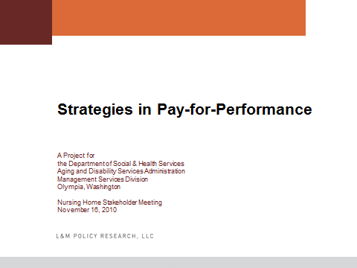



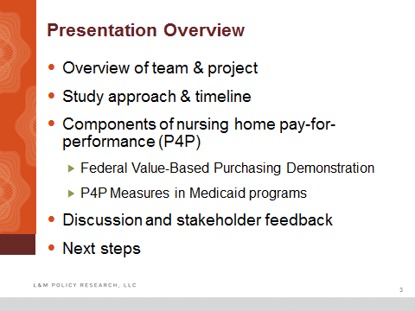

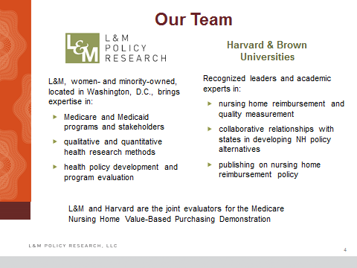

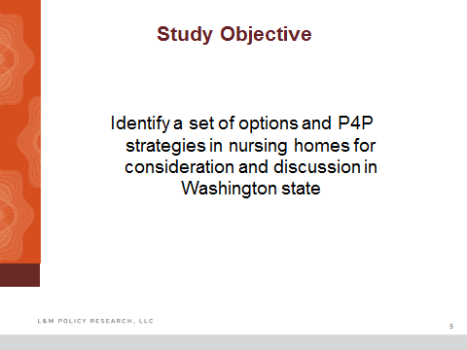

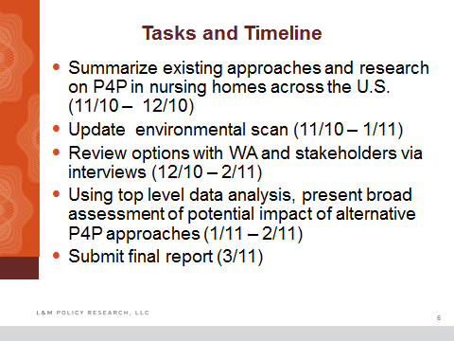

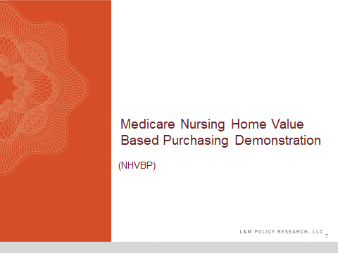

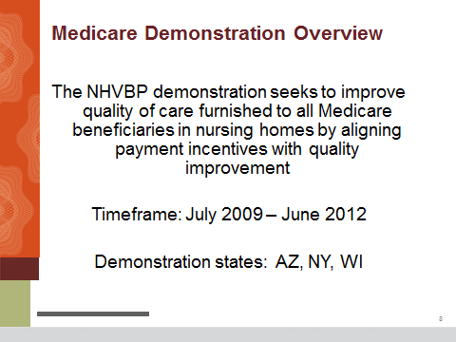

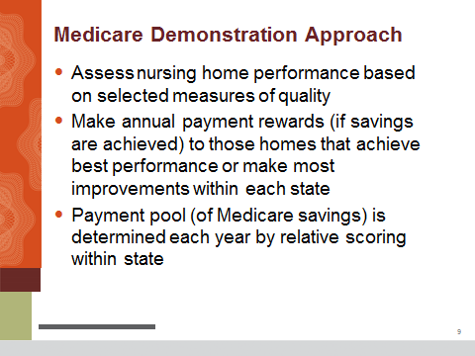

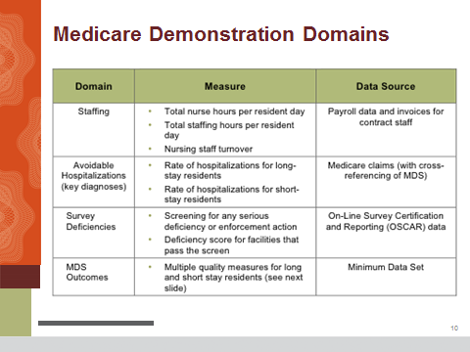

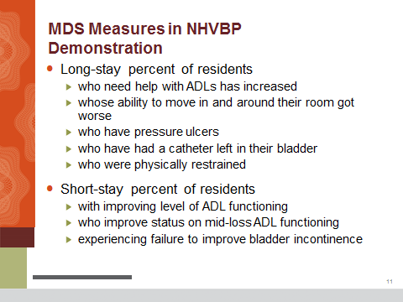

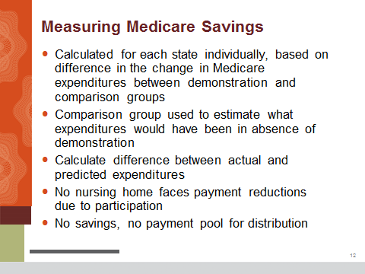

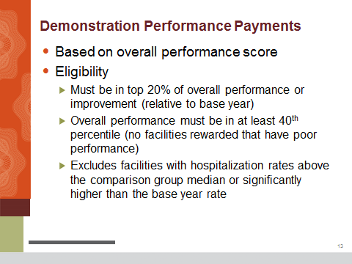

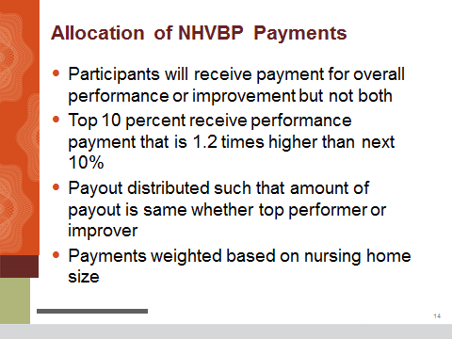

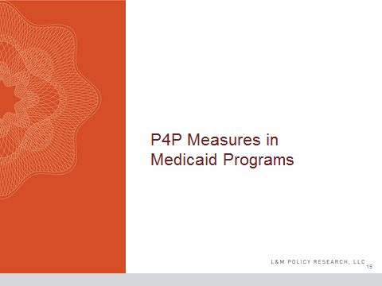

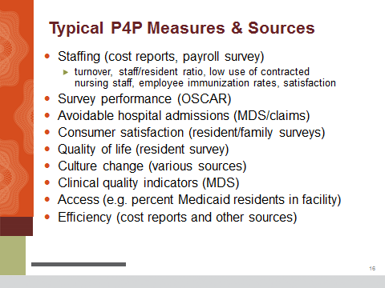

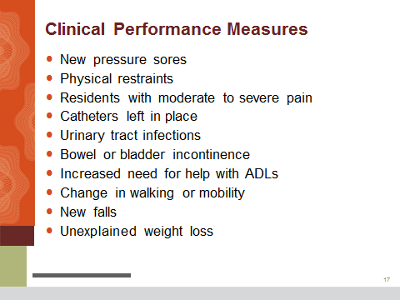

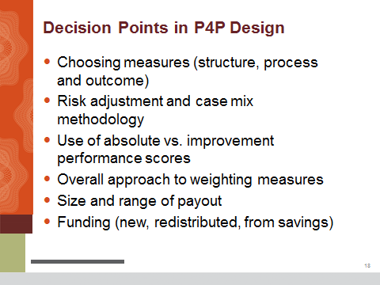



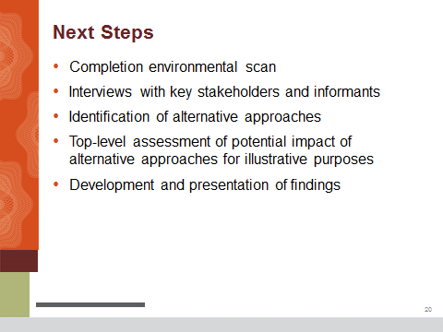



# appendix C - Stakeholder Meeting #2

## Webinar Participants

|  |  |
| --- | --- |
| * Sheree Sanker, Cascade Vista * Randi Saeter, Nikkei Concerns/Seattle Keiro * Lore Johnson, WDVA * Kate Moon, Regency at the Park * Tamela French, Lincoln Hospital District #3 * Katie Jacoby, Summitview Healthcare * Karla Heath, Providence Marianwood * Keith Fauerso, Cheney Care Center * Kate Gormally, Providence Health & Services * Tara Travers, Ida Culver House Broadview-Era Living * Russell Akiyama, Judson Park Retirement Community * Mary Prentice, Frontier Management * Karen Keller, Forks Community Hospital * Lauri St. Ours, Washington Health Care Association * Madeleine Mille-McKay, Nikkei Concerns/Seattle Keiro * Charles Button, Booker Rest Home * Joe McFadden, Ensign Facility Services * Carol Ann Andrews, Alderwood Park Convalescent Center * Warren Taylor, Avamere Skilled Nursing of Tacoma * Linda Emmett, Manor Care * Kelly Callahan, Careage * Ryan Ramsdell, Soundcare * Kelly Rhoads, Sunshine Gardens * Bill Ulrich, Consolidated Billing Services Inc. * Donna Stromski, Park Rose Care Center * Johanthan Owens, Regency Pacific * Jean Lehman, Highline Care Centers * Gail McDowell, Pinewood Terrace Nursing Center * Marita Smith, Saint Anne Nursing and Rehab Center * Kris Spears, Park Manor Rehab * Casey Bradshaw, Ensign Facility Services Inc. * Mickey Kutoff, Kutoff Consulting * Thomas Mitchell, Providence Mount St. Vincent * Jeff Neumann, Seamar Community Health Center * Terry Robertson, Josephine Home * Kenny Chan, Kin On Health Care Center * Laura Hofmann, Warm Beach Health Care Center * David Henderson, Prestige Care | * Diane Lopes, Sunrise View Convalescent Center * Lorri Carter, Buena Vista Inc. * Helen Sikov, Washington Care Center * Michael Christopherson, Avalon Health Care * Lee Ayers, Evergreen Healthcare/Shelton Health & Rehab Center * Janelle Ansell, Vashon Community Care Center * Gloria Dunn, Landmark Care Center * Tonja Myers, St. Francis of Bellingham * Mike Anbesse, BNR * Tracelle Bates, Riverview Lutheran Care Center * Marti Kullen, Avalon Health Care * Mark Greene, Extendicare Health Services Inc. * Sharon Rinehart, Panorama Conv. & Rehab Center * Mark Dronen, Cashmere Convalescent Center * Lance Hassell, Avalon Health Care * Amber Lewis, Providence Health & Services * Nancy Erckenbrack, Rainier Vista Care Center * Gary Condra, Dept. of Veterans Affairs * Cindy Craig, Sunbridge * Jeron Walker, Cottesmore of Life Care * Annette Crawford, Ridgemont Terrace * Merrideth Schwab, Prestige Care Inc. * Dale Patterson, Evergreen Healthcare * Leny Sandbeck, Richmond Beach Rehab * Sandra Whitley, Kindred Healthcare * William Callicoat, Providence Health & Services * Patricia E. Rudy, Rudy Consulting * Michael Ekness, Sun Healthcare * Jarom Eberhard, Orchard Park Health Care * Jeanne Trepanier, Columbia Basin Hospital LTC * Paul Montgomery, Aging Services of Washington * Cathie Klinger, North Cascade Health & Rehab * Larry Chinn, Evergreen Living Centers Inc. * Stacy Mesaros, ManorCare Health Services * Terry Leno, Liberty Country Place |

## Webinar Poll Results

#### Questions:

1. Of these dimensions, which one would you consider most important to include in a P4P program?

* Staffing
* Consumer Satisfaction
* Clinical Quality Indicators
* Survey Performance
* Culture Change

1. Of these dimensions, which one would you consider least important to include in a P4P program?

* Staffing
* Consumer Satisfaction
* Clinical Quality Indicators
* Survey Performance
* Culture Change

1. Of these dimensions, which one would you consider most important to include in a P4P program?

* Efficiency
* Avoidable Hospitalizations
* Access
* Re-envisioning
* Quality Improvement Program

1. Of these dimensions, which one would you consider least important to include in a P4P program?

* Efficiency
* Avoidable Hospitalizations
* Access
* Re-envisioning
* Quality Improvement Program

1. Would you prefer to measure performance in P4P based on:

* Absolute Performance
* Improved Performance
* Both

1. Would you prefer the payout structure to be:

* Lump-sum
* Percentage of Per-diem Rate
* Add-on

1. Should funding for P4P come from:

* New Money
* Redistributed Funds
* Money from Savings

#### Responses:

#### Of these dimensions, which would you consider most important to include in a P4P program?

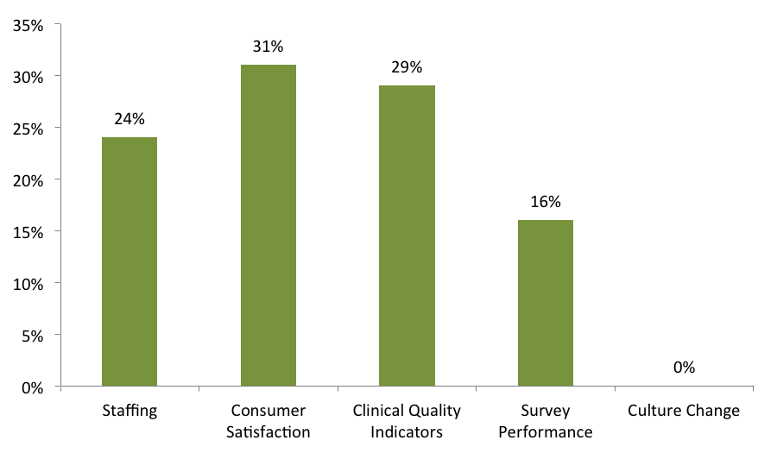

Source: Webinar Survey Percentages

Note: Webinar results are percentages of total respondents to a given question. 13 of the 57 attendees, 23 percent of the sample, did not respond to this question.

#### Of these dimensions, which would you consider least important to include in a P4P program?

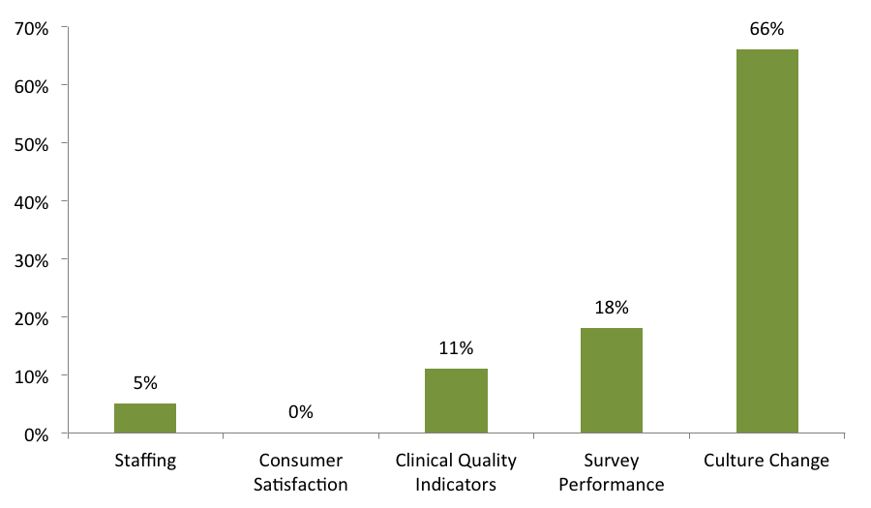

Source: Webinar Survey Percentages

Note: Webinar results are percentages of total respondents to a given question. 13 of the 57 attendees, 23 percent of the sample, did not respond to this question.

#### Of these dimensions, which would you consider most important to include in a P4P program?

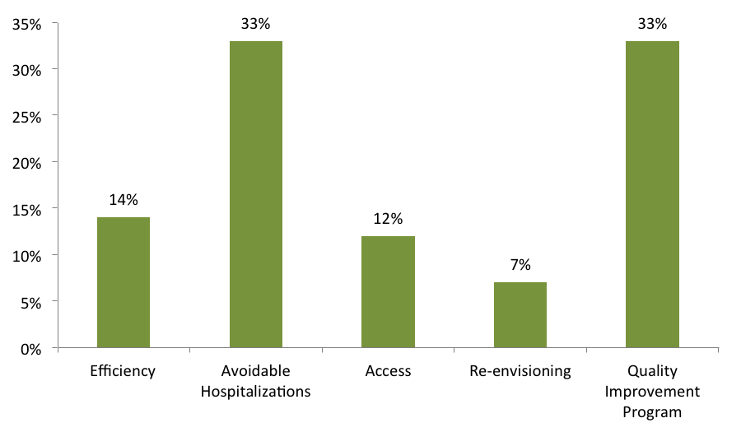

Source: Webinar Survey Percentages

Note: Webinar results are percentages of total respondents to a given question. 15 of the 57 attendees, 26 percent of the sample, did not respond to this question.

#### Of these dimensions, which would you consider least important to include in a P4P program?

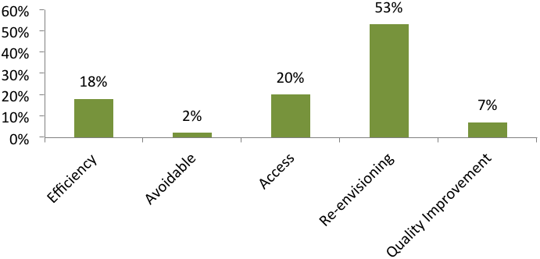

Source: Webinar Survey Percentages

Note: Webinar results are percentages of total respondents to a given question. 12 of the 57 attendees, 21 percent of the sample, did not respond to this question.

#### Would you prefer to measure performance in P4P based on absolute performance, improved performance, or both?

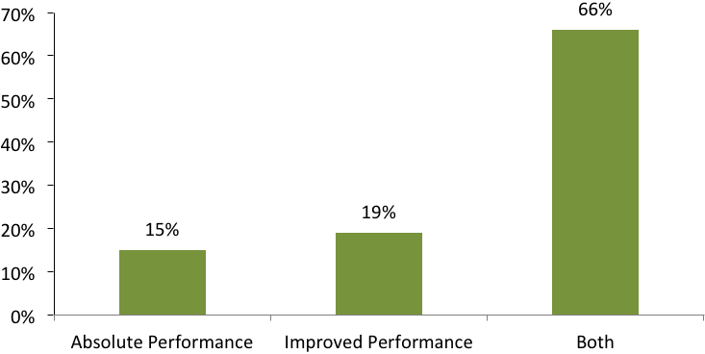

Source: Webinar Survey Percentages

Note: Webinar results are percentages of total respondents to a given question. 10 of the 57 attendees, or 18 percent, did not respond to this question.

#### Would you prefer the payout structure to be a lump sum, percentage of per diem rate, or an add-on?

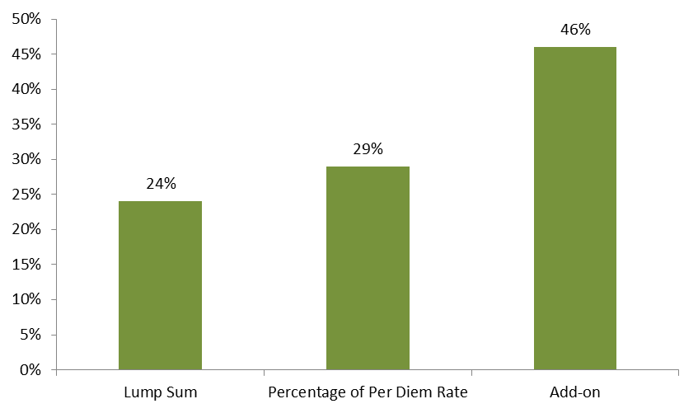

Source: Webinar Survey Percentages and Stakeholder Interviews

Note: Webinar results are percentages of total respondents to a given question. 16 of the 57 attendees, 28 percent of the sample, did not respond to this question.

#### Should funding for P4P come from new money, redistributed funds, or money from savings?

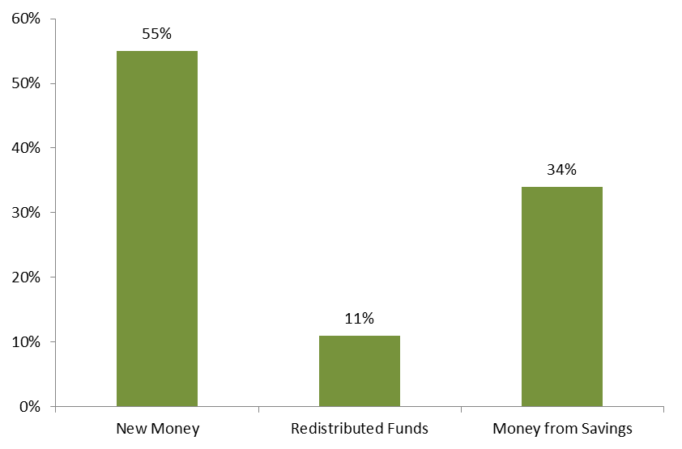

Source: Webinar Survey Percentages

Note: Webinar results are percentages of total respondents to a given question. 19 of the 57 attendees, 33 percent of the sample, did not respond to this question.

## Webinar Exit Survey Results

#### Nursing Homes

##### Twenty-eight respondents represented for-profit nursing homes, and 21 respondents represented not-for-profit nursing homes. When more than one respondent indicated the same answer, the response is followed by the number of respondents in parentheses.

|  |  |
| --- | --- |
| Question | Responses |
| Briefly describe any other issues you think are important considerations in P4P design not covered during today's Webinar. | * *The current cost-based system is underfunded. This budget-neutral P4P by its very existence means a redistribution of existing dollars. It pretends to be an incentive but actually will cut the majority of providers to even lower levels of reimbursement. With current system underfunded P4P just adds to the existing variance between cost and payment.* * *It is very important to consider objective components only in P4P.* * *As far as what to pay the performance on whether it is actual performance or improved performance, it has to be both because if you pay someone for improved performance but their performance is not at the level of another provider why should they not get a reward for already being above the others. Also, the state has cut so much out of the rate in the past two years that they have to start increasing somewhere. I think the provider tax is where they need to go.* * *Staffing, quality measures, nutrition, and daily activities.* * *Penalizing facilities for isolated G-level deficiencies. Facilities should have a more objective basis for participation in the P4P program than survey deficiencies. It could include survey findings but there has to be more. We currently have very good surveys, but we have had not-so-good surveys in the past yet our residents, families, board members, legislators, and staff think we are doing a great job and scratch their heads wondering what were the surveyors thinking. Already so many mandates!* * *Let me think about it. I have a lot of thoughts and concerns, and I would like the opportunity to share once I have organized those thoughts and concerns.* * *Any significant P4P system, without proper safeguards, would be devastating to facilities that have a mission to provide care for those who are typically turned away by most other facilities. We have had such drastic cuts and increased costs that go unrecognized, any P4P funding would result in more harm to the general patient welfare than good unless these other funding issues were completely fixed first.* * *Re-vamping the survey system to be efficient (it's not) and consistent.* |
| Identify four general clinical measures (e.g., new pressure sores) most appropriately used in P4P. | * *Pressure ulcers, weight loss, falls, pain with new MDS 3.0.* * *Uncontrolled pain, development of contractures, fecal impaction, facility acquired pressure sores* * *Pressure areas, nutrition.* * *Restraints, new pressure sores, increased pain, unexplained weight loss.* * *New Pressure Sores.* * *Skin condition (new pressure sores), weight loss – an important caveat to using any of these clinical measures would need to include consideration of diagnoses and prognosis, resident choices, avoidable vs. unavoidable.* * *Pain, pressure sores, UTI, falls.* * *Pressure sores, pain, re-hospitalization.* * *New stage 3 pressure wounds, indwelling catheters, unexplained weight loss, dehydration.* * *Catheters, unexplained weight loss, pressure ulcers.* * *Not possible to answer without a specific program outlined.* |
| Should there be risk adjustment? | * *Yes (10)* * *No(0)* * *I’m not sure(6)* * *No Response(33)* |
| If yes, which quality should be risk adjusted (staffing, survey performance, consumer satisfaction, culture change, clinical indicators)? | * *Clinical Indicators (5)* * *Survey Performance(3)* * *Staffing(2)* * *Quality Measures(1)* * *Consumer satisfaction (1)* * *Any that are used (1)* |
| Rank your preference for inclusion in P4P (most to least important): re-envisioning, avoidable hospitalizations, access, efficiency, QI program. | * *1. QI program; 2. Avoidable Hospital; 3. Access; 4. Efficiency; 5. Re-envisioning.* * *1. Efficiency; 2. Avoidable Hospitalizations; 3. Access; 4. QI Program; 5. Re-envisioning.* * *1. Avoidable hospitalizations; 2. QI Program 3. Access 4. Efficiency; 5. Re-envisioning.* * *1. QI Program.* * *1. Re-envisioning.* * *1. Avoidable hospitalizations; 2. QI program; 3. Access; 4. Efficiency; 5. Re-envisioning.* * *1. QI Program; 2. Re-envisioning; 3. Access; 4. Efficiency; 5. Avoidable Hospitalizations.* * *1. Avoidable hospitalization; 2. Access; 3. QI Program; 4. Efficiency; 5. Re-envisioning.* * *1. QI Program; 2. Avoidable Hospitalizations; 3. Efficiency; 4.Access; 5.Re-envisioning.* * *1. Access; 2. QI Program; 3. Avoidable Hospitalizations; 4. Re-envisioning.* * *1. QI Program; 2. Avoidable Hospitalizations; 3. Re-envision; 4. Access* * *1. QI Program; 2. Avoidable Hospitalizations; 3. Efficiency; 4. Access; 5. Re-envisioning.* * *Access would be a critical factor because it influences how many of the other indicators would present in the related patient population.* |
| Rank your preference for inclusion in P4P (most to least important): staffing, survey performance, consumer satisfaction, culture change, clinical indicators. | * *1. Consumer Satisfaction; 2. Clinical Indicator; 3. Staffing; 4. Survey Performance; 5. Culture Change.* * *1. Customer Satisfaction; 2. Staffing; 3. Culture Change; 4. Clinical Indicators; 5. Survey Performance* * *1. Clinical Indicators; 2. Survey Performance; 3. Consumer Satisfaction 4. Staffing; 5. Culture Change* * *1. Staffing; 2. Consumer Satisfaction; 3. Food* * *1. Customer Satisfaction; 2. Staffing; 3. Clinical Indicators; 4. Culture Change; 5. Survey Performance* * *1. Staffing; 2. Clinical Indicators; 3. Culture Change; 4. Consumer Satisfaction; 5. Survey Performance* * *1. Consumer Satisfaction; 2. Staffing; 3. Clinical Indicators; 4. Survey Performance; 5. Culture Change* * *1. Customer Satisfaction; 2. Clinical Indicators; 3. Staffing; 4. Survey Performance; 5. Culture Change.* * *1. Staffing; 2. Culture Change; 3. Clinical Indicators; 4. Consumer Satisfaction; 5. Survey Performance.* * *1. Consumer Satisfaction; 2. Clinical Indicators; 3. Staffing; 4. Culture Change; 5. Survey Performance.* * *1. Consumer Satisfaction; 2. Clinical Indicators; 3. Staffing.* * *1. Survey Performance; 2. Clinical Indicators; 3. Consumer Satisfaction; 4. Staffing; 5. Culture Change.* * *1. Consumer Satisfaction; 2. Staffing; 3. Survey; 4. Culture Change; 5. Clinical Indicators.*   Comments:  *It is not possible to answer this without specifics as to how each would be applied.*  *Note - actual outcomes were not included in the list of preferences. Survey performance is not able to be consistent from state region or state-to-state. The recent changes in MDS 3.0 may also impact facility survey outcomes.* |
| Some states publish nursing home performance on the quality measures informing their P4P systems. Should Washington do this? | * *Yes (4)* * *No (7)* * *I’m not sure (4)* * *No Response (34)* |
| What percentage of the total Medicaid nursing home budget should be devoted to incentivizing quality improvement? | * *1% at the beginning.* * *Use new money, not current funds.* * *20%* * *5% (2)* * *0% (2)* * *5% above covering the accurate costs of operation for the facilities based on a current year (prior year) costs.* * *2%* * *A very large percentage* * *I would have to take more time to consider that question* * *This should be a minor component of funding*   Additional comment to this question:  *The existing reimbursement is already below the cost of care* |
| Are you representing multiple facilities? | * *Yes (16)* * *No (33)* |
| If you are representing a nursing home, in what county is this located? | * *Chelan (2)* * *Clark(1)* * *Cowlitz (1)* * *King (13)* * *Kitsap(3)* * *Lewis(1)* * *Lincoln(1)* * *Mason(2)* * *Pierce (4)* * *Snohomish (4)* * *Spokane(2)* * *Stevens(1)* * *Thurston (2)* * *Various(2)* * *Walla Walla(1)* * *Whatcom(2)* * *Whitman(1)* * *Yakima(2)*   Note: This provides a count of the counties represented. Facilities that identified more than one county were counted multiple times for this measure only. |

*Source: Webinar Exit Poll*

**Government and Other**

##### Three respondents represented government, four respondents reported “other.”

|  |  |
| --- | --- |
| Question | Responses |
| Briefly describe any other issues you think are important considerations in P4P design not covered during today's Webinar. | * *It is imperative that the legislature and the state agency establish what their goal is and that the system be designed to address the goal.* |
| Identify four general clinical measures (e.g., new pressure sores) most appropriately used in P4P. | *I’m not a clinical expert; I defer.* |
| Should there be risk adjustment? | *Yes* |
| If yes, which quality should be risk adjusted (staffing, survey performance, consumer satisfaction, culture change, clinical indicators)? | *Staffing, Survey Performance, possibly clinical indicators.* |
| Rank your preference for inclusion in P4P (most to least important): re-envisioning, avoidable hospitalizations, access, efficiency, QI program. | * *1. QI; 2. Access; 3. Efficiency; 4. Avoidable Hospitalizations; Exclude Re-envisioning* |
| Rank your preference for inclusion in P4P (most to least important): staffing, survey performance, consumer satisfaction, culture change, clinical indicators. | * *1. Consumer Satisfaction (including family); 2. Clinical Indicators; 3. Survey Performance (bias adjusted); 4. Staffing (including therapy and regional allocations for multi providers); Eliminate Culture Change* |
| Some states publish nursing home performance on the quality measures informing their P4P systems. Should Washington do this? | *I’m not sure.* |
| What percentage of the total Medicaid nursing home budget should be devoted to incentivizing quality improvement? | * *No percentage of the existing budget, as we are significantly underfunded.* |
| Are you representing multiple facilities? | *Yes (4)*  *No (3)* |
| If you are representing a nursing home, in what county is this located? | * *Clallam(1)* * *Grant(1)* * *Kitsap(1)*   *Multiple(1)*   * *Pierce(1)* * *Spokane (1)*   Note: This provides a count of the Counties represented. Facilities that identified more than one county were counted multiple times for this measure only. |

*Source: Webinar Exit Poll*

## Webinar Questions and Comments

#### Questions and Responses

Can you provide a list of states that are currently using P4P in their SNF Medicaid programs?

*Those states are: Minnesota, Oklahoma, Utah, Vermont, Iowa, Georgia, Kansas, and Ohio*

* Will there be an evaluation procedure? Will it be done by a third party and how will that be paid for?

*We think recommendation will be made to the legislature, and the legislature will direct how this leads (i.e., this is a decision that will need to made by the Legislature, something we would recommend).*

#### Questions Answered After the Webinar

If survey performance is used as a domain, how do you adjust for regional variances or perceived biases?

*One potential method of adjusting for regional variance is to benchmark facilities against other facilities in their local area. For example, in the federal Nursing Home Value-Based Purchasing Demonstration, each state is benchmarked against other facilities in the state. We are not aware of state-based efforts that have benchmarked facilities against others within a local area.*

Do states with a lower variance between cost and rate have better outcomes?

*We are not aware of any research linking the state-based variance between cost and rate with outcomes.*

Would you agree that retention is a better measure than staff turnover?

*Both staff retention and turnover can be valuable measures of nursing home performance.*

Regarding staffing, how do you compare productivity? Do you count therapists?

*Most P4P systems include registered nurses, licensed practical nurses, and nurse aides within their staffing measures. We are not aware of P4P systems that include therapists within this measure.*

How do you adjust for what some segments of the profession perceive as surveyor biases?

*As noted above, one could potentially benchmark facilities against other facilities in their local area (with a common surveyor); however, we are not aware of other state-based P4P systems that benchmark facilities within local areas.*

The state should be looking to the Medicaid population as a whole. Should not more emphasis be placed on incentivizing improvements to current low performers? I would presume there is a strong correlation between current high performers and their already higher Medicaid rate?

*P4P systems can blend the performance incentives such that reward payments are shared by the facilities that score best in terms of absolute performance and those facilities that exhibit the largest improvement in performance. This type of system engages both strong and weak performers at baseline.*

What empirical data exists showing payment rates vs. the outcomes? It appears that those with the money are already more likely able to meet the absolute performance measures, while the lower paid facilities are permanently left without resources. Are there data that show a correlation between payment levels and staffing?

*Our study team has conducted several studies related to this issue. In general, states that have increased their payment rates have been found to have increased staffing levels and better outcomes.*

Is not a consumer satisfaction survey now a portion of the routine MDS process?

*We are not aware of any consumer satisfaction data that is routinely collected across nursing homes in Washington state as part of the MDS.*

What empirical data is there to show impact of staff turnover on outcomes? Intuitively – yes, but what does the data show? Any benchmarks showing levels of turnover vs. outcomes?

*Castle and colleagues (2007, The Gerontologist) found that high turnover was associated with lower quality (as measured by the Nursing Home Compare quality measures).*

So, isn’t utilizing the current P4P approach in Washington, that penalizes low performers rather than incentivizing them to do better, counter to improving outcomes? With lower payment rates, how can they afford to improve, especially when the state is making cuts regularly?

*As noted above, a P4P system that pays for both absolute performance and improvement in performance can engage both the high and low performers at baseline.*

Are the actual measures being re-assessed and further evaluated for true results/accuracy? For example, if facilities are paid based upon measures such as residents' maintenance of ADL skills or having pain, etc., facilities may begin to feel that they cannot accept complex, difficult, high acuity admissions or accept residents with chronic and progressive decline (even related to such normal factors such as aging!). In other words, facilities are penalized for providing heavy, complex care.

*Risk adjustment is always a key issue in employing different quality measures. Otherwise, as the questioner notes, facilities will have the incentive to select the healthiest residents.*

Regarding avoidable hospitalizations as a performance indicator: I agree, we all want to prevent hospitalizations for our elders; however, the elders we all care for have comorbidities and can be quite frail. How would you define “avoidable” hospitalizations?

*A number of different measures have been used to define “avoidable” hospitalizations. For example, the federal P4P demonstration defines avoidable hospitalizations using the following conditions: congestive heart failure, electrolyte imbalance, respiratory infection, urinary tract infection, sepsis (for short stays only) and anemia (for long stays only).*

What about facilities that are already providing good quality? How will they be rewarded?

*As noted above, a P4P system can blend payments based on absolute performance and improvement in performance.*

Will the P4P allow voluntary participation?

*Historically, state P4P systems have varied based on whether they are voluntary or mandatory. As Washington state develops its system, these are both potential options.*

Why not include therapists and others that are all a part of providing services? Therapists are very expensive. What about costs that are not included in cost reports?

*As noted above, therapists have typically not been included in staffing measures under P4P systems.*

As Medicare is a price model, does P4P have greater logic in a price versus cost based with settlement payment modes?

*In the past, P4P has been used under both price and cost-based payment models.*

#### Comments

Re-envisioning requires a nursing home to be more responsive to the community it serves. To meet consumer needs and improve the health of the community, we need more fluid, less static resources.

The survey process, while better in QIS, is still not flawless, especially related to complaint surveys.

As I looked at the poll choices available during the meeting, I couldn’t help but think about a potential rating system that would include some subjective assessments of facility performance. Since no system will be initially perfect, it would be best to err on the side of objectivity and rule out review criteria based on someone’s subjective interpretation of facility performance. Turnover rates can be calculated, survey results (much like the CMS rating system) are amenable to calculation, MDS outcome using long-term residents as the sample, and re-hospitalizations using short-term residents as the sample [avoidable hospitalizations is too subjective to include].

Funding needs to be initially from new money – cost saving from any P4P program can be included or substituted subsequent to implementation.

I have had the pleasure to do P4P in Colorado and it is very worthwhile. I especially like the incentives for those facilities that improve the most versus absolute performers because it causes poor to moderate facilities to press forward with improvements. Top performers will continue to be so because they are self-driven and because they have solid leadership and superior systems and processes in place.

Redistributed funds forces competition for funds with losers being inherent in the system. It would force lower-paid facilities based on unavailable funds.

The dimensions used should be objectively measureable. Clinical QI's is probably the most objective dimension directly tied to care. Culture change varies widely across the states, culture organizations, etc., and is the least objective dimension.

Consumer satisfaction is not defined; survey data is subjective.

Culture change seems an academic exercise when there are not resources to invest in facility infrastructure.

With re-hospitalization, there is concern that this is a hospital issue as much as a nursing home issue because of the drug structure and negative occupancy incentives in the Washington payment structure, which drives census need.

There should be some type of efficiency measurement that reduces incentives to high performers that are significantly over some cost benchmark.

Access to advance practice nurses is limited as Washington facilities are handicapped due to Medicaid payments.

Culture Change is a tool to get the performance measures and would be hard to quantify how a facility uses culture change.

I’m really concerned about how an organization would measure the performance since there are a variety of care models in all states.

The current P4P approach was initiated to penalize low performers as measured by historical turnover rates for direct care staff; the penalty makes it even more difficult to improve performance and punitive rather than incentivizing performance.

The system is seriously underfunded; it makes little sense to engage in this discussion without new money being inserted into the program.

Culture change should be the least weighted.

A provider tax is a viable option; still, the state has denied adopting a provider tax several years running.

Important items for P4P-based reimbursement rate need to be fully funded. Incentives need to go toward improving the lives of Medicaid residents. High Medicaid census facilities are least funded and as such are least able to implement processes to improve outcomes due to lack of resources. P4P should incentivize improvements. P4P that provides payment to low Medicaid census or where funding resources permit higher spending on staff and other items impacting quality would simply give more money to the rich at the expense of the majority of Medicaid residents being served.

You need to focus on improvements for the majority of Medicaid residents.

Culture change means such different things to different people and populations in different places. We believe it is most important to provide the care and environment desired and needed by our residents – not just go by a pop culture wave of “culture-change.”

I don't think an isolated G-level deficiency should be the criteria for participation. The overall CMS ranking would be a better criterion.

The money should not be carved out of existing monies, and it needs to be sustainable and predicable.

I think the indicators that are chosen should be a short list and related to consumer satisfaction.

Funds should absolutely not come from providers.

Given the current economic situation across the state and country, I would prefer the money come from savings.

It would be important to continue incentives for continued high levels of performance.

## Webinar Presentation Materials, Jan. 6, 2011

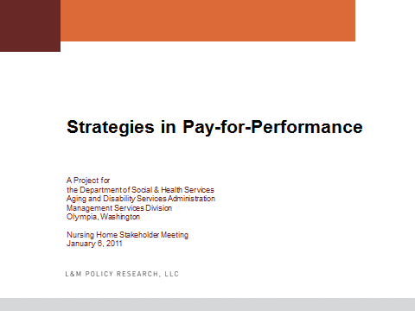



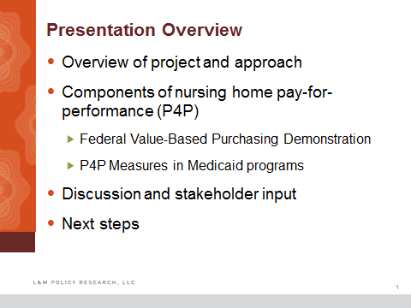

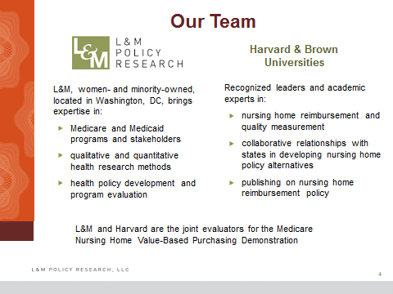



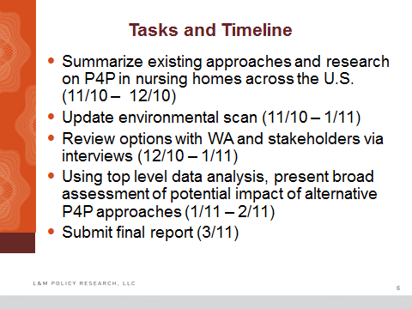

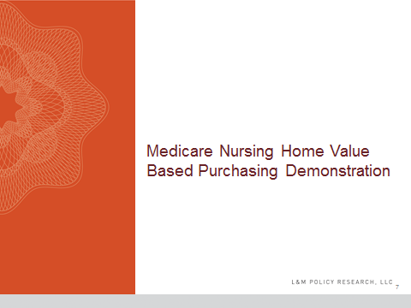

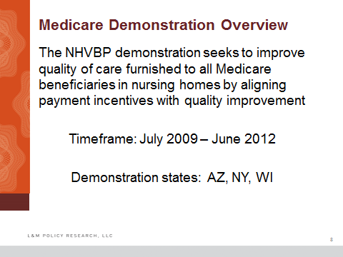

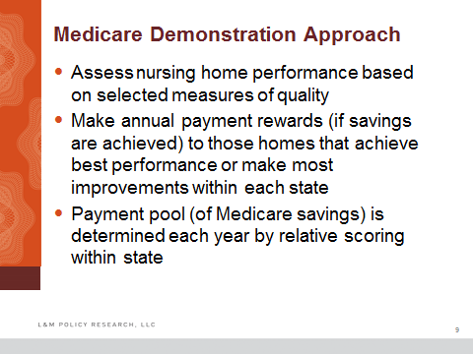

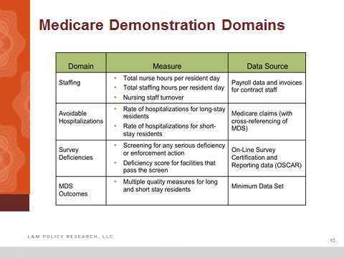

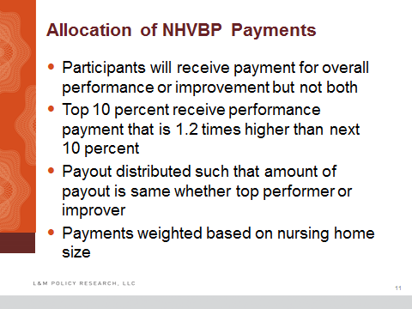

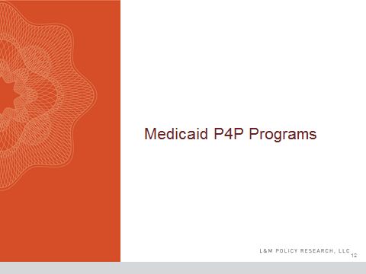

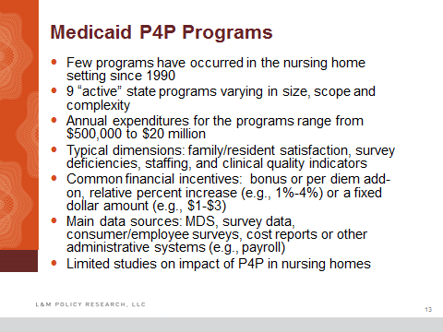

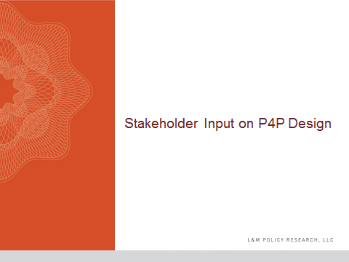

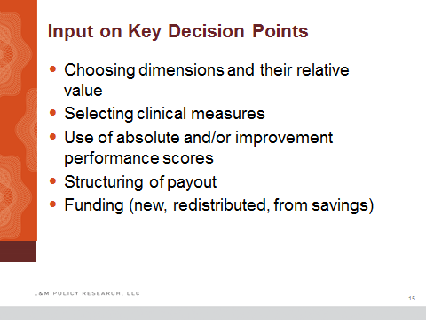

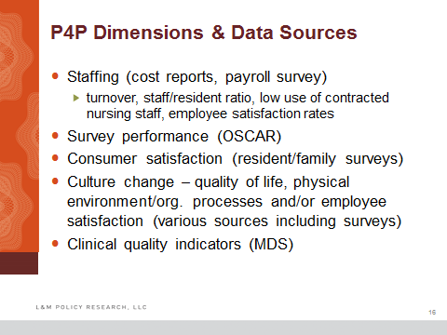

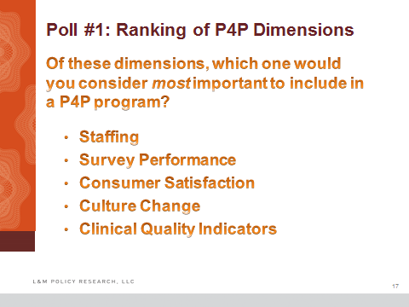

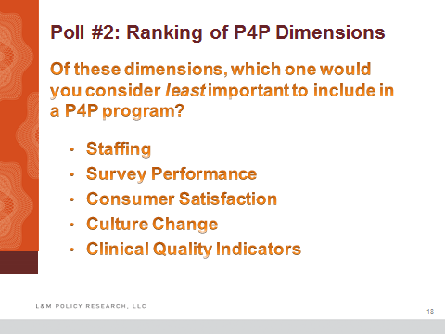

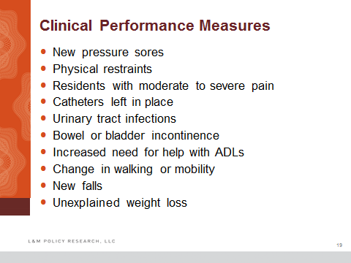

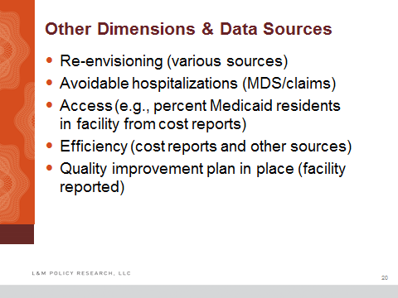

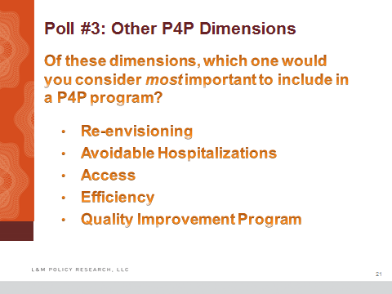

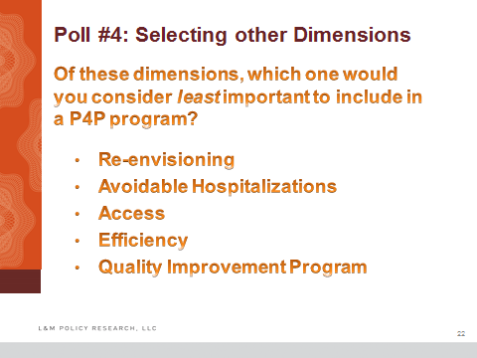

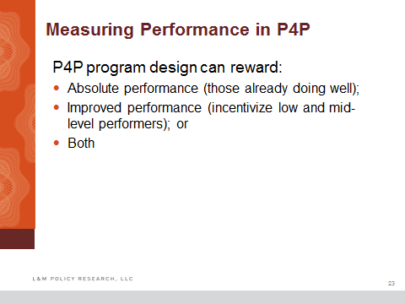

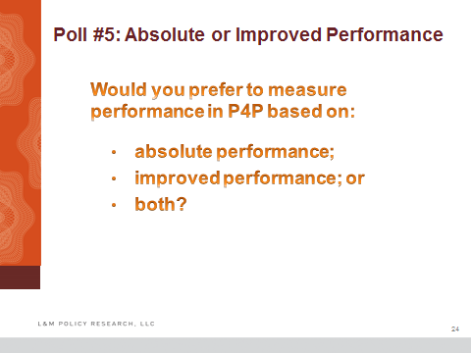

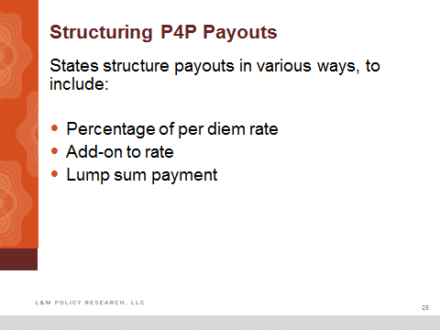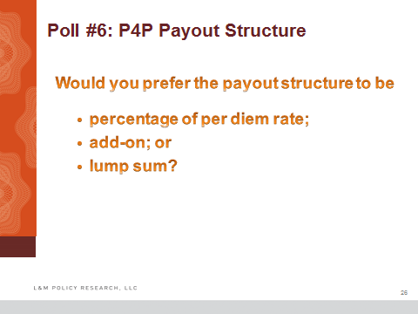

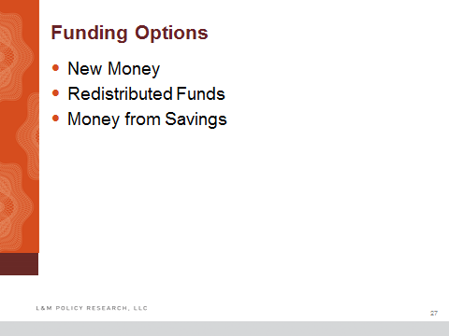

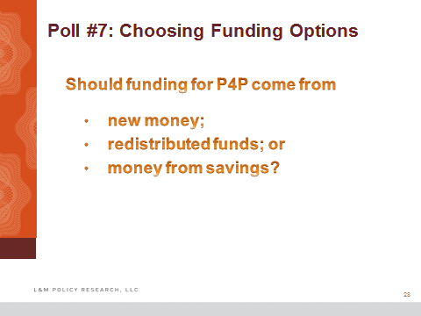

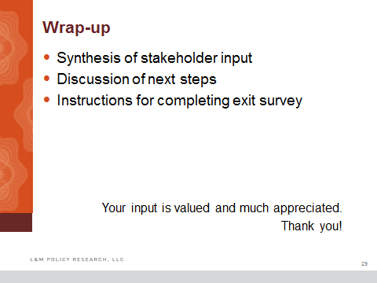



1. Broad budgetary implications can be drawn despite the missing values for 28 facilities, which primarily represented small facilities and those not present in both data sources.
2. “Re-envisioning” is encouraging facilities to become a hub in a service delivery model that spans the continuum from hospitalization to post-acute care to long-term assistance, preferably at home and in the community.
3. It is important to note that the stakeholders interviewed, as recommended by the DSHS, were primarily nursing home operators and their representatives, although the team did interview five individuals from the rate setting and survey and certification offices of DSHS.
4. L&M Policy Research, in partnership with David Grabowski, Ph.D. and his team at Harvard Medical School, has been engaged by CMS as the evaluator of this program. Year 1 results and data for the program are expected to be available for evaluation in the summer of 2011.
5. More information about the program and its implementation can be found at: http://www.cms.gov/demoprojectsevalrpts/md/itemdetail.asp?itemid=CMS1198946.
6. L&M Policy Research, in partnership with David Grabowski, Ph.D. and his team at Harvard Medical School, has been engaged by CMS as the evaluator of this program. Year 1 results and data for the program are expected to be available for evaluation in the summer of 2011.
7. More information about the program and its implementation can be found at: http://www.cms.gov/demoprojectsevalrpts/md/itemdetail.asp?itemid=CMS1198946.
8. Washington ranked 25 among U.S. states.
9. While cost components constitute the bulk of the rate, there are other factors that are used to adjust the final rate such as the bed size, occupancy rates, hold-harmless, and county.
10. The study team created a preliminary analytic file using the most recently available Nursing Home Compare data from 2009 and 2010, and additionally used WA DSHS January 2011 nursing home payment rate data containing both per diem payment amounts and total Medicaid patient days. The 201 facilities were identified through comparison of the nursing home name listed in both files.
11. The performance payment to lower-turnover facilities averaged $0.45 per patient day from July 1 to Dec. 31, 2010, while, on the other hand, the reduction to higher-turnover facilities was $0.23. Due to this discrepancy, from Jan. 1 to June 30, 2011, the DSHS will no longer provide performance payments as rates to prevent the payments to lower-turnover facilities from exceeding the reductions to higher-turnover facilities. This change should balance the performance payments and reductions by the end of the state fiscal year. 
12. ## Where possible, we calculated frequencies of responses, say, regarding the number of individuals in favor of a particular P4P design element. These are reported in tables in the next section. Interviewees were counted separately for the purpose of determining these frequencies, with each individual participating in an interview being counted as having expressed an opinion. In multi-subject interviews, one individual would typically take the lead in answering a particular question with other participants either agreeing or disagreeing with that individual’s opinions regarding the topic discussed.

   
13. Broad budgetary implications can be drawn despite the missing values for 28 facilities, which primarily represented small facilities.
14. “Re-envisioning” is encouraging facilities to become a hub in a service delivery model that spans the continuum from hospitalization to post-acute care to long-term assistance, preferably at home and in the community.
15. Colorado, Georgia, Minnesota, and Oklahoma
16. It is important to note that the stakeholders interviewed, as recommended by the DSHS, were primarily nursing home operators and their representatives, although the team did interview five individuals from the rate setting and survey and certification offices of DSHS.
17. Approximately 2,000 people use Minnesota’s report card system every month.