COVID-19 Testing, PPE

If a staff member or resident is diagnosed with COVID-19, should broader testing be implemented through the facility?
If a resident, client, or staff member at a facility tests positive for COVID-19, we advise that you contact your local health jurisdiction for immediate instruction on wider testing. Absent a positive case, you may still contact your local health jurisdiction with questions. In general, the Department of Health recommends testing anyone with symptoms of COVID-19.

Long-term care facilities are expanding testing. How broadly does this apply? Should all staff, residents, and co-inhabitants be tested?

If a resident, client, or staff member at a facility tests positive for COVID-19, we advise that you contact your local health jurisdiction for immediate instruction on wider testing. Absent a positive case, you may still contact your local health jurisdiction with questions. In general, the Department of Health recommends testing anyone with symptoms of COVID-19. The state is developing a broader COVID testing strategy for Nursing Homes.

What is the official protocol for instituting testing within long-term care facilities? Are pilot programs voluntary or required?

If a resident, client, or staff member at a facility tests positive for COVID-19, we advise that you contact your local health jurisdiction for immediate instruction on wider testing. Absent a positive case, you may still contact your local health jurisdiction with questions. In general, the Department of Health recommends testing anyone with symptoms of COVID-19.
King County has enacted a pilot program for testing in Adult Family Homes which includes, when possible, testing all residents and staff on a voluntary basis even before a case has been confirmed in a facility.

Are there limits on how much PPE a facility can purchase, or limits on how much PPE suppliers can dispense?
There is no State-imposed limit on PPE distribution from medical suppliers.
ALTSA is currently supplying PPE for AAAs, ND, PDN, DDA, RCS staff. ALTSA has begun to issue PPE to facilities contracted with ALTSA to provide care to people with a COVID-19 diagnosis. We help facilities with confirmed cases of COVID-19 with insufficient 7-day supplies unable to secure PPE through the County Emergency Management Agency. The Long-Term Care Incident Management Team will not issue more than 7 days’ worth of PPE.

Home and Community Services (HCS)

Are in-home services continuing unchanged, modified, or expanding? Do services include any housekeeping assistance? How are services accessed?
The services covered under Medicaid by HCS have not changed, but the way services are delivered has changed in order to provide additional protections against the risk of exposure and spread of COVID-19. We issued guidance on expanding telehealth and remote service delivery for services delivered in a client’s home. Personal care services that may be provided remotely include, but are not limited to, medication reminders, supervision of and reminders for personal care tasks, behavior intervention and de-escalation techniques and wellness checks. Services may include housekeeping assistance if a client’s assessment indicates that is an area of need. In addition, services such as community choice guides, behavior supports and nurse delegation may also be provided remotely when appropriate. For more information, see Management Bulletin H20-015, Management Bulletin H20-018, and Management Bulletin H20-028. Other COVID-related HCS Management Bulletins may be found on the ALTSA webpage.
If a client is suspected or confirmed to have COVID-19, the Department of Health has issued guidance for continued personal care. We have developed a way that in-home providers may request Personal Protective Equipment when providing services to a client with suspected or confirmed COVID-19. We continue to conduct initial assessments and reassessments by telephone, as outlined in Management Bulletin H20-017, and Washington residents can continue to access services by contacting their local Home and Community Services office.

Will there be a delay in the start date for Electronic Visit Verification (EVV) requirements?
Under the 21st Century Cures Acts, states must implement EVV for applicable personal care services by January 1, 2021 or be subjected to an escalating reduction in FMAP. Unfortunately, this deadline cannot be extended without an Act of Congress. There are numerous organizations such as Advancing States and NASDDDS that are advocating that the EVV implementation deadline be extended to allow states to adjust planning around the COVID-19 outbreak. Currently, DSHS is assessing it planned implementation of EVV to determine appropriate next steps. Home care agencies will likely be required to implement EVV at some point over the summer/fall depending on the circumstances with COVID-19. EVV implementation plans for Individual Providers are still being discussed.
The goal for DSHS is to avoid the FMAP penalty if possible.

Residential Care Services (RCS)

How may a Skilled Nursing Facility request funding for electronic devices for resident communication?
The technology purchases you may have heard about were funded through Civil Money Penalty (CMP) Funds. More information about that program can be found on the CMP webpage.

If a social worker has safety concerns, what steps can they take to request investigation of a facility?
Please contact the Complaint Resolution Unit at 1-800-562-6078 or online.

Is there a plan to cohort non COVID-19 residents from COVID+ facilities?
At this time we do not have specific facilities set up for non-COVID residents, however many individual facilities are setting up separate, dedicated wings or units for patients with confirmed or suspected cases of COVID-19 to cohort them separately.

Who do I contact with questions about behavioral health?
You may contact the RCS Behavioral Health Support Team by phone or by email and make a referral. Direct questions to: RCSBHST@dshs.wa.gov or (360) 725-3445

Many facilities are permitting "window visits". Is there official guidance on this topic?
There has been no official guidance released regarding how “window visits” may take place. Facilities must assure all safety precautions are followed and all social distancing requirements are followed. For specific guidance within a county, facilities should engage their local health jurisdiction or contact their RCS Field Manager for consultation.

Is there a published list of all long-term care facilities with COVID-19 diagnoses?
A list of all skilled nursing homes and assisted living facilities with confirmed reports of COVID-19 infection is posted to the ALTSA FamHelp page. This list is updated twice weekly.

How is Residential Care Services (RCS) best contacted during the pandemic?
Contact your local field office to get information pertinent to your facility and region. Although staff are working remotely, voicemail inboxes remain monitored and many staff have redirected their office lines to their cell phones. A list of field office numbers can be found here.

Visitors are restricted at long-term care facilities, but exceptions are granted in "end-of-life" situations. What qualifies as an "end-of-life" situation?
Indeed, visitors may be permitted in “end-of-life situations”, listed as excepted circumstances from visitor prohibitions imposed by Governor Jay Inslee’s Proclamation 20-16.
For skilled nursing facilities, the Centers for Medicaid and Medicare Services has given examples of “end-of-life situations”. These include situations in which “a resident is receiving hospice care and their health status is sharply declining, or when a resident is not enrolled in hospice, but their health status has sharply declined.” (QSO memo 20-28-NH)
For other program types, no specific definitions of “end of life” have yet been given. Many Assisted Living Facilities, Adult Family Homes, and other facilities have followed a model similar to the one outlined by CMS.
This is a conversation to have with a facility. The facility will know status of individual and will be in contact with a physician to determine end-of-life situations. These determinations will occur on a case-by-case basis. The home may need to limit the number of family members to have social distancing and require PPE be worn. If there are concerns, please contact RCS.
When visitation is necessary and allowable (e.g. end-of-life circumstances) facilities should make efforts to allow for safe visitation. (QSO memo 20-14-NH)
- Suggest refraining from physical contact between residents and others.
- Create dedicated visiting areas (e.g.) “clean rooms” near the entrance to the facility where residents can meet with visitors. These rooms should be disinfected after each resident-visitor meeting.
- Residents still have the right to access the Ombudsman program. Their access should be restricted per this guidance, except in compassionate care situations. However, facilities may review this on a case-by-case basis.
- Advise visitors and any individuals allowed within the facility (e.g. hospice staff) to monitor for signs and symptoms of respiratory infection for at least 14 days. If symptoms occur, notify the facility of the date that they were in the facility and any individuals that the visitor had contact with.

Other Questions

Where can I find current visitation policy for long-term care facilities?
See the "Facility Location and Visitor Status Finder" on the ALTSA FamHelp page.
Click the relevant Facility Status link for the classification of facility relevant to you. At the top of the table, you will see all current visitor guidance summarized.
Jim Kopriva (james.kopriva@dshs.wa.gov) researches updates to visitor status every week. These locator pages will be maintained to summarize all current, applicable guidance.
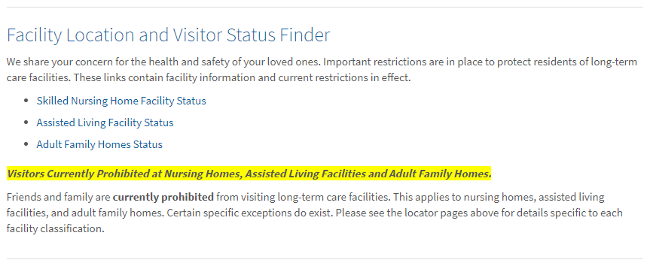

Does the federal stimulus or "economic injury payment" qualify as income? Does it affect eligibility for any programs or benefits?
The IRS instructs that the federal stimulus payment is not considered income and does not affect eligibility for government programming.

