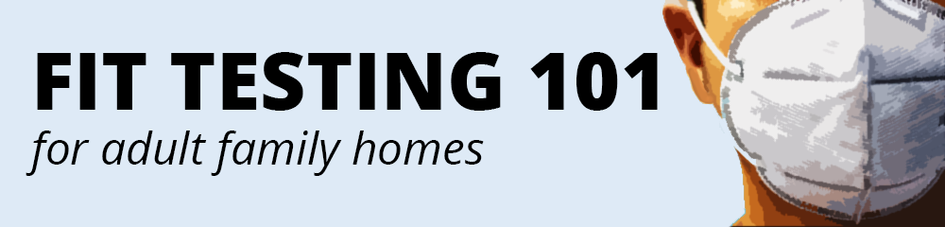
A respirator is only as good as the seal it forms to the face. A respirator works by filtering inhaled air. If contaminants sneak around the filter, the wearer is at risk. Fit testing ensures that the respirator forms a complete seal. Fit testing is legally required before a worker may use a respirator at work.
Here’s what you need to know about fit testing:
1 – START WITH A medical evaluation  Workers must be in suitable health to wear a respirator safely. A medical questionnaire must be completed by the worker and professionally reviewed. Many clinics perform medical evaluations and fit tests in a single appointment.  - WAC 296-842-14005 | 2 – Research local fit testing  Occupational medicine clinics throughout the state offer fit testing services. Search online or review our accompanying guide to locate a provider. Quantitative or qualitative fit testing are both acceptable for common disposable N95 models.  - WAC 296-842-15005
3 – EXPLORE ONSITE FIT TESTING  You may have an employee administer fit testing to others. The fitter must be properly trained and equipped, and they must observe WAC protocol. You might use online medical evaluation services if you intend to fit test onsite.  - WAC 296-842-22010 | 4 – OBSERVE OTHER REQUIREMENTS  Fit testing and medical evaluations are not the only requirements. Employers must also designate an administrator, regulate voluntary use, write a respirator program, train workers, and keep proper records.  - WAC 296-842

ADDITIONAL NOTES
- Refer to L&I’s “Which Mask for Which Task” to decide when a respirator is needed.
- Workers should be clean-shaven to be fit-tested. Facial hair may hinder a proper seal.
- Workers must be fit for each respirator worn. If issued a new model, the worker must re-test.
- We suggest fit-testing workers with several types to cover supply shortages.
- FDA emergency use authorizations allow some KN95 models to substitute for N95 models.
- Refer to these videos for tutorials on proper use of N95 respirators:
  - https://youtu.be/AUOfWbB9-e4
  - https://youtu.be/UOO1-XqSRZs

