Chapter 13: Nurse Delegation
Chapter 13 describes Department of Social and Health Services (DSHS) Nurse Delegation (ND) Program, how to determine eligibility, determining delegable tasks, case manager and nurse delegator responsibilities, the referral process, and how to authorize this service.
DSHS forms referenced are required to be used. Search by Form Number at Electronic DSHS Forms. Most forms are available in Word and PDF.

Ask the Expert
If you have questions or need clarification about the content in this chapter, please contact the Nurse Delegation Program Manager at nursedelegation@dshs.wa.gov.

Contents
Chapter 13: Nurse Delegation 1
Overview 2
What is Nurse Delegation? 2
Delegable Task Examples 4
Eligibility For Delegation Services 5
Case Manager Responsibilities 6
CARE Documentation 6
Examples from CARE 9
GetCare Documentation for TSOA 12
Referrals for Nurse Delegation 12
RN Delegator 13
Nurse Delegation Referral Timeframe 13
Skin Observation Protocol (SOP) Referral 14
Authorizing Payment 15
Authorized Delegation Units 15
Transferring Cases 16
Authorization of Nurse Delegation services; hospital or institutional 16
Authorization of Nurse Delegation services for a new client who is not currently on services. 16
Authorization of Nurse Delegation services for an existing client. 17
Splitting Social Service Lines in CARE 18
Delegator Responsibilities 19
Consumer Directed Employer Chapter 11 20
Related RCWs and WACs 22
Acronyms 23
Web Resources and Forms 24

Overview

What is Nurse Delegation?

Nurse Delegation is a role within a Registered Nurse (RN) Scope of Practice. It allows an RN to delegate specific skilled nursing tasks to nursing assistants or home care aides, also called Long-Term Care Worker (LTCW) for eligible clients who have partially met or unmet skilled nursing task needs. The laws and rules for Community Nurse Delegation are found in Revised Code of Washington (RCW) and Washington Administrative Code (WAC).

RCW 18.79.260 Registered nurse - Activities allowed - Delegation of tasks
(1) A registered nurse under his or her license may perform for compensation nursing care, as that term is usually understood, to individuals with illnesses, injuries, or disabilities.
(2) A registered nurse may, at or under the general direction of a licensed physician and surgeon, dentist, osteopathic physician and surgeon, naturopathic physician, optometrist, podiatric physician and surgeon, physician assistant, advanced registered nurse practitioner, or midwife acting within the scope of his or her license, administer medications, treatments, tests, and inoculations, whether or not the severing or penetrating of tissues is involved and whether or not a degree of independent judgment and skill is required. Such direction must be for acts which are within the scope of registered nursing practice.
(3) A registered nurse may delegate tasks of nursing care to other individuals where the registered nurse determines that it is in the best interest of the patient.
(a) The delegating nurse shall:
(i) Determine the competency of the individual to perform the tasks.
(ii) Evaluate the appropriateness of the delegation.
(iii) Supervise the actions of the person performing the delegated task; and
(iv) Delegate only those tasks that are within the registered nurse's scope of practice.
b) A registered nurse, working for a home health or hospice agency regulated under chapter 70.127 RCW, may delegate the application, instillation, or insertion of medications to a registered or certified nursing assistant under a plan of care.
(c) Except as authorized in (b) or (e) of this subsection, a registered nurse may not delegate the administration of medications. Except as authorized in (e) or (f) of this subsection, a registered nurse may not delegate acts requiring substantial skill and may not delegate piercing or severing of tissues. Acts that require nursing judgment shall not be delegated.
(d) No person may coerce a nurse into compromising patient safety by requiring the nurse to delegate if the nurse determines that it is inappropriate to do so. Nurses shall not be subject to any employer reprisal or disciplinary action by the nursing care quality assurance commission for refusing to delegate tasks or refusing to provide the required training for delegation if the nurse determines delegation may compromise patient safety.
(e) For delegation in community-based care settings or in-home care settings, a registered nurse may delegate nursing care tasks only to registered or certified nursing assistants under chapter 18.88A RCW or home care aides certified under chapter 18.88B RCW. Simple care tasks such as blood pressure monitoring, personal care service, diabetic insulin device set up, verbal verification of insulin dosage for sight-impaired individuals, or other tasks as defined by the *nursing care quality assurance commission are exempted from this requirement.
(f) The delegation of nursing care tasks only to registered or certified nursing assistants under chapter 18.88A RCW or to home care aides certified under chapter 18.88B RCW may include glucose monitoring and testing.

Delegable Task Examples
Tasks that may be delegated for the stable and predictable client, include but are not limited to:
- Oral medication and administration
- Topical medication administration
- Nasal sprays
- Eye drops
- Gastrostomy tube feedings (including medication administration)
- Wound care must be simple, non-complex, does not require frequent nurse assessment and evaluation as determined by the delegating nurse.
- Blood glucose monitoring
- Insulin or non-insulin injectables for the treatment of diabetes
- Non-sterile tracheal and oral suctioning

NOTE: Other nursing tasks may be determined appropriate by the delegating nurse. Please also refer to the Washington State Board of Nursing for updated law and rule.

Tasks that are prohibited by RCW and WAC from being delegated are:
- Administration of medications by injection (by intramuscular, intradermal, subcutaneous, intraosseous, intravenous, or otherwise) with exception of insulin injections.
- Sterile procedures
- Central line maintenance
- Anything that requires nursing judgement.

To assist with decision making, the Washington State Board of Nursing has a delegation decision-tree. WAC 246-840-940 Washington state nursing care quality assurance commission community-based and in-home care setting delegation decision tree.

Eligibility For Delegation Services
For delegation to occur, clients must be assessed as stable and predictable by the delegating RN and reside in an approved Home and Community Based setting.

Criteria for Delegation
- Stable and predictable condition means a situation in which the individual's clinical and behavioral status is known and does not require the frequent presence and evaluation of a registered nurse. RCW 18.79.260(3)(e)(iii)
- The Client can then possibly receive RN delegation for the LTCW to perform the skilled nursing task.
- Clients with medical conditions that are stable and predictable may receive nurse delegation if they reside in the following settings:
  - Their own home
  - Licensed Adult Family Homes (AFH).
  - Licensed Assisted Living Facilities (ALF); or
  - Community residential programs for people with developmental disabilities, certified by DSHS.
See AUTHORIZING PAYMENT section Who Can Delegate for details.

- Before a client can receive delegation, you must determine that the client:
- Has an “unmet” or “partially met” need for a skilled task (per CARE) such as medication management, and either:
  - Lacks the informal support to provide the delegated task, or
  - Is unwilling or unable to self-direct their care.
*See Chapter 3 Chapter 3.docx (live.com)
- Resides in an approved community setting; and
- Medicaid Care Services (MCS) and State Funded LTC for Non=Citizens receiving personal care under the state-funded programs can also receive RND services. See Chapter 7g.
- Community First Choice (CFC)
- CFC + Community Options Program Entry System (COPES)
- Roads to Community Living (RCL)
- New Freedom
- Residential Support Waiver (RSW)
- ALTSA only pays for ND if the client lives in an AFH.
- Developmental Disability Administration (DDA) Services
- MAC/TSOA

Case Manager Responsibilities
**If a nursing referral is not triggered in CARE, the case manager CAN use their professional judgement to MAKE a referral if the circumstances warrant a nurse consultation.

CARE Documentation

General
- Identify the client’s “unmet” or “partially met” need(s) for a skilled nursing service.
- Document need for RN Delegation in CARE or GetCare. LTC Manual Chapter 3 Assessment and Care Planning.
- If there is NO delegator available, the LTCW cannot perform the delegated task and a plan for the accomplishment of the task from an informal support is required.
- A temporary Plan of Care must be developed if the LTCW does not have the appropriate training and credentials. This temporary plan must be put in place until the LTCW has completed all the requirements.
- If nurse delegation is in place, identify Nurse Delegation and IP or Agency as providers in the Treatment Section of the medical screen and assign the nurse delegator and paid personal care provider(s) to the task on the Supports screen. For medication management, assign the nurse delegator and paid personal care provider(s) on the Supports screen.
- When selecting providers from the Provider List in the Treatment screen, select all relevant future providers including the Nurse Delegator. Per the Assessor's Manual 39.1.2 - "This is done so that the care plan specifically indicates how the individual's ongoing care needs will be met."
- For treatments, if nurse delegation is not yet in place, identify Nurse Delegation and IP or Agency in the Treatments section as providers and add a comment that the task will be delegated when the provider completes the training. Indicate in the comments section that delegation is being set-up but is not yet in place.
- For medication management, if nurse delegation is not yet in place, state in the Comments box that the task will be delegated when the provider completes the training. Indicate in the comments section that delegation is being set-up but is not yet in place.
- In the meantime, if the treatment/medication management is being performed by an informal provider, identify the informal provider on the Supports screen and assign the task. Reassign the task to the delegating nurse and paid provider after the IP and/or agency provider has completed the Nurse Delegation training. See LTC Manual Chapter 11 Consumer Directed Employer
- For transferring a case, if delegation is in place at the time of transfer, the receiving agency is not required to do a reassessment unless the client’s condition and needs have changed or unless the annual reassessment is due.

Service Episode Record (SER)
- Document all communication with the RND (this is important for billing and tracking), to include:
- Referrals, when sent and when returned.
- Referrals for the Skin Observation Protocol
- Phone calls and/or emails
- Changes in client’s condition
- Client’s authorized representative changes (or their contact information)
- Financial eligibility changes

Medication Screen
- Select “must be administered.”
- If applicable, indicate which medication is delegated.
- If applicable, indicate which medications do not require delegation.

Treatment Screen
- Select provider type who will be performing the delegated task for the temporary plan of care.
- Indicate that the LTCW is providing the delegated task and describe the treatment being provided.
- Indicate the provider for each treatment being provided.

Supports Screen
- If the treatment/medication management is being performed by an informal provider, identify the informal provider on the Supports screen and assign the task. Reassign the task to the delegating nurse and paid provider after the IP and/or agency provider has completed the Nurse Delegation training. See LTC Manual Chapter 11 Consumer Directed Employer.

Additional resource
- LTC Manual Chapter 11 Consumer Directed Employer.
- Care Web Help
- Chapter 8 Residential Services
- Chapter 7g State Funded Programs

Examples from CARE
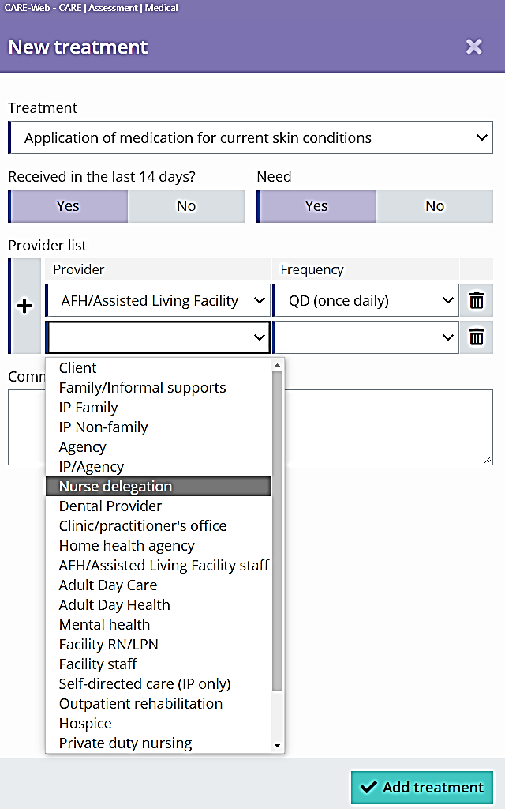

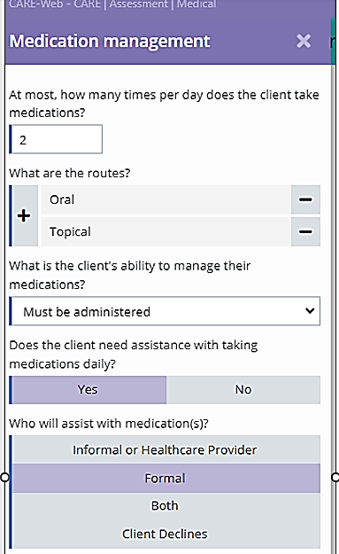
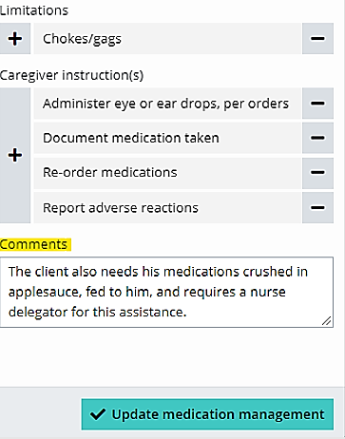

- Comments: This can remind why the client needs delegation and that one has been referred.

GetCare Documentation for TSOA
- Ensure the medication management level of assistance coding in the most current NFLOC assessment is “must be administered” or “must be administered daily”.
- If neither of these are selected, then the care receiver is not eligible for ND services related to medication management.
- Document in a Progress Note that the Home Care agency confirmed their LTCW assigned to the client meets the ND training requirements. This would be the Agency Provider (AP).
- Add the RND’s name and contact information to the Contacts section.
- Ensure the ND service has been included in the care plan including what task(s) are being delegated.
- Scan and upload the Nurse Delegation Referral and Communication Form 01-212 that was sent the RND into the client’s Electronic File Cabinet.
- Upload page 2 of this Referral form when the RND returns it to you with the results of the initial ND assessment.
- Document all contacts with the RND in a progress note.

Referrals for Nurse Delegation

General timeframe Factors for Responding to All Nursing Referrals:
Business Week Monday-Friday; Excludes Holidays and Weekends.
Time Clock starts next business day. Example: Assessment Done Friday 5/1 (2 business days clock starts) Monday 5/4.
All staff must make sure to manage the coverage to stay within timeline.
A plan for the accomplishment of the nursing task by an informal support is required when there is not a formal support in place.
LTCW
- Ensure the LTCW has active credentials and training to be delegated.
- For In-home clients:
- CDWA Chapter 11
- Agencies must ensure their employees meet all the appropriate credentials.
- Clients in an AFH or ALF: facility management is responsible for having staff already trained to provide delegated tasks when they accept a client who requires ND. (This may need to be confirmed prior to sending RN referral.

RN Delegator
- Contact a contracted RND, (preferably by phone for initial contact) to verify they are available and accepting new clients.
- Contracted Nurse Delegators DSHS Intranet site;
- Contracted Nurse Delegator DSHS Internet site
- Once verification has been obtained from the RND, authorize ND in CARE or GetCare and send a referral to the RND.
- Make referral using Nurse Delegation Referral and Communication Form 01-212. It must include:
- Authorization number
- Client demographics
- ACES ID #
- Current CARE or GetCare assessment
- Individual support plan (if applicable)
- Positive behavior support plan (if applicable)
- Consent Form 14-012 (Release of Information)

Nurse Delegation Referral Timeframe
2 business days - CM is required to make referral.
2 business days - Nurse is required to confirm receipt of the referral.
5 business days - Nurse will review file and reach out to client, family member(s) or POA/Guardian and make phone contact and home visit. *** If the nurse is unable to make timeline, document all efforts and barriers, inform case manager supervisor, and make contact as soon as possible.

10 business days - Complete all documentation.

Skin Observation Protocol (SOP) Referral
Please refer to steps below:
When a client triggers the SOP during assessment/reassessment and there is currently and RND serving that client, send the a referral using the HCS/AAA Nursing Services Referral Form 13-776.
- The RND must use these forms and return to CM:
- HCS/AAA Nursing Services Referral Form 13-776.
- Basic Skin Assessment (13-780).
- Pressure Injury Assessment and Documentation (13-783) (For each pressure injury assessed).

Nurse Delegator For HCS/AAA SOP/Nursing Triggered Referrals
In the situation where the Nurse Care Consultant (NCC) or RN Case Manager is unavailable, authorized staff may refer the Nursing Trigger – Skin Observation Protocol, to any available Contracted Nurse Delegator, who will address all other nursing triggers at the same time. All RNs are expected follow the listed timeframes for SOP. ** Please refer to DDA Policy 9.13 for DDA SOP referral
Staff will use this form to send a referral to the RND HCS/AAA Nursing Services Referral Form (#13-776)
- HCS/AAA Nursing Services Referral Form 13-776.
- Basic Skin Assessment (13-780).
- Pressure Injury Assessment and Documentation (13-783) (For each pressure injury assessed).
*Staff must ensure that you receive the above forms are received back in the specified timeframe.

- Triggered Nursing Referral Timeframe SOP (ALTSA): Chapter 24 Nursing Services
2 business days - CM is required to make referral.
2 business days - Nurse is required to confirm receipt of the referral.
5 business days - Nurse will review file and reach out to client, family member(s), or POA/Guardian and make phone contact. **** If the nurse is unable to make timeline, document all efforts and barriers, inform case manager supervisor, and make contact as soon as possible.
20 working days to make visit if necessary and complete documentation.
Total 29 working days

- Triggered Nursing Referral Timeframe (excluding SOP):
2 business days - CM is required to make referral.
2 business days - Nurse is required to confirm receipt of the referral.
10 business days - Nurse will review and use nursing judgment if phone contact and/or visit to client is necessary and will document all actions. ** If the nurse is unable to make timeline, document all efforts and barriers, inform case manager supervisor, and make contact as soon as possible.
15 business days - Complete all documentation.
Total 29 working days

Authorizing Payment
Only RNs or Home Health agencies under Nurse Delegation contract with DSHS can be paid to provide ND services.

Assisted Living Facility
- Home and Community Services (HCS) will not pay an RN to delegate in a licensed ALF. The payment relationship for RN delegation is between the nurse and the ALF facility.
- If a licensed ALF also has a contract as a DDA Group Home, DDA may pay for ND services.

Adult Family Home
- RNs who own an AFH may also be paid for ND services in addition to their daily rate when they have a DSHS RN Delegation contract.
**However, ALTSA will not pay an RN delegator to provide services in an Private Duty Nursing contracted AFH. That is considered a duplication of services.

Authorized Delegation Units
- RND is authorized for 100 units per month with P1 Service Code H2014 with Modifier U5 for the duration of the client’s CARE plan. The system will allow you to authorize services for 1200 units for up to 12 months.
- If a client needs more than the maximum number of authorized units (100 u/month), the RND is responsible for requesting additional units through the Nurse Delegation Program Manager (NDPM). DSHS Form 13-893 Nurse Delegation: Request for Additional Unit. Once approved, the NDPM will notify CM and RND.
Note: For DDA clients, ND services may be provided to individuals served by certified community residential programs for the developmentally disabled. See DDA Policy 6.15

Transferring Cases
If the LTCW does not have the required credentials and training before you transfer the case, you must:
- Provide information to the LTCW on the training requirements and process.
- Encourage the LTCW to complete all requirements as soon as possible.
- Ensure a temporary plan of care is in place to meet the client’s nursing needs until the LTCW has fulfilled the requirements.
- Communicate to the receiving agency the current plan and the future plan of the LTCW performing the delegated task once training has been completed and then document in SER that communication occurred (and method of communicating).
The receiving agency must monitor the training and registration process for the LTCW. After the LTCW’s training and registration requirements have been met, the agency needs to send a referral to a contracted ND with the authorization for payment.
Note: These instructions do not pertain to MAC/TSOA cases.

Authorization of Nurse Delegation services; hospital or institutional
- When a client resides in or admitted to an institutionalized setting, the case manager may request a DSHS contracted Nurse Delegator to assess the client to determine the appropriateness of delegation and begin the delegation process.
- Services will be authorized under an ALTSA Recipient Aid Category (RAC) 3490 State Only Adjusted Payment (SOAP) or DDA RAC 3930 State Funded Community Support Services.

Authorization of Nurse Delegation services for a new client who is not currently on services.
- Please follow steps below:
- We must use state only funds via ALTSA RAC 3490 State Only Adjusted Payment (SOAP) or DDA RAC 3930 State Funded Community Support Services to pay for nurse delegation services while client is in a hospital or institutional setting.
- Add the RAC on the RAC eligibility screen with start/end dates that match the dates of service that the client is in the institutional setting.
- Create a social service authorization for nurse delegation services.
- Because the client does not yet have personal care or other community services the service line will generate the following error, #30115 “Nurse Delegation services can only be authorized with certain other service.
- This error should be forced by the ALTSA Nursing Delegation Program Manager or the DDA case manager’s s supervisor or a DDA Payment Specialist.

Authorization of Nurse Delegation services for an existing client.
- Please follow steps below:

- We must use state only funds via the ALTSA RAC 3490 State Only Adjusted Payment (SOAP) or DDA RAC 3930 State Funded Community Support Services to pay for nurse delegation services while client is in an institutional setting.
- We will need to add the RAC and split the social service authorization to reflect the dates the client is not in a community setting.
- Add a RAC on the RAC eligibility screen with start/end dates that match the dates of service that the client is in the institutional setting.
- On the current nurse delegation authorization service line, complete the following:
  - Change the start date on the current service line to match the start date of the 3490/3930 RAC.
  - Change the end date on the same service line to match the end date of the 3490/3930RAC.
  - Change the number of units to reflect the units approved for the time client is in the institutional setting.
  - Enter a comment.
  - Hit “Submit.” By changing the start date, end date, and the units the service line will split resulting 3 service lines; 1 service line will be for dates prior to institutional admission, dates during admission, and dates after discharge.
- Because the client is not eligible for community services like personal care while in an institutional setting, the service line should generate the following error: #30115 “Nurse Delegation services can only be authorized with certain other service.”
- This error should be forced by the ALTSA Nursing Delegation Program Manager or the DDA case manager’s supervisor or a DDA Payment Specialist.

Splitting Social Service Lines in CARE
Examples
- The client lives in a residential setting, and they were authorized nurse delegation services from 5/1/2023 to 12/31/2023. Client was admitted to the hospital on 9/4/2023 and will discharge 9/10/2023:
- Update RAC eligibility screen:
  - Change the end date on the residential RAC to 9/3/2023.
  - Add the 3490 or 3930 RAC for 9/4/2023-9/9/2023.
  - Add a new residential RAC with a start date of 9/10/2023 and an end date that matches the end of the plan period.
- Update the current nurse delegation authorization:
- Change the Start date to 9/4/2023.
- Change the End date to 9/9/2023.
- Update the Units to reflect what was approved during these dates.
  - By changing both date fields and another data field (like the units or reason code) this edit is going to result in 3 service lines; one line will end 9/3/23, 1 line will go from 9/4/23-9/9/23, and another line will start at 9/10/23 with an end date that matched the original end date. After the service line splits, you will want to update the approved units on each of the affected lines.
- Update the Reason Code
- Add a processing comment.
- Select the submit button.

- The client lives in a residential setting, and they were authorized nurse delegation services from 5/1/2023 to 12/31/2023. Client was admitted to the hospital on 9/4/2023 and will discharge 9/10/2023. A bed hold was approved for 9/4/2023-9/9/2023 resulting in the RND service line ending 9/3/2023:
  - Update RAC eligibility screen:
  - Change the end date on the residential RAC to 9/3/2023.
  - Add the 3490 or 3930 RAC for 9/4/2023-9/9/2023.
  - Add a new residential RAC with a start date of 9/10/2023 and an end date that matches the end of the plan period.
  - Create 2 new service lines for the RND service (complete the authorization service line reason code):
  - Create 1 line that will match the dates of the SOAP RAC.
  - Create another line that has a start date matching the new residential RAC and an end date that matches the end of the plan period.

Delegator Responsibilities
See “Nurse Delegation Forms” for full list of forms, titles, and how to access.
- Respond to DSHS/AAA staff within two working days of receiving referral. Sign and return Page 1, DSHS Form 01-212 Nurse Delegation Referral and Communication
- Verify the LTCW’s have approved training and credentials to become delegated. DSHS Form 10-217 Nurse Delegation Nursing Assistant Credentials and Training
- Obtain consent using DSHS Form 13-678 Pg 1 Nurse Delegation: Consent for Delegation of Nursing Tasks from the client or the client’s authorized representative to provide delegation.
- Assess the client and document findings, to ensure they are stable and predictable, and their overall care needs to determine whether delegation is appropriate for the specific situation and task. (DSHS does not have an approved assessment form, the delegating RN must use their own form to document assessment)
- Communicate the results within 5 business days of the initial assessment to the CM or NCC, utilizing page 2 of the DSHS Form 01-212 Nurse Delegation Referral and Communication.
- Complete DSHS Form 14-484 Nurse Delegation Nursing Visit at each nursing visit including LTCW training and observation.
- Teach the LTCW to perform the nursing task(s). Use form DSHS 13-678 Pg 2 Nurse Delegation Instructions for Nursing Task
- Assess and monitor the LTCW’s performance and continued appropriateness of the delegated task(s) every 90 days or more frequently as needed.
- If the LTCW is delegated to administer insulin, the RND will assess the client and monitor continued competence of the LTCW. The frequency is determined by the RCW and WAC for Nurse Delegation. RCW 18.79.260 and WAC 246-840-930
- The RND can determine to assess each LTCW more frequently if necessary.
- Document using DSHS Form 14-484 Nurse Delegation Nursing Visit
- Document and perform all delegation activities as required by law, rule, policy, and contract.
- When rescinding ND, work with the CM/NCC, the client, and other identified parties; and
- Nurse completes DSHS Form 13-680 Nurse Delegation Rescinding Delegation
- WAC 246-840-960 states the registered nurse delegator may rescind delegation of the nursing task. The registered nurse delegator initiates and participates in developing an alternative plan for continuing the task. Please refer to WAC for more details.
- Respond as required to the CM request for the Skin Observation Protocol (Chapter 24) if currently serving the client.
- Report client changes in condition or needs to CM.
- Use ProviderOne for billing for documented services in a timely manner. Please use a billing tracker for records. May use DSHS Form 06-200 Nurse Delegation Billing
- Respond to ND Program Manager inquiries regarding billing, contract monitoring, and other concerns related to role performance.
- The Program Manager is responsible for monitoring the nurse’s contractual performance including communication, frequency of visits, documentation, and payments/billing.

Consumer Directed Employer Chapter 11
- Individual Provider (IP)
- CM opens authorization to RN delegator and sends the RN the delegation referral form.
- If the RN delegator approves nurse delegation with an IP, the CM will notify CDWA by phone/email.
- CDWA will verify the IP(s) credentials/training & will notify the RND if all requirements are satisfied.
- If IP lacks training, CDWA will initiate training process & notify the RND once the IP is trained.
- Agency Provider (AP) may obtain their training through a DSHS agency approved community trainer. The Agency is responsible for ensuring the AP meets the requirements for delegation.
Find a Training Class (DSHS)
  - Nurse Delegation 9 hours
  - Nurse Delegation – Diabetes 3 hours
  - Basic Training
  - Mental Health & Dementia Specialty

Training for Long-Term Care Worker (LTCW)
Basic Training
Includes one of the following:
- Fundamentals of Care
- Revised Fundamentals of Care
- The 40-hour Basic Training is part of the HCA curriculum (HCA training is 75 hours)
- In DDA Supported Living agencies, the DDA 32-hour training meets the Basic Training requirement up to January 1, 2016.
- If employed after January 1, 2016, the 40-hour CORE Basic Training is required for all DDA SL employees.
Requirements
The LTCW must:
- Have one of the following ACTIVE credentials from the Washington Department of Health per RCW 18.79.260:
- Nursing Assistant-Registered (NA-R)
- Nursing Assistant-Certified (NAC)
- Home Care Aid-Certified (HCA-C)
- Complete the 9-hour “Nurse Delegation for Nursing Assistants” training in addition to the Basic Training
- PLUS, the 3-hour “Special Focus on Diabetes” training if they will be administering insulin.
- Provide proof of completing Basic Training:
- NAC or HCA-C: Assumed through state certification.
- NA-R: See Exempt or Non-Exempt Table

Exempt | Non-Exempt
If the LTCW worked 1 day from January 1, 2011, to January 6, 2012, they are exempt from taking the Basic Training.  Needs to provide proof of working 1 day within this timeframe and provide their Basic Training certificate. | The LTCW is required to take the 40-hour Basic Training if:  - They did not work 1 day January 1, 2011, to January 6, 2012, or  - Is unable to provide proof of employment and their Basic Training certificate.  A non-exempt NA-R must be dually credentialed until passage of the Prometric test. Upon passing the test, the NA-R credential does not need to be renewed annually. Only the HCA-C credential needs to be renewed annually.

Related RCWs and WACs
RCW 18.79 Nursing Care
RCW 18.79.260 Activities Allowed – Delegation of Tasks
RCW 18.88A Nursing Assistants
RCW 74.39.050 Self-Directed Care (Individuals with functional disabilities)

WAC 246-840 Practical and Registered Nursing
WAC 246-840-910 Delegation of Nursing Tasks to Nursing Assistants or Home Care Aides
WAC 246-840-930 Criteria for Delegation
WAC 246-840-940 Delegation Decision Tree

WAC 246-335-420 Home Care Agency Delivery of Services
WAC 246-945 Medication Assistance
WAC 246-980-010-990 Home Care Aide Rules

WAC 388-71 Home and Community Services and Programs
RCW 74.39A.250 Individual Provider

WAC 388-76 Adult Family Home Minimum Licensing Requirements
WAC 388-78A Assisted Living Facility Licensing Rules
WAC 388-112A Residential Long-Term Care Services Training

WAC 388-106 Long-Term Care Services
WAC 388-106-0300 Services Provided Under COPES
WAC 388-106-1900 Services Provided Under MAC and TSOA
WAC 388-110 Contracted Residential Care Services
WAC 388-112A Residential Long-Term Care Services Training

Acronyms
AFH Adult Family Home
ALF Assisted Living Facility
ALTSA Aging and Long Term Support Administration
CFC Community First Choice
CM Case Manager
CNC Community Nurse Consultant
COPES Community Options Program Entry System
DDA Developmental Disability Administration
DOH Department of Health
DSHS Department of Social and Health Services
HCA-C Home Care Aide Certified
IP Individual Provider
LTCW Long-Term Care Worker
MAC Medicaid Alternative Care
NA-C Nursing Assistant Certified
NA-R Nursing Assistant-Registered
ND Nurse Delegation
RAC Recipient Aid Category
RCL Roads to Community Living
RND Registered Nurse Delegator
RSW Residential Support Waiver
SEIU Service Employees International Union
SER Service Episode Record
TSOA Tailored Supports for Older Adults

Web Resources and Forms

DSHS/ALTSA
Individual Providers - Home Care Aide Certification
Nurse Delegation Program
DSHS Contracted Nurse Delegator (internal)
DSHS Contracted Nurse Delegator (external)
ALTSA Long-Term Care Policy Manual

DOH
Washington State Board of Nursing
WA State Credential Verification for RNs, LPNs, and ARNPs
Multistate (MSL) RN or LPN in another state use: Nursys.com
** Primary source verification of licensure for an RN or LPN practicing in Washington State with an out of state MSL is not available on the Provider Credential Search.

Nurse Delegation Forms:
DSHS Forms page:
01-212 | ALTSA Nurse Delegation Referral & Communication Case/Resource Manager
06-200 | Nurse Delegation Billing Form
10-217 | Credentials and Training Verification
13-678 Page 1 | Consent for Delegation Process (available in 9 languages)
13-678 Page 2 | Instructions for Nursing Task
13-678A | PRN Medication
13-678B | Assumption of Delegation
13-680 | Rescinding Delegation
13-681 | Change in Medical Orders
13-893 | Request for Additional Units
13-903 | DDA Request for Additional Units
13-484 | Nursing Visit

