Records Management
The purpose of this chapter is to provide general guidance and procedures regarding Records Management including: Records Retention and Public Records Requests.

Contents
Records Management 1
Ask the Expert 2
Background 2
Records Management 3
Record Coordinators and Custodians Responsibility: 3
Prior to the destruction of any DSHS records, determine if those records need to be kept for a public records request, legal purpose (anticipated litigation or discovery), audit, or program requirement. 3
Employees Responsibility: 3
Barcode 6
Public Records Request Process 6
Receiving public records requests: 6
PRC Responsibility: 7
Adequate Search 7
Employees Responsibility: 8
Public Disclosure – AAA Responsibility 12
Public Disclosure – Individual providers (IP) and CDE 12
Disclosure of Guardian Ad Litem (gal) Information 13
Disclosure of Administrative Hearing Records 13
Disclosure of Adult Protective Services (aps) Information 14
Related RCWs and WACs 14
Related Administrative Policy 14
Acronyms 14
Forms 15

Ask the Expert
If you have questions or need clarification about the content in this chapter, please contact:
Kathy Frey HCS, Public Records Program Manager
360.725.2518 desk
HCSPublicRecords@dshs.wa.gov

Each Region has a Record Retention Coordinator

Area Agencies on Aging – Each AAA has a Public Record Coordinator and a Record
Retention Coordinator

Background
The law requires DSHS and its employees to keep DSHS records for a specific period under approved record retention schedules. Failure to keep records under the approved record retention schedules, or failure to stop destruction of records when there is notice of potential lawsuit, or an active lawsuit, audit, or public records request, could subject the employee and DSHS to penalties and fines.

The Department of Social and Health Services strongly supports principles of open government and transparency in its operations. ALTSA employees must comply with the Public Records Act (PRA) in granting access to records, with the exception of exempt confidential information, as outlined in DSHS Administrative Policy 5.02.

Home and Community Services (HCS) employees must forward public records requests to their designated PRC at hcspublicrecords@dshs.wa.gov upon receipt. If in doubt, err on the side of a PRR, as the PRC must acknowledge the request within five (5) business days per Chapter 42.56 Revised Code of Washington (RCW). All employees must comply with preserving and the destruction of records, as described in DSHS Administrative Policy 5.04.

Records Management
Records Management helps the administration and agency ensure compliance with RCW 40.14. It is the responsibility of the appointing authority to notify the HCS Public Records Program Manager (PRPM) of any staff change of their local records coordinator/custodian.
- Planned Box Disposition (PBD) Reports – Are distributed monthly to the designated records coordinator. Things to consider when reviewing your PBD report:
  - What type of records are scheduled for destruction?
  - View the contents of the box (Barcode, View Box)
  - Client records – check your Litigation Holds notices
    - Upon receipt of a Litigation Hold, request the records from SRC and place in a separate file cabinet with LOCK.
  - Adult Protective Services (APS) – immediately forward to the APS Records Manager for coordination or approval of destruction.

- Record Retention Schedules
- Record Management Training
PLEASE NOTE: If there is Potential Litigation - err on the side of preservation or contact your Public Record Coordinator.

Record Coordinators and Custodians Responsibility:
A Records Coordinator is responsible for providing assistance to those archiving program records according to the DSHS record retention schedule.

- Comply with procedures established by the Agency Records Officer, as outlined in AP 5.04.
- Assist the Agency Records Officer with records inventories.
- Review their unique DSHS Record Retention Schedules annually.
- Identify essential record series, establish office procedures for their preservation
and protection.
- Establish procedures for compliance with the General Records Retention Schedule
and unique DSHS Records Retention Schedules record retention schedules
including regular or periodic records disposition.

Prior to the destruction of any DSHS records, determine if those records need to be kept for a public records request, legal purpose (anticipated litigation or discovery), audit, or program requirement.

Employees Responsibility:
- Take DSHS Records Management 101 mandatory training annually.
- Consult with the HCS Public Records Program Manager on all matters relating to the
maintenance, retention, transfer and/or destruction of public records in accordance
with RCW 40.14.040.
- Comply with retention procedures established by this policy and division policies.
- Keep DSHS records the employee is responsible for until the records have met the
end of their approved retention period or have been imaged in accordance with
the Requirements for the Destruction of Non-Archival Paper Records After Imaging.
- Keep ESI in its original electronic format with metadata intact. (Printing and
keeping a hard copy of ESI is not a substitute for the electronic version unless
specifically approved by the State Records Committee).
- Keep any DSHS records created, sent, organized, received, or stored on DSHS or
non-DSHS resources according to the retention schedule regardless of physical
location.
- Prior to the destruction of any DSHS records, determine if those records need to be kept for a public records request, lawsuit, audit, or program requirement.

Records Coordinators Monthly Disposition Report Responsibility:

The below is an example of a Disposition Report for Office 9113 of records scheduled for disposition 03/01/2023, due to HCS Records Manager no later than 03/30/2023. (Disposition reports are a month ahead.

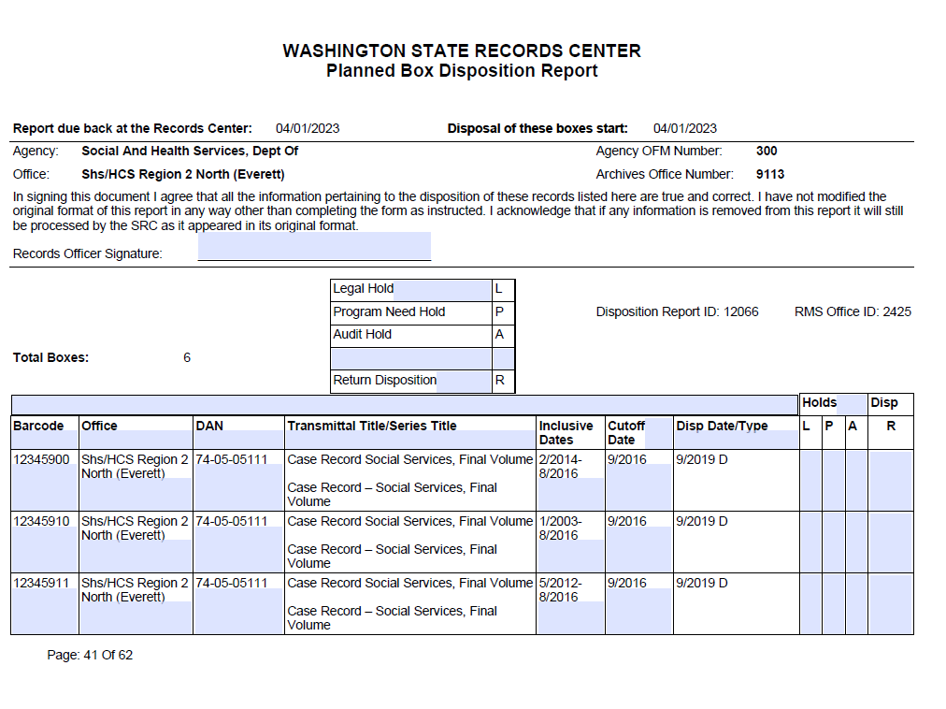
If you sign and return the above form, you are providing approval for boxes to be destroyed. If you need to hold any boxes for legal purposes or other program purposes, mark the appropriate column;
L = legal hold;
P = program hold;
A = audit hold; and
R = return boxes to your office
If you check the R column, please provide your address where you want the boxes returned.
If you do not return the form or return it blank, boxes will be returned to the address on the transmittal sheet.

Barcode Movement of Client Records:

Barcode is the DSHS records management system for social service and financial records. You will need to check Barcode for archived records.
- The SRC Barcode database is not connected to the DSHS Barcode database. The SRC does not track folders in BARCODE, therefore, they cannot place folders in transit to you, and the location in DSHS Barcode will read 999. You must move/track the folder into your location. Should you experience difficulty moving the folder into your location, please follow these steps in Barcode:
  - At the top of the screen, select:
SUBSYSTEMS
    - Select: Wand
    - Select: UNITS (far right)
      - Select: your LOCATION (and the staff person)
      - Select: Wand to (bottom left)
Wand or type: the folder tracking tag (located under Barcode, bottom right and it starts with a period “.”)
      - EXAMPLE: .DV1XVR
You can keep entering folders and when done, click done.
- Records need to be tracked “in” and “out” from location 999

Transferring and Returning a Case in DMS NOTE: Chapter 5 Case Management provides information on Transferring a physical and electronic case record and paper file from one office to another. At any point during a case transfer, the social worker/case manager may request a case transfer consultation or case staffing.

Public Records Request Process

Receiving public records requests:
Employees who receive a public records request must immediately send a copy to: HCSPublicRecords@dshs.wa.gov so the required initial response letter is sent within 5 business days. If the record/s can easily be given to the requester at the time of the request and does not require redaction, please include HCSPubliceRecords@dshs.wa.gov as a cc. If the request is verbal, the employee receiving the request must transcribe and transmit the request to HCSPublicRecords@dshs.wa.gov within one workday.

PRC Responsibility:
Adhering to AP 5.02, by inputting PRRs into ARRTS, respond timely to all requesters and tasks assigned. Keep ARRTS updated and accurate, review records carefully prior to disclosure to ensure exempt information is not disclosed and to avoid a potential privacy breach. Have a back-up PRC trained and ready to assist, attend meetings and trainings.
- Contact the HCS headquarters PRPM anytime you have:
  - A question regarding a request;
  - A request that appears to affect other administrations;
  - Reason to suspect that this request may be high profile and/or a potential media request.
- Track your time and other staff time in ARRTS.
If a Media request is received, the PRC must contact the HCS Public Records Program Manager or the ALTSA PRO immediately.

When a public records request is received:
- Provide the request to your Public Record Coordinator Immediately
- The day the request is initially received is “Day Zero”
- The 5-day letter is due (postmarked) by the close of business on “Day Five”

Preserve and retain identified records in any existing format and with metadata intact for electronic records, even if there is a printed copy, until notified by the public records coordinator that retention is no longer needed. Records that are preserved should not be redacted or altered in any way by the employee.

Provide search terms to assist with an email search
- Hard Drives
- Local Personal Folders
- Portable Storage Media (Flash drives, CD, DVD, USB drives)
- Portable Devices (Laptops, Smartphones, tablets)
- Network Drives
- SharePoint Sites
- Office, Desk and Filing Cabinets
- Recording Devices (Cameras, video cameras, audio recordings, and surveillance video).
- Personal Devises or locations outside of DSHS
- Follow AP 5.02 All staff must search their records and assist PRCs to produce records.

Adequate Search
- Adequate search is required to fully assist the requester
- Documentation of the search conducted is strongly recommended
- Notes can be placed in the task resolution in ARRTS
- Databases to be searched CARE, BARCODE, TIVA, ACD, ACES, etc.
For high profile requests and potential litigation, The PRC may provide you with the Employee search form 02-630

Employees Responsibility:
All employees should IMMEDIATELY refer all records requests to hcspublicrecords@dshs.wa.gov. Requesters may communicate their request in any format such as by phone, email, fax, face-to-face, in a letter, etc. If in doubt, please err on the side of a PRR and immediately provide to your PRC. DO NOT DELAY!

When requested by a public records coordinator to search for records regarding a public records request, employees must:

Search for records within their control that are responsive to the request. This responsibility includes any public records of the department created, sent, organized, received, or stored on DSHS and non-DSHS administered IT resources and includes those kept on or off DSHS property.

Provide access to original records or copies of records in the format requested by the public records coordinator. This responsibility includes connecting any external devices, including non-DSHS administered IT resources such as laptops or external drives, to the network or otherwise granting access to records as needed for indexing, searching, and collecting records in response to a public records request.

Public Disclosure Process

What is a Public Disclosure Request?
A request for a public (DSHS) record may include documents, audio and video recordings, pictures, e-mail, computer disks and electronic data.

- Responding to a Records Request
When the Public Records Coordinator receives the request, he/she will:
- Keep accurate notes including the date, the name of the person requesting the information, their address and a phone number you can reach them at, and the specific information that he/she is requesting.
- Compose and send a letter within 5 days. To count five days remember the following:
  - The day the request comes into the agency is “Day Zero.”
  - The 5-day letter is due (postmarked) by the close of business on “Day Five.”
  - Don’t count weekends or holidays. Count business days only.
- The “five-day letter” must do one of three things:
  - Fill the request;
  - Deny the request and explain why, citing the statute or legal basis; or
  - Request additional time to gather information to fill the request. “Additional time,” is generally a maximum of thirty business days to ensure that there is enough time to process the request. Use the maximum thirty days especially if you have a request that is agency-wide or is high profile.
- The “five-day letter” must include the following:
  - The date of the request;
  - Any changes to the request;
  - Copy and cost information (if you know it);
  - Your contact’s name and phone number/email address;
  - If you are denying or redacting, give the reason, a citation and appeal information; or
  - If you need more time, tell how long it will take, give the reason. You can take more time to fill a request based on a need to:
  - Clarify the intent of the request;
  - Locate and assemble the information requested;
  - Notify third person or agencies affected by the request; or
  - Determine whether any of the information requested is exempt.

- Determining Whether the Information is Releasable
The Public Disclosure Coordinator will then:
- Determine if the information is releasable by looking at WAC and RCW. Check if the information requested requires an authorization (release) or other administrative procedure such as a court order to obtain. (See Appendix B, Authorizations.)
- Contact the requestor if you need to further clarify the request.
- Contact your HCS headquarters coordinator anytime you have:
  - A question regarding a request;
  - A request that appears to affect other administrations;
  - Reason to suspect that this request may be high profile and/or a potential media request.
- Notifying Third Parties
The Public Disclosure Coordinator will:
- Determine if within the request there are names of third-party people such as witnesses, employees, or other organizations, contact them and give them time to block the release of their information.
- Include information in the notice that states:
  - The record(s) being requested;
  - The date you intend to release the record; and
  - How the individual or organization can prevent release of the record and the deadline to take that action.
- Send a written notice to the requestor informing him/her that:
  - The individual or organization whose personal information is contained in the requested public record has been notified;
  - You expect a response from the individual or organization regarding disclosure of their personal information by a specified date; and
  - Disclosure may be denied.
- Release the record if no one objects or the party does not respond by the specified date. If the third party does object to the information being released, they can prevent release of the record by petitioning the court for protection of the record. If you need to allow more time for someone to get a court order or for some other reason, inform the requestor of the revised date.
NOTE:
When an individual or organization, other than the subject of a record, files a lawsuit to block the disclosure of records, you must notify the Office of the Attorney General.
The superior court for the county in which the person named in the record resides, or in which the record is maintained, may grant protection of the record if the court agrees that such examination would clearly:
  - Not be in the public interest and would substantially and irreparably damage any person; or
  - Would substantially and irreparably damage vital government functions.

Public Disclosure – AAA Responsibility
Once a case is transferred from DSHS to a AAA, the AAA is responsible to produce all client records within the designated records set.

If client records are requested and the client is Case Managed by a AAA, the HCS public records coordinator will:
- Prepare the 5-day letter and forward the 5-day letter including the request to the appropriate AAA for response by the designated date.

The AAA public records coordinator will:

- Respond to the records request per the contract with DSHS.
- Send HCS public records coordinator a copy of the closure letter sent to the requester once the request is complete including the time spent by all AAA staff of fulfilling the request.

Public Disclosure – Individual providers (IP) and CDE
Effective October 1, 2021, Staff receiving a public records request for records relating to an IP should forward the request to their designated public records coordinator (PRC). ALTSA - Assistant Secretary - Consumer Directed Employment (CDE) Project (wa.gov)

The PRC will be responsible for processing the request. The PRC will review the request to determine what records are being requested, and who the owner of record is for the date range of the records requested.

- DSHS is the owner of record up to hire date of the IP with the Consumer Directed Employer (CDE). Prior to April 2022.
- CDE will be the owner of record for all IP records once the IP is hired through CDE.
- Please forward all inquiries directly to: InfoCDWA@consumerdirectcare.com
- For records owned, maintained, or used by DSHS, the PRC will process the request as usual.

The transition of IPs to CDE employment will take place in phases and be complete by April 2022. During each phase, the lead HCS PRC will receive from CDE a list of IPs. This list will be sent to the appropriate AAA. If you have questions, please contact the lead HCS PRC.

Disclosure of Guardian Ad Litem (gal) Information
It is the Case Manager’s (CM) responsibility to provide records to the client or their designated representative when conducting day to day business activity. For all public record requests, they should be submitted to hcspublicrecords@dshs.wa.gov (GAL requests for APS see https://intra.altsa.dshs.wa.gov/aps/sharepoint.htm.

Disclosure of Administrative Hearing Records
The Case Manager provides the case record and all relevant information to the administrative hearing coordinator. This should not be treated as a public records
request. Please see LTC Chapter 26

Obtaining CONSENT to Share Confidential Information (DSHS 14-012)

You are required to obtain consent prior to sharing confidential information about a client. Use DSHS 14-012 form to document this consent.
The client or representative (e.g. DPOA or guardian) may sign this form. The instructions on the consent form (DSHS 14-012) under the signatures portion of the instructions explain who can sign the consent form. In those cases where the client understands but can only make a mark in the signature box, a mark is sufficient. In these cases, a witness should sign and then make a note about the client's inability to properly sign and the reason.
You must use this form in order to obtain, use, or share confidential information about a client for the purpose of providing services to the client. If you need to list multiple providers on the consent form and cannot fit all the information in the blanks provided, you may mark the box, “See attached list,” and attach a list to the consent form to accommodate all information. Please see LTC Chapter 2 A.

Disclosure of Adult Protective Services (aps) Information
Please Refer all APS records request to APSPublicRecords@dshs.wa.gov Or Staff may use the following link to view APS policy and procedure information as needed: APS policy and procedure

Related RCWs and WACs
RCW 42.56 PUBLIC RECORDS ACT
RCW 40.14 PRESERVATION AND DESTRUCTION OF PUBLIC RECORDS
WAC 388-01 DSHS ORGANIZATION/DISCLOSURE OF PUBLIC RECORDS

Related Administrative Policy
Administrative Policy 5.01 Privacy Policy -- Safeguarding Confidential Information
Administrative Policy 5.02 Public Records Requests
Administrative Policy 5.03 Client Rights Relating to Protected Health Information
Administrative Policy 5.04 Records Management
Administrative Policy 5.07 Employees Response to Litigation Related Documents
APS Policy and Procedure

Acronyms
ACD Agency Contracts Database
ACES Automated Client Eligibility System
AAA Area Agency on Aging
ALTSA Aging and Long-Term Support Administration
AP Administrative Policy (DSHS)
APS Adult Protective Services
Barcode ESA’s primary document management system and used by other DSHS administrations.
ALTSA images client correspondence including social and financial records.
CARE Comprehensive Assessment for Reporting and Evaluation
CDE Consumer Direct Employer
DA Discovery Accelerator
ESA Economic Services Administration
IP Individual Provider
PBD Planned Box Disposition
PHI Protected Health Information
PRA Public Records Act
PRC Public Records Coordinator
PRR Public Records Request
PRPM Public Record Program Manager
RC Records Coordinator
TIVA Tracking Incidents of Vulnerable Adults (previously known as ADS Registry)
RCW Revised Code of Washington
WAC Washington Administrative Code

Forms
17-041 Request for Records
17-063 Authorization
14-012 Consent
02-630 DSHS Employee Records Search
02-629 Public Records Coordinator Search

