Section 30d Initiative 3: Foundational Community Supports – Supportive Housing
Chapter 30d describes Supportive Housing, a collaborative wraparound service for individuals with complex needs. These services are available in one of two ways for ALTSA recipients: Foundational Community Supports (FCS), or the Governor’s Opportunity for Supportive Housing (GOSH). This chapter describes, program eligibility, service areas, referral process and case coordination for Foundational Community Supports – Supportive Housing services. For more information on GOSH, please see Long-Term Care Manual Chapter 5b: Housing Resources for ALTSA Clients.

Ask the Expert
If you have questions or need clarification about the content in this chapter, please contact:
Whitney Joy Howard Lead Supportive Housing Program Manager
360.791.2358 Whitney.Howard@dshs.wa.gov

Chapter Sections |  | Page
1 | Background  Supportive Housing Services: Pre-Tenancy  Supportive Housing Services: Tenancy | Chapter #30d.3
2 | Foundational Community Supports: Supportive Housing  History  Eligibility  How can I tell if my client is enrolled in FCS-SH?  FCS-SH Referral Process  FCS-SH Client Accepted  Reimbursements  Community Choice Guides and FCS-SH Providers  How is this Funded?  Can a DDA services recipient receive FCS-SH services?  What about Contracting? | Chapter #30d.4
3 | Supportive Housing and Case Coordination | Chapter #30d.6
4 | Resources  Related RCWs and WACs  Forms  Updates to the Chapter | Chapter #30d.11

Background
Supportive Housing (SH) is a philosophy and a program that is rooted in the belief that no one should have to prove “housing readiness” to be housed. The service is an evidence-based practice with decades of research, as well as personal and professional stories that highlight the success of community living paired with intensive, personalized supports. A person is supported in the process of securing community-based, affordable housing of their choice along with individualized support to assist the person with stabilization and self-identified goals. SH adheres to the principles of Housing First, Harm Reduction, Trauma Informed Care, Motivational Interviewing, Person Centered Planning, and Strengths-Based Approach. Program participation, medication adherence, and abstinence are not required to keep one’s housing.

SH services are available in two ways for ALTSA recipients:
  - Individuals who are currently residing in the community may be eligible for Supportive Housing services under Healthier Washington Medicaid Transformation: Foundational Community Supports (FCS): Supportive Housing services.
  - Individuals with challenging or complex needs who are currently residing at Eastern or Western State Hospital or are able to be diverted from these institutions may access Supportive Housing Services through the Governor’s Opportunity for Supportive Housing (GOSH). For more information about GOSH, see Chapter 5b.

SH provides dedicated housing support to people with complex needs wishing to live independently. The service provides wraparound support, which means facilitating cross sector coordination of all services the person needs, including Long-Term Services and Supports (LTSS), mental health, substance use disorder, physical disabilities, developmental disabilities, legal and/or financial issues. Supportive Housing services may be an option for individuals who want to live independently and have a history of unsuccessful housing episodes without coordinated, focused support services. ALTSA seeks to provide person-centered, responsive, low barrier services for these individuals.

Contracted Supportive Housing Providers (SHP), service capacity and service areas are continuously expanding across the state. The ALTSA Supportive Housing Program Managers maintain the list of contracted SHPs. To find your Region’s Supportive Housing Program Manager please see the ALTSA Housing Regional Map.

Supportive Housing Services: Pre-Tenancy
These specialty services provide assistance and support to aid an eligible individual’s successful transition to independent housing. Supportive Housing Pre-Tenancy services may include, but are not limited to the following:
    - Facilitating a cross-sector system of care.
    - Locating and arranging independent, accessible housing, including working with local housing authorities and other community resource providers when applicable.
    - When relevant, liaising with and among the individual, institutional facility staff, case managers, housing providers, medical personnel, legal representatives, formal caregivers, family members, informal supports and any other involved parties.
    - Educating individual on tenant rights, expectations and responsibilities.
    - Assisting individual with filling out forms and obtaining needed documentation to aid in maintaining successful community living (forms may include initial and renewal voucher forms, lease agreements, etc.).
    - Assisting individual in developing a basic household budget.
    - Creating individualized Crisis Plan that is shared with cross sector team.

Supportive Housing Services: Tenancy
Once a Supportive Housing client has secured independent housing, signed a lease and moved into independent housing, they are considered a Supportive Housing tenant for the purposes of WAC 388-106-1710. These specialty services provide assistance and support to ensure the eligible individual’s maintenance of independent housing. Supportive Housing Tenancy services may include, but are not limited to the following:
    - Necessary assistance to support the individual’s community living, including assistance in settling disputes with landlords and/or neighbors.
    - Working with an individual to identify a broad range of life goals and providing support to meet the goals documented on the goal and service plan. This housing support plan is created with the client and the Supportive Housing Provider.
    - Assisting individual with locating and arranging transportation resources to effectively connect with community resources.
    - Facilitating connections to engage and enhance community integration activities.
    - Educating individual on accessing community settings or health services.
    - Personal skill development for individual and/or caregivers related to the individual’s care plan.
    - Connecting with emergency resources to avoid utility shut-off and/or eviction.

Foundational Community Supports: Supportive Housing

History
In 2017, Washington State and the Centers for Medicare and Medicaid Services (CMS) finalized an agreement for a five-year Medicaid Transformation Project (MTP) to improve the state’s health care systems, provide better health care, and control costs. In 2021, CMS approved a one-year extension. On June 30, 2023, CMS renewed MTP for an additional five years, beginning on July 1, 2023 and running through June 30, 2028. By renewing MTP, our state can continue to develop innovative projects, activities, and services that improve Apple Health (Medicaid). . To read the approval letter from CMS, please see here. To learn more about MTP 2.0please see HCA’s MTP renewal website. You can also read the full waiver renewal application.

The research is clear—unemployment and job insecurity, homelessness, and unstable housing contribute to poor health. Homelessness is traumatic and cyclical; it puts people at risk for physical and mental health conditions and substance use disorders. Similarly, evidence links unemployment to poor physical and mental health outcomes, even in the absence of pre-existing conditions. Foundational Community Supports (FCS)—part of Washington’s federally authorized Medicaid Transformation project—addresses these factors with targeted benefits for Supportive Housing and Supported Employment.
In 2018, FCS began providing targeted Supportive Housing and Supported Employment services for eligible Medicaid beneficiaries in Washington State.
For more information regarding ALTSA FCS Supported Employment benefits, please see LTC Manual Chapter 30c.

Eligibility
To receive Foundational Community Supports – Supportive Housing services, an individual must:
- Be 18 or older Medicaid-eligible
- Must meet at least one assessed health needs-based criteria:
  - Mental health need where there is need for improvement, stabilization or prevention of deterioration of functioning resulting from the presence of a mental illness (receiving services through a Managed Care Organization under the Behavioral Health Services Only (BHSO) plans or the Fully Integrated Managed Care (FIMC) plans).
  - Need for outpatient substance use disorder (SUD) treatment (receiving services through the Behavioral Health Services Only (BHSO) plans or the Fully Integrated Managed Care (FIMC) plans).
  - Need for assistance with three or more activities of daily living (ADL) (receiving long-term care [LTC] services)
  - Need for hands-on assistance with one or more ADL (receiving LTC services)
  - Complex physical health need, which is a long continuing or indefinite physical condition requiring improvement, stabilization or prevention of deterioration of functioning For ALTSA clients to receive Supportive Housing services through FCS, an individual must meet ALTSA Functional and Financial Eligibility.
- Must meet at least one of the following Risk Factors:
    - More than one institutional contact in the past 12 months or one 90+ day stay in an institutional setting in the past 12 months
    - More than one adult residential care* stay in the past 12 months
    - Three or more in-home caregivers in the past 12 months
    - HUD definition Chronic Homeless as verified through the homeless service system
    - PRISM score of 1.5 or higher**

ALTSA Supportive Housing Program Managers can assist in submitting referrals for ALTSA clients meeting the above eligibility criteria.

*Adult residential care settings may include:
  - Long-Term Services and Supports settings such as Adult Family Home, Assisted Living, Enhanced Adult Residential Center, Enhanced Service Facility, and
  - Behavioral Health Settings such as Evaluation and Treatment Centers, Detoxification Centers, Inpatient Substance Use Treatment Facility.
**ALTSA Supportive Housing Program Managers can verify PRISM scores for LTSS clients
Note:
- A CARE assessment determines ALTSA functional eligibility. Functional eligibility is defined in WAC 388-106-0210, 388-106-0277, 388-106-0310, 388-106-0338, or 388-106-1410
- Healthcare Authority WACs pertaining to FCS: 182-559-100 to 182-559-600
- Long Term Care WAC: 388-106-1700 to 388-106-1765

How can I tell if my client is enrolled in FCS-SH?
  - Open the client’s file in CAREWeb
  - Go to Client Details
  - Go to the Demographics screen
  - Click the “View ProviderOne Details” link
  - From the “ProviderOne Demographics” screen, click on “Managed Care”
  - Look for Program to contain “Foundational Community Supports-Housing” with Amerigroup Washington Inc listed as the plan

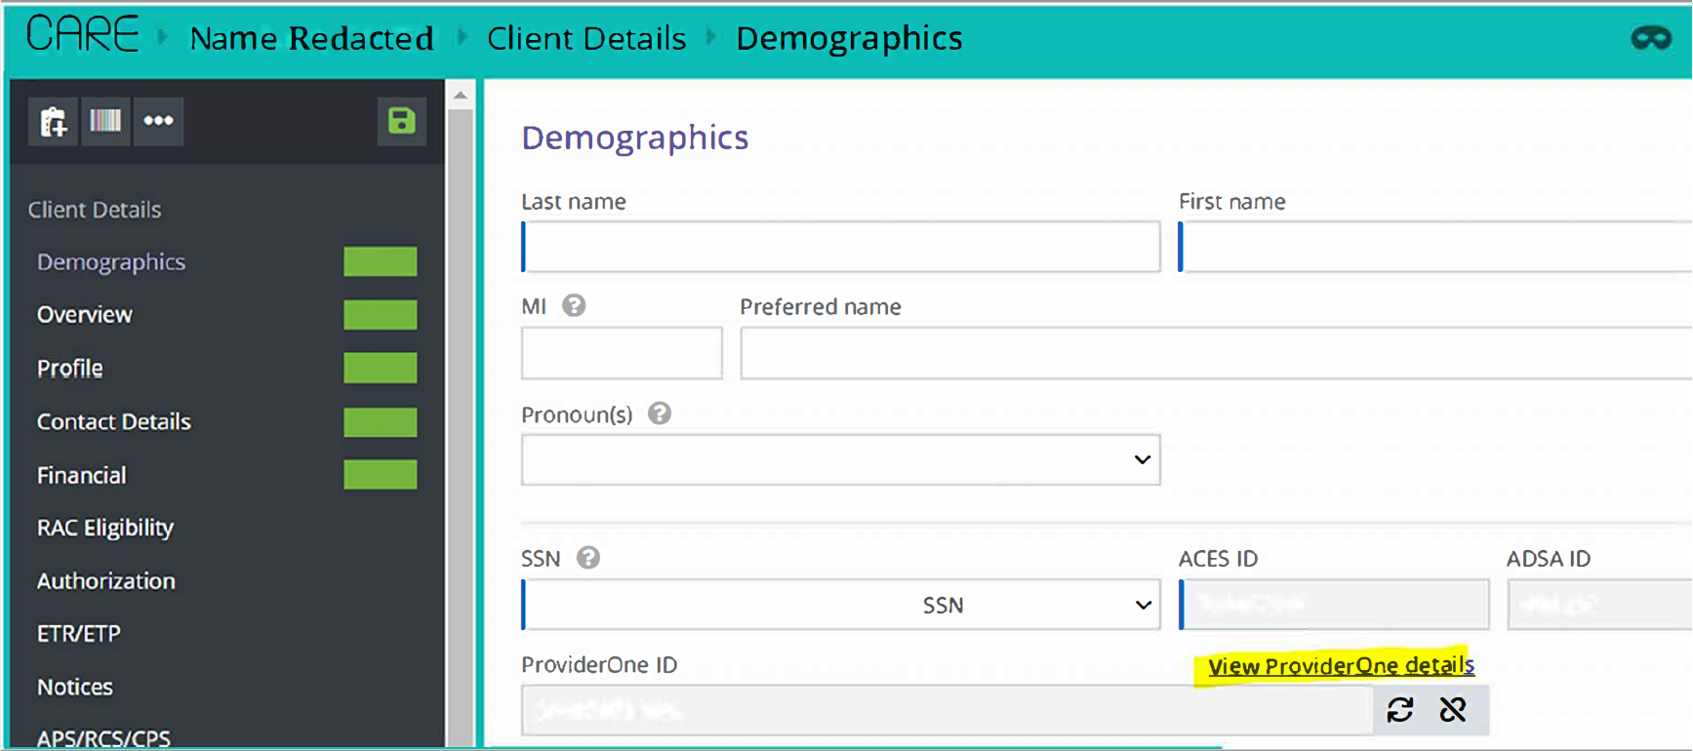

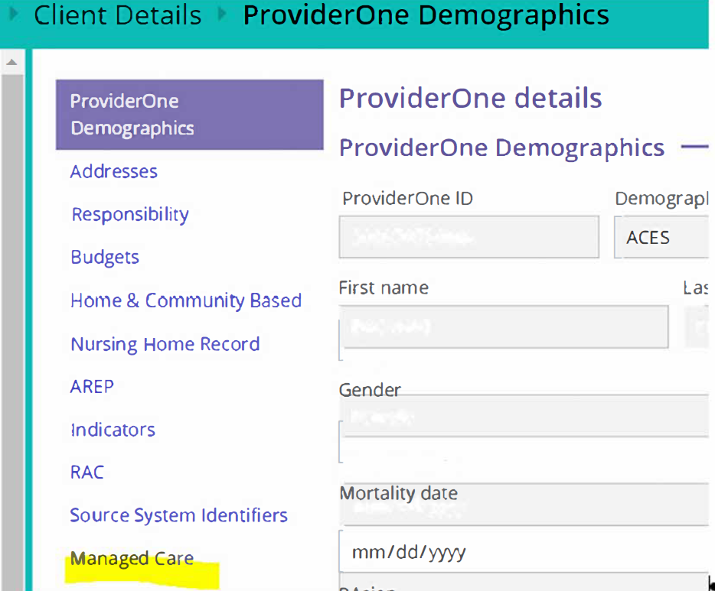

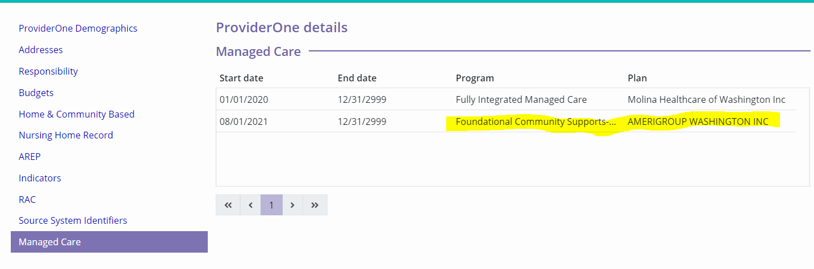
The above client is currently enrolled in Supportive Housing through Foundational Community Supports beginning 08/01/2021. Service authorization periods are 6 months but can be reauthorized by the provider if the client still wants/needs the service and is active on Medicaid.

FCS-SH Referral Process
- When case managers identify a client who could benefit from these services, speak with them about Supportive Housing services and get a verbal confirmation that they would like to be referred for these services.
- Potential client, AAA/HCS Case Manager or ALTSA contracted provider contacts ALTSA Supportive Housing Program Manager, who will facilitate eligibility determination and, with client’s verbal consent, make referral to Amerigroup.
  - Referrals can be made directly to Amerigroup by a potential client, AAA/HCS Case Manager or Amerigroup FCS contracted provider.
  - For direct referrals please see Amerigroup’s FCS Provider website.
- All referrals go through Amerigroup to determine eligibility, for service authorization and assignment to a SHP.
- If eligible for FCS, Amerigroup refers client to SHP.
- SHP accepts or declines referral
  - If SHP declines referral, Amerigroup will find another SHP to accept the referral

Regardless of whether the individual is an ALTSA recipient, anybody can make a referral for FCS. To contact Amerigroup directly about Foundational Community Supports, call 1-844-451-2828 or email fcstpa@amerigroup.com. To contact an ALTSA Supportive Housing Program Manager, call 1-844-704-6786 or email SupportiveHousing@dshs.wa.gov
To file an appeal or grievance with Amerigroup, call 1-844-451-2828 or email fcstpa@amerigroup.com
Note: Individuals on the Residential Support Waiver setting who wish to transition to an independent living setting with supports may be referred to Supportive Housing services.

FCS-SH Client Accepted
- ALTSA Supportive Housing Program Manager will email/connect the LTSS case manager with the SHP to coordinate continuity of care.
- LTSS case manager should schedule time with the SHP to discuss client needs, CM role, SHP role and assist SHP connect with client.
  - As referenced in Chapter 3, page 3.17, LTSS case manager should share the plan of care with the SHP
  - ALTSA Supportive Housing Program Manager is available to participate in meeting.
  - Best practice would be to coordinate regular check-ins between LTSS and SHP.
- Once client is authorized for Supportive Housing, the case manager must:
  - Add Supportive Housing Provider to Collateral Contacts screen
  - Add Supportive Housing under Treatments
  - Add Supportive Housing Provider as an Unpaid Provider in the Supports screen of the Care Plan and assign the task of "Supportive Housing".
  - Use the Purpose Code “Housing” for any SERs related to FCS-SH
- SHP works with client to pursue independent housing and support client in maintaining independent housing.
- LTSS case manager should work with client and SHP to identify any LTSS goods, services and/or supports client might need authorized to transition into or sustain independent housing.

Reimbursements
Community Transition and Sustainability Services are available to provide transitional or stabilizing supports for ALTSA clients to sustain community living. With prior approval from the AAA/HCS CM or ALTSA Supportive Housing Program Manager, an ALTSA contracted provider, such as a Community Choice Guide (CCG) or Governor’s Opportunity for Supportive Housing (GOSH) provider, is reimbursed for the authorized purchases after it is verified the individual received the goods or service. Based on an individual’s eligibility, the following services could be reimbursed: Shopping for necessary household goods/items or paying for rental deposit, tenant background screening to aid housing search, utility hookup fees, or rent/emergency rental assistance service.
Additionally, starting in May 2022, Amerigroup launched the Transition Assistance Program (TAP) for FCS-SH enrollees. TAP is a time-limited, flexible funding assistance that covers housing-related fees, including move-in costs, first and last month’s rent, deposits, and non-refundable fees. For more information on TAP please see the Transition Assistance Program section on Amerigroup’s FCS Provider webpage.
Community Choice Guides and FCS-SH Providers
Community Choice Guides (CCG) and FCS-SH Providers have similar pre-tenancy duties, such as housing search, identifying housing resources, independent skills development, and landlord relations. State Supportive Housing services do not include transition funds to pay for items such as background checks, application fees, security deposits or furniture. Therefore, when there are no individual or other community resources available, LTSS case managers should authorize Community Transition or Sustainability Services or Washington Roads to supplement the services provided by CCGs and/or FCS-SH Providers. Please see the reference tools document for assistance in determining the appropriate funding source.
Who authorizes a CCG and FCS-SH Providers?
CCGs are authorized in CARE by HCS and/or AAA staff per ALTSA policy.
FCS-SH Providers are contracted and authorized by Third Party Administrator, Amerigroup. These authorizations are not in CARE.
When is it OK to have both a CCG and FCS-SH authorized?
CCGs and FCS-SH Providers can work simultaneously with a client as long as there are clearly defined and separate tasks. For example, a FCS-SH Provider could assist with independent housing search and paperwork/applications, while the CCG could assist with purchasing and residential facility search.
When is it not OK to have both a CCG and FCS-SH authorized?
When both CCG and FCS-SH Providers are assisting a client with the same tasks, such as housing search, it is a duplication of service. It is important to note that not all FCS-SH referrals come from ALTSA Supportive Housing Program Managers. Referrals can come from many sources, including providers, community partners, and clients themselves. Clients may already be enrolled in FCS Supportive Housing at the time of LTSS intake/assessment.

Can FCS-SH Providers be reimbursed directly without authorizing a CCG?
Supportive Housing Providers that are contracted directly with DSHS through ALTSA’s Governor’s Opportunity for Supportive Housing (GOSH) service or through CCG contracts may complete purchasing for items pre-approved by the case manager and be reimbursed through ProviderOne. However, if a Supportive Housing Provider through Foundational Community Supports is not dually contracted with DSHS through a GOSH or CCG contract, they will not be able to purchase items directly and be reimbursed. In these cases, a case manager will need to authorize a CCG to make a purchase on behalf of a client.

Please consult your Regional Supportive Housing Program Manager if you are not sure if a FCS-SH Provider is contracted directly with DSHS.

How is this funded?
Foundational Community Supports are part of the Healthier Washington Medicaid Transformation (MT). MT is a six-year demonstration waiver funded 100% by the federal Centers for Medicare and Medicaid Services through 2022. On July 15, 2022, the State submitted a waiver renewal application for MTP to CMS. If CMS approves the application, MTP will continue for an additional five years – from 2023 – 2027.
Note: There is no participation required for clients receiving FCS - Supportive Housing services.

Can a DDA services recipient receive FCS-SH Services?
An individual receiving DDA services may be eligible for FCS Supportive Housing services. Such individuals must be found to meet an eligible health need and a risk factor. Individuals dually eligible for DDA and ALTSA services are eligible for FCS through the long term care eligibility pathway if they also meet a risk factor. Individuals only receiving DDA services could also be found eligible with a mental health diagnosis/substance abuse disorder, or experiencing homelessness with a disability determined by a coordinated entry assessment and an accompanying risk factor. Please refer to Amerigroup for specific eligibility questions. The can be reached directly by phone: 1-844-451-2828 or email fcstpa@amerigroup.com.

What about Contracting?
Amerigroup Washington Inc. was awarded the contract providing the Third Party Administrator services for FCS. Providers interested in contracting for FCS should contact Amerigroup directly by phone: 1-844-451-2828 or email fcstpa@amerigroup.com.

Supportive Housing and Case Coordination

How do SH services and Long-Term Services and Supports (personal care, client training, community transition services, etc.) complement each other?
SHPs will need to coordinate closely with case managers to ensure all necessary LTSS services are authorized. Clients who are eligible for LTSS may receive MPC, CFC, CFC + COPES, RCL and RSW services while receiving Supportive Housing services.

- Based on the LTSS program the client is eligible for, Community Supports: Goods and Services may be considered.
  - LTC Manual Chapter 7b discusses the Community First Choice (CFC) Community Transition Services (CTS) and its eligibility parameters
  - As for Community Transition and Sustainability Services (CTSS), dependent on client’s eligibility and the situation, see:
    - LTC Manual Chapter 5a for coverage under Washington Roads
    - LTC Manual Chapter 7d for COPES eligibility
    - LTC Manual Chapter 29 for coverage under RCL
  - ALTSA Supportive Housing Program Managers are available to answer questions regarding accessing these resources.
- The SHP should be in contact with the case manager as well as the ALTSA Supportive Housing Program Manager to provide updates. The case manager should document communication as a service episode record (SER).
- In partnership with the SHP, any purchases made on behalf of the individual to assist with community transition and sustainability as well as any subsequent reimbursement processing will be completed per regional policy. Any ETRs necessary for these goods and services will be completed per regional policy.
- If the individual is eligible for long term services based primarily on a psychiatric condition and the criteria indicated in LTC Manual Chapter 7h, , the case manager will follow the process as outlined in LTC Manual Chapter 7h for requesting funding from the MCO to cover the client’s personal care.

If someone receiving Supportive Housing services “refuses” or declines personal care, do I need to close the case for all services?
No, you do not need to close the case for all services if a client “refuses” or declines personal care. No authority or regulation states that a case must be closed if the individual does not receive personal care. Individuals eligible for ALTSA Supportive Housing services may struggle with obtaining or maintaining a caregiver. Certain individuals may have behavioral health challenges, and/or struggle with homelessness. Services other than Personal Care, such as Supportive Housing, may allow providers to assertively engage with clients and work with them to decide which services or interventions could enable them to reach or maintain stability. During the period of time when a client is adjusting to the idea of utilizing services, it is important to keep the case open.
Before closing out a case, consider the following:
- Certain community settings, client choice, or other situations may create a care plan where Personal Care is not feasible. Has the possibility of setting up personal care in a non-traditional setting (e.g. shelter or hygiene station) been explored?
- Other ALTSA services may be authorized in order to move an assessment to current and provide an official start date for services. Some examples of these services could be: GOSH Supportive Housing, Wellness Newsletter, PERS, Behavioral Supports, DME, Skilled Nursing, Client Training, etc. As a reminder, per Management Bulletin H18-056, AAA’s are paid to case manage clients with any open authorization for LTSS.
- What supports do the collateral contacts (including formal and informal supports) report the client is utilizing? These supports should be captured in CARE.
- Medication Management is a “look forward” screen. Will the client benefit from ongoing medication management assistance?
- What support services, outside of caregiving, will the client benefit from in order to stabilize community living?
- Has the case been staffed with an ALTSA Supportive Housing Program Manager?
Note: If you believe you must close a case, please see requirements to do so in the Challenging Cases Protocol.

Resources

Related WACs and RCWs
The following rules and policy support case management functions:

RCW 74.38.010 Legislative Recognition – Public Policy
RCW 74.38.040(1) Scope and Extent of Community-Based Services Program
RCW 74.39.005(7) Long-term Care Service Options - Purpose
RCW 74.39A.040(3)( c ) Department Assessment of and Assistance to Hospital Patients in Need of Long-term Care
RCW 74.42.057 Notification Regarding Resident likely to Become Medicaid Eligible
RCW 74.42.058 Department Case Management Services
RCW 74.39A.090 Discharge Planning-Contracts for Case Management Services and Reassessment and Reauthorization – Assessment of Case Management Roles and Quality of In-Home Care Services – Plan of Care Model Language
RCW 74.39A.095 Case Management Services – Agency on Aging Oversight Plan of Care – Termination Contract – Rejection of Individual Provider Contract
RCW 70.41.310 Long-term care -- Program information to be provided to hospitals -- Information on options to be provided to patients.
WAC 388-106-1700 to WAC 388-106-1765

Forms
Behavioral Health Personal Care Request for MCO Funding DSHS form 13-712

Updates to the Chapter
October, 2018 – Established
January, 2019 – Edits to section on when a client declines personal care that that the case may remain open to receive supportive housing services or subsidy.
August, 2019 – Edits for clarity on program services.
June, 2020 – Edits to update FCS and GOSH sections for clarity on program services and for formatting.
August, 2020 – Hyperlinks added for LTC Manual Chapters 5b and 9b; updated FCS-SH and GOSH procedural steps.
October, 2020 – Updated GOSH Pre-Tenancy Service Code, provided clarification around SHPM vs CM responsibility in “GOSH Client Accepted” section and updated link for DSHS form 13-712
February, 2021 – Rearranged chapter sections; Moved section on Governor’s Opportunity for Supportive Housing (GOSH) from Chapter 30d to Chapter 5b: Housing Resources for ALTSA Clients; Clarified FCS-SH Eligibility criteria; Added clarification that there is no participation for Supportive Housing services; Added section on verifying if client is already enrolled in FCS-SH; Added clarification around Community Choice Guides and FCS-SH Providers.
May, 2021 – Updated hyperlink in Chapter Section for Supportive Housing and Case Coordination
February, 2022 – Updated hyperlinks, Updated Medicaid Transformation Project end date to December 31,2022 to include the approved extension year, clarified some language throughout the Chapter
August, 2022 – Updated “Foundational Community Supports: History” section to include information on the five year waiver renewal application the State submitted to CMS; updated “How can I tell if my client is enrolled in FCS-SH?” section to CAREWeb version.
August 2023 – Updated with information on MTP 2.0 renewal and new end date. Reference to FCS-SH Transition Assistance Program added under Reimbursements section.

