ONLY COMPLETE THIS INVOICE VOUCHER FOR THE NA-R WHO WILL PROVIDE **NURSE DELEGATION** IN A CLIENT’S PRIVATE HOME OR COMPANION HOME.

**USE ONLY FOR INITIAL NA-R FEE’S**

Complete ALL fields for each NA-R application submitted. Failure to complete all fields will result in delay OR denial of processing.

Complete one form for each applicant.

Submit with completed [NA-R application](https://www.doh.wa.gov/Portals/1/Documents/Pubs/667025.pdf). **Instructions for form completion:**

1. Case Manager must print, sign, date, and include a phone number on the A19-1A Voucher.

The Case Manager’s signature indicates DSHS’s approval for payment, for the Department of Health (DOH) to process the application for the NA-R’s initial credentialing.

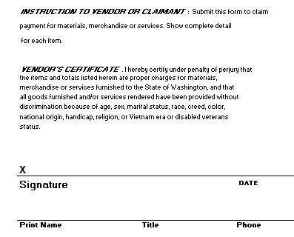

1. Complete applicants full name
2. Applicant must sign and date the A19-1A Voucher
3. List the client receiving nurse delegation services’ ID
4. List the Case/Resource Managers ID number
5. Identify the originating office(HCS/AAA/DDA)
6. For DDA: the Regional Resource or Manager must sign and approve the A19-1A Voucher
7. Submit the completed voucher and NA-R application to:

**DEPARTMENT OF HEALTH (DOH)**

**ATTN: HEALTH PROFESSIONALS**

**Debbie Remington**

**PO Box 47877**

**Olympia, WA 98504-7864**

**For questions please contact:**

**Erika Parada RN- HCS Nurse Delegation Program Manager:** [**parade@dshs.wa.gov**](mailto:parade@dshs.wa.gov)

**Doris Barret, RN- DDA Nursing Service Program Manager:** [**barreda@dshs.wa.gov**](mailto:barreda@dshs.wa.gov)