May 24, 2016

FOR IMMEDIATE RELEASE

Contact: Lynn Urvina, Family Education and Support Services 360-754-7629 or e-mail Lynn@FamilyESS.org

Six Young Artists
Speak Up About Kinship Care!
(Editor’s Note: The six children winning the awards are from Fircrest, Lacey, Pasco, Yakima, and Kent Washington. To interview a winner, contact Lynn Urvina
at 360-754-7629 or email Lynn@FamilyESS.org)

OLYMPIA – Families from across Washington will gather on Thursday, July 7th, 2016, at 1:00 pm in the Governor's Mansion located near our State Capitol Building to honor six children who submitted winning essays for the 13th annual Voices of Children contest. Each of these young children and youth, ages 5 - 19 years old, created inspirational pieces of written and/or visual art about their experiences being raised by a relative caregiver. First Lady, Trudi Inslee will present each of the six children with a signed certificate. In addition, each child will receive a $100 check donated by Twin Star Credit Union and an overnight stay at the Great Wolf Lodge for their family.

Most children find safety and comfort in the arms and care of their family, including grandparents and other relatives. For more than 2 million children in the USA, living with a grandparent, aunt, uncle, or other family member has become a permanent or long-term arrangement. When parents are unable or unwilling to care for their children, placing them with a relative caregiver can have some advantages. Kinship care reduces the trauma children experience when placed with strangers. It enhances children’s sense of identity and self-esteem, continues connections children have to their siblings and other relatives, and strengthens the family’s ability to give children the support they need. Kinship care often comes as a surprise to both the child and the relative caregiver.

What does it mean to a child who can’t live with their parents to know he or she is safe, loved, and has a place to belong? Some answers to this question are offered in the winning entries submitted to the Kinship Voices of Children Contest. The contest was originally initiated by the Statewide Kinship Oversight Coalition, and is coordinated by Family Education and Support Services in collaboration with Aging and Long Term Support Administration/DSHS, Lewis-Mason-Thurston Area Agency on Aging, and Kinship Navigators and advocates across Washington State. The event is sponsored by TwinStar Credit Union in collaboration with the Great Wolf Lodge.

This year 38 entries were received. Some are funny, some serious or even sad, but all are sincere and offer testimony to the value, sense of family, and love each young artist experienced in living with a relative caregiver. The winning entries are:

Hope, age 5 - Kent, WA
Nevaeh, age 6 - Yakima, WA
Syrus, age 8 - Pasco, WA
Xena, age 12 - Lacey, WA
Beverly, age 17 - Lacey, WA
Esther, age 17 - Fircrest, WA

In addition to the children being honored we will also acknowledge Mr. Dennis Mahar, Executive Director of the Lewis, Mason, Thurston Area Agency on Aging. Our 2016 booklet compiling all entries into the Voices of Children contest for 2016 has been dedicated to Mr. Mahar in honor of his substantial contributions to Kinship Caregivers across our State.

You will find the winning entries listed below. For more information about this contest or to learn about Kinship Care Resources contacting Lynn Urvina at 1-877-813-2828 or e-mail Lynn@FamilyESS.org.

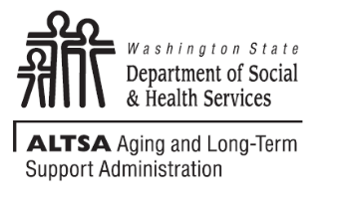
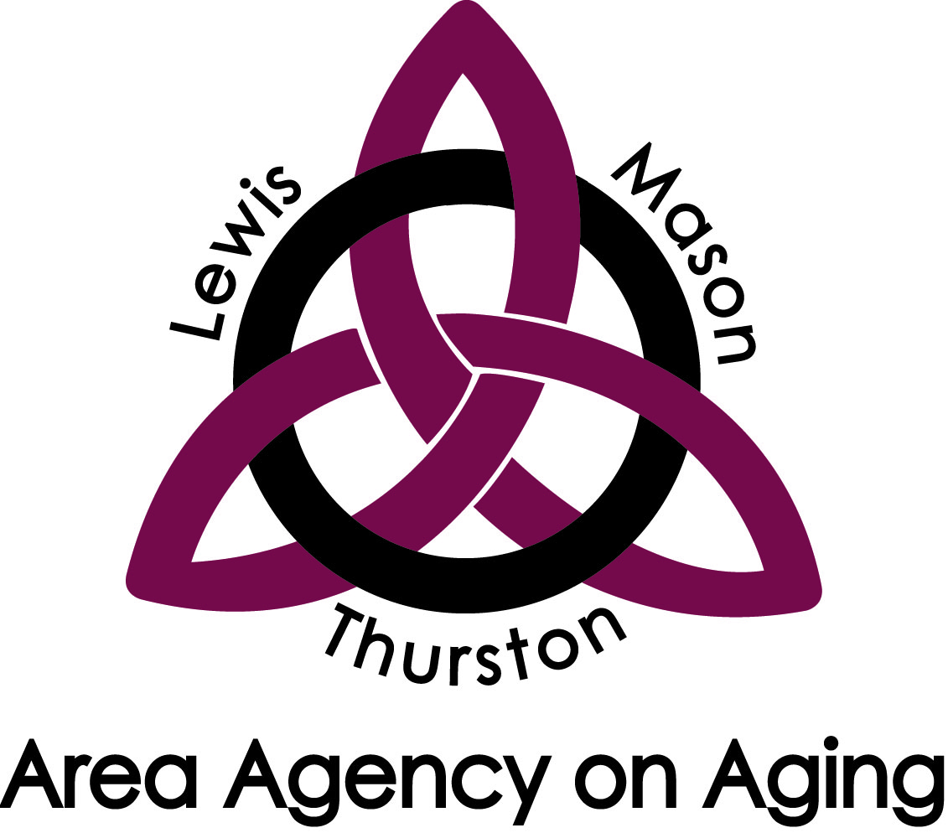
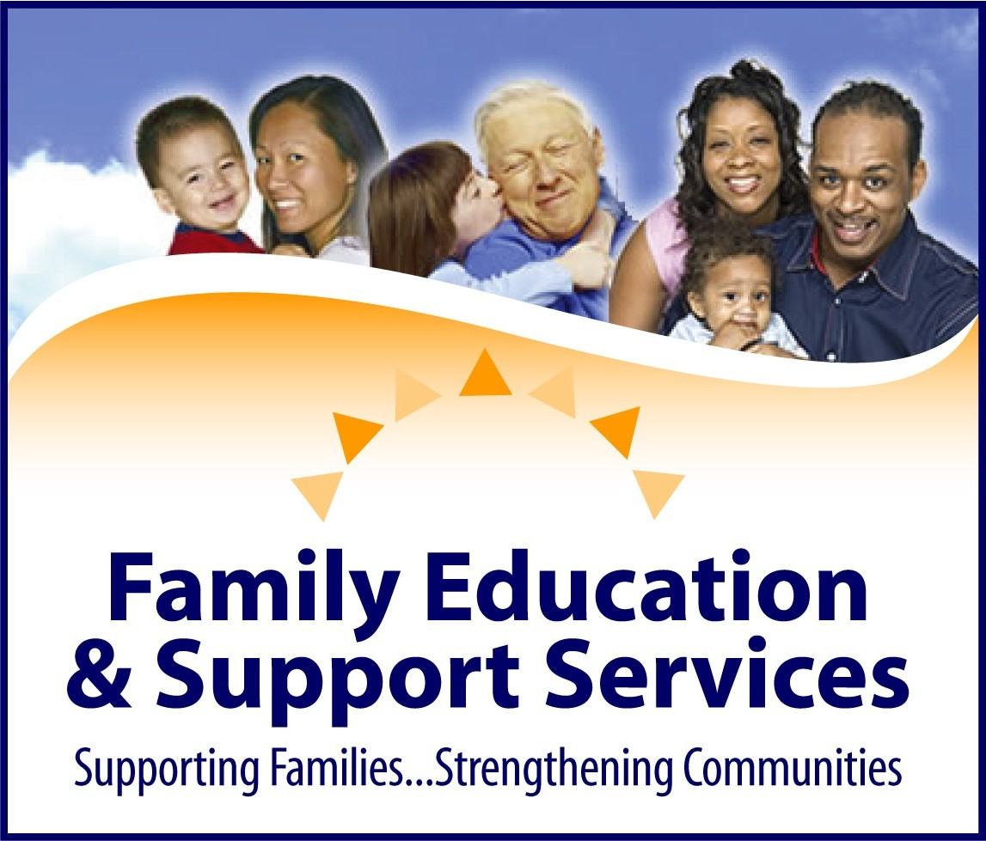

Excerpts from the winning entries are below:
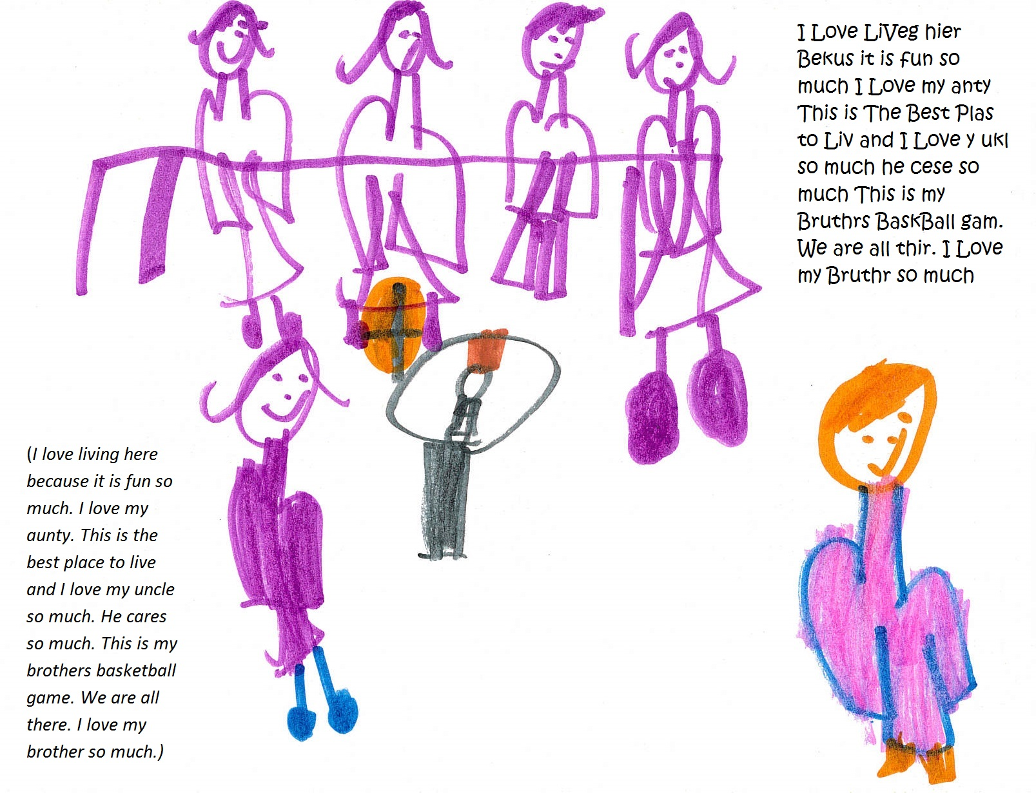
Figure 1: Hope, age 5, Kent, WA

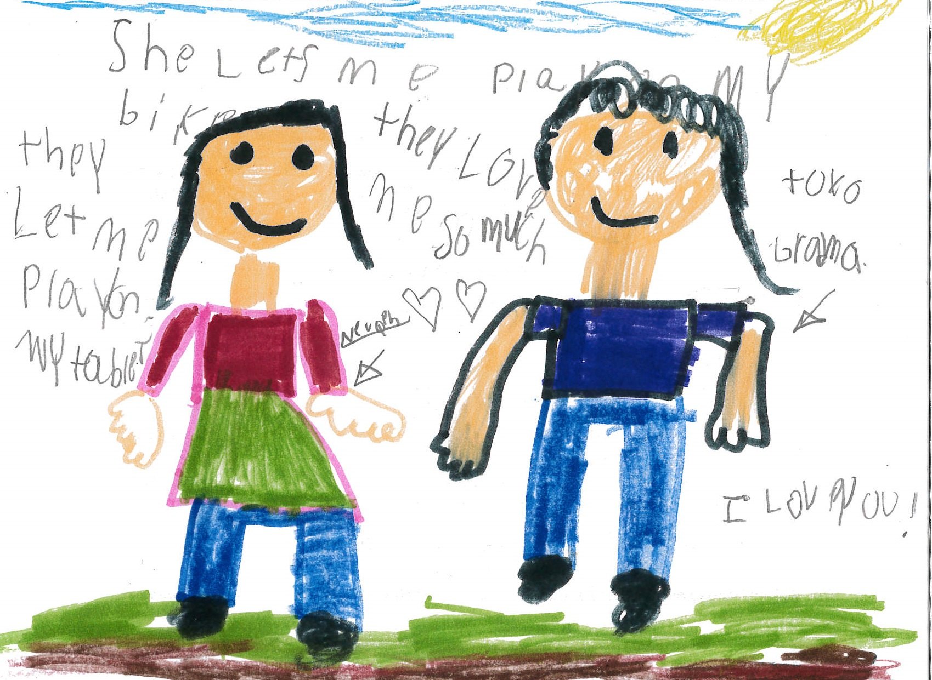
Figure 2: Nevaeh, age 6, Yakima, WA

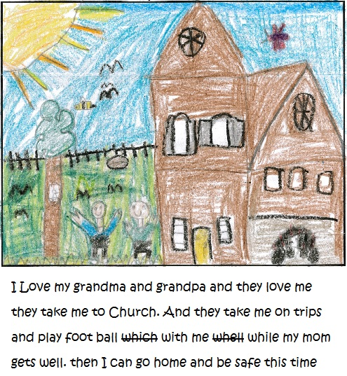
Figure 3: Syrus, age 8, Pasco, WA

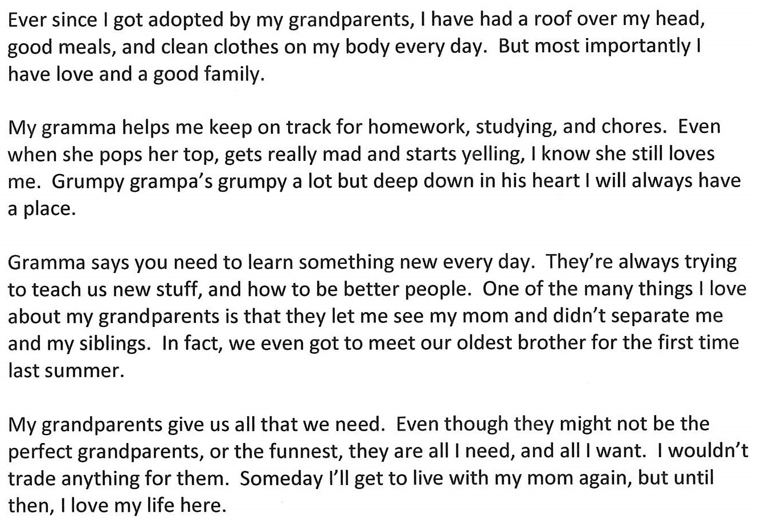
Figure 4: Xena, age 12, Lacey, WA

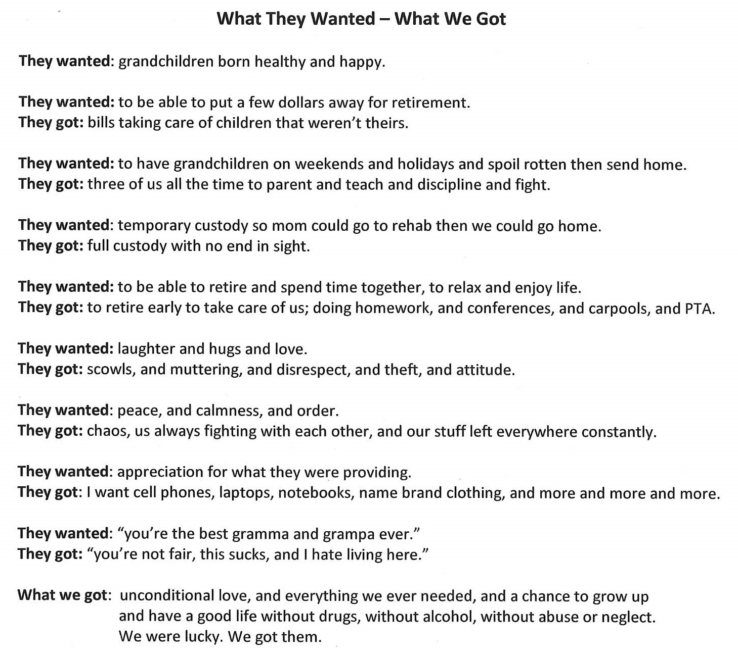
Figure 5: Beverly, age 17, Lacey, WA

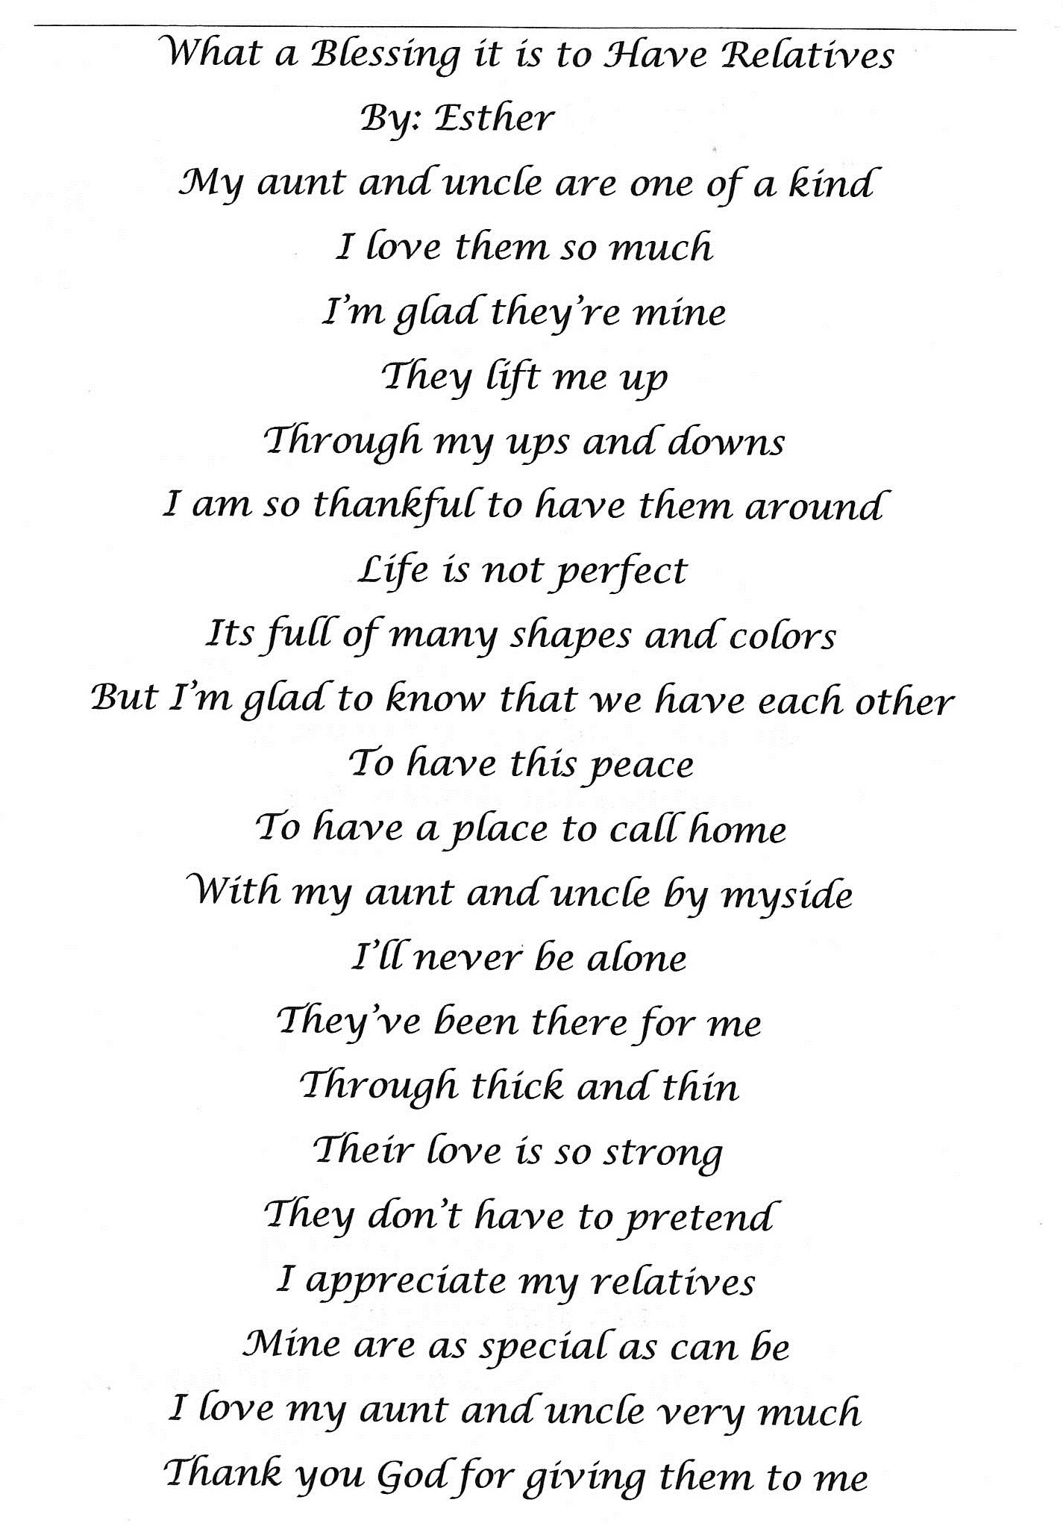
Figure 6: Esther, age 17, Fircrest, WA

