1163 Cost Report Instructions for January – December 2018
Jan 1, 2018 to Dec 31, 2018 – Providers will be paid an additional set amount based on contracted ISS hours to accommodate the providers 1163 training payroll costs (non-MSA $0.43, MSA $0.44, & King $0.46 per contracted ISS hour).
For this period of time the portion of the rate associated with 1163 training will be treated by the department as Non-ISS/Admin. On Schedule J Detail the department will not include the portion of the daily rate that applies to the 1163 training towards settlement. Additionally, there will be no hours applied to settlement on Schedule J Detail by the department in relation to the 1163 training due to the amount reimbursed being based on contracted ISS hours and not actual hours reimbursed.
Providers will need to track the actual 1163 training hours from January 1, 2018 to December 31, 2018 (see sample below)
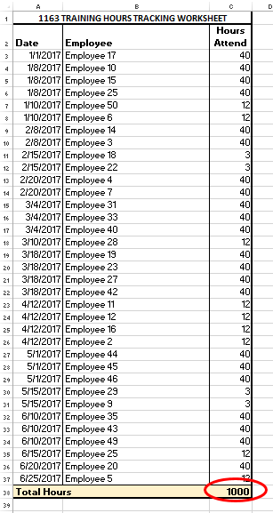
Schedule B-1 has been modified with an additional row to report the provider’s 1163 training payroll hours. At the end of the year the provider will enter the total 1163 training hours from their tracking log on Schedule B-1, Line 8, column 5 (see below).
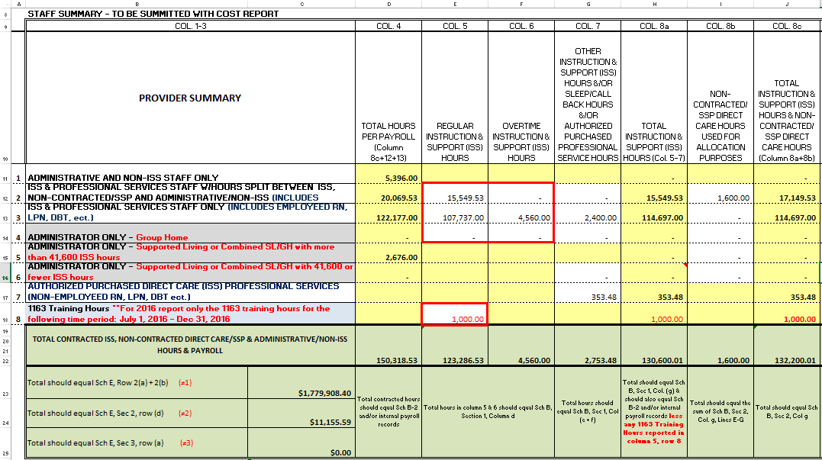
On Schedule B (see below) providers will report the total regular & OT ISS payroll hours. These hours should equal the total ISS hours reported on Schedule B-1, columns 5 plus 6, rows 2-4 (15,549.53 + 107,737.00 + 4,560.00 = 127,846.53) in Section 1, column (d) (see above).
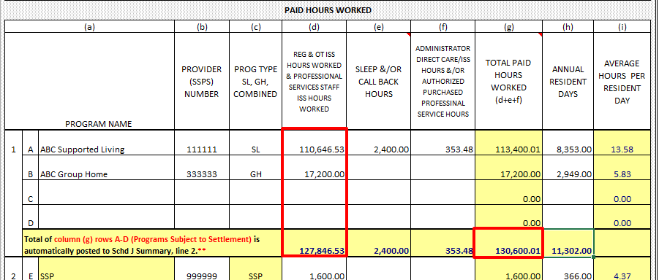

Schedule B, Section 1, Column g (130,600.01) (see above) less the 1163 training hours reported on Schedule B-1, Line 8, column 5 (1,000) (see above) will auto-post to Schedule J Summary, Line 2 for settlement (130,600.01 – 1,000 = 129,600.01) (see below).
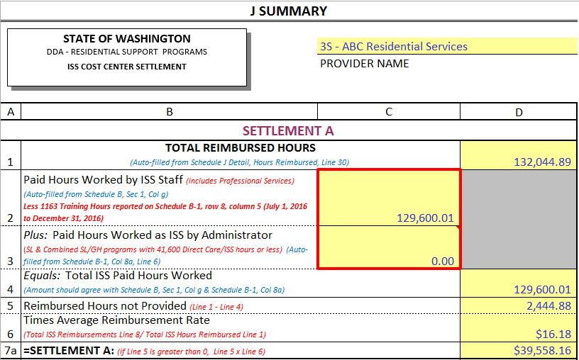
On Schedule E, Section 2, line (f) the 1163 hours reported on Schedule B-1, Line 8, column 5 will automatically be multiplied by the contracted benchmark rate for Non-MSA $16.37, MSA $16.68, or King $17.28 (see below). If the provider has a single contract in multiple counties the calculation will use an average of the relative benchmarks to produce the 1163 payroll expense to be deducted from settlement. (example: (Non-MSA $16.37 + MSA $16.68)/2 = $16.53 x Number of Hours).
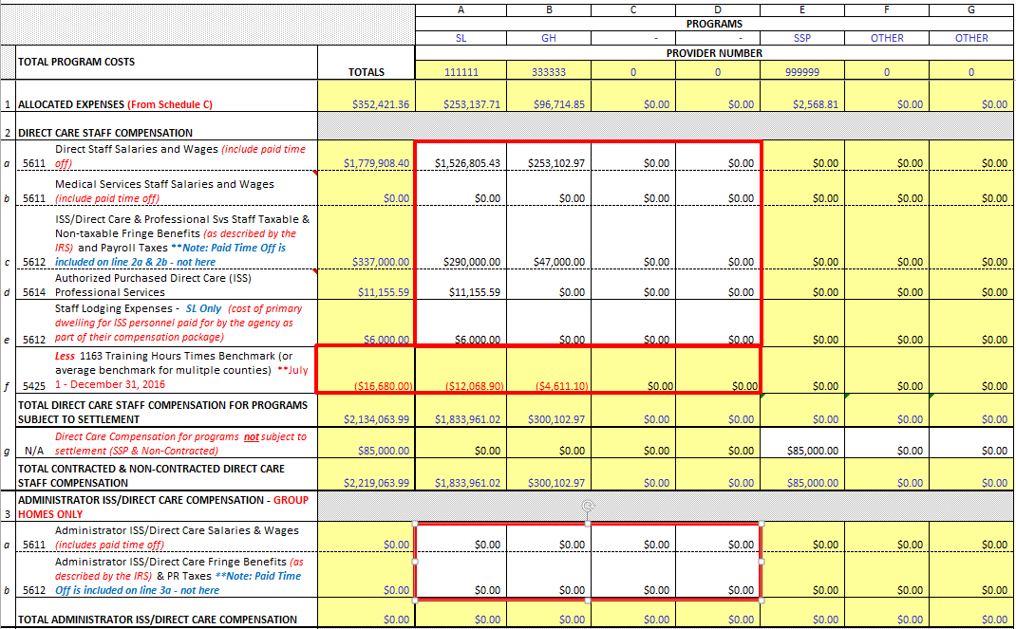

The Total Direct Care Staff Compensation for programs subject to settlement (see above) Section 2, rows a-e, columns A-D (2,134,063.99) plus Section 3, rows a-b, columns A-D (0.00) less the calculated 1163 training costs (16,680.00) will automatically post to Schedule J Summary for settlement (see below) (2,134063.99 + 0.00 – 16,680.00 = 2,117,383.99).
