Washington Department of Social and Health Services

Analysis of the Washington
Assisted Living Services
Medicaid Payment Methodology

Navigant Consulting, Inc.

Final Report - February 2015

TABLE OF CONTENTS

SECTION I: Overview OF Assisted living and services provided 4
SECTION II: Overview OF the CURRENT MEDICAID PAYMENT METHODOLOGY and rates 6
SECTION III: Access to Care 9
SECTION IV: Quality 15
SECTION V: COMPARISON OF THE COSTS OF ASSISTED LIVING SERVICES TO CURRENT RATES 18
SECTION VI: CONCLUSION 24

aPPENDICES:
aPPENDIX A: current daily rates
appendix b: assisted living enforcement action options
Appendix C: Report to the Legislature, CARE & Medicaid Payment System for Licensed Boarding Homes, Chapter 231, Laws of 2003, December 2004

INTRODUCTION

Navigant Consulting, Inc. was engaged by the Washington State Department of Social and Health Services (DSHS), also referred to as the Department, to conduct an analysis of the current Medicaid payment methodology and rates paid for Assisted Living services relative to the efficiency, accessibility and the quality of care standards established under Federal requirements. The Federal requirements that apply to the methods states employ to pay for Medicaid services, which are described in U.S.C. § 1396a (a)(30)(A), specify that a state plan for Medical Assistance (referred to herein as Medicaid) provide such methods and procedures relating to the utilization of, and the payment for, care and services available under the plan as may be necessary to safeguard against unnecessary utilization of such care and services and to assure that payments are consistent with efficiency, economy, and quality of care and are sufficient to enlist enough providers so that care and services are available under the plan at least to the extent that such care and services are available to the general population in the geographic area.

As such, our analysis focused on an evaluation of the current Washington Medicaid payment methodology and related rates relative to consistency with efficiency and economy, and access to care and quality of care in Washington State. In addition, the Department directed us to evaluate the potential impacts of modifications to the current Medicaid payment methodology for assisted living services in the State.

SECTION I: Overview OF Assisted living and services provided

An Assisted Living facility is a licensed facility of seven or more beds that provides housing, meal services and assumes general responsibility for the safety and well-being of the residents. Assisted Living facilities allow residents to live an independent lifestyle in a community setting while receiving necessary services from Assisted Living staff. Assisted Living facilities are licensed by the Department and can vary in size and ownership from small family operated facilities to a 253-bed facility operated by a national corporation. Some Assisted Living facilities provide intermittent nursing services and others may specialize in serving people with mental health problems, developmental disabilities or dementia.

Based on data provided to us by the Department, approximately 74 percent of all Assisted Living residents pay for their care privately, where the remaining 26 percent of Assisted Living residents are eligible for Medicaid services. The Department contracts with Assisted Living facilities to provide services packages for Medicaid residents in two Assisted Living settings – assisted living facilities where residents live in private apartments and residential homes where residents share a room.

Under federal regulations, federally-matched state Medicaid dollars may not be used to pay for the room and board costs associated with long-term care services, including the room and board components of costs in Assisted Living facilities. As such, Medicaid residents in Assisted Living facilities are responsible for paying for their own room and board in each setting, and the Department pays only for the allowable Medicaid services that residents receive in those settings, which are:

- In Assisted Living (AL) settings
  - Intermittent nursing services – facilities must provide this service
  - Assistance with medication administration and personal care

- In Adult Residential settings – Adult Residential Care (ARC)
  - Assistance with medication and personal care
  - Limited supervision, as needed

- In Adult Residential settings – Enhanced Adult Residential Care (EARC)
  - Assistance with medication administration and personal care
  - Limited supervision, as needed
  - Intermittent nursing services – facilities must provide this service
  - Specialized dementia care – requires competitive bids and available funding

Based on data provided to us by the Department, there were approximately 570 Assisted Living facilities in Washington State in 2014, with approximately 30,400 licensed beds. Of those, approximately 310 were Medicaid contracted (55 percent of the total number of Assisted Living facilities), and those Medicaid contracted Assisted Living facilities had approximately 18,100 licensed beds (60 percent of the total number of licensed beds). In the State of Washington, Assisted Living facilities can enter into a contract with the Department to provide care to Medicaid residents, but that contract does not require that they accept all Medicaid-eligible residents, even if they have available beds. Assisted Living facilities in Washington can refuse to accept Medicaid residents at their discretion, even if they are a Medicaid-contracted provider.

SECTION II: Overview OF the CURRENT MEDICAID PAYMENT METHODOLOGY and rates

This section describes the current Medicaid payment methodology and rates for Assisted Living services in Washington. This description is intended to provide a high level overview of how payment rates are set for Medicaid residents in Assisted Living facilities.

Methodology Used to Establish Current Rates

In Washington State, the Legislature allocates funds each year for the provision of assisted living services. Since reimbursement of these services is influenced by the level of funds allocated, the Department evaluates the budget and determines the reimbursement rates for assisted living services annually.

The Department developed a methodology in the early 2000’s to establish daily reimbursement rates for assisted living services on a client by client basis based on each client’s assignment to one of 12 unique CARE Classifications. These CARE Classifications are reflective of different levels of resources that are required to care for residents with individual needs. In July of 2008, the methodology was expanded to include 17 unique classification groups. During the same legislative session when the CARE Classifications were expanded, the Department also made updates to the benchmark and other proxies for the rate setting methodology used at that time. The benchmark components were updated to include the cost of labor, payroll taxed and fringe benefits, operations costs and capital-related costs. For a complete description of this methodology and how it was developed, please see Section V of this report.

Under the current rate setting methodology, each Medicaid-eligible Assisted Living resident is assigned to one of the 17 CARE Classifications based on an assessment of the resident using the CARE assessment tool. The daily reimbursement rate for AL, ARC, and EARC services varies based on this classification as well as the geographic area the services are provided. Based on the funds allocated by the Legislature for assisted living services, the Department determines the daily reimbursement rates for each CARE Classification and each geographic area.

Federal law requires that Medicaid providers are reimbursed at levels consistent with efficiency, economy, and quality of care, and that the level of reimbursement is sufficient to attract enough providers to provide services to the population. 42 U.S.C. § 1396a (a) (30) (A).

Note that Washington’s Medicaid State Plan, which describes the Departments methods for determining payments for Assisted Living Services, has been approved by the federal government.

Current Rates for State Fiscal Years 2015, 2016, and 2017

Appendix A of this report shows the rates currently in effect for AL, ARC and EARC services in Assisted Living facilities. Based on data provided to us by the Department, the weighted average Assisted Living rate given the anticipated number of Medicaid beneficiaries for SFY 2015 is expected to be $67.95 per day for AL services, and $62.74 per day for ARC and EARC services. The weighted rate for AL services is expected to remain the same in both SFY 2016 and SFY 2017. The weighted rates for ARC and EARC services is expected to increase to $62.76 per day in SFY 2016 and to $62.78 per day in SFY 2017.

The three geographic area groups used for rate-setting purposes are King County, all other Metropolitan Counties, and all Nonmetropolitan Counties. The counties included in each geographic area group are shown on the map in Exhibit 2.1. This Exhibit also shows the number of Assisted Living providers in each county and geographic region.
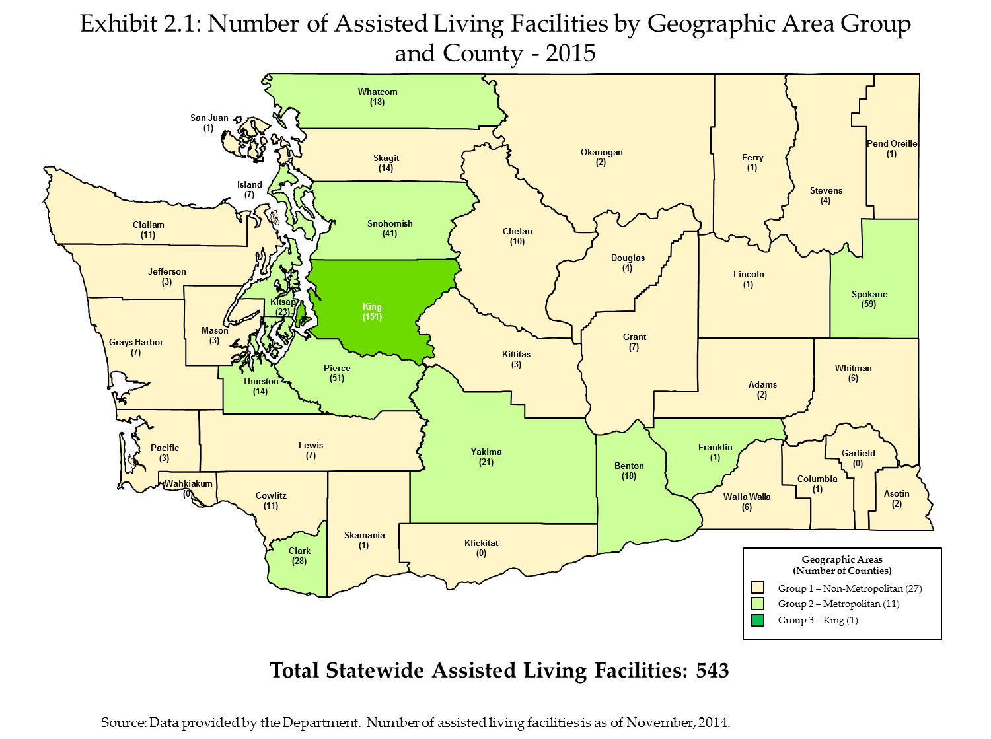

SECTION III: Access to Care

In this section, we analyze the availability of Assisted Living beds in Washington as a way to determine if barriers to access exist for Medicaid beneficiaries requiring Assisted Living services. We analyze access to care primarily using Assisted Living licensed beds and occupancy rates over time, as well as information provided to us by the Department regarding Medicaid placements.

Washington Assisted Living Capacity and Occupancy from 2008 to 2015

We first look at total Assisted Living capacity in Washington. Assisted Living capacity can be measured by the number of bed days available – that is the number of licensed beds multiplied by the number of days in the year. Table 3.1 shows the number of Assisted Living facilities, number of licensed beds and total available bed days in the state for the seven years from 2008 to 2015. This table shows that while the number of Assisted Living facilities has remained essentially constant, the number of licensed beds and available bed days has increased – by more than ten percent – over the periods shown.

Table 3.1: Assisted Living Facilities Capacity in Washington 2008 – 2015

State Fiscal Year | Number of Facilities | Number of Licensed Beds | Total Number of Bed Days Available
2008 | 545 | 27,451 | 10,047,066
2009 | 548 | 27,868 | 10,171,820
2010 | 554 | 28,435 | 10,378,775
2011 | 549 | 28,949 | 10,566,385
2012 | 548 | 29,045 | 10,630,470
2013 | 536 | 29,368 | 10,719,320
2014 | 541 | 30,260 | 11,044,900
2015 | 571 | 30,411 | 11,110,965

Source:
Number of facilities and licensed beds were provided by the Department and are as of the end of December for state fiscal years 2008 through 2014. The data for state fiscal year 2015 is as of the end of July 2014, which is the latest data available. Numbers of beds days available were calculated using the number of days in each year.

Assisted Living facilities are not required to report occupancy rates to the Department. As such, as of the date of this report, data regarding statewide occupancy levels in Assisted Living facilities were not available. However, in 2000 and 2007, the Department conducted a survey of Assisted Living facilities, regarding their occupancy levels, and the results of both years’ surveys indicated an average statewide occupancy rate of 85.3 percent.

Table 3.2 shows Assisted Living facilities’ estimated total occupied beds based on the assumption that Assisted Living facilities realized an 85.3 percent occupancy rate in each year. It also shows total beds occupied by Medicaid residents and the estimated average Medicaid utilization rate, that is, Medicaid’s share of estimated total occupied beds for 2008 through 2015.

Table 3.2: Assisted Living Medicaid Utilization in Washington 2008 – 2015
State Fiscal Year | Total Licensed Assisted Living Beds | Estimated Number of Occupied Beds at Assumed 85.3% Occupancy Rate | Number of Beds Occupied by Medicaid Residents | Estimated Average Medicaid Utilization Rate
2008 | 27,451 | 23,421 | 6,321 | 27%
2009 | 27,868 | 23,777 | 6,468 | 27%
2010 | 28,435 | 24,261 | 6,675 | 28%
2011 | 28,949 | 24,699 | 6,692 | 27%
2012 | 29,045 | 24,781 | 6,891 | 28%
2013 | 29,368 | 25,057 | 6,843 | 27%
2014 | 30,260 | 25,818 | 6,726 | 26%
2015 | 30,441 | 25,805 | 6,660 | 26%
Source:
Data provided by the Department and is as of the end of December for state fiscal years 2008 through 2014. The data for state fiscal year 2015 is as of the end of July 2014, which is the latest data available.

This table shows that the total number of licensed Assisted Living beds in the state increased by 2,990, a 10.9 percent increase, from 2008 to 2015. It also shows that the utilization of beds by Medicaid residents has fluctuated slightly over this same period, but 2015 Medicaid occupied beds were 339 greater than in 2008, or 5.4 percent greater.

Table 3.3 shows the estimated average number of unfilled beds each day in Washington Assisted Living facilities in 2008 through 2015, based on the assumed 85.3 percent average statewide occupancy rate from the Department surveys.

Table 3.3: Estimated Number of Unfilled Assisted Living Beds in Washington 2008 - 2015

State Fiscal Year | Estimated Average Number of Unfilled Beds per Day at 85.3% Occupancy Rate
2008 | 4,030
2009 | 4,091
2010 | 4,174
2011 | 4,250
2012 | 4,264
2013 | 4,311
2014 | 4,442
2015 | 4,636

Source:
Estimated Number of Unfilled Bed Days and Estimated Average Number of Unfilled Beds per Day were calculated using data provided by the Department.

This table shows that, based on the assumed occupancy rate of 85.3 percent, that there is unused Assisted Living capacity in Washington State.

Washington Assisted Living Capacity by County, For 2015

To assess whether Washington residents in all areas of the state have access to Assisted Living services, we analyzed the distribution of Assisted Living beds at the county level.
As of November 2014, the number of Assisted Living facilities per county ranged from zero in three counties to 151 in King County. Exhibit 3.1 shows that the number of licensed beds per county, for counties with at least one Assisted Living facilities, ranges from 12 to 8,210. As expected, the most urban and populous counties of King, Pierce, Snohomish and Spokane have the most Assisted Living beds. Currently, Wahkiakum, Klickitat, and Garfield Counties do not have Assisted Living facilities.
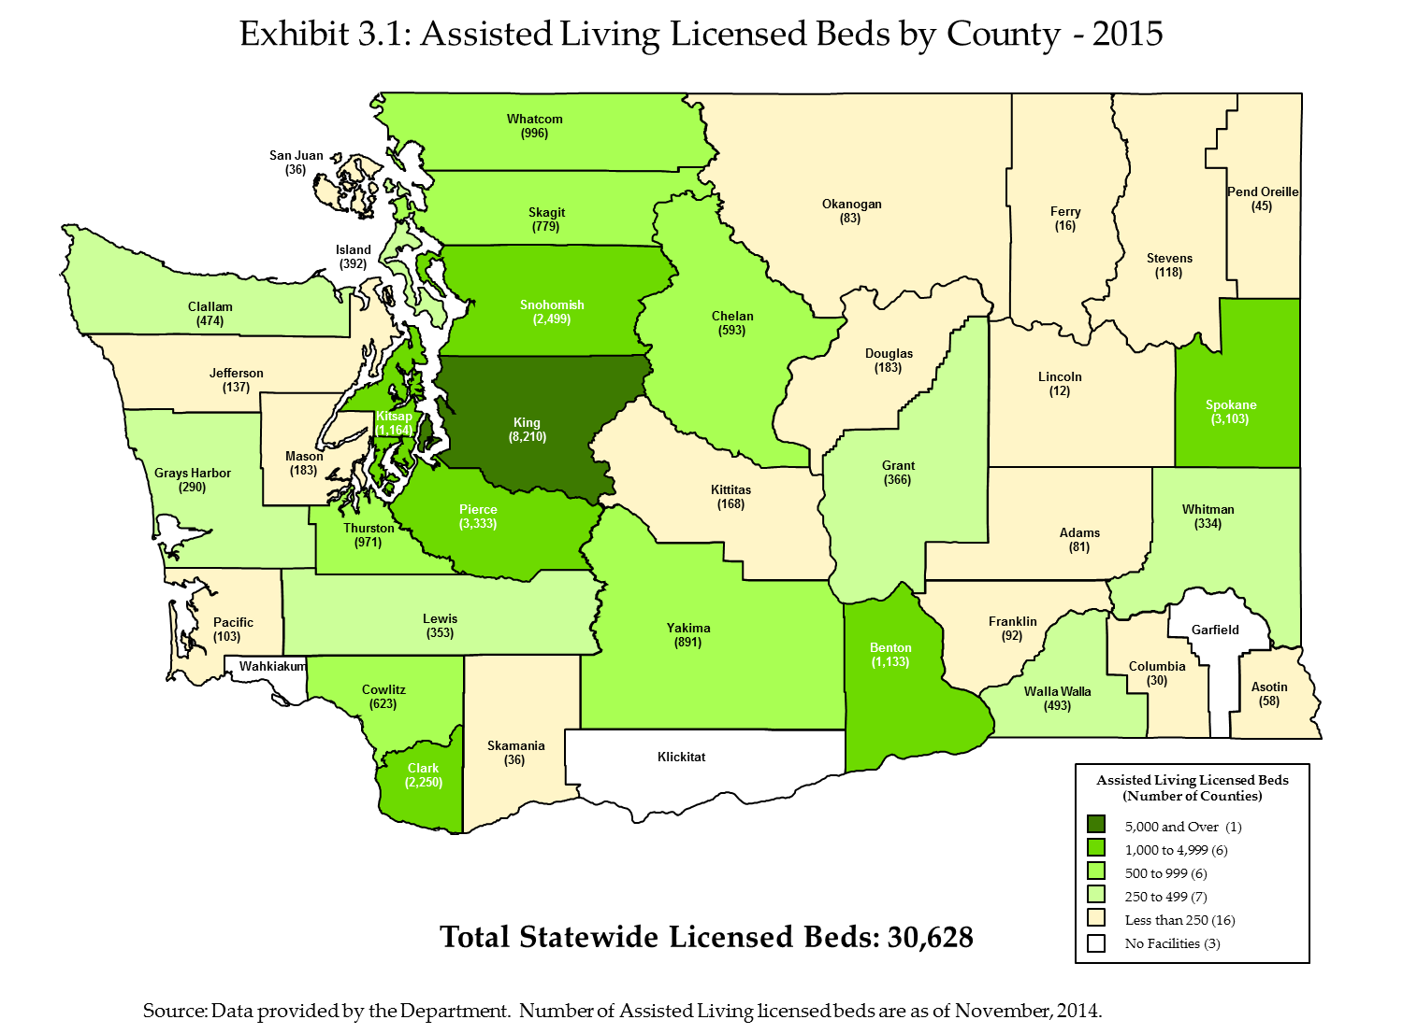

Capacity of Medicaid-contracted Assisted Living Facilities

As discussed previously, not all Assisted Living facilities are contracted with the Department to provide Medicaid services. Table 3.4 shows the change in the number of Medicaid-contracted Assisted Living facilities in Washington between 2008 and 2015 based on data provided to us by the Department, and the number of licensed beds in those Medicaid-contracted Assisted Living facilities.
Table 3.4: Medicaid-contracted Assisted Living Capacity in Washington 2008 – 2015

State Fiscal Year | Number of Medicaid-Contracted Facilities | Number of Licensed Beds in Medicaid-contracted Facilities
2008 | 351 | 18,570
2009 | 353 | 19,092
2010 | 354 | 19,312
2011 | 354 | 19,585
2012 | 348 | 19,093
2013 | 322 | 18,285
2014 | 318 | 18,190
2015 | 313 | 18,094

This table shows that the number of Medicaid-contracted Assisted Living facilities has remained fairly constant, although has decreased slightly since 2008. At the same time, as this table shows, the number of licensed beds in Medicaid-contracted facilities in 2015 is essentially the same as in 2008.

As noted earlier, Medicaid-contracted Assisted Living facilities have been determined to be qualified to accept Medicaid residents, and will accept Medicaid rates for payment of the services they provide for Medicaid residents, but they may, at their discretion, decline to accept Medicaid-eligible residents. Given this circumstance, for purposes of understanding whether there is sufficient access to Assisted Living services for Medicaid-eligible residents, it is important to know whether Medicaid-eligible residents have historically had difficulty being placed into licensed Assisted Living facilities. To understand this, we discussed Medicaid placements with Department representatives. Based on these discussions, we found that the Department generally has not experienced difficulty in placing Medicaid-eligible residents into Assisted Living facilities. The Department estimates that two percent or less of placements result in any difficulty for placement, and those that do generally involve residents with special circumstances, including:

- Bariatric (seriously obese) clients
- Clients with criminal histories, such as sexual offenses
- Clients with disabilities resulting from traumatic brain injuries or mental illness
- Clients with known histories of behavioral problems, such as physical or verbal aggression against facility staff or with other residents
- Clients with dementia and wandering

SECTION IV: Quality

In the previous section we analyzed whether Washington’s Medicaid payment methodology for Assisted Living services supports sufficient access to care for Washington’s Medicaid beneficiaries. In this section, we analyze whether Washington’s Medicaid payment methodology supports provision of care at an acceptable level of quality.

Inspections are one of the numerous quality assurance activities that occur in Assisted Living facilities. The Department has a comprehensive inspection protocol in place, which includes the identification and assessment of citations. Remedies for citations are dependent upon the severity of the circumstances, and can range from providing consultation with no plan of correction for initial citations where there is no potential harm to residents in the Assisted Living facility, to civil penalties for repeat citations, to the most severe remedy, which can result in license revocation or stop placement. For a complete description of potential enforcement action options for Assisted Living facilities, see Appendix B.

Based on the General Guidelines for Assisted Living inspections, the purpose of an inspection is to determine if the home is in compliance with applicable licensing laws and regulations, all of which are documented in the State WACs and RCWs. Licensing laws and regulations also include those that are specific to Medicaid-contracted services to assure that the facilities meet the additional Medicaid contracting requirements.

It should be noted that inspections are not limited to Assisted Living facilities providing services to Medicaid-eligible residents. All Assisted Living facilities licensed in the State of Washington are subject to licensing inspection requirement.

The following lists the operational principles for conducting an inspection of an Assisted Living facility in Washington:

- Assisted Living facilities must meet, and always be in compliance with, the applicable minimum licensing requirements.
- Assisted Living facilities are required to deliver quality care to residents in order to meet the requirements.
- Assisted Living facilities must correct all deficiencies in a timely manner. Time frames must be acceptable to the department.
- Timeliness of data collection is critical for enforcement.
- Assisted Living facilities must begin correction of any citation as soon as they are notified of a deficiency.
- The field staff will contact the Field Manager when deficiencies involving resident care issues and the likelihood of compromised resident safety should result in shortened plan of correction timeframes.
- The Field Manager will immediately refer any situation involving the likelihood of life threatening risk to a resident (imminent risk, imminent harm) to the Compliance Specialist/Assistant Director for possible immediate enforcement.
- The field staff will follow the written inspection and follow up visit principles and procedures to ensure that inspections and follow up visits are done in a consistent manner.
- Homes that do not meet all of the licensing requirements during the full inspection may have up to two follow-up inspections prior to contacting the Compliance Specialist/Assistant Director.

The Department is required to conduct inspections of every Assisted Living facility at least every 18 months, however, based on our discussions with Department staff, inspections are being conducted more frequently than the requirement, and occur on average once every 15 months.

Table 4.1 shows the number of citations for the past ten years in Assisted Living facilities which, based on the enforcement protocols shown in Appendix B, did require a Plan of Correction.

Table 4.1: Assisted Living Facility Inspection Citations Requiring Plan of Correction, 2004 - 2014

Calendar Year | Number of Citations
2004 | 5,892
2005 | 6,719
2006 | 7,016
2007 | 5,243
2008 | 5,619
2009 | 5,513
2010 | 4,679
2011 | 4,774
2012 | 4,223
2013 | 4,906
2014 | 4,033
Source: Citation data provided by the Department. Note that for calendar year 2014, citation data was available through December 8th at the time this report was completed.

Table 4.1 shows that the number of citations requiring a plan of correction was at its highest point in Calendar Year 2006 and that by Calendar Year 2014, decreased by 43 percent.

In addition to the inspection process, there are other safeguards in place for Assisted Living residents. All Assisted Living staff are required by law to report suspected abuse or neglect of a resident, which trigger the inspection process. There is also an established complaint investigation system that has the ability to quickly respond to public allegations of resident abuse and neglect. Under this system, all reports received from the public with allegations of possible abuse/neglect are assigned an onsite investigative priority.

SECTION V: COMPARISON OF THE COSTS OF ASSISTED LIVING SERVICES TO CURRENT RATES

In the previous sections of this report, we analyzed whether Washington’s Medicaid payment methodology for Assisted Living services supports sufficient access to care for Washington’s Medicaid beneficiaries and whether Washington’s Medicaid payment methodology supports provision of care at an acceptable level of quality. In this section of the report, we analyze the level of the current reimbursement rates compared to the costs to providers for providing services.

Assisted Living providers are not required to submit cost data to the Department, and as such, it is not possible to make comparisons of current rates to current cost data from the providers of Assisted Living services. However, it is possible to look back to historical data, using trending assumptions to take into consideration inflation over time, and make comparisons of rates to costs.

Based on the documentation provided to us by the Department, the most recent and comprehensive study of the relationship between the costs of providing Assisted Living services and rates is described in a report prepared by DSHS in 2004, entitled Report to the Legislature, CARE & Medicaid Payment System for Licensed Boarding Homes, Chapter 231, Laws of 2003, December 2004. That report, which is attached to this report as Appendix C, provides a description of the process used by the Department to analyze reimbursement levels for SFY 2004.

To determine the costs to providers of providing services and what an appropriate level of reimbursement would be, the Department staff and Home and Community residential care industry representatives, providers and interested parties formed workgroups. Over a two year period, the workgroups conducted research and held monthly meetings to discuss their results, proposals and issues. During this process, all cost components of providing Home and Community residential care and services were systematically identified and proxies or benchmarks were chosen to represent the market price for these components. The workgroups chose to use proxies and benchmarks for identified costs because of the prohibitive cost of collecting and updating actual cost data from the State’s Assisted Living providers. The workgroups selected various industry benchmarks for wage and salary levels, supplies, insurance, food, utilities and capital costs.

Using the product of these workgroups, the Department designed a pricing method to establish per resident day market rates for providing Assisted Living services for each CARE Classification and for the three geographic regions described previously in this report.

The Department used benchmarks to represent the market price of:

- Salaries and Wages – based on wage rates extracted from the U.S. Bureau of Labor and Statistics in 2002.
- Payroll Taxes and Fringe Benefits – based on data extracted from nursing facility Medicaid cost reports from 1999, adjusted by a 2003 legislatively mandated inflation rate.
- Operation Costs (Supplies, Utilities, Food, Taxes, Insurance, etc.) – based on data extracted from nursing facility Medicaid cost reports from 1999, adjusted by a 2003 legislatively mandated inflation rate.

The Department also used in the rate methodology:

- Staff Service Hours – based on the results of a 2001/2002 time study conducted in Boarding Homes, now known as Assisted Living facilities, to determine the number of hours actually used in the provision of care, the amount of time for each CARE Classification was established. The Department examined the amount of time staff spent caring for residents in 20 Boarding Homes and 83 Adult Family Homes.
- Size Standards – based on the median number of licensed beds by service area.
- Occupancy Rate – based on a blend of data collected from lenders, developers, appraisers and Boarding Home operators.
- Capital Costs – based on a combination of:
  - Average price per square foot for new Assisted Living facility construction in Washington State, based on information from the Marshall Valuation Service;
  - Nursing facility Medicaid cost report data from 1999 (adjusted by 2003 legislatively mandated inflation rate) to determine the cost of moveable equipment; and,
  - Assisted Living facility assessed values to determine land values.

After analyzing the level of reimbursement rates based on the components described above, the Department also made a comparison of the established rates to the actual costs of Assisted Living services from a sample of 40 Assisted Living service providers. The Department collected actual cost data from these 40 participating providers for calendar year 2003. Note that this sample was a voluntary sample, and was not a probability sample that could be used to statistically extrapolate the sample findings to the total population of Assisted Living providers in the State. The results of the comparison do, however, provide some insights as to the relationship between the established rates and total actual costs at that time.

Based on the analysis provided in the above referenced report, the statewide median rate established for SFY 2004, was lower than the median actual cost per day of the 40 providers in the voluntary sample. However, it is also important to understand that the costs incurred by the Assisted Living facilities in the voluntary sample may have included cost elements that were not necessary for the provision of the basic level of care required for Medicaid residents. Because of this issue, and understanding that it is difficult to draw conclusions from a voluntary sample of 40 providers, the Department acknowledged in the above referenced report that it is difficult to draw conclusions as to the actual costs of providing services to Medicaid residents. In the report, the Department concluded that the costs of providing these services to Medicaid residents can best be evaluated by looking at the actual rates (established independently through the pricing method), and the effect of actual rates on services provided. As such, the Department determined that the rates established through this study for SFY 2004 were a reasonable proxy for the reasonable and necessary costs of providing Assisted Living services to Medicaid residents.

As stated previously in this report, the Department does not use this analysis of the SFY 2004 reimbursement rates as a means of establishing current reimbursement rates. However, this analysis does provide useful proxy data for purposes of understanding the costs of providing assisted living services.

Analysis of Payment-to-Cost Coverage for SFY 2016

Based on the assumption that the rates determined in the SFY 2004 study represent a proxy for the reasonable and necessary costs of providing Assisted Living services to Medicaid residents, we can determine an estimate of the cost of providing Assisted Living services in SFY 2016 by applying a trend factor to approximate inflation between SFY 2004 and SFY 2016. To estimate Assisted Living providers’ current costs, we applied a trend factor to the SFY 2004 weighted average rate for Assisted Living services to account for inflation between December 2003 to December 2015, the midpoints of SFY 2004 and SFY 2016, respectively. The Department calculated a weighted average rate for Assisted Living services for both years based on the actual number of Medicaid residents in Assisted Living facilities and their distribution among the various CARE Classifications, settings and geographic area groups.

The weighted average rate for SFY 2004 represents the weighted average cost of Assisted Living services provided to Medicaid residents in that year, and we inflated this cost to December 2014 using Consumer Price Index (CPI) data for the Western Region of the US and for the Seattle Metropolitan Area as published by the U.S. Bureau of Labor Statistics. Then, because the CPI data are only available through the end of 2014, we had to extrapolate available CPI data to estimate inflation in subsequent periods. To calculate the inflation factor necessary to inflate the weighted average cost to December of 2015, we determined the annual percentage change in the CPI between the midpoint of SFY 2013 and SFY 2014. We then applied this percentage change to the index at the midpoint of SFY 2014 to estimate the index at the midpoint of SFY 2015. Using the same approach, we applied the same calculated percentage change to calculate the index at the midpoint of SFY 2016 and SFY 2017. We then compared these amounts, inflated to the midpoint of SFY 2016 and SFY 2017, to the weighted average rate for Assisted Living services in SFY 2016 and SFY 2017.

Note that we also examined the actual distribution of Medicaid residents among the care classifications, settings and geographic area groups in SFY 2004 and SFY 2015 and determined that there were not material differences in the resident mix between the two years, even with the increase in the number of care classifications from 12 to 17 over the period.

The weighted average Assisted Living services rate for SFY 2004 that the Department calculated was $59.50, which again, we assume for purposes of this analysis is a proxy for the actual costs that are necessary for providing Assisted Living services to Medicaid residents in SFY 2004. Table 5.1 below shows that inflating this $59.50 cost proxy in SFY 2004 to SFY 2016 yields an estimated current cost of providing Assisted Living services of $76.34 or $77.23, depending on which CPI inflation factor is selected. Table 5.2 below shows that inflating the cost proxy to SFY 2017 yields an estimated current cost of providing Assisted Living services of $77.59 or $78.06, depending on which CPI inflation factor is selected.

Table 5.1: Estimated Cost of Providing Assisted Living Services in FY 2016

 | SFY 2004 | Inflation Factor between Midpoints of SFY 2004 and SFY 2016 (Dec. 2003 and Dec. 2015) |  | Estimated Weighted Average Assisted Living Cost for SFY 2016
 |  | CPI West Region | CPI Seattle Area | Using West Region CPI | Using Seattle Area CPI
Average Weighted Cost for Assisted Living Services | $59.50 | 1.281 | 1.295 | $76.22 | $77.05

Table 5.2: Estimated Cost of Providing Services in FY 2017

 | SFY 2004 | Inflation Factor between Midpoints of SFY 2004 and SFY 2017 (Dec. 2003 and Dec. 2016) |  | Estimated Weighted Average Assisted Living Cost for SFY 2017
 |  | CPI West Region | CPI Seattle Area | Using West Region CPI | Using Seattle Area CPI
Average Weighted Cost for Assisted Living Services | $59.50 | 1.304 | 1.312 | $77.59 | $78.06

We compared the estimated weighted average cost of providing assisted living services in SFY 2016 with the estimated 2016 weighted average Assisted Living rate for Medicaid residents of $65.90 which was calculated by the Department. As Table 5.3 below shows, we estimate that payment-to-cost coverage for SFY 2016 is approximately 86 percent, assuming the rates shown in Appendix A of this report. The payment-to-cost ratio for SFY 2017 is approximately 85 percent.

Table 5.3: Medicaid Payment-to-Cost Ratio SFY 2016

Inflating FY 2004 Average Weighted Cost by: | Estimated Weighted Average Cost for Assisted Living Services in FY 2016 | Weighted Average Rate for Assisted Living Services for FY 2016 | Payment-to-Cost Ratio
CPI West Region | $76.22 | $65.90 | 86.5%
CPI Seattle Area | $77.05 | $65.90 | 85.6%

Table 5.4: Medicaid Payment-to-Cost Ratio SFY 2017

Inflating FY 2004 Average Weighted Cost by: | Estimated Weighted Average Cost for Assisted Living Services in FY 2017 | Weighted Average Rate for Assisted Living Services for FY 2017 | Payment-to-Cost Ratio
CPI West Region | $77.59 | $66.14 | 85.2%
CPI Seattle Area | $78.06 | $66.14 | 84.7%

In FY 2011, the payment to cost ratio for the CPI West Region and the CPI Seattle Area was 94.4 percent and 93.7 percent respectively. As shown in Table 5.3, it appears in FY 2016, the payment to cost ratio has decreased from the FY 2011 levels. The payment to cost ratio for FY 2016 is 86.5 percent and 85.6 percent for the CPI West Region and the CPI Seattle area respectively. As shown in Table 5.4, it appears in FY 2017, the payment to cost ratio further decreases compared to the FY 2011 levels. The payment to cost ratio for FY 2017 is 85.2 percent and 84.7 percent for the CPI West Region and the CPI Seattle are respectively.

SECTION VI: CONCLUSION

Based on the analyses described in this report, it appears that there is sufficient access to Assisted Living beds in Washington State for Medicaid residents at an acceptable level of quality. The number of beds occupied by Medicaid residents has increased over the past five years and there have been no waiting lists for Assisted Living placement generally. Assisted Living quality does not appear to be declining, as measured by the recent trend in the number of inspection citations requiring correction plans in recent years, while the number of facilities and the number of beds has increased.

In addition, the rates that Washington State pays for Medicaid-contracted Assisted Living services are consistent with federal requirements for efficiency and economy, to the extent that they are based on what the State has determined to be reflective of the market-based prices for the various components used to calculate rates. Washington’s Medicaid State Plan, which describes the methods used to establish rates for Assisted Living Services, has been approved by the federal government. Moreover, the Assisted Living rates are prospective and standardized – that is, rates are the same for all providers for each CARE Classification (with some geographic adjustment). As such, providers know the rates in advance of contracting with the Department and accepting Medicaid residents. Because the rates are standardized and prospective without a retrospective cost settlement component, the payment methodology provides additional incentives for providers to prudently manage the costs associated with providing services.

It should be noted, that the number of providers that are contracted to provide Medicaid services (and their related beds) have declined in recent years. It is difficult to attribute this decline to specific factors, such as the adequacy of rates, or perhaps a decline in the demand for services. In any case, the Department should continue to monitor this trend to make certain that access to care is not affected.

The Comprehensive Assessment Reporting Evaluation (CARE) is the standard client assessment tool used by case managers in Washington State to document a client’s functional ability, determine eligibility for long-term care services, evaluate what and how much assistance a client will receive, and develop a plan of care.
Metropolitan Counties are those counties that are in one of the national Metropolitan Statistical Areas, and comprise Benton, Clark, Franklin, Island, Kitsap, Pierce, Snohomish, Spokane, Thurston, Whatcom, and Yakima counties.
Nonmetropolitan Counties are those counties that are outside of one of the national Metropolitan Statistical Areas, and comprise Adams, Asotin, Chelan, Clallam, Columbia, Cowlitz, Douglas, Ferry, Garfield, Grant, Grays Harbor, Jefferson, Kittitas, Klickitat, Lewis, Lincoln, Mason, Okanogan, Pacific, Pend Orielle, San Juan, Skagit, Skamania, Stevens, Wahkiakum, Walla Walla and Whitman counties.
Based on 365 days in the calendar year for 2009, 2010, 2011, 2013, 2014, and 2015, and 366 days in the calendar year for 2008 and 2012.
Consumer Price Index – All Urban Consumers, All items and CPI – All Urban Consumers, Seattle-Tacoma-Bremerton, All items.

