Washington Department of Social and Health Services (DSHS)

Analysis of the Washington
Nursing Facility
Medicaid Payment Methodology

Navigant Consulting, Inc.

Final Report – February 2015

TABLE OF CONTENTS

SECTION I: Overview OF CURRENT MEDICAID PAYMENT METHODOLOGY 2
SECTION II: Access to Care 7
SECTION III: Quality 25
SECTION IV: PAYMENT-TO-COST-ANALYSIS 31

aPPENDICES:
aPPENDIX A: Overview Of Medicaid Rate Setting For Nursing Facilities In Washington
aPPENDIX B: Summary And Detail Of Payment-To-Cost By Quartile – State Fiscal Year 2016
aPPENDIX C: Summary And Detail Of Payment-To-Cost By Quartile – State Fiscal Year 2017

INTRODUCTION

Navigant Consulting, Inc. was engaged by the Washington State Department of Social and Health Services (DSHS), also referred to as “the Department”, to conduct an analysis of the current Medicaid payment methodology and rates paid for nursing facility services relative to the efficiency, accessibility and the quality of care standards established under Federal requirements. The Federal requirements that apply to the methods states employ to pay for Medicaid services, which are described in U.S.C. § 1396a (a)(30)(A), specify that a state plan for Medical Assistance (referred to herein as Medicaid) provide such methods and procedures relating to the utilization of, and the payment for, care and services available under the plan as may be necessary to safeguard against unnecessary utilization of such care and services and to assure that payments are consistent with efficiency, economy, and quality of care and are sufficient to enlist enough providers so that care and services are available under the plan at least to the extent that such care and services are available to the general population in the geographic area.

As such, our analysis focused on an evaluation of the current Washington Medicaid payment methodology and related rates for nursing facilities relative to consistency with efficiency and economy, and access to care and quality of care in Washington State. In addition, the Department directed us to evaluate the potential impacts of modifications to the current Medicaid payment methodology for nursing facilities in the State.

SECTION I: Overview OF CURRENT MEDICAID PAYMENT METHODOLOGY

This section describes the current Medicaid payment methodology for nursing facilities in Washington. This description is intended to provide a high level overview of how payment rates are set for Medicaid residents in nursing facilities. Medicaid rates are facility-specific in Washington and are related to the Medicaid costs of providing services, occupancy levels and the resource needs of individual residents.

Current Methodology

Medicaid nursing facility rates are set by the Nursing Home Rates Section of the Office of Rates Management (ORM), part of the Aging and Long-Term Support Administration (ALTSA) within Aging and Disability Services (ADS) of the Department of Social and Health Services (DSHS).

The overall Medicaid rate is comprised of rates for as many as thirteen separate components. The first six below are the main components that have existed for years; the last seven are minor components that have been added recently:

  - Direct Care – nursing care and related care provided to residents;
  - Therapy Care – speech, physical, occupational, and other therapy;
  - Support Services – food and dietary services, housekeeping, and laundry;
  - Operations – administration, utilities, accounting, and maintenance;
  - Property – depreciation allowance for real property improvements, equipment and personal property used for resident care;
  - Financing Allowance – return on the facility’s net invested funds, i.e., the value of its tangible fixed assets and allowable cost of land;
  - A low-wage worker add-on in the amount of $1.57 per resident day for facilities electing to accept it. This began on July 1, 2008 and is intended to increase wages and benefits and/or staffing levels in lower-paid job categories. The methodology for SFY 2016 rates will not include this add on;
  - A second low-wage worker add-on in the estimated amount of $2.53 per resident day for facilities electing to accept it. This add-on, which is similar though not completely identical to the first in terms of the job categories eligible for it, was added for SFY 2015 only. It is funded by an increase in the Safety Net Assessment (see below) for SFY 2015. The methodology for SFY 2016 rates will not include this add-on;
  - A pay-for-performance supplemental payment add-on for high-performing facilities. To be eligible, a facility must have a direct care staff turnover rate of 75% or below. The funds to make this payment come from item (10);
  - A 1 percent reduction to the rates of facilities that have a direct care staff turnover rate above 75%. Items (9) and (10) began with July 1, 2010 rates;
  - A direct care rate add-on of $3.63 per Medicaid resident day, funded by the increase in the Safety Net Assessment. The methodology for SFY 2016 and 2017 rates will not include this add-on;
  - For SFY 2015, a support services rate add-on of $1.12 per Medicaid resident day, funded by the increase in the Safety Net Assessment. The methodology for SFY 2016 and 2017 rates will not include this add-on; and
  - For SFY 2015, a therapy care rate add-on of $0.05 per patient day, also funded by the increase in the Safety Net Assessment. The methodology for SFY 2016 and 2017 rates will not include this add-on.

In addition, for SFYs 2014 and 2015, a hold-harmless rate for facilities is continued. Each facility’s rate as calculated on July 1, 2013 (and again on July 1, 2014) under the methodology then in effect is compared to the facility’s rate in effect June 30, 2010. If the July 1, 2013 rate is lower, the difference is paid as an add-on. (This is called the “comparative analysis” add-on.) Also, if the July 1, 2013 direct care rate is greater than the June 30, 2010 direct care rate, the facility receives a 10% add-on to its direct care component rate to compensate for taking on more-acute residents. The same calculation and comparison was made for rates in SFYs 2012 and 2013. The methodology for SFY 2016 and 2017 rates will not include these add-ons.

Component rates are based on examined and adjusted costs from each facility’s Medicaid cost report. For the period from July 1, 2007 through June 30, 2009, the direct care, operations, support services, and therapy care rate components were based on the 2005 cost report. From July 1, 2009, through June 30, 2015 those same four rate components are based on the 2007 cost report. Beginning July 1, 2015 (for SFY 2016 and 2017), those same four rate components will be based on 2013 cost report data. After that, those same four rate components will be automatically rebased every other year, in odd-numbered years, using the cost report from two years prior to the rebase period. As such, rates paid on July 1, 2017 will be based on the 2015 cost report. Property and financing allowance components are rebased annually.

All component rates use, directly or indirectly, the number of resident days – the total of the days in residence at the facility for all eligible residents - for the applicable report period. Essentially, resident days are divided into allowable costs for the period, to obtain facility costs expressed as per resident day amounts.

For most rate components, resident days are subject to minimum occupancy levels. If resident days are below the minimum, they are increased to the imputed occupancy level. Since the same amount of costs is then being divided by a greater number of resident days, this has the effect of reducing per resident day costs and the component rates based on such costs. If the actual occupancy level is higher than the minimum, the actual number of resident days is used. The minimum occupancy for therapy care and support services component rates is 85%. For operations, financing allowance, and property component rates, the minimum occupancy is 87% for essential community providers – i.e., facilities at least a forty minute drive from the next closest nursing facility – in recognition of their location in lesser-served areas of the state. Other providers are separated into “small” (60 or fewer licensed beds) and “large” (more than 60 licensed beds) non-essential community providers. For small non-ECPs, the minimum occupancy for operations, financing allowance, and property component rates is 92%; for those same three component rates, the minimum occupancy for large non-ECPs is 95%. For all providers the direct care component rate is based on actual facility occupancy.

For more detailed information on how each of the rate components is determined, please refer to Appendix A.

Peer Groups

Washington has three peer groups which are based on geographic location. Each peer group comprises groupings of counties. The counties included in each peer group are shown on the map in Exhibit 1.1. The first peer group, King County, represents an urban area, which tends to have higher wages and non-labor input prices than other urban and rural areas. The second peer group encompasses the other urban counties – defined as those categorized as Metropolitan Statistical Areas (MSAs) - in Washington, with the third peer group comprising nonurban counties.

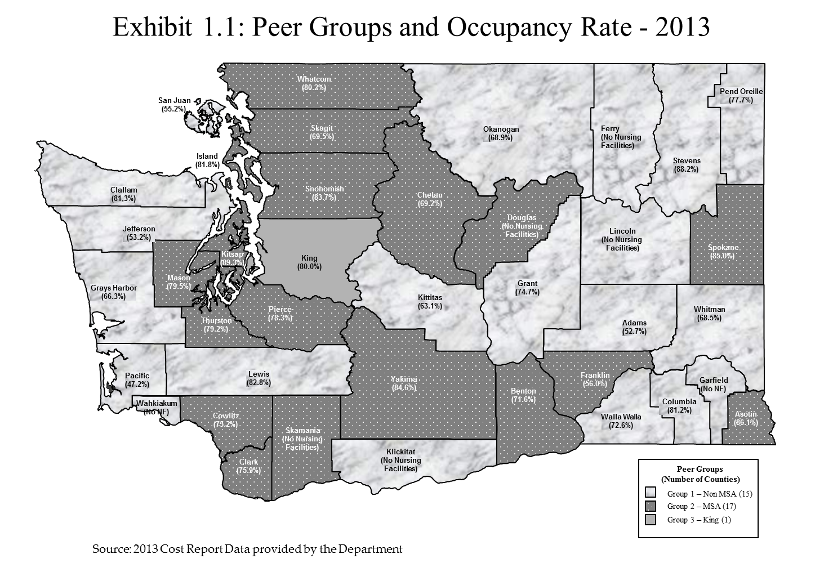
Bed Banking

Previously, facilities could engage in bed banking under Ch. 70.38 RCW by temporarily reducing the number of patient beds for which they were licensed. This option could result in an upward revision of component rates. When beds were unbanked – i.e., returned to licensed status – component rates could be subject to downward revision, if indicated. Beginning July 1, 2010, facilities may still bank beds but bed banking has no effect on rates. For purposes of computing occupancy levels, licensed beds will include any beds banked under Ch. 70.38 RCW. Beds that are relinquished are permanently removed, and are not included in the number of licensed beds.

Adjustments and Review

Settlement

In a process called settlement, direct care, therapy care, and support services component rates are compared to each facility’s expenditures in those categories for each report period. A facility may retain any overpayment up to 1.0% in each of these three rate components. There is a limited ability to shift cost savings from one component to cover a deficit in another component. After any allowable shifting is done, a facility must return overpayments of more than 1.0% to DSHS. The purpose of the settlement process is to provide facilities an additional incentive to spend their rate for the necessary care and well-being of their residents.

Budget Dial

Over and above all the rate setting methodologies provided in both the statutes and regulations, there is the budget dial imposed by RCW 74.46.421. In the biennial appropriations act, the Legislature sets a statewide weighted average maximum nursing facility payment rate for each state fiscal year. By statute, DSHS is required to reduce rates for all Medicaid participating nursing facilities statewide by a uniform percentage, after notice and on a prospective basis only, if the statewide average facility total rate approaches these limits. The budget dial ensures that total Medicaid nursing facility spending does not exceed the amount appropriated by the Legislature. The state’s operating budget set the budget dial rate for SFY 2016 at $187.90, and for SFY 2017 at $190.37. These amounts represent increases over the budget dial rates in SFY 2015 of $178.82 and include rate adjustments proposed in the Governor’s budget that will be considered in the upcoming legislative session.

Again, please refer to Appendix A for a more detailed description of the current rate-setting process.

SECTION II: Access to Care

In this section, we analyze the availability of nursing facility beds in Washington as a way to determine if barriers to access exist for Medicaid eligibles requiring nursing facility care. We analyze access to care primarily using two measures: nursing facility occupancy rates and the number of per capita nursing facility beds for the aged population. We analyze these metrics looking at trends over time, and in comparison to other states.

The analysis will suggest whether the current Medicaid payment methodology has resulted in access concerns for Medicaid beneficiaries and for Washington residents in general. The analysis will also suggest whether there are sufficient numbers of nursing facilities willing to provide services at the rates Washington pays to assure that Medicaid beneficiaries have access to care.

Washington Nursing Facility Capacity and Occupancy from 2006 to 2013

Nursing facility capacity can be measured by the number of beds days available. Table 2.1 shows the number of nursing facilities in the state, the total number of nursing facility beds and total available bed days for the eight years from 2006 to 2013. This table shows that the number of beds and available bed days in recent years, have decreased slightly. The analysis in Table 2.1 excludes closed facilities and facilities that did not serve any Medicaid residents during 2013.

It is important to note one new nursing facility opened in November of 2014. This facility adds 46 beds and 16,790 available bed days to the capacity in Washington State.

Table 2.1: Nursing Facility Capacity in Washington 2006 – 2013

Calendar Year | Number of Facilities | Number of Beds at Year End | Number of Bed Days Available
2006 | 234 | 21,577 | 7,843,865
2007 | 231 | 21,329 | 7,785,085
2008 | 227 | 21,574 | 7,896,084
2009 | 221 | 21,134 | 7,611,452
2010 | 210 | 20,776 | 7,583,240
2011 | 211 | 20,869 | 7,617,185
2012 | 213 | 20,762 | 7,578,130
2013 | 209 | 20,600 | 7,519,000

Source:
Number of Facilities, Number of Beds at Year End and Number of Bed Days Available were determined from data provided by the Department.

It is important to note that the number of beds available in Washington is affected by State law, as codified in the Washington Administrative Code (WAC). The WAC describes the State’s Certificate of Need (CON) policy that requires demonstration of a need for new beds before a nursing facility license can be approved. For new licensed beds to be approved, a provider must demonstrate a need for new beds, with the criterion for comparison being 40 nursing facility beds per 1,000 population aged 70 and older. This criterion, which was established effective October 6, 2008 (the previous criterion was 40 beds per 1,000 population aged 65 and older) was modified at the urging of the State’s nursing home industry. The State, working jointly with the industry, determined that this standard would be sufficient to assure access to services in Washington.

Table 2.2 shows nursing facilities’ total resident days, total Medicaid resident days and the average Medicaid utilization rate, that is, Medicaid’s share of total resident days for 2006 through 2013. Total resident days decreased 13.2 percent over this period. The Medicaid utilization rate also decreased between 2006 and 2013 from 63.1 percent to 59.6 percent, likely due to the Department’s efforts to enhance capacity and opportunities for care in non-institutional home and community-based settings.

Table 2.2: Nursing Facility Medicaid Utilization in Washington 2006 – 2013
Calendar Year | Number of Total Resident Days | Number of Medicaid Resident Days | Average Medicaid Utilization Rate
2006 | 6,866,473 | 4,330,720 | 63.1%
2007 | 6,755,338 | 4,149,481 | 61.4%
2008 | 6,632,100 | 4,028,671 | 60.7%
2009 | 6,369,275 | 3,886,492 | 61.0%
2010 | 6,122,754 | 3,592,405 | 58.7%
2011 | 6,120,296 | 3,685,180 | 60.2%
2012 | 6,085,563 | 3,656,784 | 60.1%
2013 | 5,956,826 | 3,549,713 | 59.6%

Source:
Number of Total Resident Days, Number of Medicaid Resident Days and Average Medicaid Utilization Rate were determined from data provided by the Department.

Nursing facility occupancy rates measure the extent to which existing beds are filled with patients. Thus, occupancy rates are one of the metrics that can be used to measure the industry’s efficiency – how well physical plants are utilized. Occupancy rates can also be indicators of whether there is sufficient nursing facility capacity to meet the population’s demand for services. High occupancy rates may suggest potential access problems as people seeking nursing facility services may face difficulty in finding a bed.

Table 2.3 shows the average occupancy rates in Washington nursing facilities in 2006 through 2013, and the number of unfilled nursing facility beds on an annual and daily basis.

Table 2.3: Nursing Facility Occupancy Rates and Unfilled Beds in Washington 2006 - 2013

Calendar Year | Average Occupancy Rate | Number of Unfilled Beds Days | Average Number of Unfilled Beds per Day
2006 | 87.5% | 977,392 | 2,678
2007 | 86.8% | 1,029,747 | 2,821
2008 | 84.0% | 1,263,984 | 3,454
2009 | 83.7% | 1,242,177 | 3,403
2010 | 80.7% | 1,460,486 | 4,001
2011 | 80.3% | 1,496,889 | 4,101
2012 | 80.3% | 1,492,567 | 4,089
2013 | 79.2% | 1,562,174 | 4,280

Source:
Average Occupancy Rate, Number of Unfilled Bed Days and Average Number of Unfilled Beds per Day were calculated using data provided by the Department.

The average occupancy rate for nursing facilities in Washington has fluctuated and declined over the period of 2006 to 2013. The 2013 average occupancy rate of 79.2 percent means that on average there were 4,280 empty nursing facility beds per day across the state.

Washington Nursing Facility Capacity and Occupancy by County, For 2013

To assess whether Medicaid beneficiaries in all areas of the state have sufficient access to nursing facility services, we analyzed the distribution of nursing facility beds and utilization at the county level.
In 2013, the number of nursing facilities per county ranged from 1 in Asotin, Columbia, Franklin, Island, Jefferson, Pacific, Pend Oreille and San Juan counties to 52 in King County. Exhibit 2.1 shows that the number of beds per county, for counties with at least one nursing facility, ranged from 34 to 5,781. As expected, the most urban and populous counties of King, Pierce and Snohomish have the most nursing facility beds. Of the eight counties with only one facility, the bed count ranges from 34 in Columbia to 125 in Franklin.

Currently, Ferry, Lincoln, Garfield, Wahkiakum, Klickitat, Douglas and Skamania counties do not have nursing facilities; however, each county supports Medicaid eligible residents by other means through adult family homes and assisted living, with the exception of Garfield County which has no nursing facilities, adult family homes or assisted living. There are twelve adult family homes in Klickitat has with a total of 63 beds, Lincoln has three homes with 17 beds, Douglas has nine homes with 50 beds, and Wahkiakum has one home with four beds. There are four assisted living facilities in Douglas County with 185 beds, one in Ferry County with 16 beds, one in Lincoln with 12 beds and one in Skamania with 36 beds.

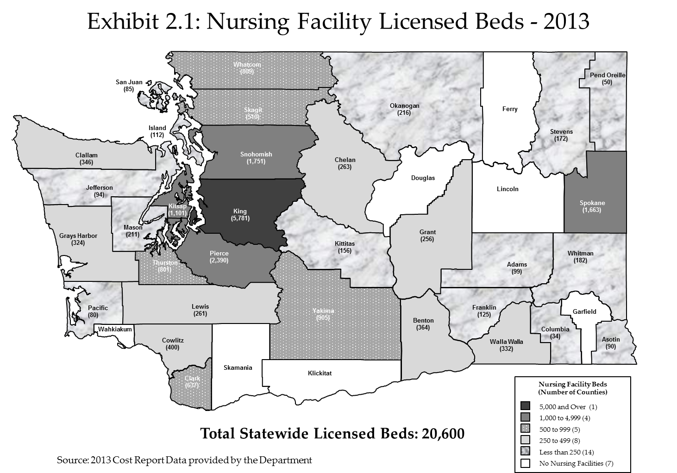
Exhibit 2.2 shows the average nursing facility occupancy rates in each county in 2013. At the county level, average occupancy rates ranged from a low of 47.2 percent to a high of 89.3 percent. Twelve of the state’s 39 counties have an average occupancy rate for nursing facilities in 2013 between 80 percent and 90 percent.

There were four counties with average occupancy rates of 85 percent or greater in 2013 (Kitsap, Asotin, Stevens, and Spokane) with the highest being 89.3% percent (Kitsap).
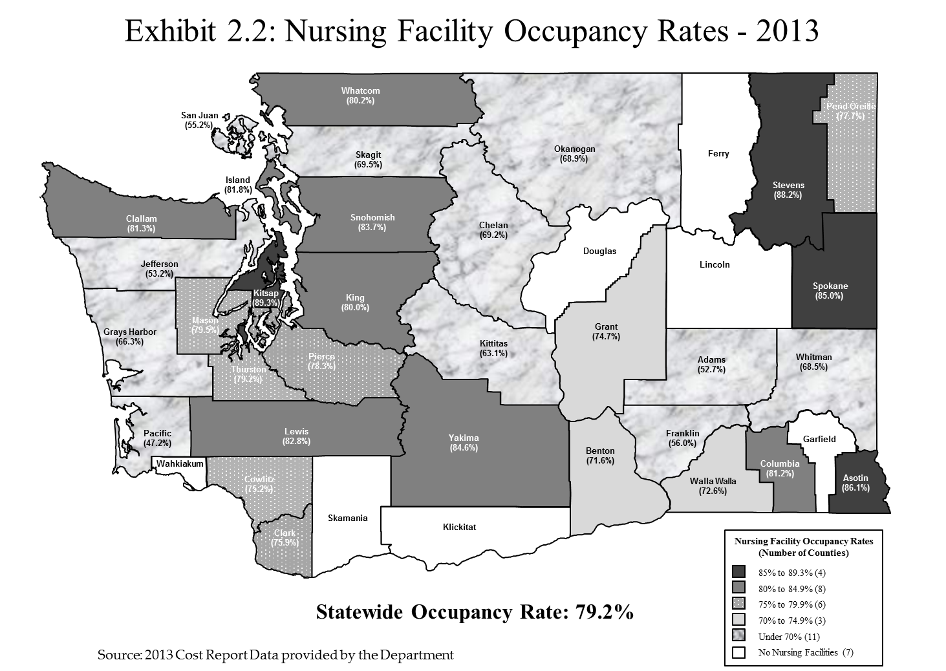
Exhibit 2.3 shows the average Medicaid utilization rates by county for 2013, which ranged from 44.5 percent to 78.6 percent. Medicaid utilization for 13 of the counties was within the 60 percent to 70 percent range.

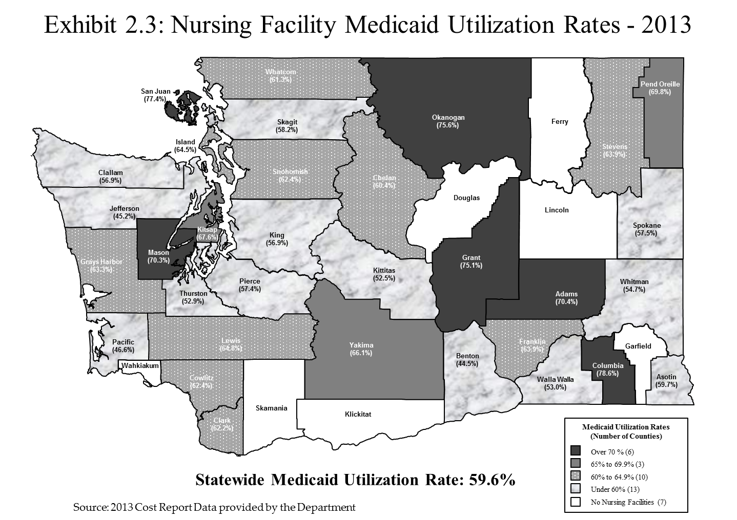
Nursing Facility Capacity in Washington Compared with Other States

Another way to analyze the adequacy of Washington’s nursing facility capacity is to compare it with the capacity in similar states.

Table 2.4 shows the nursing facility occupancy rates for states in the Centers for Medicare and Medicaid Services (CMS) Region X for the nine years 2006 through 2014. In 2014, Washington’s occupancy rates were greater than those in Idaho and Oregon, but less than Alaska, as was the case in 2006 through 2012.

Table 2.4: Nursing Facility Occupancy Rates for States in CMS Region X: 2006 – 2014

State | 2006 | 2007 | 2008 | 2009 | 2010 | 2011 | 2012 | 2013 | 2014
Alaska | 84.1% | 85.2% | 84.7% | 86.7% | 87.3% | 93.8% | 88.2% | 78.4% | 85.8%
Washington | 86.3% | 85.5% | 83.4% | 83.2% | 83.0% | 82.6% | 80.3% | 80.1% | 80.5%
Idaho | 75.6% | 76.9% | 74.9% | 72.6% | 71.8% | 71.0% | 68.7% | 67.8% | 64.8%
Oregon | 65.4% | 66.3% | 68.2% | 63.8% | 62.4% | 61.5% | 60.8% | 60.5% | 60.9%

Sources:
- States in CMS Region X: CMS website at http://www.cms.hhs.gov/RegionalOffices/downloads/SeattleRegionalOffice.pdf
- Utilization rates for 2006 through 2008: “Nursing Home Data Compendium” by CMS, 2009 Edition.
- Occupancy rates for 2009, 2010, 2011, 2012, 2013, and 2014 are as of June of each year: “OSCAR Data Report: Nursing Facility Operational Characteristics Report” by American Health Care Association Research Department, June 2009, 2010, 2011, 2012, 2013, 2014 Updates.

Table 2.5 compares Washington’s nursing facility occupancy rates over the same nine year period with states that have the largest senior populations in the country. Six of the eight states had nursing facility occupancy rates greater than Washington’s in the most recent three years.
Table 2.5: Nursing Facility Occupancy Rates for States with Largest Senior Populations: 2006 – 2014

State | 2006 | 2007 | 2008 | 2009 | 2010 | 2011 | 2012 | 2013 | 2014
New York | 92.7% | 92.6% | 92.7% | 92.7% | 92.4% | 92.2% | 91.8% | 91.9% | 90.9%
Pennsylvania | 90.4% | 88.9% | 89.3% | 90.7% | 90.8% | 90.9% | 90.2% | 90.6% | 90.2%
Ohio | 87.9% | 86.8% | 86.5% | 86.7% | 85.8% | 85.3% | 85.2% | 84.5% | 84.2%
Florida | 88.2% | 87.8% | 87.5% | 88.0% | 87.8% | 87.8% | 87.7% | 87.5% | 87.7%
Michigan | 88.8% | 86.6% | 86.3% | 86.2% | 85.2% | 84.8% | 84.9% | 84.7% | 84.2%
California | 85.7% | 85.0% | 85.3% | 84.8% | 84.8% | 85.1% | 85.1% | 84.9% | 85.0%
Illinois | 78.0% | 77.9% | 78.1% | 78.9% | 78.6% | 78.0% | 78.3% | 77.8% | 77.5%
Texas | 73.0% | 71.9% | 71.6% | 73.2% | 73.4% | 71.2% | 71.1% | 71.9% | 72.2%
Washington | 86.3% | 85.5% | 83.4% | 83.2% | 83.0% | 82.6% | 80.3% | 80.1% | 80.5%

Sources:
- States with the largest senior populations: “Nursing Home Data Compendium” by CMS, 2008 Edition.
- Utilization rates for 2006 through 2008: “Nursing Home Data Compendium” by CMS, 2009 Edition.
- Occupancy rates for 2009, 2010, 2011, 2012, 2013, and 2014 are as of June of each year: “OSCAR Data Report: Nursing Facility Operational Characteristics Report” by American Health Care Association Research Department, June 2009, 2010, 2011, 2012, 2013, 2014 Updates.

We also analyzed Washington’s nursing facility capacity on a per capita basis compared with similar states. Table 2.6 shows the number of nursing facility beds per 1000 population age 65 and older and age 85 and older in 2013 for states in CMS Region X. Of the four states in Region X, Washington had more beds per capita than all but Idaho.

Table 2.6: Nursing Facility Beds per Capita for Senior Population for States in
CMS Region X – 2013

State | Beds per 1000 Population Age 65 and Older | Beds per 1000 Population Age 85 and Older
Idaho | 26.7 | 236.0
Washington | 22.5 | 182.6
Oregon | 20.0 | 155.7
Alaska | 10.3 | 144.6
Average for Four States | 19.9 | 179.7
Average for States excluding Washington | 19.0 | 178.8

Sources:
- States in CMS Region X: CMS website at http://www.cms.hhs.gov/RegionalOffices/downloads/SeattleRegionalOffice.pdf
- Beds per 1000 Population Age 65 and Older and Beds per 1000 Population Age 85 and Older: Calculated by Navigant using total beds reported in “OSCAR Data Report: Nursing Facility Operational Characteristics Report” by American Health Care Association Research Department, June 2013 Update, and population estimates for July1, 2013 released June 2014 by the U.S. Census Bureau, Population Division.

Table 2.7 shows Washington’s nursing facilities beds per 1000 population aged 65 and older, and aged 85 and older, to the same metrics for all other Western states for 2013 (excluding Hawaii). This comparison shows that Washington’s metrics generally fall in the middle of the ranking of all Western states.

Table 2.7: Nursing Facility Beds per Capita for Senior Population for Western States – 2013

State | Beds per 1000 Population Age 65 and Older | Beds per 1000 Population Age 85 and Older
Montana | 40.7 | 335.0
Wyoming | 37.9 | 346.9
Colorado | 31.8 | 295.9
Utah | 30.2 | 276.0
Idaho | 26.7 | 236.0
California | 25.1 | 200.0
Washington | 22.5 | 182.6
New Mexico | 22.1 | 212.1
Oregon | 20.0 | 155.7
Arizona | 16.1 | 159.1
Nevada | 15.7 | 198.0
Alaska | 10.3 | 144.6
Average for Twelve States | 24.9 | 228.5
Average for States excluding Washington | 25.1 | 232.7

Sources:
- The Western states listed above were identified and selected by Navigant, Inc.
- Beds per 1000 Population Age 65 and Older and Beds per 1000 Population Age 85 and Older: Calculated by Navigant using total beds reported in “OSCAR Data Report: Nursing Facility Operational Characteristics Report” by American Health Care Association Research Department, June 2013 Update, and population estimates for July1, 2013 released June 2014 by the U.S. Census Bureau, Population Division.
Table 2.7 also shows that there is a significant range of values, which may be affected by the level to which each state has invested in alternative non-institutional home and community-based options. In other words, if more options are available to persons in states with alternative residential settings, it would be reasonable to assume that fewer nursing facility beds would be needed.
Based on 2009 data published in the 2012 edition of “Across the States” by AARP, Washington is second in the nation in Medicaid home and community-based services spending for older people and adults with physical disabilities as a percentage of total long-term care spending. Figure 2.1 illustrates how Washington has used its 2009 Medicaid long-term care dollars for home and community-based services compared to nursing facility services.
Figure 2.1: Medicaid Long-Term Spending for Seniors and Adults with Physical Disabilities in Washington

Source:
Medicaid Long-Term Spending for Older People and Adults with Physical Disabilities “Across the States” by AARP, 2012 Edition.

Figure 2.2 makes the same comparison nationally for 2009, which, when compared to Washington, illustrates that Washington has committed a significantly higher percentage of its Medicaid long-term care resources to alternative settings.
Figure 2.2: Medicaid Long-Term Spending for Seniors and Adults with Physical Disabilities in the United States

Source:
Medicaid Long-Term Spending for Older People and Adults with Physical Disabilities “Across the States” by AARP, 2012 Edition.
Understanding that comparisons of nursing facility beds per 1,000 aged population might be affected by the extent to which alternative residential settings are available, we analyzed Washington’s nursing facility capacity on a per capita basis compared with states that have made a similar commitment to these alternatives. To make this comparison, we identified other states that have spent more than 40 percent of Medicaid long-term care funds on home and community-based services.
Table 2.8 compares the number of beds in Washington per 1,000 population age 65 and age 85 and older to other states in the country that have spent more than 40 percent of their Medicaid long-term care dollars on home and community-based alternatives. This table shows that, when sorted by beds per 1,000 population age 65 and older and aged 85 and older, Washington generally falls in the middle of the ranking.

Table 2.8: Nursing Facility Beds per Capita for Senior Population in 2013 for States that spent more than 40 Percent of Medicaid long-term funds on HCBS
State | Percentage of Medicaid Funds Spent on HCBS Waivers | 2013 Beds per 1,000 Population Age 65 and Older | 2013 Beds per 1,000 Population Age 85 and Older
Texas | 50% | 43.7 | 424.5
Minnesota | 60% | 38.9 | 275.7
California | 55% | 25.1 | 200.0
Washington | 62% | 22.5 | 182.6
New Mexico | 65% | 22.1 | 212.1
Oregon | 59% | 20.0 | 155.7
Arizona | 44% | 16.1 | 159.1
Alaska | 56% | 10.3 | 144.6
Average for Eight States | 56% | 24.8 | 219.3
Average for States excluding Washington | 56% | 25.2 | 224.5

Sources:
- The states listed above were identified by AARP in the 2012 edition of “Across the States” as having spent more than 40 percent of their Medicaid long-term care funds on home and community-based services.
- The Percentage of Medicaid Funds Spent on HCBS Waivers: “Across the States” by AARP, 2012 Edition.
- Beds per 1000 Population Age 65 and Older and Beds per 1,000 Population Age 85 and Older: Calculated by Navigant using total beds reported in “OSCAR Data Report: Nursing Facility Operational Characteristics Report” by American Health Care Association Research Department, June 2013 Update, and population estimates for July 1, 2013 released June 2014 by the U.S. Census Bureau, Population Division.

We also analyzed Washington’s nursing facility capacity on a per capita basis with comparable states in close proximity to Washington that spent more than 50 percent of Medicaid long-term care funds on home and community-based services. Table 2.9 shows that Washington has a comparable number of beds per 1,000 population age 65 and older and age 85 and older to those ratios in California and Oregon.
Table 2.9: Nursing Facility Beds per Capita for Senior Population for California, Washington and Oregon

State | Percentage of Medicaid Funds Spent on HCBS Waivers | 2013 Beds per 1,000 Population Age 65 and Older | 2013 Beds per 1,000 Population Age 85 and Older
California | 55% | 25.1 | 200.0
Washington | 62% | 22.5 | 182.6
Oregon | 59% | 20.0 | 155.7
Average for Three States | 59% | 22.5 | 179.4
Average for States excluding Washington | 57% | 22.5 | 177.9

Sources:
- The states listed above were identified by Navigant Consulting, Inc. due to their proximity to Washington and having spent more than 50 percent of Medicaid funds on HCBS waivers.
- The Percentage of Medicaid Funds Spent on HCBS Waivers: “Across the States” by AARP, 2012 Edition.
- Beds per 1,000 Population Age 65 and Older and Beds per 1,000 Population Age 85 and Older: Calculated by Navigant using total beds reported in “OSCAR Data Report: Nursing Facility Operational Characteristics Report” by American Health Care Association Research Department, June 2014 Update, and population estimates for July1, 2013 released June 2014 by the U.S. Census Bureau, Population Division.

Conclusion

Based on the analyses described in this section, it appears that there is sufficient access to nursing facility beds in Washington State. Between 2006 and 2013, although the total number of beds decreased slightly, nursing facility occupancy rates decreased and the total number of unfilled beds increased each year, except in 2009 and 2012 when unfilled beds decreased slightly, 1.5 percent from 2008 and 1.4 percent from 2011. There appears to be capacity in virtually every county across the State.

Washington’s total bed capacity per 1,000 aged population, which is purposefully restricted based on the WAC (which is supported by the State’s nursing home industry), is very comparable to other states that have made similar commitments to home and community-based services options.

SECTION III: Quality

In the previous section we analyzed whether Washington’s Medicaid payment methodology for nursing facilities supports sufficient access to care for Washington’s Medicaid beneficiaries. In this section, we analyze whether Washington’s Medicaid payment methodology supports provision of care at an acceptable level of quality.

Comparative Analysis of Quality in Washington and Other States

Our analysis was intended to determine if the level of quality provided in Washington’s nursing facilities is acceptable when compared with other states. To make this comparison, we analyzed data on deficiencies cited in nursing facility surveys for the Medicare and Medicaid programs and compiled by the Centers for Medicare and Medicaid Services (CMS) and reported in its annual Nursing Home Data Compendium.

To add context to this analysis, we first compared the basic care needs of residents in Washington’s nursing facilities to those in nursing facilities in other states that have made significant commitments to home and community-based service options. To measure care needs, we examined the percentage of residents in each state that required assistance with one of the five Activities of Daily Living (ADL), otherwise referred to as ADL impairments, which were published in the CMS’ 2012 Nursing Home Data Compendium. The five ADLs analyzed in that publication were:

- Mobility
- Dressing
- Eating
- Transferring
- Toileting

ADL impairments were identified for each of these activities if a resident required extensive assistance with that activity.

As shown in Table 3.1, among states identified as having spent more than 40 percent of their Medicaid long-term care funds on home and community-based services, Washington has the highest percentage of residents with 4 or more ADL impairments in nursing facilities. This generally indicates that Washington has been effective in transitioning residents into appropriate non-institutional environments, and that those cared for in nursing facility settings generally have higher ADL impairments.

Table 3.1: Distribution of Activity of Daily Living (ADL) Impairment in Nursing Home Residents – 2012

Number of ADL Impairment
Percent of Residents
State | 0 | 1-3 | 4 and 5
Washington | 11.6 | 14 | 74.4
California | 18.6 | 16.8 | 64.6
Minnesota | 18.1 | 17.6 | 64.3
New Mexico | 28.3 | 19.3 | 52.5
Oregon | 15.4 | 18.6 | 66.0
Texas | 24.4 | 17.2 | 58.4
Arizona | 18.9 | 17.4 | 63.7
Alaska | 24.2 | 16.0 | 59.8
Average for Eight States | 19.9 | 17.1 | 63.0
Average for States Excluding Washington | 21.1 | 17.6 | 61.3

Sources:
- The states listed above were identified by AARP in the 2012 edition of “Across the States” as having spent more than 40 percent of their Medicaid long-term care funds on home and community-based services.
- Distribution Scope: “Nursing Home Data Compendium” by CMS, 2013 Edition.

Understanding that those in nursing facilities in Washington have high needs, we then examined the number and percentage of survey deficiencies in Washington’s nursing facilities. Surveys are conducted to ensure that nursing facilities are meeting State and federal standards which spell out how care must be provided to nursing home residents. Surveys are performed by teams of State employees (usually three or four people) who are specialists in nursing home care. The surveyors have backgrounds in nursing, social work, dietetics, sanitation, health care administration and counseling. These individuals must pass a test administered by the federal government to qualify as nursing home surveyors.

A deficiency is a determination by DSHS that a nursing home has violated one or more specific licensure or certification regulations. Deficiencies range in scope and severity from isolated violations with no actual harm to residents to widespread violations that cause injuries or put residents in immediate jeopardy of harm. Deficiencies are cited as a result of an on-site inspection. It is important to note that the severity of survey deficiencies can vary significantly, and that the national average of surveys that resulted in no deficiency in 2012 was only 9.5 percent (8.5 percent in Washington). This means that on average nationally, 90.5 percent of all surveys had some deficiency noted (91.5 percent in Washington). However, some deficiencies are more serious than others.

Exhibit 3.1 shows the scope and severity matrix which identifies the scope and severity ratings that can be applied to survey deficiencies for nursing facilities. A score is assigned to each deficiency based on the level of severity and scope of the deficiency. The scores range from “A”, being the least serious ranking and “L”, being the most serious ranking.

Exhibit 3.1 Scope and Severity Grid for Rating Nursing Home Deficiencies
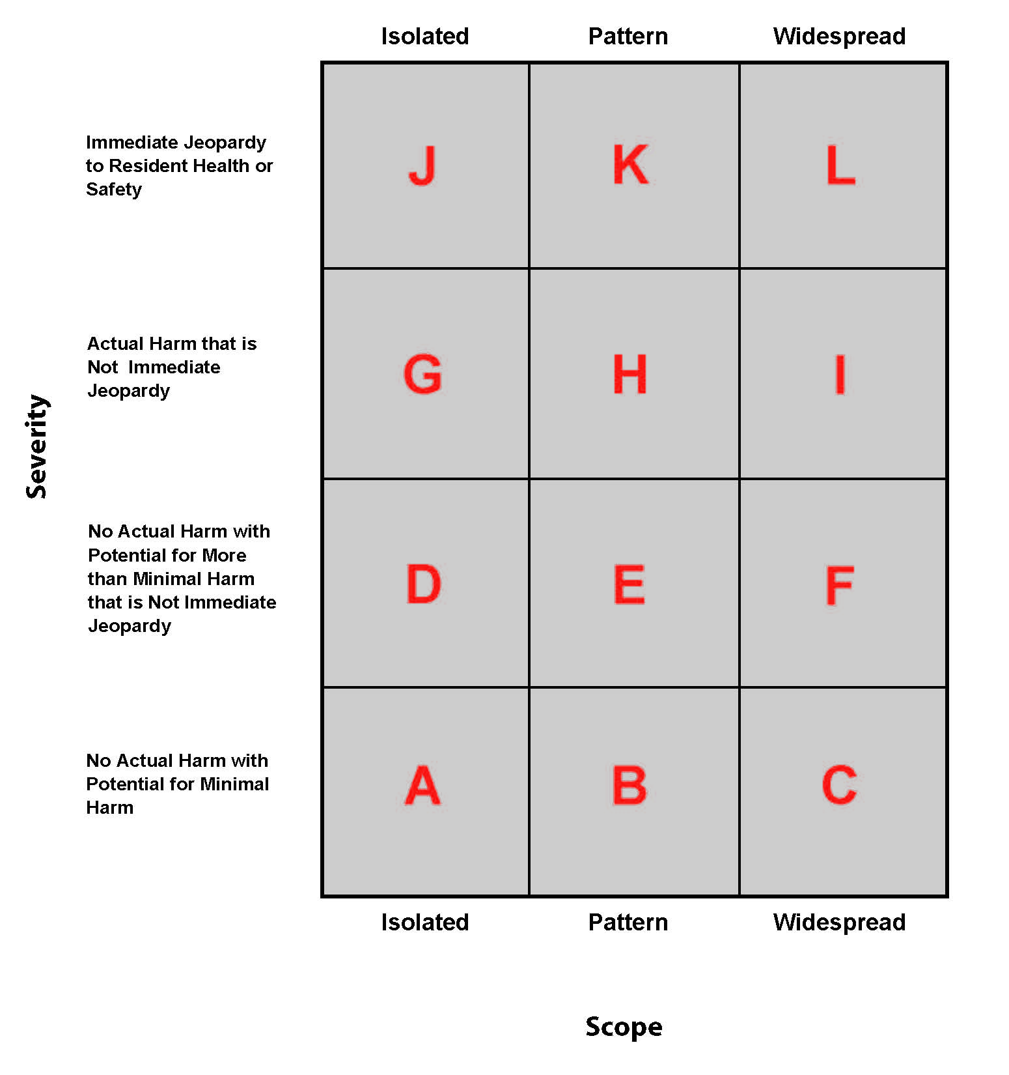
Source:
Scope and Severity Grid for Rating Nursing Home Deficiencies: “Nursing Home Data Compendium” by CMS, 2012 Edition.

To measure the significance of survey deficiencies in Washington nursing facilities, we initially analyzed those that fell into categories H, I, K or L, which we believe to measure the most severe of deficiencies. Table 3.2 shows the percentage of nursing facility survey deficiency citations resulting in the most serious deficiencies that constitute substandard quality of care for Washington and other states identified as having spent more than 40 percent of their Medicaid long-term care funds on home and community-based service options.

This table shows that the percentage of Washington’s nursing facility survey deficiency citations in these categories were comparable, and often times lower than the percentages of the other states analyzed.
Table 3.2: Percentage Distribution of Scope and Severity of Health Deficiency Citations in Nursing Homes – 2012

 | Distribution by Scope/Severity
State | H | I | K | L
Washington | 0.0 | 0.0 | 0.1 | 0.0
California | 0.1 | 0.0 | 0.1 | 0.1
Minnesota | 0.1 | 0.0 | 0.2 | 0.0
New Mexico | 2.8 | 0.0 | 5.0 | 1.3
Oregon | 0.0 | 0.0 | 0.0 | 0.0
Texas | 0.6 | 0.0 | 1.7 | 0.1
Arizona | 0.2 | 0.0 | 0.0 | 0.0
Alaska | 2.4 | 0.0 | 1.2 | 2.4
United States Average | 0.2 | 0.0 | 0.4 | 0.1
Average for Eight States | 0.8 | 0.0 | 1.0 | 0.5
Average for States excluding Washington | 0.9 | 0.0 | 1.2 | 0.6
Sources:
- The states listed above were identified by AARP in the 2012 edition of “Across the States” as having spent more than 40 percent of their Medicaid long-term care funds on home and community-based services.
- Distribution by Scope/Severity: “Nursing Home Data Compendium” by CMS, 2013 Edition.

Understanding that these data are from Federal Fiscal Year (FFY) 2012, we confirmed with DSHS representatives the distribution of deficiency citations does not change significantly from period to period.
Table 3.3 shows the trend in the percentage of nursing facility surveys that indicated health deficiencies in Washington nursing facilities from 2005 to 2012. This table shows that beginning in 2009, the number of deficiency citations increased slightly through 2012 for several of the deficiency scopes shown below. But also note that for the most part, citations were lower in 2012 than in 2011.
Table 3.3: Nursing Home Survey Resulting in Deficiency Citations in Washington – 2005 to 2012

Deficiency Scope | 2005 | 2006 | 2007 | 2008 | 2009 | 2010 | 2011 | 2012
Surveys Resulting in a Health Deficiency of Actual Harm or Immediate Jeopardy to Residents | 22.8 | 26.3 | 24.8 | 20.1 | 15.5 | 17.7 | 20.1 | 17.0
Surveys Resulting in a Health Deficiency of Immediate Jeopardy to Residents | 1.9 | 1.2 | 2.1 | 1.6 | 1.7 | 3.0 | 5.7 | 1.4
Surveys Resulting in a Citation for Substandard Quality of Care | 2.7 | 3.7 | 3.3 | 2.9 | 1.7 | 3.4 | 5.7 | 0.9
Surveys Resulting in a Citation for Use of Restraints | 3.8 | 2.9 | 4.5 | 2.9 | 1.7 | 1.7 | 1.7 | 2.4
Surveys Resulting in a Deficiency for Failure to Treat or Prevent Pressure Ulcers | 20.4 | 19.8 | 23.6 | 21.3 | 21.1 | 20.3 | 14.4 | 12.3
Source:
Distribution Scope: “Nursing Home Data Compendium” by CMS, 2013 Edition.

Again, understanding that these data are only published through Federal Fiscal Year (FFY) 2012, we confirmed with the Department representatives that deficiency citations do not change significantly from period to period.

Conclusion

Based on the analyses shown in this section, it appears that quality of care, as measured by the metrics described, compares favorably to other states analyzed. Understanding that there is a lag in the timing of the reporting of these deficiency criteria (the most current from 2012), it is difficult to correlate such changes to changes in the Medicaid rates paid for services. While we believe that the quality of care provided in Washington’s nursing facilities is generally adequate, we would recommend that the Department continue to monitor subsequent survey results to determine if the same trends continue.

SECTION IV: PAYMENT-TO-COST-ANALYSIS

In this section, we describe our analysis of payments under the current Medicaid payment methodology in relation to the allowable costs incurred by nursing facilities for serving Medicaid-eligible residents. First, we estimated what Medicaid allowable costs will be for State Fiscal Year (SFY) 2016 using historical cost data reported by the State’s nursing facilities, adjusted to reflect trends in inflation to SFY 2016. We then compared the estimated SFY 2016 costs to an estimate of Medicaid payments for the same period, based on weighted average of payment rates for all of SFY 2016.

We then conducted similar analyses comparing estimated SFY 2017 costs to what payments would be in SFY 2017.

Estimation of Costs for State Fiscal Years Ended 2016 and 2017

Base Costs

We estimated Medicaid costs using calendar year 2013 adjusted costs and resident days data provided by the Department. The data provided by the Department included the 209 nursing facilities that currently participate in the Medicaid program, and included five cost categories: Direct Care (DC) costs, Therapy Care (TC) costs, Support Services (SS) costs, Operations (OP) costs, and Property (PR) costs. These amounts were “adjusted” amounts that according to the Department included only “Medicaid allowable” costs. These amounts were also adjusted to reflect the change in provider assessment costs between 2013 and 2016, and 2017. We divided each cost category by adjusted total days to calculate an average cost per day for each of the five cost categories.

It should be noted that although the Washington Medicaid rate setting methodology includes several other rate components and adjustments, we did not add any additional costs for these components or adjustments. These other components and adjustments, which are described in detail in Appendix A, are not reflective of additional costs incurred by the providers, so it was not necessary to adjust the costs for these components or adjustments for purposes of this analysis.

Adjustment for Case Mix Index (CMI)

We adjusted the Direct Care cost component to take into account each nursing facility’s average case mix index. We divided each nursing facility’s average Direct Care cost per day by the average annual facility wide case mix index (CMI) from 2013. The resulting amount was the average Direct Care cost per day adjusted to a facility CMI of 1.0.

We then adjusted the Direct Care cost category to reflect the resource needs of Medicaid residents. To do this, we multiplied each nursing facility’s average Direct Care cost per day (which had been previously adjusted to reflect a facility CMI of 1.0) times the average facility-specific Medicaid CMI from the period of October 2013 through March 2014. These indexes were the most recent CMI data available. The resulting amount was the average Direct Care cost per day adjusted for the facility’s Medicaid CMI.

Adjustment for Cost Growth

To bring the 2013 costs forward to the years under analysis (SFYs 2016 and 2017), we applied a cost growth factor. The cost growth factor was calculated using the change in the CMS Prospective Payment System Skilled Nursing Facility Input Price Index. We identified the index at the midpoint of each analysis year (SFY 2016 and SFY 2017) and divided by the index at the midpoint of the 2013 cost year. The resulting cost growth factor was 1.056, or a 5.6 percent increase between SFY 2013 and SFY 2016, and 1.086, or a 8.6 percent increase between SFY 2013 and SFY 2017. Using the cost growth factors, we updated each of the average cost per day amounts for the cost components described previously to estimate the SFY 2016 and 2017 amounts.

After applying the cost growth factor to each component, we added together all the cost components, including the Direct Care cost component adjusted for the most current Medicaid CMI described above, to calculate the total estimated average cost per day for SFYs 2016 and 2017.

Estimation of Rates for State Fiscal Years Ended 2016 and 2017

The rates utilized in this analysis were calculated and provided to us by the Department. It is our understanding that the rate estimates are based on the methodology described in Section I of this report and in Appendix A and include rate adjustments proposed in the Governor’s budget that will be considered in the upcoming legislative session.

Other Considerations

It should be noted that in estimating the costs for SFYs 2016 and 2017, we did not make any adjustment for potential “case mix creep”, or inherent increase in CMI over time. We also did not adjust for potential “settlements” that are part of the rate setting process.

Analysis of Payment-to-Cost Coverage

We compared the rates for SFYs 2016 and 2017, calculated by and provided to us by the Department, to the average cost per day adjusted for the facility’s Medicaid CMI and for the cost growth percentages described in the cost section above. For each nursing facility, we analyzed the rates for SFY 2016 and SFY 2017 separately, to calculate payment-to-cost ratios.

For each nursing facility, we multiplied estimated rates described above for each year by the nursing facility’s 2013 adjusted Medicaid days to estimate total payments. Similarly, we multiplied each nursing facility’s average cost per day adjusted for the facility’s Medicaid CMI, and adjusted for cost growth, by the nursing facility’s 2013 adjusted Medicaid days to estimate total costs. We used the total payments and total costs to calculate weighted average payment-to-cost ratios for various groups of facilities.

For each rate year, we categorized the 209 nursing facilities into three groups by type of facility:

- Standard nursing facilities (196 facilities)
- Hospital-based nursing facilities (9 facilities)
- Veterans and tribal nursing facilities (4 facilities)

We analyzed these groups separately because of the differences in cost structures between the groups. We then examined the characteristics of nursing facilities in each group. The overall results for each year are shown in the table below.

Table 4.1: Medicaid Payment-to-Cost Ratio, By Facility Type Group, By Year

Type of Facility | Payment-to-Cost Ratio (Weighted Average)  Based on Rates Provided by the Department
 | SFY 2016 | SFY 2017
Standard Nursing Facilities | 91.2% | 89.7%
Hospital-Based Nursing Facilities | 75.4% | 73.9%
Veterans & Tribal Nursing Facilities | 59.5% | 58.6%
All Nursing Facilities | 89.4% | 88.0%

For each year, we further categorized the standard nursing facilities into one of four quartiles based on the nursing facility’s payment-to-cost ratio. Nursing facilities with the highest payment-to-cost ratios were categorized into Quartile 1, while those with the lowest payment-to-cost ratios were categorized into Quartile 4. We then examined the characteristics of nursing facilities in each category.

State Fiscal Year 2016 Rates

Overall Results – All Nursing Facilities

As shown in the table above, the rates expected to be in effect for SFY 2016 following the current methodology will result in a statewide average payment-to-cost ratio of 89.4 percent. The standard nursing facilities are expected to have a slightly higher ratio of 91.2 percent.

Occupancy – Standard Nursing Facilities

Examining the results by payment-to-cost quartile shows that average and median occupancy for facilities in Quartile 1 is higher than the rates for Quartiles 2, 3 and 4. This statistic generally indicates that the rate setting system “rewards” facilities with higher occupancies.

Medicaid Percentage – Standard Nursing Facilities

Examining the results by payment-to-cost quartile shows that facilities in Quartile 1 (highest payment-to-cost ratios) tend to have a high Medicaid percentage, while facilities in Quartile 4 (lowest payment-to-cost ratios) have the lowest Medicaid percentage. This statistic generally indicates that the rate setting system “rewards” facilities with higher Medicaid percentages. Note that the median value generally follows the same trend.

Cost Per Day – Standard Nursing Facilities

Examining the results by payment-to-cost quartile shows that the median cost per day adjusted to a facility CMI of 1.0 increases with each successive quartile. That is, facilities in Quartile 1 (highest payment-to-cost ratios) have the lowest cost per day and facilities in Quartile 4 (lowest payment-to-cost ratios) have the highest cost per day. This statistic indicates that the rate setting system “rewards” facilities with lower cost per day.

Highest Quartile – Standard Nursing Facilities

Examining the nursing facilities in the highest quartile (Quartile 1) shows that all of the 49 nursing facilities have payment-to-cost ratios between 97.2 and 102.0 percent. Twelve nursing facilities have payment-to-cost ratios of 100 percent or higher.

See Appendix B for additional detail on the analysis of the SFY 2016 rates.
State Fiscal Year 2017 Rates

As shown in the Table 4.1 above, the proposed rate to be paid in SFY 2017 results in a statewide average payment-to-cost ratio of 88.0 percent. The standard nursing facilities have a slightly higher ratio of 89.7 percent.

Occupancy – Standard Nursing Facilities

Examining the results by payment-to-cost quartile shows that average and median occupancy for facilities in Quartile 1 is higher than the rates for Quartiles 2, 3, and 4. This statistic generally indicates that the rate setting system “rewards” facilities with higher occupancies.

Medicaid Percentage – Standard Nursing Facilities

Examining the results by payment-to-cost quartile shows that facilities in Quartile 1 (highest payment-to-cost ratios) tend to have a high Medicaid percentage, while facilities in Quartile 4 (lowest payment-to-cost ratios) have the lowest Medicaid percentage. This statistic generally indicates that the rate setting system “rewards” facilities with higher Medicaid percentages. Note that the median value generally follows the same trend.

Cost Per Day – Standard Nursing Facilities

Examining the results by payment-to-cost quartile shows that median cost per day adjusted to a facility CMI of 1.0 increases with each successive quartile. This statistic indicates that the rate generated by this option would “reward” facilities with lower cost per day.

Highest Quartile – Standard Nursing Facilities

All 49 nursing facilities in Quartile 1 have payment-to-cost ratios of between 100.2 percent and 95.7 percent. Four nursing facilities have payment-to-cost ratios of 100 percent or higher.

See Appendix C for additional detail on the analysis of the SFY 2017 rates.

Conclusion

Our analysis shows that Washington’s current Medicaid payment methodology will pay, in SFY 2016, approximately 91.2 percent of Medicaid allowable costs incurred by nursing facilities that are not hospital-based, veterans or tribal facilities, and 89.4 percent when including those facilities. We estimate that 12 nursing facilities would receive 100 percent or more of their Medicaid allowable cost, with an additional 60 facilities receiving more than 95 percent of cost, and another 42 receiving 90 percent or more. Our analyses of access to and quality of care, described in Sections 2 and 3 of this report, respectively, indicate that the current methodology provides rates for services that have been sufficient to maintain adequate access to care of reasonable quality. We should note, however, that the data related to the frequency of survey deficiencies shows some slight increases for some deficiency categories.

The current system appears to have been designed to effectively pay a higher proportion of costs to the providers who are the most efficient, as measured by lower average Medicaid cost per day, adjusted for differences in case-mix, and as measured by total occupancy rates and Medicaid utilization. In other words, nursing facilities with lower case-mix adjusted cost per day, higher occupancy and higher Medicaid utilization tend to fare better under the current system when compared to the costs of providing services.

It is expected that rates in SFY 2017 will result in slightly lower payment-to-cost coverage than in SFY 2016. It would be difficult to predict the impact of no funding or rate increases upon access and quality in the State’s nursing facilities. We believe that it may motivate the facilities to operate more efficiently by reducing expenditures and possibly require facilities to increase rates for private pay residents, and/or increase other non-operating revenue such as investment income and donations.

We recommend that, with the anticipated rates for both SFYs 2016 and 2017, and any potential freezes or reductions to the rates in future periods, the State carefully and closely monitor any changes in access and quality so that appropriate responses can be made in a timely manner. We also recommend that the State carefully monitor the survey process, and the resulting occurrences of survey deficiencies, to make certain that such deficiencies do not continue to increase.

Nursing facilities calculate their bed days available each year by multiplying the number of licensed beds in operation by the number of days the beds were operational. Facilities report available bed days on their annual cost reports.
Assumes 365 days in the calendar year for 2006, 2007, 2009, 2010, 2011, 2013 and 366 days in the calendar year for 2008 and 2012.
These occupancy rates vary from those presented in Table 2.3 because they are from different data sources. Occupancy rates shown in Table 2.3 are calculated using bed days available as reported by nursing facilities each year in their annual cost reports submitted to the Department. The source for the all states’ data is the Online Survey, Certification and Reporting (OSCAR) which is a data network that CMS maintains in cooperation with the state long-term care surveying agencies. OSCAR is a compilation of all the data elements collected by surveyors during the inspection survey conducted at nursing facilities for the purpose of certification for participation in the Medicare and Medicaid programs.
Note that while the State currently uses the statistic “nursing facility beds per 1000 population aged 70 and older” for purposes of measuring bed need in Washington, similar statistics for other states were not available in the data relied upon to prepare this report.
Data in the Nursing Home Data Compendium are from the Online Survey, Certification and Reporting (OSCAR) which is a data network that the CMS maintains in cooperation with the state long-term care surveying agencies. OSCAR is a compilation of all the data elements collected by surveyors during the inspection survey conducted at nursing facilities for the purpose of certification for participation in the Medicare and Medicaid programs.
A case mix index is a measure, expressed as a factor, which is indicative of the expected “relative” resources that will be required to care for individuals in a nursing facility. Using data extracted from a nationally standardized resident assessment instrument, a case mix score is determined for each nursing facility resident, which indicates the resources required for that resident compared to the average of all residents. A facility’s case mix index is the average of the case mix scores for all residents in the facility at a given point in time.
This case mix index was calculated “without defaults”. As we understand, a CMI calculated “without defaults” excludes any individuals with a missing case mix score. A CMI “with defaults” would include those individuals in the counts and add a 1.0 case mix score for the individual.
This CMI was calculated “with defaults” as described in the previous footnote.

