Analysis of the Washington Assisted Living Services Medicaid Payment Methodology

April 2017

  - Prepared for:
  - Washington State Department of Social and Health Services (DSHS)

Submitted by:
Navigant Consulting, Inc.
1201 Third Avenue
Suite 3320
Seattle, Washington 98101

navigant.com
Table of Contents
Section I: Overview of Assisted Living and Services Provided 3
Section II: Overview of the Current Medicaid Payment Methodology and Rates…… 5
Section III: Access to Care 8
Section IV: Quality 14
Section V: Comparison of the Costs of Assisted Living Services to Current Rates 16
Section VI: Conclusion 20

APPENDICES:

APPENDIX A: Current Daily Rates

APPENDIX B: Assisted Living Enforcement Action Options

APPENDIX C: Report To The Legislature, Care & Medicaid Payment System For Licensed Boarding Homes, Chapter 231, Laws Of 2003, December 2004

Introduction

Navigant Consulting, Inc. was engaged by the Washington State Department of Social and Health Services (DSHS), also referred to as the Department, to conduct an analysis of the current Medicaid payment methodology and rates paid for Assisted Living services relative to the efficiency, accessibility and the quality of care standards established under federal requirements. The federal requirements that apply to the methods states employ to pay for Medicaid services, which are described in U.S.C. § 1396a (a)(30)(A), specify that a state plan for Medical Assistance (referred to herein as Medicaid) provide such methods and procedures relating to the utilization of, and the payment for, care and services available under the plan as may be necessary to safeguard against unnecessary utilization of such care and services and to assure that payments are consistent with efficiency, economy, and quality of care and are sufficient to enlist enough providers so that care and services are available under the plan at least to the extent that such care and services are available to the general population in the geographic area.

As such, our analysis focused on an evaluation of the current Washington Medicaid payment methodology and related rates relative to consistency with efficiency and economy, and access to care and quality of care in Washington State. The rates analyzed in this report are for State Fiscal Year (SFY) 2018.

Section I: Overview of Assisted Living and Services Provided

An Assisted Living facility is a licensed facility of seven or more beds that provides housing, meal services and assumes general responsibility for the safety and well-being of the residents. Assisted Living facilities allow residents to live an independent lifestyle in a community setting while receiving necessary services from Assisted Living staff. Assisted Living facilities are licensed by the Department and can vary in size and ownership from small family operated facilities to a 253-bed facility operated by a national corporation. Some Assisted Living facilities provide intermittent nursing services and others may specialize in serving people with mental health problems, developmental disabilities or dementia.

Based on data provided to us by the Department, approximately 76 percent of all Assisted Living residents pay for their care privately, where the remaining 24 percent of Assisted Living residents are eligible for Medicaid services. The Department contracts with Assisted Living facilities to provide services packages for Medicaid residents in two Assisted Living settings – Assisted Living facilities where residents live in an apartment setting and either have their own room or they share a room.

Under federal regulations, federally-matched state Medicaid dollars may not be used to pay for the room and board costs associated with long-term care services, including the room and board components of costs in Assisted Living facilities. As such, Medicaid residents in Assisted Living facilities are responsible for paying for their own room and board in each setting, and the Department pays only for the allowable Medicaid services that residents receive in those settings, which are:

- In Assisted Living (AL) settings
  - Intermittent nursing services – facilities must provide this service
  - Assistance with medication administration and personal care

- In Adult Residential settings – Adult Residential Care (ARC)
  - Assistance with medication and personal care
  - Limited supervision, as needed

- In Adult Residential settings – Enhanced Adult Residential Care (EARC)
  - Assistance with medication administration and personal care
  - Limited supervision, as needed
  - Intermittent nursing services – facilities must provide this service
  - Specialized dementia care – requires competitive bids and available funding

Based on data provided to us by the Department, there were 537 Assisted Living facilities in Washington State in 2016, with 31,862 licensed beds. Of those, 303 were Medicaid contracted (56 percent of the total number of Assisted Living facilities), and those Medicaid contracted Assisted Living facilities had 18,539 licensed beds (58 percent of the total number of licensed beds). In the State of Washington, Assisted Living facilities can enter into a contract with the Department to provide care to Medicaid residents, but that contract does not require that they accept all Medicaid-eligible residents, even if they have available beds. Assisted Living facilities in Washington can refuse to accept Medicaid residents at their discretion, even if they are a Medicaid-contracted provider.

Section II: Overview of the Current Medicaid Payment Methodology and Rates
This section describes the current process used to establish the Medicaid payment rates for Assisted Living services in Washington. This description is intended to provide a high level overview of how payment rates are set for Medicaid residents in Assisted Living facilities. This section also provides some context on how the process for establishing the rates has evolved in recent years.

Methodology Used to Establish Current Rates

In Washington State, the rate setting process for Assisted Living services has evolved over the years. For purposes of establishing rates, in the early 2000’s, the Department facilitated stakeholder workgroups, which over a two year period identified important cost components as well as reasonable proxies to represent the market price for each of the components that could be used for rate-setting purposes. The cost components identified by the workgroups included wages, benefits, operating costs, capital costs, and occupancy rates among several others. Considering the product of these workgroups, the Department established rates for Assisted Living services. The reimbursement rates established varied by client based on each client’s assignment to one of 12 unique CARE Classifications that reflect the different levels of resources required to care for residents with different needs and also by geographic service area.

While this stakeholder process and analysis of rate components initially informed the process of establishing rates, the Medicaid reimbursement rates for Assisted Living services have been largely driven by the funding appropriated by the Legislature. Each year the Legislature allocates funding for the provision of Assisted Living services and based on the level of the funding the Department determines the daily reimbursement rates. This process occurs on an annual basis. The current reimbursement rates for AL, ARC, and EARC services still vary based on the CARE Classification an individual is assigned to as well as the geographic area where the service is provided.

In July of 2008, the CARE Classifications were expanded from 12 to 17 unique classification groups based on the funding approved by the Legislature. Federal law, described in 42 U.S.C. § 1396a (a) (30) (A), requires that Medicaid providers are reimbursed at levels consistent with efficiency, economy, and quality of care, and that the level of reimbursement is sufficient to attract enough providers to provide services to the population. Note that Washington’s Medicaid State Plan, which describes the Department’s methods for determining payments for Assisted Living Services, has been approved by the federal government.

Current Rates for State Fiscal Year 2018

Appendix A of this report shows the SFY 2018 rates for AL, ARC and EARC services in Assisted Living facilities. Based on data provided to us by the Department, the weighted average Assisted Living rate given the anticipated number of Medicaid beneficiaries for SFY 2018 is expected to be $69.62 per day for AL services, and $65.22 per day for ARC and EARC services.

The three geographic area groups used for rate-setting purposes are King County, all other Metropolitan Counties, and all Nonmetropolitan Counties. The counties included in each geographic area group are shown on the map in Exhibit 2.1. This Exhibit also shows the number of Assisted Living providers in each county and geographic region.

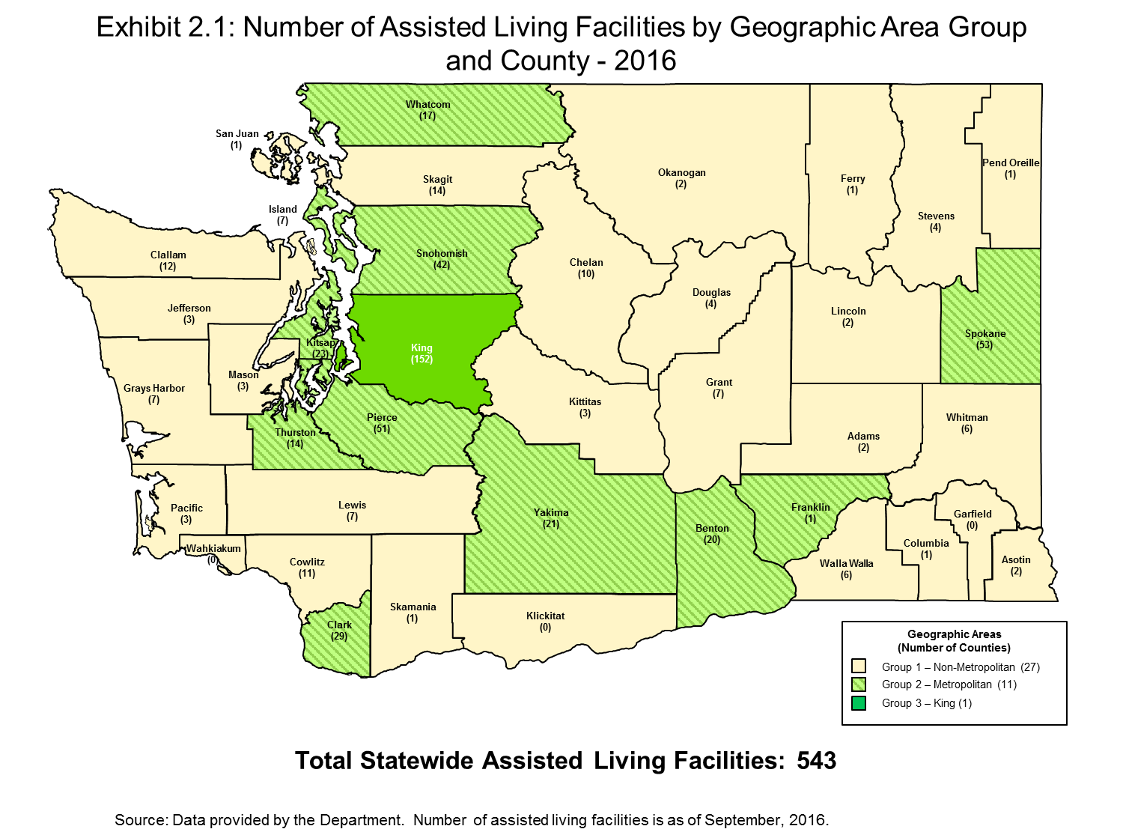

Section III: Access to Care
In this section, we analyze the availability of Assisted Living beds in Washington as a way to determine if barriers to access exist for Medicaid beneficiaries requiring Assisted Living services. We analyze access to care primarily using Assisted Living licensed beds and occupancy rates over time, as well as information provided to us by the Department regarding Medicaid placements.

Washington Assisted Living Capacity and Occupancy from 2008 to 2017

We first look at total Assisted Living capacity in Washington. Assisted Living capacity can be measured by the number of bed days available – that is the number of licensed beds multiplied by the number of days in the year. Table 3.1 shows the number of Assisted Living facilities, number of licensed beds and total available bed days in the state for the ten years from 2008 to 2017. This table shows that while the number of Assisted Living facilities has remained essentially constant, the number of licensed beds and available bed days has increased – by more than eighteen percent – over the periods shown.

Table 3.1: Assisted Living Facilities Capacity in Washington 2008 – 2017

State Fiscal Year | Number of Facilities | Number of Licensed Beds | Total Number of Bed Days Available
2008 | 544 | 26,920 | 9,852,720
2009 | 543 | 27,499 | 10,037,135
2010 | 547 | 28,241 | 10,307,965
2011 | 548 | 28,721 | 10,483,165
2012 | 541 | 28,829 | 10,551,414
2013 | 533 | 29,149 | 10,639,385
2014 | 548 | 29,555 | 10,787,575
2015 | 571 | 30,441 | 11,110,965
2016 | 535 | 31,290 | 11,452,140
2017 | 537 | 31,862 | 11,629,630
Source:
Number of facilities and licensed beds were provided by the Department and are as of July for state fiscal years 2008 through 2017. Numbers of beds days available were calculated using the number of days in each year.

Assisted Living facilities are not required to report occupancy rates to the Department. As such, as of the date of this report, data regarding statewide occupancy levels in Assisted Living facilities were not available. However, in 2000 and 2007, the Department conducted a survey of Assisted Living facilities, regarding their occupancy levels, and the results of both years’ surveys indicated an average statewide occupancy rate of 85.3 percent.

Table 3.2 shows Assisted Living facilities’ estimated total occupied beds based on the assumption that Assisted Living facilities realized an 85.3 percent occupancy rate. It also shows total beds occupied by Medicaid residents and the estimated average Medicaid utilization rate, that is, Medicaid’s share of estimated total occupied beds for 2008 through 2017.

Table 3.2: Assisted Living Medicaid Utilization in Washington 2008 – 2017
State Fiscal Year | Total Licensed Assisted Living Beds | Estimated Number of Occupied Beds at Assumed 85.3% Occupancy Rate | Number of Beds Occupied by Medicaid Residents | Estimated Average Medicaid Utilization Rate
2008 | 26,920 | 22,968 | 6,321 | 28%
2009 | 27,499 | 23,462 | 6,468 | 28%
2010 | 28,241 | 24,095 | 6,675 | 28%
2011 | 28,721 | 24,505 | 6,692 | 27%
2012 | 28,829 | 24,597 | 6,891 | 28%
2013 | 29,149 | 24,870 | 6,843 | 28%
2014 | 29,555 | 25,216 | 6,726 | 27%
2015 | 30,441 | 25,966 | 6,660 | 26%
2016 | 31,290 | 26,690 | 6,826 | 26%
2017 | 31,862 | 27,178 | 6,652 | 24%
Source:
Data provided by the Department and is as of July for state fiscal years 2008 through 2017.

This table shows that the total number of licensed Assisted Living beds in the state increased by 4,942, an 18.4 percent increase, from 2008 to 2017. It also shows that the utilization of beds by Medicaid residents has fluctuated slightly over this same period, but 2017 Medicaid occupied beds were 331 greater than in 2008, or 5.2 percent greater.

Table 3.3 shows the estimated average number of unfilled beds each day in Washington Assisted Living facilities in 2008 through 2017, based on the assumed 85.3 percent average statewide occupancy rate from the Department surveys.

Table 3.3: Estimated Number of Unfilled Assisted Living Beds in Washington 2008 - 2017

State Fiscal Year | Estimated Average Number of Unfilled Beds per Day at 85.3% Occupancy Rate
2008 | 3,952
2009 | 4,037
2010 | 4,146
2011 | 4,216
2012 | 4,232
2013 | 4,279
2014 | 4,339
2015 | 4,475
2016 | 4,600
2017 | 4,697
Source:
Estimated Number of Unfilled Bed Days and Estimated Average Number of Unfilled Beds per Day were provided by the Department.

This table shows that, based on the assumed occupancy rate of 85.3 percent, that there is unused Assisted Living capacity in Washington State.

Washington Assisted Living Capacity by County, For 2016

To assess whether Washington residents in all areas of the state have access to Assisted Living services, we analyzed the distribution of Assisted Living beds at the county level.
As of October 2016, the number of Assisted Living facilities per county ranged from zero in three counties to 152 in King County. Exhibit 3.1 shows that the number of licensed beds per county, for counties with at least one Assisted Living facilities, ranges from 16 to 8,530. As expected, the most urban and populous counties of King, Pierce, Snohomish and Spokane have the most Assisted Living beds. Currently, Wahkiakum, Klickitat, and Garfield Counties do not have Assisted Living facilities.
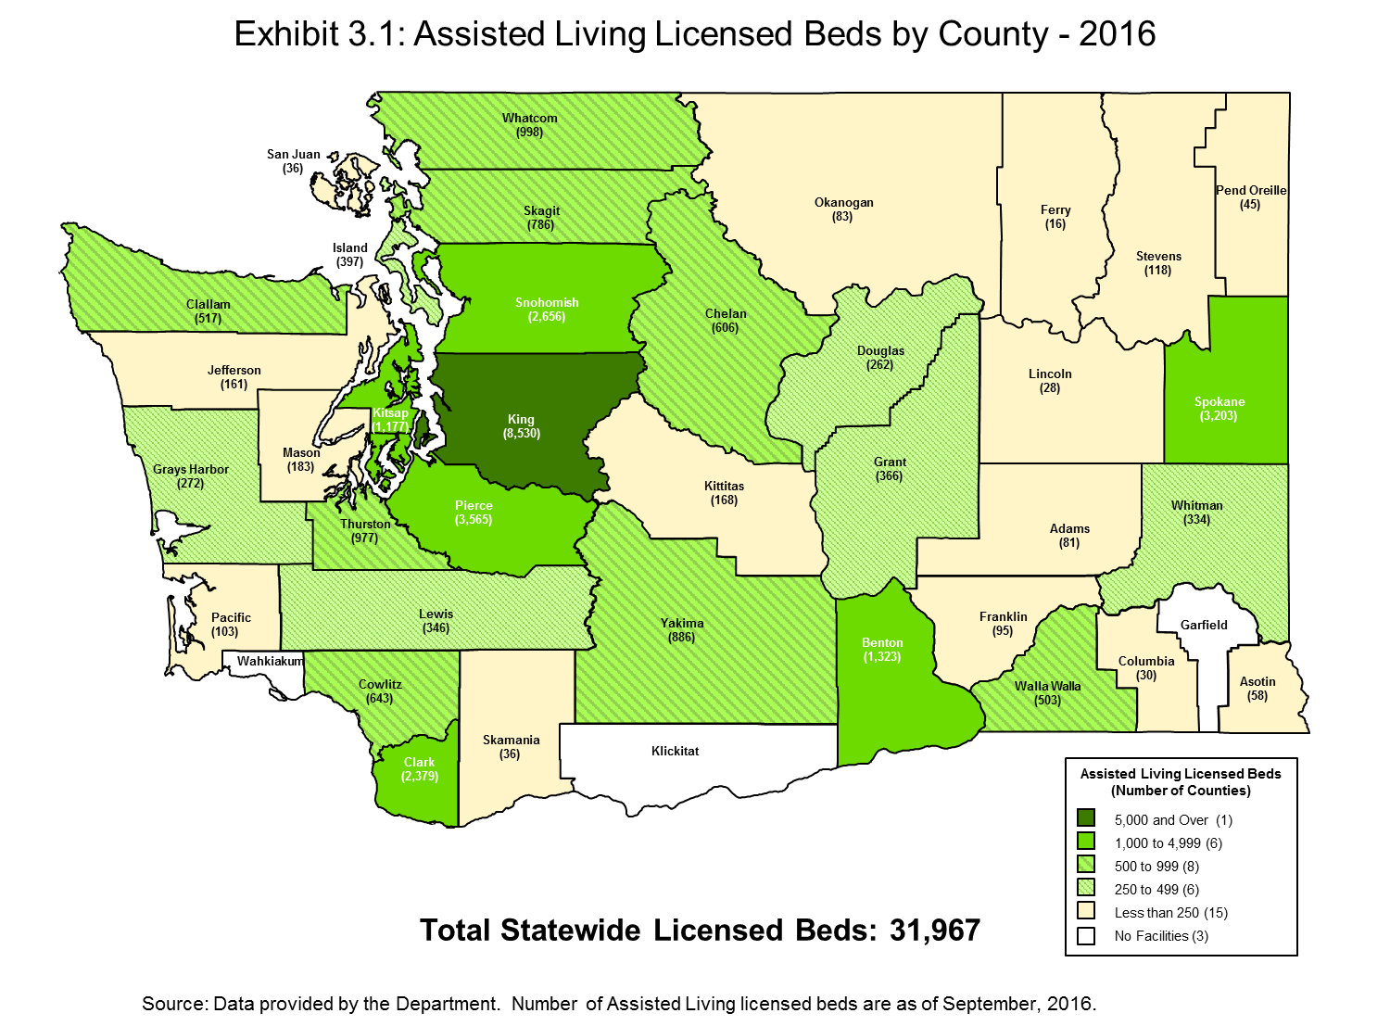
Capacity of Medicaid-contracted Assisted Living Facilities

As discussed previously, not all Assisted Living facilities are contracted with the Department to provide Medicaid services. Table 3.4 shows the change in the number of Medicaid-contracted Assisted Living facilities in Washington between 2008 and 2017 based on data provided to us by the Department, and the number of licensed beds in those Medicaid-contracted Assisted Living facilities.

Table 3.4: Medicaid-contracted Assisted Living Capacity in Washington 2008 – 2017

State Fiscal Year | Number of Medicaid-Contracted Facilities | Number of Licensed Beds in Medicaid-contracted Facilities
2008 | 351 | 18,570
2009 | 353 | 19,092
2010 | 354 | 19,312
2011 | 354 | 19,585
2012 | 348 | 19,093
2013 | 322 | 18,285
2014 | 318 | 18,190
2015 | 328 | 19,785
2016 | 308 | 19,027
2017 | 303 | 18,539

This table shows that the number of Medicaid-contracted Assisted Living facilities has remained fairly constant, although has decreased since 2008. At the same time, as this table shows, the number of licensed beds in Medicaid-contracted facilities in 2017 has decreased slightly since 2008.

As noted earlier, Medicaid-contracted Assisted Living facilities have been determined to be qualified to accept Medicaid residents, and will accept Medicaid rates for payment of the services they provide for Medicaid residents, but they may, at their discretion, decline to accept Medicaid-eligible residents. Given this circumstance, for purposes of understanding whether there is sufficient access to Assisted Living services for Medicaid-eligible residents, it is important to know whether Medicaid-eligible residents have historically had difficulty being placed into licensed Assisted Living facilities. To understand this, we discussed Medicaid placements with Department representatives. Based on these discussions, we found that the Department generally has not experienced difficulty in placing Medicaid-eligible residents into Assisted Living facilities. The Department estimates that two percent or less of placements result in any difficulty for placement, and those that do generally involve residents with special circumstances, including:

- Bariatric (seriously obese) clients
- Clients with criminal histories, such as sexual offenses
- Clients with disabilities resulting from traumatic brain injuries or mental illness
- Clients with known histories of behavioral problems, such as physical or verbal aggression against facility staff or with other residents
- Clients with dementia and wandering

Section IV: Quality
In the previous section we analyzed whether Washington’s Medicaid payment methodology for Assisted Living services supports sufficient access to care for Washington’s Medicaid beneficiaries. In this section, we analyze whether Washington’s Medicaid payment methodology supports provision of care at an acceptable level of quality.

Inspections are one of the numerous quality assurance activities that occur in Assisted Living facilities. The Department has a comprehensive inspection protocol in place, which includes the identification and assessment of citations. Remedies for citations are dependent upon the severity of the circumstances, and can range from providing consultation with no plan of correction for initial citations where there is no potential harm to residents in the Assisted Living facility, to civil penalties for repeat citations, to the most severe remedy, which can result in license revocation or stop placement. For a complete description of potential enforcement action options for Assisted Living facilities, see Appendix B.

Based on the General Guidelines for Assisted Living inspections, the purpose of an inspection is to determine if the home is in compliance with applicable licensing laws and regulations, all of which are documented in the State WACs and RCWs. Licensing laws and regulations also include those that are specific to Medicaid-contracted services to assure that the facilities meet the additional Medicaid contracting requirements.

It should be noted that inspections are not limited to Assisted Living facilities providing services to Medicaid-eligible residents. All Assisted Living facilities licensed in the State of Washington are subject to licensing inspection requirement.

The following lists the operational principles for conducting an inspection of an Assisted Living facility in Washington:

- Assisted Living facilities must meet, and always be in compliance with, the applicable minimum licensing requirements.
- Assisted Living facilities are required to deliver quality care to residents in order to meet the requirements.
- Assisted Living facilities must correct all deficiencies in a timely manner. Time frames must be acceptable to the department.
- Timeliness of data collection is critical for enforcement.
- Assisted Living facilities must begin correction of any citation as soon as they are notified of a deficiency.
- The field staff will contact the Field Manager when deficiencies involving resident care issues and the likelihood of compromised resident safety should result in shortened plan of correction timeframes.
- The Field Manager will immediately refer any situation involving the likelihood of life threatening risk to a resident (imminent risk, imminent harm) to the Compliance Specialist/Assistant Director for possible immediate enforcement.
- The field staff will follow the written inspection and follow up visit principles and procedures to ensure that inspections and follow up visits are done in a consistent manner.
- Homes that do not meet all of the licensing requirements during the full inspection may have up to two follow-up inspections prior to contacting the Compliance Specialist/Assistant Director.

At a minimum, the Department is required to conduct inspections of every Assisted Living facility at least once within an 18 month period. Based on our discussions with Department staff, inspections are currently being conducted within the 18 month requirement and on average occur at approximately once every 15 months.

Table 4.1 shows the number of citations for the past ten years in Assisted Living facilities which, based on the enforcement protocols shown in Appendix B, did require a Plan of Correction.

Table 4.1: Assisted Living Facility Inspection Citations Requiring Plan of Correction, 2007 - 2016

Calendar Year | Number of Citations
2007 | 5,243
2008 | 5,619
2009 | 5,513
2010 | 4,679
2011 | 4,774
2012 | 4,223
2013 | 4,906
2014 | 4,852
2015 | 4,425
2016 | 4,493
Source: Citation data provided by the Department. Note that for calendar year 2016, citation data was available through December 1st at the time this report was completed.

Table 4.1 shows that the number of citations requiring a plan of correction was at its highest point in Calendar Year 2008 and that by Calendar Year 2016, decreased by 36 percent. During this time there was an implementation of a new Tracking Incidents among Vulnerable Adults (TIVA) system. This new incident tracking system has allowed for better information collection on reported incidents. As a result, incidents which require field investigations are more accurately identified and issues can be addressed with the Assisted Living provider therefore preventing some citations. In recent years the fluctuation in the number of citations has remained fairly consistent.

Section V: Comparison of the Costs of Assisted Living Services to Current Rates
In the previous sections of this report, we analyzed whether Washington’s Medicaid payment methodology for Assisted Living services supports sufficient access to care for Washington’s Medicaid beneficiaries and whether Washington’s Medicaid payment methodology supports provision of care at an acceptable level of quality. In this section of the report, we analyze the level of the current reimbursement rates compared to the costs to providers for providing services.

Assisted Living providers are not required to submit cost data to the Department, and as such, it is not possible to make comparisons of current rates to current cost data from the providers of Assisted Living services. However, it is possible to look back to historical data, using trending assumptions to take into consideration inflation over time, and make comparisons of rates to costs.

As discussed in Section II of this report, in the early 2000’s, to determine the costs of providing services and what an appropriate level of reimbursement would be, the Department staff and Home and Community residential care industry representatives, providers and interested parties formed workgroups. Over a two year period, the workgroups conducted research and held monthly meetings to discuss their results, proposals and issues. During this process, all cost components of providing Home and Community residential care and services were systematically identified and proxies or benchmarks were chosen to represent the market price for these components. The workgroups chose to use proxies and benchmarks for identified costs because of the prohibitive cost of collecting and updating actual cost data from the State’s Assisted Living providers. The workgroups selected various industry benchmarks for wage and salary levels, supplies, insurance, food, utilities and capital costs. The Department used this information to establish rates for 2004.

After considering the level of the reimbursement rates based on the components and proxies identified by the workgroups, the Department also made a comparison of the established rates to the actual costs of Assisted Living services from a sample of 40 Assisted Living service providers. The Department collected actual cost data from these 40 participating providers for calendar year 2003. Note that this sample was a voluntary sample, and was not a probability sample that could be used to statistically extrapolate the sample findings to the total population of Assisted Living providers in the State. The results of the comparison do, however, provide some insights as to the relationship between the established rates and total actual costs at that time.

At the conclusion of this process, DSHS prepared a report in 2004, entitled Report to the Legislature, CARE & Medicaid Payment System for Licensed Boarding Homes, Chapter 231, Laws of 2003, December 2004. That report, which is attached to this report as Appendix C, provides a description of the process used by the Department to analyze reimbursement levels for SFY 2004.

Based on the analysis provided in that report, the statewide median rate established for SFY 2004 was lower than the median actual cost per day of the 40 providers in the voluntary sample. However, it is also important to understand that the costs incurred by the Assisted Living facilities in the voluntary sample may have included cost elements that were not necessary for the provision of the basic level of care required for Medicaid residents. Because of this issue, and understanding that it is difficult to draw conclusions from a voluntary sample of 40 providers, the Department acknowledged in the above referenced report that it is difficult to draw conclusions as to the actual costs of providing services to Medicaid residents. In the report, the Department concluded that the costs of providing these services to Medicaid residents can best be evaluated by looking at the actual rates (established independently through the pricing method), and the effect of actual rates on services provided. As such, the Department determined that the rates established through this study for SFY 2004 were a reasonable proxy for the reasonable and necessary costs of providing Assisted Living services to Medicaid residents.

Since Assisted Living providers are not required to submit cost data to the Department, as mentioned earlier, and the Department concluded through the extensive study conducted that the SFY 2004 rates established are a reasonable proxy for the costs of providing services at that time, for the purposes of this report the best information of the costs for providing services we can rely on are the SFY 2004 calculated reimbursement rates.

As stated previously in this report, the Department does not use this analysis of the SFY 2004 reimbursement rates as a means for establishing current reimbursement rates. The reimbursement rates are currently dependent upon the funding appropriated by the Legislature for these services, where each year the Department establishes the reimbursement rates based on that available funding. However, this analysis does provide useful proxy data for purposes of understanding the costs of providing Assisted Living services.

Analysis of Payment-to-Cost Coverage for SFY 2018

Based on the assumption that the rates determined in the SFY 2004 study represent a proxy for the reasonable and necessary costs of providing Assisted Living services to Medicaid residents, we can determine an estimate of the cost of providing Assisted Living services in SFY 2018 by applying a trend factor to approximate inflation between SFY 2004 and SFY 2018. To estimate Assisted Living providers’ current costs, we applied a trend factor to the SFY 2004 weighted average rate for Assisted Living services to account for inflation between December 2003 to December 2017, the midpoints of SFY 2004 and SFY 2018, respectively.

We inflated the SFY 2004 cost assumption to December 2015 using Consumer Price Index (CPI) data for the Western Region of the US and for the Seattle Metropolitan Area as published by the U.S. Bureau of Labor Statistics. Then, because the CPI data are only available through October 2016, we had to extrapolate available CPI data to estimate inflation in subsequent periods. To calculate the inflation factor necessary to inflate the weighted average cost to December of 2017, we determined the annual percentage change in the CPI between the midpoint of SFY 2015 and SFY 2016. We then applied this percentage change to the index at the midpoint of SFY 2016 to estimate the index at the midpoint of SFY 2017. Using the same approach, we applied the same calculated percentage change to calculate the index at the midpoint of SFY 2018. We then compared this amount, inflated to the midpoint of SFY 2018, to the weighted average rate for Assisted Living services in SFY 2018.

Note that we also examined the actual distribution of Medicaid residents among the CARE classifications, settings and geographic area groups in SFY 2004 and SFY 2017 and determined that there is a slight decline in the percentage of clients classified in levels 11 through 17 and an increase in the percentage of clients classified in levels 1 through 10 between the two years. Note that while the weighted average rate reflects this change in case mix, we have not made any adjustments for changes in client mix to the proxy for costs used in the analysis.

The weighted average Assisted Living services rate for SFY 2004 that the Department calculated was $59.50, which again, we assume for purposes of this analysis is a proxy for the actual costs that are necessary for providing Assisted Living services to Medicaid residents in SFY 2004. Table 5.1 below shows that inflating this $59.50 cost proxy in SFY 2004 to SFY 2018 yields an estimated current cost of providing Assisted Living services of $79.73 or $81.46, depending on which CPI inflation factor is selected.

Table 5.1: Estimated Cost of Providing Services in SFY 2018

 | SFY 2004 | Inflation Factor between Midpoints of SFY 2004 and SFY 2018 (Dec. 2003 and Dec. 2017) |  | Estimated Weighted Average Assisted Living Cost for SFY 2018
 |  | CPI West Region | CPI Seattle Area | Using West Region CPI | Using Seattle Area CPI
Average Weighted Cost for Assisted Living Services | $59.50 | 1.340 | 1.369 | $79.73 | $81.46

We compared the estimated weighted average cost of providing Assisted Living services in SFY 2018 with the estimated 2018 weighted average Assisted Living rate for Medicaid residents of $67.62 which was calculated by the Department. As Table 5.2 below shows, we estimate that payment-to-cost coverage for SFY 2018 is approximately 84 percent, assuming the rates shown in Appendix A of this report.

Table 5.2: Medicaid Payment-to-Cost Ratio SFY 2018

Inflating FY 2004 Average Weighted Cost by: | Estimated Weighted Average Cost for Assisted Living Services in SFY 2018 | Weighted Average Rate for Assisted Living Services for SFY 2018 | Payment-to-Cost Ratio
CPI West Region | $79.73 | $67.62 | 84.8%
CPI Seattle Area | $81.46 | $67.62 | 83.0%

The payment to cost ratio for FY 2018 is 84.8 percent and 83.0 percent for the CPI West Region and the CPI Seattle area respectively.

It should be noted that reimbursement rates for AL, ARC, and EARC services across the CARE Classification have not changed between SFY 2017 and SFY 2018. The reimbursement rates have remained the same.

Comparison of Medicaid Reimbursement to Other Payers

In addition to examining the payment-to-cost ratios for Medicaid’s reimbursement, we also compared Medicaid reimbursement rates to commercial insurance reimbursement data. The purpose of this comparison is to determine how Medicaid’s reimbursement for Assisted Living services compares to reimbursement by other payers.

We relied on Truven Health MarketScan® data to identify commercial reimbursement for services provided in Assisted Living facilities in Washington. Truven is one of several nationally recognized companies that collect and make available (through licensing arrangements) both public and commercial claim-level data for various healthcare-related services, which can be licensed for analytical use. Their datasets are relied upon by numerous analytical consulting and actuarial firms to support rate benchmarking and negotiation, and to support establishing actuarially sound waiver and capitation rates across the country. Navigant has subscribed and licensed the use of the Truven datasets to support our work for many of our state and commercial clients, which allows us to reference this data for purposes of this report, and will allow us to update this analysis in future years. The most recent available data is for claims in calendar year (CY) 2015. Using this dataset we identified claims associated with Assisted Living facilities in Washington. Since the rates at Medicaid programs vary depending on the state, it is important to match claims provided in specific areas to the comparable Medicaid reimbursement rates for that area.

The Truven commercial data contained claim information for several MSAs in Washington, and upon examining the data, we determined that the highest claim volume was for the Seattle-Bellevue-Everett MSA. However, the total observations available were still low in that there were only 29 claims that showed an allowed payment amount. Because this volume was low, instead of calculating and comparing average reimbursement rates, we identified the lowest, median, and highest commercial daily reimbursement amounts, and compared those to the same Medicaid reimbursement rates for King County. The allowed payment amount we relied on reflects any coinsurance, copayments, deductibles, as well as any amount covered by the commercial payer related to the claim.

It should also be noted that since the commercial data is for CY 2015, for the purposes of this comparison, we calculated average Medicaid reimbursement rates for CY 2015 for CARE classifications, A Low, C Med, and E high as the average of the reimbursement rates effective for SFY 2015 and SFY 2016. We recognize that this rate comparison is for a period that is earlier than the effective rate period that is the subject of this report, however, to make a comparison to commercial rates as mandated by the federal requirement, this period was the most current, and therefore the best period that commercial data was available for comparison purposes.

Table 5.3 reflects the lowest, median, and highest Medicaid and commercial daily reimbursement amounts.

Table 5.3: Medicaid and Commercial Reimbursement Ranges CY 2015

 | Medicaid |  | Commercial
 | AL | ARC/EARC
Lowest | $66.40 | $47.09 | $22.00
Median | $80.58 | $66.88 | $32.22
Highest | $161.89 | $161.89 | $250.00

The Medicaid reimbursement rates for the lowest and median value CARE classifications identified are higher for CY 2015 than the same values for the commercial reimbursement rates. However, it is important to note that there are a few limitations with this analysis when comparing these results. The comparison does not take into account acuity since it is not possible to crosswalk Truven claims data to different CARE classifications. In addition, although we selected the MSA in the Truven data with the highest volume, the volume of commercial claims reported for the Seattle-Bellevue-Everett MSA is still fairly low and as a result we do not have a large sample of data available to compare the Medicaid rates to.
Further, the Medicaid rates reflected include a room and board component. While Medicaid payment for room and board is not eligible for federal matching purposes, such costs are included in the published rates to better compare the total reimbursement providers will receive once the provider collects the room and board costs from the individual. The Medicaid rates include approximately $22.05 in daily room and board costs. When comparing to the Truven commercial data, it should be noted that the Truven data is not explicit as to whether a room and board component is included in the payments on the commercial side. At the same time, it is our assumption that room and board is included in the Truven commercial claims data because commercial payers are not prohibited from including room and board as is the Medicaid program. In other words, it is likely that the commercial claims in the Truven data include such costs, but at the same time, there is a possibility that in some instances room and board has been excluded. But whether or not the room and board costs are in the Truven data, the Medicaid rates are still comparable.

Section VI: Conclusion

The purpose of this report is to determine whether Washington’s SFY 2018 Medicaid reimbursement rates for Assisted Living services are consistent with the federal requirements described in U.S.C. § 1396a (a)(30)(A). These requirements specify that Medicaid reimbursement rates should be sufficient to enlist enough providers for services and to ensure the services provided are of adequate quality. As such, in this report we focused on evaluating access and the quality of services provided over the past ten years.

Our evaluation of access to Assisted Living services can be found in section II of this report. Between SFY 2008 and SFY 2017, the number of Assisted Living providers has remained fairly stable while the number of licensed beds and available bed days have increased by approximately 18 percent. Over the same period, although the number of beds occupied by Medicaid residents has fluctuated, in 2017 the number of Medicaid occupied beds exceeded the beds occupied in 2008 by 331 beds. In addition, since SFY 2008, the estimated number of unfilled beds has steadily increased annually through SFY 2017. In addition, the number of beds occupied by Medicaid residents has remained fairly stable in recent years and there have been no waiting lists for Assisted Living placement generally.

It should be noted that the number of Medicaid-contracted facilities as well as the number of Medicaid-licensed beds have declined in recent years. It is difficult to attribute this decline to specific factors, such as the adequacy of rates, or perhaps a decline in the demand for services. Based on all of the information related to access, there do not appear to be issues with access to services.

Based on our review of available citation data provided by the Department for CY 2008 through CY 2016, the quality of services provided also do not appear to be declining as measured by the recent trend in the number of inspection citations requiring correction plans in recent years.

The rates that Washington State pays for Medicaid-contracted Assisted Living services are consistent with federal requirements for efficiency and economy, to the extent that they are based on what the State has determined to be reflective of the market-based prices for the various components used to calculate rates. Washington’s Medicaid State Plan, which describes the methods used to establish rates for Assisted Living Services, has been approved by the federal government. Moreover, the Assisted Living rates are prospective and standardized – that is, rates are the same for all providers for each CARE Classification (with some geographic adjustment). As such, providers know the rates in advance of contracting with the Department and accepting Medicaid residents. Because the rates are standardized and prospective without a retrospective cost settlement component, the payment methodology provides additional incentives for providers to prudently manage the costs associated with providing services.

We understand that it is difficult to directly attribute trends in utilization, capacity, quality, and other factors described in this report to the rates paid for services, and to know with certainty how these trends might be affected by rates established by the Department. As such, we recommend that the Department continue to monitor changes in access and quality over time so that any issues that might arise can be investigated and addressed in a timely manner.

Metropolitan Counties are those counties that are in one of the national Metropolitan Statistical Areas, and comprise Benton, Clark, Franklin, Island, Kitsap, Pierce, Snohomish, Spokane, Thurston, Whatcom, and Yakima counties.
Nonmetropolitan Counties are those counties that are outside of one of the national Metropolitan Statistical Areas, and comprise Adams, Asotin, Chelan, Clallam, Columbia, Cowlitz, Douglas, Ferry, Garfield, Grant, Grays Harbor, Jefferson, Kittitas, Klickitat, Lewis, Lincoln, Mason, Okanogan, Pacific, Pend Orielle, San Juan, Skagit, Skamania, Stevens, Wahkiakum, Walla Walla and Whitman counties.
From 2008 until 2014 an assumed occupancy rate of 85.32 percent was used to calculate the estimated number of occupied beds. From 2015 through the present an assumed occupancy rate of 85.3 percent was used.
From 2008 until 2014 an assumed occupancy rate of 85.32 percent was used to calculate the estimated number of occupied beds. From 2015 through the present an assumed occupancy rate of 85.3 percent was used.
Based on 365 days in the calendar year for 2009, 2010, 2011, 2013, 2014, 2015, and 2017, and 366 days in the calendar year for 2008, 2012, and 2016.
Consumer Price Index – All Urban Consumers, All items and CPI – All Urban Consumers, Seattle-Tacoma-Bremerton, All items.

