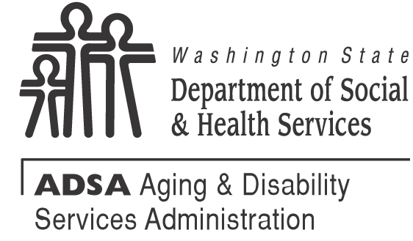
July 28, 2026

Print, sign and retain this certificate as documentation for department review, per WAC 388-78A-2550.
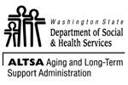
I, type your full name here, certify I have reviewed the information presented in the Department of Social and Health Services’ training on the Washington state statutes and administrative rules related to the operation of an assisted living facility.

Assisted Living Facility Administrator Date

