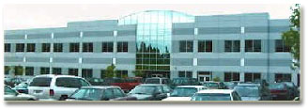
Blake Office East Building
4500 10th Ave. SE Lacey, WA
Residential Care Services of ADSA/DSHS is on the 1st floor
Administrative Services Division of MSA/DSHS is on the 2nd floor.
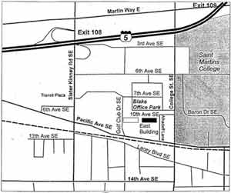

Directions from the North:
- Begin on I-5 heading South
- Take Exit 109 and make a right at the light onto Martin Way
- Make a left at the next light onto College Street
- Continue about a mile and make a right on Pacific Ave.
- Make a right onto Alhadoff Lane (next to the Mayan Restaurant)
- Go about 20 feet. Turn left and Blake East is the first building on the left.
Directions from the South:
- Begin on I-5 heading North
- Take the College Street Exit and make a right at the light onto College Street SE
- Continue about 3/4 of a mile and turn right on Pacific Ave.
- Make a right onto Allhadoff Lane (next to the Mayan Restaurant)
- Go about 20 feet. Turn left and Blake East is the first building on the left.
**Parking is scarce - you are encouraged to carpool or use alternative transportation. You may also park at the Lacey Government Center Bldg, which is within view of our building, with our parking pass. Please contact the office you are visiting or go to 1st floor reception for a visitor parking pass for Blake East, Blake West or Lacey Government Center.

