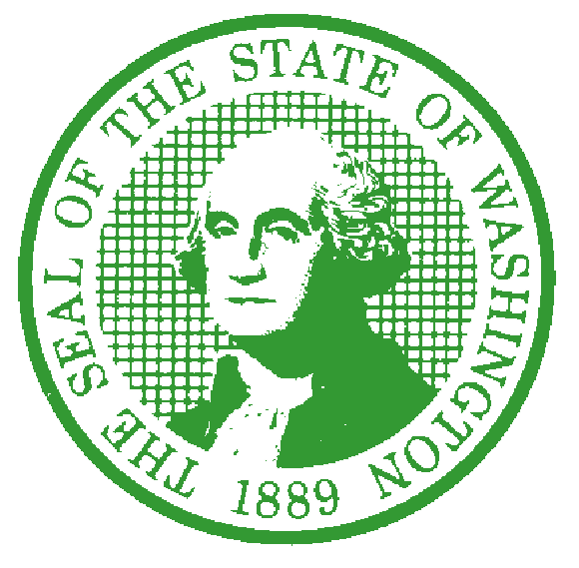

STATE OF WASHINGTON
DEPARTMENT OF SOCIAL AND HEALTH SERVICES
Aging and Long-Term Support Administration
PO Box 45600, Olympia, Washington 98504-5600

December 20, 2019

TO: Interested Persons

FROM: Libby Wagner, Adult Family Home Policy Program Manager
Aging and Long-Term Support Administration
Residential Care Services

SUBJECT: CONCISE EXPLANATORY STATEMENT (per RCW 34.05.325)
For Significant Legislative Rules
Proposed as WSR 19-17-065 and 19-21-117

SUBJECT MATTER AND WAC NO.:
WAC Chapter 388-76 Adult Family Home Minimum Licensing Requirements
New Section:
388-76-10401 Home and community-based setting requirements

REASON FOR ADOPTION: This proposal incorporates federal requirements for Home and Community Based Settings into the state licensing requirements for adult family homes. These regulations improve quality of life in adult family homes by giving residents greater opportunities to make decisions about their lives and care. The intent of these changes are to ensure that residents are able to receive care in a homelike setting and reduce dependence on isolating settings or institutions. By incorporating federal requirements into the state regulations, this will help adult family home providers to understand and meet their obligations.
DESCRIPTION OF HOW THE RULE IMPLEMENTS A LEGISLATIVE DIRECTIVE OR INTENT: Chapter 70.128 RCW requires adult family homes to follow all state and federal laws. 70.128.040 RCW directs the department to ensure the rules, policies, and procedures used to regulate adult family homes are not overly complex, but rather are easy to understand. Adult family homes are already bound by the federal home and community based setting requirements. This new rule adapts those requirements into state regulations to make it easier for them to be found by adult family home providers.
STATUTES AUTHORIZING THE ADOPTION OF RULES ON THIS SUBJECT: 70.128.040 RCW

DESCRIPTION OF THE PROCESS TO INVOLVE PUBLIC STAKEHOLDERS IN THIS RULE’S DEVELOPMENT: In addition to the required notification and comment process that is part of the rule making process, the text of the new rule was provided to the Adult Family Home Council, the office of the Long Term Care Ombuds Program, and multiple interested adult family home licensees for feedback.
The draft language was posted on the Adult Family Home provider website. A letter was also posted, with notifications of the posting going to stakeholders to inform them of the rule-making process and to encourage them to contact us regarding questions or suggestions for the rule development. A public hearing was held on September 24, 2019. After the first public hearing, it was determined that the rule constituted a significant legislative rule, although the original CR 102 filing had not listed it as such. A supplemental CR 102 was filed to correct that error, opening a second public comment period. A second public hearing was held on November 26, 2019. No public comments were received in either public comment period.

CHANGES MADE SINCE THE RULE WAS PROPOSED: (check one)

The rule text being adopted and Cost-Benefit Analysis do not differ from proposal.

The rule text being adopted and/or Cost-Benefit Analysis contain only editorial changes from the proposal.

The text of the adopted rule and/or Cost-Benefit Analysis vary from the proposal. The changes, other than editing changes, follow: Please see table below.

The changes were made because:

SUMMARY OF COMMENTS RECEIVED | THE DEPARTMENT CONSIDERED ALL THE COMMENTS. THE ACTIONS TAKEN IN RESPONSE TO THE COMMENTS, OR THE REASONS NO ACTIONS WERE TAKEN, FOLLOW.

cc: DSHS Rules Coordinator

