INFORMAL DISPUTE RESOLUTION (IDR)

PROVIDER REQUEST FORM INSTRUCTIONS

All items marked with a red asterisk (*) must be completed for the request form to be successfully submitted to the IDR Unit.

Provider Type
AFH – Adult Family Home
ALF – Assisted Living Facility
CCRSS – Certified Community Residential Services and Supports (supported living, group training homes)
ESF – Enhanced Services Facility
Group Home – Licensed as either ALF or AFH
ICF/IID – Intermediate Care Facilities for Individuals with Intellectual Disabilities
NH - Nursing Home traditional or panel
NH IIDR – Nursing Home Independent Informal Dispute Resolution (documentation review by independent contractor)

License Number/CCN Number/Certification Number:
The License number is used to identify Adult Family Home, Assisted Living, Enhanced Service Facility, and Group Home providers. The license number can be found on the Statement of Deficiencies:
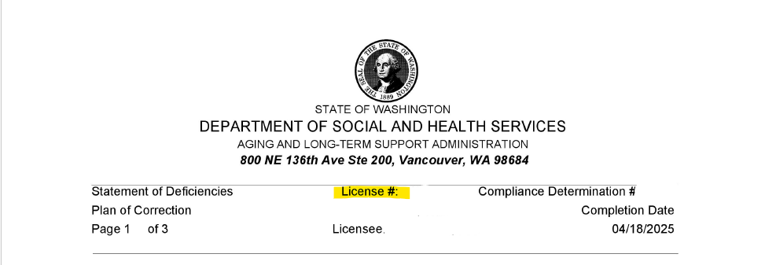

The CCN number is used to identify Intermediate Care Facilities for Individuals with Intellectual Disabilities and Nursing Home providers. The CCN number can be found on the Statement of Deficiencies, CMS form 2567:
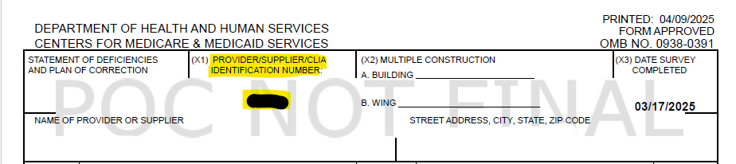

The Certification Number is used to identify Certified Community Residential Services and Supports providers. The Certification number can be found on the Statement of Deficiencies:
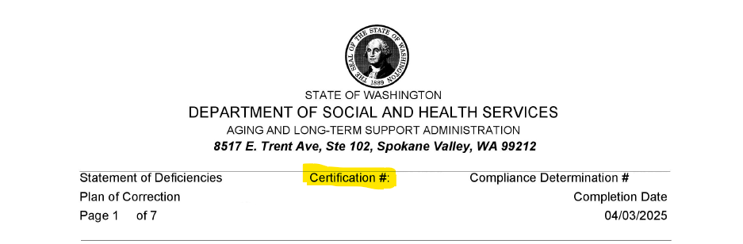

Facility Name
This is the name of the home/facility/agency that is listed on the license/CCN/Certification.

Mailing Address
List the address where correspondence is to be sent via postal mail.

Facility Contact
List the name of the person who IDR will contact regarding the dispute request.

Facility Contact Email and Phone Number
List a valid email address and telephone number for contact person requesting the dispute.

Submission
Working Days: any day the department is open for business (Monday through Friday, not to include holidays).

Calendar Days: any day of the month (including holidays and weekends).

IDR Review:
- Traditional IDR
  - Meeting between the provider and an IDR Program Manager. This meeting is scheduled for two hours regardless of the number of citations in dispute. No other staff from Residential Care Services are included in this meeting. This option is available to all provider types.
- Panel IDR
  - Meeting will be a virtual Teams meeting with a volunteer panel and an IDR Panel Chair. The volunteer panel consists of a provider representative, a Residential Care Services representative and a consumer representative. A panel IDR meeting is scheduled for 90 minutes and is only available for 3 or fewer disputed citations. This option is only currently available for Adult Family Home and Nursing Home providers.
Please refer to the IDR website for in-depth IDR Guidelines: Informal Dispute Resolution (IDR) | DSHS

IDR Review Type:
- Supporting Documentation Reviewed (no meeting)
  - There will be no meeting with the provider under this option. This is strictly a review by the Program Manager or Panel Volunteers of submitted written documentation.
- Virtual (video meeting)
  - This is a scheduled meeting which is held virtually through Teams. A Teams meeting invitation will be sent to the provider with information on when and how to join the meeting with the video/camera on.
- Telephone (meeting over telephone)
  - This is a scheduled meeting over the telephone with no cameras. A meeting invitation will be sent to the provider with information on the date and time the meeting is scheduled for along with the telephone number to call.

Statement of Deficiency (SOD) Date:
This is the date of the SOD also known as Completion Date, not the cover letter date or enforcement letter date.
Example of where to find the SOD date for AFH, ALF, ESF, Group Homes and CCRSS providers can be found in the highlighted portion of the following image:
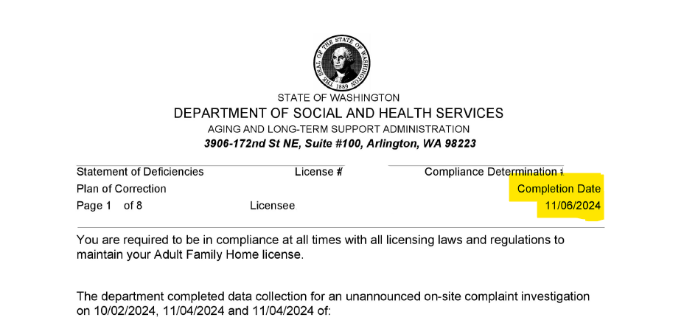

Example of where to find the SOD date for NH and ICF/IID providers can be found in the highlighted portion from the Statement of Deficiencies, CMS form 2567:

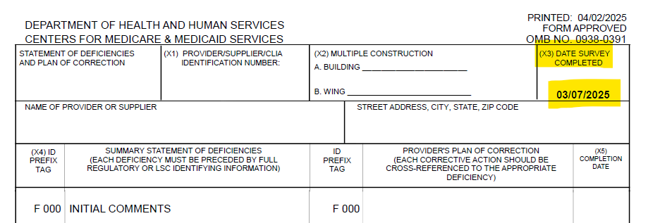

Note: If you do not have a SOD (ie: such as a consultation only letter or enforcement pending investigation), you can use the consultation or enforcement letter date in lieu of a SOD date.

Compliance Determination/Event ID Number:
The Compliance Determination number is found in the upper right hand corner on the first page of the SOD and applies to only AFH, ALF, ESF, Group Homes, and CCRSS providers. An example of where to find the Compliance Determination number can be found in the highlighted portion of the following image:

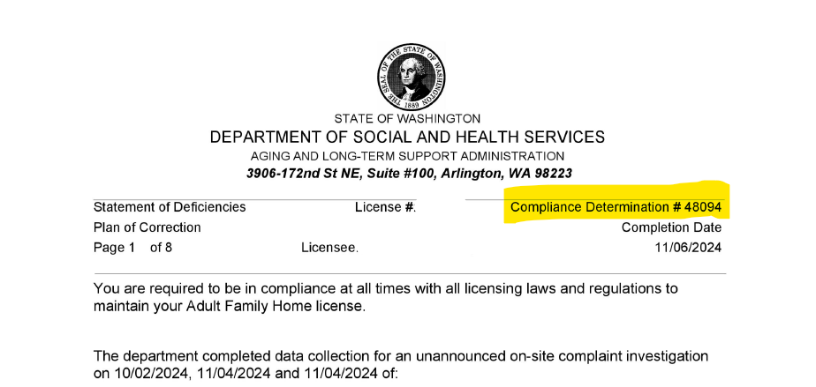

Event ID: Can be found on the Statement of Deficiencies, CMS form 2567 at the very bottom and applies to only NH and ICF/IID providers.
An example of where to find the Event ID# can be found in the highlighted portion of the following image:

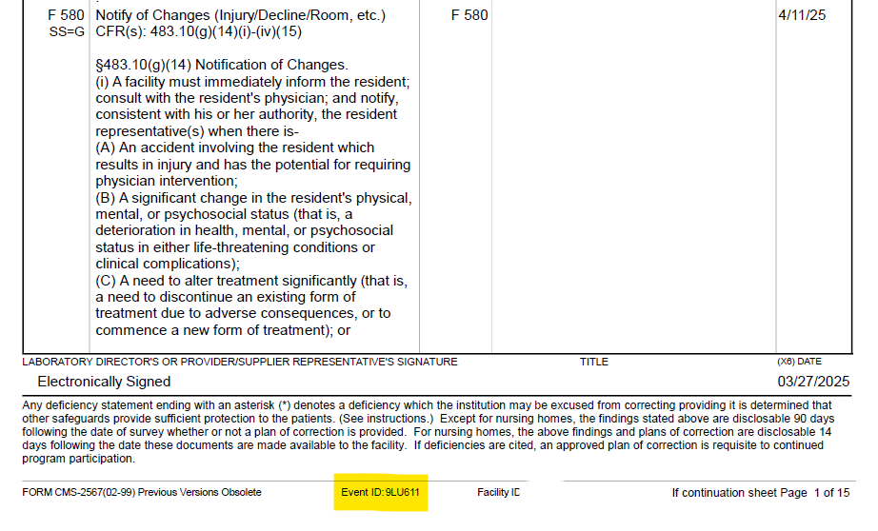

Regulation(s) Being Disputed:
Regulation refers to WAC, RCW, CFR or Ftag as applicable by provider type. List in a single line item the regulation being disputed. If you are disputing multiple regulations, you can list them all in this section, please separate by a comma.

Enforcement Action:
Select Yes if there are enforcement actions regarding the citation in dispute, select No if there are not enforcement actions. Examples of enforcement actions can include, but not limited to: civil fines, stop placement, and revocation.

Reason(s) for Dispute:
Please provide a brief explanation of why you are disputing the citation. If you are disputing more than one citation, provide a brief explanation for each dispute.

File Upload:
It is helpful to provide documentation that can support your dispute. Only send documentation that is relevant to the issue being disputed.

You will receive confirmation of the IDR Request Form submission. Retain this confirmation for your records.

Once the request has been submitted and confirmation send to you, the IDR team will reach out to you with any further questions and/or information on moving forward with selecting a date and time for the IDR meeting.

You can also choose to email or fax the documentation to the IDR unit. Please be sure to include your Facility Name and License/CCN number/Certification number on the correspondence.
Email: RCSIDR@dshs.wa.gov
Fax: 360-725-3225

What if I want to withdraw an IDR request?
To withdraw a previously submitted IDR request, please contact the IDR unit at RCSIDR@dshs.wa.gov or by calling 360-725-3233.

