PRINT TROUBLESHOOTING

1. Do you have enough paper?

- Make sure you load an adequate supply of paper prior to printing the full application. (The number of pages for each application is noted next to the listing for each application type.)

2. Are you receiving an error message that looks like this?
(Note: The error message may reference a different section number
than the one shown in the example below.)

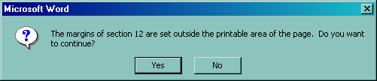

- If you receive one or more messages similar to the above that pertain to any section of the application, click on "Yes" to continue printing.

- This will have no adverse effect on the final printed product.

- Failure to click on the “Yes” box will result in only partial printing of the application.

3. Still having trouble?
- Contact RCS Business Analysis & Applications Unit at (360) 725-2420.

