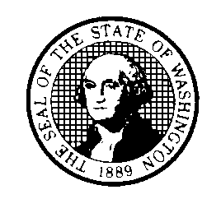
STATE OF WASHINGTON
DEPARTMENT OF SOCIAL AND HEALTH SERVICES
Residential Care Services
PO Box 45600, Olympia, WA 98504-5600
________________________________________________________________
Statement of Deficiencies/ Certification#: Completion Date:
Plan of Correction (Provider Name) (Green Card Date)
Page 1 of 2
_____________________________________________________________________________
You are required to be in compliance at all times with all laws and regulations to maintain your certification.

The department completed data collection for the unannounced on-site
(choose one of the following and delete the rest:) Certification Inspection, Certification Inspection Follow-Up; Complaint Investigation referencing Complaint Number(s) (if complaint insert, complaint numbers); Complaint Investigation Follow-Up on (insert all dates on-site for all types of visits) of :

(Insert Provider Name/Address)

We reviewed the following sample during the unannounced on-site visit: (sample number) of (total number) current clients and (if any) former clients.

The (department staff and/or contracted evaluators) that inspected/investigated the agency:
(Investigator/Evaluator name here)

From:
DSHS, Aging and Disability Services Administration
Residential Care Services
PO Box 45600
Olympia, WA 98504-5600

Because of the on-site visit(s) the department found that you are not in compliance with the laws and regulations as stated in the cited deficiencies in the enclosed report.

Residential Care Services Date

I understand that to maintain certification I must comply with all of the laws and regulations at all times.

Administrator (or Representative) Date

(insert WAC reference)

This requirement was not met as evidenced by:
(Start with based on statement here then list findings)

Plan of Correction: Date Completed:

