

STATE OF WASHINGTON
DEPARTMENT OF SOCIAL AND HEALTH SERVICES
Aging and Long-Term Support Administration
PO Box 45600, Olympia, Washington 98504-5600
April 27, 2022

ALTSA: ICF/IID #2022-010
QSO-22-15-NH & NLTC & LSC UPDATE TO COVID-19 EMERGENCY DECLARATION BLANKET WAIVERS FOR SPECIFIC PROVIDERS

Dear ICF/IID Superintendent:

In response to the COVID-19 public health emergency (PHE), the Center for Medicare and Medicaid Services (CMS) enacted several temporary emergency declaration blanket waivers. The waivers were intended to provide health care providers with extra flexibilities during the PHE.

On April 7, 2022, CMS released QSO-22-15-NH announcing the end of waivers for 42 CFR 483.470(j) listed below. These waivers will expire 60 days from the date the memo was released, which will be June 5, 2022.

Facility and Medical Equipment Inspection, Testing, & Maintenance (ITM): CMS waived ITM requirements for facility and medical equipment to reduce disruption of patient care and potential exposure or transmission of COVID-19.

Life Safety Code (LSC) and Health Care Facilities Code (HCFC) ITM: CMS waived ITM required by the LSC and HCFC, with specified exceptions, which permitted facilities to adjust scheduled ITM frequencies and activities to the extent necessary.

Outside Windows and Doors for ICF/IID: CMS waived the requirement to have an outside window or outside door in every sleeping room. This permitted spaces not normally used for patient care to be used for patient care and quarantine.

Life Safety Code for ICF/IID: CMS waived these specific LSC provisions.
- Fire Drills: Due to the inadvisability of quarterly fire drills that move and mass staff together, CMS permitted a documented orientation training program related to the current fire plan, which considered current facility conditions.
- Temporary Construction: CMS waived requirements that would otherwise not permit temporary walls and barriers between patients.

Thank you for your continued commitment to resident health and safety. If you have any questions, please contact Debbie Hoeman, ICF/IID Policy Program Manager, at (360) 725-3210 or Debbie.Hoeman@dshs.wa.gov.

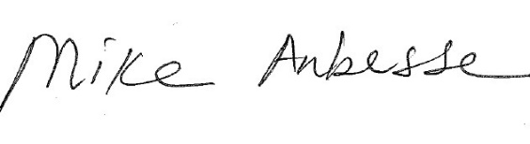
Sincerely,

Mike Anbesse, Director
Residential Care Services

DSHS: “Transforming Lives”

