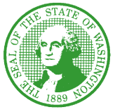

STATE OF WASHINGTON
DEPARTMENT OF SOCIAL AND HEALTH SERVICES
Aging and Long-Term Support Administration
PO Box 45600, Olympia, Washington 98504-5600
May 26, 2022

ALTSA: NH #2022-031
CR-103E FILED TO EXTEND EMERGENCY RULES AMENDING NURSING HOME REQUIREMENTS FOR DISASTER AND EMERGENCY PREPAREDNESS
AND RESIDENT ROOMS

Dear Nursing Facility/Home Administrator:

On June 23, 2020, the Department of Social and Health Services (the department) filed an emergency rule (WSR 20-14-026) related to fire drills, windows in resident rooms and quality assurance requirements in response to the significant threat of COVID-19. Since then, the department filed consecutive extensions to maintain the emergency rules, with the most recent extension (WSR 22-04-038), effective February 3, 2022.

The Centers for Medicare and Medicaid Services (CMS) released QSO-22-15-NH & NLTC & LSC, announcing the lapse of the CMS 1135 blanket waiver related to quality assessment and assurance requirements on May 7, 2022. CMS continued the federal waivers related to fire drills and windows in each resident rooms. The department filed WSR 22-11-088 effective May 7, 2022, which cancels and supersedes WSR 22-04-038, reimplementing the requirements related to quality assessment and assurance under WAC 388-97-1760 for consistency with federal requirements. In addition, WSR 22-11-088 extends the amendment of the disaster preparedness and resident room rules to continue to align Washington state nursing home rules with federal rules.
The following amendments continue to be suspended under this rule filing effective May 7, 2022:
- WAC 388-97-1740 to remove the requirement for periodic fire drills. Documentation on training and responding to a fire is still required.
- WAC 388-97-2400 to waive the requirement for a transparent glass window. This will increase the ability for facilities to temporarily increase capacity by utilizing windowless space for resident rooms.

Additionally, the department filed a CR-101 (WSR 20-21-034) on October 12, 2020 to begin permanent rule making on the above rules and other related rules. The CR-101 is available on Aging and Long Term Support Administration’s (ALTSA) Information for Nursing Home Professionals web page, under “NH Rule Filings”. The department remains in discussion about adding language to the rules to explain the circumstances and times under which suspension of the rules was necessary due to COVID-19.

Thank you for your continued commitment to resident health and safety. If you have any questions, please contact Molly McClintock, Nursing Home Policy Program Manager, at
(360) 742-6966, or molly.mcclintock@dshs.wa.gov.

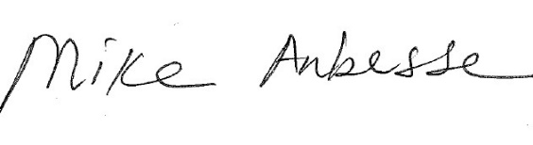
Sincerely,

Mike Anbesse, Director
Residential Care Services
DSHS: “Transforming Lives”

