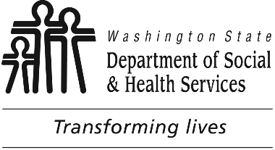

November XX, 2021

TO: Interested Persons

FROM: Sondra Silverman, LTC Policy Program Manager

SUBJECT: CONCISE EXPLANATORY STATEMENT (RCW 34.05.325)
For rules not considered significant

For rules proposed as WSR _21-18-104

WAC(s): WAC 388-97-0001, Definitions; WAC 388-97-1090, Direct Care Hours; and other related rules as may be required to implement EHB 1564 (Chapter 301, Laws of 2019).

REASON FOR ADOPTION: Required to implement EHB 1564 (Chapter 301, Laws of 2019).

CHANGES MADE SINCE THE RULE WAS PROPOSED: (check one)

The text being adopted does not differ from the text of the proposed rule.

The text being adopted contains only editorial changes from the proposed rule.

The text of the adopted rule varies from the text of the proposed rule. The changes (other than editing changes) follow:

The changes were made because:

SUMMARY OF COMMENTS RECEIVED | THE DEPARTMENT CONSIDERED ALL THE COMMENTS. THE ACTIONS TAKEN IN RESPONSE TO THE COMMENTS,  OR THE REASONS NO ACTIONS WERE TAKEN, FOLLOW.
No comments received. | No comments received.

cc: DSHS Rules Coordinator

