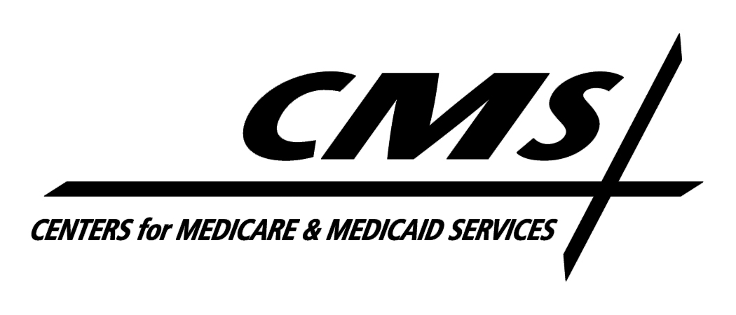Department of Health & Human Services
Centers for Medicare & Medicaid Services
7000 Security Boulevard, Mail Stop 02-02-38
Baltimore, Maryland 21244-1850

Center for Medicaid, CHIP, and Survey & Certification/Survey & Certification Group

Ref: S&C: 11-35-NH
DATE: August 12, 2011

TO: State Survey Agency Directors

FROM: Director
Survey and Certification Group

SUBJECT: Mandate of Section 6121 of the Affordable Care Act for Nurse Aide Training in Nursing Homes

Memorandum Summary

- Section 6121 of the Affordable Care Act mandates enhanced nurse aide training – The law mandates the inclusion of training for nurse aides working in nursing homes on abuse prevention and care of persons with dementia;
- Centers for Medicare & Medicaid Services Actions - Interpretive Guidelines have been revised for the Inservice Training Tag (F497). We are developing a regulation to mandate these topics and training materials that nursing homes may use to train staff.

We are pleased to report on the progress of a project mandated by Section 6121 of the Affordable Care Act to enhance the skills of nurse aides in two important areas:

- How to care for residents with dementia
- How to prevent resident abuse

The initial training requirements for new nurse aides currently include these topics. To fulfill the mandate of Section 6121, we have revised the Interpretive Guidelines for regulatory tag F497 to mandate the inclusion of these two topics in each nurse aide’s yearly training program. We are also working on revising the regulation to specifically include these two topics.

In addition, we have awarded a contract to Chenega Government Consulting, LLC for the analysis of current training products and the development of additional materials for nursing home professionals to use in training nurse aide staff on these topics. As part of this project, we will be consulting with experts and national stakeholder groups in order to ensure that any products developed will promote person-centered care as well as current clinical standards, principles and practices.

Page 2 – State Survey Agency Directors

In an effort to assist facilities to comply with this provision, we are attaching a list of training products that are currently available for these topics, as well as a description of the training development project. While the initial training focuses on nurse aides, it is our intent that facilities will expand the scope to include other direct and non-direct care staff in future trainings on abuse prevention and care of residents with dementia. If you have any questions or comments you may contact Karen Schoeneman at (410)786-6855, Karen.Schoeneman@cms.hhs.gov or Chris Allen at (410) 786-3322, Chris.Allen@cms.hhs.gov.

/s/
Thomas E. Hamilton

Attachments:
Alternative Training Materials for Sec 6121 of the Affordable Care Act
Prevention of Abuse and Care of Persons with Dementia

cc: Survey and Certification Regional Office Management

