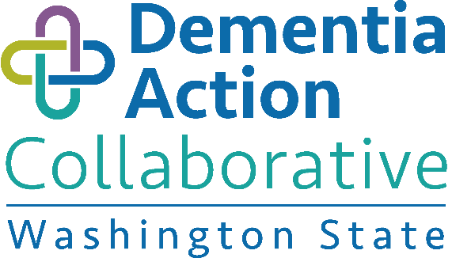

Dementia Action Collaborative:

Implementing the Washington State Plan to Address Alzheimer’s Disease and Other Dementias
September 27, 2017 | 9:30 a.m. to 3:30 p.m.
Tukwila Community Center | Directions: 12424 42nd Ave S, Tukwila, WA 98168

Celebrate! Collaborate! Activate!
DAC Members: | Bill Moss, Chair, Aziz Aladin, Basia Belza, Dave Budd, Carla Calogero, Leslie Emerick, Eric Erickson, John Ficker, Aime Fink, Charissa Fotinos, Jan Higman, Debbie Hunter, Patricia Hunter, Suman Jayadev, Arlene Johnson, Senator Karen Keiser, Todd Larson, Bob LeRoy, Maureen Linehan, Kathy Lofy, Cathy Macaul, Myriam Marquez, Jason McGill, LeighBeth Merrick, Emma Medicine White Crow, Diane Oakes, Mimi Pattison, Jerry Reilly, Kristoffer Rhoads, Marty Richards, Tatiana Sadak, Diane Thompson, Bruce Smith, Lauri St. Ours, Representative Steve Tharinger, Robert Wellington, Cheryl Townsend Winter
Staff: | Lynne Korte, Susan Engels, Hilarie Hauptman
Facilitator: | Porsche Everson, Relevant Strategies
PRE-READ | - Bree Collaborative Evidence-Based recommendations for Dementia  - DAC Position Paper – Brief Cognitive Screening Tools for Primary Care  - Dementia Plan Goals-Strategies-Recommendations Tracking
Meeting Goals | - Review accomplishments and about upcoming work 2017-2018  - Identify support/collaboration needed to complete recommendations in motion  - Identify priorities/action steps going into 2018

Agenda
9:30 - 10:00 am | Welcome and Networking | Bill Moss, DAC Chair  Porsche Everson, Facilitator
10:00 – 10:40 | Evidence-based Recommendations | Bree Collaborative | Ginny Weir, MPH  Bree Collaborative
10:40 – 11:10 | What’s New in the Fight Against Alzheimer’s? | Suman Jayadev, MD  UW Alzheimer’s Disease Research Center
11:10 – 12:10 | DAC Subcommittee Reports | Accomplishments & New Work  Exciting accomplishments, new work (2017/2018), anything needed from DAC – input, connections?  - Public Awareness-Community Readiness  - Long Term Services and Supports  - Health-Medical | Subcommittee Chairs  Cheryl Townsend-Winter  Bob LeRoy  Kris Rhoads
12:10 – 12:40 | Working Lunch – Share Program/Event Announcements | DAC Members
12:40 – 1:20 | Subcommittee Meet Up Time | Subcommittee Chairs
1:20– 1:45 | Brain Health Messaging Input | Marci Getz. MPH  Washington State Dept of Health
1:45 – 2:10 | Increased Supports for Family Caregivers  - CARE Act & Paid Family Medical Leave Act  - Medicaid Waiver & Caregiver Outreach Campaign | Cathy MacCaul, AARP  Susan Engels, ALTSA
2:10 – 2:30 | Advocacy Planning  - What are your agency’s current plans for legislative session?  - Is there a unified message/request that DAC stakeholders might want to put forward? | Bill Moss, ALTSA  Maureen Linehan, W4A  Bob LeRoy, Alz Association  Cathy MacCaul, AARP
2:30 – 3:00 | Moving Forward – Priority actions 2017-2018  Considering our framework of working through heightened collaboration and within existing resources.  - What’s working well?  - Is there anything we can do differently to improve our efficiency or AD Plan implementation? | Porsche
3:00 – 3:15 | Public Comment | Porsche
3:15 – 3:30 | Next Steps & Wrap Up | Bill/Lynne

