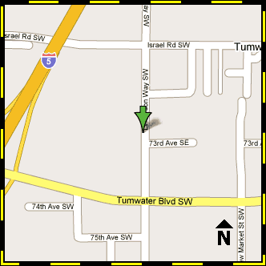

7273 Linderson Way SW
Tumwater, WA
98501-5414
(360) 902-5799
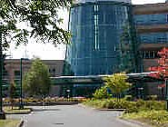

Labor & Industries' central office building, and the Tumwater service location, is located on Linderson Way between Israel Road and Tumwater Boulevard.

Interstate 5
Traveling north or south on Interstate 5, take Exit 101 (Tumwater Blvd.), head east to the first light. Turn left onto Linderson Way. The main entrance and visitor parking is the next entrance on the left after 73rd Ave SE.

City of Tumwater
Take Capitol Way south from Olympia to Israel Road, west to Linderson and left to the building.

