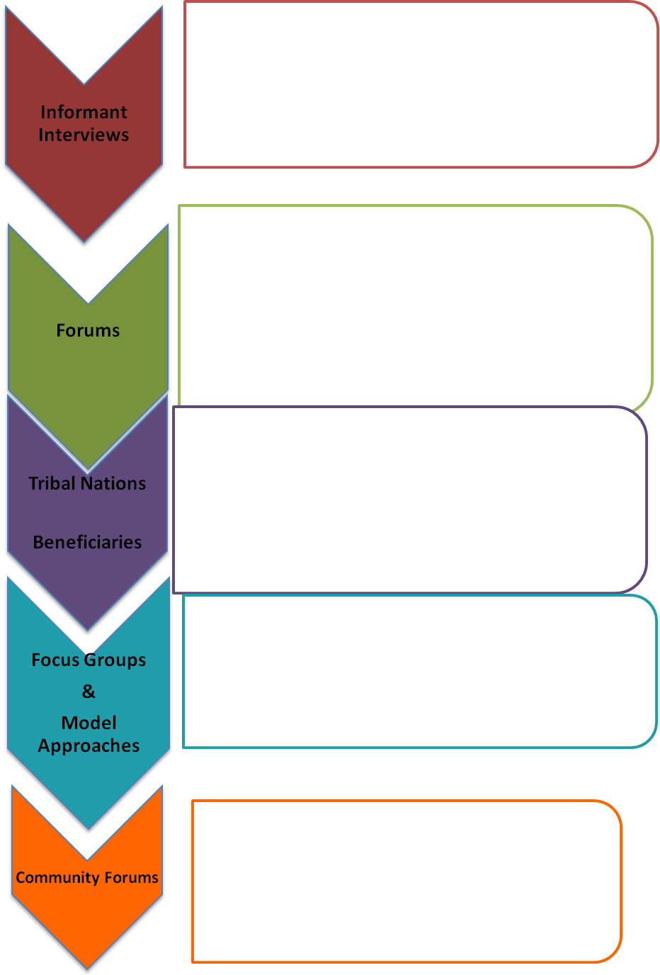
- Meet with beneficiaries/informants for input and feedback on:
- →Overview of Engagement Process & Framework
- →Description of forum meetings and break-out sessions, what is crucial for these groups to identify during the limited time together
- →Lessons Learned from past stakeholder work
- →Identify 2-3 beneficiaries who are interested in speaking with us
4 meetings (Yakima, Spokane, Everett, Lacey); targeted invitations to consumers, advocates, and providers
- Overview Forum: Share givens/limitations of current system, Governor’s messages, population overview, age wave & chronic condition data.
- 2 Breakout Forums: Primary Care and Community Based Care(challenges, opportunities, and core elements
- Final Forum: Interdependency discussion identifying common core elements of both discussions; ways to ensure coordination
These meetings will shape future engagement work

Concurrent engagement with Tribal Nations
Forum meeting with Tribal Nations

Concurrent process with beneficiaries
→Outreach to consumer organizations to identify representatives
→Methods will include surveys, forums, and focus groups

Facilitate focus groups with beneficiaries, advocates, and providers to drill down on core elements of model(s) and gaps in information. Iterative process with beginnings of model design approaches.
- Design work on specific components of model
- Targeted consumer and stakeholder feedback
→Interdependency and outcome measurements, etc

Unveiling of Duals Design model prior to submission

TIMELINE

July & August

August

thru

December

September
thru
December

Feb
March
DUALS ENGAGEMENT FRAMEWORK

Purpose: To inform and engage internal and external feedback to incorporate on an ongoing basis.
July 26, 2011

