Agenda  Service Experience Team Meeting  September 21st, 2017 9:00-12:00 |  | Location  ALTSA, Home and Community Services Holgate Office  1737 Airport Way S Suite 130; N95-2 Seattle, WA 98134  Bear Creek Room  Phone: 206-341-7600

Welcome, Introductions, Setting the Stage
- Introductions
- Ground rules
- Review charter
- Team why

Consumer Survey
- What does it cover?
- When does it happen?

Legislative Handout
- Review of plans for next legislative session

ALTSA Programs and Services Handout

Brief review of handout

Electronic Visitor Verification (EVV)

Overview of new rule & opportunities for feedback

Close of day

What’s next for the Service Experience Team?

Plus Delta

Evaluations
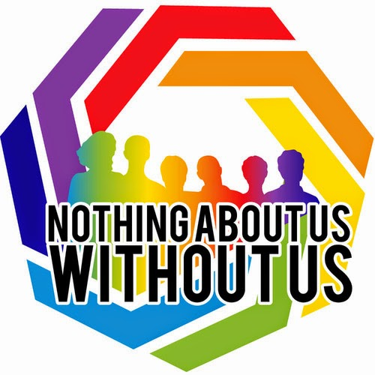
Don’t worry! We will take breaks when needed.

