Heart Disease, Stroke and Diabetes Prevention
Order Form

To order below materials: Please send this form to Marissa Floyd at Marissa.Floyd@doh.wa.gov any questions please call 360-236-3677. To turn form in by mail please use address below:
Washington State Department of Health
ATTN: Marissa Floyd (PPE)
310 Israel Road SE
Tumwater WA 98501
Pub # | Description | Size | Laminated | Non-Laminated | Picture | Qty. | Language
345-274 | Blood Pressure Tracker: This pocket-sized publication is for individuals to track blood pressure readings. | 8.5x5.5 card. (Print on 8.5x11 paper, then fold.) |  |  | 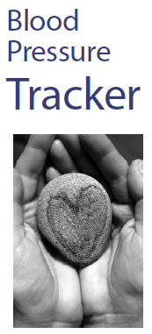 |  | English  Spanish  Chinese  Vietnamese  Russian
340-268 | Know Your Blood Pressure Numbers: This poster, designed to be used in a health clinic setting, gives information about blood pressure numbers and why it is important to keep track of blood pressure. | 11x17  8.5x11 |  |  | 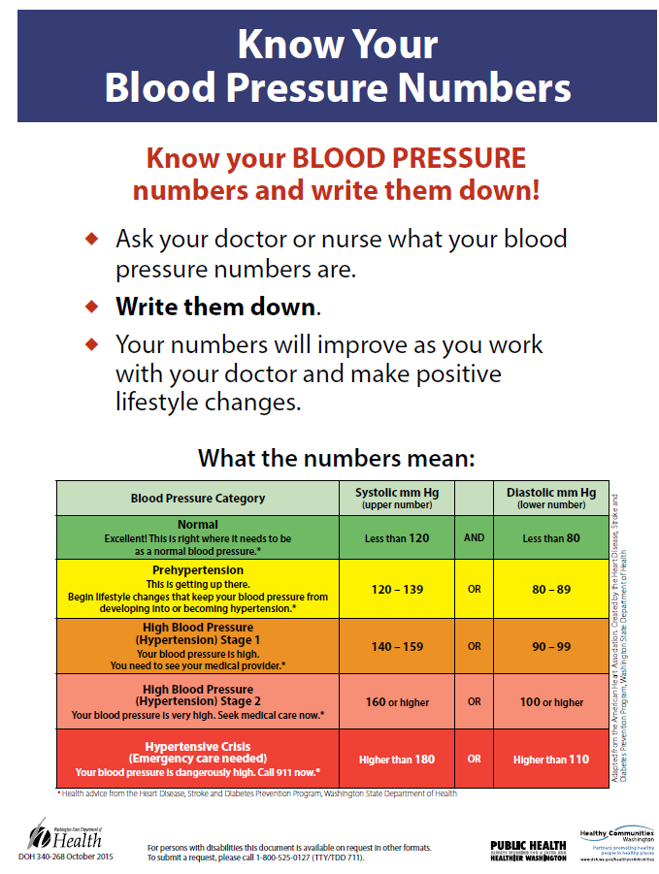 |  | English  Spanish  Chinese  Vietnamese  Russian
340-267 | Checking Your Blood Pressure: Taking Your Blood Pressure Poster: This poster shows how to take your blood pressure and is designed to be used by health care providers. | 11x17  8.5x11 |  |  | 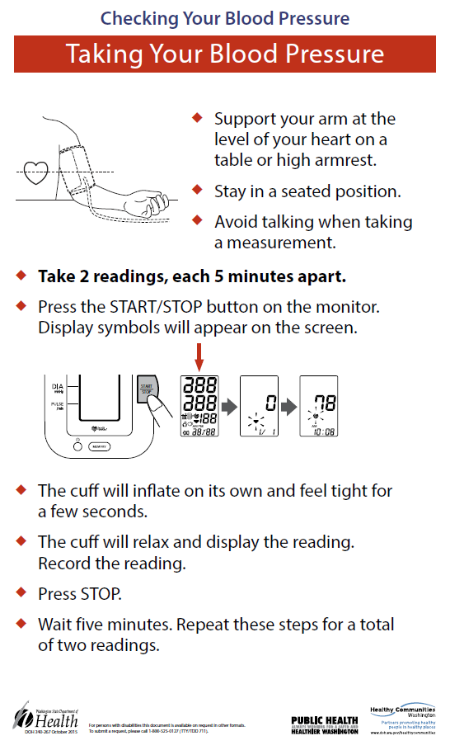 |  | English  Spanish  Chinese  Vietnamese  Russian
345-288 | What's the Big Deal About Controlling My Blood Pressure?: This poster, designed to be used in a health clinic setting, gives suggestions for making lifestyle changes that can lower blood pressure | 11x17  8.5x11 |  |  | 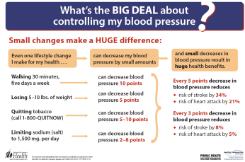 |  | English  Spanish  Chinese  Vietnamese  Russian
340-265 | Checking Your Blood Pressure: Before You Begin: This poster shows the steps to take for accurate measurement of your blood pressure and is designed to be used by health care providers | 11x17  8.5x11 |  |  | 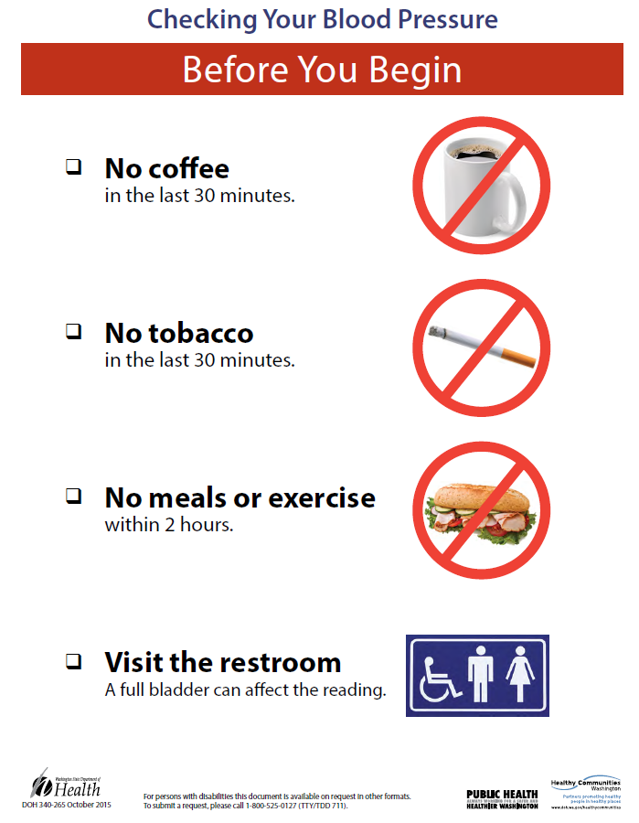 |  | English  Spanish  Chinese  Vietnamese  Russian
340-269 | Checking Your Blood Pressure: How to Check Your Blood Pressure: This poster shows the steps to take for accurate measurement of your blood pressure and is designed to be used by health care providers. | 11x17  8.5x11 |  |  | 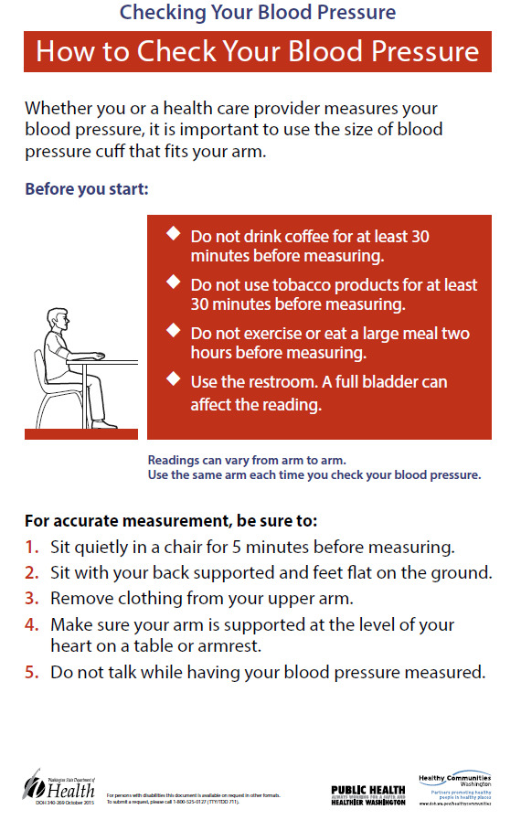 |  | English  Spanish  Chinese  Vietnamese  Russian
345-306 | Blood Pressure Measurement Training Kit: This kit provides information necessary to evaluate, organize, and train staff on the accurate measurement of blood pressure for the adult patient. It consists of a Training Guide, PowerPoint presentation, and training video, all packaged on a CD. The kit is available to any healthcare agency or medical professional and for training of healthcare staff. | NA |  |  |  |  | English  Spanish  Chinese  Vietnamese  Russian
345-273 | How to Check Your Blood Pressure: This publication describes the steps for someone to take their own blood pressure. The manual includes a tear-out wallet card to track blood pressure readings. | 8.5x5.5 booklet |  |  | 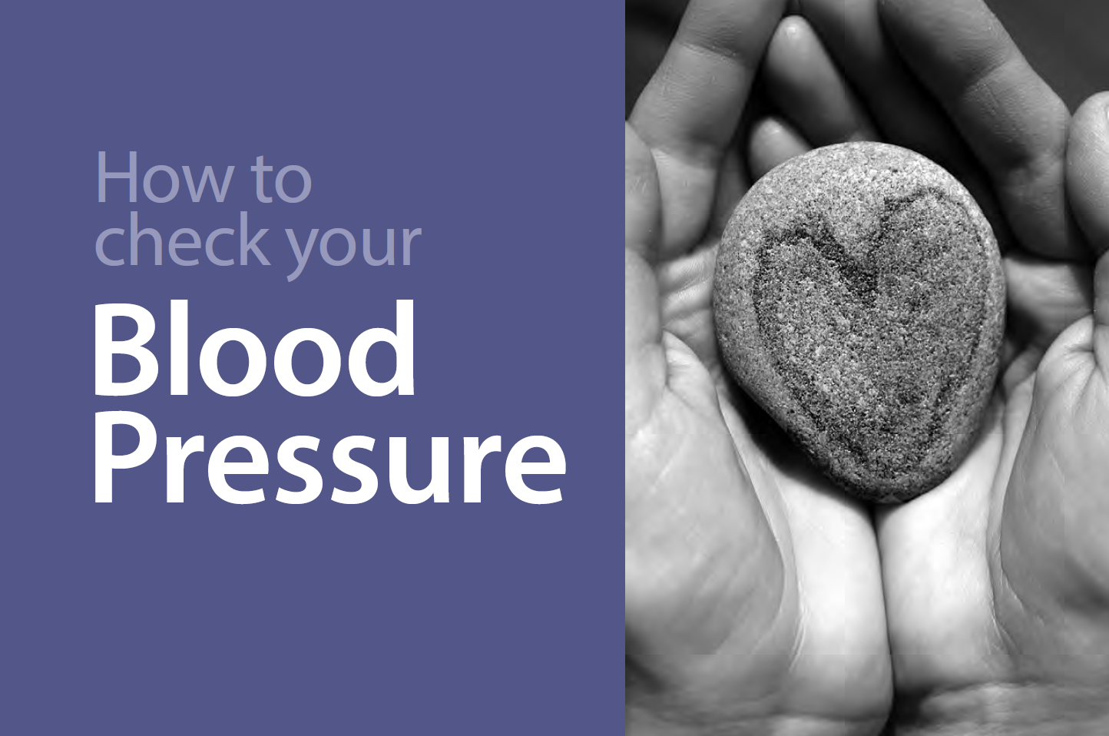 |  | English  Spanish  Chinese  Vietnamese  Russian
340-272 | What is Blood Pressure?: This publication will be available for patients in health clinics. It outlines the importance of improving your blood pressure and the risks associated with having high blood pressure. The publication also includes questions to ask your medical provider, ideas for making healthy lifestyle changes and online resources. | 8.5x11 brochure |  |  |  |  | English  Spanish  Chinese  Vietnamese  Russian
345-283 | Improving the Screening, Prevention, and Management of Hypertension – An Implementation Tool for Clinic Practice Teams: This 130-page publication is for health care professionals and specifically clinic practice teams. It is meant to serve as a quality improvement guide and a compilation of resources to support practices in their efforts to improve blood pressure control. | 8.5x11 toolkit |  |  | 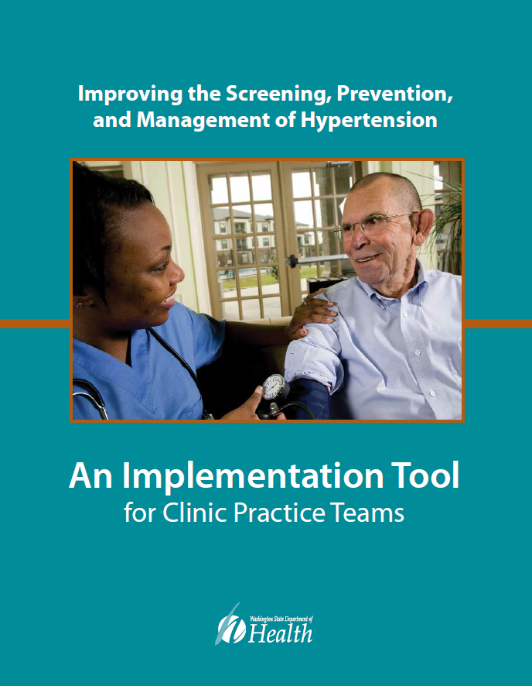 |  | English

