REPORT TO THE LEGISLATURE

Long-Term Care Workforce Workgroup

Recommendations on
“Informed Choice”

RCW 74.39A.058

October 1, 2022

Compiled on behalf of the workgroup by the
Washington State Department of Social and Health Services
PO Box 45600 Olympia, WA 98504-5600
(360) 725-2272
https://www.dshs.wa.gov/altsa

TABLE OF CONTENTS

Contents
Executive Summary 5
Challenges 6
Impact 9
Solution 10
Summary of Recommendations 13
Background 14
Legislative Mandate 14
Washington State Background Check Process 17
Individual Provider Background Check Results 18
Self-Direction Defined 19
Long-Term Care Forecast Statistics 21
Work Group Composition and Process 23
Work Group Process: Integrated Approach 24
Telling Our Stories 26
Racial Disparities in Charges and Disqualifications in Providing Paid Home Care Services 29
Study of the States 33
State Comparison Chart 38
Risk Assessments 39
Dignity of Risk 39
Paid vs. unpaid care relationships 41
Risk to state and administrative employer 41
Client responsibility 41
Risk Recommendations 42
Recommendations 44
Guiding Principles 44
Program Recommendations – Further Detail 46
1. Process Recommendations: 46
2. Client Impact Recommendations: 47
3. Caregiver Impact Recommendations: 48
4. Administrative Employer Impact Recommendations: 49
5. Tribal Government Recommendations: 50
6. Liability Recommendations: 50
7. Disqualifying Crimes Recommendations: 51
8. Communication Strategy Recommendations: 52
9. Program Quality Assurance Recommendations: 53
10. Risk Recommendations for Agencies and Clients: 53
Conclusion 54
Summary and Next Steps 54
Appendixes 57
Appendix 1 Engrossed House Bill 1411 Section 2 57
Appendix 2 Informed Choice Work Group Member Roster 59
Appendix 3 Informed Choice Work Group Charter 61
Appendix 4 Additional Acknowledgements 64
Appendix 5 Background Check Central Unit Process 66
Appendix 6 Summary of Informed Choice Guiding Principles – Polling Results 68
Appendix 7 Department of Health Briefing Paper 72
Appendix 8 State Research 74

Executive Summary

During the 2021 Regular Legislative session Substitute House Bill 1411 passed and was signed into law on July 27, 2021. Section two of this bill directs the Department of Social and Health Services (the department) to convene a workgroup to make recommendations for a process of Informed Choice to allow people relying on Medicaid services to hire a trusted individual as their Individual Provider — although this person has been disqualified because of their conviction record through the statutorily required background check process. These recommendations apply only to recipients of Medicaid services who choose to self-direct their identified services and supports and choose to hire an Individual Provider. These recommendations do not extend to all long-term care workers.

This report meets the requirement of Substitute House Bill 1411 to provide the Washington State Legislature with a final report by Dec. 1, 2022.

Substitute House Bill 1411 was sponsored by Representatives Simmons, Davis, Santos, Valdez, Berry, and Fitzgibbon.

The bill directs the department to facilitate a workgroup process to:

- Submit recommendations for a process of Informed Choice.

- Propose a communication strategy to inform older adults and people with disabilities about the Informed Choice process.

Workgroup members representing the diversity and interests of Washington’s residents, including Tribal Governments, community-based organizations, persons with conviction histories and persons receiving Medicaid services who are recipients of unpaid care from across the state, were invited as specified in the bill. Monthly meetings were conducted Jan. 2022 through July 2022. Meetings were conducted online via Zoom due to Covid-19 restrictions and safety protocols.

The Department of Social and Health Services is responsible for implementing the laws as written and amended by the legislature. The department values choice and the opportunity for recipients of Medicaid services to receive care in their own homes. The department submits this report and the enclosed policy recommendations on behalf of the 1411 Informed Choice workgroup.

Washington State is a national leader in creating and offering health service initiatives that deliver innovative and transformative solutions that foster healthy and safe communities — initiatives whose foundations are built on preserving choice, maintaining independence, and promoting dignity and control over the decisions that affect Washington’s residents — including individuals with disabilities and older adults who need assistance to live in the community.

The workgroup’s recommendations for Informed Choice support these core values along with the Department of Social and Health Services’ goal of promoting more power of choice for Washington State citizens.

Challenges

Growing Client needs vs. Individual Provider shortages:

The Department of Social and Health Services has identified a need for more health and long-term care Individual Providers to serve aging and vulnerable adults.

- Washington’s population over age 65 is expected to almost double by 2040, growing from 1.2 million to nearly 2 million.
  - Those 85 and older are identified as having a significantly higher rate of functional limitations and chronic health conditions.
  - An increasing proportion of the state’s older population, 65 and older, is becoming more diverse with more language diversity.

- The Office of Financial Management census (2020) identified approximately 175,924 people in Washington State with Intellectual and Developmental Disabilities.
  - As of July 2021, 49,282 people were enrolled with the Developmental Disabilities Administration.
  - Only 21% of people with Intellectual and Developmental Disabilities were known to/served by state agencies.
  - Paid service caseloads have grown at an average annual rate of 3%, since 2018. The paid services caseload increased by 4,107 clients.
  - Residents with Intellectual and Developmental Disabilities are younger, working-aged people, with increasingly complex needs.

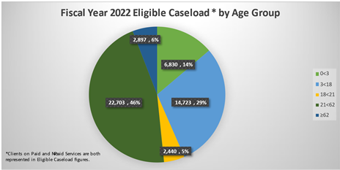

Washington’s pool of Individual Providers, needed to support its vulnerable adult and Intellectual and Developmental Disabilities population and their complex health needs, is insufficient to keep pace with the projected demand, let alone meet those needs in culturally responsive ways.

Racial Inequity in Criminal Legal System

The criminal legal system has resulted in the exponential growth in the rate of sentencing and incarceration in the United States over the past 30 years. 28% of Washingtonians now have criminal conviction histories – many of which disqualify them from becoming paid Individual Providers. These disqualifiers often impede their ability to obtain work and care for their families. Sentencing practices, rooted in historical racism, have impacted persons of color at higher rates and with more severe punishments. The criminal legal system and policies such as background checks continue to disproportionately harm communities of color by limiting reentry into meaningful employment. They may perpetuate poverty and foster an imbalance of opportunity for persons of color.

Background Checks May Discourage Entry into Workforce:

Washington law implements a rigorous background check process for Individual Providers who serve clients receiving Medicaid services. Persons with a conviction history may be disqualified from providing care or undergo an employer review process that may result in their removal from employment consideration.
Although the number of applicants that are disqualified or require review are low (see sample data on page 18), it is worth noting that the requirement to undergo a background check may be reducing the number of overall applicants intimidated by the background check process and may be contributing to a shortage of caregivers in this state.

Disqualifying Crimes

Washington State prohibits persons with pending charges, Adult Protective Service/Child Protective Service registries, and certain criminal convictions from providing paid care as an Individual Provider to people receiving Medicaid services in their own homes. The state has added exclusions to Individual Provider employment that are more expansive than the Federal disqualifying requirements outlined by the Office of the Inspector General. This has resulted in a list of disqualifiers that has created a barrier for clients who wish to hire a trusted, but disqualified person as their Individual Provider. These laws and policies have had a higher impact on people of color who have received unequal and sometimes racist sentences. Informed Choice does not change the underlying federal Medicaid law disqualifications. Workgroup recommendations pertain only to the additional restrictions created in state law.

Protections May Create Unintended Consequences:

In addition to workforce shortages, Washington State enacted laws and policies over the past several decades, like background checks, intended to provide an enhanced sense of safety and reduce the potential for harm for vulnerable adults receiving paid care services. These laws and policies likely have disproportionately impacted individuals from historically underrepresented communities and furthered continuing cycles of poverty. These protections have contributed to limiting entry into the workforce and removed the benefit of receiving payment for services provided. Ultimately, these laws and policies have restricted the opportunity for choice for those receiving services.

Competition in Labor Market

Healthcare organizations and state agencies are competing against all other industries for workers—many of which offer attractive wage and benefit packages for entry level positions.

State Laws

Due to Washington’s estate and tort laws, the client cannot assume full responsibility for their choice of an Individual Provider and waive the state, area agencies on aging and Consumer Direct Care Washington, LLC of liability. Allowing the client absolute and unilateral decision-making authority to hire an Individual Provider with a conviction history could have unintended consequences and potentially result in financial judgments against Consumer Direct Care Washington, LLC, the state, or the area agencies on aging.

Implementation of the Informed Choice program should include clear liability protections for Consumer Direct Care Washington, LLC, the state, and the area agencies on aging for any harm resulting from a client’s choice to hire an Individual Provider with a conviction history. Liability protections would provide protection to these agencies only within the scope of Informed Choice and as it relates to the Individual Provider hiring decision. Liability protections would not release the state, area agencies on aging or Consumer Direct Care Washington, LLC, for dereliction of oversight or duties in any other capacity.

Impact

When Individual Provider options are limited, choice and the opportunity to hire the person who can best meet one’s needs culturally, geographically, and physically becomes limited.

In some rural or Tribal areas, care recipients and Tribal Government representatives report that caregivers are scarce. Recipients of Medicaid services may go without needed support for their activities of daily living and/or become dependent on caregivers who do not qualify to become paid Individual Providers. This may place both the care recipient and the provider at risk for increased economic instability and health stressors according to AARP’s 2020 Report on Caregiving in the US.

Washington’s vulnerable adults need access to flexible and responsive care services and supports. Most people desire to receive those services in their own homes, and with Individual Providers they know and trust because the types of activities and tasks performed can be intimate and personal, such as dressing, bathing, and toileting.

The results of unfair, racially biased sentencing practices and the state’s rules determining Individual Provider eligibility for recipients of Medicaid services have disproportionately impacted Black, Indigenous and people of color.

When caregiver support is difficult to access, the risk that an individual may go without services not only increases but, the risk that an individual may go without consistent, culturally competent care is intensified—particularly for historically marginalized populations and Tribal communities in Washington.

Solution

- Expand the long-term care workforce by creating a new avenue of choice for people receiving Medicaid services when selecting their Individual Provider by implementing the Informed Choice program.

- Change policies for disqualifying crimes and background checks that have created unintended roadblocks to employment and contributed to barring persons with conviction histories, particularly for people of color who have been disproportionately impacted by the criminal justice system, from becoming an Individual Provider.

“This bill is a great step towards helping Washington meet its many goals all at once.

It will help many families in need of a caregiver to have a larger workforce eligible to meet those demands.

It will ensure that families who want to quit their job to care for their loved ones can do that without zero pay.

It will give individuals who have turned their lives around an opportunity to have a meaningful career with purpose.

In addition, because communities of color are disproportionately impacted with conviction records, it will make further progress on racial equity . . . It is a step forward.”

- Tarra Simmons, State Representative 23rd District

In forming these recommendations, the workgroup acknowledges the following:

- The quantitative impact of the Informed Choice program on the state’s Long-Term Care workforce projections are undetermined, however, workgroup members along with the Aging and Long-Term Support Administration, and the Developmental Disabilities Administration strongly support the rights of a person receiving public benefits to enjoy the freedom to direct their care services, hire the caregiver of their choice, and to be free from abuse, neglect, and exploitation. The Informed Choice recommendations support Washingtonians with disabilities and those who are aging to access the same flexibilities enjoyed by individuals who can pay for care services out of pocket.

- The number of Individual Providers that have been disqualified by background checks appears small when compared to the number of overall caregivers that will be needed to meet the state’s forecasted need (see page 21) but creating opportunity for more individuals to become Individual Providers may have significant, personal impact for a person receiving Medicaid services.

- The potential for abuse or neglect within the Informed Choice client/Individual Provider relationship exists, as it does within every client/caregiver relationship.
The caregiver’s conviction history may imply a presumption of higher risk that may be no greater or less than any other caregiver.

The meaningful, individual impacts of the Informed Choice program, such as personalized, culturally responsive care from a trusted individual will contribute to higher levels of client satisfaction, care service personalization, and safety.

The workgroup recommends reevaluation of the state’s concept of protection, through systems like background checks and registries. Are these processes creating unsafe situations by limiting a client’s choice of provider? Are recipients of Medicaid services institutionalized because trusted individuals are ineligible as caregivers?

Medicaid recipients desire caregivers who are family or trusted individuals. Many disqualified individuals are already providing unpaid care. Many people are willing and able to do this. However, it can place others at risk for economic impacts that may be contributing to cycles of poverty in Washington’s vulnerable and underrepresented communities.

By creating a new avenue of choice for its residents, Washington State can foster greater economic independence for its citizens. The Informed Choice program will put initiatives in place to begin to correct the disproportionate economic impacts that have been experienced by people of color and Tribal communities because of unfair criminal justice sentences. This process enables a Medicaid recipient to hire trusted persons with conviction histories. It gives the trusted individual a chance for meaningful work, and it helps move them into stable community engagement through the opportunity for jobs formerly unavailable to them.

Forging new paths of independence for Washington’s vulnerable citizens requires a planned approach to realize these opportunities and to address program risks.

The workgroup pursued a thoughtful process to examine client risks such as abuse, neglect, fraud, and undue influence. They also discussed the financial risks for state and administrative employers due to tort law in Washington and acknowledge that responsibility for the client’s hiring decision cannot be fully transferred to a client. Issues surrounding decisional capacity, evaluating the disqualifying crimes list, and creating liability protections will require further action and statutory change by the legislature to implement an Informed Choice program.

The workgroup weighed these risks and unresolved challenges against the opportunity risk that would be lost by failing to implement a program that improves client outcomes by allowing recipients of Medicaid services to direct their care more fully.

The workgroup supports client autonomy in the Individual Provider hiring decision and advocates for a system that balances the dignity of the client with strong liability protections for Consumer Direct Care Washington, LLC and future administrative employers, and immunity for the state and area agencies on aging as it pertains to the self-directed client’s choice of provider and hiring decision.

The Informed Choice program recommendation is a small, but impactful first step for individuals with disabilities and older adults who need assistance to live in the community
to be able to design and direct a portion of their healthcare delivery. This step empowers choice, safety, cultural competency, economic stability, a broad and diverse workforce, racial equity, and the anticipation of a higher level of person-focused care.

Summary of Recommendations

The workgroup agreed to a set of Guiding Principles to establish person-centered outcomes for an Informed Choice program (see page 44).

The recommendations focused on ten key areas:

- Program process
- Impacts to recipients of Medicaid services
- Impacts to caregivers
- Impacts to the state, area agencies on aging, and administrative employer
- Tribal Government
- Liability
- Disqualifying crimes
- Communication strategies
- Quality Assurance
- Risks for agencies and clients

Detailed program recommendations can be found on pages 46.

Background

Legislative Mandate

Substitute House Bill 1411 contains 3 sections. The sections have been presented in this report, out of order, as Sections 1 and 3 provide necessary background information. Section 2 is the impetus for this report and the workgroup’s recommendations.

HB 1411 Section 1

The bill amended the law to make six formerly permanently disqualifying convictions only be disqualifying for a period. Once the time has elapsed, the convictions are no longer disqualifying, and a long-term care employer (all settings) performs a Character, Competence, and Suitability review. For Individual Providers, the Consumer Directed Employer and the client perform this review.

Disqualifying Crime (prior to HB 1411) | Amended as of July 25, 2021
Selling Marijuana to a person under RCW 96.500.401 | After 3 years or more have passed between the most recent conviction and the date the background check is processed
Theft in the first degree under RCW 9A.56.030 | After 10 years or more have passed between the most recent conviction and the date the background check is processed
Robbery in the second degree under RCW.9A.56.210 | After five years or more have passed between the most recent conviction and the date the background check is processed
Extortion in the second degree under RCW 9A.36.021 | After five years or more have passed between the most recent conviction and the date the background check is processed
Assault in the second degree under RCW 9A.36.021 | After five years or more have passed between the most recent conviction and the date the background check is processed

HB 1411 Section 3

Implement a Certificate of Restoration of Opportunity.

The bill authorizes the Department of Social and Health Services to exercise its discretion regarding whether to permit or prohibit a person with a Certificate of Restoration of Opportunity to have unsupervised access to children, vulnerable adults, or individuals with mental illness or developmental disabilities. It removed long-term care workers and other service providers from the exempted individuals list.

The bill creates a new process for long-term care workers to receive “Review Required” background check result letters instead of “Disqualify” when a Certificate of Restoration of Opportunity has been granted.

HB 1411 Section 2 - Legislative Mandate

Section 2, RCW 74.39A Informed Choice, requires that the department facilitate a workgroup to recommend expanding the long-term care workforce while continuing to recognize the importance of protecting vulnerable people.

The department is directed to convene a workgroup to make recommendations for a process of Informed Choice which would allow a person receiving Medicaid services to hire an Individual Provider, although that person has been disqualified from participating in a state paid program to compensate them for care provided, due to their conviction record.

Recipients of Medicaid services, who choose to live at home, are offered the choice at their assessment between receiving care from an employee of a licensed home care agency or an Individual Provider. An Individual Provider may be a family member, friend or trusted individual selected by the client. Home care agencies are statutorily prohibited, in most instances, from being paid if the caregiver is related to the person to whom they are providing care. The individual who needs care hires and supervises the caregiver, but the caregiver is paid by the state for these services. Individual Providers are employed with a private employer, Consumer Direct Care Washington, LLC to provide these services when they meet the requirements.
Individual Providers are represented by the Service Employees International Union Local 775.

It also directs the workgroup to consider the following topics in the formation of a recommended process:

- Client safety
- Client direction
- Racial equity
- Cultural competence
- Economic consequences of unpaid caregiving on caregivers and people receiving care
- Categories of eligible workers (family, friend, trusted individuals, or others)
- Disqualifying crimes
- Mechanisms for consideration (attestation, petition, other)
- Workforce development
- Disparities in charges and disqualifications in providing paid home care services

See Appendix One for Section Two of the bill.

This report meets the requirement to provide the Washington State Legislature with a final report by Dec. 1, 2022.

Washington State Background Check Process

Requirements in Washington State statute and rule require a robust system of background checks for Individual Providers prior to having unsupervised access to, working with, or providing supervision, care, or treatment to vulnerable adults or children.

- Individual Providers must complete a Washington State Name/Date of Birth check and a Federal Fingerprint Check.

- If they pass the in-state check a person may work provisionally for 120-days pending the outcome of the fingerprint check.

- Applicants found with a disqualifying conviction, pending charge or negative action may not work as paid Individual Providers, regardless of the wishes of the client.

- Applicants with convictions or pending charges that are not automatically disqualifying must undergo an employer review of Character, Competence and Suitability.

- Washington State’s list of disqualifying crimes exceeds the Federal requirements.

Although the number of applicants disqualified due to the state name/date of birth and national fingerprint checks is low, Washington’s required system of background checks likely creates a chilling effect on the number of applicants. The requirements may prevent prospective Individual Providers from applying because of concerns that they cannot pass the background check requirements.

- Bea Rector, Assistant Secretary, Aging and Long-Term Support Administration

Individual Provider Background Check Results

The Background Check Central Unit is the entity within the department that conducts background checks on Individual Providers. Consumer Direct Care Washington, LLC is the contracted Consumer Directed Employer established in RCW 74.39A.500 and acts as the administrative employer for Individual Providers.

Statistical data was pulled by the Background Check Central Unit from 2019 and presented to the workgroup to reflect data from a “normal/pre-pandemic” year. Federal fingerprint checks were paused during the pandemic from March 2020 - April 2022, by proclamation of the Governor. Less than one percent of the Individual Providers were disqualified due to the State or Federal Fingerprint checks in 2019.

2019 Name/Date of Birth Background Check Results (STATE)

 | All LTC Workers (103,013) | Individual Providers (20,737)
No Record | 88,353 | 17,198
Review Required | 14,013 | 3,407
Disqualified | 1,447 (1.4%) | 132 (0.6%)

2019 Fingerprint Background Checks (FEDERAL)

 | All LTC Workers  (51,183) | Individual Providers (12,081)
No Record | 44,409 | 10,072
Review Required | 6,683 | 1,976
Disqualified | 91 (0.2%) | 33 (0.3%)

2019 Top 10 Disqualifying Crimes – Individual Providers

By Type:
- Assault 4/Simple assault (less than 3 years)
- Drug crimes involving manufacture, delivery or possess w/intent to manufacture or deliver
- Theft 3 (less than 3 years)
- Theft 1
- Assault 3
- Assault 2
- Robbery
- Residential burglary
- Theft 2 (less than 5 years)
- Welfare theft / welfare fraud (Convicted on or after 7.1.04)

Self-Direction Defined

The Informed Choice program recommendations apply only to recipients of Medicaid services who wish to self-direct their healthcare services in their own homes.

According to the organization, Applied-Self Direction, client self-direction is a model of long-term care service delivery that helps people of all ages, with all types of disabilities, maintain their independence at home.

When a person self-directs, they decide how, when, and from whom their services and supports will be delivered.

Self-direction prioritizes participant choice, control, and flexibility. This contrasts with "traditional" services received from an agency, where the agency controls most aspects of service delivery, including who will provide the service.

In self-direction, the participant selects and trains their own staff, develops their staff's schedules, and sets their own standards for how their services will be delivered. Today, over 1 million Americans self-direct, and most self-directed services are funded by Medicaid. Self-directed services are a flexible, person-centered, and cost-effective alternative to nursing homes and other institutional settings.

Nationally, services that are most often self-directed include personal care, transportation, and respite. Participants often choose to hire family members and friends to provide these and other services.

An individual who wants to self-direct but, is unable or unwilling to perform employer duties themselves, may appoint a representative to serve as the employer on their behalf. These supports help ensure self-direction is accessible to everyone, regardless of their age (over 18) or disability.

Each state differs in its self-directed program options. Washington’s program, established over four decades ago, enables a client to choose to receive in-home care services from an Individual Provider. The client, or their representative, has primary responsibility for locating, screening, hiring, supervising, and terminating the Individual Provider. The Consumer Directed Employer is the administrative employer.

Self-directed care under Chapter 74.39 RCW must be directed by an adult client with a functional disability, living in their own home, for whom the health-related tasks are provided.
The adult client is responsible to train the Individual Provider in the health-related tasks which the client self-directs and that they cannot do without assistance because of their disability.

Washington State’s Developmental Disabilities Administration currently serves 16,969 clients under eighteen years of age who have paid caregivers with parents or legal guardians making decisions on behalf of the care recipient that reflect their preferences and choices.

Washington’s program of self-direction allows a family member to provide skilled tasks and be paid for those services – enabling family members, employed as Individual Providers, to provide health-related tasks that other long-term care providers can perform only under nurse delegation.

Self-direction is based on the principle that people with disabilities are in the best position to plan and manage their own services.

- Applied Self-Direction Website

Informed Choice implications

The workgroup’s Informed Choice recommendations remove discretion for hiring, only in instances related to the conviction history of the Individual Provider, from Consumer Direct Care Washington, LLC.

Consumer Direct Care Washington, LLC would maintain discretion for all other administrative employment practices. They request continued discretion in the hiring process, depending on the nature and recency of the offense, until statutory liability protections, specific to Informed Choice, are established.

SEIU 775 requests a deadline by which liability protections are established and discretion to overrule client self-determination by the administrative employer is phased out.

Without additional statutory protections for the state, area agencies on aging, and administrative employers, due to the state’s joint and several liability laws and wrongful death statute RCW 4.20.020, the Informed Choice recommendations place these agencies at risk for litigation or associated judgments related to the client’s choice to hire a trusted individual as their Individual Provider when that person has been disqualified from paid service due to their conviction history.

Long-Term Care Forecast Statistics
(Age, Need, Preferences, Demographics):

Washington’s population over age 65 is expected to nearly double by 2040 from 1.2 million to nearly 2 million.

- Approximately 70% of individuals who reach age 65 will need long-term care in their lifetime.
- Most will want to live in their own homes and in community-based settings.
- Those 85 and older have a significantly higher rate of functional limitations including:
  - Severe chronic health conditions.
  - Need for more health and long-term care supports and services.
Based on projections, if 6.1% of the current population over age 65 is receiving personal care assistance per month now, then by 2040 121,600 people, per month, will require personal care assistance.
- The Intellectual and Developmental Disabilities population in Washington State is estimated to be 175,924.
- 49,512 individuals are enrolled with Developmental Disabilities Administration.
- The average rate of growth for the Intellectual and Developmental Disabilities population is projected to grow 3% annually.

People of color comprise an increasing proportion of the older population as a more diverse group of residents reach age 65.

- The number of people born outside of the United States now living in our state grew by 54% in the years 2000-2014.
  - It is estimated that 46.7% of people in Washington born outside of the United States is limited in English-proficiency.
  - Current estimates indicate 4% of the Medicaid funded long-term services and supports caseload population are limited in English-proficiency.
- The racial and Hispanic population projections show that in 2030:
- Nearly one in three residents will be a person of color.
- Asian and Pacific Islander and Hispanic populations will.
continue to be the largest and fastest growing minority groups.
Workforce Projections and Impacts

- By 2030, nearly 77,000 certified caregivers are estimated to be needed to serve consumers of Medicaid services in all long-term care settings.
- When factoring in high industry turnover rates, the total number of caregivers needed increases to as high as 125,000.
- As of July 2022, 48,000 Individual Providers were employed with Consumer Direct Care Washington, LLC, serving clients who wish to receive services in their own home.

Washington State has developed a nationally acclaimed service delivery model to meet these growing demands. Unpaid caregivers are a critical component of the caregiver model. Washington State has developed wrap-around services to support the over 850,000 unpaid caregivers who serve as the backbone of the Long-Term Services and Supports system in WA state.

However, not all people are able to provide unpaid care services, and, in some cases, unpaid caregiving is shown to have significant impacts:
  - More than 50% of unpaid family caregivers have had negative consequences at work, including demotions, job loss or loss of wages.
  - 1 in 6 people leave the workforce entirely.
  - The demands of unpaid caregiving can contribute to generational poverty.
  - Unpaid caregivers have higher rates of depression, poor physical health and higher rates of chronic diseases when compared to non-caregivers.

The same people that are disproportionately impacted (historically underrepresented communities) are more likely to depend on care from unpaid family members (national survey).
  - Example: 44% of Latinos and 34% of Black people over age 70 are receiving home-based family caregiving, compared to 25% of non-Hispanic white people.

Through the establishment of self-directed programs, Washington State has created avenues which allow individuals to become paid caregivers and that enable a person receiving Medicaid services to direct their care with a more person-centered approach.

The Informed Choice program would serve as an additional opportunity to expand the caregiver workforce and support a client’s freedom to choose an Individual Provider who best matches their service and cultural preferences.

Work Group Composition and Process

Substitute House Bill 1411 defines the composition of the workgroup. The Assistant Secretary of ALTSA is the Executive Project Sponsor. Members included representatives from across the state including recipients of unpaid care, self-advocates, persons with disqualifying convictions, members from the Spokane Tribe and Squaxin Island Tribe, and other community-based organizations, as specified in the legislation. Appendix two contains a comprehensive list of workgroup members.

The workgroup began monthly meetings in Jan. 2022 beginning with an overview of the bill and development of a group process which included:

- Group Agreements – how we will work together as we discuss sensitive and controversial topics.
- A workplan process and flow – including consensus on an integrated discussion approach that centered the topics outlined in the bill on the client and caregiver experiences.
- Telling Our Stories – a dedicated time each meeting to share the lived experiences of workgroup members. Workgroup members agreed to accept these stories, without question and answer or evaluation, to respect the experience of the storyteller.
- Subject matter expert participation, as needed, such as the Background Check Central Unit.

Work Group Process: Integrated Approach

The workgroup agreed to approach the topics outlined in the bill through the lens of the impacts on clients and caregivers.
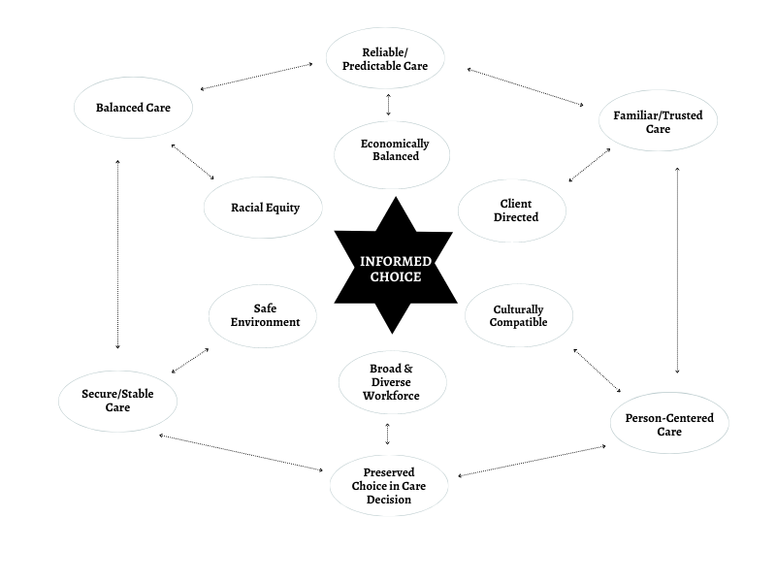

Client Focused Discussion/Considerations:
Client Choice; Decisional Capacity; Description of a Trusted Individual; Consistency/Reliability, Cultural Competence/Sensitivity; Risks and Rewards

Individual Provider Discussion/Considerations:
Workforce re-entry barriers; Racial Equity; Disproportionate impacts of the Criminal Justice System on paid and unpaid caregivers; Expanding workforce options/opportunities; Economic stability; Increased oversight; Trust; Risks and Rewards

Workgroup sessions included discussions of scenarios like the following, in which the workgroup broke into small groups and discussed why or why not the person described would be a suitable Individual Provider and whether exceptions were warranted for this person. Workgroup members were then asked to discuss a similar scenario with changed facts that included a variation in the type of crime, a continued history of non-disqualifying convictions, discussion of undue influence, and general suitability of the prospective provider.

Scenario
Grandma has always had a close relationship with her grandson. The grandson was involved in a shooting as a teenager. He was tried as an adult and convicted of high-level felony crimes. The grandson served his time. It has now been 10 years since he was released.

Since then, he found a job, is raising a family and is involved in his community. Grandma now qualifies for state assistance to help with her activities of daily living. Her grandson takes care of her by taking her to doctor’s appointments, reminding her to take her medications and helps cook her food.

Grandma’s physical health is declining and her need for assistance is increasing. The grandson is finding it hard to balance his roles as an employee, father, and caregiver for his grandmother. He is tired and stretched thin. Sometimes, he must take time off work to care for his grandmother. His employer is becoming frustrated and complains about the time he takes off. Due to his conviction history, the grandson does not qualify to be a paid caregiver for a person receiving Medicaid services.

The grandson feels it is important to care for his grandmother. She does not want anyone else as her caregiver, yet the situation is causing problems for the grandson at work and trying to do it all is affecting his health and personal relationships. This causes stress and worry for grandma, as well.

Successful reentry from prison to community is difficult due to employment barriers, technology and social changes, and family situations which may or may not be welcoming, among many others. These challenges can create instability economically, mentally, and socially. Some of the individual’s challenges might include lack of family or community support, resources, income, housing, medical care, transportation, etc.

In the scenario listed above the grandson has done everything he can to maintain a clean record and become a productive member of his community.

Workgroup discussion centered around whether the grandson is a suitable Individual Provider and whether an exemption process is warranted that would allow him to be paid through Medicaid.

Workgroup members strongly supported the concept of this individual qualifying under Informed Choice to be a paid provider but, were less confident when the facts were changed - citing the complicated nature of determining suitability without a deeper review of the facts and the individual.

Telling Our Stories

Each workgroup session incorporated time for sharing from people with lived experience –
centering on the voices of the people most directly impacted and who stand to benefit the most from change. Names have been changed to respect their privacy.

Meet John and Cathy
John is a recipient of unpaid care. John shared with the workgroup, during the first session, that he became disabled after being hit by a train over 20 years ago. Due to the severity of his injuries, he became reliant on pain medications, struggled to keep employment, and at times was homeless.

John qualified for state assistance but, found it difficult to find safe, reliable caregivers. He shared instances of qualified caregivers stealing his pain medications or not showing up for their shifts.

Frustrated, he reconnected with a former friend, Cathy, who was willing and available to be his caregiver.

Cathy was unable to qualify as his paid caregiver due to a previous conviction in which she utilized a federal agency credit card for personal use. Cathy shared that the crime occurred during a situation in which she was the victim of domestic violence and had to quickly relocate with her child. She admits it was a wrong choice. She fulfilled the terms of her sentence and has since gone to law school (she has not yet taken the bar exam), obtained employment, and continues to provide unpaid care for John.

John is fully aware of Cathy’s history and trusts her as his caregiver. He no longer trusts strangers to fulfill this role. Cathy is stretched thin between her caregiver role, her full-time employment and motherhood but, she continues to support John because she feels it is the right thing to do.

Meet Linda
Linda is a recipient of unpaid care. She has been on daily dialysis since the 1970s. She uses a wheelchair and endures a lot of pain that can cause her to be incapacitated for days at a time. She relies on caregivers to help her ambulate and for other activities of daily living.

Linda’s recent caregiver did not qualify for paid service due to a theft conviction that occurred when he was a young man many years ago. He has since shown himself to be reliable and is a contributing member of the community.
Linda shared her frustration with previous paid caregivers, including examples of dropping her while ambulating and sleeping on the job. Linda no longer trusts her care to a stranger but, her current caregiver can no longer afford to continue to provide unpaid care and has sought other employment. Although she qualifies for assistance, Linda elects not to have a caregiver out of fear and apprehension. Linda stated that her granddaughter could qualify as a paid caregiver but, Linda feels she is not suitable. Linda asks that she be trusted to make decisions about the quality of her own care when it comes to identifying the best person to provide that service.

Tribal Government Focus

The formal workgroup included two federally recognized Tribal members representing Tribal Governments – one from each side of the state. These workgroup members represented the interests of other Tribal Governments who participated in a separate subcommittee which met to discuss the impacts of background checks on Tribal communities.

Tonya’s mother-in-law was an elder in the rural Lower Elwha Klallam community. As her health began to fail, she qualified for Medicaid financial support which allowed her to seek paid care assistance. However, in her rural setting, no one was available.

Urgently requiring care, she hired a struggling family member who had become clean and sober to be her caregiver. Due to her conviction history as a younger person, this young woman could not pass the background check to become an Individual Provider. It was important for the mother-in-law to have someone she knew and trusted. The family found ways to pay the caregiver privately, although it was very difficult.

Taking a chance was worth it. This person was an amazing caregiver.

Through caring for Tonya’s mother-in-law, that family member found purpose and self-worth. The trust that her family had for her enabled her to keep pushing forward. After Tonya’s mother-in-law passed away, the caregiver found a job, rented a home, purchased a car, and is now thriving.

That family knew what she was capable of and gave her a chance. It changed the trajectory of her life.

- Tonya A.S, daughter-in-law of a Lower Elwha Klallam Tribal Member
Subcommittee Tribal representatives cited targeted police action, high levels of Child Protective Services reports, drug charges and other crimes they felt were charged at higher rates. These actions placed additional burdens on Tribal families and individuals seeking care support. Fewer individuals passed background checks, because of the disproportionate rates of charges and convictions.

Participants also cited the difficulty of finding qualified caregivers on Tribal land and in rural areas. Participants cited a desire to care for their elders but, the background check process and the disqualifying crimes lists bar many members of their communities from qualifying as Individual Providers.

Tribal members cited these disqualifications as factors contributing to ongoing poverty in their communities.

Tribal members state that they are better suited to judge the character, competence, and suitability of their own community members and often have higher requirements than the state.
Tribal communities know their members and want the freedom to make community decisions that support the wellbeing of their elders and help to erase poverty.

- Charlene A., Workgroup Member,
Squaxin Island Tribe

While the Tribal subcommittee participants support and contributed to the Informed Choice recommendations, Tribal representatives asserted their right to individual Tribal government sovereignty over background checks and who should be allowed to be a paid caregiver.

Due to Medicaid provider qualifications and Tribal rules this would require further collaboration between Tribal governments and the department.

Racial Disparities in Charges and Disqualifications in Providing Paid Home Care Services

Nationally, a past criminal conviction of any sort reduced the likelihood of a job applicant to receive an offer of work for any type of employment by 50 percent (all industries).

Persons with disqualifying criminal convictions may be “locked-out” of healthcare positions due to a disqualifying background check or because of employer concerns over non-disqualifying crimes, when there is a requirement for an employer review. The Legislature could provide immunity protections for employers that would remove the employer requirement.

Additionally, because of Washington State’s rigorous background check requirements, many individuals, who may be eligible to become an Individual Provider, likely do not attempt the background check requirement to determine if they could qualify.

In 2014, employment barriers meant that nationally 1.7 million workers were unable to join the labor market, which cost at least $78 billion to the economy.

For those who are fortunate enough to navigate workforce barriers, they are generally further penalized by receiving 40% less in wages. In 2009, this meant there were 8 million more people in poverty due to mass incarceration in the United States.
(Although, in Washington State Individual Providers with non-disqualifying convictions do receive the same wages as Individual Providers with no convictions, if they are hired.)

Additionally, in the U.S., 2.7 million children currently have an incarcerated parent, 10 million children have experienced parental incarceration in their lifetime (0 - 17 years), families see a decrease of 64% in family assets, 62% of individuals re-entering from prison have legal/financial debt related to the criminal justice system which contributes to challenges establishing credit, opening bank accounts, and saving money.

Out of 7.61 million Washington State residents, 2.14 million people (28.1%) have felony or misdemeanor conviction records that span the last two decades.

Current systems disproportionately impact communities of color.
- 4.2% of the state’s population are African American, but comprise:
  - 11% of residents with a criminal record.
  - 15% with any felony record.
  - 22% with a Class A felony record.

The workgroup discussed the possibility that systems, such as Washington State’s background check requirement and Washington State’s disqualifying crimes lists, while designed to protect Washington’s vulnerable population, may create unintended consequences that have led to the further impoverishment of historically underrepresented groups by creating economic and health stressors, racial inequities in the labor pool, and cultural incompatibility issues between clients and caregivers by excluding caring and ready persons from the long-term care workforce.

The workgroup also examined rates of recidivism.

According to the Washington State Department of Corrections data from June of 2022,

- The number of individuals released from incarceration in 2011, who reoffended with a class A felony over a ten-year period was 2.9 percent.
- Most of those individuals reoffended within the first three years of release.

Studies show recidivism decreases over time.

After enough time following a prior offense passes without new charges, people with a conviction history are no more likely to be arrested than the average citizen. For those who commit their first crime at a young age or whose first crime is a serious offense, it takes about eight years without another offense to “redeem” themselves. For others, such as those who commit non-serious crimes, it can take as little as three years.

Individuals with criminal convictions may be unable to provide care for family members when torn between caring for their loved one and maintaining economic stability.

It impacts a person’s sense of dignity and purpose and creates barriers that perpetuate poverty and slow individual and community growth.

The workgroup concluded that the Informed Choice process is an opportunity to expand the available pool of Individual Providers and empower persons receiving Medicaid, who self-direct their care services, to make choices that they believe will promote safe and healthy outcomes.

Meet Anne
Workgroup member Anne shared that for the last five years she has been coordinating care for her children who live with disabilities. It has been her experience that many caregivers that have come her way are justice impacted and do not pursue a career of paid caregiving for the state. Each caregiver’s story is different. Listening to each individual applicant helps Anne discern whether they should be part of her children’s care team.

Anne feels that the stipulation of pending charges being equivalent to a conviction is wrong. The prospective caregiver has not been convicted, only charged.
The law as it is currently written sentences an individual, for the purposes of state employment as a caregiver, prior to their actual court date/hearing. Employment opportunities become closed doors and the hope of a career in caregiving narrows to private parties willing to take a risk.

Anne is one of those individuals willing to take a risk. She interviews and screens all individuals that express interest (applicants) and makes sure to hear their side of the story. She has found many competent, quality caregivers that would not pass the state’s background check requirement. She is convinced that there are more accurate and fairer metrics the state could use to keep vulnerable people safe, while allowing people who have had experience with the justice system to be employed as caregivers.

Anne’s experiences with caregivers with conviction histories/pending charges have been positive. Her children and those caregivers she chose to trust, have benefitted. However, there is a financial impact to this decision. When Anne hires caregivers who cannot be employed with the state, those care costs run into the tens of thousands of dollars annually. Anne states that the caregiver shortage is now, and that actions must be taken regarding unpaid family supports, pending charges and the background check process, at it currently stands.

Study of the States

Throughout the United States, informed choice models exist that allow person-centered choices and exceptions for those individuals whose conviction history may have been a barrier to providing care. These structures and background check processes are executed and named differently, but there are themes that appear throughout the states.

The states below were selected to show the variety and creativity for a common goal: To allow clients the freedom of choice around their care.

It is important to note however, that liability laws and tort claim maximums vary greatly from state to state and may influence state laws related to informed choice models.

CALIFORNIA

California’s consumer-directed program is called In-Home Support Services (IHSS). The county of residence provides oversight for client-caregiver employment relationships. If an individual has a conviction history and is selected by a client to be a caregiver, there is an appeals process to request an exception called a “provider waiver” from the county where services would be rendered. For caregivers that obtain a waiver, the IHSS program utilizes state-only dollars – no federal funding is accessed.

California’s waiver process includes completion of a form where the recipient acknowledges the provider’s conviction history. The disqualifying crime(s) are individually listed. The provider is named as the client’s hiring choice. The client accepts the responsibility for hiring the person named on the form to work in their home. Depending on their assessed needs, they may have more than one caregiver. The client must acknowledge that they understand the county and the State of California are immune from any liability, due to the risk of any actions that may occur, because of the decision to hire the person as their IHSS provider. (See Appendix 8)

The county keeps a record of the forms and agreements until the 10-year period after conviction or incarceration has passed. The formerly convicted caregiver can provide care only to the specific client who filed the appeal.

The background checks for in-home care come from the Department of Justice (DOJ) and the county provides oversight. California does not have a renewal or recertification of background checks within a set timeframe. The California DOJ sends arrest notifications to the county.

Direct application of California’s waiver process would not have the same result in Washington because of differences in each state’s tort laws and waivers of sovereign immunity.

ILLINOIS

There are three registries as part of the Illinois background check process:

Healthcare Worker Registry

If there is a finding on the background check, the applicant can request a Waiver.
- There are convictions that are automatically waived when the required time restraint has been completed.
- Process approval (completion of the packet to be sent into the Department of Public Health for decisional review)

Illinois has a Rehabilitation Healthcare Worker waiver process to allow an individual to work with a disqualifying criminal history. If the waiver is granted, an individual can be hired by a client even though there is a conviction on their record. There is a waiting period after the conviction date to apply for the waiver. The waiting period varies depending on the crime (there are felony convictions with a 10-year period). The individual must have met the obligations of the courts under the terms of parole, completion of any court-ordered treatment programs and a current fingerprint check is required. There are automatically disqualifying crimes that can only be addressed through the courts. In 2021, 2,000 waiver requests were received in Illinois; 1,300 were granted and 300 denied. The discrepancy in numbers was due to incomplete applications. The waiver team consists of 3 staff and a legal advisor. The process typically can be completed within 3-4 weeks.

Child Abuse and Neglect Registry

There is also a waiver review process if an individual is on this registry. It can take several months to get a determination decision.

Adult Protective Services Registry

If an individual is on this registry, they are not allowed to work with individuals within Home Based Service programs and must be removed from providing care.

Within the Self-Directed program, the client hires their own staff. If the selected caregiver has a waiver, they have met the background check requirements for the state of Illinois. There is no formal assessment process at intake to determine if the client can or should direct their own services. During the person-centered planning process, the care coordinators are responsible for determining the services needed and how the individual would like to direct those services. If the individual wants to self-direct, they can purchase the personal support services from an agency or hire their own. Illinois has a waiver service called “Self-Direction Assistance” which a person can purchase.

These agencies can assist the individual in hiring, training, terminating, scheduling, ensuring timesheets are completed correctly, etc. but the person is still considered to be self-directing their own services. This is simply an agency that supports them in the process.

There is a policy which enables the State Agency to restrict the right of the individual to self-direct services because they have demonstrated they are unable to satisfactorily direct their own services.

The care coordinator agencies, called Independent Service Coordination (ISC) agencies in IL, assist to an extent. The recipient and caregiver enter into an agreement.

Also, within the self-directed program, there is no training requirement when an individual hires a caregiver. If an agency hires a caregiver on behalf of the recipient, there is a 120-hour training program required and ongoing follow-up of the care that is being provided.

MISSOURI

Missouri Department of Health and Senior Services has what is called a “Good Cause Waiver.” Their background check screening requirements includes a review of 7 databases. If there is a finding, the applicant (recipient) has the right to apply for a Good Cause Waiver (GCW). If granted, the waiver does not correct or remove the finding, but lifts the hiring restriction and allows the individual to be employed by the recipient. This waiver is reviewed for individual applicants whose criminal history has disqualified them from employment within all facility types as well as the consumer directed services program. There is a disqualifications list where the applicant is not eligible to apply. The caregiver completes an application for Good Cause Wavier form and an explanation for each finding. There is also a sponsorship letter from an employer, or three reference letters sent in with the application. If the waiver is approved, the applicant can work for the individual recipient only. The waiver is not transferrable.

EDR= Employee Disqualification Registry If individuals are placed on this registry as a result of a substantiated finding of abuse neglect or misuse of funds, they are prohibited from working in a licensed long-term care facility and/or any funded service supplied by the Department. An exception can be requested. The exception is a compilation of written materials describing why an exception should be granted. The Exception Committee meets twice a month and has the authority to approve the request with or without parameters.

It is called "exception" because the department, in its administrative authority, is stating that it is excepting that individual from enforcement of their administrative rules that prohibit them from employment. Missouri regulations do not allow people convicted of certain crimes to hold certain types of employment; the committee may determine to grant an individual an exception to the regulation. An exception could be granted for an in-home care provider. This exception would not be transferrable to other clients.

WISCONSIN

Wisconsin’s self-directed model is called IRIS. The participant can hire their own staff and request an individual who has a conviction history. There is a discretionary review that is not a formal court appeal. There are crimes that do not have the option for the review process and permanently disqualify the caregiver from providing care. The discretionary review of appealable crimes is determined by a state employee with the Wisconsin Administrative Code as their guide for decisions. The client and caregiver fill out a document describing why they believe discretionary permissions should be granted for the selected individual to provide care. Some decisional factors include the type of job, the offense(s), person’s history (completion of rehabilitative requirements/probation), and participant’s statement. See Appendix Wisconsin Administrative Code DHS 12.06. The review is for the specific individual within the IRIS program only and is not transferrable to other participants.

NEW MEXICO

New Mexico has a unit called the Caregivers Criminal History Screening Program. New Mexico maintains a disqualifying conviction list and an abuse registry. When a person submits to a background check in New Mexico, the lookback period is 99 years. A formal reconsideration request is possible after the background check results are received. The packet submitted consists of information regarding their probation status, court standing, any fulfilled requirements, testimonials and if the charges were dismissed. Once submitted, the individual can continue to work supervised until the review is completed. Specified documents are needed for the reconsideration review and there must be a proposed employer, who can be either an individual, facility, or home health agency. The review is conducted by the reconsideration committee comprised of Department of Health managers where there is a vote. A favorable vote results in an employment clearance determination. The applicant would be able to work in any facility type or setting. The state utilizes a service called Rapback (Record of Arrest and Prosecution Background). This is a system by which an electronic notification is sent if an employee were to be arrested or charged. The unit is notified of the information along with the employer of record.

NEW YORK

New York’s self-direction program has been in place since 1995. New York has limited documentation regarding the informed choice process. New York’s self-directed model is called the Consumer Directed Personal Assistance Program (CDPAP). The person chosen to provide care can be a family member, a neighbor, a friend, or even a previously employed caregiver.

Exclusions:

- The client’s spouse.
- The client’s parent if the client is a minor child.
- The client’s legal guardian.
- Anyone who is a part of or affiliated with a Fiscal Intermediary.

The state of New York does not require a background check to be a caregiver for self-direction. A CDPAP consumer can obtain a background check, but it is not required, and the consumer would have to pay for it. There is a contract between the Consumer and a Fiscal Intermediary (FI) which outlines the roles and responsibilities. The FI does all the onboarding of the personal assistant (PA) and pays the PA. They would also maintain compliance with labor and industry standards (such as required testing and training).

State Comparison Chart

State | Consumer Directed Services | Background Check Required | Disqualifying Crimes | Permanent | Time Limit | Decisional Capacity | Waiver
California | Yes | Yes | Yes | Yes | Yes | No | Yes-Waiver
Illinois | Yes | Yes | Yes | Yes | Yes | No | Yes-Waiver
Missouri | Yes | Yes | Yes | Yes | Yes | SLUMS | Yes-Waiver
Wisconsin | Yes | Yes | Yes | Yes | Yes | No | Yes-Waiver (Discretionary Review)
New Mexico | Yes | Yes | Yes | Yes | Yes | No | Yes-Waiver (Re-consideration)
New York | Yes | No | N/A | N/A | N/A | Yes-Physician form | N/A
Washing-ton | Yes | Yes | Yes | Yes | Yes | No | No*

State Comparison Chart Definitions:

Decisional Capacity- There are no additional steps for individuals to participate in the consumer directed program based on their cognitive status. Missouri has the SLUMS required to be given and New York has a form that a physician completes and a nursing assessment which includes a cognitive screening prior to participating in the program. The remaining states do not have a formal process to assess decisional capacity as a requirement to participate in this program. They do have statements that indicate the recipient or someone else must be able to hire and train their staff.

Disqualifying Crimes-Criminal convictions, pending charges, and negative actions that automatically disqualify a person from having unsupervised access to vulnerable adults. Disqualifying crimes in these states expand upon the Federal disqualifying crimes on the OIG list.

Permanent (Disqualifying crimes)- Convictions on record that cannot be waived or removed

SLUMS-The Stain Louis University Mental Status-Examination for detecting mild cognitive impairment and dementia.

Time Limits- States have varying time limits for different criminal convictions. Once that time is passed the individual is not automatically disqualified if the number of years has passed since the conviction. The state of Washington has the employer complete a review if an individual has been convicted of those crimes and it is past the time restriction.

Waiver- An action to waive the prohibition against employment based on the criminal history of an individual. Most states have a list of disqualifying crimes/convictions that would not be considered for the waiver request process. A waiver does not change the criminal record; convictions will still appear on the background check. The approved waiver will allow an employer to hire an individual with a disqualifying conviction as a direct care worker if he or she is granted a waiver. Waivers do not transfer to another employer.

*Washington has a Character Competence and Suitability Review-when a staff member or applicant has a finding on their Background Check that is either not disqualifying or due to conviction(s) being past the required time limits. The employer reviews the conviction information, considers certain factors like the length of time that has passed since the conviction or pattern of offenses and decides as to their suitability for employment given the information available. The employer may gather additional information from the applicant.

Risk Assessments

This section describes risks that were broadly considered by the workgroup and includes risks to individuals and agencies.

The workgroup established that risks such as abuse or neglect of an individual are possible whenever a client and caregiver enter a relationship, regardless of whether the caregiver has a conviction history.

In fact, while a background check prevents an individual with a conviction history from becoming a paid Individual Provider, it does not protect the recipient of care services from interacting with individuals with convictions who are most likely already providing informal/unpaid care services. The Informed Choice recommendations would formalize those relationships and may create space for improved safety by requiring caregiver training.

Dignity of Risk

Dignity of Risk means being able to make a choice even if it could have negative consequences for you. Negative consequences could be things like getting injured, getting lost, and being heartbroken. Experiencing negative consequences helps all of us to learn. It is natural to want to protect someone, but it is important to not take away someone’s dignity of risk. When someone has both self-determination (the right all people have, to make personal decisions) and dignity of risk, they are more likely to become independent.

The workgroup was referred to a video developed by the Mental Health Recovery Institute of Australia which discussed why it is important to prioritize Dignity of Risk.

The concept of Dignity of Risk encourages:

- An individual’s right to make choices and take risks.
- Freedom to make mistakes, get it wrong, and learn from those mistakes.
- Personal freedom.
- Agencies to recognize an individual’s right to decide how they want to live their life.
- A legal process to determines capacity and involuntary treatments.

The workgroup also discussed:

- Do background checks create greater protections for clients or are they limiting their freedoms? How does this impact their safety?

- Is a disqualified person with a conviction record any more likely to commit an act of abuse or neglect than someone who does not have a conviction history?

- How does time since conviction factor into the likelihood of an individual to reoffend?

- Would formalizing a relationship, in which unpaid care is occurring, make it safer?

- Do the circumstances of the crime that was committed by the individual, in their past, impact their suitability to provide care to a loved one, now? Are they connected?

- Does the potential that an act of abuse or neglect may occur justify keeping a system that creates barriers to client freedoms?

- How can we safeguard vulnerable adults from undue influence? Is the normal case management process, along with an informal client support system, enough?

- Are the systems designed to protect vulnerable adults overreaching and creating unsafe circumstances?

- Do vulnerable adults have the right to make decisions that raise their level of risk?

- Is safety compromised when clients do not have consistent care?

- Is safety compromised when clients do not have culturally appropriate care?

The workgroup affirmed that Dignity of Risk, defined as an individual’s right to make choices and take risks is a foundational element in directing one’s healthcare services, even when that choice may lead to failure.

However, it should be noted that creating this opportunity for greater choice in the selection of an Individual Provider through Informed Choice may create new legal risks to the state, area agencies on aging, and the administrative employer. Shifting the risk entirely to the client via an Informed Choice waiver process is not possible under current Washington State tort law.

Paid vs. unpaid care relationships

In most cases, the disqualified person the client would like to choose as their Individual Provider is already a family member or well-known friend. The disqualifying conviction only precludes the person from being paid by the state to provide care. The conviction does not prevent the person from having unsupervised contact, including living with the vulnerable adult, and providing the exact same care for no remuneration.

In these informal relationships, the caregiver has no requirement for training or certification. Stressors to both the client and caregiver increase when the unpaid caregiver may be attempting to juggle another job and provide care.
Everyone deserves a second chance. Families just want to take care of their own family.

- Manuel A., Workgroup Member

Risk to state and administrative employer

Where an employer knows that the employee has a criminal history, it can result in a duty to protect the public from the employee. The workgroup’s recommendations include legislation that prohibits Consumer Direct Care Washington, LLC from overriding a client’s decision to hire an individual provider due to their conviction history, assuming all other normal employment parameters are met. If this recommendation is followed, the department and its contractor, Consumer Direct Care Washington, LLC, need effective tort liability. The workgroup’s recommendations place the administrative employer in a situation where it may have duty to protect the client, but no authority to act.

Administrative employers, the state and area agencies on aging are at risk for lawsuits without statutory protections.

Client responsibility

Along with the right to make your own decisions is the right to fail. The workgroup supports the right of the client to choose their caregiver. As such, the workgroup feels that the client assumes responsibility for their decisions, and it encourages transparency of information between client and Individual Provider. This includes documentation between both parties, indicating they are aware of the prospective Individual Provider’s conviction history.

However, unlike some of the models and example waiver forms from other states, the use of an informed choice agreement signed by the client and Individual Provider will not provide complete liability protection for the state, area agencies on aging, or administrative employer, as it does in other states.

While it may be effective as to the estate of the client, it will not bind other possible plaintiffs. In Washington, certain surviving family members have standing to sue for the wrongful death. See RCW 4.20.020. An agreement signed by the client, even if effective as to the estate, would not foreclose lawsuits.

Signed agreements between the client receiving Medicaid services and the Individual Provider do not adequately protect the state, area agencies on aging, or the administrative employer from liability.

Risk Recommendations

Unpaid caregiving is the backbone of the Long-Term Services and Supports system. It is the right of the client to participate in an informal care relationship. However, the workgroup recommends creating an opportunity, through Informed Choice, to formalize unpaid care relationships that are already occurring, as it may benefit the client to have the Individual Provider receive formal training and undergo credentialing requirements.

The workgroup agreed that more safety concerns exist by limiting a client’s freedom of choice than may occur because of a trusted individual’s conviction history.

An Informed Choice program creates many opportunities: expansion of the workforce, the furthering of economic stability for clients and Individual Providers, reduction of client and caregiver stressors, increased opportunity for culturally sensitive care services, and addressing the impacts created through unfair and targeted sentencing practices that have led to the continuation of poverty in many underrepresented communities. These opportunities may be lost if the overarching concern driving state policies is centered more on liability concerns than client preferences.

The majority opinion held by the workgroup is that clients should have autonomy in Individual Provider hiring decisions, related to the prospective caregiver’s conviction history.

A small minority of workgroup members, representing the interests of administrative employers, strongly disagreed with the recommendation to allow the client to override the disqualifying crimes list in the hiring process. Representatives of administrative employers and home care agencies felt it removed the discretion for the administrative employer to decline a candidate due to their disqualifying crime and therefore created liability exposure.

Organizations representing administrative employers support the value of client choice, but prefer to maintain the current background check process for Individual Providers –
requesting no implementation on HB 1411 Informed Choice until the statutory changes are implemented to include protection from liability regarding the client’s hiring decision.

Meet Jennifer
Workgroup member Jennifer R., The Arc of Spokane, shared her experience gained from 14 years in workforce development related to those with background issues.

Jennifer shared that she had witnessed many positive outcomes when employers were willing to hire applicants with conviction records. In her experience, second chance employees “had high rates of retention and loyalty” to their employers. She noted that there is a gap for second chance employees in the general workforce. Although there is often training available, it does not translate easily into job placement as employers are resistant to take chances on persons with conviction histories because of liability concerns. Jennifer shared a tool that her agency had used, “The Federal Bonding program” sponsored by the U.S. Department of Labor. The Bond covers the first 6 months of employment at no cost. She cited that it is a very successful program, and that the actual number of claims have been extremely low, as those with conviction histories who find meaningful employment want to successfully retain the position.

In her experience, she has seen many instances where persons with past significant crimes turned their lives around and became successful and loyal employees when given the chance. She encouraged the workgroup to support second chance applicants and reach out to agencies and ask for individual consideration of an applicant and the specific conviction history – not just a pass/go because they have a conviction history.

Recommendations

Guiding Principles

The workgroup agreed on a set of guiding principles to be clear on the values held to be most important. The guiding principles were developed from focused conversations about the client and caregiver experiences, layered with the topics outlined in the bill. This led to the identification of the desired outcomes of a (future) Informed Choice program.

Following are the guiding principles and desired Informed Choice program outcomes:

Client:
- The opportunity to choose your Individual Provider is important and empowering.
- Every situation is different. A client should have the opportunity to evaluate a caregiver and discern who and what will work best for them.
- Clients would rather choose someone they know than a stranger.
- A client’s consistent cognition to direct tasks and supervise their employee is necessary.

Caregiver:
- A prospective Individual Provider’s contributions to supporting their family, establishing stability, and contributing to their community should be recognized and commended.
- Background checks apply the same standard to everyone. It may be unfairly limiting when considering:
  - Time since conviction.
  - Age at the time of the crime.
  - People of color have been disproportionately charged and sentenced at higher levels.
  - Every situation is unique.

Utilizing these guiding principles, the workgroup then discussed and identified Informed Choice program objectives. A polling system allowed workgroup members to vote on their individual agreement or disagreement with statements pointing to desired future outcomes/benefits of an Informed Choice program.

The workgroup reacted to seventeen statements and were given opportunity for comment. The polling was conducted during a workgroup meeting and was left open for an additional week following the meeting so that absent members could participate. Out of 25 workgroup members, 16 members participated.

At the following meeting, the workgroup refined the proposed outcomes/benefits of a future state Informed Choice program.
(Polling results can be found in Appendix 6)
As a result of the Informed Choice program . . . client focus:

- A client’s options for Individual Providers become broader than the previous process allowed.
- Client choice is preserved, elevated, and honored.
- The client’s autonomy and independence are supported and respected.
- The client can make a clear employment choice because they have an established relationship with the caregiver, and they are fully aware of the prospective Individual Provider’s background (including conviction history).
- The client assumes responsibility for employment decisions.

As a result of the Informed Choice program . . . client and Individual Provider relationship:

- A client’s sense of safety may be enhanced.
- A client’s feelings of personal safety may be enhanced by receiving care from a trusted individual.
- Economic and health stressors for both clients and Individual Providers may be reduced by the transition from an informal to a formal/paid care relationship.
- Client care needs are more likely to be met consistently and reliably when care is delivered by a trusted and familiar person.
- The client enjoys improved levels of person-centered care because they have employed a trusted and familiar Individual Provider.

As a result of the Informed Choice program . . . equity, justice, and inclusion:

- Reduced employment barriers for caregivers expands client options and supports long-term care workforce needs.
- Individual Providers are selected or declined for employment by the client based on their ability to perform care services, not their conviction history or background check.
- Client/Individual Provider relationship is beneficial to both parties.
- Clients and their Individual Provider may experience greater economic stability when transitioned from an informal to a formal/paid relationship.
- Self-directed programs promote equity, inclusivity, and access by opening doors for persons with disqualifying background checks.
- Persons who have been disproportionately impacted by the criminal justice system are recognized for their abilities and not a label.
- Care provided is culturally appropriate and responsive to a client’s unique needs.
- Clients living in rural areas now have more potential caregivers to choose from.

Program Recommendations – Further Detail

Process Recommendations:

The workgroup agreed that upholding the client’s right to self-direct their own healthcare choices and creating opportunity for control over their decisions eliminated the need for additional programmatic oversight.

- The process/program should be simple and straightforward in presentation and execution. The workgroup recommends a process that makes it easy for clients and prospective Individual Providers to access, understand and enter the Informed Choice program.
- The program should follow the existing self-direction process, procedures and protocols for clients and Individual Providers.
- All persons receiving Medicaid services, who wish to self-direct those services, will be informed during the initial assessment about the Informed Choice option.
- Prospective Individual Providers will be hired by a client and co-managed by Consumer Direct Care Washington, LLC (previously the department) for all administrative aspects.
- Consumer Direct Care Washington, LLC provides Individual Providers one place for all administrative needs (payroll, taxes, tracks training & certification, background checks) and maintains discretion and oversight for normal employment practices.
- Individual Providers will be paid through state Medicaid or waiver programs facilitated through Consumer Direct Care Washington, LLC.
- People receiving Medicaid services who choose self-direction will train for specific client needs and preferences, supervise, and dismiss, if necessary, their Individual Provider.
- The workgroup recommends that the Informed Choice process follow the current Department of Social and Health Services’ self-direction program process infrastructure.
- Case Management (for client) occurs at:
  - Initial assessment to identify client care needs and discuss care options
  - Annual assessment
  - Significant change of condition assessment upon notification
  - Ongoing through monitoring visits
- Client safeguards are supported through normal case management and reported according to established protocols, e.g., fraud concerns, abuse or neglect concerns, undue influence concerns.
- The program will follow current protocols to elevate safety and care service concerns, including reports of abuse or neglect.
- Informed Choice Individual Providers recommended to undergo the same training as all other Individual Providers.
- Fund a “Navigator” position to assist clients and applicants with education and resources related to background checks, the process of vacating crimes, or questions related to a required Character, Competence and Suitability review.

Client Impact Recommendations:

The workgroup agreed that the key tenant of the Informed Choice program is honoring the person receiving Medicaid services and respecting their discretion and preferences.

The client should enjoy autonomy in their hiring decision and can choose to disregard caregiver disqualifications related to conviction history. The client should have full authority to make decisions about who provides their care – this includes being able to hire a trusted individual who has a prior conviction history that would normally disqualify the caregiver from being a paid Individual Provider in the Medicaid program.

Within the Informed Choice program:

- The client:
  - Acts as the primary “Employer” with discretion for caregiver selection.
  - Chooses their Individual Provider.
  - Determines how best to meet their unique care needs.
  - Formalizes care relationships that are already occurring.
  - Receives care that is culturally sensitive and respectful.
- Learns from their mistakes, which includes the right to fail, learn and try again.
- The client entering self-directed services will be assessed for care services and continue through the normal process.
- Clients will be informed about liability risks in a language that they understand.
- Under Washington State law, individuals are presumed to have decisional capacity unless determined through the courts.
- Relies on existing state law related to decision making and individuals that can make decisions on behalf of a client.
- The workgroup acknowledges that decisional capacity may change over time and may require action, should a concern about a client’s decision-making arise.
- The workgroup recommends transparency of information between the client and the prospective Individual Provider. The client automatically receives a copy of the Name Date of Birth background check from Consumer Direct Care Washington, LLC/administrative employer. The client is informed by the administrative employer how to request a copy of the Federal Fingerprint Check from the prospective Individual Provider. This information to be included in all Informed Choice informational/educational/training materials.
- The workgroup recommends that a document be signed by both the client and caregiver acknowledging that they are participating in the Informed Choice program: acknowledging that the caregiver has a disqualifying conviction, that the caregiver’s participation in the Informed Choice program is only for the purpose of providing care to the specific client, and that this exemption may not be used with another client unless that client also enters the Informed Choice program.
- The client is informed and understands the potential risks of their hiring decision.
- Clients will be encouraged to identify additional informal support persons in the care plan – not related to the provision of care services.
- Clients may elevate concerns about their Individual Provider to their case manager or Consumer Direct Care Washington, LLC.

- Caregiver Impact Recommendations:

The workgroup reviewed the need for expansion of the long-term care workforce and recognizes the gap between the existing pool of qualified providers and the forecasted need to serve persons receiving Medicaid services. Informed Choice helps to expand the options for hiring Individual Providers.

It is the client’s right to choose whether to enter a formal care relationship and it is important to honor those preferences. For those who may desire to formalize the care relationship, the Informed Choice program offers an opportunity to provide paid services to formerly disqualified providers. Formalizing this relationship provides additional training and credentialing to the Individual Provider.

Although the workgroup feels the emphasis of the Informed Choice process should be focused on the opportunity and potential positive impacts for the client, the workgroup also sees the opportunity to open a door into the long-term care workforce for those who have been formerly disqualified, due to their conviction history.

- The prospective Individual Provider’s suitability to provide services is focused on their present ability and not their conviction history.
- The workgroup supports the concept of second chances for trusted individuals selected by the clients participating in the Informed Choice program.
- The Individual Provider is authorized to provide services to the client only within the Informed Choice program. This process does not allow the same individual to work for a home care agency or another self-directing client unless that client is also participating in the Informed Choice program.
- A trusted individual is identified and defined by the client, according to the client’s preferences and values.
- As noted previously, Individual Providers participating in the Informed Choice program will be held to the same job performance standards and administrative requirements as all other Individual Providers.
- Individual Providers participating in Informed Choice will follow all administrative employment requirements or will be terminated from employment.
- The workgroup recommends that Individual Providers participating in the Informed Choice program must participate in the same trainings as all other Individual Providers.

For an Informed Choice Individual Provider to be issued a credential or registration from the Department of Health and be paid through Medicaid funds, the Department of Health proposes either creating a new statutory exemption or a new section in Chapter 18.88B RCW creating a new registration/credential. See Appendix 8 for a Department of Health briefing paper with further analysis of the ask, options, and recommendation.

Administrative Employer Impact Recommendations:

The workgroup acknowledges that the co-employer relationship may place the administrative employer, currently Consumer Direct Care Washington, LLC, in an untenable position if their authority for hiring decisions related to the prospective provider’s conviction history is removed, but their liability for client safety remains the same.

A strong majority of the workgroup agreed that authority for the choice of a client’s caregiver should remain with the client. Workgroup members representing the administrative employer and the representative supporting home care agencies would prefer to maintain discretion in the hiring process depending on the nature and recency of the offense and request that this discretion is continued if Informed Choice progresses, until statutory liability protections are in place.

- The Consumer Direct Care Washington, LLC/administrative employer may not override a client’s hiring decision, as it relates to the Individual Provider’s conviction history. However, the administrative employer can override the client’s hiring decision for other reasons – including if the provider is otherwise ineligible to work, is unsuitable (not related to conviction history), or incapable of providing the needed services.
- The administrative employer will conduct normal business practices and hold the Informed Choice Individual Provider to the same standards for hiring, employment, corrective action, grievance, and termination, as all other Individual Providers.
- Case managers, the managing employer, and formal/informal decision makers will elevate job performance concerns to the client and administrative employer.
- Clients and Individual Providers will utilize existing infrastructure for grievances.
- Statutory liability protections must be created for the administrative employer.

While the workgroup agreed that Consumer Direct Care Washington, LLC/ administrative employer should not override the client’s choice of caregiver due to their conviction history, they also support the administrative employer’s right to conduct normal business decisions as it relates to the Individual Provider’s job performance. For example, if the Individual Provider does not meet training requirements.

Tribal Government Recommendations:

Workgroup representatives included two federally recognized tribal members representing Government Tribes from East and West of the Cascades. These members represented the interests of their communities and the broader interests of Washington State’s 29 Federally recognized Tribal Governments.

Additionally, the department conducted separate meetings open to all Tribal Governments to facilitate knowledge of the formal workgroup proceedings and to invite additional Tribal Government perspectives. HB 1411 formal Tribal workgroup members attended these meetings and promoted the interests of participating Tribal Governments at the formal HB 1411 monthly workgroup meeting.

Tribal members asserted their claim for a government-to-government system which would facilitate Tribal sovereignty for individual communities and implement their own Tribal codes and rules for members of their own communities.

Tribal participants cited many instances of targeted policing which have disproportionately impacted tribal members, locked them out of paid Individual Provider positions and contributed to the cycle of poverty in Tribal communities.

Tribal workgroup members support the recommendations for an Informed Choice process but, request the Legislature authorize additional study or a pilot program to determine a process whereby Tribes may utilize their government’s own rulemaking and codes.

- Tribal governments support the Informed Choice process.
- Tribal governments assert sovereignty over decisions about caregiver disqualifications within their individual communities.
- Recommend further study or pilot program. Will need to include review of Medicaid rules.
- Tribal governments request that the Informed Choice program outcomes extend into licensed Tribal Health/Home agencies.

Liability Recommendations:

The workgroup strongly agreed that the State, area agencies on aging, and current and future administrative employers need statutory liability protection. If the other recommendations are adopted, the administrative employer will no longer have the discretion to reject the client’s hiring choice of an Individual Provider, based on their conviction history. Consumer Direct Care Washington, LLC will maintain discretion over all other functional hiring and employment processes.

As stated in other areas of this report, shifting the responsibility entirely to the client via an Informed Choice waiver process is not possible under current Washington State law.
In Washington State, certain surviving family members have standing to sue for the wrongful death. See RCW 4.20.020. An agreement signed by the client, even if effective as to the estate, would not foreclose lawsuits.

- The client enters Informed Choice with knowledge of the prospective Individual Provider’s conviction history.
- Implement a formal signed form between client and Individual Provider to document client’s acknowledgment of the Individual Provider’s conviction history. Document should be simple, easy to understand and available in multiple languages. (See Appendix Seven for sample form.) (Note: This document provides little protection for state, area agencies on aging and administrative employer).
- Include complete statutory liability protections for current (Consumer Direct Care, Washington, LLC) and future administrative employers, the State of Washington, and area agencies on aging operating under delegated state authority for case management.
- Case manager training to introduce Informed Choice program to client is recommended.

Disqualifying Crimes Recommendations:

The workgroup strongly supports the concepts of 1) a client’s discretion to hire their caregiver of choice and 2) second chances for persons with disqualifying convictions in their past. The workgroup felt that a more nuanced evaluation of the disqualifying crimes lists and related sources, by a committee of legal professionals, community-based organizations, and persons with lived experience, is necessary.

SEIU 775 does not support limiting eligibility to the Informed Choice program based on crime, beyond what is mandated by the Office of the Inspector General.

The workgroup was divided about the disqualifying crimes lists but, a majority did feel certain crimes should remain disqualifying for entry into Informed Choice. They did not reach consensus on which of the crimes should remain disqualifying. They felt other factors should be weighed in addition to the type of crime such as:

- Time since conviction.
- Equity issues in sentencing.
- Age of person at the time of the crime.
- Conviction history since the time of the disqualifying crime.
- Events, such as job status and community involvement since the time of the disqualifying crime.

The workgroup recommends the legislature appoint a committee to review the list of disqualifying crimes lists in WAC 388-113-0020 and negative actions in 388-113-0030 to determine the following:

- Which disqualifying crimes and negative actions, such as Adult Protective Services and Child Protective Services final and founded findings, should remain “off the table” for Informed Choice? Examples cited: recent crimes against vulnerable adults, fraud, and financial exploitation.
- Which disqualifying crimes can be changed from permanently disqualifying to time limited?
- Confirm federal exclusions (Office of Inspector General list) remain in place and would exclude an individual from participation in the Informed Choice process.
- Discuss whether pending charges should remain disqualifying vs. actual convictions.

In evaluating these Washington Administrative Codes, the workgroup recommended that the committee appointed by the legislature to review the disqualifying crimes list in Washington Administrative Code 388-113-0020 and negative actions in Washington Administrative Code 388-113-0030 include members who will advocate for a comprehensive review that includes further evaluation of the consequences of sentencing on underrepresented communities.

Communication Strategy Recommendations:

Substitute House Bill 1411 mandated that the workgroup propose a communication strategy to inform older adults and people with disabilities about the Informed Choice process.

The workgroup recommended the creation of informational video(s) and brochures with specialized messaging to targeted groups with the goals of:

- Educating older adults and individuals with disabilities, who are recipients of Medicaid services, about the Informed Choice program.
- Informing prospective Individual Providers about the Informed Choice program.
- Training case managers.
- Informing and training Tribal Governments and community-based organizations.
- Reaching out to community members who may have been formally disqualified as an Individual Provider or have not applied due to their conviction history.

The workgroup highlighted many, although not an exhaustive list of community-based advocacy organizations that they felt would be important to reach such as:

- Civil Survival Project
- The Arc
- Parent Coalition
- Immigrant Groups
- Veterans Centers
- People First, Self-Advocates in Leadership, and Disability Rights Washington
- Prison re-entry programs

The workgroup recommends the legislature provide funding for program brochures and training materials to be developed and disseminated in the community. The workgroup requests funding also be designated for community-based organizations to implement educational opportunities and member training for Informed Choice.

Program Quality Assurance Recommendations:

Although not identified in the bill, workgroup members support the idea of implementing a customer experience survey for clients enrolled in Informed Choice to assess broad program outcomes.

Survey questions might include:

- Program accessibility and ease.
- Client-centeredness.
- Improved client outcomes.
- # Of clients entering program.
- # Of Individual Providers entering program.
- # Of Individual Providers new to caregiving.
- # Of clients and prospective Individual Providers declined entry to Informed Choice and why?
- # Of Individual Providers leaving the program and why?
- Length of time the Individual Provider is employed with the client.
- Demographics of clients and Individual Providers.

The workgroup also recommends a system be designed for capturing and reporting data.

Risk Recommendations for Agencies and Clients:

- Accept recommendations to promote power of client choice and expand the long-term care workforce by broadening the opportunity for new Individual Providers.
- Transfer liability by providing the state, area agencies on aging, and administrative employers statutory protections and move responsibility for the caregiver choice to the client.
- Mitigate risks by:
  - Honoring a client’s choice and anticipating positive care results.
  - Utilize current systems, with supplemental training, to elevate care or abuse/neglect concerns.
    - Additional work needed to identify a process for when a client’s decisional capacity raises a concern.
- Acknowledge and accept that the Informed Choice process will be an imperfect process but, the opportunities to expand the workforce and to support culturally responsive care, is an important policy step to increase client autonomy and choice.

Conclusion

Summary and Next Steps

Why is a creative approach like Informed Choice necessary, now?

Washington’s residents need care and there are not enough qualified caregivers to meet the rapidly rising demand.

Disqualified, unpaid caregivers are already providing needed care to meet the needs of their family members and their communities. But care is labor and requires time and attention to meet the needs of the person. Although many caregivers can provide unpaid care and do so willingly, informal caregivers and their care recipients may be negatively impacted by the strain of balancing unpaid caregiving with other employment, family obligations, and their community responsibilities.

- Greater than 50% of unpaid family caregivers have had negative consequences at work, including demotions, job loss or loss of wages.
- 1 in 6 leave the workforce entirely.
- Contributes to generational poverty.
- Higher rates of depression, poor physical health, and higher rates of chronic disease than non-caregivers.

It is the right thing to do.

Washingtonians desire to make decisions about how their healthcare is received. They prefer independence and want to receive care in their own homes, instead of institutional settings. They prefer to receive care from someone they know and trust and who can meet their needs in ways that respect their cultural and language differences.

The concept of dignity of risk presumes an individual’s right to make their own decisions, the right to fail, and the right to learn from their mistakes.

By investing in programs, such as Informed Choice, that lead with the concept of dignity of risk and that empowers freedoms and choice, Washington state will open doors for client independence, caregiver self-worth, and Tribal sovereignty.

When systems designed to protect vulnerable adults limit their freedoms and result in furthering economic instability, contribute to health stressors, and disqualify willing caregivers, we must reevaluate the perceived safety benefits of our systems.

Informed Choice empowers a client-centric solution by giving the client the respect and autonomy to choose the Individual Provider that can best meet their needs, and in doing so, results in a more balanced, reliable, trusted, and safer model of care.

The workgroup recommends the Legislature take the following next steps:

Support the concept of dignity of risk for clients receiving Medicaid services by supporting a client’s freedom to hire their Individual Provider of choice.

Approve the recommendations outlined in this report necessary to implement the Informed Choice program including:

- Revisions to current state statute to modify background checks and create client autonomy in the hiring decision.

- Create statutory liability protections for current and future administrative employers, the State of Washington, and Area Agencies on Aging.

- Authorize 1 DSHS FTE program manager position to implement the Informed Choice program.

- Authorize 1 FTE Background Check Central Unit “Navigator” position.

- Appoint a committee to review the disqualifying crimes and Adult Protective Services and Child Protective Services registries to determine which crimes and negative actions should be off the table for the Informed Choice program. The workgroup recommends that this committee be comprised of both legal experts and community-based organizations to evaluate the lists and continue to discuss the disproportionate impacts of the criminal justice system on underrepresented communities.

- Appoint a committee to draft a client/Individual Provider agreement.

- Create a legislative exception to the Disqualifying Crimes list.

- Authorize statutory changes to align workgroup recommendations for Informed Choice Individual Provider training and credentials with the home care aide statute and rules found in RCW 18.88.

- Authorize funds to create multi-language informational/educational/training materials for Informed Choice.
- Authorize funds to compensate community-based organizations for training time to educate recipients of Medicaid services and community members on the Informed Choice program, the program risks, Informed Choice client rights, Individual Provider exemptions and liability issues.

The workgroup also recommends that the legislature direct the department to continue discussion on the following initiatives, identified outside the scope of the Informed Choice program, but deemed necessary of continued work.

- Authorize the continued study or implementation of a pilot program establishing Tribal sovereignty over background checks.

- Tribal Governments request that the Legislature extend the Informed Choice program outcomes into Tribal Health/Home agencies.

- Continued review of the disqualifying crimes list to remove crimes and/or move crimes from disqualifying to time limited – with consideration of equity issues.

- Reevaluate the opportunity for spouses and parents to become paid caregivers.

Appendixes
Appendix 1: Engrossed House Bill 1411 Section 2
Appendix 2: Informed Choice Work Group Member Roster
Appendix 3: Informed Choice Work Group Charter
Appendix 4: Acknowledgements
Appendix 5: BCCU Background Check Process
Appendix 6: Poll Results (Guiding Principles/Program Outcomes)
Appendix 7: Department of Health Briefing Paper
Appendix 8: State Research

Appendix 1 Engrossed House Bill 1411 Section 2

SUBSTITUTE HOUSE BILL 1411 Section 2

NEW SECTION. Sec. 2. A new section is added to chapter 74.39A RCW to read as follows:

(1) The department shall facilitate a work group dedicated to expanding the long-term care workforce while continuing to recognize the importance of protecting vulnerable adults, racial equity in client choice, just compensation for unpaid care work while preserving choice for those who wish to be informal caregivers without pay, and paid services.

The work group shall identify recommendations on informed choice through a process by which older adults and people with disabilities may hire a trusted individual with a criminal record that would otherwise disqualify the person from providing paid home care services under this chapter.

The work group's recommendations on the informed choice process shall include
(1)(a) Client safety; (b) Client direction; (c) Racial equity; (d) Cultural competence; (e) Economic consequences of unpaid caregiving on caregivers and people receiving care;(f) Categories of eligible workers (family, friend, trusted individuals, or others); (g) Disqualifying crimes, if any; (h) Mechanisms for consideration (attestation, petition, other); and (i) Workforce development.

(2)(a) The work group shall consist of: (i) Two representatives from the department; (ii) Two representatives from community-based organizations that represent people with criminal records; (iii) One representative from a community-based organization that represents Black communities; (iv) Two representatives, one from the west side of the Cascade mountains and one from the east side of the Cascade mountains, from federally recognized tribes; (v) One representative from a community-based organization that represents immigrant populations or persons of color; (vi) Three representatives from the union representing the majority of long-term care workers in Washington; (vii) One representative of a consumer-directed employer; (viii) One representative of an association representing area agencies on aging in Washington; (ix) One representative from the office of the state long-term care ombuds; (x) One representative from the office of the state developmental disability ombuds; (xi) One representative of an association representing Medicaid home care agencies; (xii) One representative from the Washington state attorney general's office; (xiii) Four representatives from organizations representing seniors and individuals with physical or developmental disabilities; (xiv) Two representatives who are current or previous consumers of personal care services and who represent the diversity of the disability community; and (xv) Two representatives who receive unpaid care from individuals who are unable to become Medicaid paid home care workers because of disqualifying convictions. (b) The department shall invite the participation of persons with expertise in the background check process to provide advice and consultation to the work group with respect to the development of the proposed process under subsection (1) of this section. (c) Appointments to the work group shall be made by the department.

The department shall convene the meetings of the work group and serve as the facilitator. 3) The work group shall devote at least one meeting to review and analyzing racial disparities relevant to the work group's direction under subsection (1) of this section, including disparities in charges and disqualifications in providing paid home care services under this chapter.
(4) The work group must submit its recommendations to the legislature by December 1, 2022. The recommendations must include a proposed process for clients to hire a trusted individual with a criminal record. The proposed process must include a recommended communication strategy to inform older adults and people with disabilities in Washington about the process.
(5) This section expires July 1, 2023.

Appendix 2 Informed Choice Work Group Member Roster

Name(s) | Represents
Heather Lum  Enhanced Case Management Program Manager, DDA  Stacy Graff  Individual Provider and Administrative  Hearing Program Manager | (2) Representatives from the Department
Susan Mason/Shelley Drake - Alternate  What’s Next Washington  Kelly Olson/Prachi Dave - Alternate  Civil Survivor Project | (2) Representatives from community-based organization that represent people with criminal records
NiRae Petty/Zyna Bakari - Alternate  Urban League | (1) Representative from a community-based organization that represents Black communities
Charlene Abrahamson  Squaxin Island Tribe  Angie Matt/ Tawhnee Colvin – Alternate  Spokane Tribe | (2) Representatives, one from west side of the Cascade mountains and one from the east side of the Cascade mountains, from federally recognized tribes
Manuel Abrego  La Resistencia | (1) Representative from a community-based organization that represents immigrant populations or persons of color
Agustina Cardenas  SEIU 775  Margaret Diddams  SEIU 775  Monique Taylor-Swann  SEIU 775 | (3) Representative from the union representing the majority of long-term care workers in Washington
Laura Jones  Consumer Direct Care | (1) Representative of a consumer-directed employer
Aaron Van Valkenburg  Pierce County AAA Director | (1) Representative from an association representing area agencies on aging in Washington
Patricia Hunter  WA State LTC Ombuds | (1) Representative from the office of the state long-term care ombuds
Betty Schwieterman/Lisa Robbe - Alternate  State DD Ombuds | (1) Representative from the office of the developmental disability ombuds
Michael Howard  Executive Director | (1) Representative of an association representing Medicaid home care agencies
Sahar Fathi/Kelly Richburg - Alternate  Policy Director  ATG POL Policy Unit | (1) Representative from the Washington state attorney general’s office
Cathleen MacCaul  Advocacy Director  AARP Washington  Robbin Starr  Administrator/President  Access Living, Inc.  Adrienne Stuart  Commerce Specialist  Developmental Disabilities Council  Jennifer Ranney  Advocacy and Family Support Director  ARC-Spokane | (4) Representative from organizations representing seniors and individuals with physical or developmental disabilities
Mike Gantala  Self-Advocate  Shellie Williams Anderson  Service Experience Team member | (2) Representatives who are current or previous consumers of personal care services and who represent the diversity of the disability community
Jesse Dunn  Lucille Parker | (2) Representatives who receive unpaid care from individuals who are unable to become Medicaid paid home care workers because of disqualifying convictions

Appendix 3 Informed Choice Work Group Charter

Informed Choice Work Group Charter

Sponsor: Bea Rector, ALTSA  Interim Assistant Secretary, DSHS | Project lead: Nina Banken, Long-Term Care Workforce Project Manager, DSHS/ALTSA/HCS

Mission
The workgroup’s mission is to make recommendations to the legislature that expand the long-term care workforce and address equity, diversity, and inclusion concerns, while protecting client safety.

Purpose
This workgroup will recommend the components of a process of Informed Choice in Client-Directed hiring decisions that will allow older adults and people with disabilities to hire a trusted individual with a criminal conviction that would otherwise disqualify the person from providing paid home care services.

The workgroup will deliver a report with recommendations and a communication strategy to the Legislature by December 1, 2022.

Background
House Bill 1411 was brought to the legislature to address issues concerning:
- Workforce Expansion
- Background Check barriers to employment
- Client Choice
- Client Safety
- Economic impacts on paid versus unpaid services/Just compensation
- Racial Equity
- Cultural Competence
House Bill 1411 passed in July 2021 and enacted the following:
- Modifications to Chapter 43.20A in which formerly Disqualifying Crimes became time limited
- A new section (2) was added to chapter 74.39A RCW directing DSHS to convene and facilitate a workgroup to make recommendations on a process of Informed Choice in Client-Directed Hiring Decisions

Context
State law requires long-term care workers paid through the Medicaid program to undergo a criminal background check prior to having unsupervised access to, working with, or providing supervision, care, or treatment to vulnerable adults or children.
In the state of Washington, a long-term care worker with an automatically disqualifying conviction, pending charge, or negative actions listed in WAC 388-113-0030, through Adult Protective Services, cannot be hired by a client, Consumer Direct Washington, or Home Care Agency, regardless of the wishes of the client.
Some offenses have a time limit for disqualification. Once the defined amount of time has passed, the person may be allowed to work in a position with access to minors and vulnerable adults depending on the results of an employer review called a Character, Competence and Suitability review.

In 2019, 2567 applicants were disqualified from employment under the ALTSA/DDA list in WAC 388-113-0020.

Guiding Principles
The following are guiding principles for reference in the course of the work group’s deliberations:
- Address the shortage of long-term care workers
- Client safety
- Racial disparities and social inequities must be considered in all recommendations
- Equal opportunity for sharing of diverse perspectives and experiences within the group
- The recommendations made by this group will not transfer to employment in residential care facilities or home care agencies at this time. Ideas that may have applications outside of the scope of this project will be captured and shared for future projects.

Roles and Responsibilities of the Workgroup:
- Members are invited to offer a short introduction to the workgroup at the initial meeting to introduce the group they represent and state their interest and experience with this topic
- Members are invited to provide questions and/or concerns to the facilitator prior to meetings
- Members will participate in on-line, scheduled meetings or send a representative if they are unable to attend a meeting
- Members will make final recommendations that have been evaluated for operational feasibility
- The workgroup facilitator will coordinate the meetings, timeline, meeting agendas, translation services, meeting minutes and follow-up communications
- The workgroup facilitator will write the final report and circulate for internal/external approvals

Timeline
- January 2022 introductory meeting
- Monthly meetings January 2022 – July 2022
- Workgroup report review August 2022
- Report finalized October 2022
- Report delivered to Legislature December 1, 2022

Communication
Transparency will be maintained through effective communication. Workgroup members may expect that:
- The Department will create minutes for all regular meetings.
- The sponsor or their designee will be responsible for official communication with the Legislature and retains final authority on the content of the final report.

Appendix 4 Additional Acknowledgements

The project’s success was due to the generous contribution of time and expertise from several individuals. In addition to the work group members listed in Appendix 2, the Department would like to recognize the following individuals:

State Agencies

Background Check Central Unit, DSHS
Stephen Ssemaala, BCCU Rules & Policy Advisor, DSHS/FFA
Sara Allen, Background Checks Counsel, DSHS/FFA
Mark Tyler, Systems Manager, DSHS/FFA
Deana Warner, Management Analyst 5, DSHS/FFA
Monika Vasil, Director, Contracts, Legal & Background Checks, DSHS/FFA

Economic Services Division
James Walker, Administrator, Employment Connections, ESD

Office of Attorney General
Paul DesJardien, Assistant Attorney General, Office of Attorney General
Lisa Erwin, Senior Counsel, Office of Attorney General

Department of Corrections
Thea Mounts, Director, Research and Data Analytics
Karl Jones, Principal Research Statistician

Provider Associations
Washington Healthcare Association
Applied Self-Direction

Group Facilitator/Advisor
Porsche Everson, Relevant Strategies

Department of Social and Health Services
Rachelle Ames, Care Management Unit Manager
Marietta Bobba, Planning and Development Program Manager, DSHS/ALTSA
Tim Collins, Senior Director of Indian Policy, DSHS/OOS/OIP
Chris Cornell, Background Check Project Manager, DSHS/DDA
Nicole Dronen, SET Enhancement Project Manager, DSHS/ALTSA/HCS
Tawnee Garlinghouse, Administrative Assistant 3, DSHS/ALTSA/HCS
Alec Graham, Office Chief, Home and Community Services and Supports, DSHS/ALTSA/HCS
Debbie Johnson, MTD Program Manager, DSHS/ALTSA/HCS
Nichole Ossa, EDI Administrator, DSHS/ESA/CSD
Will Reeves, Due Process Unit Manager, DSHS/ALTSA/APS
Tavares Terry, Director of Communications and Government Relations, DSHS/ALTSA
Cheryl Timmons, Program Integrity Manager, DSHS/ALTSA/HCS

Developmental Disabilities Administration
Beth Krehbiel, Director, Division Field Services
Jaime Bond, Interim Office Chief, Program & Policy Development
Teresa Boden, Quality and Compliance Office Chief
Melissa Randles, Acting State Plan Services Unit Manager
Robert Schroeter, Medicaid Compliance Administrator
Jean Paul Strozewski, Data Consultant 4

Appendix 5 Background Check Central Unit Process

BCCU uses a centralized database, Background Check System (BCS), to conduct background checks for Department of Social and Health Services (DSHS) programs and authorized service providers who serve vulnerable adults, juveniles, and children. They process approximately 310,000 background checks annually, including approximately 140,000 fingerprint-based checks. However, these numbers have dropped since the pandemic began. Currently, the estimated numbers are 270,000 background checks annually, including 126,000 fingerprint checks.
Some authorized service providers include:
- Adult in-home care providers
- Long-term residential care for adults
- Services for people with developmental disabilities
- Residential programs for children and youth

BCCU’s programs use statutory, rule, and/or policy authorizations to conduct background checks. Some of the authorities include:
- RCW 43.43.837;
- RCW 43.43.832;
- RCW 71.09.115
- RCW 43.20A.710; and
- RCW 74.39A.056.
- WAC chapter 388-113
- WAC chapter 388-06

BCCU uses the following sources of Information:
- Applicant Self-Disclosure
- Department of Corrections (DOC)
- Federal Bureau of Investigation (FBI)
- Negative Actions
- Washington State Courts and other state court systems
- Washington State Patrol (WSP)
- Western Identification Network (WIN)

BCCU uses the reported information to determine the type of result notification based on the criteria set by the DSHS program that oversees the background check activities; each program has different criteria, https://www.dshs.wa.gov/ffa/disqualifying-list-crimes-and-negative-actions
- The results are provided to the authorized service providers and DSHS programs that requested the background check
- BCCU does not make hiring or contracting decisions; BCCU collects and reports the information reported. Decisions to hire or contract an applicant are made by the hiring entity or DSHS program. The rules or protocols entities are expected to follow are based on the laws and rules of the DSHS oversight program and on their own internal policies and procedures
Equivalency analysis is conducted by BCCU to make the most reasonable assessment of what a particular non-Washington offense (i.e., out-of-state, federal, foreign, etc.) would be comparable to if the offense were committed in Washington state.

If there is no disposition and the offense or negative action could potentially be disqualifying, whether permanently or within the offense’s stated time limit, BCCU will send an additional-information packet to the Applicant to request more information about the offense and its disposition.

An Additional Information Packet (“AIP”) is sent to the Applicant either when the provided information is not sufficient to complete the equivalency or if there is a discrepancy in the controlling statute and the information provided.
AIP is also used when there is an unclear conviction.
It is important for Applicants to pay attention to the questions asked and provide the requested information to prevent delays in completing the background check.

Additional Information Packets are sent to applicants and must be returned by mail, fax, or attached in an email. The information cannot be provided over the phone

An applicant needs to review their Additional Information Packet first before submitting the required documents. An Applicant Affidavit and/or court documents may be required. An Applicant Affidavit is included in the packet

An Applicant Affidavit is a legal form, and all required fields must be filled out and the form needs to be signed.

If an Applicant Affidavit is electronically signed, a photo ID must be attached

Appendix 6 Summary of Informed Choice Guiding Principles – Polling Results

Workgroup members completed a poll indicating their agreement with the proposed guiding principles. Each proposed guiding principle had a standard set of responses:
- Strongly Disagree
- Disagree
- Agree
- Strongly Agree

Most of the workgroup responses were Agree and Strongly Agree (coded as 3 and 4 respectively). In some cases, there were a few individuals who chose Disagree or Strongly Disagree, as shown below. When asked why they chose to disagree or strongly disagree, respondents often indicated that they did not feel that principle was important, or they felt the wording was confusing.

As a Result of the Informed Choice Program/Process – Client Focus

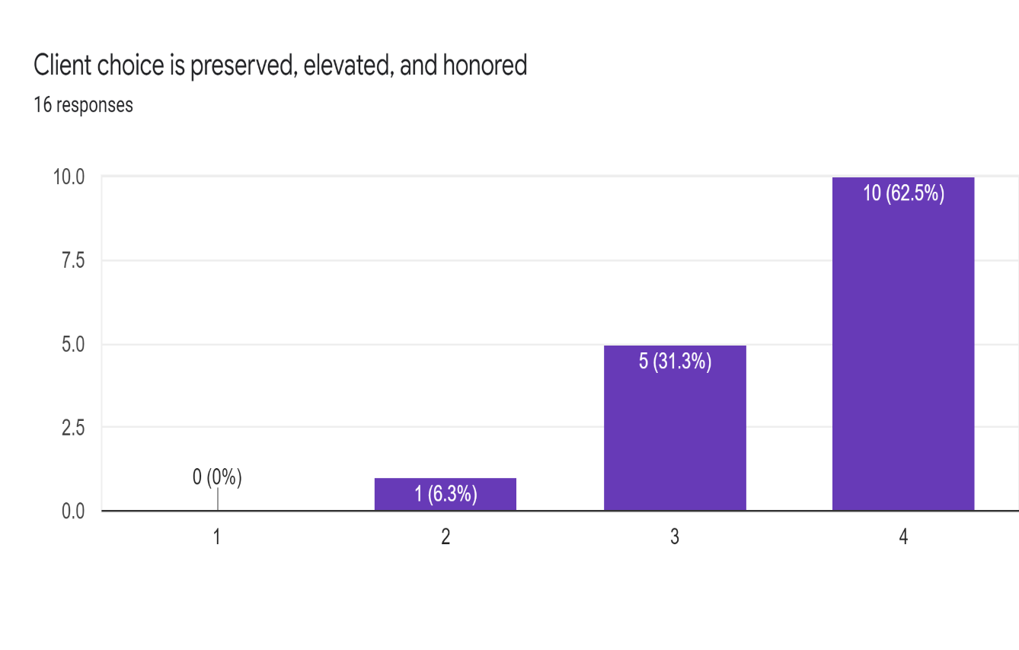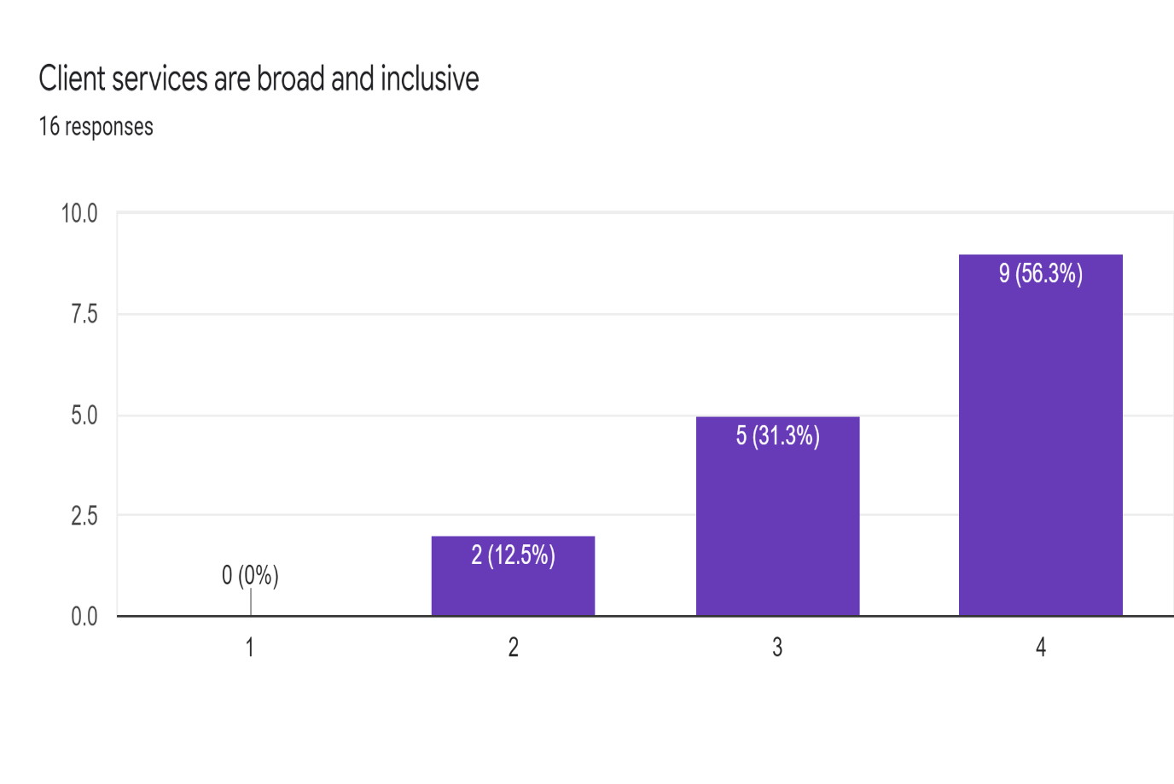
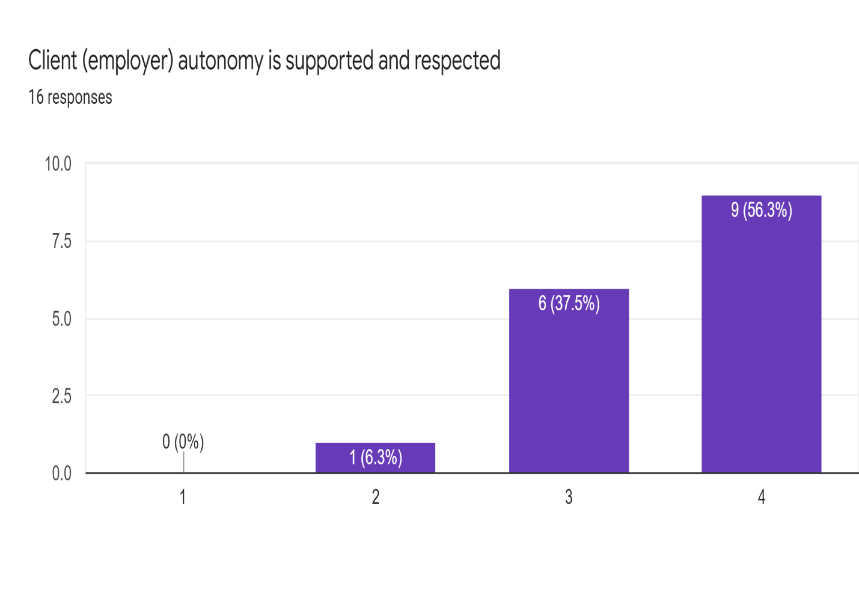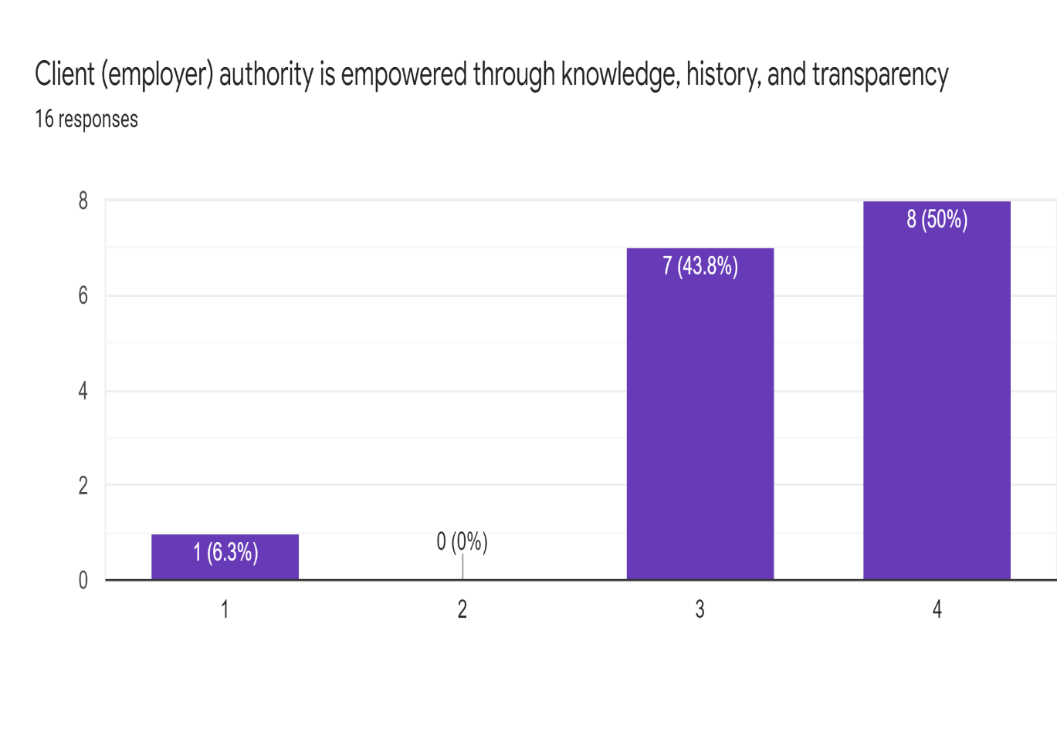
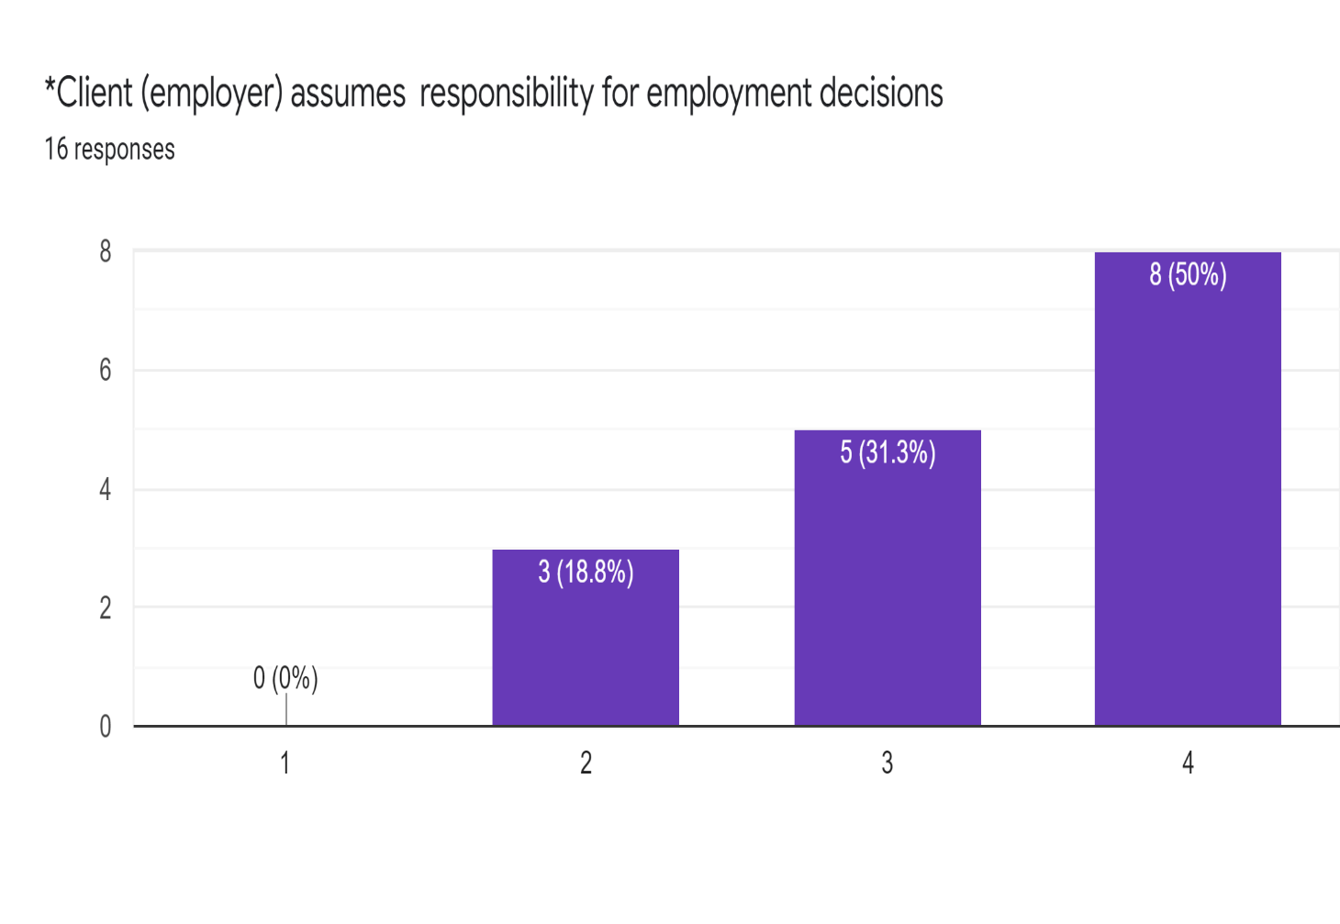
As a Result of the Informed Choice Program/Process – Client & Caregiver Relationship

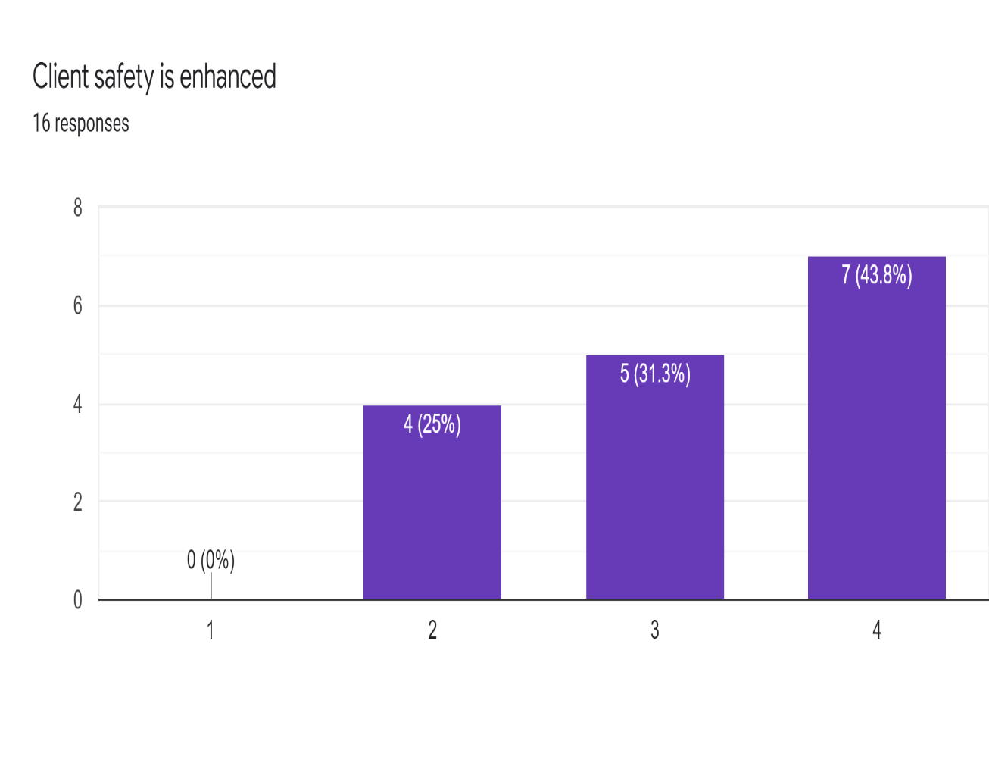
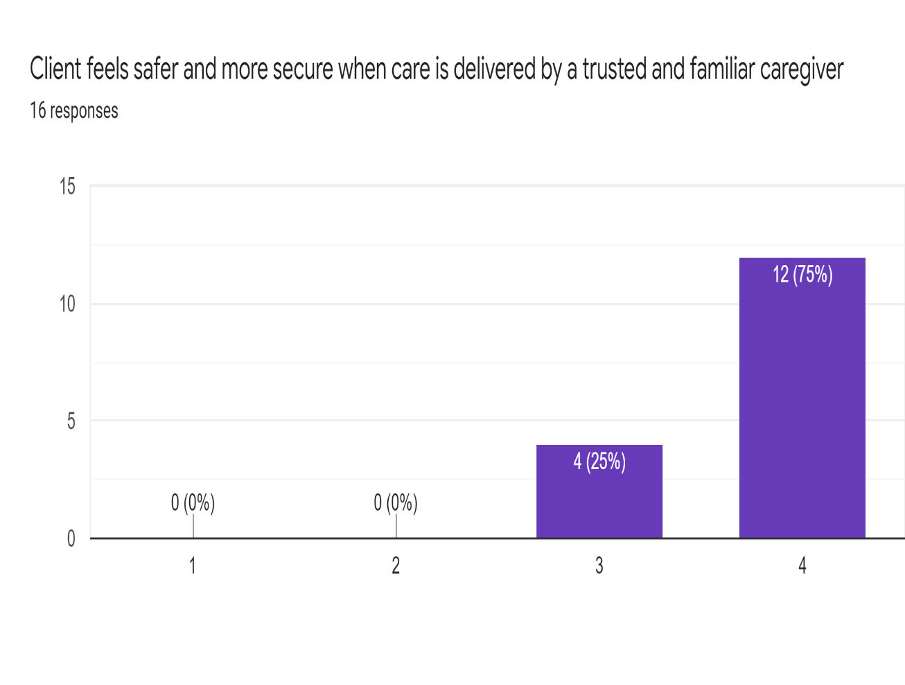

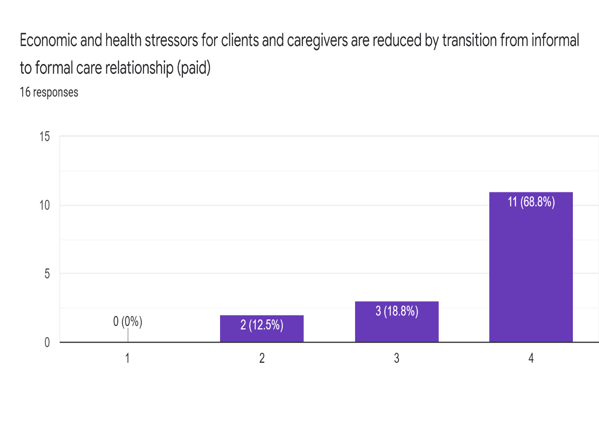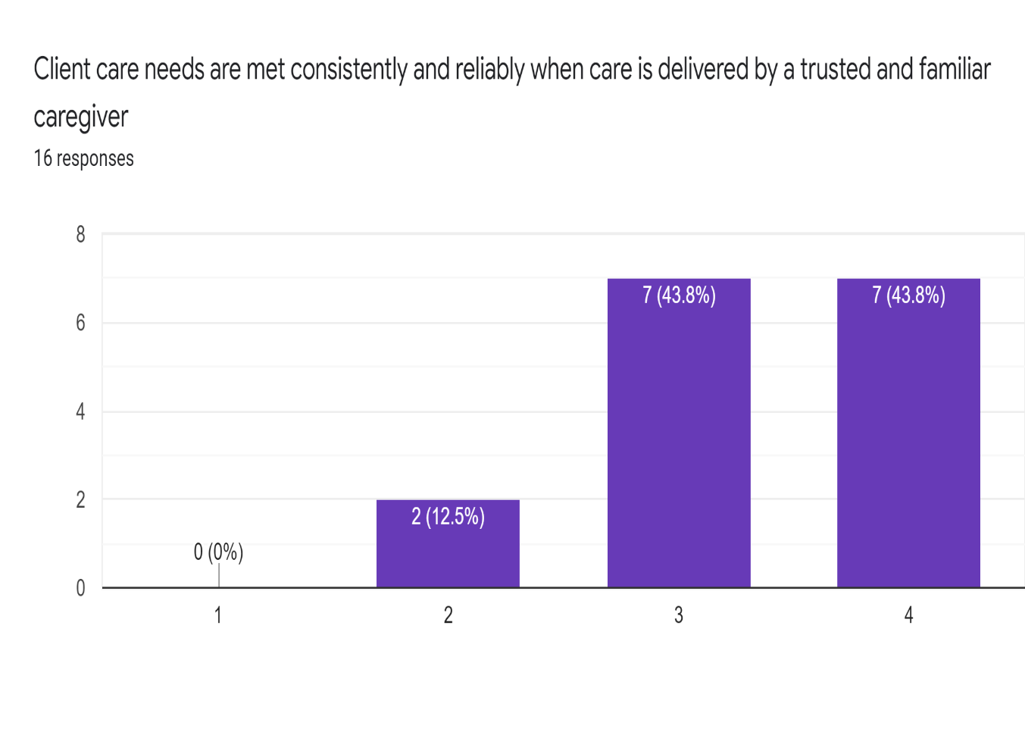
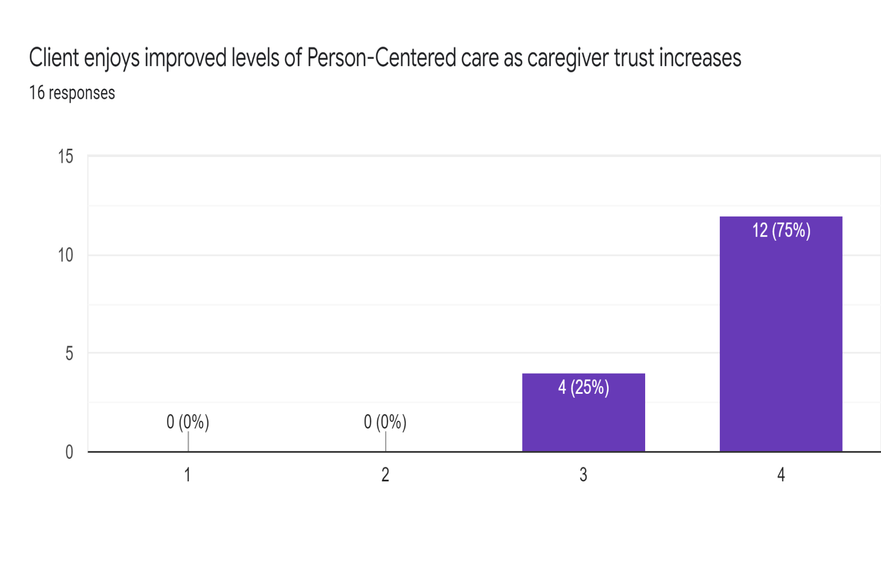
As a Result of the Informed Choice Program/Process – Equity, Justice, and Inclusion

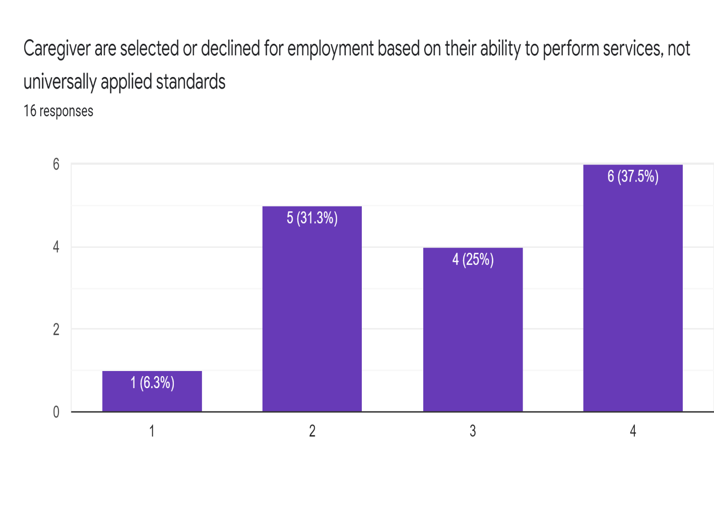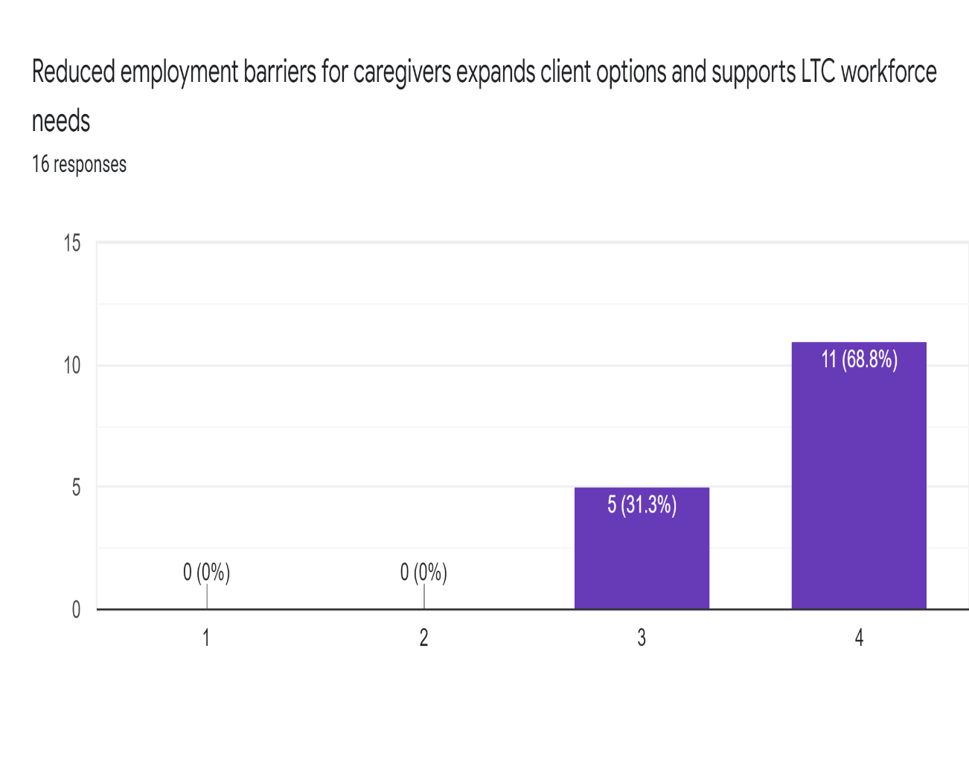
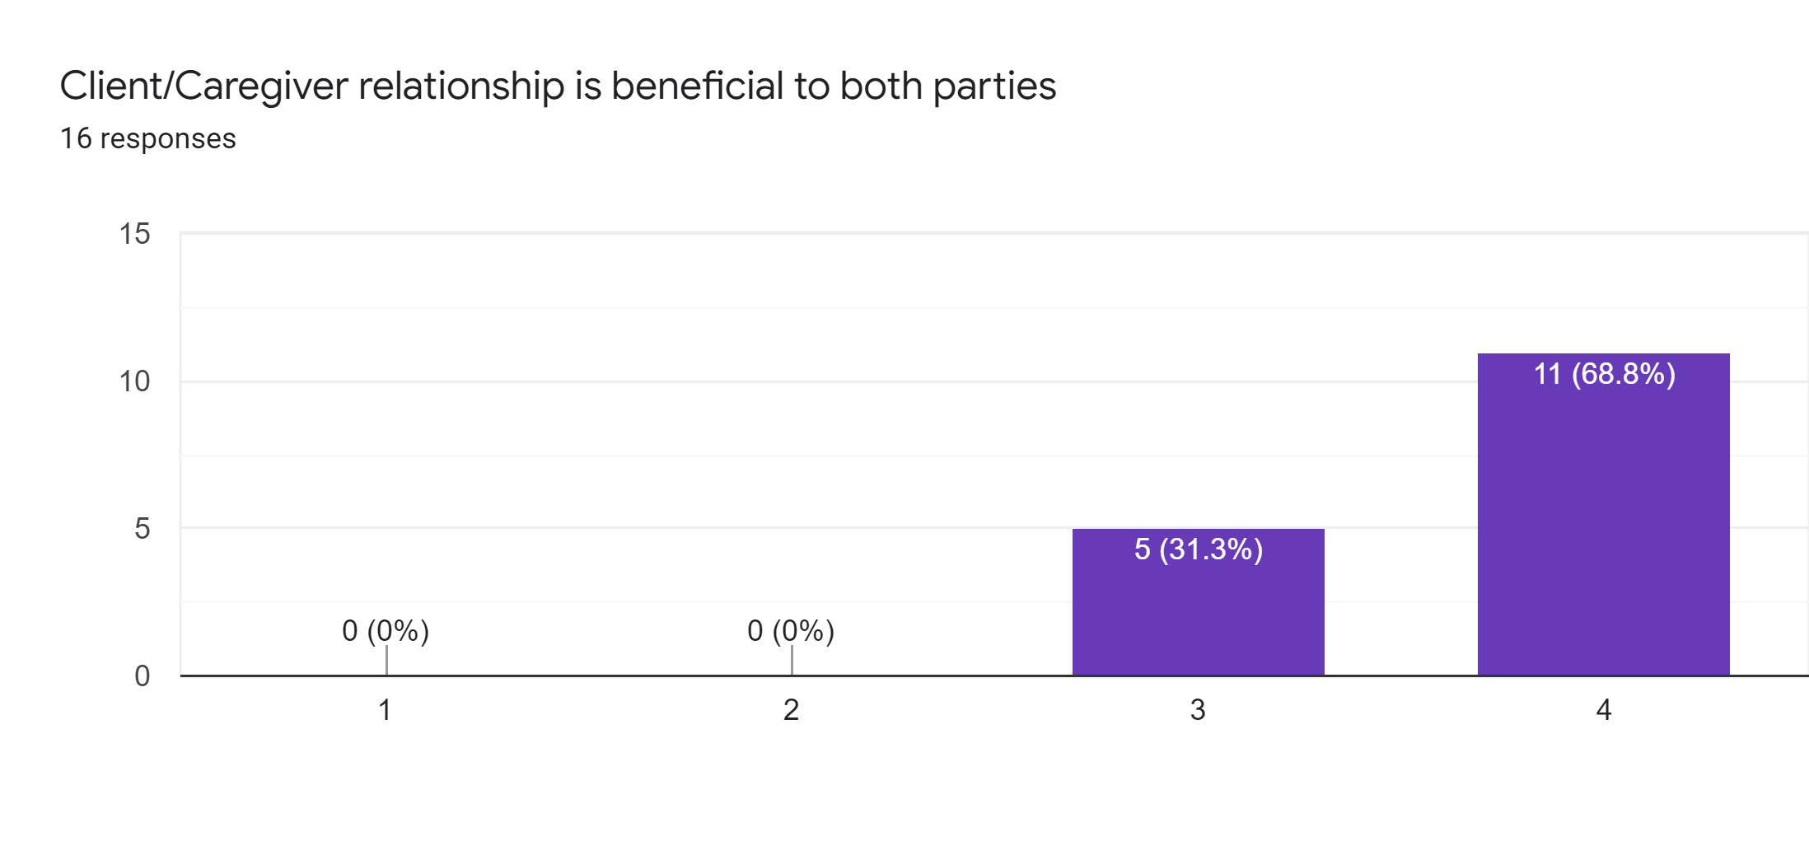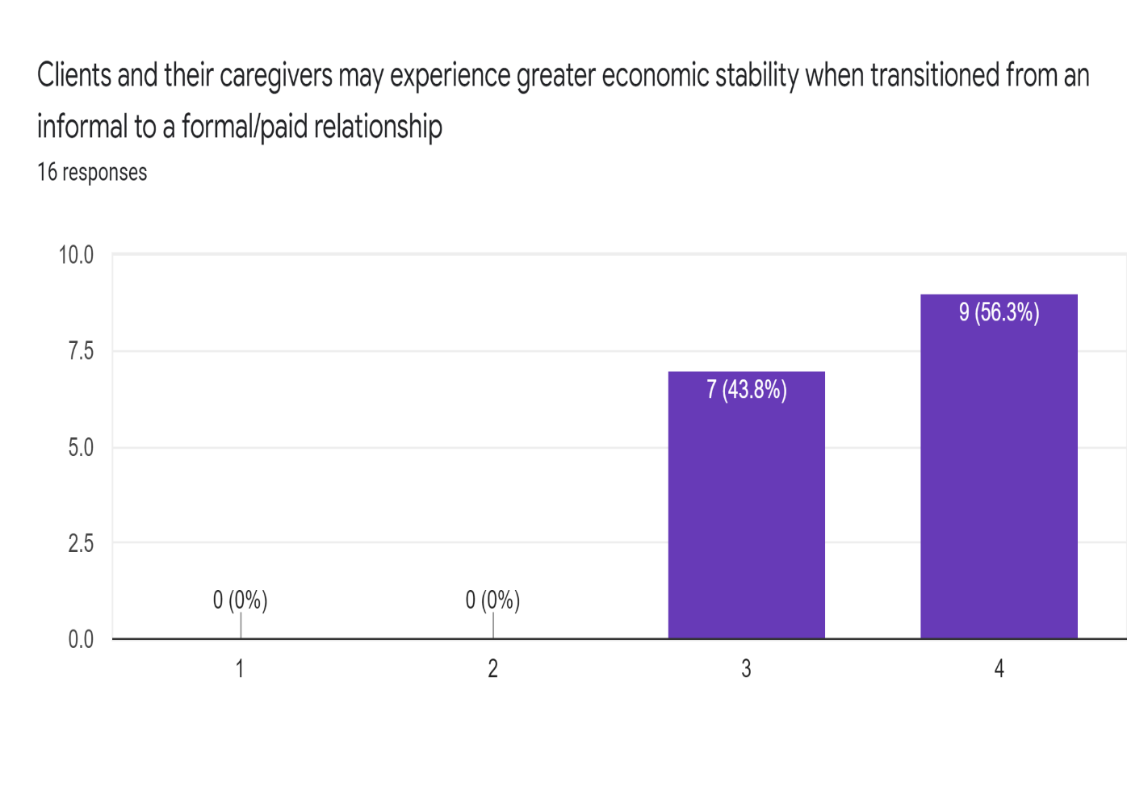

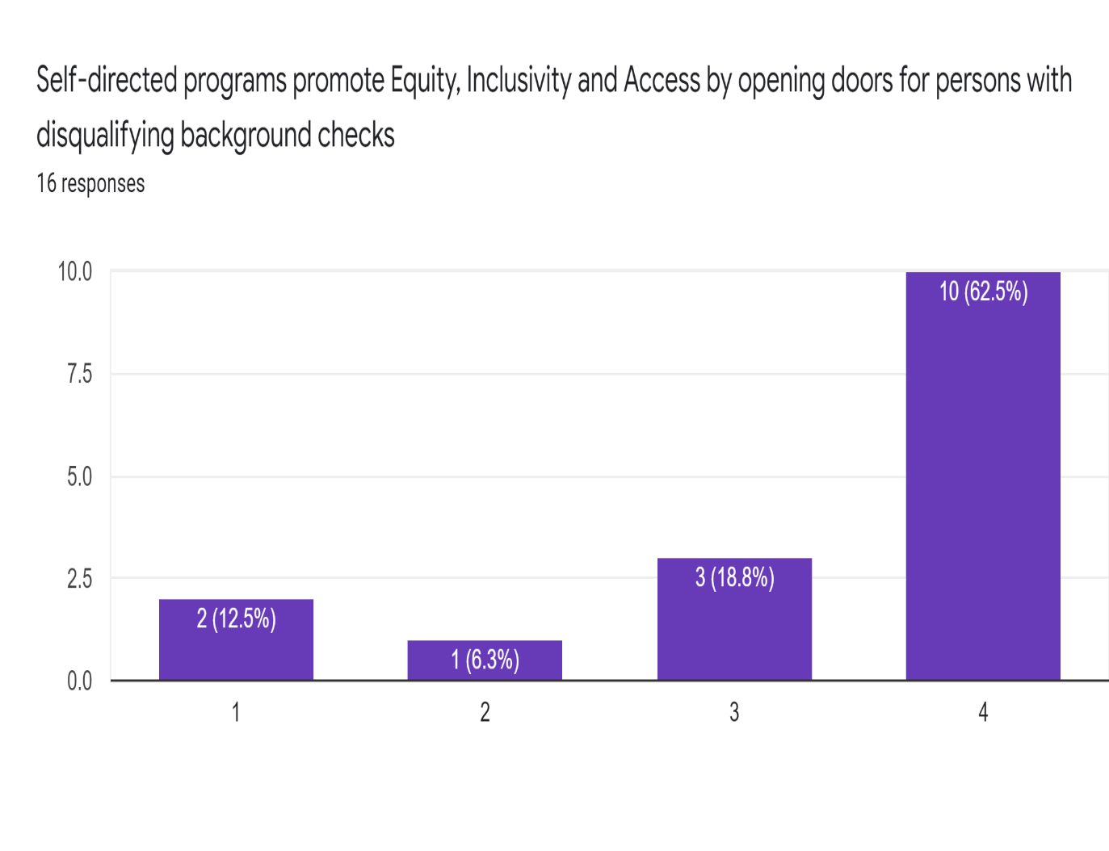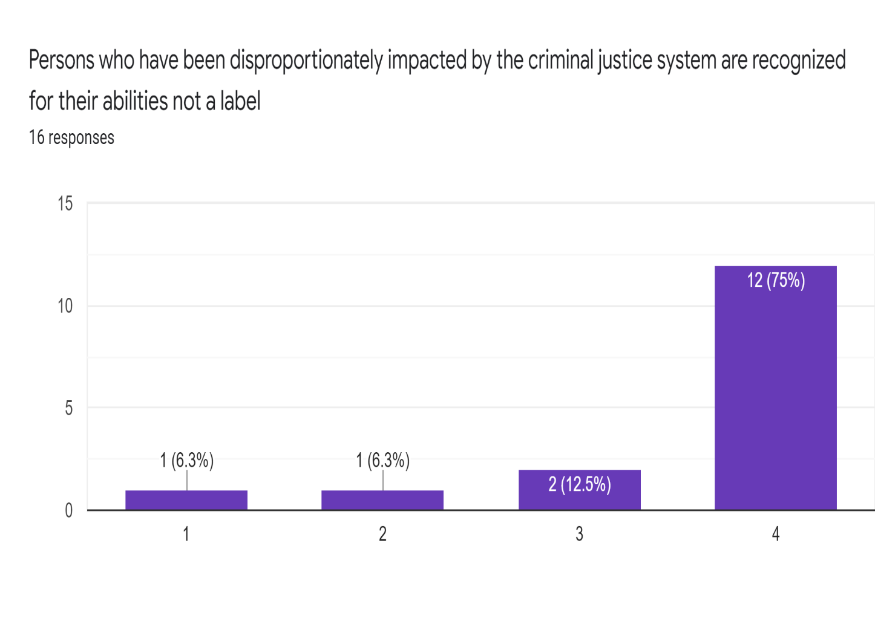
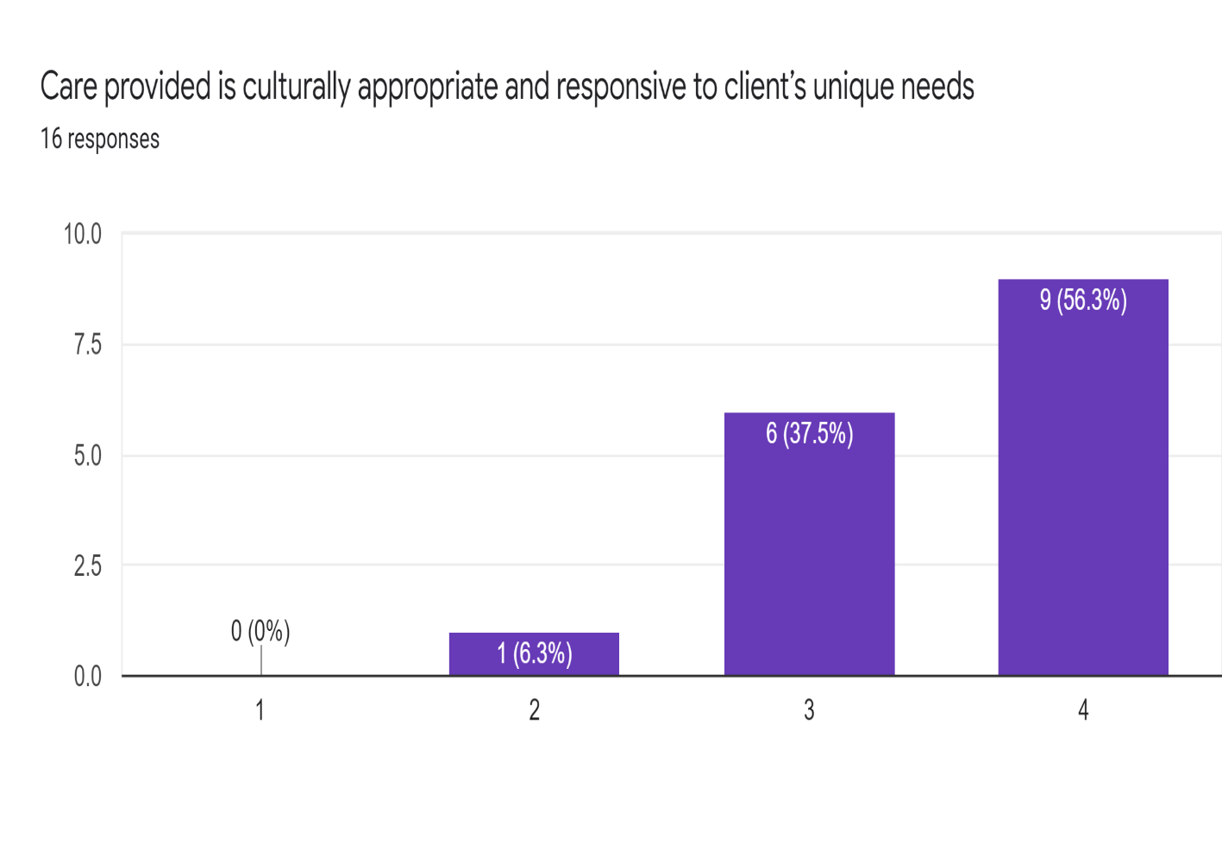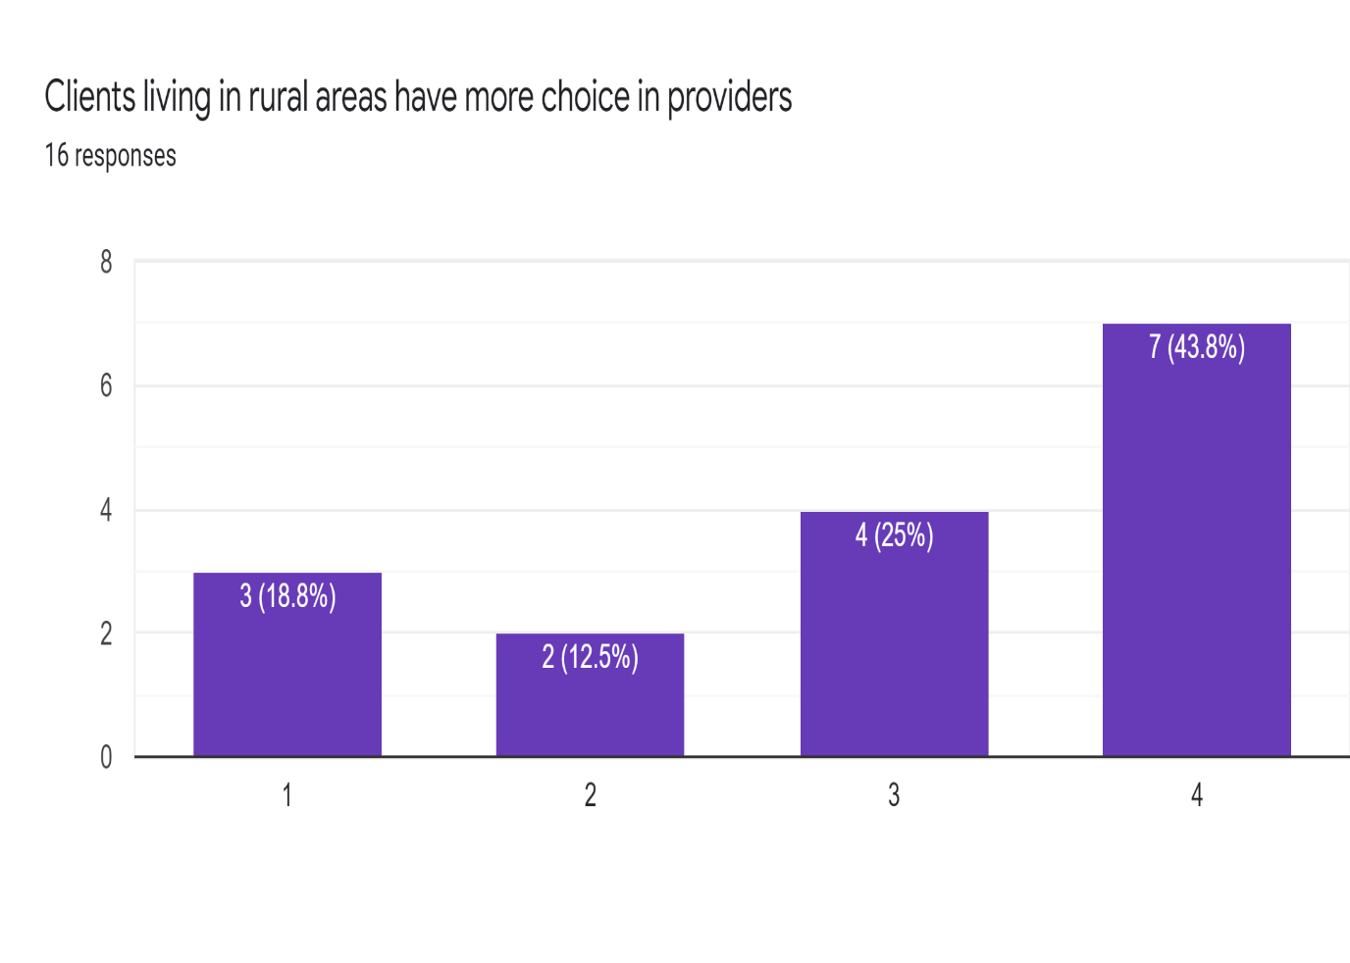

Appendix 7 Department of Health Briefing Paper

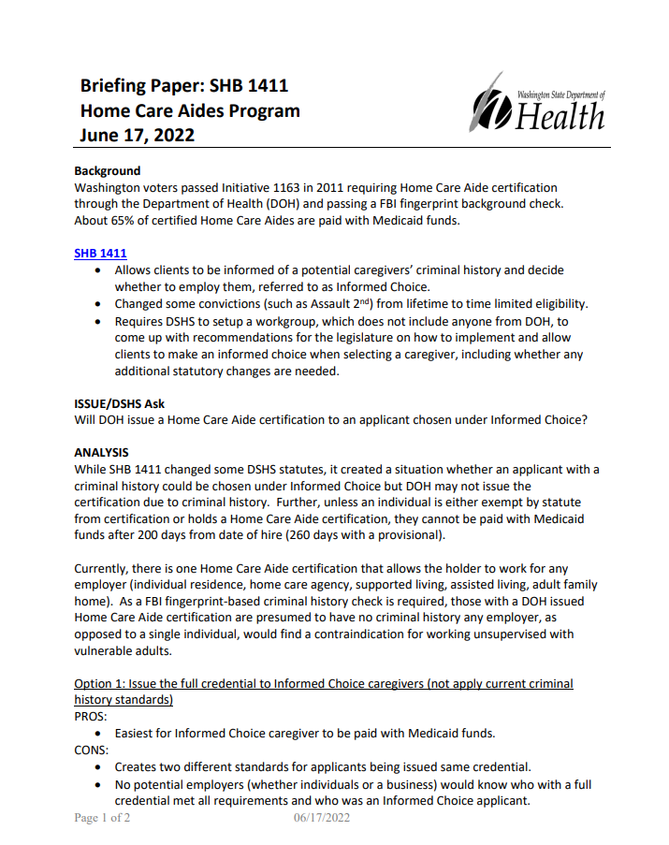
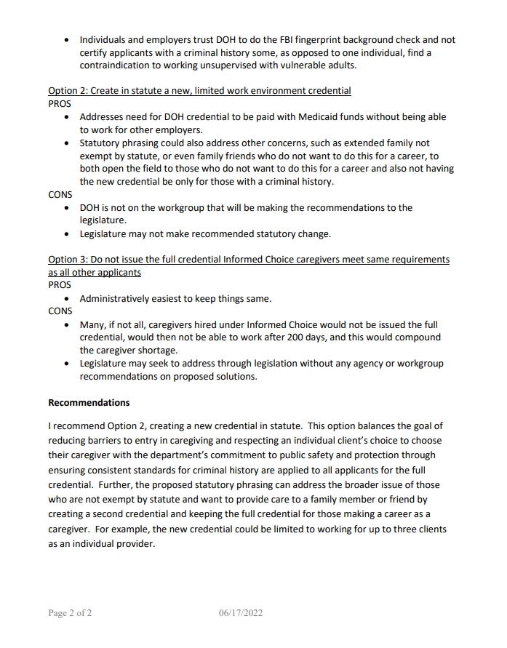

Appendix 8 State Research

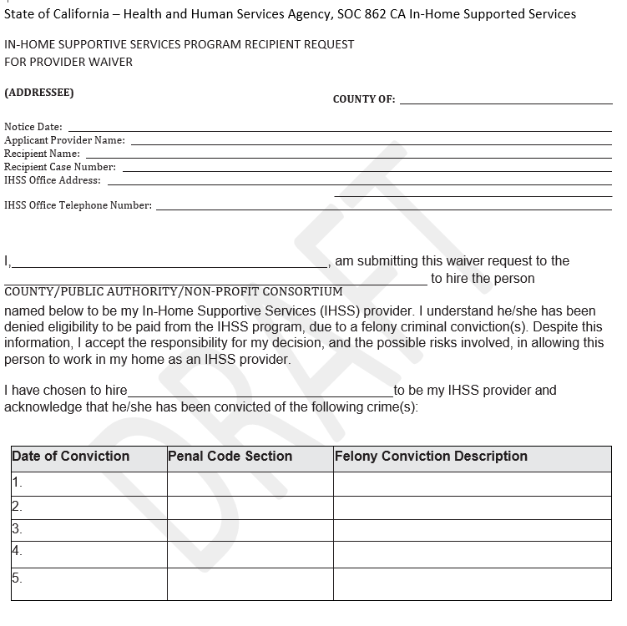

ALTSA Working Strategic Plan 2021-2023, p. 5
WA State Plan on Aging – 2018-2022 p. 17
DDA 2021 Caseload and Cost Report, Data Source CARE point in time July 2021 page 14.
In-Home and Residential Long-Term Supports for Person with Intellectual or Developmental Disabilities: Status and Trends 2018 published 12/21, Institute on Community Integration, University of Minnesota, National Residential Information Systems Project, Page 32.
Caregiving in the U.S., 2020 Report, National Alliance for Caregiving (NAC) and AARP
RCW 43.43.837; RCW 43.43.832; RCW 71.09.115; RCW 42.20A.710; RCW 74.39A.056
https://www.dshs.wa.gov/ffa/disqualifying-list-crimes-and-negative-actions
https://www.appliedselfdirection.com
ALTSA Working Strategic Plan 2021-2023, p. 5. Estimates from the state Office of Financial Management WA State Plan on Aging, p. 4
DDA 2021 Caseload and Cost Report, Data Source CARE point in time July 2021 page 14.
WA State Plan on Aging 2018-2022, p. 17
WA State Plan on Aging – 2018-2022 p. 17
WA State Plan on Aging 2018-2022, p. 23
Measuring Impact of Caregiver Support in Washington State: A Model for Policy Change, DSHS/HCS/Bea Rector
AARP Caregiving in the US 2020; American Psychological Association: Mental and Physical Health Effects of Family Caregiving (Pinquart & Sorensen, 2003; Vitaliano, Zhang & Scanlon, 2003).
Cultural Diversity and Caregiving, Weiss et al, 2005, American Psychological Association
Friedman, Matthew. “Just Facts: As Many Americans have Criminal Records as College Diplomas.” Brennan Center. 17 November 2015. https://www.brennancenter.org/our-work/analysis-opinion/just-facts-many-americans-have-criminal-records-college-diplomas
2009 Justice Department study National Conference of State Legislature https://www.ncsl.org/research/labor-and-employment/barriers-to-work-individuals-with-criminal-records.aspx#:~:text=Approximately%2077%20million%20Americans%2C%20or,that%20requires%20an%20occupational%20license.
The Pew Charitable Trusts, “Collateral Consequences: Incarceration’s Effect on Economic Mobility available at https://www.pewtrusts.org/~/media/legacy/uploadedfiles/pcs_assets/2010/collateralcosts1pdf.pdf DeFina, Robert H. and Hannon, Lance, “The Impact of Mass Incarceration on Poverty” (Rochester: Social Science Research Network, 2009), available at https://papers.ssrn.com/sol3/papers.cfm?abstract_id=1348049
Friedman, Matthew. “Just Facts: As Many Americans have Criminal Records as College Diplomas.” Brennan Center. 17 November 2015. https://www.brennancenter.org/our-work/analysis-opinion/just-facts-many-americans-have-criminal-records-college-diplomas
2009 Justice Department study National Conference of State Legislature https://www.ncsl.org/research/labor-and-employment/barriers-to-work-individuals-with-criminal-records.aspx#:~:text=Approximately%2077%20million%20Americans%2C%20or,that%20requires%20an%20occupational%20license. The Pew Charitable Trusts, “Collateral Consequences: Incarceration’s Effect on Economic Mobility available at https://www.pewtrusts.org/~/media/legacy/uploadedfiles/pcs_assets/2010/collateralcosts1pdf.pdf DeFina, Robert H. and Hannon, Lance, “The Impact of Mass Incarceration on Poverty” (Rochester: Social Science Research Network, 2009), available at https://papers.ssrn.com/sol3/papers.cfm?abstract_id=1348049
The Pew Charitable Trusts: Pew Center on the States. Collateral Costs: Incarceration’s Effect on EconomiMobility. Washington, DC. 2010; Bryan L. Sykes and Michelle L. Maroto, “A Wealth of Inequalities: Mass Incarceration, Employment, and Racial Disparities in U.S. Household Wealth, 1996 to 2011,” The Russell Sage Foundation Journal of the Social Sciences 2 (6) (2016): 129-152, available at https://muse.jhu.edu/article/639847/pdf. US Department of Health and Human Services Office of Minority Health Disparities Action Plan Mauer, M., Nellis, A., Schirmir, S.; Incarcerated Parents and Their Children - Trends 1991 - 2007, The Sentencing Project, Feb. 2009 - http://www.sentencingproject.org
The Washington State Second Chance Expungement Gap 2020 – p. 1-2
Friedman, Matthew. “Just Facts: As Many Americans have Criminal Records as College Diplomas.” Brennan Center. 17 November 2015. https://www.brennancenter.org/our-work/analysis-opinion/just-facts-many-americans-have-criminal-records-college-diplomas
Mental Health and Developmental Disabilities National Training Center; Self-Determination & Dignity of Risk - MHDD National Training Center (mhddcenter.org)
Mental Health Recovery Institute; https://youtu.be/Nf4Y7v-SLtc
See “Liability Recommendations,” page 47, for further analysis of this recommendation.
The Federal Bureau of Investigation prohibits dissemination of Federal Background Check information, except by the prospective Individual provider themself.
Caregiving in the U.S., 2020 Report, National Alliance for Caregiving (NAC) and AARP

