CLINIC LOGO | Patient Label Here

ALCOHOL USE QUESTIONS (AUDIT)
Drinking alcohol can affect your health and some medications you may take. Please help us provide you with the best medical care by answering the questions below.

One drink equals: | 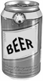  12 oz. beer |  | 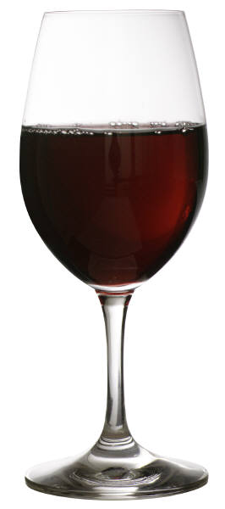  5 oz. wine |  |  | 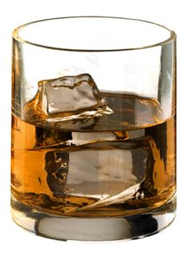  1.5 oz. liquor (one shot)
Place an X in one box that best describes your answer to each question.
In the past 12 months… | 0 | 1 |  | 2 | 3 |  | 4
1. How often do you have a drink containing alcohol? | Never | Monthly or less |  | 2 to 4 times a month | 2 to 3 times a week |  | 4 or more times a week
2. How many drinks containing alcohol do you have on a typical day when you are drinking? | 1 or 2 | 3 or 4 |  | 5 or 6 | 7 to 9 |  | 10 or more
3. How often do you have 5 or more drinks on one occasion? | Never | Less than monthly |  | Monthly | Weekly |  | Daily or almost daily
4. How often during the last year have you found that you were not able to stop drinking once you had started? | Never | Less than monthly |  | Monthly | Weekly |  | Daily or almost daily
5. How often during the last year have you failed to do what was normally expected from you because of drinking? | Never | Less than monthly |  | Monthly | Weekly |  | Daily or almost daily
6. How often during the last year have you needed a first drink in the morning to get yourself going after a heavy drinking session? | Never | Less than monthly |  | Monthly | Weekly |  | Daily or almost daily
7. How often during the last year have you had a feeling of guilt or remorse after drinking? | Never | Less than monthly |  | Monthly | Weekly |  | Daily or almost daily
8. How often during the last year have you been unable to remember what happened the night before because of your drinking? | Never | Less than monthly |  | Monthly | Weekly |  | Daily or almost daily
9. Have you or someone else been injured because of your drinking? | No |  |  | Yes, but not in the last year |  |  | Yes, during the last year
10. Has a relative, friend, doctor, or other health care worker been concerned about your drinking or suggested you cut down? | No |  |  | Yes, but not in the last year |  |  | Yes, during the last year
Add scores for each column, then add across this row.
TOTAL

Date_________________________
SCORING:

Each response from the AUDIT has a score ranging from 0 to 4. The top of each column has a number. That number equals the score value for responses in that column. After a patient has completed the AUDIT, add up each column score, and then sum all five columns for the patient’s score. Below are the scoring guidelines for the AUDIT.

Guidelines for Interpretation for AUDIT
Score | Risk Level | Intervention
0-6 (Female)  0-7 (Male) | Zone I | Feedback and alcohol education
7-15 (Female)  8-15 (Male) | Zone II | Brief intervention
16-19 | Zone III | Brief intervention plus brief therapy
20-40 | Zone IV | Brief intervention plus referral to chemical dependency treatment
Babor TF, Higgins-Biddle JC , Saunders JB, Monteiro MG. AUDIT: The Alcohol Use Disorders Identification Test Guidelines for Use in Primary Care. 2nd Edition. World Health Organization. 2001

