Drinking alcohol, using marijuana, or using drugs other than those required for medical reasons can affect your health. These activities can also affect the medications you take. Please help us provide you with the best possible medical care by answering the questions below.
For WOMEN (18-65 years) and ANYONE (66 years and older)
ONE DRINK EQUALS
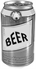  12 oz. beer | 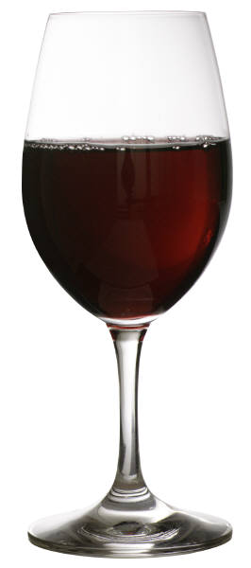  5 oz. wine | 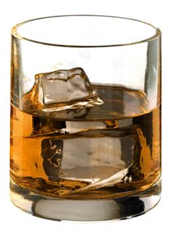  1.5 oz. liquor (one shot)
Please answer the questions below. |  |  | None  (0) | 1  or More
1. How many times in the past year have you had 4 or more drinks in a day?
2. How many times in the past year have you used a recreational drug or used a prescription medication for non-medical reasons?

For MEN (18-65 years)
ONE DRINK EQUALS
12 oz. beer | 5 oz. wine | 1.5 oz. liquor (one shot)
Please answer the questions below. |  |  | None  (0) | 1  or More
1. How many times in the past year have you had 5 or more drinks in a day?
2. How many times in the past year have you used an recreational drug or used a prescription medication for non-medical reasons?

Examples of drugs include but are not limited to:
marijuana, solvents like paint thinners, tranquilizers like Valium, barbiturates, cocaine, methamphetamine, hallucinogens like LSD, ecstasy, or narcotics like heroin.

