Do you know how to report Abuse, Neglect, Exploitation or Abandonment?
CALL
Complaint Resolution Unit (CRU)
1-800-562-6078
Or Scan QR Code below to make an online report
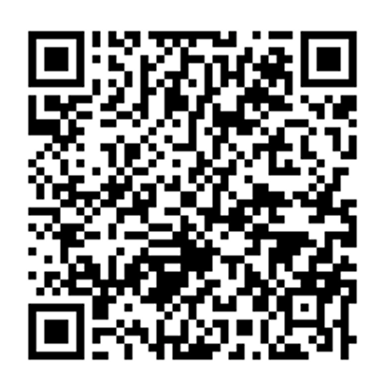
Other Important Phone Numbers
Emergency Services: 911
Mental Health Crisis Line: 988
Poison Control: 1-800-222-1222
Non-Emergency Police: (enter your local non-emergency phone number)
DDA Office: (enter your local DDA main office number)
DD Ombuds: 1-833-727-8900
House Supervisor: (name and phone number)
After Hours On-Call: (phone number)
Address: (enter home address)
Do you know how to report Abuse, Neglect, Exploitation or Abandonment?
CALL
Complaint Resolution Unit (CRU)
1-800-562-6078
Or Scan QR Code below to make an online report
Other Important Phone Numbers
Emergency Services: 911
Mental Health Crisis Line: 988
Poison Control: 1-800-222-1222
Non-Emergency Police: (enter your local non-emergency phone number)
DDA Office: (enter your local DDA main office number)
DD Ombuds: 1-833-727-8900
House Supervisor: (name and phone number)
After Hours On-Call: (phone number)
Address: (enter home address)
Do you know how to report Abuse, Neglect, Exploitation or Abandonment?
CALL
Complaint Resolution Unit (CRU)
1-800-562-6078
Or Scan QR Code below to make an online report

Do you know how to report Abuse, Neglect, Exploitation or Abandonment?
CALL
Complaint Resolution Unit (CRU)
1-800-562-6078
Or Scan QR Code below to make an online report
Do you know how to report Abuse, Neglect, Exploitation or Abandonment?
CALL
Complaint Resolution Unit (CRU)
1-800-562-6078
Or Scan QR Code below to make an online report

Do you know how to report Abuse, Neglect, Exploitation or Abandonment?
CALL
Complaint Resolution Unit (CRU)
1-800-562-6078
Or Scan QR Code below to make an online report

