

**vANCOUVER**

**Developmental disabilities administration**

**Continuing education**

**Training**

January 17, 2018 CEUs Pending Approval 9 AM to 4 PM

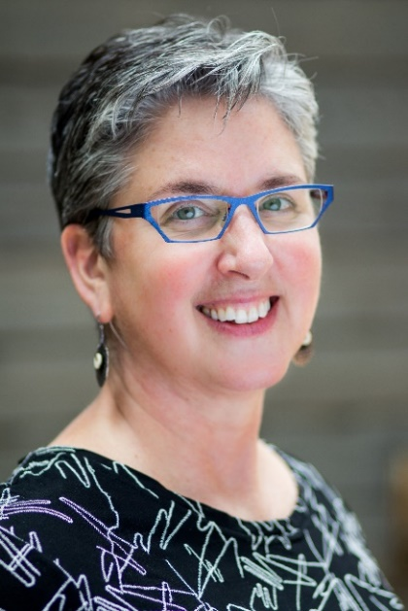

**Communication, You Don’t Say, Non-Linguistic Communication Strategies**

**A Hands-On Participatory Training**

**Are you playing with, living with or working with someone who does not use formal language to communicate? How do they participate in the choices of their life? People with communication disorders, sensory losses and cognitive challenges often process and assimilate information and express ideas in alternative formats.**

**We’ll tap your hidden wisdom to learn concrete steps for building communication skills thru hands on activities that help our focus shift to concrete methods. Take time to develop new files & pathways to gather and exchange information.**

**You will leave this session with clear steps to take; establishing relationship based motivating activities that work to build communication! This is an active and fun session- come ready to learn thru challenging playful activities!**

**Jennifer White** is the Executive Director of Able Opportunities, Inc., a national consulting company specializing in vocation, education, and communication goals and programs for students and adults. She has spent her career creating tools and strategies that shift service supports from Compliance to Alliance. As a subject matter expert, she develops corporate disability inclusion programs, provides testimony, designs agency programs and trains frontline staff.

**Presenter: Jennifer White**

From North:

Head South on I-5. Take exit 1C (E Mill Plain Blvd) and turn RIGHT (west) onto Mill Plain Blvd. Turn LEFT onto Franklin Street, RIGHT on Evergreen Blvd, and LEFT on Harney Street. Brick building immediately on your left.

From South:

Head North on I-5. Take exit 1B (City Center) and follow around onto C Street. Turn LEFT on Evergreen Blvd, and LEFT on Harney Street. Brick building immediately on your left.

From East/Hwy 14:

Head East on Hwy 14. Take CITY CENTER exit (center lane) and follow around onto C Street. Turn LEFT on Evergreen Blvd, and LEFT on Harney Street. Brick building immediately on your left.

For Questions: Call Rob Henrikson at 360-993-6953,

Do not call to register, use form attached.

**

There is no parking in the DSHS Parking lots. Parking on the streets are primarily metered. There are some Long-Term meters along Evergreen Blvd. Please bring coins for the metered parking.

[Vancouver DDA, 907 Harney St, Suite 200,](https://binged.it/2ej6eGp)

[Vancouver, WA 98660](https://binged.it/2ej6eGp)

**vANCOUVER**

**Developmental Disabilities Administration**

**Communication, , Non-Linguistic Communication Strategies**

**Registration Form**

**Please register early as space is limited and the training sessions fill quickly. Registration ends two weeks before date of training. We will email/send a confirmation.**

**Please tell us at least two weeks in advance if you need a special accommodations** by writing it in the space below. We need two weeks to process your request. If you don’t receive a confirmation of this request please contact us. You can call Rob Henrikson at 360-993-6953.

I need this special accommodation: ________________________________________

**Send this registration form via mail, email or fax to:**

**Rob Henrikson, Developmental Disabilities Administration**

**907 Harney St, Suite 200, Vancouver, WA 98660**

**Fax 360-737-2057**

**Email–** [**Robert.Henrikson@dshs.wa.gov**](mailto:Robert.Henrikson@dshs.wa.gov)

**Additional classes are listed online at** <https://www.dshs.wa.gov/dda/dda-provider-training>

|  |  |  |  |  |  |
| --- | --- | --- | --- | --- | --- |
| |  |  | | --- | --- | | Who can attend, Check one:   Licensed AFH Provider,   AFH Resident Manager,   AFH Caregiver,   Assisted Living Administrator   Assisted Living Caregiver   Companion Home Provider   Alternative Living Provider   DDA Residential Program Employee   DDA Employment Program Employee   Other, i.e. Family, parent, teachers, others who want to learn more. Please describe:  ____________________________________________ | Please fill out, if you can, the below information:  Name of Company/Employer/AFH:  ______________________________________  City of Company/Employer/AFH:  ______________________________________   Phone Number:  ______________________________________  Info about CEUs:  Individual Providers, can attend, but CEUs do not apply. IPs go through the Training Partnership for CEUs.  CE credits for others with DOH credentials may be allowable at the discretion of your licensing board. It is the responsibility of attendees with other certifications/ licenses to verify that this CE activity meets your licensing boards’ standards and acceptability as a CE event. | | |  |  | | --- | --- | |  |  | |
| Who can attend, Check one:   Licensed AFH Provider,   AFH Resident Manager,   AFH Caregiver,   Assisted Living Administrator   Assisted Living Caregiver   Companion Home Provider   Alternative Living Provider   DDA Residential Program Employee   DDA Employment Program Employee   Other, i.e. Family, parent, teachers, others who want to learn more. Please describe:  ____________________________________________ | Please fill out, if you can, the below information:  Name of Company/Employer/AFH:  ______________________________________  Address of Company/Employer/AFH:  ______________________________________  ______________________________________    Phone Number:  ______________________________________   Individual Providers, can attend, but CEUs do not apply. IPs go through the Training Partnership for CEUs. |

Participants Name: ___________________________________________________________

Provide Email, Fax, or Address to send confirmation notice: (Email is preferred)

________________________________________________________

________________________________________________________

Phone number in case of last minute changes to training: _______________________________

January 17, 2018 CEUs Pending Approval 9 AM to 4 PM