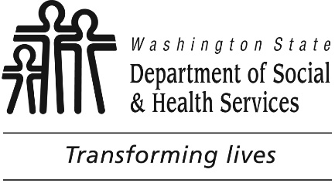

**Tacoma**

**Developmental disabilities administration**

**Continuing education Training**

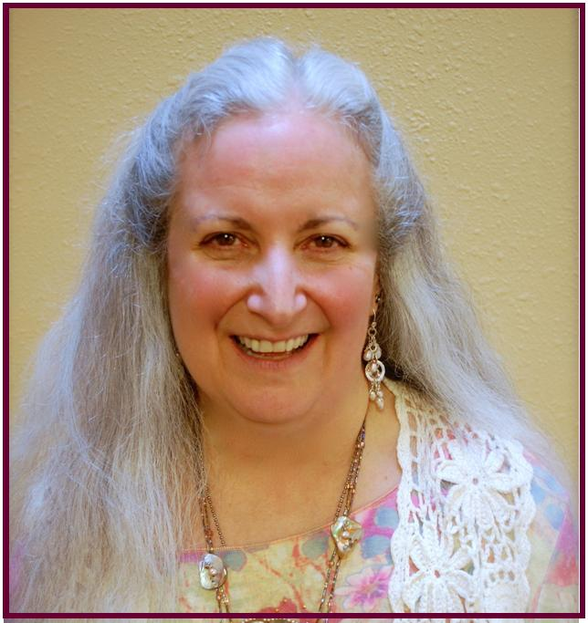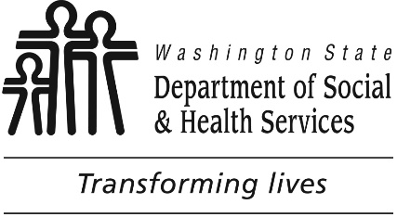

# **Creating Meaningful Interactions & Relationships - Finding Our Common Humanity**

**Attendees in this workshop will examine values, stereotypes and preconceived notions about people with disabilities. Discussion will focus on how these factors influence the work of staff supporting people with disabilities. Interactive exercises will promote attitudes and strategies that emphasize validation of people with disabilities as valued members of the community who have valid feelings, thoughts & experiences as well as unique gifts to share with others.**

**Deborah** has committed more than 30 years of her life to providing services to and advocating on behalf of individuals with intellectual and developmental disabilities. With a BA in Special Education and a MA in services for individuals who are deaf or hard of hearing, her career path has taken her, if not through, at least to, every door in this field in the Greater Pacific Northwest.

Weaving through her Inclusion Advocacy, her work with Employment & Residential agencies, and contract work as a Trainer, Consultant, and Technical Assistance provider is this central theme, tying together in neat package what might otherwise pass for the vocational equivalent of a social-butterfly: To deny access to community devalues and diminishes what it means to be human. But to seek identity and understanding through community strengthens and enriches all humanity.

[DDA Tacoma Office, 1305 Tacoma Ave S., Suite 300, Tacoma, WA 98402](https://binged.it/2efAX8C)

**Parking is not available in the Garage attached to our Tacoma DDA office/the Work Source Bldg. People park on the street or in pay to park lots.** Suggested Parking information will be provided with confirmations.

You must attend all of the training to receive a certificate. Class starts promptly if you are late you will be asked to sign up for a future training.

**From I5 South:**

Merge onto I-705 N via EXIT 133 toward City Center

Take the A Street exit on the left toward City Center

Keep left to take the S. 15 Street ramp toward Pacific Ave

Turn slight left onto S 15th St

Turn right onto Tacoma Ave S

1305 TACOMA AVE S is on the right

**From I5 North:**

Take the I-705 N / WA-7 S exit, EXIT 133, toward City Center / Pacific Avenue

Take the exit on the left toward City Center / Tacoma Dome

Merge onto I-705 N via the exit on the left toward City Center

Take the A Street exit on the left toward City Center

Keep left to take the S. 15 Street ramp toward Pacific Ave

Turn slight left onto S 15th St

Turn right onto Tacoma Ave S

1305 TACOMA AVE S is on the right.

For Questions: Call Melody

Erickson at 253-404-5560.

Do not call to register, use form attached.

**Presenter:**

**Deborah Moskowitz**

February 1st, 2018 Total of 6 CEUs 9 AM to 4 PM

I wish to attend this training.

Participants Name/s: ____________________________________________________________________

Provide Email, Fax, or Address to send confirmation notice: (Email is preferred, please put the “title” of the training and the word “registration” in email subject line when emailing registrations)

_____________________________________________________________________________________

Phone number in case of last minute changes to training: _______________________________________

**Tacoma**

**Developmental Disabilities Administration**

**creating meaningful interactions & relationships**

**Registration Form**

**Please register early as space is limited and the training sessions fill quickly. Registration ends two weeks before date of training. We will email/send a confirmation, please allow a week to process before calling if you have not received a confirmation.**

**Please tell us at least two weeks in advance if you need a special accommodations** by writing it in the space below. We need two weeks to process your request. If you don’t receive a confirmation of this request please contact us. You can call Melody Erickson at 253-404-5560.

I need this special accommodation: ________________________________________

**Send this registration form via mail, email or fax to:**

**Melody Erickson,** Developmental Disabilities Administration

1305 Tacoma Ave. S., Suite 300, Tacoma, WA 98402

**Fax (253) 597.4368 Email–** [**melody.erickson@dshs.wa.gov**](mailto:melody.erickson@dshs.wa.gov)

**Additional classes are listed online at** <https://www.dshs.wa.gov/dda/dda-provider-training>

|  |  |  |  |
| --- | --- | --- | --- |
| Who can attend, Check one:   Licensed AFH Provider,   AFH Resident Manager,   AFH Caregiver,   Assisted Living Administrator   Assisted Living Caregiver   Companion Home Provider   Alternative Living Provider   DDA Residential Program Employee   DDA Employment Program Employee   Other, i.e. Family, parent, teachers, others who want to learn more. Please describe:  ____________________________________________ | Please fill out, if you can, the below information:  Name of Company/Employer/AFH:  ______________________________________  City of Company/Employer/AFH:  ______________________________________   Phone Number:  ______________________________________  Info about CEUs:  Individual Providers, can attend, but CEUs do not apply. IPs go through the Training Partnership for CEUs.  CE credits for others with DOH credentials may be allowable at the discretion of your licensing board. It is the responsibility of attendees with other certifications/ licenses to verify that this CE activity meets your licensing boards’ standards and acceptability as a CE event. |  |  |

February 1st, 2018 Total of 6 CEUs 9 AM to 4 PM