

**Vancouver**

**Developmental disabilities administration**

**Continuing education Training**

**

**Presenter:**

**Britta Saltonstall, PhD, BCBA**

**From North:**

Head South on I-5. Take Exit #101 Tumwater Blvd. Turn LEFT onto Tumwater Blvd. Travel approximately 1 mile. Turn LEFT onto Capitol Blvd. Go past Israel Road to the buildings with the fountain and clock. Just past the clock tower, turn right into parking lot.

**From South:**

Head North on I-5. Take Exit #101 Tumwater Blvd. Turn RIGHT onto Tumwater Blvd. Travel Approximately 1 mile. Turn LEFT onto Capitol Blvd. Go past Israel Road to the buildings with the fountain and clock. Just past the clock tower, turn right into parking lot.

**Directions from Yelm Hwy**

Head away from Lacey towards Tumwater on the Yelm Hwy. Take a LEFT on the light at Henderson Blvd. Follow it to Tumwater Blvd. Take a RIGHT at Tumwater Blvd. Turn RIGHT onto Capitol Blvd. Go one block past Israel Road to the buildings with the fountain and clock. Just past the clock tower, turn right into parking lot.

There is no parking in the DSHS Parking lots. Parking on the streets are primarily metered. There are some Long-Term meters along Evergreen Blvd. Please bring coins for the metered parking.

For Questions: Call Rob Henrikson at 360-993-6953. Do not call to register, use form attached.

**You must attend all of the training to receive a certificate. Class starts promptly if you are late you will be asked to sign up for a future training.**

[Vancouver DDA, 907 Harney St, Suite 200,](https://binged.it/2ej6eGp)

[Vancouver, WA 98660](https://binged.it/2ej6eGp)

# **Supporting and Promoting Healthy Social-Sexuality in Individuals with Intellectual & Developmental Disabilities**

**Learning Objectives:** Approved for 6 CEUs

In this 6 hour training Dr. Saltonstall will cover hallmarks of typical social-sexual development, ways these may be interpreted in the development of individuals with Intellectual and Developmental Disabilities, and methods to assist supported individuals in being safe, healthy, and successful in social interactions.

Included in this presentation:

• Understand a developmental theory of sexual safety skill acquisition

• How to arrange and respect privacy in daily living settings

• Teaching personal space awareness and boundaries to individuals w/DD

• Reinforcing positive body concept for individuals w/DD

• Dispel myths about sexuality and disability

• Familiarize with healthy sexual development

• Recognize basic components of sexuality education

**Dr. Saltonstall,** has worked with children and adolescents with developmental disabilities, their families and their teachers for over twenty years, the last ten years have been focused on topics of sexuality and disability. A Board Certified Behavior Analyst since 2001, Dr. Saltonstall maintains a private practice while also teaching graduate courses at the University of Washington.

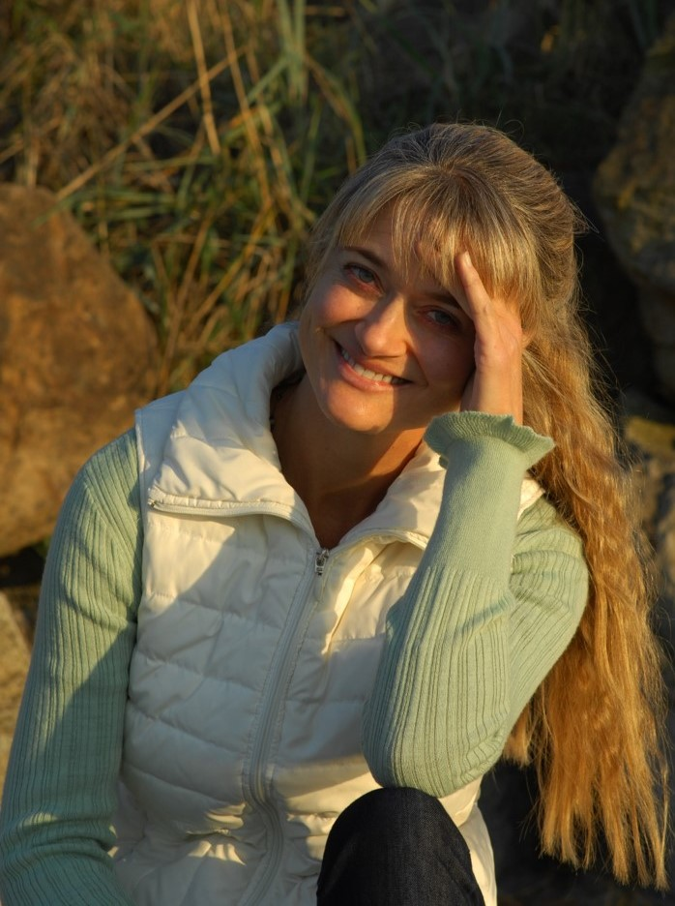

February 12, 2018 Total of 6 CEU’s 9 AM to 4 PM

**Vancouver**

**Developmental Disabilities Administration**

**Supporting and Promoting Healthy Social-Sexuality in Individuals with Intellectual & Developmental Disabilities**

**Registration Form**

**February 12, 2018 Total of 6 CEUs 9 AM to 4 PM**

I wish to attend this training.

Participants Name/s: ____________________________________________________________________

Provide Email, Fax, or Address to send confirmation notice: (Email is preferred, please put the “title” of the training and the word “registration” in email subject line when emailing registrations)

_____________________________________________________________________________________

Phone number in case of last minute changes to training: _______________________________________

**Please register early as space is limited and the training sessions fill quickly. We will email/send a confirmation, please allow a week to process before calling if you have not received a confirmation.**

**Please tell us at least two weeks in advance if you need a special accommodations** by writing it in the space below. We need two weeks to process your request. If you don’t receive a confirmation of this request please contact us. You can call Rob Henrikson at 360-993-6953.

I need this special accommodation: ________________________________________

**Send this registration form via mail, email or fax to:**

**Rob Henrikson, Developmental Disabilities Administration**

**907 Harney St Suite 200 Vancouver, WA 98660**

**Fax (360) 737-2057 Email – Robert.henrikson@dshs.wa.gov**

**Additional classes are listed online at** <https://www.dshs.wa.gov/dda/dda-provider-training>

|  |  |  |  |
| --- | --- | --- | --- |
| Who can attend, Check one:   Licensed AFH Provider,   AFH Resident Manager,   AFH Caregiver,   Assisted Living Administrator   Assisted Living Caregiver   Companion Home Provider   Alternative Living Provider   DDA Residential Program Employee   DDA Employment Program Employee   Other, i.e. Family, parent, teachers, others who want to learn more. Please describe:  ____________________________________________ | Please fill out, if you can, the below information:  Name of Company/Employer/AFH:  ______________________________________  City of Company/Employer/AFH:  ______________________________________   Phone Number:  ______________________________________  Info about CEUs:  Individual Providers, can attend, but CEUs do not apply. IPs go through the Training Partnership for CEUs.  CE credits for others with DOH credentials may be allowable at the discretion of your licensing board. It is the responsibility of attendees with other certifications/ licenses to verify that this CE activity meets your licensing boards’ standards and acceptability as a CE event. |  |  |