**Tacoma**

**Developmental disabilities administration**

**Continuing education Training**

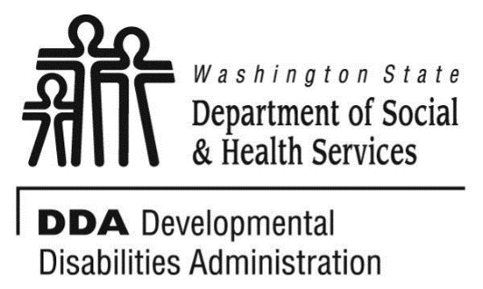

Figure Developmental Disabilities Administration Logo

Figure Developmental Disabilitiies Administration Logo

March 25, 2019 Total of 6 CEUs Free Training 9 AM to 4 PM

[DDA Tacoma Office, 1305 Tacoma Ave S., Suite 300, Tacoma, WA 98402](https://binged.it/2efAX8C)

**Communication Supports at Home/Residential/Community Environment for Adults with Autism 9AM to Noon 3 CEUs**

This course will review issues of communication and choice for adults with autism at home and strategies for success. We will address communication issues at home for adults with autism around favorite activities, foods, family/staff, and more. We will cover strategies for easy communication supports for home and in the community. We will learn to develop a “First/Then Communication Tool.

**Different Learning Styles for Adults with Autism**

**1PM to 4PM 3 CEUs**

This course will address how best individuals with Autism learn and retain information. Discuss an overview of cognitive abilities and learning strengths of an individual with autism. Learn why people with autism have difficulty organizing thoughts, tasks, and process. Review why people with autism focus on details and are unable to see the whole, or how things fit together and have difficulty integrating information, extracting meaning and distinguishing among relevant details. In this training, we will develop a Visual Schedule.

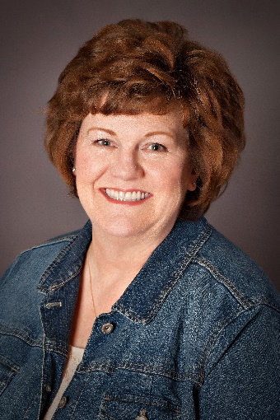

Presented by Monica Meyers

Monica Meyer is an Autism Consultant who provides Technical Assistance and training to Residential and Supported Employment agencies supporting individuals with Classic Autism, specifically those who are non-verbal. Monica’s is an activist in the promotion of Autism Specific “Best-Practice, Evidence Based” Strategies that support communication, choice and independence. Monica has a wide range of knowledge and expertise in “Best-Practice, Evidence Based” Strategies that includes Picture Exchange Communication Systems, TEACCH, Pivotal Response Training, Social Stories™ to name a few.

For Questions: Call Melody Erickson at 253-404-5560. Do not call to register, use form attached

**Parking is not available in the Garage attached to our Tacoma DDA office/the Work Source Bldg.**

• Current areas are Tacoma Ave S in front of the garage attached to our building and going south on Tacoma Ave S. There are no spots in front of our building and going North on Tacoma Ave S.

• More free street parking is on (S. 14th St), (S. G St), (S. 15th St), (S. 17th St) and (Court E and S. Fawcett Ave between S. 15th and S. 17th Streets). Parking is your responsibility.

• Republic Parking NW 253-627-4401. Has uncovered parking lots the closest is on the S. Fawcett/Court D St and S. 15th St. www.rpnw.com and click Tacoma for more locations and maps.

**Tacoma**

**Developmental Disabilities Administration**

**Communication Supports and learning styles**

**Registration Form**



March 25, 2019 Total of 6 CEUs Free Training 9 AM to 4 PM

To register either email this completed form or put this information into the body of an email.

Participants Name: ___________________________________________________________

Provide Email to send confirmation notice: _____________________________________________

Phone number in case of last minute changes to training: _______________________________

Check which trainings you want: __ both trainings, __Communications Training, __ Learning Styles Training

Who can attend, Check one:

 Licensed AFH Provider,

 AFH Resident Manager,

 AFH Caregiver,

 Assisted Living Administrator

 Assisted Living Caregiver

 Companion Home Provider

 Alternative Living Provider

 DDA Residential Program Employee

 DDA Employment Program Employee

 DSHS Employee

 Other, i.e. Family, parent, teachers, others who want to learn more. Please describe:

____________________________________________

Please fill out, if you can, the below information:

Name of Company/Employer/AFH:

______________________________________

City of Company/Employer/AFH:

______________________________________

 Phone Number:

______________________________________

Info about CEUs:

Individual Providers, can attend, but CEUs do not apply. IPs go through the Training Partnership for CEUs.

CE credits for others with DOH credentials may be allowable at the discretion of your licensing board. It is the responsibility of attendees with other certifications/ licenses to verify that this CE activity meets your licensing boards’ standards and acceptability as a CE event.

**Please register early as space is limited and the training sessions fill quickly, usually a month in advance. We will email a confirmation, please allow a week to process before calling if you have not received a confirmation.**

**If assistance for persons with disabilities is needed, please give us the information** by writing it in the space below. If you do not receive a confirmation of this request, please contact us. You can call Melody Erickson at 253-404-5560. I need this special accommodation: __________________________________

**Send this registration form via mail, email or fax to:**

**Melody Erickson,** Developmental Disabilities Administration

1305 Tacoma Ave. S., Suite 300, Tacoma, WA 98402

**Fax (253) 597.4368 Email–** [**Melody Erickson**](mailto:melody.erickson@dshs.wa.gov)

**Additional classes are listed online at** [DDA Provider Training Opportunities](https://www.dshs.wa.gov/dda/dda-provider-training)