**VAncouver**

**Developmental disabilities administration**

**Continuing education Training**

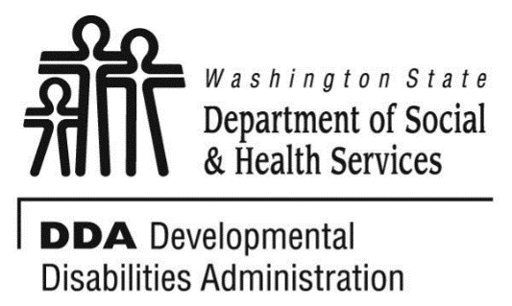

Figure 1 Developmental Disabilities Administration Logo

Figure 2 Developmental Disabilitiies Administration Logo

March 28, 2019 6 CEUs Free Training 9 AM to 4 PM

[DDA Vancouver Office, 907 Harney St., Suite 200, Vancouver, WA 98660](https://binged.it/2efAX8C)

**Communication Supports At Home/Residential/Community Environment for Adults with Autism 9AM to Noon**

This course will review issues of communication and choice for adults with autism at home and strategies for success. We will address communication issues at home for adults with autism around favorite activities, foods, family/staff, and more. We will cover strategies for easy communication supports for home and in the community. We will learn to develop a “First/Then Communication Tool.

**Different Learning Styles for Adults with Autism**

**1PM to 4PM**

This course will address how best individuals with Autism learn and retain information. Discuss an overview of cognitive abilities and learning strengths of an individual with autism. Learn why people with autism have difficulty organizing thoughts, tasks, and process. Review why people with autism focus on details and are unable to see the whole, or how things fit together and have difficulty integrating information, extracting meaning and distinguishing among relevant details. In this training, we will develop a Visual Schedule.

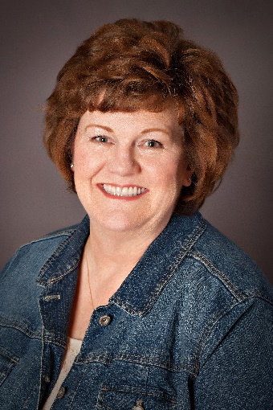

Presented by Monica Meyers

Monica Meyer is an Autism Consultant who provides Technical Assistance and training to Residential and Supported Employment agencies supporting individuals with Classic Autism, specifically those who are non-verbal. Monica’s is an activist in the promotion of Autism Specific “Best-Practice, Evidence Based” Strategies that support communication, choice and independence. Monica has a wide range of knowledge and expertise in “Best-Practice, Evidence Based” Strategies that includes Picture Exchange Communication Systems, TEACCH, Pivotal Response Training, Social Stories™ to name a few.

For Questions: Call Rob Henrikson at 360-993-6953. Do not call to register, use form attached

Parking on the streets are primarily metered. There are some Long-Term meters along Evergreen Blvd. Please bring change for the metered parking.

**Vancouver**

**Developmental Disabilities Administration**

**Communication Supports and learning styles**

**Registration Form**



March 25, 2019 6 CEUs Free Training 9 AM to 4 PM

To register either email this completed form or put this information into the body of an email.

Participants Name: ___________________________________________________________

Provide Email to send confirmation notice: _____________________________________________

Phone number in case of last minute changes to training: _______________________________

Who can attend, Check one:

 Licensed AFH Provider,

 AFH Resident Manager,

 AFH Caregiver,

 Assisted Living Administrator

 Assisted Living Caregiver

 Companion Home Provider

 Alternative Living Provider

 DDA Residential Program Employee

 DDA Employment Program Employee

 DSHS Employee

 Other, i.e. Family, parent, teachers, others who want to learn more. Please describe:

____________________________________________

Please fill out, if you can, the below information:

Name of Company/Employer/AFH:

______________________________________

City of Company/Employer/AFH:

______________________________________

 Phone Number:

______________________________________

Info about CEUs:

Individual Providers, can attend, but CEUs do not apply. IPs go through the Training Partnership for CEUs.

CE credits for others with DOH credentials may be allowable at the discretion of your licensing board. It is the responsibility of attendees with other certifications/ licenses to verify that this CE activity meets your licensing boards’ standards and acceptability as a CE event.

**Please register early as space is limited and the training sessions fill quickly, usually a month in advance. We will email a confirmation, please allow a week to process before calling if you have not received a confirmation.**

**If assistance for persons with disabilities is needed, please give us the information** by writing it in the space below. If you do not receive a confirmation of this request, please contact us. You can call Rob Henrikson at 360-993-6953. I need this special accommodation: __________________________________

**Send this registration form via mail, email or fax to:**

**Rob Henrikosn,** Developmental Disabilities Administration

907 Harney St., Suite 200, Vancouver, WA 98660

**Fax (360) 737.2057 Email–** [**Rob Henrikson**](mailto:henrirn@dshs.wa.gov)

**Additional classes are listed online at** [DDA Provider Training Opportunities](https://www.dshs.wa.gov/dda/dda-provider-training)