

**Tumwater**

**Developmental disabilities administration**

**Continuing education Training**

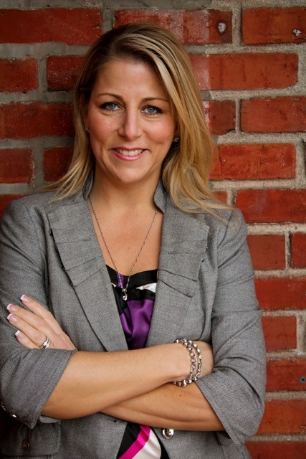

**From North:**

Head South on I-5. Take Exit #101 Tumwater Blvd. Turn LEFT onto Tumwater Blvd. Travel approximately 1 mile. Turn LEFT onto Capitol Blvd. Go past Israel Road to the buildings with the fountain and clock. Just past the clock tower, turn right into parking lot.

**From South:**

Head North on I-5. Take Exit #101 Tumwater Blvd. Turn RIGHT onto Tumwater Blvd. Travel Approximately 1 mile. Turn LEFT onto Capitol Blvd. Go past Israel Road to the buildings with the fountain and clock. Just past the clock tower, turn right into parking lot.

**Directions from Yelm Hwy**

Head away from Lacey towards Tumwater on the Yelm Hwy. Take a LEFT on the light at Henderson Blvd. Follow it to Tumwater Blvd. Take a RIGHT at Tumwater Blvd. Turn RIGHT onto Capitol Blvd. Go one block past Israel Road to the buildings with the fountain and clock. Just past the clock tower, turn right into parking lot.

**Presenter:**

**Shannon Sessions**

# **Creating A Pro-Active Safety Plan 9AM-12PM**

**Learning Objectives:** Approved for 3 CEUs

# During the 3-hour course “Creating a Pro-Active Safety Plan,” caregivers will learn how to teach their clients, of any age, how to be safer at their individual developmental level- without scaring them, through teachable moments, role-playing and repetition.

# **Internet Safety For the People We Support 1PM -4PM**

**Learning Objectives:** Approved for 3 CEUs

During the 3-hour course “Internet Safety & Cyber-Bullying Awareness ~A Caregiver’s Guide,” caregivers will gather commonsense tactics to help themselves and their clients with disabilities to stay safe online, understand the dark-side of the internet and it’s risks, realize how easy it is for a stranger to get personal information, become more aware of current and quickly shifting trends and appreciate the need to team up with your clients ASAP and learn what they’re doing and brainstorm fair internet limits.

**Shannon Sessions** is the Director of SafetySessions.net with a diverse background and passion for public safety Shannon started the program in 2010. Prior to that she had been a Crime Prevention Specialist and Public Affairs Officer for law enforcement for nearly a decade.

Shannon is also an Air Force Veteran, a former firefighter and has experience as a reporter/editor-in-charge of a variety of local newspapers in the Puget Sound region in Washington State, reporting primarily on public safety issues.

Park in the Visitor Parking. Take the stairs or the elevator to the 3rd Floor. Directly to your left is the Reception area. Class starts promptly at 9:00 if you are late you will be asked to sign up for a future training.

For Questions: Call Dana Lattin at 360-725-4258. Do not call to register, use form attached.

**You must attend all of the training to receive a certificate. Class starts promptly if you are late you will be asked to sign up for a future training.**

[Tumwater DDA, 6860 Capitol Blvd SE, Bldg 2,Third Floor, Olympia, WA 98504](https://binged.it/2fmdWAu)

March 8th, 2018 Total of 6 CEUs 9 AM to 4 PM

I wish to attend these checked trainings: Pro-Active Safety Plan and/or Internet Safety

Participants Name/s: ____________________________________________________________________

Provide Email, Fax, or Address to send confirmation notice: (Email is preferred, please put the “title” of the training and the word “registration” in email subject line when emailing registrations)

_____________________________________________________________________________________

Phone number in case of last minute changes to training: _______________________________________

**tumwater**

**Developmental Disabilities Administration**

**Safety Plans and internet safety**

**Registration Form**

**Please register early as space is limited and the training sessions fill quickly. Registration ends two weeks before date of training. We will email/send a confirmation, please allow a week to process before calling if you have not received a confirmation.**

**Please tell us at least two weeks in advance if you need a special accommodations** by writing it in the space below. We need two weeks to process your request. If you don’t receive a confirmation of this request please contact us. You can call Dana Lattin at 360.725.4258.

I need this special accommodation: ________________________________________

**Send this registration form via mail, email or fax to:**

**Dana Lattin, Developmental Disabilities Administration**

**PO Box 45315, Olympia, WA 98504**

**Fax (360) 586.6502  Email– dana.lattin@dshs.wa.gov**

**Additional classes are listed online at** <https://www.dshs.wa.gov/dda/dda-provider-training>

|  |  |  |  |
| --- | --- | --- | --- |
| Who can attend, Check one:   Licensed AFH Provider,   AFH Resident Manager,   AFH Caregiver,   Assisted Living Administrator   Assisted Living Caregiver   Companion Home Provider   Alternative Living Provider   DDA Residential Program Employee   DDA Employment Program Employee   Other, i.e. Family, parent, teachers, others who want to learn more. Please describe:  ____________________________________________ | Please fill out, if you can, the below information:  Name of Company/Employer/AFH:  ______________________________________  City of Company/Employer/AFH:  ______________________________________   Phone Number:  ______________________________________  Info about CEUs:  Individual Providers, can attend, but CEUs do not apply. IPs go through the Training Partnership for CEUs.  CE credits for others with DOH credentials may be allowable at the discretion of your licensing board. It is the responsibility of attendees with other certifications/ licenses to verify that this CE activity meets your licensing boards’ standards and acceptability as a CE event. |  |  |

March 8th, 2018 Total of 6 CEUs 9 AM to 4 PM