**VAncouver**

**Developmental disabilities administration**

**Continuing education Training**

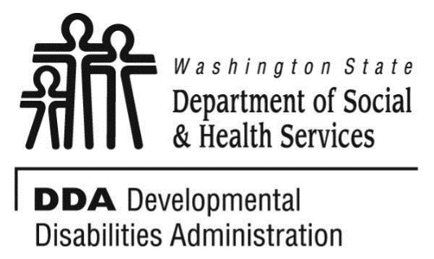

Figure 1 Developmental Disabilities Administration Logo

Figure 2 Developmental Disabilitiies Administration Logo

April 02, 2019 6 CEUs Free Training 9 AM to 4 PM

[DDA Vancouver Office, 907 Harney St., Suite 200, Vancouver, WA 98660](https://binged.it/2efAX8C)

**Hoarding Disorder**

**Assessment, Treatment, and Intervention**

As Hoarding Disorder continues to be a growing problem and public health concern, professionals are challenged in finding effective approaches to address the issue. This presentation will provide a brief background of hoarding, assessment tips, effective treatment approaches and information about in-home interventions/cleanouts.

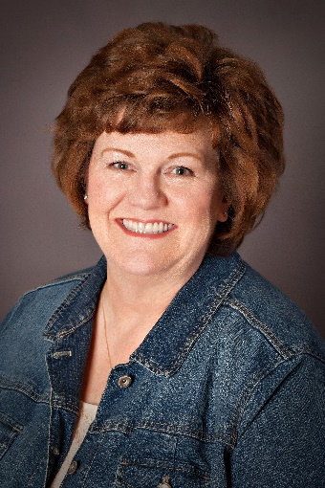

Presented by Leslie Shapiro

Leslie Shapiro, MA is a Licensed Marriage and Family Therapist Associate in Washington State. In her clinical practice as a mental health therapist for The Hoarding Project and Northwest Relationships in Tacoma, Washington, Leslie works with people who suffer from Obsessive-Compulsive Disorder and Hoarding Disorder. Prior to completing her Master’s degree in Couples and Family Therapy at Antioch University Seattle, she worked as a residential organizer and coach. This experience whetted her appetite to better understand clients and acquire the skills necessary to become a therapist. Leslie currently serves as a staff consultant, educator, and mental health therapist for The Hoarding Project in Tacoma, and serves as a member of the King/Pierce County Hoarding Task Force in Western Washington. She can be contacted at leslie@thehoardingproject.org

For Questions: Call Rob Henrikson at 360-993-6953. Do not call to register, use form attached

**Directions to the Vancouver DDA Office**

**From North:**

Head South on I-5. Take exit 1C (E Mill Plain Blvd) and turn RIGHT (west) onto Mill Plain Blvd. Turn LEFT onto Franklin Street, RIGHT on Evergreen Blvd, and LEFT on Harney Street. Brick building immediately on your left.

**From South:**

Head North on I-5. Take exit 1B (City Center) and follow around onto C Street. Turn LEFT on Evergreen Blvd, and LEFT on Harney Street. Brick building immediately on your left.

**From East/Hwy 14:**

Head East on Hwy 14. Take CITY CENTER exit (center lane) and follow around onto C Street. Turn LEFT on Evergreen Blvd, and LEFT on Harney Street. Brick building immediately on your left.

Parking on the streets are primarily metered. There are some Long-Term meters along Evergreen Blvd. Please bring change for the metered parking.

**Vancouver**

**Developmental Disabilities Administration**

**Communication Supports and learning styles**

**Registration Form**



April 02, 2019 6 CEUs Free Training 9 AM to 4 PM

To register either email this completed form or put this information into the body of an email.

Participants Name: ___________________________________________________________

Provide Email to send confirmation notice: _____________________________________________

Phone number in case of last minute changes to training: _______________________________

Who can attend, Check one:

 Licensed AFH Provider,

 AFH Resident Manager,

 AFH Caregiver,

 Assisted Living Administrator

 Assisted Living Caregiver

 Companion Home Provider

 Alternative Living Provider

 DDA Residential Program Employee

 DDA Employment Program Employee

 DSHS Employee

 Other, i.e. Family, parent, teachers, others who want to learn more. Please describe:

____________________________________________

Please fill out, if you can, the below information:

Name of Company/Employer/AFH:

______________________________________

City of Company/Employer/AFH:

______________________________________

 Phone Number:

______________________________________

Info about CEUs:

Individual Providers, can attend, but CEUs do not apply. IPs go through the Training Partnership for CEUs.

CE credits for others with DOH credentials may be allowable at the discretion of your licensing board. It is the responsibility of attendees with other certifications/ licenses to verify that this CE activity meets your licensing boards’ standards and acceptability as a CE event.

**Please register early as space is limited and the training sessions fill quickly, usually a month in advance. We will email a confirmation, please allow a week to process before calling if you have not received a confirmation.**

**If assistance for persons with disabilities is needed, please give us the information** by writing it in the space below. If you do not receive a confirmation of this request, please contact us. You can call Rob Henrikson at 360-993-6953. I need this special accommodation: __________________________________

**Send this registration form via mail, email or fax to:**

**Rob Henrikosn,** Developmental Disabilities Administration

907 Harney St., Suite 200, Vancouver, WA 98660

**Fax (360) 737.2057 Email–** [**Rob Henrikson**](mailto:henrirn@dshs.wa.gov)

**Additional classes are listed online at** [DDA Provider Training Opportunities](https://www.dshs.wa.gov/dda/dda-provider-training)