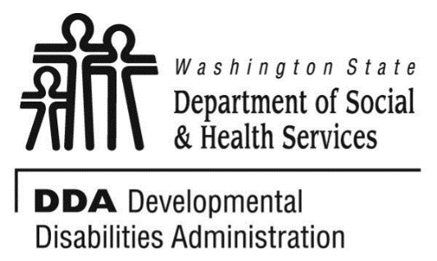

**Aberdeen**

**Developmental disabilities administration**

**Continuing education**

**Training**

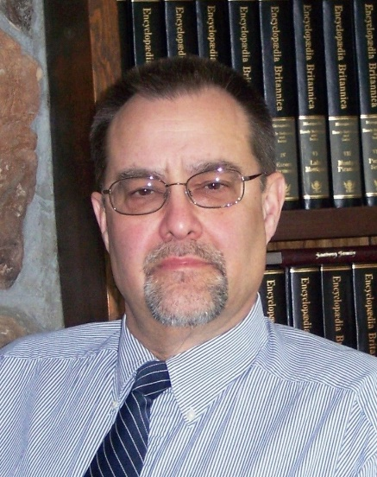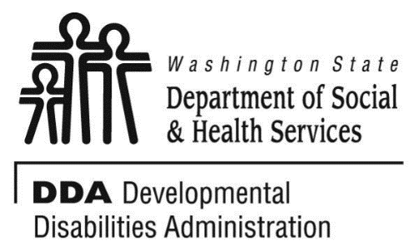

**Reflective Listening**

Reflective Listening is a communication strategy that can be used to bring about acceptable, non-challenging behavior. In this training you will learn the steps of Reflective Listening; listen, repeat, rephrase, reflect feeling, confirm listening.

**Training Objectives:**

* Demonstrate how to do reflective listening
* Identify and demonstrate the types of reflective listening that you can do.
* Recognize when reflective listening is done incorrectly.
* Recognize the connection between Reflective Listening and the ABC Model of Challenging Behavior.

Dr. Edward Fischer has worked 15 years with individuals with developmental disabilities and Autism. He works for the Developmental Disabilities Administration in Region 3 with the Regional Clinical Team. He is also associate faculty at two universities where he teaches clinical and forensic psychology and serves as dissertation chair and committee member.

Class Size: Limited to 30 Participants

[The Elliot Building, 415 W Wishkah St, suite 1B,](https://binged.it/2lcOC7A) [Aberdeen,](https://binged.it/2lcOC7A) WA 98520 [Google Maps](http://maps.google.com/?q=415+W.+Wishkah+St.%2C+Aberdeen%2C+WA%2C+98520%2C+us), [Yahoo! Maps](http://maps.yahoo.com/maps_result?addr=415+W.+Wishkah+St.&csz=Aberdeen%2C+WA&country=us), [MapQuest](http://www.mapquest.com/maps/map.adp?searchtype=address&country=US&address=415+W.+Wishkah+St.&city=Aberdeen&state=WA&zipcode=98520)

Please check in at the DDA/HCS Lobby on the main floor

* You must pre-register by sending the attached registration form to Dana Lattin.

*fax - 360.586.6502*

*email – dana.lattin@dshs.wa.gov or*

*mail - DDA attn.: Dana Lattin - DDA*

* + *PO Box 45315*
  + *Olympia, WA 98504*
* Please let us know, two weeks, prior to trainings if you need special accommodation.
* There is no charge for this workshop.
* If you need to cancel, PLEASE CALL so that someone else can attend.

**You must attend all of the training to receive a certificate. Class starts promptly if you are late you will be asked to sign up for a future training.**

**Presenter: Dr. Edward Fischer**

**From Westbound 12:**

Follow signs toward Aberdeen

Go through downtown on Wishkah St – (heading toward Hoquiam.)

415 W Wishkah St is located at the corner of W Wishkah St and South “L” St.

**From Hoquiam:**

Follow Simpson Ave.

Turn right on N Park St.

Turn left on West Heron St

Turn Left on South “M” St

415 W Wishkah St is located in the block to the right.

The DDA/HCS is located on the main floor of the building.

Parking is free, but limited so please provide time to find parking to make it to the training on time.

.

Questions, if you get lost or in the event of inclement weather, call Selina Olson at 360.537.4366.

**Do not call to register, use attached form.**

Wednesday April 11th, 2018 6 CEUs 9 AM to 4 PM

|  |  |
| --- | --- |
| Who can attend, Check one:   Licensed AFH Provider,   AFH Resident Manager,   AFH Caregiver,   Assisted Living Administrator   Assisted Living Caregiver   Companion Home Provider   Alternative Living Provider   DDA Residential Program Employee   DDA Employment Program Employee   Other, i.e. Family, parent, teachers, others who want to learn more. Please describe:  ____________________________________________ | Please fill out, if you can, the below information:  Name of Company/Employer/AFH:  ______________________________________  City of Company/Employer/AFH:  ______________________________________   Phone Number:  ______________________________________  Info about CEUs:  Individual Providers, can attend, but CEUs do not apply. IPs go through the Training Partnership for CEUs.  CE credits for others with DOH credentials may be allowable at the discretion of your licensing board. It is the responsibility of attendees with other certifications/ licenses to verify that this CE activity meets your licensing boards’ standards and acceptability as a CE event. |

Participants Name/s: ____________________________________________________________________

Provide Email, Fax, or Address to send confirmation notice: (Email is preferred, please put the “title” of the training and the word “registration” in email subject line when emailing registrations)

_____________________________________________________________________________________

Phone number in case of last minute changes to training: _______________________________________

**Please register early as space is limited and the training sessions fill quickly. Registration ends two weeks before date of training. We will email/send a confirmation, please allow a week to process before calling if you have not received a confirmation.**

**Please tell us at least two weeks in advance if you need a special accommodations** by writing it in the space below. We need two weeks to process your request. If you don’t receive a confirmation of this request please contact us. You can call Dana Lattin 360.725.4258.

I need this special accommodation: ________________________________________

**Send this registration form via mail, email or fax to:**

**Dana Lattin,** Developmental Disabilities Administration

PO Box 45315, Tumwater, WA 98504

**Fax (360) 586.6502 Email–** [**dana.lattin@dshs.wa.gov**](mailto:dana.lattin@dshs.wa.gov)

**Additional classes are listed online at** <https://www.dshs.wa.gov/dda/dda-provider-training>

Wednesday April 11th, 2018 6 CEUs 9 AM to 4 PM

**Aberdeen**

**Developmental Disabilities Administration**

**Reflective Listening**

**Registration Form**