

**Port Angeles**

**Developmental disabilities administration**

**Continuing education**

**Training**

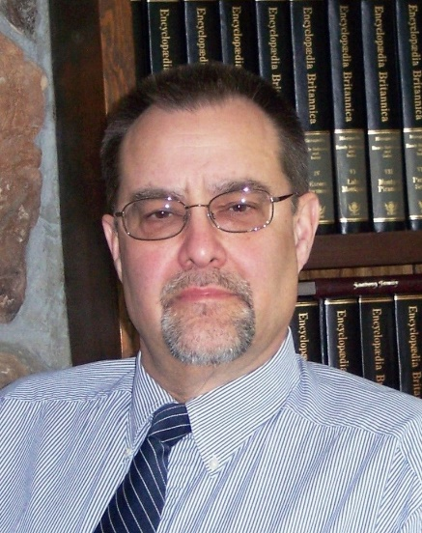**

[Port Angeles DDA Office, 201 West 1st St, Ste. 2,](https://binged.it/2lcOC7A)

[Port Angeles WA 98362](https://binged.it/2lcOC7A)

**Presenter: Dr. Edward Fischer**

**Directions to Port Angeles DDA**

**(Forks-West side) East access to Port Angeles from US – 101 E.**  Turn Left onto S Lincoln Street. Take Left at 4th stop light. You’re now on E Front Street stay in left lane. Take 3rd left onto N Oak Street. Take 1st Right at alley between West Front Street and West 1st Street. Take 1st Right in alley and you will be in shared Parking lot.

**(Sequim- East side)West access to Port Angeles from US – 101 W** Follows straight onto E Front Street. Get into left lane and stay on Front Street which leads into downtown Port Angeles with 3 stoplights. Take 3rd left onto N Oak St.  Take 1st Right at alley between West Front Street and West 1st Street. Take 1st Right in alley and you will be in Parking lot at back of 201 & 203 West First Street. If you reach two-lane merging into one lane, you have missed your turn.  Stay in Left lane on Front Street and turn Left onto First Street, stay in left lane.  We are located on corner of First Street and N Oak Street. Take left at 1st light your now on N Oak Street take 1st alley access located to your left, and take first right into Parking Lot.

Parking Lot is in back of 201 & 203 West First Street. **Parking lot is 3 hour parking only – this will require moving your car during training breaks.** Park and walk out to Oak Street take a right, walk up to corner.  Take a right and you’re at the front entry to 201 West First Street.

After entering, go left up stairway or take the elevator to the 2nd floor, the Ball Room is located at end of hall last door to your left.

If you get lost or in the event of inclement weather, call 360-565-2700 to get further direction or to find out if the training will be held as scheduled. Please don’t be late; doors will close at start time.

We ask while here that you follow safety and security rules.

Please do not wander around our office, either stay in the training room or leave the DDA office. Thank you.

**Supported Independence Model**

The Supported Independence Model (SIM) is a support staff strategy to avoid or prevent certain challenging behaviors. It is based on the notion that individuals with disabilities can be sensitive to their need for support. Their independence can be threatened when they do not have control over the supports. That threat can lead to challenging behaviors. By following three straight forward SIM principles support staff can:

* Maintain and increase an individual’s personal control and independence
* Preserve a person’s dignity and self-esteem
* Avoid unpleasant setting conditions that can lead to challenging behaviors
* Prevent setting events that can trigger challenging behaviors

SIM is consistent with the Developmental Disabilities Administration mission of **“Transforming lives by providing support and fostering partnerships that empower people to live the lives they want.”**

Dr. Edward Fischer has worked 15 years with individuals with developmental disabilities and Autism. He works for the Developmental Disabilities Administration in Region 3 with the Regional Clinical Team. He is also associate faculty at two universities where he teaches clinical and forensic psychology and serves as dissertation chair and committee member.

Tuesday May 15th, 2018 6 CEUs 9 AM to 4 PM

|  |  |
| --- | --- |
| Who can attend, Check one:   Licensed AFH Provider,   AFH Resident Manager,   AFH Caregiver,   Assisted Living Administrator   Assisted Living Caregiver   Companion Home Provider   Alternative Living Provider   DDA Residential Program Employee   DDA Employment Program Employee   Other, i.e. Family, parent, teachers, others who want to learn more. Please describe:  ____________________________________________ | Please fill out, if you can, the below information:  Name of Company/Employer/AFH:  ______________________________________  City of Company/Employer/AFH:  ______________________________________   Phone Number:  ______________________________________  Info about CEUs:  Individual Providers, can attend, but CEUs do not apply. IPs go through the Training Partnership for CEUs.  CE credits for others with DOH credentials may be allowable at the discretion of your licensing board. It is the responsibility of attendees with other certifications/ licenses to verify that this CE activity meets your licensing boards’ standards and acceptability as a CE event. |

Participants Name/s: ____________________________________________________________________

Provide Email, Fax, or Address to send confirmation notice: (Email is preferred, please put the “title” of the training and the word “registration” in email subject line when emailing registrations)

_____________________________________________________________________________________

Phone number in case of last minute changes to training: _______________________________________

**Please register early as space is limited and the training sessions fill quickly. We will email/send a confirmation, please allow a week to process before calling if you have not received a confirmation.**

**Please tell us at least two weeks in advance if you need a special accommodations** by writing it in the space below. We need two weeks to process your request. If you don’t receive a confirmation of this request please contact us. You can call Dana Lattin 360.725.4258.

I need this special accommodation: ________________________________________

**Send this registration form via mail, email or fax to:**

**Dana Lattin,** Developmental Disabilities Administration

PO Box 45315, Tumwater, WA 98504

**Fax (360) 586.6502 Email–** [**dana.lattin@dshs.wa.gov**](mailto:dana.lattin@dshs.wa.gov)

**Additional classes are listed online at** <https://www.dshs.wa.gov/dda/dda-provider-training>

Tuesday May 14th, 2018 6 CEUs 9 AM to 4 PM

**Port Angeles**

**Developmental Disabilities Administration**

**Supported Independence Model**

**Registration Form**