**Tacoma**

**Developmental disabilities administration**

**Continuing education Training**

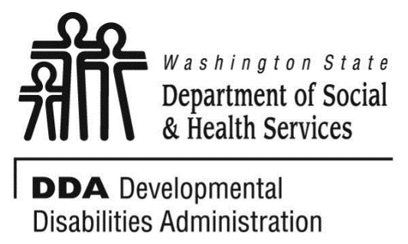

Figure 1 Developmental Disabilities Administration Logo

Figure 2 Developmental Disabilitiies Administration Logo

May 16, 2019 6 CEUs Free Training 9 AM to 4 PM

[DDA Tacoma Office, 1305 Tacoma Ave S., Suite 300, Tacoma, WA 98402](https://binged.it/2efAX8C)

**Supporting Individuals through**

**Challenging Situations**

Supporting an individual who is going through challenging situations is one of the hardest tasks, we, as care providers have. This course will expand on the DDA guidelines and explore how we can provide the best support possible for individuals going through difficult times. It will look at specific strategies for supporting the individual as well as ourselves as care providers.

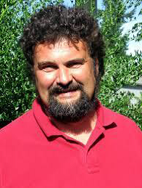

Presented by Chuck Goodwin

Chuck Goodwin has worked over 30 years with individuals with developmental disabilities in a variety of capacities. He has worked in both the residential and vocational arenas providing direct support for individuals. For the past 16 years as a private consultant around the Northwest, he has provided trainings on such subjects as positive supports, history and values around services, job coaching, reducing stress, and supporting individuals through challenging situations, precision training, natural supports, utilizing community resources and vocational issues.

Class Size: Limited to 50 Participants.

For Questions: Call Melody Erickson at 253-404-5560.

Do not call to register, use form attached

**Parking is not available in the Garage attached to our Tacoma DDA office/the Work Source Bldg.**

• Current areas are Tacoma Ave S in front of the garage attached to our building and going south on Tacoma Ave S. There are no spots in front of our building and going North on Tacoma Ave S.

• More free street parking is on (S. 14th St), (S. G St), (S. 15th St), (S. 17th St) and (Court E and S. Fawcett Ave between S. 15th and S. 17th Streets). Parking is your responsibility.

• Republic Parking NW 253-627-4401. Has uncovered parking lots the closest is on the S. Fawcett/Court D St and S. 15th St. www.rpnw.com and click Tacoma for more locations and maps.

**Tacoma**

**Developmental Disabilities Administration**

**Supporting Individuals Through challenging situations -Registration Form**



May 16, 2019 6 CEUs Free Training 9 AM to 4 PM

To register either email this completed form or put this information into the body of an email.

Participants Name: ___________________________________________________________

Provide Email to send confirmation notice: _____________________________________________

Phone number in case of last minute changes to training: _______________________________

Who can attend, Check one:

 Licensed AFH Provider,

 AFH Resident Manager,

 AFH Caregiver,

 Assisted Living Administrator

 Assisted Living Caregiver

 Companion Home Provider

 Alternative Living Provider

 DDA Residential Program Employee

 DDA Employment Program Employee

 DSHS Employee

 Other, i.e. Family, parent, teachers, others who want to learn more. Please describe:

____________________________________________

Please fill out, if you can, the below information:

Name of Company/Employer/AFH:

______________________________________

City of Company/Employer/AFH:

______________________________________

 Phone Number:

______________________________________

Info about CEUs:

Individual Providers, can attend, but CEUs do not apply. IPs go through the Training Partnership for CEUs.

CE credits for others with DOH credentials may be allowable at the discretion of your licensing board. It is the responsibility of attendees with other certifications/ licenses to verify that this CE activity meets your licensing boards’ standards and acceptability as a CE event.

**Please register early as space is limited and the training sessions fill quickly, usually a month in advance. We will email a confirmation, please allow a week to process before calling if you have not received a confirmation.**

**If assistance for persons with disabilities is needed, please give us the information** by writing it in the space below. If you do not receive a confirmation of this request, please contact us. You can call Melody Erickson at 253-404-5560. I need this special accommodation: __________________________________

**Send this registration form via mail, email or fax to:**

**Melody Erickson,** Developmental Disabilities Administration

1305 Tacoma Ave. S., Suite 300, Tacoma, WA 98402

**Fax (253) 597.4368 Email–** [**Melody Erickson**](mailto:melody.erickson@dshs.wa.gov)

**Additional classes are listed online at** [DDA Provider Training Opportunities](https://www.dshs.wa.gov/dda/dda-provider-training)