**Tacoma**

**Developmental disabilities administration**

**Continuing education Training**

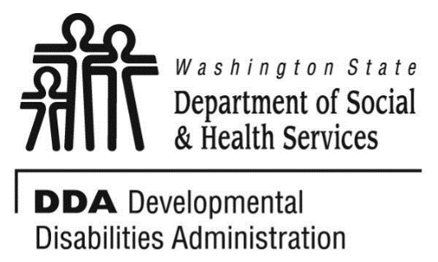

Figure 1 Developmental Disabilities Administration Logo

Figure 2 Developmental Disabilitiies Administration Logo

May 20, 2019 6 CEUs Free Training 9 AM to 4 PM

[DDA Tacoma Office, 1305 Tacoma Ave S., Suite 300, Tacoma, WA 98402](https://binged.it/2efAX8C)

**Medication Awareness**

Many of us feel that we experience, Better living through Chemistry! But do we really??!

In this session we will discuss the role of medications in our health and wellbeing. We will discuss the difference between treatment; cures; and management of symptoms. We will consider side effects; adverse reactions and extra pyramidal reactions and their implications on the short as well as long term. We will explore the impact pharmacological interventions have in the management of symptoms.

We will also consider systems that ensure medications are provided according to regulations. i.e. maintaining MAR’s: the 5 (no 6) rights of medication management, storing, organizing, securing and disposing of medications; the role of the delegating nurse; pharmacist and the clinician.

**

Presented by Shanti Potts

Shanti Potts has over 25 years’ experience working with and advocating for seniors, with a passion for teaching and learning. She works extensively with unpaid family caregivers and professional care providers. She has been employed as an instructor at Clark Community College, Lower Columbia Community College, Area Agency on Aging & Disabilities of SW Washington, Developmental Disabilities Administration & PeaceHealth Southwest Medical Center. Shanti has presented at conferences for the King County Prosecutor’s office, the Alzheimer’s Association, the Clark County Bar Association, the Nisqually Tribal Elders, Clark County Sheriff’s Crisis Intervention trainings, and various other local organizations.

For Questions: Call Melody Erickson at 253-404-5560. Do not call to register, use form attached

**Parking is not available in the Garage attached to our Tacoma DDA office/the Work Source Bldg.**

• Current areas are Tacoma Ave S in front of the garage attached to our building and going south on Tacoma Ave S. There are no spots in front of our building and going North on Tacoma Ave S.

• More free street parking is on (S. 14th St), (S. G St), (S. 15th St), (S. 17th St) and (Court E and S. Fawcett Ave between S. 15th and S. 17th Streets). Parking is your responsibility.

• Republic Parking NW 253-627-4401. Has uncovered parking lots the closest is on the S. Fawcett/Court D St and S. 15th St. www.rpnw.com and click Tacoma for more locations and maps.

**Tacoma**

**Developmental Disabilities Administration**

**Medication awareness**

**Registration Form**



May 20, 2019 6 CEUs Free Training 9 AM to 4 PM

To register either email this completed form or put this information into the body of an email.

Participants Name: ___________________________________________________________

Provide Email to send confirmation notice: _____________________________________________

Phone number in case of last minute changes to training: _______________________________

Who can attend, Check one:

 Licensed AFH Provider,

 AFH Resident Manager,

 AFH Caregiver,

 Assisted Living Administrator

 Assisted Living Caregiver

 Companion Home Provider

 Alternative Living Provider

 DDA Residential Program Employee

 DDA Employment Program Employee

 DSHS Employee

 Other, i.e. Family, parent, teachers, others who want to learn more. Please describe:

____________________________________________

Please fill out, if you can, the below information:

Name of Company/Employer/AFH:

______________________________________

City of Company/Employer/AFH:

______________________________________

 Phone Number:

______________________________________

Info about CEUs:

Individual Providers, can attend, but CEUs do not apply. IPs go through the Training Partnership for CEUs.

CE credits for others with DOH credentials may be allowable at the discretion of your licensing board. It is the responsibility of attendees with other certifications/ licenses to verify that this CE activity meets your licensing boards’ standards and acceptability as a CE event.

**Please register early as space is limited and the training sessions fill quickly, usually a month in advance. We will email a confirmation, please allow a week to process before calling if you have not received a confirmation.**

**If assistance for persons with disabilities is needed, please give us the information** by writing it in the space below. If you do not receive a confirmation of this request, please contact us. You can call Melody Erickson at 253-404-5560. I need this special accommodation: __________________________________

**Send this registration form via mail, email or fax to:**

**Melody Erickson,** Developmental Disabilities Administration

1305 Tacoma Ave. S., Suite 300, Tacoma, WA 98402

**Fax (253) 597.4368 Email–** [**Melody Erickson**](mailto:melody.erickson@dshs.wa.gov)

**Additional classes are listed online at** [DDA Provider Training Opportunities](https://www.dshs.wa.gov/dda/dda-provider-training)