**Tacoma**

**Developmental disabilities administration**

**Continuing education Training**

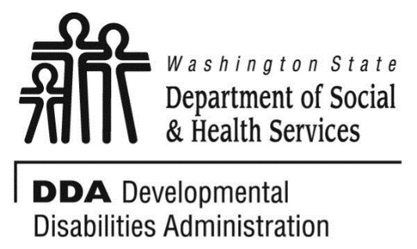

Figure 1 Developmental Disabilities Administration Logo

Figure 2 Developmental Disabilitiies Administration Logo

June 24, 2019 6 CEUs Free Training 9 AM to 4 PM

[DDA Tacoma Office, 1305 Tacoma Ave S., Suite 300, Tacoma, WA 98402](https://binged.it/2efAX8C)

**Managing Challenging Behaviors**

In this program we will define behavior as it pertains to the population, understand what the cause & effect of behaviors mean to the caregiver and explore individual learning styles.  We will explore a few commonly used problem solving methods, attempt to understand assessment protocols for changes in behavior and consider prevention approaches.  We will discuss self care of the caregiver, consistency, empowerment and choice as we look at behaviors like handling a client’s anger, resistance, anxiety, as well as disrespectful and sexual behaviors.  And finally time permitting, we will also learn a couple of skills for communicating in challenging situations.   This session is interactive so bring your challenges and let’s work on some solution seeking.

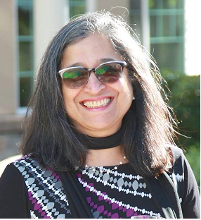

Presented by Shanti Potts

Shanti Potts has over 25 years’ experience working with and advocating for seniors, with a passion for teaching and learning. She works extensively with unpaid family caregivers and professional care providers. She has been employed as an instructor at Clark Community College, Lower Columbia Community College, Area Agency on Aging & Disabilities of SW Washington, Developmental Disabilities Administration & PeaceHealth Southwest Medical Center. Shanti has presented at conferences for the King County Prosecutor’s office, the Alzheimer’s Association, the Clark County Bar Association, the Nisqually Tribal Elders, Clark County Sheriff’s Crisis Intervention trainings, and various other local organizations.

For Questions: Call Melody Erickson at 253-404-5560. Do not call to register, use form attached

**Parking is not available in the Garage attached to our Tacoma DDA office/the Work Source Bldg.**

• Current areas are Tacoma Ave S in front of the garage attached to our building and going south on Tacoma Ave S. There are no spots in front of our building and going North on Tacoma Ave S.

• More free street parking is on (S. 14th St), (S. G St), (S. 15th St), (S. 17th St) and (Court E and S. Fawcett Ave between S. 15th and S. 17th Streets). Parking is your responsibility.

• Republic Parking NW 253-627-4401. Has uncovered parking lots the closest is on the S. Fawcett/Court D St and S. 15th St. www.rpnw.com and click Tacoma for more locations and maps.

**Tacoma**

**Developmental Disabilities Administration**

**Managing Challenging Behaviors**

**Registration Form**



June 24, 2019 6 CEUs Free Training 9 AM to 4 PM

To register either email this completed form or put this information into the body of an email.

Participants Name: ___________________________________________________________

Provide Email to send confirmation notice: _____________________________________________

Phone number in case of last minute changes to training: _______________________________

Who can attend, Check one:

 Licensed AFH Provider,

 AFH Resident Manager,

 AFH Caregiver,

 Assisted Living Administrator

 Assisted Living Caregiver

 Companion Home Provider

 Alternative Living Provider

 DDA Residential Program Employee

 DDA Employment Program Employee

 DSHS Employee

 Other, i.e. Family, parent, teachers, others who want to learn more. Please describe:

____________________________________________

Please fill out, if you can, the below information:

Name of Company/Employer/AFH:

______________________________________

City of Company/Employer/AFH:

______________________________________

 Phone Number:

______________________________________

Info about CEUs:

Individual Providers, can attend, but CEUs do not apply. IPs go through the Training Partnership for CEUs.

CE credits for others with DOH credentials may be allowable at the discretion of your licensing board. It is the responsibility of attendees with other certifications/ licenses to verify that this CE activity meets your licensing boards’ standards and acceptability as a CE event.

**Please register early as space is limited and the training sessions fill quickly, usually a month in advance. We will email a confirmation, please allow a week to process before calling if you have not received a confirmation.**

**If assistance for persons with disabilities is needed, please give us the information** by writing it in the space below. If you do not receive a confirmation of this request, please contact us. You can call Melody Erickson at 253-404-5560. I need this special accommodation: __________________________________

**Send this registration form via mail, email or fax to:**

**Melody Erickson,** Developmental Disabilities Administration

1305 Tacoma Ave. S., Suite 300, Tacoma, WA 98402

**Fax (253) 597.4368 Email–** [**Melody Erickson**](mailto:melody.erickson@dshs.wa.gov)

**Additional classes are listed online at** [DDA Provider Training Opportunities](https://www.dshs.wa.gov/dda/dda-provider-training)