**Vancouver**

**Developmental disabilities administration**

**Continuing education Training**

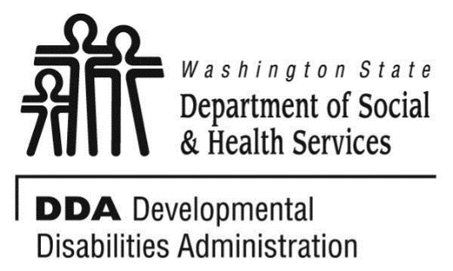

Figure 1 Developmental Disabilities Administration Logo

Figure 2 Developmental Disabilitiies Administration Logo

October 11, 2019 9 AM to 4 PM 6 CEUs

**Healthy Eating; Healthy Living**

Many factors affect our health, quality of life and longevity. Some we cannot control, such as our genetic makeup or our age or our past. However, going forward we can make changes to our lifestyle. By taking steps toward healthy living, we can not only reduce our risk of heart disease, cancer, stroke and other serious diseases but we can live engaged and fulfilling lives to the fullest possible potential. In this session we will discuss the various elements of healthy eating. We will consider, the role of nutrition and nutrients in our day to day lives; the challenges we face in making healthy choices; the myths and realities of food choices; and the changes we need to make to work towards goals of healthy eating and healthy living. We will also deliberate healthy living using a holistic approach of considering individual aspects of our physical, mental, social, emotional and spiritual health and well-being.

Join us for a fun and interactive session as we explore together healthy eating and healthy living.

[**Click here to register**](https://www.eventbrite.com/e/healthy-eating-healthy-living-vancouver-october-11-2019-registration-66260371555)

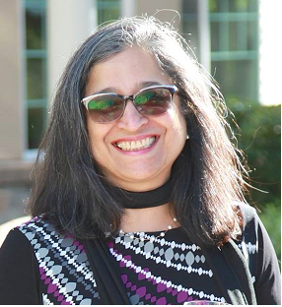

Presented by Shanti Potts

**Shanti Potts** has over 25 years’ experience working with and advocating for seniors, with a passion for teaching and learning. She works extensively with unpaid family caregivers and professional care providers. She has been employed as an instructor at Clark Community College, Lower Columbia Community College, Area Agency on Aging & Disabilities of SW Washington, Developmental Disabilities Administration & PeaceHealth Southwest Medical Center. Shanti has presented at conferences for the King County Prosecutor’s office, the Alzheimer’s Association, the Clark County Bar Association, the Nisqually Tribal Elders, Clark County Sheriff’s Crisis Intervention trainings, and various other local organizations.

[DDA Vancouver Office, 907 Harney St., Suite 200, Vancouver, WA 98660](https://binged.it/2efAX8C)

*Parking on the streets are primarily metered. There are some Long-Term meters along Evergreen Blvd. Please bring change for the metered parking.

*You must attend all of the training to receive a certificate. Class starts promptly at 9:00am. If you are late, you may be asked to sign up for a future training.

**Class Size: Limited to 28 Participants** **Additional classes are listed online at** [DDA Provider Training Opportunities](https://www.dshs.wa.gov/dda/dda-provider-training)