

**Developmental Disabilities Administration**

Region 1

Presents Trainings for

Continuing Education

2017

Creating a Pro-Active Safety Plan

&

Internet Safety & Cyber-Bullying Awareness

Presented by

Shannon Sessions

Shannon Sessions is the Director of SafetySessions.net with a diverse background and passion for public safety Shannon started the program in 2010. Prior to that she had been a Crime Prevention Specialist and Public Affairs Officer for law enforcement for nearly a decade.

Shannon is also an Air Force Veteran, a former firefighter and has experience as a reporter/editor-in-charge of a variety of local newspapers in the Puget Sound region in Washington State, reporting primarily on public safety issues.

Who Should Attend?

AFH Providers/Resident Managers/Caregivers, Assisted Living Administrators/Caregivers, SL Staff, CH Providers, AL Providers, Supported Employment Staff. This is not for Individual Provider to earn their Continuing Education credits.

Training is approved for 6 hours of Continuing Education credits. There is no charge for this training

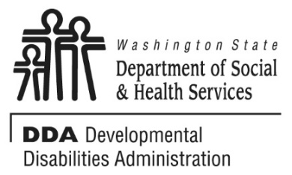

Yakima - Monday, October 23, 2017 9a-4p

Kennewick – Tuesday, October 24, 2017 8:30a-3:30p

Spokane – Wednesday, October 25, 2017 9a-4p

Moses Lake – Thursday, October 26, 2017 9a-4p

Creating a Pro-Active Safety Plan

&

Internet Safety & Cyber-Bullying Awareness

During the 3-hour course “Creating a Pro-Active Safety Plan,” caregivers will learn how to teach their clients, of any age, how to be safer at their individual developmental level- without scaring them, through teachable moments, role-playing and repetition.

During the 3-hour course “Internet Safety & Cyber-Bullying Awareness ~A Caregiver’s Guide,” caregivers will gather commonsense tactics to help themselves and their clients with disabilities to stay safe online, understand the dark-side of the internet and it’s risks, realize how easy it is for a stranger to get personal information, become more aware of current and quickly shifting trends and appreciate the need to team up with your clients ASAP and learn what they’re doing and brainstorm fair internet limits.

To Register:

* You must pre-register by contacting Arin Swinger at [**Swingal@dshs.wa.gov**](mailto:Swingal@dshs.wa.gov)or **509-764-5795**
* This class is limited to 35 attendees, and you must be registered to attend.



Locations:

**Yakima –** [**1002 N 16th Ave**](https://www.google.com/maps/place/1002+N+16th+Ave,+Yakima,+WA+98902/@46.6146297,-120.5340399,17z/data=!3m1!4b1!4m5!3m4!1s0x5499d81c85ba5eb7:0x3022b9f590c4f656!8m2!3d46.6146297!4d-120.5318459) **(Yakima CSO, Room 5)**

**Kennewick -** [**401 North Young St**](https://www.google.com/maps/place/401+N+Young+St,+Kennewick,+WA+99336/@46.213459,-119.221333,17z/data=!3m1!4b1!4m5!3m4!1s0x549879ec0b119cc7:0xc39c0a69c2db922a!8m2!3d46.213459!4d-119.219139)**, Kennewick WA 99336 (United Way Building)**

**Spokane -** [**1608 W Boone Ave**](https://www.google.com/maps/place/1608+W+Boone+Ave,+Spokane,+WA+99201/@47.6686506,-117.4385531,17z/data=!3m1!4b1!4m5!3m4!1s0x549e1850cd2060a1:0x618723dad02a08f!8m2!3d47.6686506!4d-117.4363591)**, Spokane WA 99201 (Division of Child Support Office)**

Moses Lake - [309 East 5th Ave](https://www.google.com/maps/place/309+E+5th+Ave,+Moses+Lake,+WA+98837/@47.1294262,-119.2755513,17z/data=!3m1!4b1!4m5!3m4!1s0x549938bb26edb3f7:0x4ff51a6b039a1f1a!8m2!3d47.1294262!4d-119.2733573), Moses Lake, WA 98837 (Work Source Building, room 107)

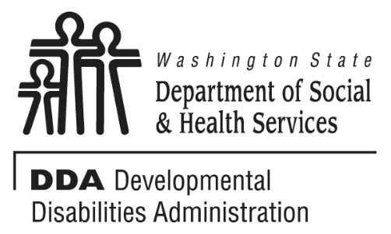

If you get lost or in the event of inclement weather, call 509-751-4638 to get further direction or to find out if the training will be held as scheduled. Please don’t be late; doors will close at start time.

We ask while here that you follow safety and security rules of the venue. Please always wear the badge (when provided) and sign in/out if required by the venue. Thank you.

Due to limited seating, priority will be given to those working with persons with developmental/intellectual disabilities.

**Additional Classes are listed Online**

<http://www.dshs.wa.gov/dda/dda-provider-training>

**Purpose Statement**

**The Developmental Disabilities Administration (DDA) endeavors to make a positive difference in the lives of people eligible for services, through offering quality supports and services that are: individual/ family driven; stable and flexible; satisfying to the person and their family; and able to meet individual needs. Supports and services shall be offered in ways that ensure people have the necessary information to make decisions about their options and provide optimum opportunities for success.**

* INDIVIDUAL WORTH AND DEVELOPMENT
* CONTINUITY AND COORDINATION OF SERVICES
* COMMUNITY PARTICIPATION AND PARTNERSHIP
* RESPECT FOR EMPLOYEES
* SERVICES QUALITY AND PERFORMANCE ACCOUNTBAILITY
* NONDISCRIMINATION

Transforming Lives

**Developmental Disabilities Administration**

Region 1

Presents Workshops for

Continuing Education:

2017