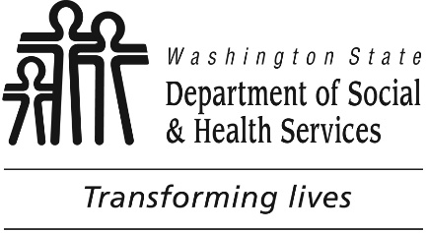

**TUMWATER**

**Developmental disabilities administration**

**Continuing education**

**Training**

November 9th, 2017 CEUs Pending Approval 9 AM to 4 PM

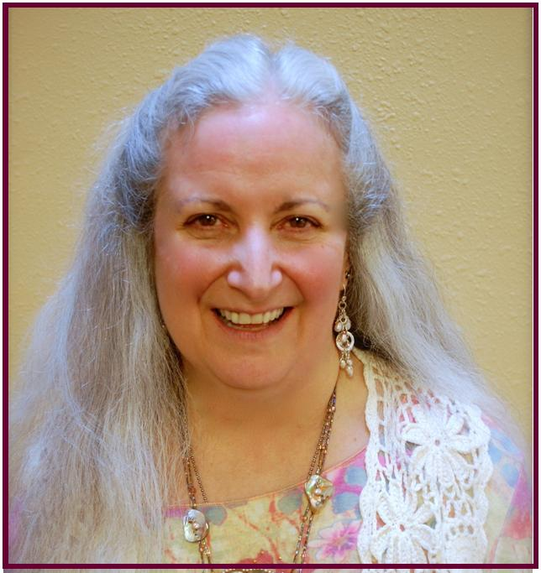

Creating Meaningful Interactions & Relationships - Finding Our Common Humanity

Attendees in this workshop will examine values, stereotypes and preconceived notions about people with disabilities.  Discussion will focus on how these factors influence the work of staff supporting people with disabilities. Interactive exercises will promote attitudes and strategiesthat emphasize validation of people with disabilities as valued members of the community who have valid feelings, thoughts & experiences as well as unique gifts to share with others.

Deborah has committed more than 30 years of her life to providing services to and advocating on behalf of individuals with intellectual and developmental disabilities. With a BA in Special Education and a MA in services for individuals who are deaf or hard of hearing, her career path has taken her, if not through, at least to, every door in this field in the Greater Pacific Northwest.

Weaving through her Inclusion Advocacy, her work with Employment & Residential agencies, and contract work as a Trainer, Consultant, and Technical Assistance provider is this central theme, tying together in neat package what might otherwise pass for the vocational equivalent of a social-butterfly: To deny access to community devalues and diminishes what it means to be human. But to seek identity and understanding through community strengthens and enriches all humanity.

**Presenter: Deborah Moskowitz**

**From North:**

Head South on I-5. Take Exit #101 Tumwater Blvd. Turn LEFT onto Tumwater Blvd. Travel approximately 1 mile. Turn LEFT onto Capitol Blvd. Go past Israel Road to the buildings with the fountain and clock. Turn RIGHT into the parking lot.

**From South:**

Head North on I-5. Take Exit #101 Tumwater Blvd. Turn RIGHT onto Tumwater Blvd. Travel Approximately 1 mile. Turn LEFT onto Capitol Blvd. Go past Israel Road to the buildings with the fountain and clock. Turn RIGHT into the parking lot.

**Directions from Yelm Hwy**

Head away from Lacey towards Tumwater on the Yelm Hwy. Take a LEFT on the light at Henderson Blvd. Follow it to Tumwater Blvd. Take a RIGHT at Tumwater Blvd. Turn RIGHT onto Capitol Blvd. Go one block past Israel Road to the buildings with the fountain and clock. Turn RIGHT into the parking lot.

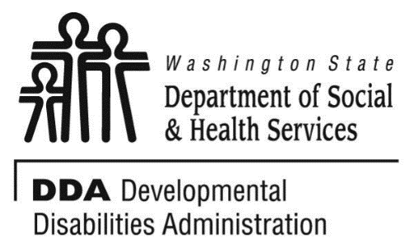

Turn RIGHT into the parking lot entrance. Park in the Visitor Parking. Take the stairs or the elevator to the 3rd Floor. Directly to your left is the Reception area. You must attend the whole training to receive a certificate. Class starts promptly if you are late you will be asked to sign up for a future training. For Questions: Call Dana Lattin at 360-725-4258. Do not call to register, use form attached.

[Tumwater DDA, 6860 Capitol Blvd SE, Bldg 2,Third Floor, Olympia, WA 98504](https://binged.it/2fmdWAu)

**Please register early as space is limited and the training sessions fill quickly. Registration ends two weeks before date of training.**

**Please tell us at least two weeks in advance if you need a special accommodations** by writing it in the space below. We need two weeks to process your request. If you don’t receive a confirmation of this request please contact us. You can call Dana Lattin at 360-725-4258.

I need this special accommodation: ________________________________________

**Send this registration form via mail, email or fax to:**

**Dana Lattin, Developmental Disabilities Administration**

**PO Box 45315, Olympia, WA 98504**

**Fax (360) 586.6502**

**Email– dana.lattin@dshs.wa.gov**

**Additional classes are listed online at** <https://www.dshs.wa.gov/dda/dda-provider-training>

|  |  |  |  |  |  |
| --- | --- | --- | --- | --- | --- |
| |  |  | | --- | --- | | Who can attend, Check one:   Licensed AFH Provider,   AFH Resident Manager,   AFH Caregiver,   Assisted Living Administrator   Assisted Living Caregiver   Companion Home Provider   Alternative Living Provider   DDA Residential Program Employee   DDA Employment Program Employee   Other, i.e. Family, parent, teachers, others who want to learn more. Please describe:  ____________________________________________ | Please fill out, if you can, the below information:  Name of Company/Employer/AFH:  ______________________________________  City of Company/Employer/AFH:  ______________________________________   Phone Number:  ______________________________________  Info about CEUs:  Individual Providers, can attend, but CEUs do not apply. IPs go through the Training Partnership for CEUs.  CE credits for others with DOH credentials may be allowable at the discretion of your licensing board. It is the responsibility of attendees with other certifications/ licenses to verify that this CE activity meets your licensing boards’ standards and acceptability as a CE event. | | |  |  | | --- | --- | |  |  | |
| Who can attend, Check one:   Licensed AFH Provider,   AFH Resident Manager,   AFH Caregiver,   Assisted Living Administrator   Assisted Living Caregiver   Companion Home Provider   Alternative Living Provider   DDA Residential Program Employee   DDA Employment Program Employee   Other, i.e. Family, parent, teachers, others who want to learn more. Please describe:  ____________________________________________ | Please fill out, if you can, the below information:  Name of Company/Employer/AFH:  ______________________________________  Address of Company/Employer/AFH:  ______________________________________  ______________________________________    Phone Number:  ______________________________________   Individual Providers, can attend, but CEUs do not apply. IPs go through the Training Partnership for CEUs. |

Participants Name: ___________________________________________________________

Provide Email, Fax, or Address to send confirmation notice: (Email is preferred)

________________________________________________________

________________________________________________________

Phone number in case of last minute changes to training: _______________________________

**TUMWATER**

**Developmental Disabilities Administration**

**creating meaningful interactions & Relationships**

**Registration Form**

November 9th, 2017 CEUs Pending Approval 9 AM to 4 PM