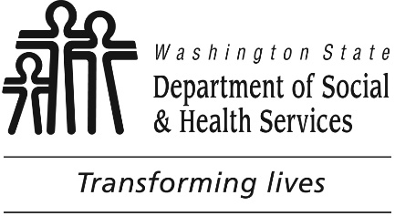

**Tacoma**

**Developmental disabilities administration**

**Continuing education Training**

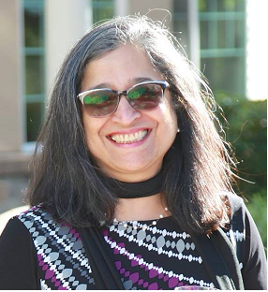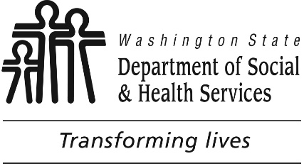

**Presenter:**

**Shanti Potts**

**From I5 South:**

Merge onto I-705 N via EXIT 133 toward City Center

Take the A Street exit on the left toward City Center

Keep left to take the S. 15 Street ramp toward Pacific Ave

Turn slight left onto S 15th St

Turn right onto Tacoma Ave S

1305 TACOMA AVE S is on the right

**From I5 North:**

Take the I-705 N / WA-7 S exit, EXIT 133, toward City Center / Pacific Avenue

Take the exit on the left toward City Center / Tacoma Dome

Merge onto I-705 N via the exit on the left toward City Center

Take the A Street exit on the left toward City Center

Keep left to take the S. 15 Street ramp toward Pacific Ave

Turn slight left onto S 15th St

Turn right onto Tacoma Ave S

1305 TACOMA AVE S is on the right.

For Questions: Call Melody

Erickson at 253-404-5560.

Do not call to register, use form attached.

# **Roles, Relationships, and Sexuality**

Join us for a closer look at the Roles we play, Relationships we foster and issues in Sexuality we must navigate as we support our clients. Each of us is unique. Our values, beliefs, cultural heritage, spiritual beliefs and personal comfort levels play a significant role in how we approach the complexities of sexuality. In this program we will work to build a better understanding of the unique needs and challenges of our population and develop some mindful approaches to supportive care in this venue of relationships and sexuality.

**Shanti Potts** has over 25 years’ experience working with and advocating for seniors, with a passion for teaching and learning. She works extensively with unpaid family caregivers and professional care providers. She has been employed as an instructor at Clark Community College, Lower Columbia Community College, Area Agency on Aging & Disabilities of SW Washington, Developmental Disabilities Administration & PeaceHealth Southwest Medical Center. Shanti has presented at conferences for the King County Prosecutor’s office, the Alzheimer’s Association, the Clark County Bar Association, the Nisqually Tribal Elders, Clark County Sheriff’s Crisis Intervention trainings, and various other local organizations. She is a member of the Area Agency on Aging and Disabilities management.

**Parking is not available in the Garage attached to our Tacoma DDA office/the Work Source Bldg.**

* There are a few spots available in angle parking in front of our building’s garage on Tacoma Ave, not in front of the bldg. itself.
* There is an uncovered fenced Republic parking lot at the Tacoma Public Library (one block north of the corner of 13th and Tacoma Ave and across the street from DDA)
* There is free street parking south of our bldg. and on perpendicular streets to Tacoma Ave, Do not park in 2 hour or other areas you are not allowed to.
* Transit, carpool, and or drop off/pick up is recommended.

You must attend all of the training to receive a certificate. Class starts promptly if you are late you will be asked to sign up for a future training.

[DDA Tacoma Office, 1305 Tacoma Ave S., Suite 300, Tacoma, WA 98402](https://binged.it/2efAX8C)

November 30th, 2017 Total of 6 CEUs 9 AM to 4 PM

I wish to attend this training.

Participants Name/s: ____________________________________________________________________

Provide Email, Fax, or Address to send confirmation notice: (Email is preferred, please put the “title” of the training and the word “registration” in email subject line when emailing registrations)

_____________________________________________________________________________________

Phone number in case of last minute changes to training: _______________________________________

**Tacoma**

**Developmental Disabilities Administration**

**Roles, Relationships, and sexuality**

**Registration Form**

**Please register early as space is limited and the training sessions fill quickly. Registration ends two weeks before date of training. We will email/send a confirmation, please allow a week to process before calling if you have not received a confirmation.**

**Please tell us at least two weeks in advance if you need a special accommodations** by writing it in the space below. We need two weeks to process your request. If you don’t receive a confirmation of this request please contact us. You can call Melody Erickson at 253-404-5560.

I need this special accommodation: ________________________________________

**Send this registration form via mail, email or fax to:**

**Melody Erickson,** Developmental Disabilities Administration

1305 Tacoma Ave. S., Suite 300, Tacoma, WA 98402

**Fax (253) 597.4368 Email–** [**melody.erickson@dshs.wa.gov**](mailto:melody.erickson@dshs.wa.gov)

**Additional classes are listed online at** <https://www.dshs.wa.gov/dda/dda-provider-training>

|  |  |  |  |
| --- | --- | --- | --- |
| Who can attend, Check one:   Licensed AFH Provider,   AFH Resident Manager,   AFH Caregiver,   Assisted Living Administrator   Assisted Living Caregiver   Companion Home Provider   Alternative Living Provider   DDA Residential Program Employee   DDA Employment Program Employee   Other, i.e. Family, parent, teachers, others who want to learn more. Please describe:  ____________________________________________ | Please fill out, if you can, the below information:  Name of Company/Employer/AFH:  ______________________________________  City of Company/Employer/AFH:  ______________________________________   Phone Number:  ______________________________________  Info about CEUs:  Individual Providers, can attend, but CEUs do not apply. IPs go through the Training Partnership for CEUs.  CE credits for others with DOH credentials may be allowable at the discretion of your licensing board. It is the responsibility of attendees with other certifications/ licenses to verify that this CE activity meets your licensing boards’ standards and acceptability as a CE event. |  |  |

November 30th, 2017 Total of 6 CEUs 9 AM to 4 PM