**Shanti Potts** has over 25 years’ experience working with and advocating for seniors, with a passion for teaching and learning. She works extensively with unpaid family caregivers and professional care providers. She has been employed as an instructor at Clark Community College, Lower Columbia Community College, Area Agency on Aging & Disabilities of SW Washington, Developmental Disabilities Administration & PeaceHealth Southwest Medical Center. Shanti has presented at conferences for the King County Prosecutor’s office, the Alzheimer’s Association, the Clark County Bar Association, the Nisqually Tribal Elders, Clark County Sheriff’s Crisis Intervention trainings, and various other local organizations.

**Tumwater**

**Developmental disabilities administration**

**Continuing education Training**

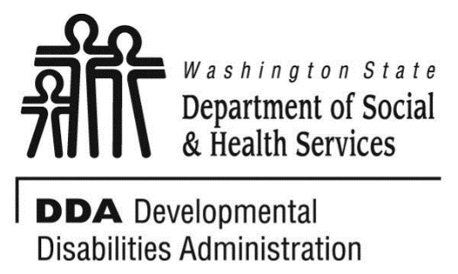

Figure 1 Developmental Disabilities Administration Logo

Figure 2 Developmental Disabilitiies Administration Logo

November 21, 2019 9 AM to 4 PM 6 CEUs

Communication

Communication is the art of being able to structure and transmit a message in a way that another can easily understand and/or accept. Interpersonal communication is the foundation of human interaction and can sometimes become a challenge when the person we are attempting to engage with is differently abled. In this session we will discuss: the different forms of communication; elements that impact success in communication; about listening; strategies for successful communications; effects of cognitive losses on communication success; and communication techniques in difficult or conflicted situations.

Join us as we explore ways for reaching the people we support, in a positive and empowering manners.

[Click here to register](https://www.eventbrite.com/e/communication-tumwater-november-21-2019-registration-66229142147)

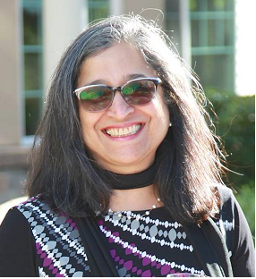

Tumwater DDA, 6860 Capitol Blvd SE, Bldg 2,Third Floor, Olympia, WA 98504

Take the stairs or the elevator to the 3rd Floor. Directly to your left is the Reception area. You must attend all of the training to receive a certificate. Class starts promptly at 9:00, if you are late you may be asked to sign up for a future training.

Class Size: Limited to 36 Participants

**Additional classes are listed online at** [DDA Provider Training Opportunities](https://www.dshs.wa.gov/dda/dda-provider-training)