Washington State’s
RESIDENTIAL SERVICES CURRICULUM
4.1 EDITION

FACILITATOR GUIDE

Program Manager: Sarah Blanchette DDA Residential Training
Funding for the revisions made to the Residential Services Curriculum 4th Edition provided by Roads to Community Living. Public Access to this curriculum is permitted.

Training Objectives
As a result of participating in this segment of training, learners will be able to:
- Identify the Residential Service Guidelines
- Defend the value of each of the six Residential Service Guidelines
- Relate the importance of the Residential Service Guidelines to their lives (as staff) and to the lives of those we support
- Create a dramatization of the qualities of a meaningful life, using a variety of mediums
- Balance health and safety versus power and choice in problem solving scenarios
Estimated Time
2 to 2.5 hours, depending on the number of participants

Supplies
Laptop or computer connected to a projector/monitor
External speakers for laptop or computer
Internet access
Paper and pens for participants
Residential Services Curriculum Toolkit (per participant)
Post-it Notes (3 or 4 post-its per participant)
White board & white board markers
Problem Solving Scenario cards: Health & Safety vs. Power & Choice
Envelopes and blank paper for Thank You Card activity

Preparation before training |  | Review Facilitator Guide for this chapter and ensure each participant has their Curriculum Toolkit available.
 | g | Opening Engaging Activity (6 minutes)
Say  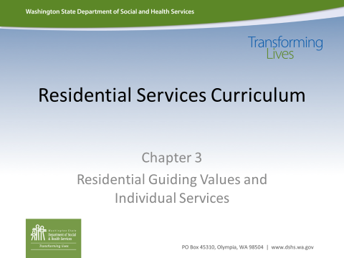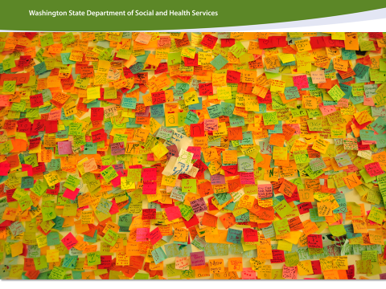 |  | I am going to give each of you 3 post-it notes. Write one thing on each note that you value and you think you wouldn’t want to live without. For example, perhaps folks may write down: Parent, Fitness, Finish my degree, New car, Read, Driver’s License.  OPTION: You may choose to write your initials on the post-it (this will allow the trainer to insure everyone is included in the activity).
Note |  | Note to Facilitator: While participants are writing their notes, write the Residential Service Guidelines on chart paper or whiteboard. It is recommended to write them in this sequence to make the acronym C-H-I-R-P-S.

- Competence
- Health and Safety
- Integration
- Relationship
- Power and Choice
- Status
Activity |  |  |  | Have participants decide under which word (that you placed on the board/walls) they believe each of their values fit.  Provide a few minutes for participants to get up and place their notes under each Residential Service Guideline.
 |  |  |  | Teach and Train (15 Minutes)
Curriculum  Toolkit |  |  |  | Have participants turn to the Curriculum Toolkit section of this chapter: Residential Service Guidelines.
Activity |  |  |  | Walk participants through the page in the Curriculum Toolkit, discussing each Residential Service Guideline as you help them each one.
Ask |  |  |  | As we look at the values on the sticky-notes we have placed on the wall, what additional Residential Service Guidelines might they also fit under?
Note |  |  |  | Note to Facilitator: While the Residential Service Guidelines appear separated on the visual, this is an opportunity to emphasize the categories of important areas of life spill into one another.
 |  |  |  | Demonstrate Learning: Application to Real Work (10-15 min)
Activity |  |  |  | Have participants take someone else’s post-it note off of the wall and return to their seat.  Explain that the note that has been taken from the wall represents the thing you value under that Residential Service Guideline which will no longer be a part of your life.

Ask |  | How do you feel about losing one of the things you value in your life? How do you feel about the person who removed that important thing from your life?  How do you think this activity relates to your work with individuals you will support?
Immerse (45 minutes)
Say |  | Most of us will support individuals throughout portions of each day. We are going to work in small teams to creatively approach the assigned portion of a day we are given in this next activity. We will need to consider what a meaningful life could look like during the hours of a day that your group is assigned. Since you may not know the people you will be supporting yet, use your own experiences and interests with your group for ideas.
Curriculum  Toolkit |  | Refer to the Curriculum Toolkit section for this chapter to make for their time slot presentations, or to take notes when groups present.
Note |  | Note to Facilitator: Assign participants to small groups and give each group a time segment of the day:  - 8am-noon  - noon-4pm  - 4pm-8pm  - 8pm-midnight
Activity |  | Explain to participants that the task for each group is to think beyond, “I took the individual into the community…” and consider that a meaningful life is more. In each group’s portion of the day they were assigned, they need to come up with a way to creatively share (in 2-3 minutes) what a meaningful life may look like or include during that period of time in a day.  Encourage groups to think of using the following ideas (or making these things) to showcase in 2-3 minutes what a meaningful like may look like:  - cartoon  - book  - song  - storybook  - rap  - poem  - news article  - news brief  - skit

• use personal technology to aid group’s presentation
Provide 10-15 minutes for groups to create their 2-3 minute presentation for their assigned segment of a day.
Activity |  |  |  | Allow groups 3 minutes to present their showcase of a meaningful day. Invite them to present from the time periods of the morning to the end of the day.
 |  |  |  | Teach and Train (10 minutes)
Ask |  |  |  | The following questions may be helpful in debriefing the group presentations about a meaningful life:  - What were some challenges for your group in deciding what a meaningful life looks like for your assigned timeframe?  - Where did you get your ideas?  - Did you see your life represented in the presentations?  - Were there any presentations that were not appealing or not your preference? Why?  - How do we determine qualities of a meaningful life with those we support?  - What examples did you see of the Residential Service Guidelines?  - Were all of the Residential Service Guidelines represented?
Note |  |  |  | Note to Facilitators: Guide the discussion to include asking opinions, listening, honoring choices, making suggestions, trying new things, and empowering people to be in charge of their lives.
 |  |  |  | Apply-Demonstrate Learning Application to Real Work (45 Min)
Activity |  |  |  | Problem Solving Scenarios: Health & Safety vs. Power & Choice  In small groups have people problem solve the following scenarios. Depending on the size of the class, you can choose to have each group focus on one or all 5. Allow groups 2-5 min. to discuss options depending on how many scenarios the groups are examining. (Print scenarios from the last pages of this chapter if you would like; cut into strips as Scenario Cards to provide groups.)  • Food- Person you support has high blood pressure, and wants to eat pre-packaged ramen noodles on a daily basis.

- Activity- Person you support wants to walk to the neighborhood market alone, but there is concern about a lack of street safety skills. There is only one staff per 3 supported individuals and the housemates don’t want to go.
- Smoking- You support someone who smokes and has been diagnosed with asthma.
- Staying up late- The person you work with has a doctor’s order to check his blood sugar at 7 am every morning and he insists on staying up late. This causes him to yell at the staff when they try to wake him for the glucose check.
- Refusing to bathe/shower- A woman you support has a skin condition that requires daily bathing and application of medicated lotion. She often refuses to take a shower, sometimes for several days in a row.
Note |  |  |  | Note to Facilitator: Remind participants that our number one responsibility is to help people to manage and protect their health and safety. Refer the group back to the DSP Roles discussed earlier  (Advocate, Partner, Encourager). Even if their choices may pose a risk, we need to allow for that dignity of risk. This needs to be balanced with common sense; the individual requires your support to ensure safety. Discuss this fine line.
Reflection & Celebration (5 minutes)
Say |  |  |  | Let’s each think of whom we have in our lives that have helped fulfill one of the Residential Service Guidelines and contribute to our meaningful life. We will take a few minutes and write a thank you note to that person. This is just for you to do with, as you like. You may use the envelope provided.  We are celebrating the fact that now we know what Residential Service Guidelines are!
Activity |  |  |  | Take a few moments and allow time to write thank you cards.
 | 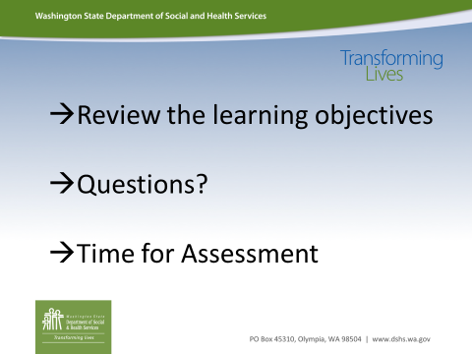
Activity |  |  |  | Please administer the assessment at the end of this chapter.
Note |  |  |  | Note to Facilitator: Please review the objectives in the Curriculum Toolkit on the first page with participants. Ask participants to circle the objectives for this chapter in which they believe they need more clarity. Allow for question and answer dialogue to ensure that all of the objectives have been met.  Hand out the assessment for this chapter to each participant. End of chapter assessments should take approximately 10 minutes.  As a learning tool, it will be important for each student to leave the training with the correct answers. Please review the answers and ensure that each student has marked the correct answer. When you review the assessment with students, note where people are having difficulty and review that section again with the whole group or determine where you will address this in the next chapter. Ensure that you reteach/retrain topics where learning gaps were identified.  Due to the confidential nature of the assessments in this course, please collect and shred all completed assessments.

Problem Solving Scenario: Health & Safety vs. Power & Choice

Food
Person you support has high blood pressure, and wants to eat pre-packaged ramen noodles on a daily basis.

**************************************************************************** Problem Solving Scenario: Health & Safety vs. Power & Choice

Activity
Person you support wants to walk to the neighborhood market alone, but there is concern about a lack of street safety skills. There is only one staff per 3 supported individuals and the housemates don’t want to go.

**************************************************************************** Problem Solving Scenario: Health & Safety vs. Power & Choice

Smoking
You support someone who smokes and has been diagnosed with asthma.

**************************************************************************** Problem Solving Scenario: Health & Safety vs. Power & Choice

Staying up late
The person you work with has a doctor’s order to check his blood sugar at 7 am every morning and he insists on staying up late. This causes him to yell at the staff when they try to wake him for the glucose check.

**************************************************************************** Problem Solving Scenario: Health & Safety vs. Power & Choice

Refusing to bathe/shower
A woman you support has a skin condition that requires daily bathing and application of medicated lotion. She often refuses to take a shower, sometimes for several days in a row.

