Washington State’s
RESIDENTIAL SERVICES CURRICULUM
4.1 EDITION

FACILITATOR GUIDE

Program Manager: Sarah Blanchette DDA Residential Training
Funding for the revisions made to the Residential Services Curriculum 4th Edition provided by Roads to Community Living. Public Access to this curriculum is permitted.

Training Objectives
As a result of participating in this segment of training, learners will be able to:
- Name two functions of behavior
- List at least two examples of triggers (antecedents)
- Examine the categories of setting events (physical/medical, environmental, social/psychological)
- Summarize the purpose of a functional assessment
- Identify environmental elements that support positive behavior
- Distinguish between natural consequences
- Identify why punishment is unacceptable
- Identify conditions that create potential power struggles
- Role play active (reflective) listening skills
- Provide examples of how dignity and respect are reflected in daily interactions
- Recognize the stages of the escalation cycle and what types of interventions might be appropriate at each stage
Estimated Time
3 hours, depending on the number of participants

Supplies
Laptop or computer connected to a projector/monitor
External speakers for laptop or computer
Internet access
Paper and pens for participants
Residential Services Curriculum Toolkit (per participant)
Communication Cards for communication exercise (found at the end of this guide, which should be copied & cut out, and can be glued or taped onto 3x5 index cards)
PBS Problem Solving Scenarios

Preparation before training |  | Review Facilitator Guide for this chapter and ensure each participant has their Curriculum Toolkit available. Copy the last pages of this facilitator guide, cut out the Communication Cards and PBS Problem Solving Scenarios.
Opening: Engaging Activity (7 minutes)
Note |  | Note to Facilitator: Ask the following question exactly as stated. Raise your own hand when you ask the question, but do not tell participants to raise theirs.  What you will see is that most people will raise their own hands in response to the question. This provides the opening to talk about how we learn behavior, i.e., social learning, social cues, modeling, etc.
Ask |  | How many of you would like an all-expenses paid vacation? Why did you raise your hands?
Say |  | Learned behavior serves a purpose; it has a function.
Note  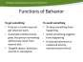  Curriculum  Toolkit |  | Label an easel chart with two columns. In the first column write: “To get something” and in the other column write: “To avoid something”. You will complete the list as participants share their answers to the next several questions.  See Functions of Behavior in the Curriculum Toolkit section of this chapter. Encourage participants to take notes and use a reference in your dialogue.
Ask |  | Label #1 “Get something.”  Ask the group: When you observe a child in a store having a tantrum what are they trying to “get”? (Answers could include a toy, food item, or just attention.) Some learned behaviors tell us that if we cat a certain way, we get something we want. We tend to think of this as something that someone gives us.

Another function of behavior is “Automatic reinforcement” when no other individual is part of the equation. We get something that we want but no one else is involved. These can be things like self-stimulation, rocking, nervous knees (when the knee “jiggles”),

Now ask the group: Why do you drive the speed limit?
When someone answers, “to avoid a speeding ticket,” label #2 “Avoid something.”

What happens in your vehicle when you don’t put on your seatbelt? How do you react?
When someone says, “I put on my seatbelt,” ask, Why?

As they answer, “Stop something negative from continuing.” The annoying chime stops when you put the seatbelt on.
Teach and Train (3 minutes)
Say |  | These are the two basic functions of behavior. In the past you have heard of three functions but newer information indicates that people have two functions of behavior with sub categories.  “Get something” could refer to a tangible object, attention, control, or stimulation. Automatic reinforcement occurs when a person’s behavior creates a favorable outcome for them while no other person was involved in any way.  “Avoid something” could be to avoid attention or an undesired activity. Stop something negative from continuing could refer to environmental stimulus or unwanted attention.
Immerse (25 minutes)
Say  Curriculum  Toolkit |  | Functional assessments attempt to determine the function (or purpose) of someone’s behavior. They are the foundation for positive behavior support plan development. This is how we ensure that people get their needs met in effective and socially acceptable ways.  Behavior does not occur in a vacuum. There are reasons for behavior, and assessing this helps us understand why it occurs.  In order to address behavioral concerns we must first understand them.

 |  | Refer to the Curriculum Toolkit section for this section called Evaluation.
Say |  | The areas we want to evaluate when determining the function of behavior are:  Communication: Do they use words in a non-typical way? What nonverbal cues do they use Do they need adaptive equipment?  Skills (abilities): Are we asking them to do something they are not about to manage? Is there a skill they want to learn?  History/Interest: What are their life experiences? Have they experienced trauma? What brings this person joy?  Diagnosis: Are there chronic health conditions? Do they have a dual diagnosis? Are they receiving adequate support?  Medications: Are effects and side effects being monitored? Are there problematic drug interactions?  Possible triggers/setting events: Are there environmental, medical/physical, social/psychological circumstances to consider? What happens just before the problem behavior?
Activity  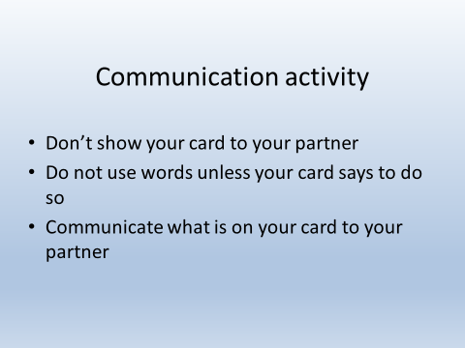 |  | Communication Activity:  Use the Communication Cards found at the end of this guide, which should be copied & cut out, and can be glued or taped onto 3x5 index  cards. (See list of Supplies at the beginning of this Guide.)  Pass one card to each person with the instructions not to show it to others. You can preselect role plays to assign to specific participants if desired.  Explain that the person acting out the card is not to use words unless their card has specific instructions to do so.  Have staff take turns attempting to communicate what is on their card while the rest of the group tries to understand. Some statements might be more easily understood than others. With larger groups, you could pair staff, and have them practice in their pairs simultaneously. It is most beneficial to have all staff hear and participate in all of the possible communications.  Communication Card Statements:  • I am thinking of the day my mother visited me six months ago. I miss her.

- Who are these people in my home today? And why did that person point at me? I am frightened and anxious.
- Consider this blank. Don’t express any emotion or behavior.
- I have the most terrible headache. (No use of arms)
- Nobody has really talked to me all day, or sat down at my level to even let me see them. I am so lonely.
- I have an itch in the middle of my back and I can’t reach it. (No use of hands)
- I am not sure why, but I am feeling cranky.
- I haven’t eaten yet today, and I am so hungry! But, I will only eat my favorite food. (Close eyes to indicate blindness)
- I have my spending check and I want to shop! (You speak, but can only answer “Batman” for yes, and “Robin” for no.)
- I can’t find my book, and I am almost done reading it.
- I am worried about my work at my new job. I am not sure I am doing a good job.
- I am sure my housemate took my favorite mug, and I want it back! It is not fair that my stuff gets taken!
Ask |  | What was difficult about trying to communicate? What was difficult about trying to listen? Did anyone feel like giving up? Or, did you find yourself frustrated to the point of wanting to physically or verbally lash out?  Your experience only lasted a few minutes. How would your behavior change if this was your life?
Say |  | Communication is only one piece that we evaluate in understanding the function of behavior. However, it is the catalyst which allows all of us to get our needs met.  There are other reasons that people may act in ways we might not expect. It could be that we have made an assumption about someone’s skill set. Our history and diagnosis will also change how we interact. Side effects of medications may change our ability to cope. Finally, all of us are subject to a variety of setting events; circumstances that set the stage for a “good” or “bad” day.
Immerse (5 minutes)
Ask |  | What does a really good start to your day look like? Invite the person next to you to describe. (30 seconds)  What does a really bad day look like? Invite the person next to you to describe. (30 seconds)

 |  |  |  | Ask the class to watch this video and think about what events set the caregiver up for having a good or bad day and what events set up the individual being supported to have a good or bad day? What events made a difference in both the lives of the caregiver and the person being supported?
Show |  |  |  | Show Kill Off video (14:10), which depict setting events.
Note |  |  |  | Note to Facilitator: While participants are viewing the video, you may want to label a whiteboard or chart pad with the three categories of setting events (physical/medical, environmental, social/psychological).
Apply (20 minutes)
Ask |  |  |  | What kind of setting events did you see?  As responses are shared, list them under the appropriate category of setting events (physical/medical, environmental, social/psychological) on the whiteboard or chart paper.
Activity |  |  |  | In groups or pairs, have class participants list other setting events that could fall under those categories.  Large groups could work on a single category.  Small groups could work on all categories, depending on class size and dynamics.  After 3-5 minutes ask the groups to either post their lists where all can see, or list their ideas on the board under the categories.
Note |  |  |  | Note to Facilitator: Be sure to keep the list on the board, for an upcoming role play activity.  Acknowledge that a variety of setting events may overlap into multiple categories (i.e., “my roommate is noisy” could fall under social as well as environmental setting events.)
Ask |  |  |  | Why might it be helpful to identify possible setting events for someone you are supporting?  Responses should include:  - knowing the setting events can help us not take the behavior personally  - we may have the ability to change or influence the setting events to support more positive behavior

Immerse (35 minutes)
Say |  | Some environmental setting events are ones we do not have control over, like the weather, the change of seasons, time of the sunrise and sunset, etc. There are some elements of people’s environments that we may be able to change in order to support positive behavior.
Activity |  | Divide the class into at least 3 groups, and distribute the PBS Problem Solving Scenarios, one for each group (copied and cut from the end of this facilitator guide).  Have each group discuss what could be done to change the environment based on the hypothetical situation. Once the groups have had 2-3 minutes to problem solve, provide time to share with the whole group.
Note |  | Note to Facilitator: There are three PBS Problem Solving Scenarios provided. (More can be added based on class size as needed.) For very large classes, more than one group could problem solve the same scenario.  - A young man who uses a wheelchair is frustrated because he wants to prepare his own food, but his kitchen is not very accessible. This causes the staff to prepare the food for him, since it is “easier.”  - A woman you support is very routine-oriented, to the point of becoming escalated when her routines change. She does not tell time, nor does she read.  - An elderly gentleman receiving services seems very easily overstimulated, which causes increased anxiety.
Say |  | When we have an opportunity to create more supportive environments, we should take the steps to do so!

Activity  Curriculum Toolkit |  | Turn to the curriculum toolkit and observe the roller coaster model.  Break the group into small groups of 3-5 people. Have a volunteer describe a “bad morning” what happened that contributed to a bad morning (example: woke up late, no coffee, stuck in traffic, late to work, etc). Now have that volunteer describe ONE event that would/has set them off or trigger that made the situation escalate.  For example, during a bad morning I wake up late, no time for coffee, late for work and caught in traffic, if someone cuts me off on the freeway I might have an incident of road rage (crisis).  Then have that volunteer talk about how they “cool down” or de-escalate.
Immerse (20 minutes)
Show  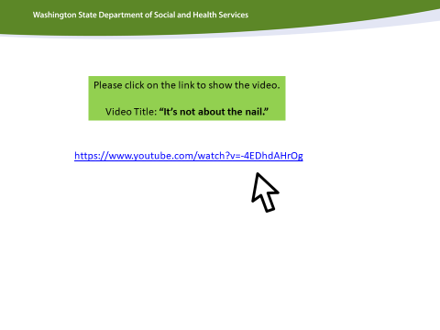 |  | Active listening can be hard, especially when you feel you have a solution.  Show It’s Not About the Nail video (2:08)
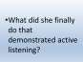  Ask |  | What did the woman eventually do that demonstrated active listening?  - Validating feelings like, “That must be really hard.”  - Supportive body language: nodding, eye contact, proximity  - Silence: allowing Joe to talk without interrupting

Say |  |  |  | We are going to replay the role-play in order to practice active listening, by one’s and three’s switching roles. This time the “one’s” choose one or two setting events, and the “three’s” choose a trigger, without sharing.  And our two’s will be the observers.
Activity |  |  |  | Allow at least 1-2 min. for the conversations.  Debrief the difference between this version of the role play with the first version. Ensure you lead the conversation to include that active listening implies what the person has to say is valid and worthy of your respect.
Say |  |  |  | Speaking of respect, think about what it would be like to hire a plumber who came into your home and didn’t bother to greet you, or ask you what you needed. Would that be acceptable?
Apply- Demonstrate Learning Application to Real Work (15 minutes)
Ask  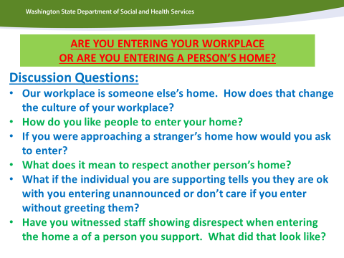 |  |  |  | Lead a discussion about how a DSP’s workplace is another person’s home and how we enter that environment matters. See PPT for discussion questions
Activity  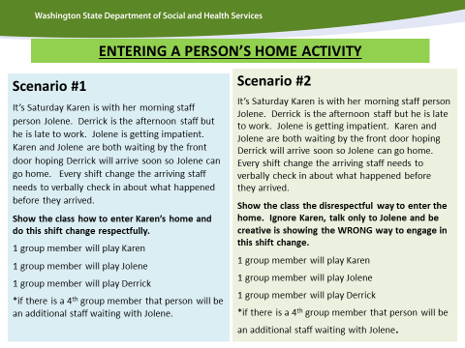 |  |  |  | This Activity asks you to break the group into small groups of 3-5 people and give them either Scenario #1 or Scenario #2 and have them demonstration (act this out) in front of the class and lead a discussion about these scenarios.
Teach & Train (15 minutes)
Curriculum  Toolkit |  |  | In your Curriculum Toolkit for section for this chapter, look at the list named Escalating Behavior list.
Activity  Curriculum  Toolkit |  |  | Using a scale of 1 – 10, write in each behavior. 1 is the mildest and 10 is the most intense.  Ask for a few volunteers to share what they rated as most and least intense. Referring to the roller coaster image Escalating Cycle on the Curriculum Toolkit page, ask people to label it with the following: Baseline, Escalation, Peak, and De-escalation. Once labeled, ask them to consider where some of the behaviors would fall on the cycle.
Note |  |  | Note to Facilitator: Answers will vary based on personal experience,  i.e., swearing could be baseline for one person, and peak escalation for someone else. Use these differences as a way to illustrate that behavior takes on different meaning for different people. (This is a great place to reference examples from work about what escalates people supported.)
Say |  |  | By labeling the degrees of intensity, we can assess appropriate strategies or interventions that are effective for the different stages of escalation.
Activity  Curriculum  Toolkit |  |  | Have participants write any 5 of the behaviors they rated on the blanks provided on the Curriculum Toolkit page. Review the variety of strategies shown.  Invite people to draw lines to connect any behavior to the strategy (or strategies) they feel might be most successful to support someone to get their needs met. Remind participants to consider where they believe the behavior would fall on the escalation cycle.
Apply- Demonstrate Learning Application to Real Work (20 minutes)
Ask |  |  | What do you think would happen if instead of considering how to support someone based on their levels of escalation, your response was to control them?
Say  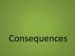 |  |  | Trying to control someone’s behavior does not help to get their needs met. It can also lead to us mistakenly thinking that punishment is helpful. Punishment is not a way to teach, it is about trying to enforce consequences. Natural and logical consequences are how we learn best.  Natural consequences, which may be negative OR positive, are:  - universal - would occur with any of us  - a result of actions or inaction  - not imposed by staff  - based on societal norms  - not punishment  - the best teacher for future behavior  Example:  “If I didn’t make my bed this morning, does that effect whether or not I go to the movies tonight?” The answer is “no” the two are unrelated. If I spend all my money at lunch, however, I will not be able to afford to go to the movies tonight – this is a “natural consequence.”  If we tell someone that they cannot go to the movies if they don’t make their bed, or because they yelled at staff earlier, then we are imposing punishment. Not only would this provide fuel for a power struggle, it is disrespectful, and could be deemed abuse, particularly in adult supported living settings.
Reflection & Celebration (15 minutes)

Ask |  | What if…  There was a way to know about the setting events or triggers for a person you support?  What if…  You had a list of strategies that were most successful in encouraging people to choose appropriate ways to handle challenges?  What if…  We collected that information and used it to create a Positive Behavior Support Plan?
Say |  | Good news! People you support will have a Positive Behavior Support Plan designed to help them overcome challenging behavior that might be getting in the way of their success. That plan will provide you with important tools!
Curriculum  Toolkit |  | In the Curriculum Toolkit section for this chapter, find the page labeled My PBS Plan.
Say |  | You will have an opportunity to write a brief plan for yourself. There are more components in a plan for people you support, but because this is about you, there are some details you already know. Included would be a description and history of:  - abilities  - life experiences & interests  - communication skills  - medical/psychiatric conditions  - medications currently prescribed  In addition, you would find the functional assessment of the challenging behavior(s), teaching strategies, plans for data collection and more.
Activity |  | Take a few moments to reflect on what you know, what you have learned, and apply it to this plan for yourself.
Note |  | Note to Facilitator: Once people have had a few minutes of reflection and writing, ask for a few volunteers to share what they wrote. Be sure to validate and praise contributions, illustrating the point that we are all on a continual path of learning and growing. We could all use a little PBS on that path!
Activity  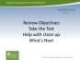 |  | Please administer the assessment at the end of this chapter.
Note |  | Note to Facilitator: As a learning tool it will be important for each participant to leave the training with the correct answers. Please review the answers and ensure that each participant has marked the correct answer. When you review the assessment with participants, note where people are having difficulty and review that section again with the whole group or determine where you will address this in the next  Chapter. Ensure that you reteach/retrain topics where learning gaps were identified. Due to the confidential nature of the assessments in this course, please collect and shred all upon completion.
This page left intentionally blank.

Communication Activity Cards
I am thinking of the day my mother visited me six months ago.  I miss her. | Who are these people in my home today?  And why did that person point at me?  I am frightened and anxious.
Consider this blank. Don’t express any emotion or behavior. | I have the most terrible headache.  (No use of arms)
Nobody has really talked to me all day, or sat down at my level to even let me see them.  I am so lonely. | I have an itch in the middle of my back and I can’t reach it.  (No use of hands)
I am not sure why, but I am feeling cranky. | I haven’t eaten yet today, and I am so hungry!  But, I will only eat my favorite food.  (Close your eyes to indicate blindness)
I have my spending check and I want to shop!  (You speak, but can only answer  “Batman” for yes, and “Robin” for no.) | I can’t find my book, and I am almost done reading it.
I am worried about my work at my new job. I am not sure I am doing a good job. | I am sure my housemate took my favorite mug, and I want it back! It is not fair that my stuff gets taken!

This page left intentionally blank.

Problem Solving Scenarios
(Copy and cut into strips to distribute)

- A young man who uses a wheelchair is frustrated because he wants to prepare his own food, but his kitchen is not very accessible. This causes the staff to prepare the food for him, since it is “easier.”

- A woman you support is very routine-oriented, to the point of becoming escalated when her routines change. She does not tell time, nor does she read.

- An elderly gentleman receiving services seems very easily over-stimulated, which causes increased anxiety.

